Tugas Minggu 2
Pemrograman JAVA

Oleh:
Alexander Gracetantiono
NIM( 51170018 )

Rangkuman Minggu 2
Materi : Class and Object

Class adalah rancangan atau blueprint yang merepresentasikan beberapa properti atau methods.
Object adalah class yang terisi dengan value, object juga dapat disebut sebagai contoh dari class, satu class dapat memiliki banyak object
Properties adalah variable pada class.
Method adalah fungsi yang dimasukan didalam class.

Contoh Class:
public class Sepeda {

private int roda;
private String pemilik;
int test;

public int getRoda() {
return roda;
}

}
Deklarasi Class
Properties
Function

public class SepedaMain {

public static void main(String[] args) {

Sepeda sepedaObj = new Sepeda();

sepedaObj.setRoda(2);

System.out.println("Jumlah roda: "+sepedaObj.getRoda());

}
}
Fungsi deklarasi main, untuk definisi bahwa ketika program di run, jalankan main
Membuat instance of class.
Contoh cara penggunaan fungsi dari class.
Memanggil Class sebagai object

Kasus 1
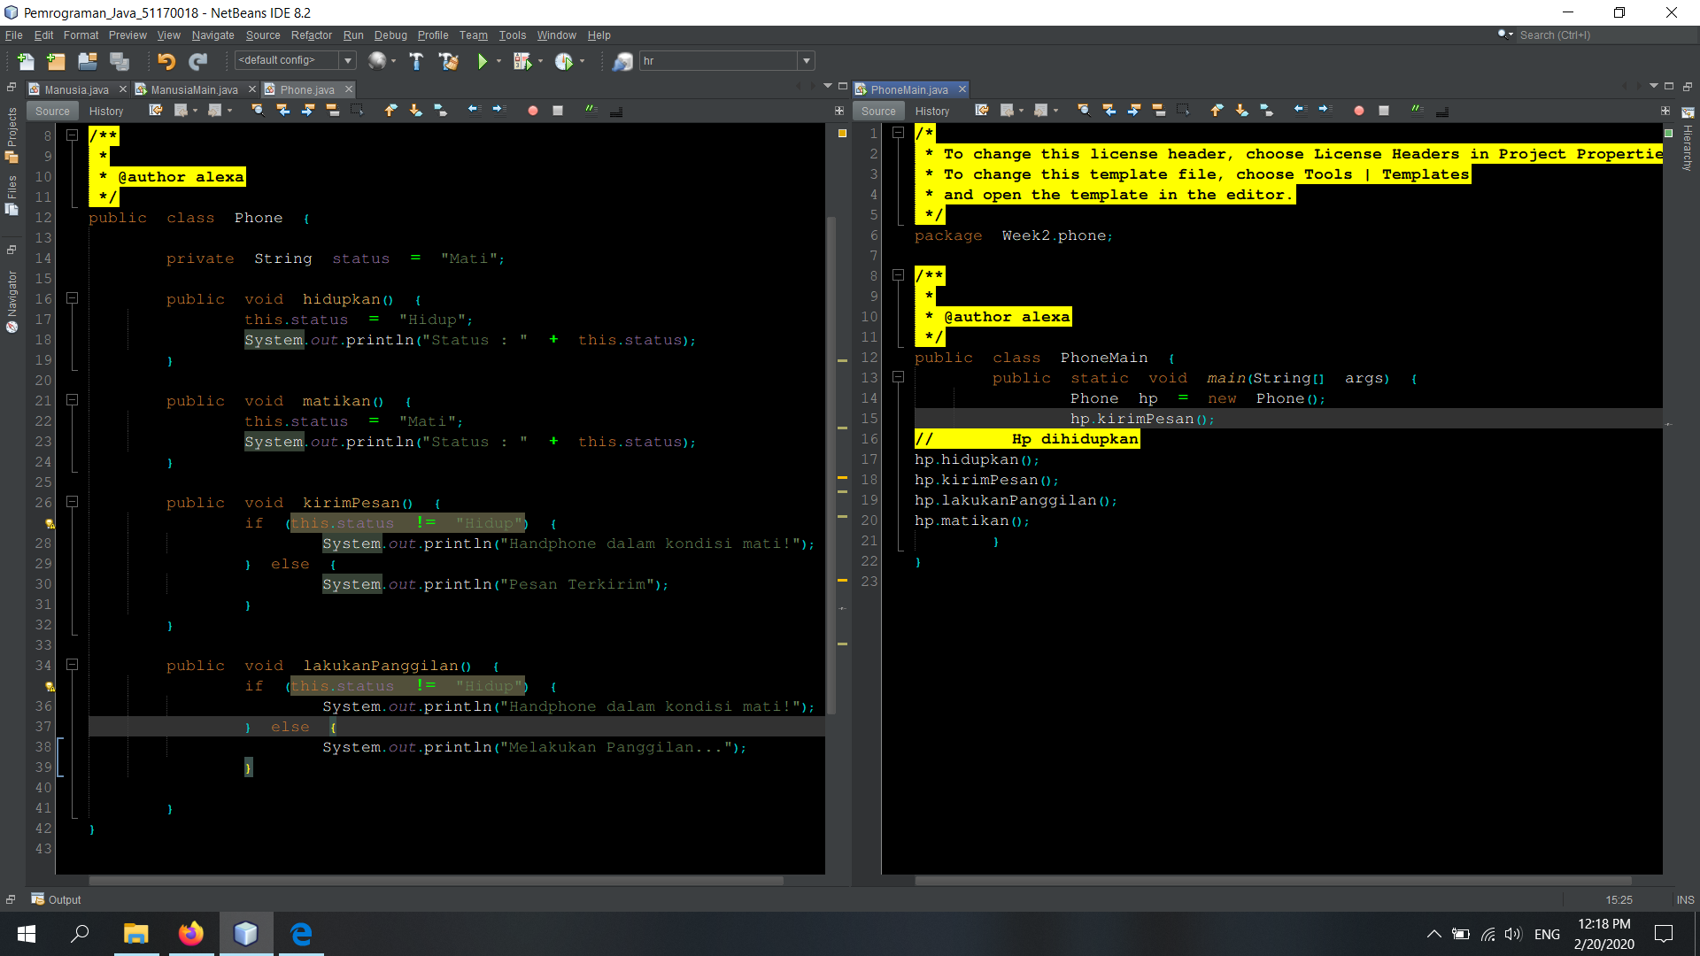
/**
*
* @author alexa
*/
public class PhoneMain {

public static void main(String[] args) {
Phone hp = new Phone();
hp.kirimPesan();
// Hp dihidupkan
hp.hidupkan();
hp.kirimPesan();
hp.lakukanPanggilan();
hp.matikan();
}
}

package Week2.phone;

/**
*
* @author alexa
*/
public class Phone {

private String status = "Mati";

public void hidupkan() {
this.status = "Hidup";
System.out.println("Status : " + this.status);
}

public void matikan() {
this.status = "Mati";
System.out.println("Status : " + this.status);
}

public void kirimPesan() {
if (this.status != "Hidup") {
System.out.println("Handphone dalam kondisi mati!");
} else {
System.out.println("Pesan Terkirim");
}
}

public void lakukanPanggilan() {
if (this.status != "Hidup") {
System.out.println("Handphone dalam kondisi mati!");
} else {
System.out.println("Melakukan Panggilan...");
}

}
}

Kasus 2
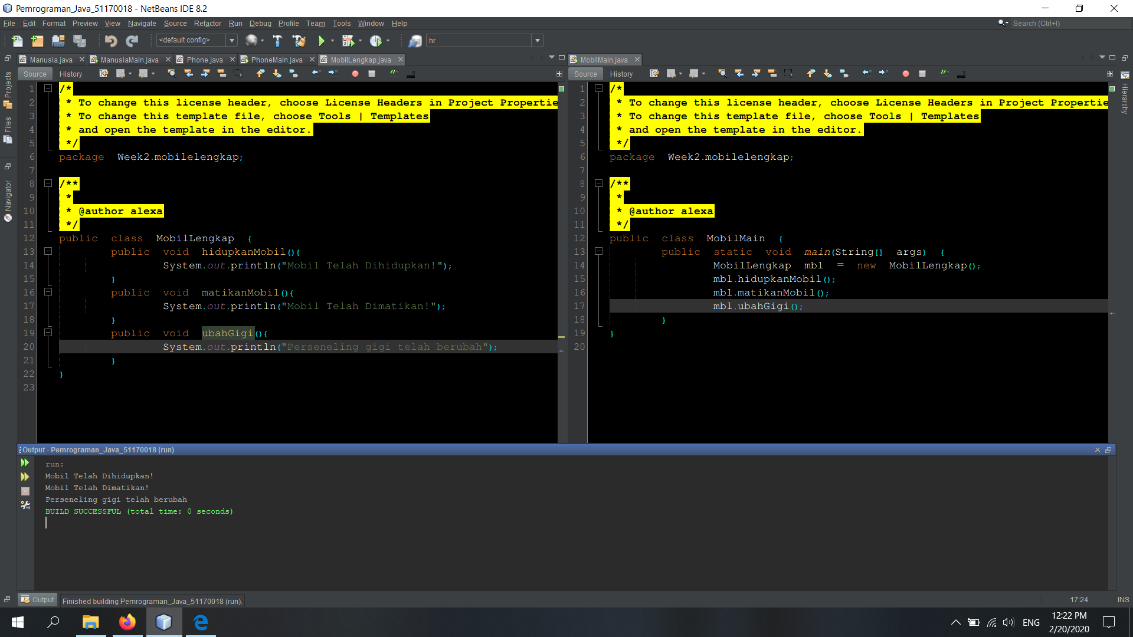
package Week2.mobilelengkap;

/**
*
* @author alexa
*/
public class MobilMain {
public static void main(String[] args) {
MobilLengkap mbl = new MobilLengkap();
mbl.hidupkanMobil();
mbl.matikanMobil();
mbl.ubahGigi();
}
}

package Week2.mobilelengkap;

/**
*
* @author alexa
*/
public class MobilLengkap {
public void hidupkanMobil(){
System.out.println("Mobil Telah Dihidupkan!");
}
public void matikanMobil(){
System.out.println("Mobil Telah Dimatikan!");
}
public void ubahGigi(){
System.out.println("Perseneling gigi telah berubah");
}
}

Kasus 3
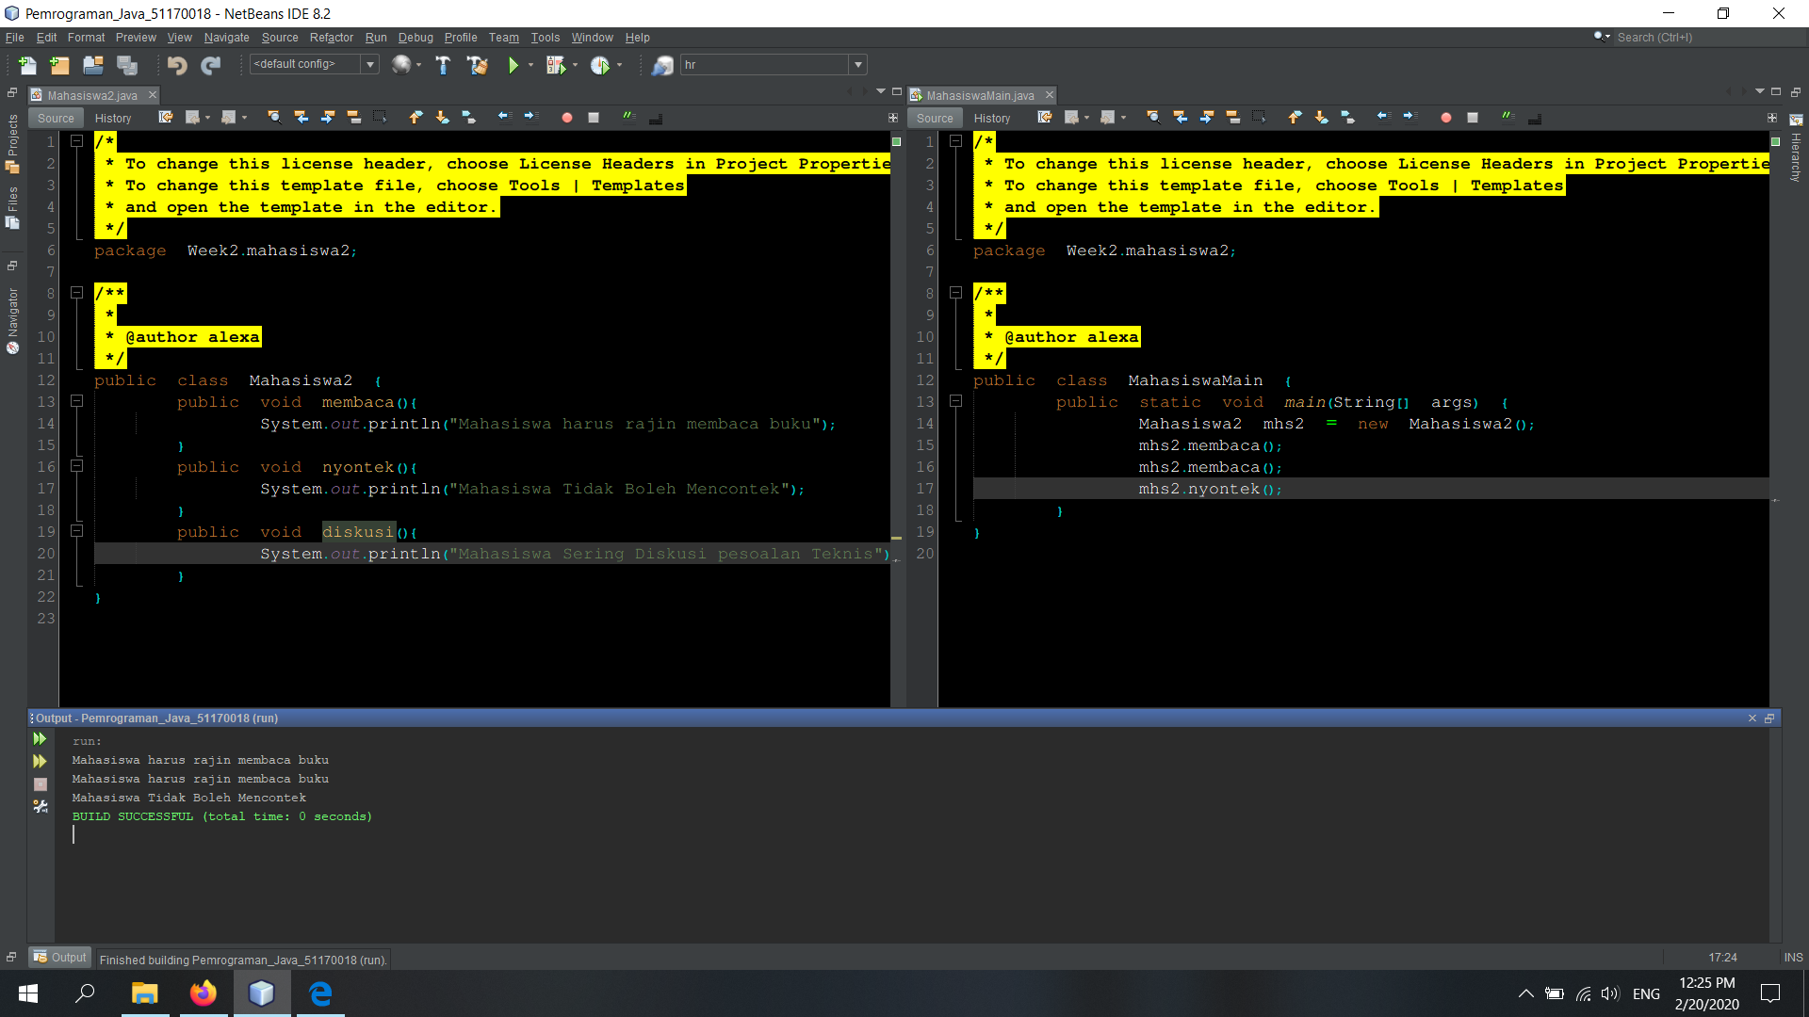
package Week2.mahasiswa2;

/**
*
* @author alexa
*/
public class MahasiswaMain {
public static void main(String[] args) {
Mahasiswa2 mhs2 = new Mahasiswa2();
mhs2.membaca();
mhs2.membaca();
mhs2.nyontek();
}
}

/*
* To change this license header, choose License Headers in Project Properties.
* To change this template file, choose Tools | Templates
* and open the template in the editor.
*/
package Week2.mahasiswa2;

/**
*
* @author alexa
*/
public class Mahasiswa2 {
public void membaca(){
System.out.println("Mahasiswa harus rajin membaca buku");
}
public void nyontek(){
System.out.println("Mahasiswa Tidak Boleh Mencontek");
}
public void diskusi(){
System.out.println("Mahasiswa Sering Diskusi pesoalan Teknis");
}
}

Kasus 4
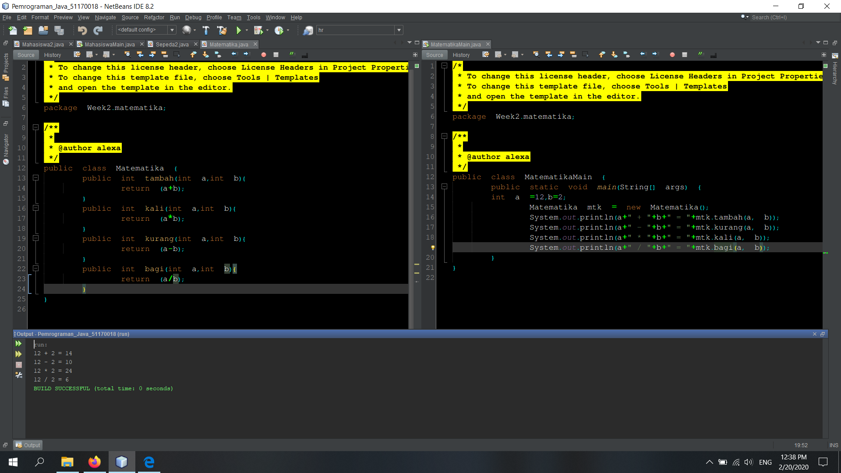
package Week2.matematika;

/**
*
* @author alexa
*/
public class MatematikaMain {
public static void main(String[] args) {
int a =12,b=2;
Matematika mtk = new Matematika();
System.out.println(a+" + "+b+" = "+mtk.tambah(a, b));
System.out.println(a+" - "+b+" = "+mtk.kurang(a, b));
System.out.println(a+" * "+b+" = "+mtk.kali(a, b));
System.out.println(a+" / "+b+" = "+mtk.bagi(a, b));
}
}

package Week2.matematika;

/**
*
* @author alexa
*/
public class Matematika {
public int tambah(int a,int b){
return (a+b);
}
public int kali(int a,int b){
return (a*b);
}
public int kurang(int a,int b){
return (a-b);
}
public int bagi(int a,int b){
return (a/b);
}
}

Kasus 5
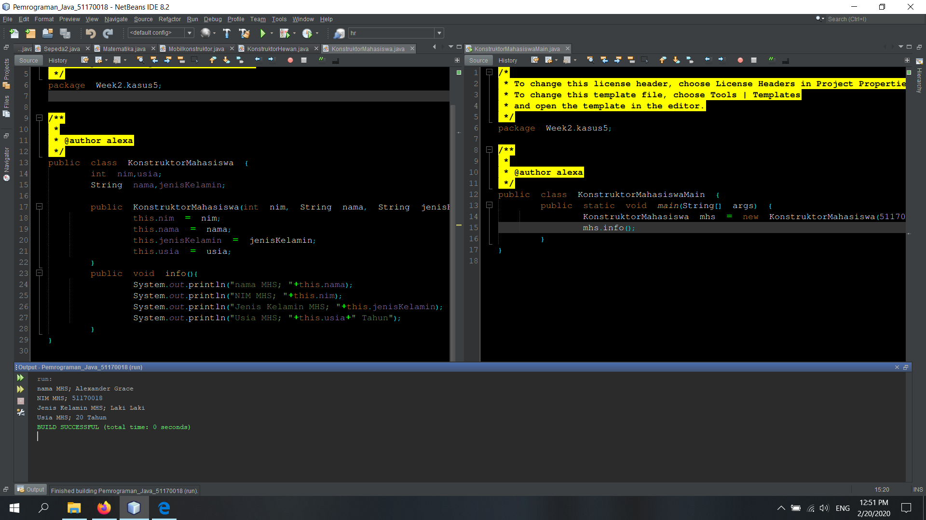
package Week2.kasus5;

/**
*
* @author alexa
*/
public class KonstruktorMahasiswaMain {
public static void main(String[] args) {
KonstruktorMahasiswa mhs =
new KonstruktorMahasiswa(51170018, "Alexander Grace", "Laki Laki",20);
mhs.info();
}
}

package Week2.kasus5;

public class KonstruktorMahasiswa {
int nim,usia;
String nama,jenisKelamin;

public KonstruktorMahasiswa(int nim, String nama,
String jenisKelamin, int usia) {
this.nim = nim;
this.nama = nama;
this.jenisKelamin = jenisKelamin;
this.usia = usia;
}
public void info(){
System.out.println("nama MHS; "+this.nama);
System.out.println("NIM MHS; "+this.nim);
System.out.println("Jenis Kelamin MHS; "+this.jenisKelamin);
System.out.println("Usia MHS; "+this.usia+" Tahun");
}
}

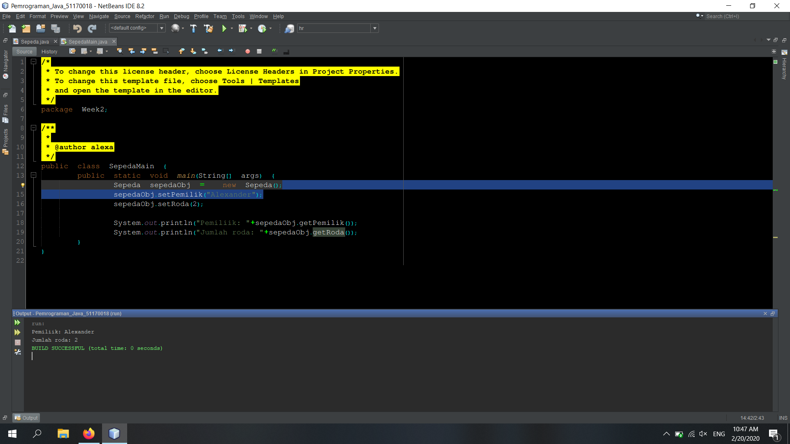
Latihan 1
///Main
package Week2;

/**
*
* @author alexa
*/
public class SepedaMain {
public static void main(String[] args) {
Sepeda sepedaObj = new Sepeda();
sepedaObj.setPemilik("Alexander");
sepedaObj.setRoda(2);

System.out.println("Pemiliik: "+sepedaObj.getPemilik());
System.out.println("Jumlah roda: "+sepedaObj.getRoda());

sepedaObj.printSepeda();
}
}

package Week2;

/**
*
* @author alexa
*/
public class Sepeda {
private int roda;
private String pemilik;
int test;
public int getRoda() {
return roda;
}

public void setRoda(int roda) {
this.roda = roda;
}

public String getPemilik() {
return pemilik;
}

public void setPemilik(String pemilik) {
this.pemilik = pemilik;
}
public void printSepeda(){
System.out.println("Roda: "+this.roda);
System.out.println("Pemilik: "+this.pemilik);
}
}

Latihan 2
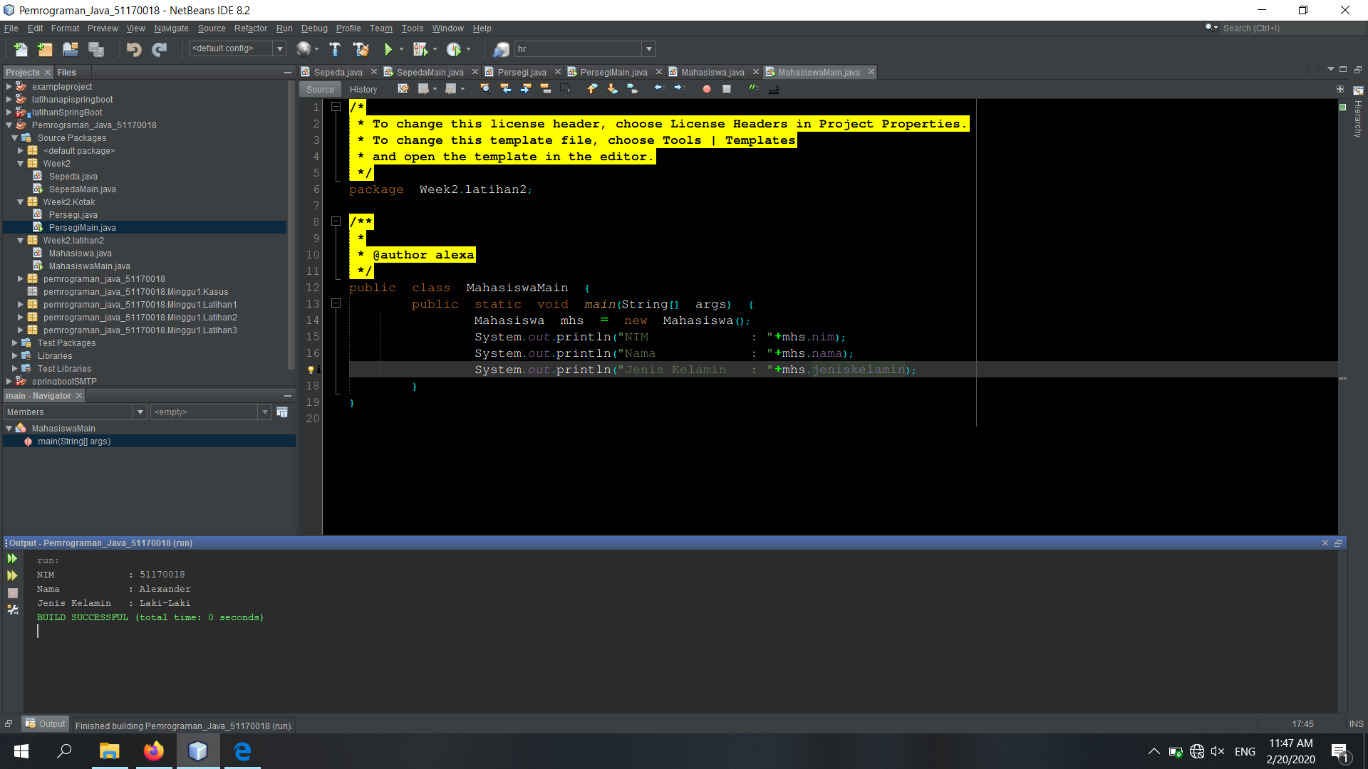
package Week2.latihan2;

/**
*
* @author alexa
*/
public class MahasiswaMain {
public static void main(String[] args) {
Mahasiswa mhs = new Mahasiswa();
System.out.println("NIM : "+mhs.nim);
System.out.println("Nama : "+mhs.nama);
System.out.println("Jenis Kelamin : "+mhs.jeniskelamin);
}
}

package Week2.latihan2;

/**
*
* @author alexa
*/
public class Mahasiswa {
String nim = "51170018",
nama="Alexander",
jeniskelamin="Laki-Laki";

}

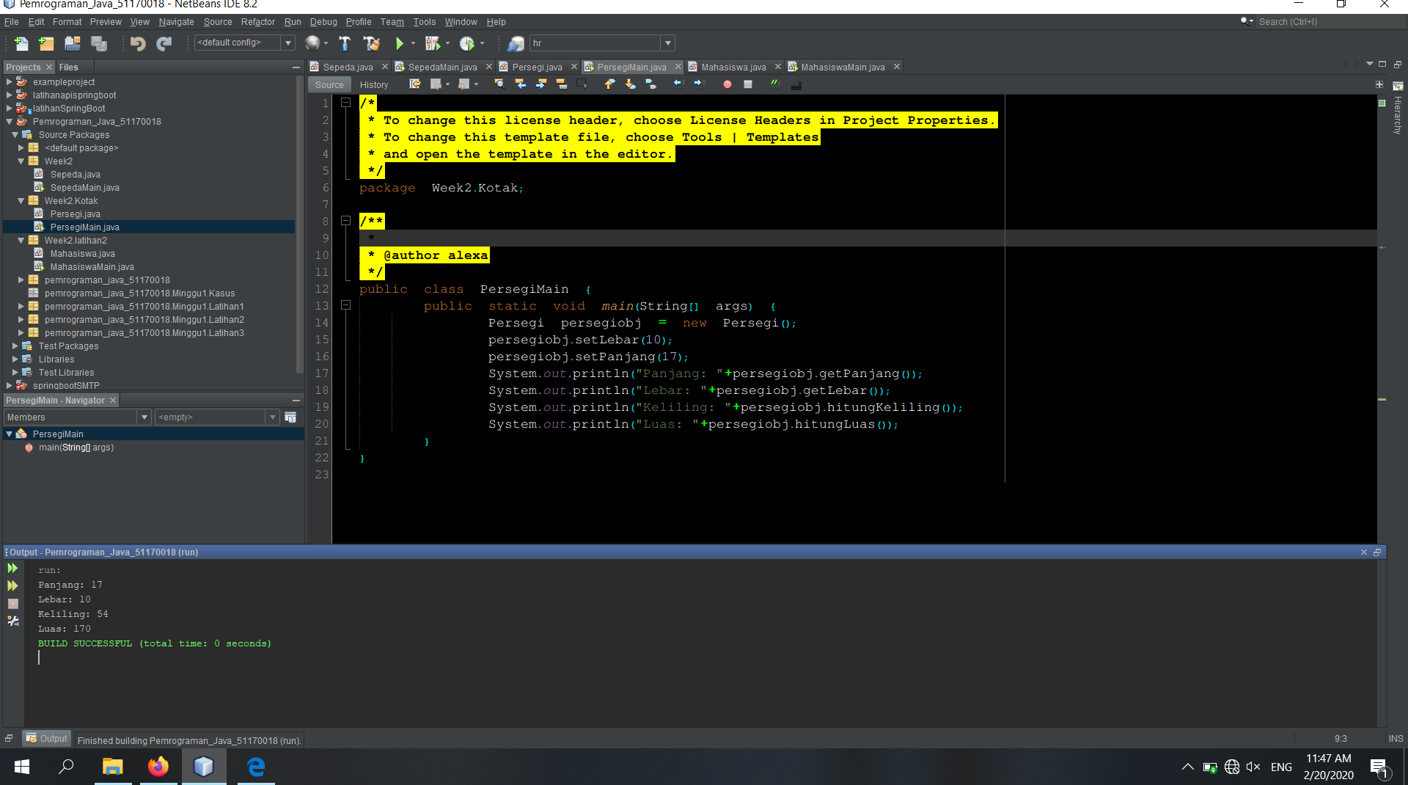
Latihan 3
package Week2.Kotak;
/**
*
* @author alexa
*/
public class Persegi {
private int panjang;
private int lebar;

public int getPanjang() {
return panjang;
}

public void setPanjang(int panjang) {
this.panjang = panjang;
}

public int getLebar() {
return lebar;
}

public void setLebar(int lebar) {
this.lebar = lebar;
}

public int hitungLuas(){
return (this.lebar*this.panjang);
}
public int hitungKeliling(){
return (2*this.lebar + 2*this.panjang);
}
}

package Week2.Kotak;

/**
*
* @author alexa
*/
public class PersegiMain {
public static void main(String[] args) {
Persegi persegiobj = new Persegi();
persegiobj.setLebar(10);
persegiobj.setPanjang(17);
System.out.println("Panjang: "+persegiobj.getPanjang());
System.out.println("Lebar: "+persegiobj.getLebar());
System.out.println("Keliling: "+persegiobj.hitungKeliling());
System.out.println("Luas: "+persegiobj.hitungLuas());
}
}
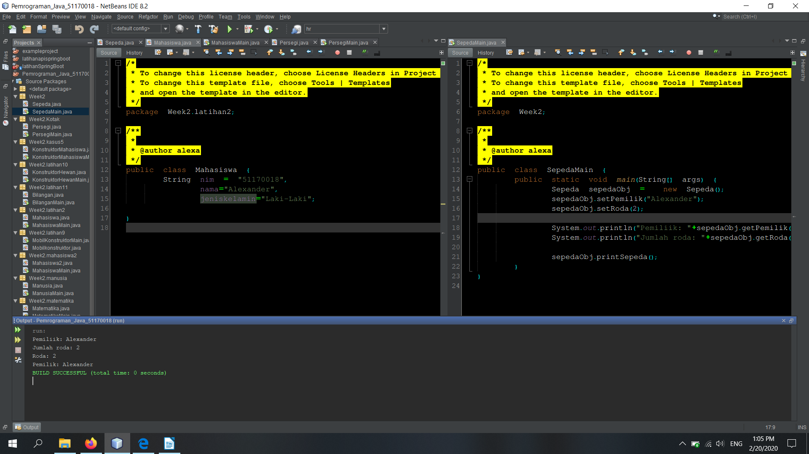
Latihan 4package Week2;

/** *
* @author alexa
*/
public class Sepeda {
private int roda;
private String pemilik;
int test;
public int getRoda() {
return roda;
}

public void setRoda(int roda) {
this.roda = roda;
}

public String getPemilik() {
return pemilik;
}

public void setPemilik(String pemilik) {
this.pemilik = pemilik;
}
public void printSepeda(){
System.out.println("Roda: "+this.roda);
System.out.println("Pemilik: "+this.pemilik);
}

}

///Main package Week2;

/**
*
* @author alexa
*/
public class SepedaMain {
public static void main(String[] args) {
Sepeda sepedaObj = new Sepeda();
sepedaObj.setPemilik("Alexander");
sepedaObj.setRoda(2);

System.out.println("Pemiliik: "+sepedaObj.getPemilik());
System.out.println("Jumlah roda: "+sepedaObj.getRoda());

sepedaObj.printSepeda();
}
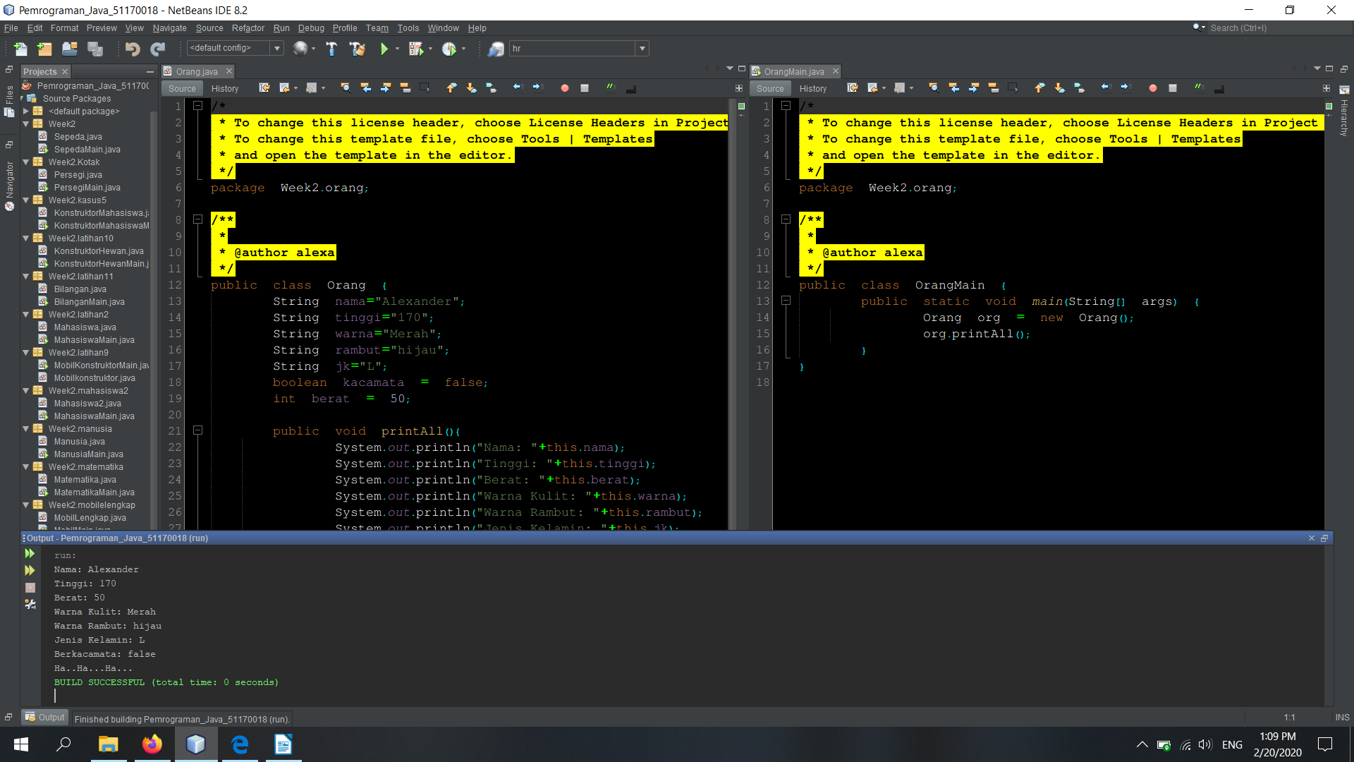
latihan 5/*
* To change this license header, choose License Headers in Project Properties.
* To change this template file, choose Tools | Templates
* and open the template in the editor.
*/
package Week2.orang;

/**
*
* @author alexa
*/
public class Orang {
String nama="Alexander";
String tinggi="170";
String warna="Merah";
String rambut="hijau";
String jk="L";
boolean kacamata = false;
int berat = 50;

public void printAll(){
System.out.println("Nama: "+this.nama);
System.out.println("Tinggi: "+this.tinggi);
System.out.println("Berat: "+this.berat);
System.out.println("Warna Kulit: "+this.warna);
System.out.println("Warna Rambut: "+this.rambut);
System.out.println("Jenis Kelamin: "+this.jk);
System.out.println("Berkacamata: "+this.kacamata);
if(this.kacamata){
System.out.println("Hic...Hic...Hic...Hic");
}else{
System.out.println("Ha..Ha...Ha...");
}
}
}

/*
* To change this license header, choose License Headers in Project Properties.
* To change this template file, choose Tools | Templates
* and open the template in the editor.
*/
package Week2.orang;

/**
*
* @author alexa
*/
public class OrangMain {
public static void main(String[] args) {
Orang org = new Orang();
org.printAll();
}
}

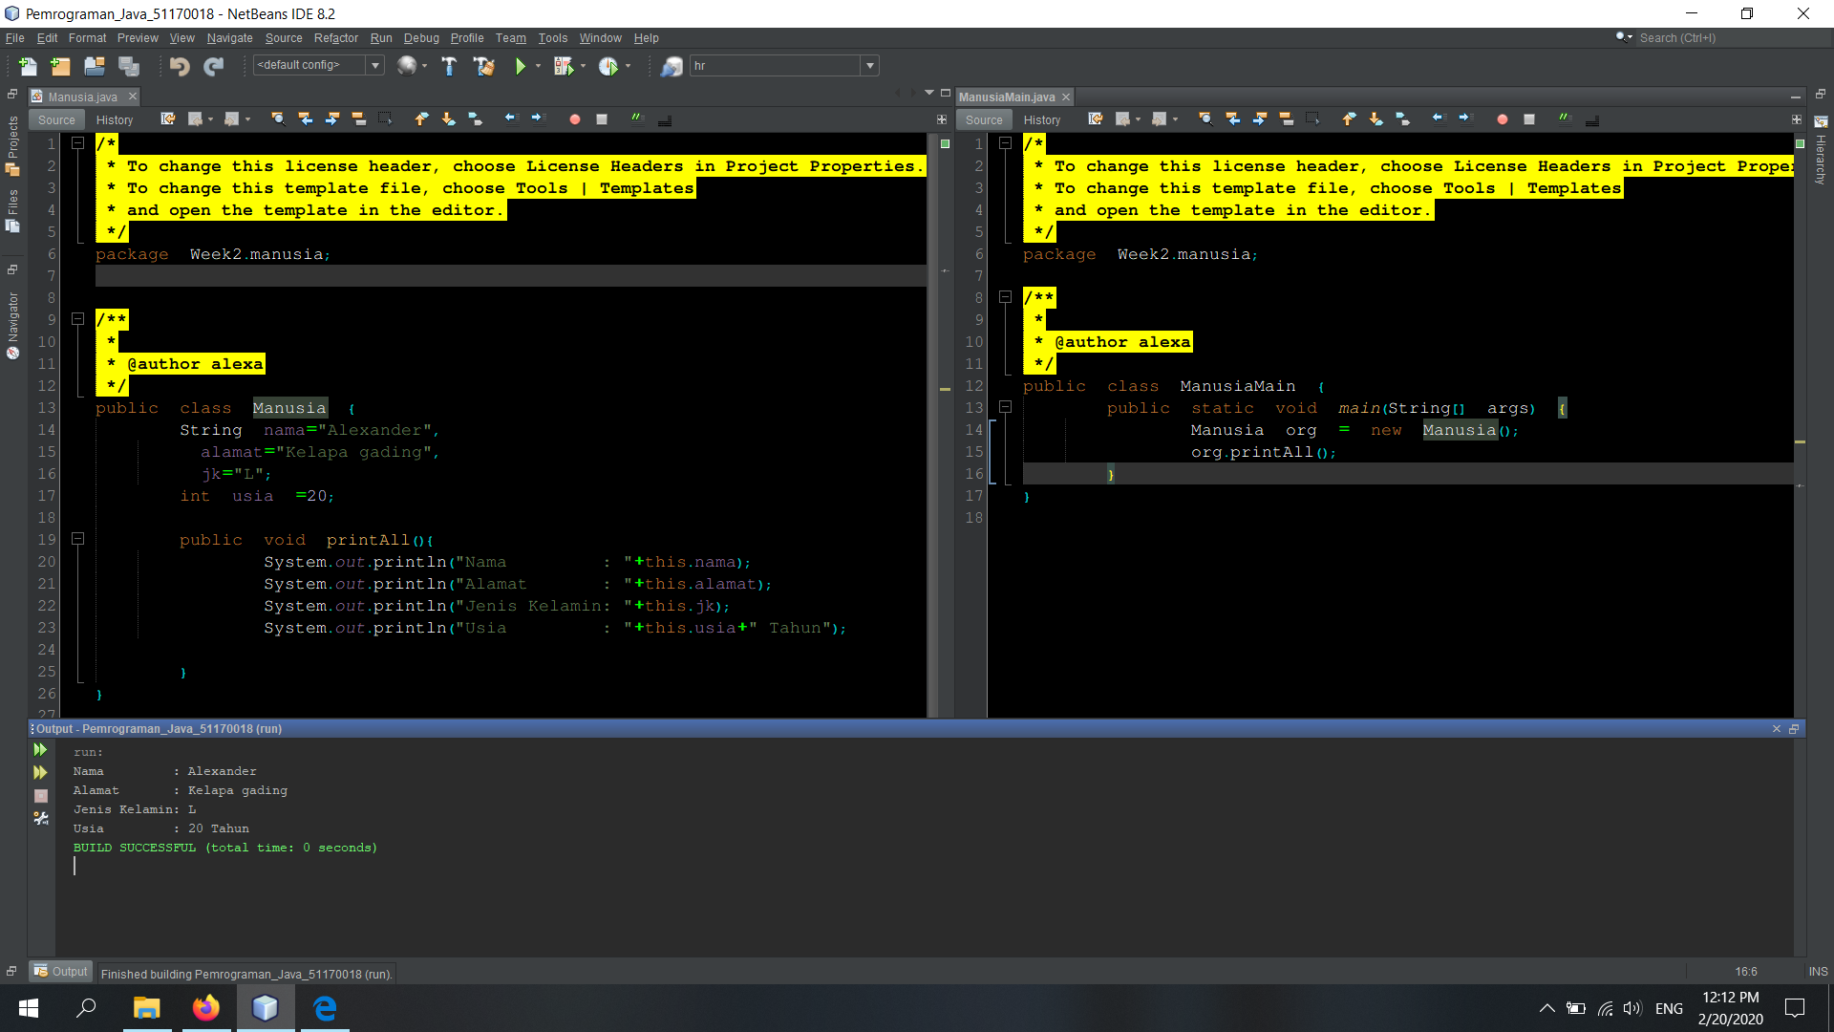
Latihan 6
/* * To change this license header, choose License Headers in Project Properties.
* To change this template file, choose Tools | Templates
* and open the template in the editor.
*/
package Week2.manusia;

/**
*
* @author alexa
*/
public class Manusia {
String nama="Alexander",
alamat="Kelapa gading",
jk="L";
int usia =20;

public void printAll(){
System.out.println("Nama : "+this.nama);
System.out.println("Alamat : "+this.alamat);
System.out.println("Jenis Kelamin: "+this.jk);
System.out.println("Usia : "+this.usia+" Tahun");

}
}

/*
* To change this license header, choose License Headers in Project Properties.
* To change this template file, choose Tools | Templates
* and open the template in the editor.
*/

package Week2.manusia;
/**
*
* @author alexa
*/
public class ManusiaMain {
public static void main(String[] args) {
Manusia org = new Manusia();
org.printAll();
}
}
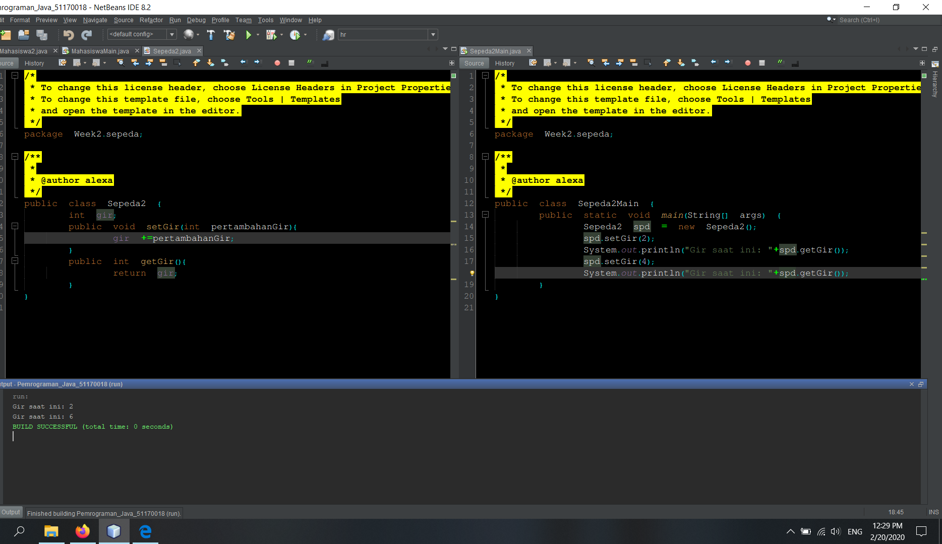
Latihan 7
/* * To change this license header, choose License Headers in Project Properties.
* To change this template file, choose Tools | Templates
* and open the template in the editor.
*/
package Week2.sepeda;

/**
*
* @author alexa
*/
public class Sepeda2 {
int gir;
int kecepatan;
public void tambahKecepatan(int akselerasi){
kecepatan += akselerasi;
System.out.println(kecepatan);
}
public void setGir(int pertambahanGir){
gir +=pertambahanGir;
System.out.println(gir);
}
public int getGir(){
return gir;
}
}

/*
* To change this license header, choose License Headers in Project Properties.
* To change this template file, choose Tools | Templates
* and open the template in the editor.
*/
package Week2.sepeda;

/**
*
* @author alexa
*/
public class Sepeda2Main {
public static void main(String[] args) {
Sepeda2 spd = new Sepeda2();
spd.setGir(2);
System.out.println("Gir saat ini: "+spd.getGir());
spd.setGir(4);
System.out.println("Gir saat ini: "+spd.getGir());

spd.tambahKecepatan(20);
spd.tambahKecepatan(44);
}
}

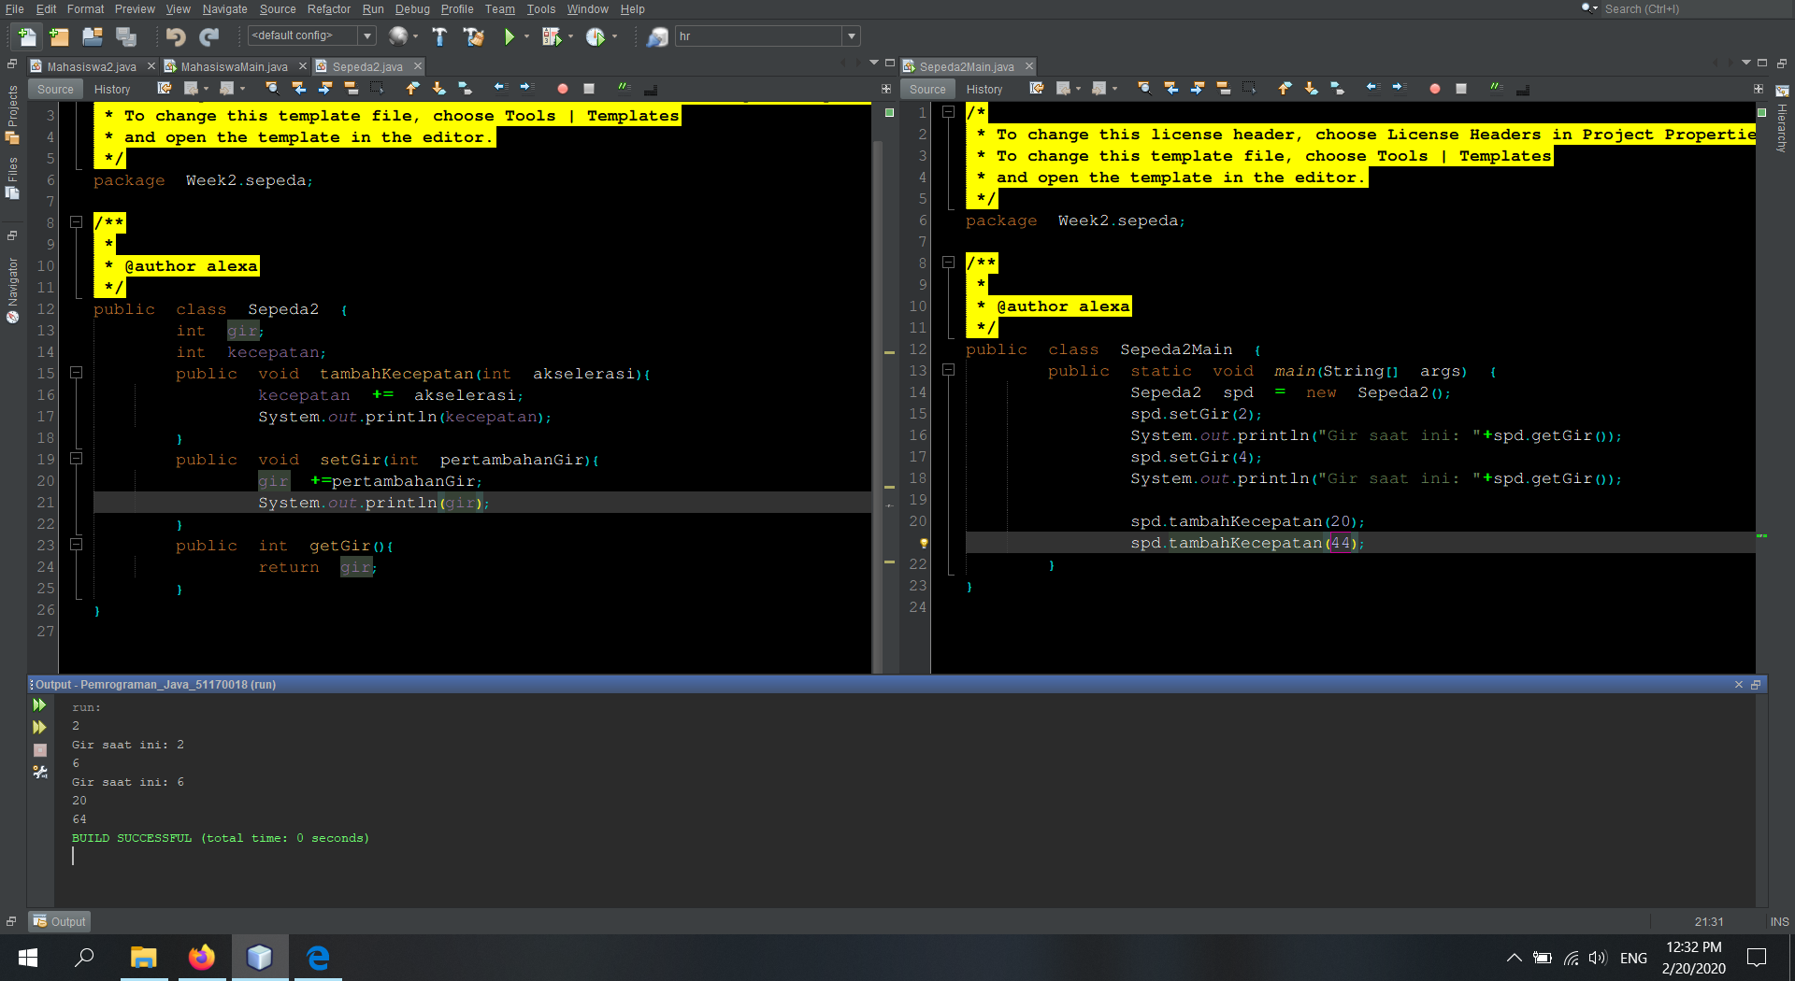
Latihan 8

package Week2.sepeda;
/**
*
* @author alexa
*/
public class Sepeda2 {
int gir;
int kecepatan;
public void tambahKecepatan(int akselerasi){
kecepatan += akselerasi;
System.out.println(kecepatan);
}
public void setGir(int pertambahanGir){
gir +=pertambahanGir;
System.out.println(gir);
}
public int getGir(){
return gir;
}
}
/*
* To change this license header, choose License Headers in Project Properties.
* To change this template file, choose Tools | Templates
* and open the template in the editor.
*/
package Week2.sepeda;

/**
*
* @author alexa
*/
public class Sepeda2Main {
public static void main(String[] args) {
Sepeda2 spd = new Sepeda2();
spd.setGir(2);
System.out.println("Gir saat ini: "+spd.getGir());
spd.setGir(4);
System.out.println("Gir saat ini: "+spd.getGir());

spd.tambahKecepatan(20);
spd.tambahKecepatan(44);
}
}

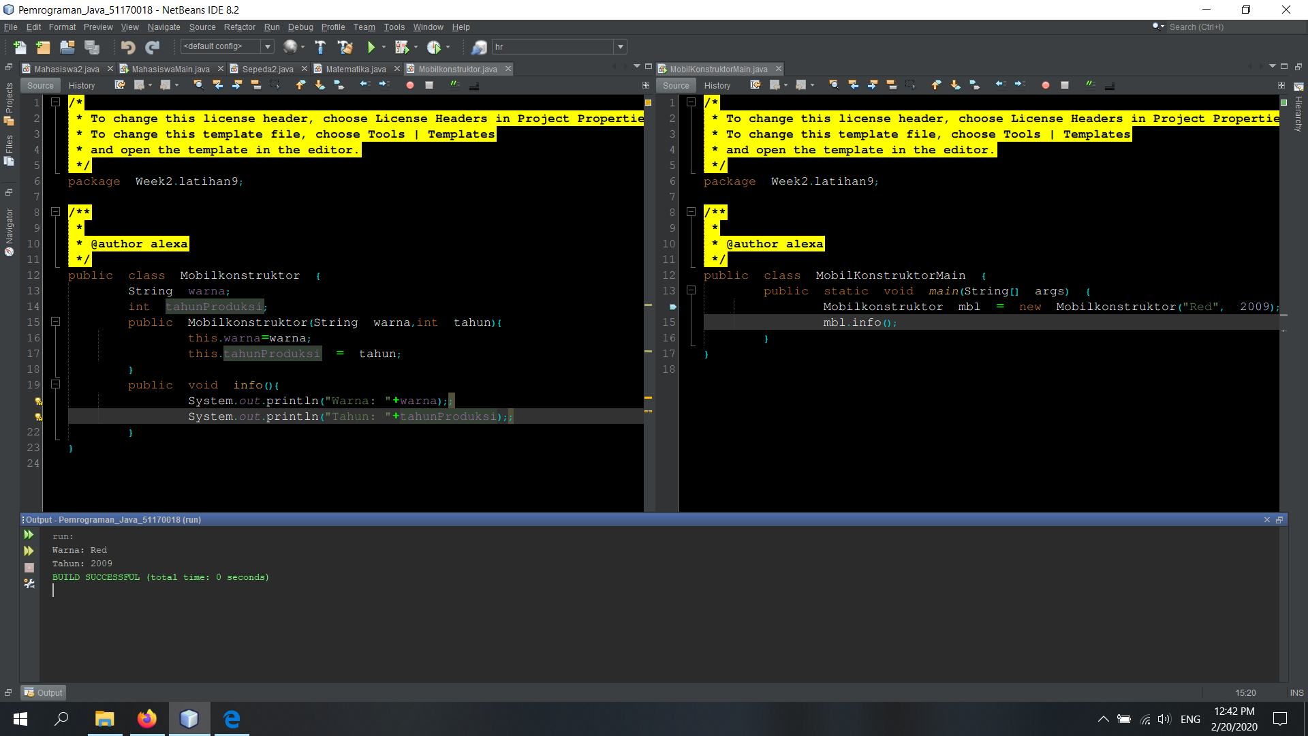
Latihan 9
/* * To change this license header, choose License Headers in Project Properties.
* To change this template file, choose Tools | Templates
* and open the template in the editor.
*/
package Week2.latihan9;

/**
*
* @author alexa
*/
public class Mobilkonstruktor {
String warna;
int tahunProduksi;
public Mobilkonstruktor(String warna,int tahun){
this.warna=warna;
this.tahunProduksi = tahun;
}
public void info(){
System.out.println("Warna: "+warna);;
System.out.println("Tahun: "+tahunProduksi);;
}
}

/*
* To change this license header, choose License Headers in Project Properties.
* To change this template file, choose Tools | Templates
* and open the template in the editor.
*/
package Week2.latihan9;

/**
*
* @author alexa
*/
public class MobilKonstruktorMain {
public static void main(String[] args) {
Mobilkonstruktor mbl = new Mobilkonstruktor("Red", 2009);
mbl.info();
}
}
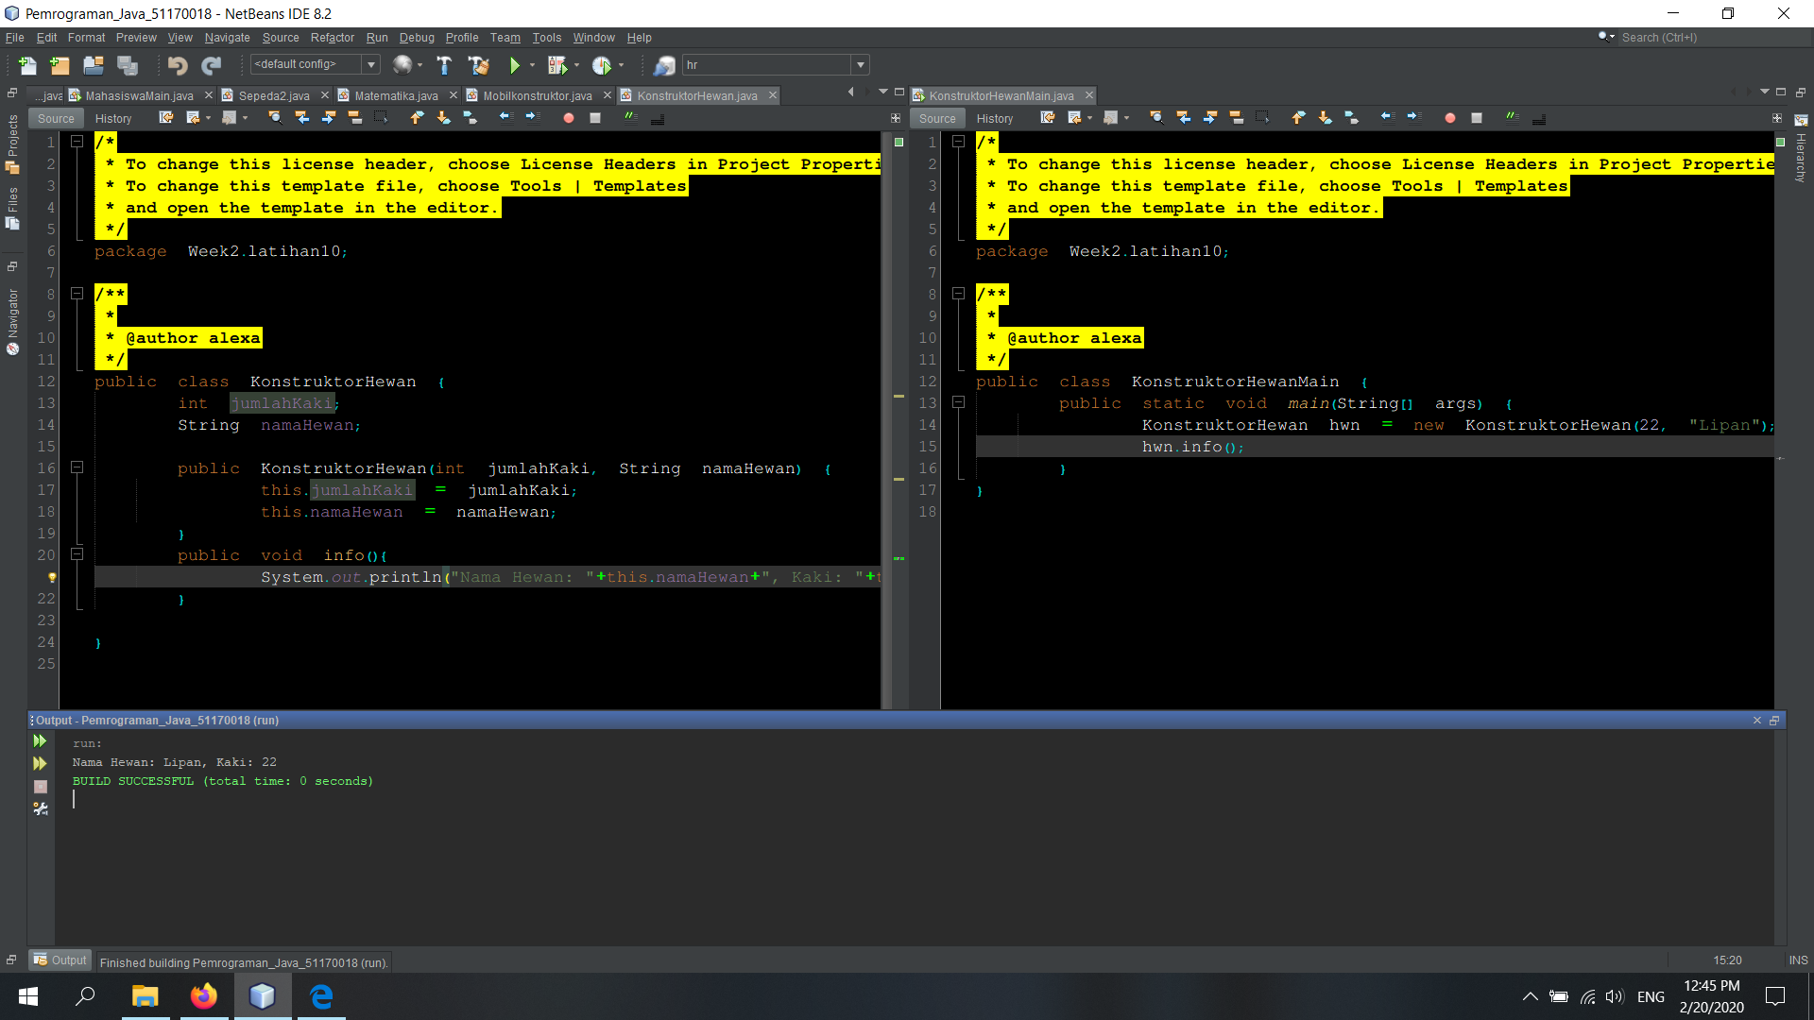
Latihan 10

/* * To change this license header, choose License Headers in Project Properties.
* To change this template file, choose Tools | Templates
* and open the template in the editor.
*/
package Week2.latihan10;

/**
*
* @author alexa
*/
public class KonstruktorHewanMain {
public static void main(String[] args) {
KonstruktorHewan hwn = new KonstruktorHewan(22, "Lipan");
hwn.info();
}
}

/*
* To change this license header, choose License Headers in Project Properties.
* To change this template file, choose Tools | Templates
* and open the template in the editor.
*/
package Week2.latihan10;

/**
*
* @author alexa
*/
public class KonstruktorHewan {
int jumlahKaki;
String namaHewan;

public KonstruktorHewan(int jumlahKaki, String namaHewan) {
this.jumlahKaki = jumlahKaki;
this.namaHewan = namaHewan;
}
public void info(){
System.out.println("Nama Hewan: "+this.namaHewan+", Kaki: "+this.jumlahKaki);
}

}
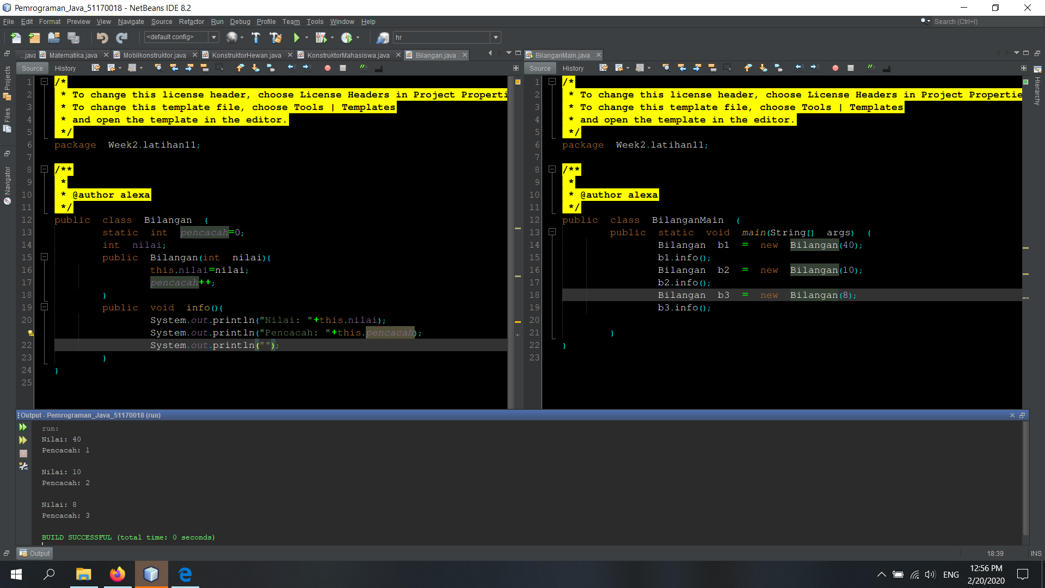
Latihan 11

/* * To change this license header, choose License Headers in Project Properties.
* To change this template file, choose Tools | Templates
* and open the template in the editor.
*/
package Week2.latihan11;

/**
*
* @author alexa
*/
public class Bilangan {
static int pencacah=0;
int nilai;
public Bilangan(int nilai){
this.nilai=nilai;
pencacah++;
}
public void info(){
System.out.println("Nilai: "+this.nilai);
System.out.println("Pencacah: "+this.pencacah);
System.out.println("");
}
}

/*
* To change this license header, choose License Headers in Project Properties.
* To change this template file, choose Tools | Templates
* and open the template in the editor.
*/
package Week2.latihan11;

/**
*
* @author alexa
*/
public class BilanganMain {
public static void main(String[] args) {
Bilangan b1 = new Bilangan(40);
b1.info();
Bilangan b2 = new Bilangan(10);
b2.info();
Bilangan b3 = new Bilangan(8);
b3.info();

}
}

