
Software Engineering Department
Braude College of Engineering

Final Project – Phase A (61998)
Deep learning-based analysis of edgent hebrew sources
26-1-R-19
Alexander Gruman
320648918
Shlomo Zrihan
206877698

Advisor’s:
Dr. Renata Avros
Prof. Zeev Volkovich

Link to GitHub:
https://github.com/AlexanderGruman/DeepImpostersProject

1.Abstract
Authorship attribution and style analysis are challenging tasks, particularly when the goal is to detect subtle stylistic differences within a single extensive text. This project develops a research and experimentation framework for Hebrew authorship-style analysis on the Five Books of the Torah (plain text without vowels and cantillation), aiming to examine whether the text demonstrates consistent writing style or evidence of multiple distinct styles.
The proposed approach combines two complementary methods. The first is Deep Impostors, a technique that segments texts, trains a model to distinguish between "impostor" writing styles, and converts each analyzed text into a numerical style signal. The second is Sen2Pro, which represents each segment not as a fixed embedding but as a probabilistic representation. This method captures uncertainty by sampling multiple embeddings (e.g., via dropout) and estimating the mean and covariance.
By integrating Sen2Pro into the Deep Impostors pipeline, the study investigates whether probabilistic sentence embeddings improve robustness and sensitivity to stylistic nuances in Hebrew. Experiments compare multiple configurations, including different Hebrew BERT-based models, segmentation strategies, and impostor-set constructions. The outcome includes quantitative measures (distance matrices, anomaly scores, clustering results) and visualizations that highlight stylistic consistency or potential shifts across and within the Torah books.
2.Introduction
Authorship attribution in classical and religious texts is one of the most challenging and fascinating problems in digital humanities and biblical studies. Much like diagnosing complex phenomena in medicine or psychology, identifying an author’s stylistic “fingerprint” inside a large, layered work requires tools that are both sensitive and precise.
A widely discussed view in modern biblical scholarship, often associated with the Documentary Hypothesis, argues that the Torah is not a uniform work produced by a single hand, but rather a carefully edited composition assembled from multiple sources across different periods (Friedman, 1987). In practice, the identification of such layers has largely relied on manual analysis and philological intuition—an approach that is inherently slow and, to some extent, subjective. Moreover, it is reasonable to assume that earlier research traditions may reflect various forms of bias (methodological, historical, or interpretive), especially when they depend heavily on human judgment.
One of the motivations of this project is therefore to explore whether a more data-driven, computational workflow can support a cleaner and more reproducible style analysis, where conclusions are derived from measurable outputs rather than from intuition alone.
Against this need for objective computational tools, Dr. Zeev Volkovich and Dr. Renata avros developed the Deep Impostors approach (Volkovich & Avros, 2025). In their work on Shakespearean authorship, they introduced a method for author verification based on dynamically comparing a target text to a set of “impostors”—reference texts with distinct styles that do not belong to the candidate author. By converting texts into a “stylistic signal” and applying anomaly detection, their method showed that it is possible to capture subtle stylistic differences and flag works that do not match the expected author profile, offering a quantitative perspective on long-standing historical questions.

However, applying this approach to Biblical Hebrew introduces challenges that are far less common in modern English corpora. Standard language-model embeddings (such as those derived from BERT) typically represent a text segment as a single point in vector space (Devlin et al., 2019), which may fail to reflect the ambiguity, polysemy, and structural complexity that characterize ancient Hebrew. To address this gap and strengthen the discriminative power of Deep Impostors in this setting, the present project integrates Sen2Pro (Probabilistic Sentence Embeddings). Sen2Pro adopts a probabilistic view of representation, modeling each sentence as a distribution rather than a single vector. This makes it possible to quantify not only the content of a segment but also uncertainty—both model uncertainty and data uncertainty—thereby helping the system capture nuanced variation that deterministic representations may overlook.

In this study, the combined architecture is applied to a Biblical corpus using a Hebrew language model (Hebrew BERT) adapted for historical texts. Transitioning from Shakespearean studies to the Bible requires more than a linguistic shift; it demands a careful reevaluation of text segmentation and impostor selection, given the scale and unique structure of the biblical text.
The overarching goal of this research is to develop a system that produces a continuous and accurate stylistic profile of the corpus, enabling an empirical examination of whether the text exhibits evidence of multiple distinct writing styles. Beyond this specific research question, the project aims to provide scholars with a novel analytical and visual tool for exploring stylistic layers and patterns in biblical literature.
3.Related work
  - Stylometry and Author Verification
3.1.1 Stylometry
Stylometry is the study of writing style using measurable features from text. Classic stylometry represents texts using features such as bag-of-words, word-frequency vectors, and character/word n-grams. While these features are computationally efficient and often effective, they can be sparse and typically fail to capture semantic meaning or word order comprehensively.

3.1.2 Author Verification
Author verification addresses a specific question: Does a given text match the writing style of a specific author (or source set)? An important configuration is extrinsic verification, which utilizes external reference texts as a practical "negative class" to assist the model in defining the characteristics of non-authorship (Potha & Stamatatos, 2020).

    - The Impostors Framework
The impostor’s framework supports author verification by comparing the target text not only to the candidate author, but also against a pool of impostor texts with different styles (Koppel & Winter, 2014).
In the classical approach, similarity is tested repeatedly under different random feature subsets.
In Deep Impostors, the same idea is modernized: a learned separator is trained on pairs of impostor collections, applied to short segments of the target text, and the local outputs are aggregated (e.g., averaged over chunks) to form a continuous representation of the text that can be analyzed further.

  - Sen2Pro: Probabilistic Sentence Embeddings
3.2.1 The Concept: From Point to Probabilistic Embeddings
Most sentence-embedding pipelines treat a sentence as a single vector (a point estimate). Sen2Pro argues that this is limiting because sentence embeddings have a “many-to-one” nature:
many slightly different realizations of meaning (or noisy realizations of the same sentence) can map to different vectors, and the embedding should ideally reflect that uncertainty.
As illustrated in Figure 1, standard language models map a sentence to a single fixed point in vector space (left), which assumes zero uncertainty. In contrast, Sen2Pro represents the sentence as a probability distribution—visualized as an ellipse (right)—thereby explicitly capturing the uncertainty associated with the text.

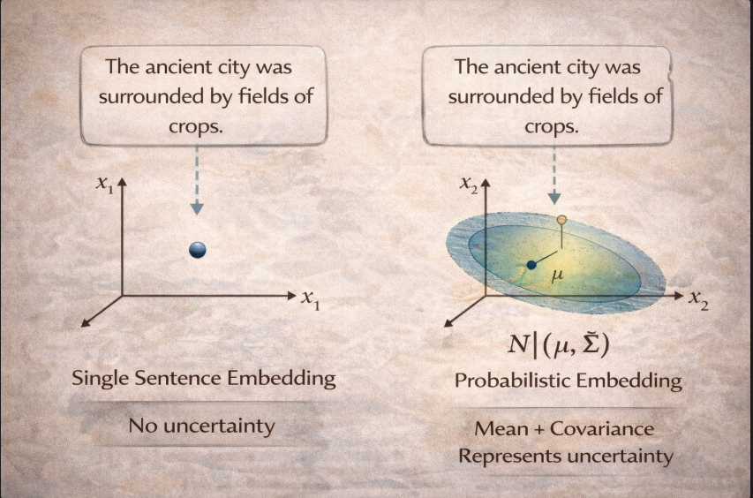
Figure 1: Visual comparison between a standard point embedding (left) and a Sen2Pro probabilistic embedding (right).

Sen2Pro therefore models a sentence representation as a distribution $N(μ,Σ)$ rather than a single vector and aims to estimate the mean and covariance of that distribution (Shen et al., 2023). using a pretrained language model $f_{θ}$ in a plug-and-play manner (i.e., without expensive retraining of a new probabilistic model)

3.2.2 Sources of Uncertainty: Model and Data
Sen2Pro separates uncertainty into two complementary sources:
- Model uncertainty is estimated by keeping the sentence fixed while “varying the model,” implemented via Monte-Carlo dropout sampling: for the same sentence $s$, multiple stochastic forward passes yield a set of embeddings $S_{m}={\left\{x_{i}=f_{{\hat{θ}}_{i}}\left(s\right)\right\}}_{i=1}^{N}$ (i.e for the same sentence “$s$” it goes through “${f_{\hat{θ}}}_{i}$” i.e model with dropout activated) (Gal & Ghahramani, 2016).
- Data uncertainty is estimated by keeping the model fixed while “varying the sentence slightly” through lightweight word-level augmentation (drop/swap/replace/insert), producing augmented sentences $s_{i}$ And embeddings $S_{d}={\left\{x_{i}=f_{θ}\left(s_{i}\right)\right\}}_{i=1}^{N}$.

3.2.3 Mathematical Formulation
After sampling, Sen2Pro estimates the distribution parameters using standard empirical estimators. The key definitions are summarized in Table 1.

Table 1: Definitions of symbols and estimators used in the Sen2Pro probabilistic framework.

$$μ=\frac{1}{\left|S\right|}\sum_{x∈S}{x}$$ | $$Σ=\frac{1}{\left|S\right|}\sum_{x∈S}{\underset{Covariance Matrix}{\underbrace{\left(x-μ\right){\left(x-μ\right)}^{T}}}}$$
$S≔$ Set of embedded vector’s i.e $S_{m} or S_{d}$  $$x≔embedded vector from the set$$  $μ≔$vector with same $dim$ as $x_{i},$representing the sentence main “semantic meaning” as function of all the embedded vector’s mean. | $x-μ≔$ deviation vector (how far this specific sample embedding is from the average embedding) & (if the deviation is small, that run is very close to the “typical” representation. If it is large, that run is more different).  Cov’ Matrix:= an entry $(a,b)$ is: ${\left(x-μ\right)}_{a}⋅{\left(x-μ\right)}_{b}$ i.e measures how the deviation in dimension $a$ relates to the deviation in dimension $b$ for the sample.

The covariance matrix $Σ$ of size $d×d$ provides crucial information regarding the uncertainty and spread of the embeddings:
Diagonal Entries (Variances): The diagonal values ($Σ_{a,a}$) epresent the variance of each dimension across samples. It can be inferred that a large diagonal value indicates that the corresponding dimension is unstable or "noisy."

Off-diagonal Entries (Covariances): The off-diagonal values ($Σ_{a,b}$ where $a≠b$) indicate how two dimensions change relative to each other. A positive covariance suggests that the dimensions tend to increase or decrease simultaneously, whereas a negative covariance implies an inverse relationship.

Diagonal enteries $Σ_{a,a}$ – These are the variances. They tell us how much dimension $a$ changes on its own across samples.

3.2.4 Interpreting Representation Stability
The concept of representation stability is visually illustrated in Figure 2. As depicted, "stable" sentences map to compact distributions (blue ellipses), indicating high model confidence. Conversely, "unstable" sentences map to broad, dispersed distributions (orange ellipses), reflecting uncertainty.

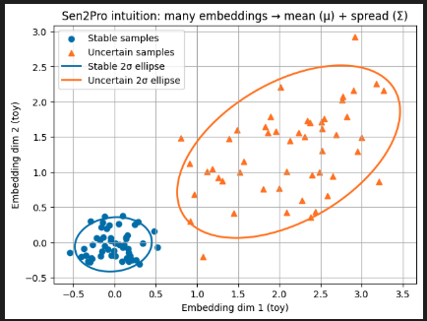
Figure 2: Visualization of Sen2Pro probabilistic embeddings: stable samples
(blue) versus uncertain samples (orange)

The practical implication for this project is that sentences can be compared based on the distance between distributions rather than merely vector distance. As detailed in Table 2, a stable representation (small $Σ$) implies that the model consistently represents the sentence, while an unstable representation (large $Σ$) suggests low confidence, potentially due to rare phrasing or linguistic complexity.

Table 2: Interpretation of stable versus unstable representations: characteristics and underlying causes.
Stable representation – the embeddings are very similar to each other (small spread, small $Σ)$. For our goals this means the model “sees” the sentence consistently, so the representation is likely reliable. | Unstable representation - the embeddings are more spread out (large spread, large $Σ$). For our goals this means the model is not confident about how to represent the sentence. This can happen due to rare/archaic phrasing, ambiguity, limited context, problematic tokenization, or simply because the model is not well adapted to Biblical Hebrew.

3.2.5 Practical Applications of the Framework
Reliability Weighting and Flagging: Segments containing unstable embeddings can be treated as less reliable during the analysis. In practice, these segments may be marked as "low confidence" or assigned a lower weight when aggregating results. This ensures that a small number of noisy segments does not distort the final conclusions.
Detecting Complex Text Regions: Consistently high uncertainty (large $Σ$) across a sequence of neighboring segments indicates that the language model struggles to represent that specific part of the corpus. This difficulty may stem from rare or archaic vocabulary, unusual phrasing, or tokenization mismatches. Thus, the system can identify specific text regions that are inherently difficult to model.
Comparing Language Models: The framework allows for the comparison of different Hebrew BERT models. A model that is better suited for the task is expected to produce fewer high-uncertainty segments and generate more stable representations across the entire corpus.
Validating Adaptation (MLM Fine-Tuning): Uncertainty metrics can be used to evaluate the effectiveness of Masked Language Modeling (MLM) fine-tuning. A decrease in uncertainty and an increase in signal consistency following the fine-tuning process serve as evidence that the model adaptation was successful.

  - The Deep Impostors Framework
3.3.1 Text Segmentation: Batches and Chunks
Deep Impostors builds on the impostor’s philosophy: instead of trying to directly “recognize the author,” the method constructs a relative style signal by repeatedly comparing target text segments against pairs of external impostor corpora (Volkovich & Avros, 2025). The core representation step treats a document $D$ as a sequence of fixed-length batches: $D=\left\{d_{1},…,d_{t}\right\}.$ Where each $d_{i}$ is a text batch of length $L$ wrods (the final shorter remainder is omitted). The segmentation process involves dividing the continuous text into fixed-length batches, which are later aggregated into chunks, as depicted in Figure 3.

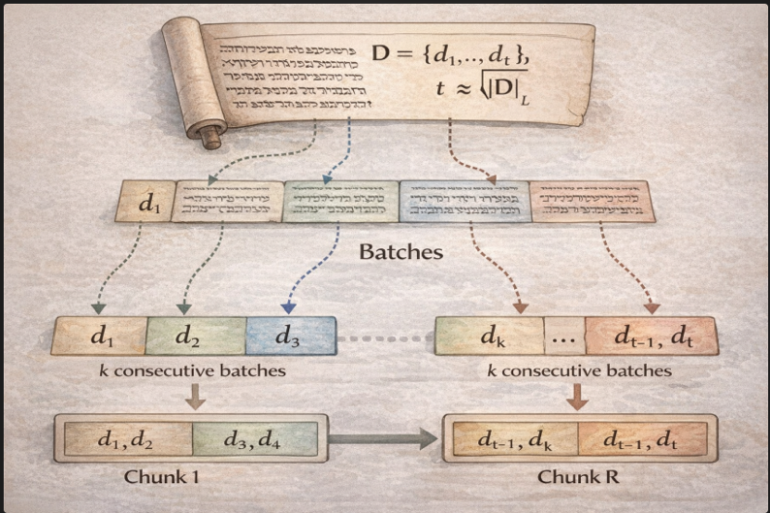
Figure 3: The segmentation process: converting a document into batches and aggregating them into chunks.

3.3.2 The Pairwise Separator Model
A supervised classifier $S$ is trained on pairs of impostor collections $(Z_{i},Z_{j})$ to learn a separator $S_{i,j}$ that distinguishes batches from impostor $i$ vs. impostor $j$. (The complete workflow, from input segmentation to signal generation and analysis, is illustrated in Figure 4.)

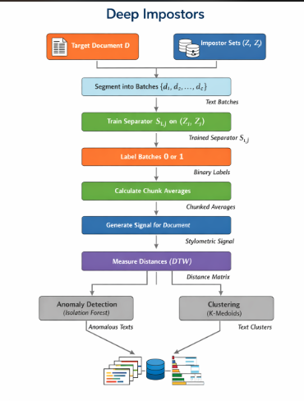
Figure 4: The Deep Impostors pipeline: from text segmentation and separator training to signal extraction and anomaly detection.

Then, the trained separator assigns binary labels (0/1) to batches from the tested document collection based on their similarity to $Z_{i}$or $Z_{j}$ effectively transforming the tested text into a binary sequence of local decisions.

3.3.3 Style Signal Extraction
To convert this binary sequence into an “actionable” style representation, the sequence of batch scores is grouped into chunks of fixed size $k$ (each chunk contains $k$consecutive batches), and each chunk receives the average of its batch labels.
This produces a numeric signal whose values lie in $\{0,\frac{1}{k},\frac{2}{k},…1\}$. Zeev & Renata also summarizes this as a procedural algorithm: segment into batches, train $S_{i,j}$ ,score each batch, then average every $k$ scores to form the signal. Once each text becomes a signal, Deep Impostors compares texts by comparing signals. A central tool used is Dynamic Time Warping (DTW).

3.3.4 Sequence Comparison with Dynamic Time Warping (DTW)
DTW (Dynamic Time Warping) is a way to compare two sequences of numbers even if they are not perfectly aligned in time. Instead of matching point 1 with point 1, point 2 with point 2, etc., DTW is allowed to “stretch” or “compress” parts of one sequence so similar patterns can line up. Then it computes a distance based on how well the two sequences can be matched after this flexible alignment (Sakoe & Chiba, 1978). We want this because two texts can show a similar stylistic pattern, but that pattern may appear earlier in one text and later in another, or progress at a different speed. A strict one-to-one comparison would call them different just because of shifting or length differences, while DTW can still recognize that the overall shape is similar. In Deep Impostors, this helps us compare “style signals” in a more robust way across documents or sections.

3.3.5 Anomaly Detection and Clustering
The method then forms a pairwise distance matrix between texts/signals and applies outlier/anomaly detection. the anomaly stage is described as building a distance matrix, embedding each text as its distance-row (Kuratowski-type embedding), and applying Isolation Forest, where normalized negative scores correspond to anomalous documents (Liu et al., 2008). Clustering is used to summarize structure (e.g., a larger “core” cluster vs. a smaller “suspicious” cluster), using K-medoids to split the score matrix into two clusters and interpret the larger group as the likely genuine/core group (Kaufman & Rousseeuw, 1990). Deep Impostors is implemented with different separator models; the paper explicitly studies both a CNN-based and a BERT-based approach (Devlin et al., 2019) on a large literary collection, and it emphasizes that the segmentation parameters $L$ (batch length) and $k$ (batches per chunk) stronly influence results and must trade off stability vs. signal length/resolution.

3.4 Synthesis: Motivation for a Combined Approach
The reviewed methodologies provide the foundation for the proposed research framework. Deep Impostors offers a complete signal-based pipeline for style analysis—spanning from segmentation and pairwise training to the generation of continuous style signals and outlier detection.

Complementing this structure, Sen2Pro allows for the replacement of static single-vector embeddings with distributional representations. By explicitly encoding uncertainty via sampling and estimation, this integration aims to improve robustness, particularly in challenging linguistic domains such as Biblical Hebrew, where segmentation choices and domain mismatches often introduce significant noise.

Consequently, the combined approach leverages the structural analysis capabilities of Deep Impostors with the probabilistic sensitivity of Sen2Pro, aiming to achieve a more accurate and stable stylometric profile.
4. Project Description

4.1 Project Goals and Requirements
The primary objective of this project is to develop and evaluate a computational research framework for analyzing writing style within a Biblical corpus. The goal is to empirically examine whether the text exhibits stylistic consistency or provides evidence of multiple distinct writing styles (e.g., multiple authors). To achieve this, the following requirements have been defined:

4.1.1 Functional Requirements:
- Corpus Processing and Segmentation: The system shall support the ingestion of a Hebrew text corpus (e.g., the Pentateuch) and perform text segmentation into fixed-length batches and aggregated chunks for analysis.

- Separator Model Training: The system shall train a binary classifier (separator) capable of distinguishing between pairs of external "impostor" texts, learning features that differentiate writing styles.

- Style Signal Extraction: The system shall convert the sequence of local classification decisions into a continuous "style signal" along the target text, representing stylistic variations.

- Probabilistic Analysis (Sen2Pro Integration): The system shall incorporate probabilistic sentence embeddings to explicitly model and quantify uncertainty, replacing deterministic vector representations.

- Outlier Detection and Clustering: The system shall identify stylistic outliers and perform clustering analysis at multiple resolution levels: the book level, the chapter level, and the segment level.

4.1.2 Non-Functional Requirements:
- Signal Stability: The generated style signals and analytical results must be reproducible and consistent across repeated runs with minor parameter variations, ensuring that detected anomalies reflect genuine stylistic shifts rather than stochastic noise.

- Linguistic Sensitivity: The system is required to handle the unique complexities of Biblical Hebrew, including archaic vocabulary and structural ambiguity, which challenge standard modern language models.

- Resource Efficiency: Given the computational cost of probabilistic sampling (Sen2Pro), the system shall implement optimization mechanisms such as embedding caching to enable feasible execution in resource-constrained environments (e.g., Google Colab).

4.2 Requirements Gathering
The requirements for this project were not derived from a traditional client-specification model but were established to address specific gaps in existing research and to meet the need for objective computational tools in biblical studies.

The need for objectivity: Traditional biblical scholarship, such as the Documentary Hypothesis, has largely relied on manual analysis and philological intuition. These methods are inherently slow, subjective, and prone to interpretative bias. A core requirement was, therefore, to develop a data-driven, computational workflow that derives conclusions from measurable outputs rather than human judgment.

Foundation in Existing Research: The architectural design is directly based on the Deep Impostors methodology developed by Dr. Zeev Volkovich and Dr. Renata Avros. Their work on Shakespearean authorship demonstrated that comparing a target text against a set of "impostors" can successfully verify authorship. The current project adapts this proven methodology to the distinct challenges of an ancient Semitic language.

Addressing Linguistic Complexity: The requirement to integrate Sen2Pro emerged from the understanding that standard deterministic language models (like BERT) often fail to capture the ambiguity and polysemy characteristic of Biblical Hebrew. Consequently, the system was required to model sentences as distributions to quantify uncertainty, thereby filtering out "noise" caused by linguistic difficulty rather than actual stylistic differences.

4.3 Research and Development Process
The research methodology follows a structured, multi-phase approach designed to adapt the Deep Impostors framework to the biblical domain:

1. Model Selection and Validation: The initial phase involves selecting an appropriate Hebrew language model (e.g., Hebrew BERT). Candidate models undergo quality checks, including tokenization suitability assessment and stability verification, to ensure they can effectively separate impostor sources during preliminary training.

2. Impostor Data Collection: A diverse set of external Hebrew text collections is curated to serve as "impostors," providing the necessary negative class examples for the training process.

3. Pipeline Implementation: The core development phase focuses on building the Deep Impostors pipeline, including the integration of the Sen2Pro module for probabilistic representation. This stage involves implementing the segmentation logic, the separator classifier, and the signal extraction mechanisms.

4. Experimentation and Optimization: The final phase consists of iterative experiments comparing the baseline system against the Sen2Pro-enhanced version, optimizing parameters such as batch size and sampling count to balance accuracy with computational efficiency.

4.4 Expected Challenges
The project addresses several significant challenges:
Linguistic Complexity: Biblical Hebrew differs significantly from modern Hebrew in vocabulary and structure. Standard language models may struggle with archaic phrasing, potentially introducing noise into the style signals.

Computational Constraints: The integration of Sen2Pro, which requires multiple forward passes per sentence to estimate uncertainty, significantly increases the computational load. Executing these models within resource-constrained environments (e.g., Google Colab) necessitates efficient resource management.

Stochastic Stability: Ensuring that the detected stylistic patterns are robust and not merely artifacts of random initialization or sampling noise is a critical challenge that requires rigorous stability testing.

4.5 Tools and Technologies
The system is implemented using the following stack:
• Language: Python.
• Deep Learning Framework: PyTorch / HuggingFace Transformers (for Hebrew BERT models).
• Probabilistic Modeling: Sen2Pro (official implementation).
• Analysis Algorithms: Scikit-learn (Isolation Forest), FastDTW (Dynamic Time Warping), K-Medoids (Clustering).

4.6 Solution Description
The proposed solution is a modular pipeline based on the Deep Impostors methodology, enhanced with a probabilistic embedding layer. The architecture, illustrated in Figure 4, consists of the following stages:

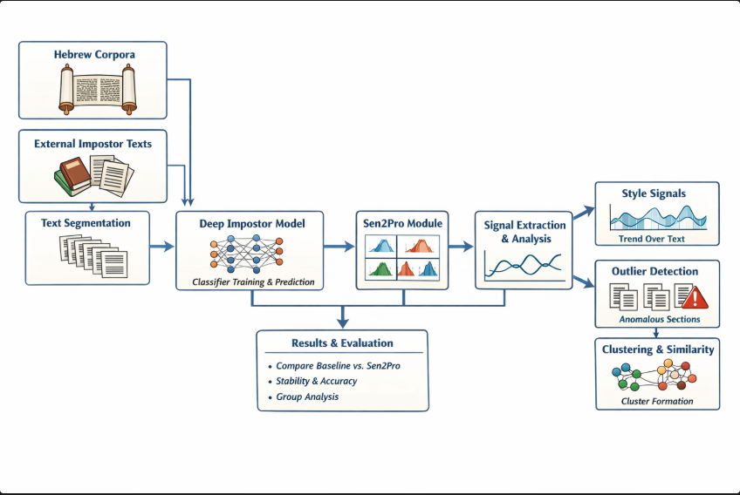
Figure 4: High-level system architecture: integrating the Deep Impostors pipeline with the Sen2Pro probabilistic module.

4.6.1 Data Preparation and Segmentation
The target corpus is first segmented into fixed-length batches. Concurrently, external Hebrew text collections are processed to serve as impostor references.

4.6.2 Classifier Training
A binary separator classifier is trained to distinguish between pairs of impostor sources. As shown in Figure 5 (Training Strategies), the system supports different training regimes—ranging from freezing the language model (Strategy A) to full fine-tuning (Strategy C)—to balance discriminative power with stability.

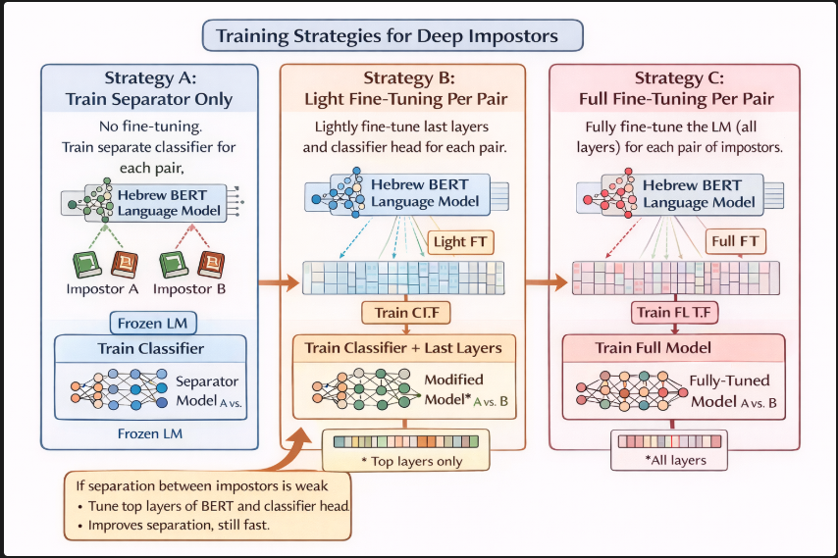
Figure 5: Comparison of separator training strategies: (A) Frozen Language Model, (B) Light Fine-Tuning, and (C) Full Fine-Tuning.

4.6.3 Probabilistic Representation (Sen2Pro Integration)
Before classification, text segments are processed by the Sen2Pro module. Instead of generating a single vector, the module produces a distributional representation (mean and covariance) via Monte-Carlo sampling, allowing the classifier to account for model uncertainty (Gal & Ghahramani, 2016).

4.6.4 Signal Extraction and Analysis
The trained separator is applied to the target corpus, generating local predictions that are aggregated into a continuous "style signal." This signal visualizes stylistic behavior along the text. Finally, distance-based comparisons (using DTW) and outlier detection algorithms (Isolation Forest) are applied to identify distinct stylistic groups.

4.7 Success Metrics
Success is defined primarily by the stability and reproducibility of the style signals, rather than by a binary "true/false" classification.

- Signal Stability: The style signal for a given text must remain consistent across repeated runs with different random seeds or impostor pairs. Instability indicates that the model is reacting to noise rather than style.

- Cluster Consistency: The resulting grouping of text units (e.g., separating distinct biblical books) should remain stable across experiments.

- Uncertainty Correlation: High uncertainty scores from Sen2Pro should correlate with known difficult or corrupt text segments, validating the model's sensitivity.

4.8 Testing Process
The evaluation strategy involves a comparative and multi-level analysis:

4.8.1 Comparative Analysis:
Baseline vs. Enhanced System A controlled experiment compares two pipeline configurations:

- Baseline: Standard Deep Impostors using deterministic embeddings.
- Enhanced: The proposed pipeline integrating Sen2Pro. This comparison aims to quantify whether the probabilistic approach improves signal stability and outlier detection accuracy compared to the baseline.

4.8.2 Multi-Granularity Analysis Outlier detection is performed at three distinct levels of resolution to validate findings:
• Book Level: Examining whether entire books cluster as distinct units.
• Chapter Level: Providing a detailed view of stylistic transitions within books.
• Segment Level: Identifying specific localized anomalies. Consistent identification of outliers across these levels increases confidence in the stylistic analysis.

5 Refrences
Devlin, J., Chang, M.-W., Lee, K., & Toutanova, K. (2019). BERT: Pre-training of deep bidirectional transformers for language understanding. In Proceedings of the 2019 Conference of the North American Chapter of the Association for Computational Linguistics: Human Language Technologies, Volume 1 (Long and Short Papers) (pp. 4171–4186). Association for Computational Linguistics.
Friedman, R. E. (1987). Who wrote the Bible? Summit Books.
Gal, Y., & Ghahramani, Z. (2016). Dropout as a Bayesian approximation: Representing model uncertainty in deep learning. In Proceedings of the 33rd International Conference on Machine Learning (pp. 1050–1059).
Kaufman, L., & Rousseeuw, P. J. (1990). Finding groups in data: An introduction to cluster analysis. John Wiley & Sons. https://doi.org/10.1002/9780470316801
Koppel, M., & Winter, Y. (2014). Determining if two documents are written by the same author. Journal of the Association for Information Science and Technology, 65(1), 178–187. https://doi.org/10.1002/asi.22954
Liu, F. T., Ting, K. M., & Zhou, Z.-H. (2008). Isolation forest. In 2008 Eighth IEEE International Conference on Data Mining (pp. 413–422). IEEE. https://doi.org/10.1109/ICDM.2008.17
Potha, N., & Stamatatos, E. (2020). Improved algorithms for extrinsic author verification. Knowledge and Information Systems, 62(5), 1903–1921. https://doi.org/10.1007/s10115-019-01408-4
Sakoe, H., & Chiba, S. (1978). Dynamic programming algorithm optimization for spoken word recognition. IEEE Transactions on Acoustics, Speech, and Signal Processing, 26(1), 43–49. https://doi.org/10.1109/TASSP.1978.1163055
Shen, L., Jiang, H., Liu, L., & Shi, S. (2023). Sen2Pro: A probabilistic perspective to sentence embedding from pre-trained language model. arXiv (arXiv:2306.02247).
Volkovich, Z., & Avros, R. (2025). Comprehension of the Shakespeare authorship question through deep impostors approach. Digital Scholarship in the Humanities. Advance online publication, 1–21. https://doi.org/10.1093/llc/fqaf009

