
Software Engineering Department
Braude College of Engineering
Final Project – Phase B (61998)
Deep learning based analysis of edgent hebrew sources

subtitle
CODE: 26-1-R-19
By:
Alexander Gruman
Shlomo Zrihan

Advisor:
Dr. Zeev Volkovich
Dr. Renata Avros

Link to GitHub:
https://github.com/AlexanderGruman/DeepImpostersProject

1. Problem Overview and Background
The field of writing-style analysis and authorship attribution is a research area that tries to examine whether it is possible to identify a stylistic “fingerprint” of a text using measurable features. In our project, we focused on this problem in the context of ancient Hebrew texts, especially the Five Books of the Torah. The main question is not necessarily to determine in a final and absolute way who wrote each part, but rather to check whether it is possible to build a computational system that extracts stylistic signals from the text, compares them, and helps identify similarity, difference, or anomalies between different textual units.
In Phase A of the project, we presented the theoretical background of the field, especially the Deep Impostors approach. The main idea behind this approach is to train a model to distinguish between different external texts, called impostors, and then use the trained model to examine how it “sees” the target text. In this way, a long text can be transformed into a numerical sequence, or in other words, a stylistic signal that represents the stylistic behavior along the text. In Phase A, we also presented the Sen2Pro approach, which suggests representing a sentence or text segment not as a single vector, but as a probabilistic distribution. This approach is especially important when working with ancient Hebrew, because the language includes rare words, non-modern structures, and sometimes high ambiguity for standard language models.
In Phase B, our goal was to turn these theoretical ideas into a working experimental system. During the project, we built two main versions of the system: the first version is based on Deep Impostors with a CNN model and Hebrew FastText representations, and the second version examines the integration of Sen2Pro and probabilistic representations as part of the stylistic analysis process.

2. General Description of the System
The system we developed is a research system for analyzing writing style in Hebrew texts. It receives a text corpus, performs preprocessing, divides the text into small textual units, converts each unit into a numerical representation, trains a separator model on pairs of external texts, and then applies the model to the target texts. The main output of the system is a stylistic signal for each tested textual unit. This signal makes it possible to compare books, chapters, or different text segments, and to examine whether there are similar or anomalous patterns between them.
The intended users of the system are mainly researchers or students in the fields of Natural Language Processing, stylometry, digital humanities, and biblical studies. The system is not a commercial software product with a regular user interface, but rather a research experimentation environment that allows users to run different test scenarios, change parameters, generate results, and analyze them using graphs, distance matrices, and statistical analysis tools.

3. Solution Description
The solution we built is a full research pipeline for Hebrew writing-style analysis. It is based on the Deep Impostors methodology and was later extended toward Sen2Pro and probabilistic representations. The purpose of the pipeline is to take a long Hebrew text, in our case the Five Books of the Torah, break it into smaller units, convert them into numerical representations, apply machine learning models to them, and finally produce stylistic signals, graphs, clusters, and anomaly scores that allow stylistic analysis of the text.

3.1 CNN-Based Deep Impostors Pipeline
In the first version, we implemented a CNN-based Deep Impostors pipeline using Hebrew FastText-initialized word representations and a hybrid Conv1D-BiLSTM-Attention separator model. First, the system loads the corpora, cleans the texts from punctuation marks, irrelevant characters, and vowel marks, and then divides them into fixed-size windows. Each such window represents a small segment of the text. Then, each word in the window is converted into a vector using Hebrew FastText, so each window becomes a numerical structure that can be given as input to a neural network. The CNN is used as a separator model, meaning that it is trained to distinguish between two different external sources, called impostors. After the model learns to distinguish between two external styles, it is applied to the target text, in our case the books or chapters of the Torah. For each window in the target text, the model produces a decision or probability, and the sequence of these decisions along the text becomes the stylistic signal.

3.2 Analytical Algorithms and Output Processing
After the stylistic signal is created, the analytical algorithms are applied. To compare different stylistic signals, we used FastDTW, which makes it possible to compare sequences even when they are not perfectly aligned or when there are differences in length. Then, distance matrices are created to represent the similarity or difference between the different textual units. Based on these matrices, we used K-Medoids clustering on the precomputed FastDTW distance matrix, to check whether certain units tend to group together stylistically. In addition, we used Isolation Forest for anomaly detection, meaning that we checked which books, chapters, or segments appear different compared to the other tested units. Finally, graphs and visualizations were produced, including graphs of the signals themselves, anomaly graphs, clustering results, and two-dimensional visualizations that help us understand the results more intuitively.

3.3 Sen2Pro-Based Extension
In the second version of the system, we examined the integration of Sen2Pro. The main idea in this approach is not to rely only on a single fixed representation of a text segment, but to represent it probabilistically. In other words, instead of saying that each segment is one point in the vector space, In our implementation, the Sen2Pro-style representation is built by running Hebrew BERT several times with MC Dropout, calculating a mean vector and per-dimension variance, and concatenating them into a probabilistic-style representation.
This means that the system can receive not only a representation of “what the segment is,” but also information about how stable or unstable that representation is. For ancient Hebrew texts, this is especially important, because the model may encounter rare words, less modern linguistic structures, or sentences that are difficult to represent in a clear and consistent way.

3.4 Comparison Between CNN and Sen2Pro Outputs
The final method we used was not to examine Sen2Pro as a completely separate system, but to compare its outputs with the outputs of the CNN version. In other words, we looked at the graphs, stylistic signals, anomaly results, and clustering results produced by both methodologies, and checked whether there was agreement between them. This comparison helped us understand where the pipeline stands, whether it produces stable patterns, and whether two relatively different approaches lead to similar conclusions. When we saw similarity between the outputs of CNN and the outputs of Sen2Pro, it strengthened the assumption that the system is not just reacting to random noise or to one specific parameter, but is identifying more meaningful stylistic patterns.

3.5 Additional Analysis Options Enabled by Sen2Pro
In addition, Sen2Pro opened more options for analysis. Since its representation is probabilistic, in the future it will be possible not only to perform clustering or anomaly detection based on regular distances, but also to include measures of uncertainty, representation stability, and spread. For example, if two segments look semantically close, but one of them is represented in a very unstable way, this can be taken into account as part of the analysis. In this way, Sen2Pro adds another layer of information above the existing pipeline and allows us to expand the research beyond a regular comparison of vectors or signals.

4. Research and Development Process
The work process in this project was a gradual research and engineering process. At the beginning, we focused on understanding the Deep Impostors methodology and adapting it to Hebrew. In Phase A of the project, the background, goals, and research direction were defined. In Phase B, we moved to the actual implementation of the system, running experiments, analyzing results, and continuously improving the pipeline.

4.1 Data Collection
One of the main stages at the beginning of the work was collecting the data. Since the research deals with the Bible, we do not really have a clear “alternative author” that can be directly compared to it. Therefore, we had to build wide and diverse impostor groups. We did not want to focus on only one writing style, one period, or one type of text, because we understood that semantics and style change over time, according to cultural context, literary genre, and linguistic usage. In a way, semantics behaves like slang: words, expressions, and ways of phrasing can change their meaning or character between different periods. Therefore, we collected texts by poets, writers, and Hebrew sources from as wide a range of the language as possible, in order to create a more diverse comparison environment. This was a logical and methodological choice: since we do not have another text that we know for certain was written by the same source that wrote the Bible, the closest option within the Deep Impostors framework is to compare the Bible against a broad range of external Hebrew styles, rather than against one narrow source.

4.2 Text Cleaning and Preprocessing
After collecting the texts, we built a cleaning and preprocessing process. We had to make sure that all files were loaded correctly, that the encoding was consistent, that there were no unwanted characters, and that there were no technical differences between the files that could artificially affect the model. After that, we divided the texts into fixed windows and built the infrastructure that converts each window into a numerical representation using FastText. At this stage, we had to deal with large files, words that do not appear in the model, and the need to save intermediate results in order to avoid repeated calculations.

4.3 Development of the CNN Version
Later, we developed the CNN version of the system. We built a model that receives word windows represented as vectors, is trained on pairs of impostors, and is then applied to the Torah texts. At first, we worked at the book level, meaning that each of the Five Books of the Torah was examined as a separate unit. Later, we extended the system to the chapter level, in order to get a finer resolution and check whether there are internal areas in the text that show different stylistic behavior. Each run produced different results: stylistic signals, distance matrices, clustering results, anomaly detection scores, and graphs.

4.4 Integration of Sen2Pro
At the same time, we worked on integrating Sen2Pro. This stage required us to understand how the probabilistic idea of Sen2Pro could be combined with the Deep Impostors analysis framework. The goal was not only to replace one component with another, but to check whether the outputs of Sen2Pro correspond to the outputs of CNN. Therefore, we focused on comparing the outputs: whether the anomalies are similar, whether the clustering points to similar groups, whether the graphs show close patterns, and whether the stylistic signals tell a similar story. In this way, we could understand whether Sen2Pro strengthens the Deep Impostors result or points to additional directions for analysis.

4.5 Development Environment and Computational Resources
From a technical point of view, one of the things that helped the project progress was the use of Google Colab with GPU. During the work, we understood that running these kinds of models, especially when performing repeated experiments, requires significant computational power. Therefore, we purchased a Colab subscription, which allowed us to use stronger resources and significantly reduce running times. This directly affected the development pace: instead of waiting a long time between experiments, we could make changes, run again, check the result, draw conclusions, and improve the system relatively quickly. In practice, this allowed us to work in an iterative development process: run, check, fix, improve, and repeat.

4.6 Iterative Research Process
Throughout the development process, we kept an experimental approach. At each stage, we checked whether the result looked stable, whether it repeated across different runs, and whether it made sense compared to what we expected to receive. When we saw problems, such as instability, slow loading, partial result files, or difficulty comparing graphs, we improved the system accordingly. In this way, the project developed from a basic implementation of an algorithm into a full sequence of experiments, analyses, and comparisons between two different methodologies.

5. Tools and Technologies
The system was developed in Python and was mainly run in Google Colab. For machine learning and data processing, we used libraries such as TensorFlow/Keras, PyTorch, NumPy, Pandas, and Scikit-learn. For word representation, we used a Hebrew FastText model, and in the Sen2Pro part we also used Transformer-based models and HuggingFace libraries. For signal analysis, we used FastDTW to compare sequences, Isolation Forest for anomaly detection, clustering algorithms such as KMeans or KMedoids, and Matplotlib for creating graphs and visualizations.
The Google Colab environment allowed us to work with GPU and run relatively heavy experiments without setting up a dedicated server. However, Colab also created limitations, mainly in terms of running time, disconnections, memory limits, and repeated loading of large files.

6. Challenges During the Work

6.1 Adapting Deep Impostors to Hebrew
One of the main challenges was adapting the Deep Impostors approach to Hebrew. Most existing examples and studies in this field work on English texts, while Hebrew introduces additional difficulties: rich morphology, connected words, ancient texts, and lack of uniformity between different sources. Therefore, we had to perform careful text cleaning and make sure that the system was not affected by technical signs or artificial differences between the files.

6.2 Running Time and Resource Limitations
Another challenge was running time. The Hebrew FastText model with 300 dimensions is a very large file, and loading it in Colab took a long time. In addition, each experiment included model training, applying the model to the target texts, calculating signals, saving results, and analyzing them. When running dozens of experiments, the total running time became very significant. To handle this problem, we added saving of intermediate results, more efficient data loading, caching, and a mechanism that allows continuing an experiment after a stop or crash.

6.3 Result Stability
Another issue was result stability. In a research project of this type, it is not enough to get a “nice” result in one run. We need to check whether the result repeats when changing impostor pairs, data order, or certain parameters. Therefore, we invested a significant part of the work in building repeated-run mechanisms and cumulative analysis of results.

6.4 Computational Cost of Sen2Pro
In the Sen2Pro version, one of the challenges was the computational cost. A probabilistic representation requires several samples for the same text segment, so it is more expensive than a regular single representation. In addition, it was not clear in advance whether models trained on modern Hebrew would fit biblical Hebrew well. Therefore, the work with Sen2Pro was mainly exploratory: to check what can be learned from the approach, what advantages it adds, and what its computational cost is compared to the CNN version.

7. Results and Conclusions
At the end of Phase B, we succeeded in building a working research system that implements Deep Impostors in Hebrew and allows analysis of the Five Books of the Torah at different levels. The system produces stylistic signals, distance matrices, clustering results, anomaly detection scores, and graphs that help understand the similarity and difference between textual units. In addition, we were able to examine another methodology based on Sen2Pro and integrate it as part of the comparison of results.

7.1 Similarity Between CNN and Sen2Pro
The main finding from our point of view is that we obtained a strong similarity between the outputs of the two methodologies, CNN and Sen2Pro. The similarity appeared at several levels: in the stylistic signals, in the anomaly results, in the clustering results, and in the way certain textual units behaved across the runs. The fact that two relatively different approaches, one based on CNN and FastText and the other based on probabilistic representations and Transformers, point to similar patterns strengthens our confidence in the pipeline. This means that the results do not come only from a random choice of one model or from a single parameter, but may reflect a deeper stylistic structure in the data.

7.2 Research Value of Comparing Both Methodologies
In addition, the comparison between CNN and Sen2Pro helped us better understand where the pipeline stands from a research point of view. The CNN version gave us a stable and convenient basis for many runs, while Sen2Pro gave us another layer of perspective on the data. Instead of looking only at decisions or distances, we can start thinking also about representation stability, spread, uncertainty, and probabilistic behavior of text segments. Therefore, we see Sen2Pro not only as another way to get a similar result, but also as a direction that expands the research space. It allows us to continue playing with additional parameters and checking how they affect the semantic and stylistic analysis.

7.3 Importance of the Impostor Groups
Another conclusion is that the impostor groups have a very central role in the results. Since the model learns to distinguish between external texts, the signal produced for the Bible is always relative to the comparison space we defined. Therefore, the choice to collect texts from a wide range of writers, styles, and periods was significant. It allowed the system not to lock onto a very narrow difference, but to examine the target text against a broader range of the Hebrew language.

7.4 Overall Conclusion
Overall, the project achieved its main goal: building a full research pipeline for Hebrew writing-style analysis, implementing Deep Impostors using CNN, examining a more advanced direction using Sen2Pro, and comparing the two methodologies. The result is not only a system that produces graphs, but a research basis that can be further expanded: replacing models, changing window sizes, changing impostor groups, testing additional distance metrics, and integrating uncertainty measures into the clustering and anomaly detection process.

sen2pro | 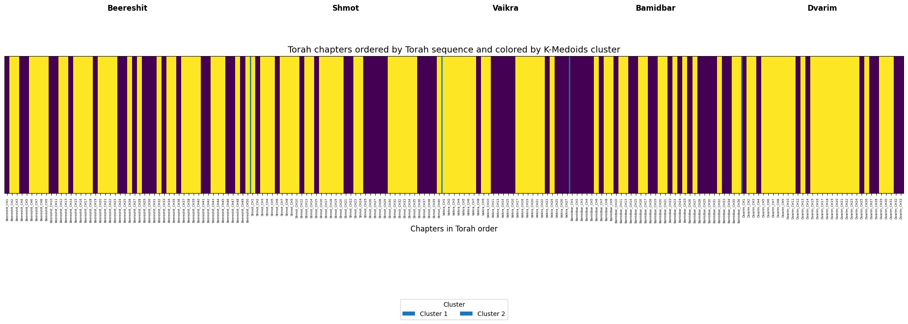
cnn | 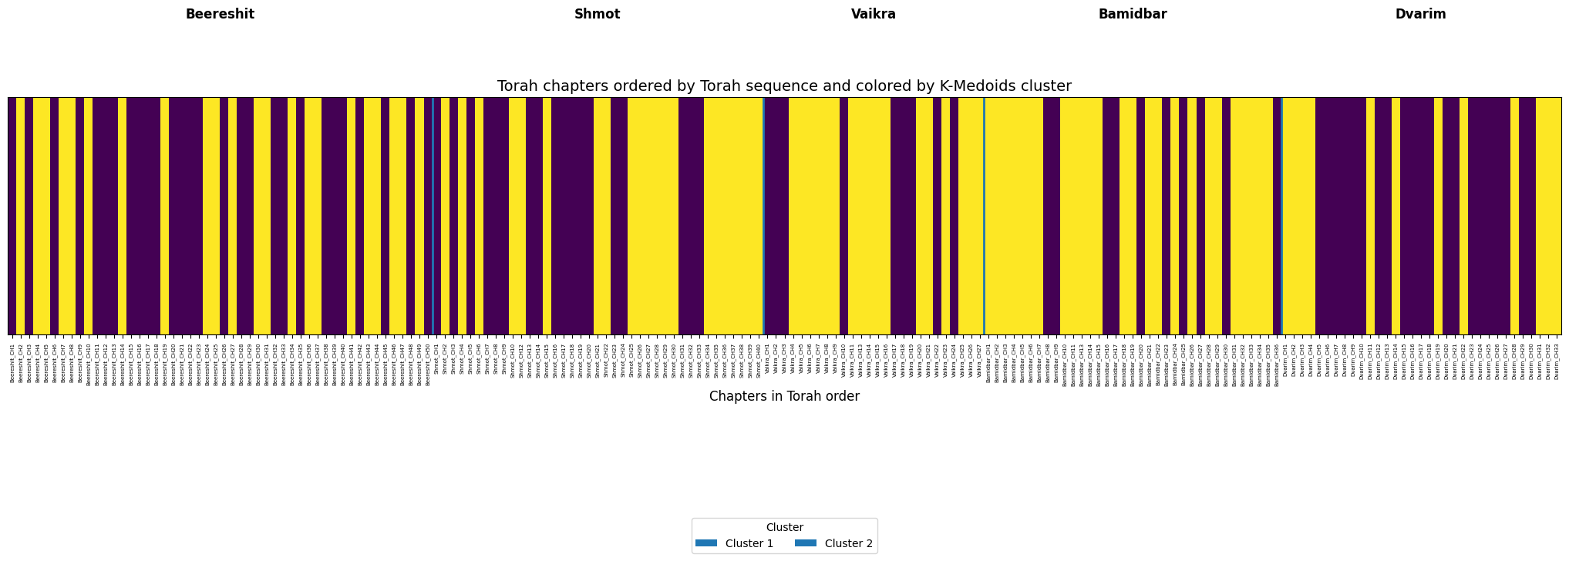

7.5 K-Medoids Analysis by Torah Chapters
The graphs show a division of the Torah chapters into two clusters, according to the original order of the chapters. In both methodologies, CNN and Sen2Pro, it can be seen that the division does not fully match the borders between the books. Instead, there are internal changes inside each book. In other words, the model does not identify only “book versus book,” but also local stylistic differences within the books themselves.
In the CNN results, the changes between the clusters look sharper, especially in Genesis, Numbers, and Deuteronomy. In Sen2Pro, a similar picture is received regarding the existence of internal division, but in some places the sequences look more stable or wider. This difference fits the nature of the models: CNN is more sensitive to local patterns inside word windows, while Sen2Pro/Transformer takes broader context and representation stability into account.
The conclusion is that both approaches point to internal stylistic patterns along the Torah, and not only to a division by books. The similarity between them strengthens the reliability of the pipeline, while the differences between them can be used as a basis for further checking how the type of representation affects the clustering results.
sen2pro | 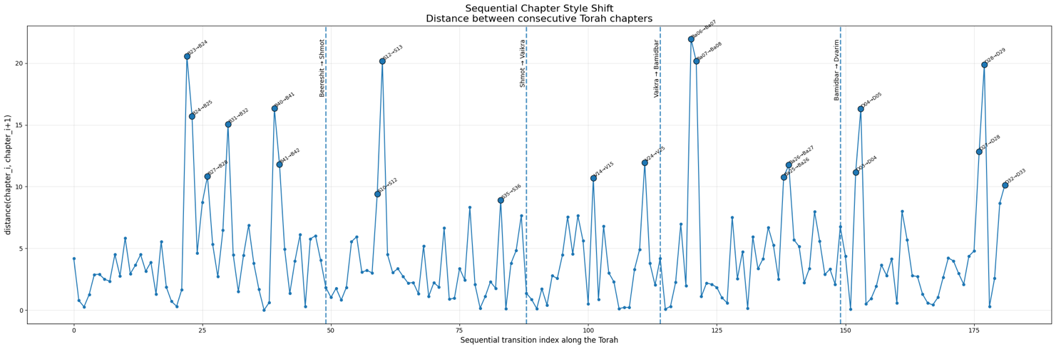
cnn | 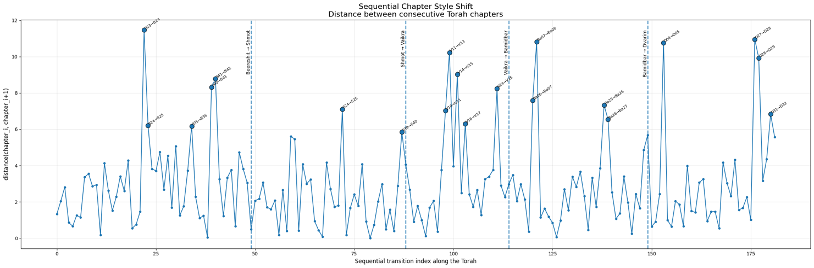

7.6 Sequential Chapter Style Shift Analysis
These graphs show the stylistic distance between every two consecutive chapters in the Torah. In other words, each point shows how “sharp” the transition from one chapter to the next looks stylistically according to the pipeline. A high jump in the graph indicates a transition where the model detects a relatively significant stylistic change.
In the CNN results, several clear jumps can be seen, for example around the transition between Genesis 23–24, around certain areas in Leviticus and Numbers, and at the beginning of Deuteronomy. In Sen2Pro, a very similar picture is received in terms of the locations of the main jumps: strong jumps also appear around Genesis 23–24, Numbers 6–7, Deuteronomy 4–5, and Deuteronomy 28–29. This means that both methodologies identify similar areas where there is a strong stylistic change between neighboring chapters.
The main difference is that in Sen2Pro the values themselves are higher, and some peaks are sharper. This makes sense because Sen2Pro is based on Transformer representations and on a more probabilistic view of the text, so it may emphasize more strongly transitions where the semantic or stylistic representation changes.
The conclusion is that the similarity between CNN and Sen2Pro strengthens the result: this is not only noise from one model, but two different methods that detect similar stylistic transitions along the Torah. These peaks can be used as interesting points for further textual or research analysis.
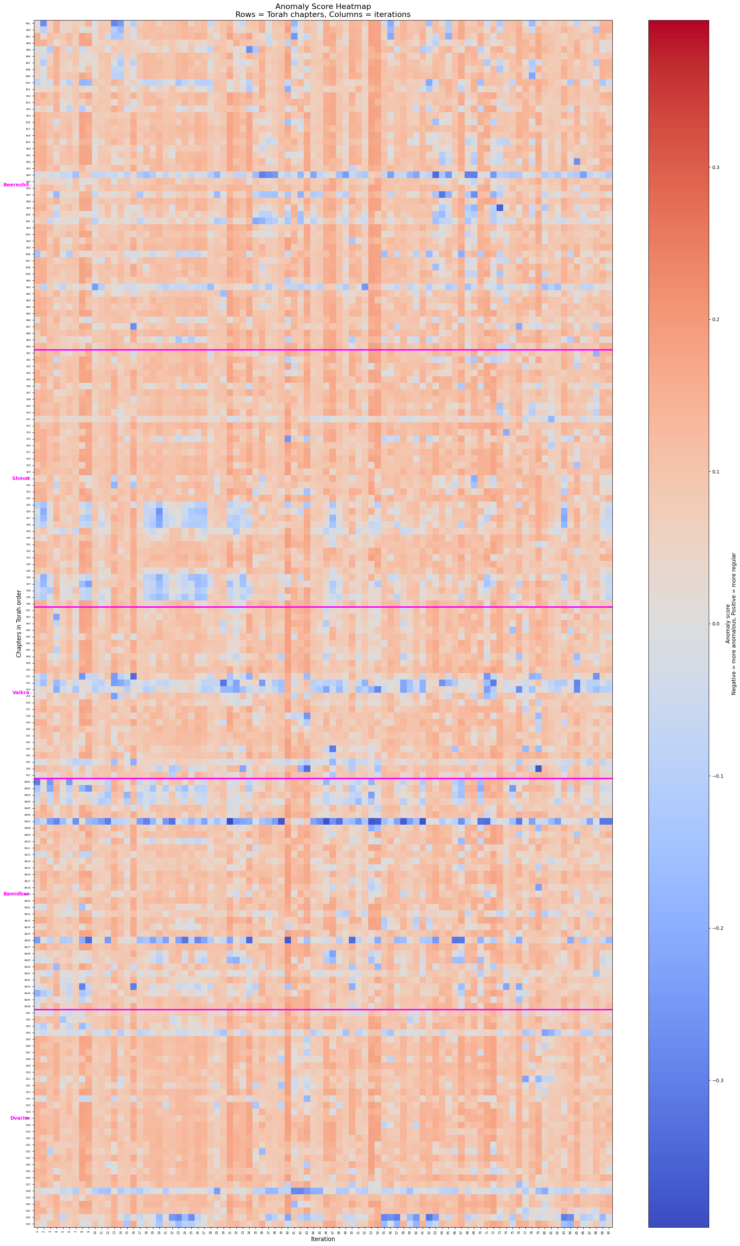 | 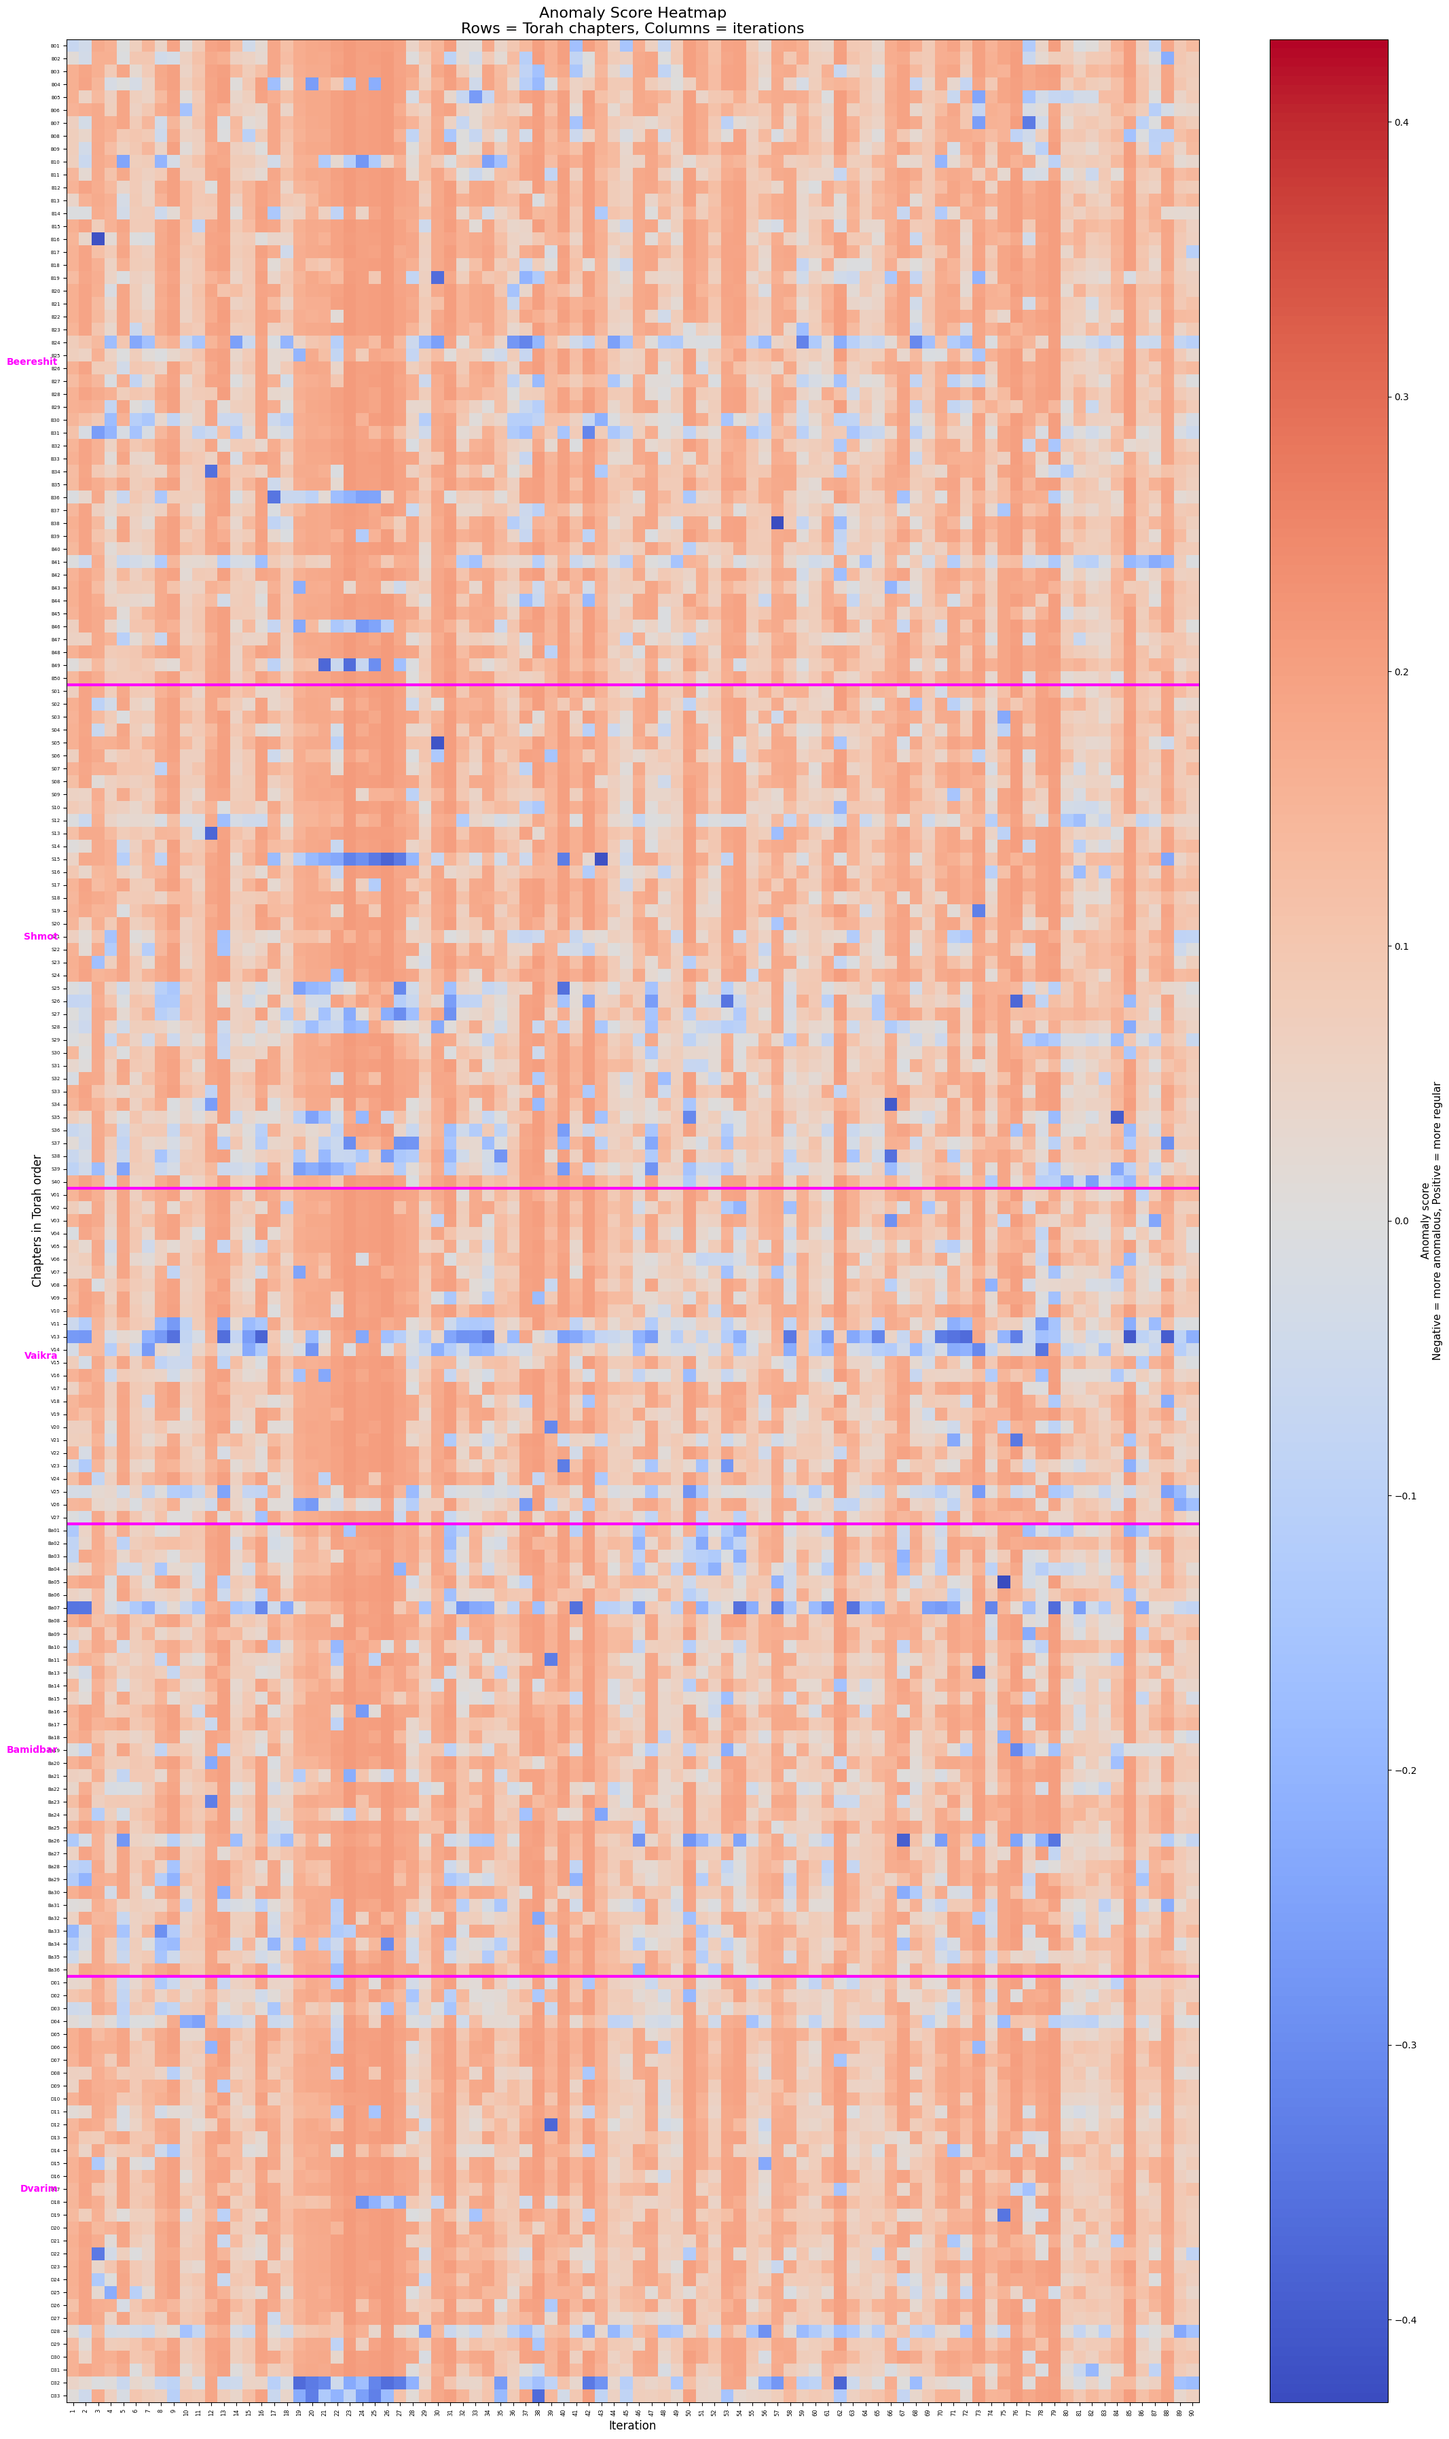
sen2pro | cnn

7.7 Comparison of the Anomaly Heatmap between CNN and Sen2Pro
In the heatmaps, each row represents a Torah chapter, and each column represents a different iteration of the experiment. Warm colors indicate a higher anomaly score, while cold colors indicate a lower score. In both methodologies, repeated horizontal patterns can be seen across many iterations. This means that some chapters repeatedly receive relatively anomalous or different behavior.
In the CNN results, the anomaly heatmap looks sharper and more scattered, with more local changes between iterations. In Sen2Pro, the picture is slightly smoother and more stable, but the same general areas are still preserved. In other words, both methods point to similar areas in the Torah where relatively anomalous behavior appears, while Sen2Pro presents them in a more consistent and softened way.
The conclusion is that here as well, there is good agreement between the two methodologies. Despite the difference in the representation method, both identify similar anomaly patterns along the chapters. This strengthens the assumption that the system detects a real structure in the data, and not only random noise from a specific model.

8. Project Metrics Achievement
In Phase A, several main goals were defined: building a system that can process Hebrew corpora, implementing Deep Impostors in Hebrew, producing stylistic signals, performing distance and anomaly analysis, and examining the integration of Sen2Pro. In Phase B, we achieved these goals to a high degree. The system is able to perform all stages of the pipeline, starting from reading the input files and ending with producing results and graphs. In addition, experiments were performed at several levels of resolution, including analysis by books and analysis by chapters.
However, it is important to mention that this is a research project, so success cannot be measured only by a simple binary accuracy score. The purpose of the system is not to provide a final “yes” or “no” answer about a specific author, but to provide an analysis tool that produces measures, signals, and comparisons. Therefore, the main success metrics were the ability to produce stable results, run repeated experiments, identify patterns, and analyze how different parameters affect the results.

9. Lessons Learned
One of the main lessons from the project is that in this type of research, it is not enough to build a model that only works technically. A full process must be built around it: data collection, cleaning, saving results, analysis, comparison, stability testing, and drawing conclusions. At the beginning, we thought that the main challenge would be implementing the model itself, but in practice we understood that the broader challenge was building a research pipeline that can be trusted and whose results can be reproduced.
Another lesson is the importance of choosing diverse data. Since the Bible is a unique text and we do not have a simple “ground truth” comparison group, we had to think creatively about the impostor groups. The understanding that style and semantics change across different periods led us to collect texts from a wider range of writers and genres. In retrospect, this was an important decision, because it allowed the system to work against a broader stylistic space and not rely on a comparison that is too limited.
Regarding Sen2Pro, we learned that it should not be seen only as a “heavy” or more expensive component in terms of running time. Although there are running-time differences compared to the CNN version, its contribution can be very meaningful, because it opens the door to a richer analysis of the data. Instead of receiving only a single representation of a text segment, Sen2Pro allows us to think in terms of probabilistic representation, uncertainty, and stability. From our point of view, this is a very important addition, because it allows us to examine not only what the model decided, but also how stable the representation behind that decision is.
In addition, working with Transformers gave us advantages that do not exist in the same way in CNN models. A CNN model is good at identifying local patterns, such as nearby word combinations or repeated patterns in a short area of the text. In contrast, Transformers are able to consider a wider context through the Attention mechanism. This means that each word can “look” at other words in the text, and not only at its close neighbors. This can be especially helpful in Hebrew, where the meaning of a word or expression can change according to context. In addition, Transformers are usually pretrained on large amounts of text, so they can contain richer linguistic knowledge than a model trained from scratch on the limited data of the project. When these advantages are combined with Sen2Pro, we get not only a model that understands context more deeply, but also the ability to examine the confidence and stability of the representations it produces.
Another important lesson is that comparing different methodologies can be stronger than relying on a single model. The fact that CNN and Sen2Pro produced similar outputs in the main patterns gave us more confidence in the results. Instead of saying “this model found a pattern,” we can say that two different approaches point in a similar direction. This is a significant advantage in a research project, where the goal is not only to reach a result, but also to estimate how reliable it is.
In retrospect, if we had started again, we would have defined a uniform format for all experiments earlier, including folder names, output file structure, and parameter documentation. As the project grew, the number of runs, graphs, and files increased significantly, and experiment management became an important part of the work. However, this process also improved our understanding of how to properly build a research system: not only code that runs a model, but a system that allows research, comparison, documentation, and future development of the idea.

Appendix A — User Guide

A.1 General User Guide Overview
The system developed in this project is a research system for analyzing writing style in Hebrew texts using two main methodologies: a Deep Impostors version based on CNN and FastText, and a Deep Impostors version based on Hebrew BERT combined with Sen2Pro-style representations. Both notebooks are intended to run in Google Colab, where the user runs the cells in order, defines the input and output paths, and finally receives analysis outputs that include stylistic signals, distance matrices, anomaly scores, clustering results, and graphs.
The system is not intended for a regular end user, but rather for a research user — for example, a student, researcher, or developer who wants to run experiments on Hebrew corpora, compare textual units, and check whether repeated stylistic patterns exist. The normal flow is a process where the user prepares the input folders, runs the relevant notebook, and then examines the output files that were created.
Before starting, the user should prepare a project folder in Google Drive. In our implementation, the root folder was defined as /content/drive/MyDrive/ deep_imposters_final_project/. Inside this folder, the main input folders should appear: torah_chapters, which contains the text files of the Torah chapters or the Torah units that should be tested; imposters, which contains texts from the first group of authors; and imposters1, which contains texts from the second group of authors. Each author is stored in a separate folder, and inside each author folder there are text files in .txt format. This structure is important because the system builds experiments by choosing author pairs — one author from imposters and one author from imposters1.
In the CNN version, a Hebrew FastText vector file is also required. The system uses this file to convert each Hebrew word into a numerical vector, and then to build input windows for the CNN network. In the Sen2Pro version, the FastText file is not needed, because the representations are produced using a Hebrew BERT model, for example avichr/heBERT, which is loaded through Transformer libraries.

A.2 Running the CNN Version
To run the CNN version, the user should open the relevant Colab notebook and run the first cells in order. First, Google Drive is mounted. Then, the required libraries are installed, such as fastdtw, gensim, nltk, kmedoids, and tensorflow. After that, the libraries are imported and the system classes are defined. After the cells that define the classes have been executed, the user should make sure that the paths in the main running cell point to the correct project folder.
In the main running cell of the CNN version, two main objects are defined: PipelinePaths and ExperimentConfig. The PipelinePaths object defines the project folder and the results folder. In our implementation, the project folder is deep_imposters_final_project, and the results folder of the CNN version is usually hebrew_results. The ExperimentConfig object defines the experiment parameters, such as the vector size embedding_dimension=300, the chunk size, the representation method hebrew_fasttext_vec, and the CNN model settings.
After defining the paths and parameters, the user creates a DeepImpostorsPipeline object and runs the command pipeline.run(). In a full run, the system goes over author pairs from the two impostor folders, trains a CNN model for each pair, applies the model to the Torah units, and produces analysis outputs. During the run, the system cleans the Hebrew texts, removes vowel marks and cantillation marks, removes punctuation marks, removes English letters, and keeps only Hebrew tokens. Then it divides the texts into blocks, converts them into FastText embeddings, trains the CNN network, produces predictions for the Torah units, builds stylistic signals, calculates a distance matrix using FastDTW, and applies Isolation Forest and KMedoids for anomaly and cluster analysis.
For a user who wants to check that the system works before running a full experiment, there is an option to run a single-pair test. In this cell, two authors are defined, for example Yehuda Alharizi and Berechiah ha-Nakdan, and the system runs the full pipeline only on this pair. This test is recommended before a full run, because it allows the user to verify that the paths are correct, the text files are loaded, the FastText file is located in the correct place, and the system is able to generate output files. After this test, the user can open the output folder and check that files such as accuracy/loss graphs, res_report files, a distance matrix, and clustering results were created.
If the user wants to start a full experiment from the beginning, they should run the cell that executes pipeline.reset_progress() and then pipeline.run(resume=False). This action resets the progress file and starts the entire experiment from scratch. If the run was stopped in the middle, for example because Colab disconnected, the user should run the definition cells again and then run the recovery cell that executes pipeline.run(resume=True). In this mode, the system reads the progress.json file and continues from the next author pair that has not yet been completed.

A.3 Running the Sen2Pro Version
To run the Sen2Pro version, the user should open the relevant Colab notebook and run the cells in order. Here as well, the process starts by mounting Google Drive and installing the required libraries. Then, the system components are defined: corpus loading, text cleaning, division into segments, creation of BERT representations with MC Dropout, building a balanced dataset, training a classifier, predicting on the Torah texts, building style signals, calculating a distance matrix, performing anomaly and clustering analysis, and saving the outputs.
In the Sen2Pro version, the ExperimentConfig object includes parameters suitable for working with Hebrew BERT: the model name bert_model_name, maximum length max_length, number of words in each segment, number of MC Dropout samples through mc_samples, number of epochs, batch size, learning rate, dropout rate, and whether to freeze the BERT layers using freeze_bert. In our implementation, the method used is Sen2Pro-style, based only on model uncertainty through MC Dropout. In other words, there is no data augmentation such as word deletion, word replacement, or adding new words. Instead, the same segment is sampled several times through the model with active dropout. This approach allows the system to obtain both a representation and an uncertainty measure for each segment.
The user can run the Sen2Pro version in two ways. The first way is a full run, where the system goes over all author pairs from imposters and imposters1. In this run, the output folder is usually defined as hebrew_bert_sen2pro_results. The second way is a single-pair test, for example Yehuda Alharizi against Berechiah ha-Nakdan, where the output folder is a dedicated test folder such as hebrew_bert_sen2pro_single_pair_sanity_check. As in the CNN version, the single-pair test is recommended before a full run.
During the Sen2Pro run, the system cleans the texts, divides them into word segments, passes each segment through Hebrew BERT several times with MC Dropout, and calculates a representation that includes probabilistic information. Then, a balanced dataset is built from the two impostor authors, a classifier is trained, and the model is applied to the Torah chapters. From the predictions, two types of signals are created: a regular signal and a weighted signal. The weighted signal uses uncertainty information to give different weights to different segments. After that, the system calculates a distance matrix, applies KMedoids and Isolation Forest, and saves the outputs.

A.4 Output Files
At the end of a correct run, the user receives several types of files in the results folder. The accuracy and loss files show the model training process in each iteration. The res_report files include anomaly detection scores for the textual units. The res_report_summ files include normalized summaries of distances. The res_report_Dist files include clustering labels. In addition, a distance matrix is saved in .csv format and sometimes also in .npy format. In the Sen2Pro version, more detailed files are also saved, such as predictions, style_signals, and run metadata.
The user should use these outputs to compare the two methodologies. In other words, after running the CNN version and the Sen2Pro version, the user examines whether similar patterns appear in the signal graphs, anomaly results, and clustering results. If both methodologies point to similar structures, this strengthens the confidence that the pipeline identifies meaningful patterns and not only random noise. These outputs are the basis for the research analysis of the project, according to the idea of Deep Impostors, where a text is converted into a stylistic signal, compared using DTW, and then analyzed using anomalies and clustering.
It is important to note that at the bottom of the notebooks there are also debug, validation, and additional testing cells. Some of these cells were intended to help during development and are not necessarily required for a regular system run. Therefore, in the normal user scenario, the user should mainly run the definition cells, the single-pair sanity check, and then the full run or resume cell. The final testing cells can be used by a developer or maintainer who wants to check shapes, the number of segments, label distribution, or validation split correctness, but they are not a required part of the normal flow.

Appendix B — Maintenance Guide

B.1 General Maintenance Overview
The system is built as two main Colab notebooks, one for the CNN version and one for the Sen2Pro version. Both notebooks implement the same general research idea — Deep Impostors — but they do it using different representations and models. From a maintenance point of view, it is recommended to treat the two notebooks as two parallel pipelines with a similar structure: paths and configuration component, corpus loading component, text cleaning component, unit segmentation component, numerical representation component, training component, prediction-on-Torah component, distance and anomaly analysis component, and result-saving component.
The recommended running environment is Google Colab with GPU. For the CNN version, a GPU is required to speed up network training, but RAM is also very important because the Hebrew FastText file is large. For the Sen2Pro version, a GPU is mainly required for running Hebrew BERT and MC Dropout sampling. During the project, a Colab subscription was used in order to get a stronger and more stable running environment, which made it possible to run repeated experiments and improve the system iteratively.

B.2 Folder Structure
The expected folder structure of the system is as follows:
deep_imposters_final_project/ is the root project folder. Inside it, there is torah_chapters/, which contains the Torah or Torah chapter files as .txt files. In addition, there is imposters/, where each subfolder represents an author from the first impostor group, and imposters1/, where each subfolder represents an author from the second impostor group. For the CNN version, the Hebrew FastText file must be located in the path defined in PipelinePaths. The output folders are separate, for example hebrew_results/ for CNN, hebrew_bert_sen2pro_results/ for Sen2Pro, and sanity/debug folders for test runs.
When maintaining or modifying the system, it is important not to change the input folder names without updating PipelinePaths accordingly. This class is the central place for paths, so every change in the folder structure should start there. If a new experiment should be run without deleting previous results, it is recommended to define a new results_root instead of overwriting an existing output folder.

B.3 CNN Version Components
In the CNN version, the TextPreprocessor component is responsible for Hebrew text cleaning: removing vowel marks and cantillation marks, removing English letters, removing punctuation marks, and keeping only Hebrew tokens. If in the future the cleaning policy should be changed, for example to allow hyphens, keep quotation marks, remove short words, or add stopwords, this is the place to make the change.
The EmbeddingTrainer component is responsible for loading FastText vectors and building a local Word2Vec model for the current corpus. In practice, it loads the pretrained vectors into memory, initializes existing words from FastText, and then performs short training on the experiment corpus. If the embedding model should be replaced, for example by using binary FastText, another Word2Vec model, or embeddings saved in advance, the change should be made in this component.
The SequenceEmbedder component converts token lists into fixed-size blocks. In the CNN version, the sequence length is derived from chunk_size and batch_factor, where sequence_length = chunk_size // batch_factor. Changing the window size directly affects the number of blocks, the input shape of the network, and the length of the stylistic signal that will be produced. Therefore, every change to these parameters should be documented, because they affect the research results.
The RCNNAClassifier component defines the model. In the current implementation, the model includes Conv1D layers with several kernel sizes, MaxPooling layers, BiLSTM layers, an Attention mechanism, Dropout, and a Dense layer for binary classification. If the model architecture should be changed, for example by reducing the number of filters, changing the LSTM size, or replacing sigmoid with softmax, this should be done carefully and the label format should still be checked.
The DistanceAnalyzer component is responsible for converting model predictions into signals and analyzing the distances. It performs batch prediction on all Torah blocks, combines predictions according to batch_factor, calculates a symmetric FastDTW distance matrix, and then applies Isolation Forest. If the distance metric should be changed, for example from FastDTW to Euclidean, Cosine, or Wasserstein distance, this is the main component where the change should be made.
The ResultWriter component saves the graphs and reports. It is responsible for saving accuracy/loss graphs, res_report, res_report_summ, res_report_Dist files, and distance matrices. If a new output is added, such as a t-SNE graph or a comparison report between CNN and Sen2Pro, it is recommended to add its saving logic through this component in order to keep a uniform output structure.

B.4 Sen2Pro Version Components
In the Sen2Pro version, the structure is similar, but the representation component is different. Here too, there are PipelinePaths, ExperimentConfig, PipelineState, CorpusRepository, and TextPreprocessor. After cleaning, the Segmenter component divides the texts into segments according to a fixed number of words, for example 50 words. Then, Sen2ProBertEncoder creates representations using Hebrew BERT.
In the current implementation, Sen2Pro-style refers to model uncertainty using MC Dropout only. This means that each segment passes through the model several times with active dropout, and from these samples a mean representation and uncertainty measure are obtained. It is important to emphasize that this notebook does not implement data uncertainty through augmentations such as drop, swap, replace, or insert. If in the future the research should be expanded and a fuller Sen2Pro implementation should be built, an augmentation component can be added before the encoding stage.
The AuthorPairDataset component and the build_balanced_training_pairs component are responsible for building a balanced dataset from two impostor authors. This balancing is important so that the classifier does not learn only the larger class. If in the future there are authors with very different amounts of text, the balancing mechanism should be checked to make sure it does not create excessive duplication of a small number of examples.
The Sen2ProAuthorClassifier component is the classifier that receives the representations produced by BERT/Sen2Pro-style and returns a binary decision. The Trainer component is responsible for training the classifier, validation split, early stopping, and choosing the best model according to validation loss. If BERT itself should also be trained and not only the classifier, the freeze_bert parameter should be changed, but it should be taken into account that this significantly changes the nature of the experiment and requires more resources.
The TorahPredictor component applies the classifier to Torah segments. After that, StyleSignalBuilder builds stylistic signals from the predictions. In this version, the weighted signal is especially important, because it can combine uncertainty information. DistanceAnalyzer calculates the distance matrix, and AnomalyAndClusteringAnalyzer applies Isolation Forest and KMedoids. ResultWriter saves the outputs, including reports, distance matrices, segment-level predictions, style signals, and metadata.

B.5 Installation and Dependencies
In the CNN version, the required notebook libraries should be installed: fastdtw, gensim, nltk, kmedoids, tensorflow, as well as general libraries such as numpy, pandas, matplotlib, sklearn, and scipy if they are not already available in the Colab environment. The Hebrew FastText file must be located in the defined path, and it must be readable using gensim.models.KeyedVectors.load_word2vec_format.
In the Sen2Pro version, libraries for working with Transformers and PyTorch should be installed, such as torch and transformers, as well as the analysis libraries numpy, pandas, matplotlib, sklearn, fastdtw, and kmedoids. The Hebrew BERT model is downloaded through HuggingFace according to the model name defined in bert_model_name. If the system is used in an environment without internet access or with access limitations, the model should be downloaded in advance or stored in Drive.
There is no need to install an external system such as a database. All work is done on text files, CSV files, NPY files, and JSON files inside Google Drive. This matches the nature of the project as a research system and not as a client-server product.

B.6 Run Management and Recovery
Both notebooks include a progress.json mechanism, whose purpose is to allow the run to continue after stopping. In a full run, after each author pair is completed, the system saves the current state. If Colab disconnects, the definition cells should be run again, followed by the resume cell. The progress.json file should not be deleted if the user wants to continue from the same point. If a completely new experiment should be started, reset_progress should be used or a new output folder should be defined.
It is recommended for the maintainer to first run a single-pair sanity check before every major code change. This test makes it possible to verify that the change did not break the loading, cleaning, training, prediction, and output-saving stages. Only after the single-pair test finishes and valid output files are created, it is recommended to run a full experiment.
It should be noted that the final cells in the notebooks, especially debug and validation cells, are mainly intended for development testing. Some of them may depend on a specific notebook state, temporary parameters, or files created in previous runs. Therefore, they should not be treated as part of the official user flow. From a maintenance point of view, it is recommended to keep them as tools for developers, but to document that they are not required for a normal run. If these cells should become an official part of the system, they should be cleaned, verified to run from scratch, and given clear names and outputs.

B.7 Recommendations for Future Maintenance and Improvement
In order to continue developing the system in an organized way, it is recommended in the future to separate the research code from the running cells. In other words, the main classes should be moved to separate Python files, for example preprocessing.py, cnn_pipeline.py, sen2pro_pipeline.py, analysis.py, and result_writer.py, while the notebook should contain only running cells and documentation. This change will make maintenance, testing, reuse, and comparison between versions easier.
In addition, it is recommended to define an external configuration file, for example JSON or YAML, where all experiment parameters will be stored: input paths, output folder, model names, window size, number of epochs, number of MC Dropout samples, the type of signal used for distance calculation, and the clustering type. This will make it easier to reproduce experiments and compare results.
It is also recommended to save detailed metadata for each run. Such metadata should include the run date, notebook version, tested author names, experiment parameters, input file names, and model type. This is especially important in a research project, because the results depend strongly on the selected parameters and corpora.
Finally, when extending the Sen2Pro version, data uncertainty can also be added, not only model uncertainty. In other words, slightly different versions of the same segment can be created using gentle augmentation operations, and then it can be checked how the representation changes. In addition, uncertainty measures can be integrated directly into clustering or anomaly detection, and not only used for building a weighted signal. This direction can make the system stronger and give it a better ability to distinguish between a real stylistic change and a textual area that the model simply struggles to represent.
In general, the system is built in a way that makes it possible to continue using it even after the end of the project: adding corpora, replacing models, changing parameters, adding distance metrics, and performing new comparisons between CNN and Sen2Pro outputs. According to the Phase B requirements, this maintenance guide is meant to support exactly this continued life of the system — usage, modification, updating, and improvement over time, while describing the running environment and the dedicated installations of the developed software.

