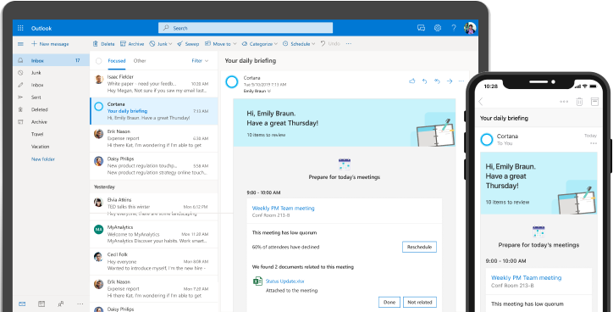

# Introducing the new daily Briefing email from Cortana

The Briefing email summarizes what’s most important for the day ahead to help you feel more in control of your calendar and tasks. Cortana will send you the Briefing email near the start of your workday (as set in Outlook) when you have relevant items to help you plan the day ahead. You won’t receive an email on days when Cortana doesn’t have any suggestions. See [Briefing email overview](https://docs.microsoft.com/Briefing/be-overview) to learn more.

## What the Briefing email can help you do

|  |  |
| --- | --- |
|  | **Prepare for meetings**  Review documents and tasks that help you prepare for upcoming meetings.  Open related documents and emails directly from Briefing, which saves you from having to search for them. |
| **Keep your commitments**  Follow up on email commitments and requests that might have fallen through the cracks.  You can mark a task as done, and it won’t be shown again, or dismiss one that’s not relevant, which helps Cortana learn what type of information is helpful to you. |  |
|  | **Schedule focus time**  Dedicate time on your calendar to work on outstanding tasks and prepare for meetings without interruption. |

## Data privacy and security

Only you can see your Briefing email, which summarizes existing information that’s already available directly in your Office 365 mailbox. It’s GDPR compliant, and you can unsubscribe at any time with the Unsubscribe link at the end of every email.