title: Viva Insights - Headspace description: Microsoft Viva Insights app – Use the Headspace feature author: paul9955 ms.author: v-pausch ms.topic: article localization_priority: normal ms.prod: Mya manager: scott.ruble audience: Admin

# Mindfulness content from Headspace

[!NOTE] The Headspace experience is currently internal only and will not be disclosed to customers until 6:00 AM PDT on June 17, 2021. Please do not share this documentation broadly.

Viva Insights has introduced a curated set of guided meditations and Focus music from Headspace. Reach these resources on the [Home](viva-insights-home.md) page to help you start your day grounded, relax your mind before a big presentation, or find focus before starting an important project. In just a few minutes a day, meditation and mindfulness with Headspace can help you decrease stress and increase focus.

[!NOTE] As of June 2021, Headspace is only available to users who have their language in Teams set to English. Additional languages will be supported soon.

## Start a guided meditation

Any time you want, you can start a guided meditation that’s been designed for the current time of day:

1. Open the **Home** page of Microsoft Viva Insights:

* 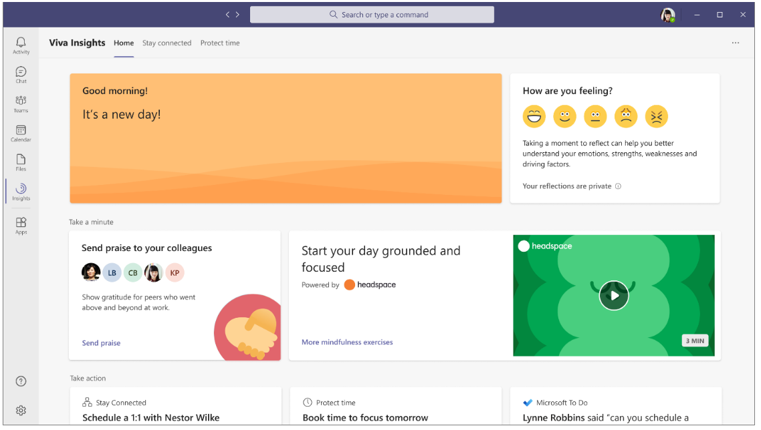
* Home page with Headspace

1. To start the Headspace exercise, select the ‘Play’ button on the **Headspace** card:

* 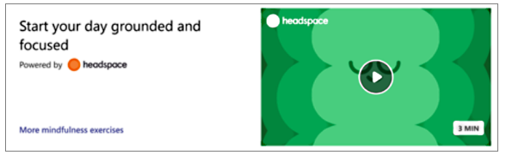
* Headspace card

1. (Optional) Browse through a curated set of meditations that are designed to fit different scenarios within the flow of your day. To see your options, open the **Practice mindfulness** page by selecting **More mindfulness exercises**.
2. Under **Practice mindfulness**, select a meditation option in the **Guided meditations** area or a musical option in the **Focus music** area:

* 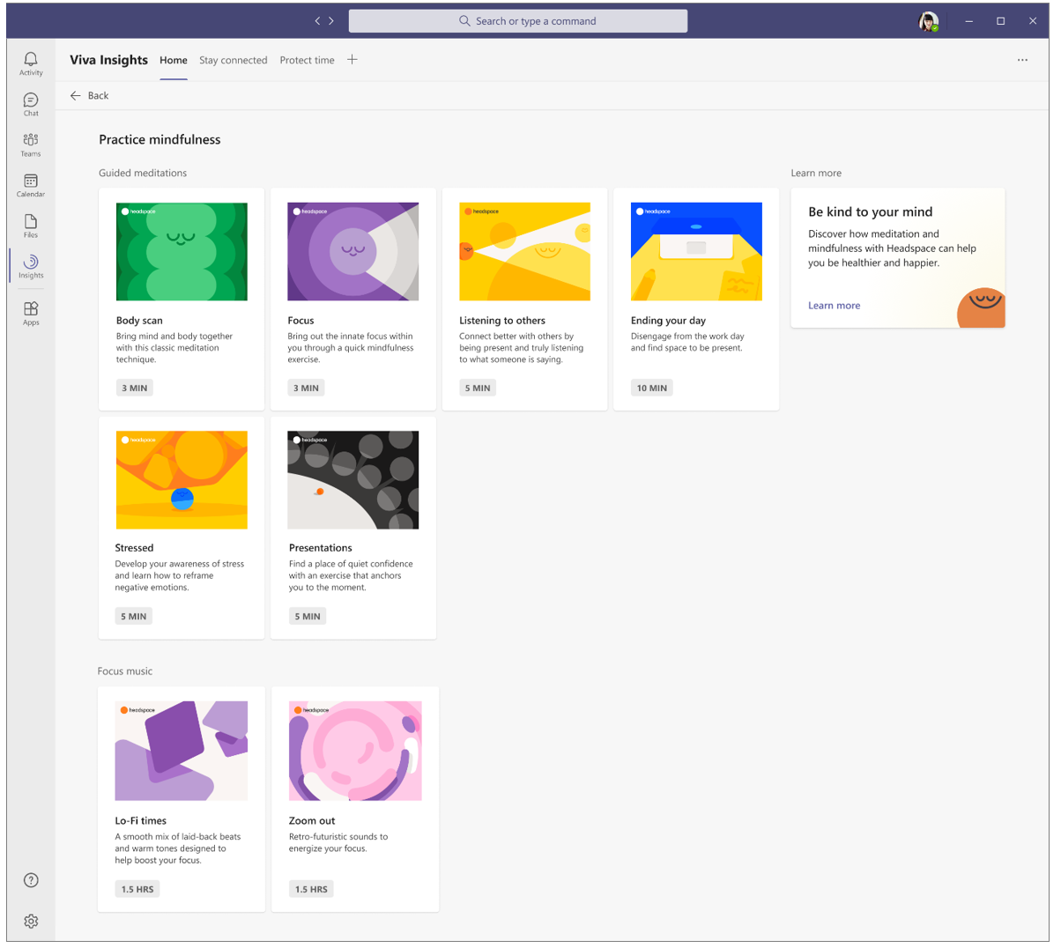
* Mindfulness options is running

## Run Headspace in the background

You can open and run Headspace in a new window. This lets you play its musical meditations while continuing your collaboration in Teams.

1. Locate the pinned Insights app on the left navigation pane of Teams.
2. Right-click the Insights icon.
3. Select **Pop out app**.

* 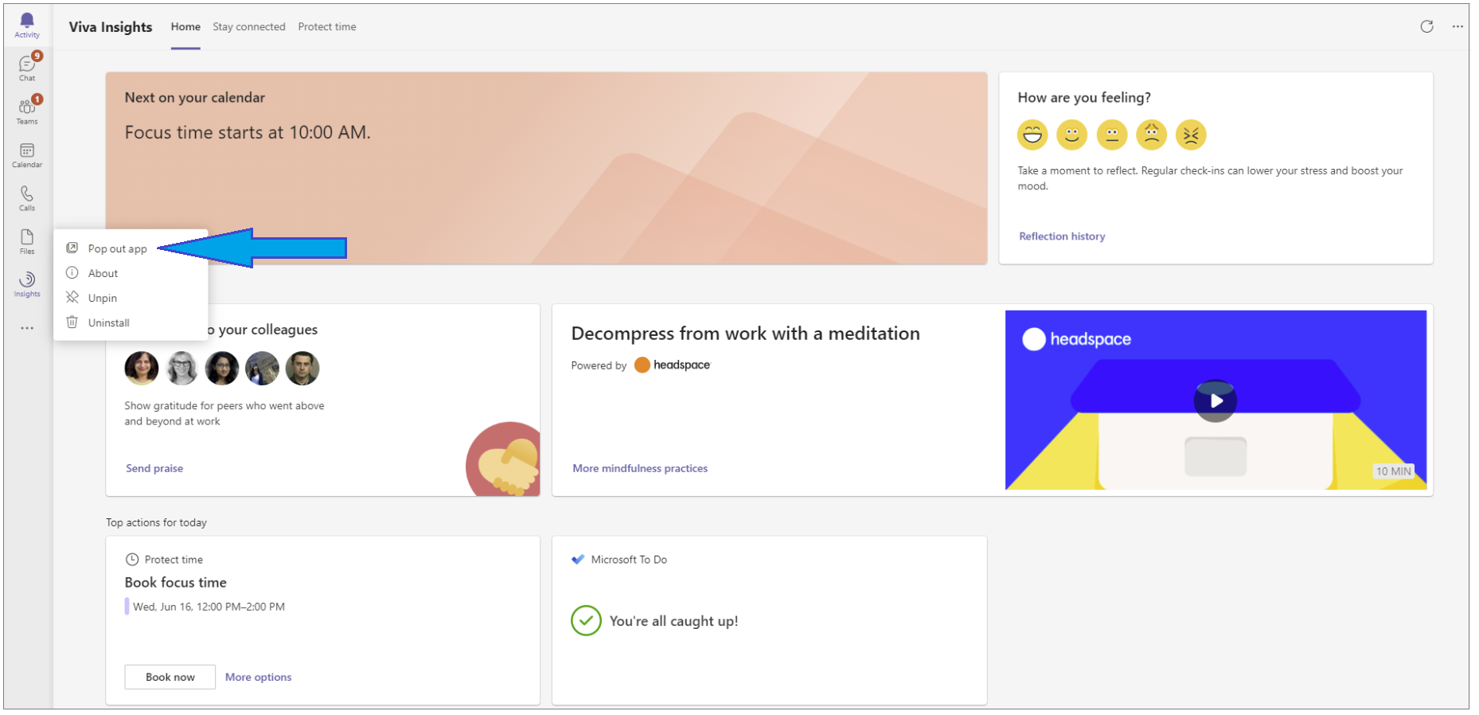
* Pop-out Headspace app
* This opens a new window in which the Insights app is running.

1. In this second window, start Headspace and then start a meditation as described in Start a guided meditation.
2. Optionally, minimize the Insights window that you just opened. You can continue working in Teams in the original Teams window.

## Frequently asked questions

#### Q1. I have questions about meditation and other best practices. Where can I look for answers?

**A1.** Check out the Headspace app’s [Questions about meditation](https://www.headspace.com/meditation-101/faq) page.

## Related topics

[Microsoft Viva Insights app Home page](viva-insights-home.md)