# Discover the Viva Insights app

The Microsoft Viva Insights app is pre-installed in Microsoft Teams for most organizations. This means that you won’t need to find and install it, as described in Install the app. After it is installed, you can pin it to the Teams app bar (the left navigation bar) to make it easy to find. To learn how, see Discover and pin the app.

## Prerequisites

To be able to use the Viva Insights app, you must have the following:

* Access to Microsoft Teams
* An Exchange Online account

## Discover and pin the app

### On desktop and web clients

1. Select **More** (the ellipsis) on the Microsoft Teams app bar.
2. In the search field, type **Viva Insights**.

* 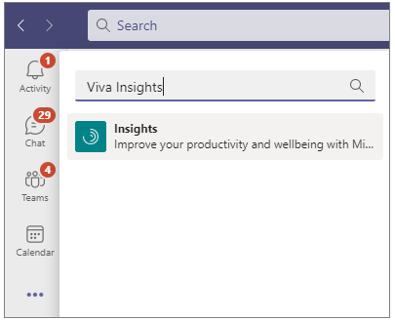

1. Select **Insights** to open the app.
2. Right-click the app icon and select **Pin** (Pin an app.) to make and keep your app visible in the Teams app bar.

* 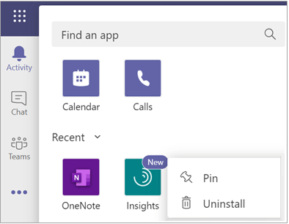

[!Tip] You can reorder apps in the Teams app bar by dragging the apps’ icons. For more information about pinning and unpinning apps in Microsoft Teams, see [Pin an app for easy access](https://support.microsoft.com/office/pin-an-app-for-easy-access-3045fd44-6604-4ba7-8ecc-1c0d525e89ec).

### On the iOS and Android mobile platforms

1. Select **More** (the ellipsis) on the Microsoft Teams app bar.
2. Select **Insights** to open the app.
3. Select **Reorder** and then drag the app’s icon to remove it from the **More** section.

* 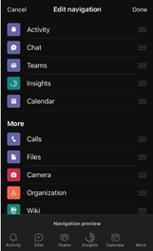

1. Select **Done** to save your changes.

### Install the app

This section describes how to install the Microsoft Viva Insights app for yourself. (If you’re an admin who will install the Viva Insights app for an organization, see [Admin tasks](viva-teams-app-admin-tasks.md).)

1. Open Microsoft Teams on the web or in a desktop client.
2. At the bottom of the Microsoft Teams app bar (on the left), select **Apps**:

* 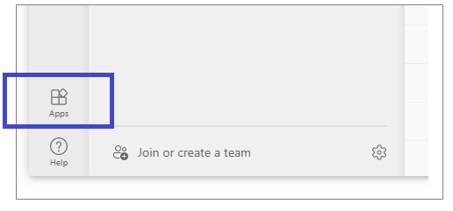

1. In the search field under **Apps**, type **Microsoft Viva Insights**:

* 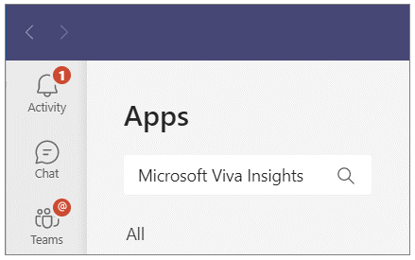

1. Select the **Insights** app:

* 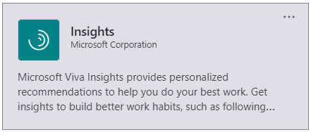

1. Select **Add**:

* 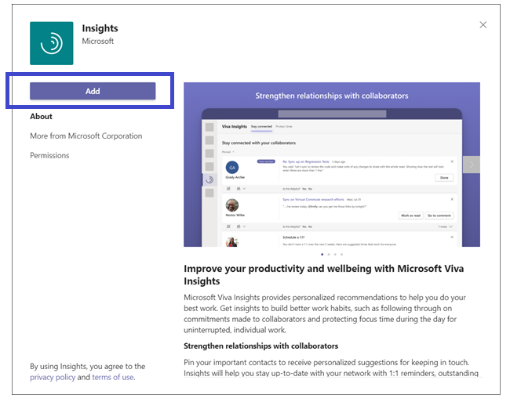

This step adds the Insights app to all the places where you might use Microsoft Teams: the Teams desktop client, Teams on the web, and Teams on a mobile device. After you’ve added the Insights app, you have access to all of its features, including [Praise](viva-insights-praise.md), [Protect time](viva-insights-protect-time.md), [Reflect](viva-insights-reflect.md), [Stay connected](viva-insights-stay-connected.md), and [Virtual commute](viva-insights-virtual-commute.md).

[!Note] You can also locate the Insights app through this link: <https://aka.ms/InsightsTeamsApp>.

### Uninstall the app

This section describes how to uninstall the Microsoft Viva Insights app from Teams.

1. In Teams, select the ellipsis (…) on the left pane:

* 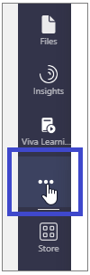

1. If the Viva Insights app is not visible in your most recent view, find it by using search:

* 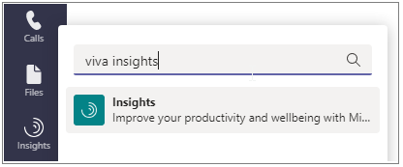

1. Right-click the **Insights** app and then select **Uninstall** on the shortcut menu:

* 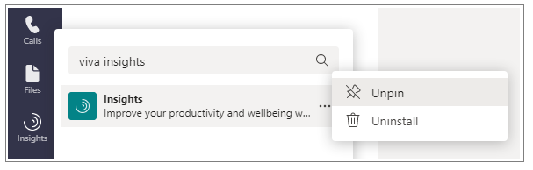

1. In the window that appears, select **Uninstall**:

* 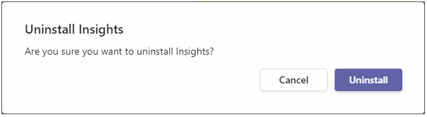

The Viva Insights app is now uninstalled from Teams:



## Related topics

[Viva Insights overview](viva-teams-app.md)