# MyAnalytics plans and environments

[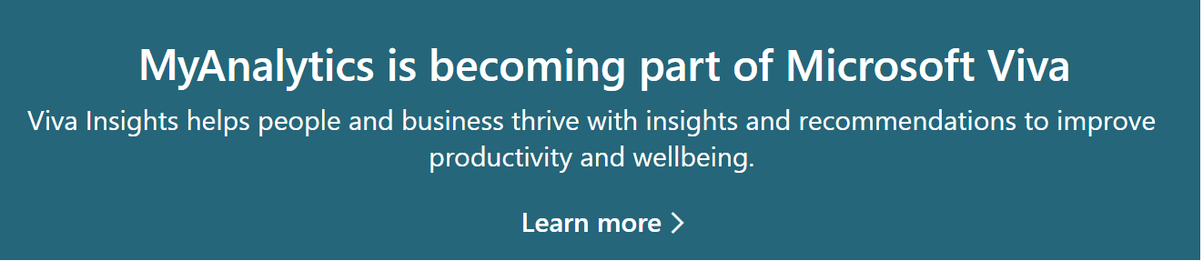](https://www.microsoft.com/microsoft-viva/insights)

## Availability of features

The MyAnalytics [Dashboard](../use/dashboard-2.md), [Digests](../use/email-digest-2.md), [Insights Outlook add-in](../use/add-in.md), and [Inline suggestions](../use/mya-notifications.md) are available to users whose organization uses the following Microsoft 365 or Office 365 plans.

|  |  |
| --- | --- |
| Plan | Service plan |

|

Microsoft 365 E3

Microsoft 365 Business

Microsoft 365 A3 for faculty/students

Office 365 E3

Office 365 E1

Office 365 A3 for faculty/students

Office 365 E3 Developer

Office 365 G3

Business Premium

Business Essentials | Insights by MyAnalytics | |

Microsoft 365 E5

Microsoft 365 E5 without Audio Conferencing

Office 365 Enterprise E5

Office 365 Nonprofit E5

Office 365 G5

MyAnalytics add-in | MyAnalytics (Full) and Insights by MyAnalytics | |

Microsoft 365 A5 for faculty/students

Office 365 A5 for faculty/students | MyAnalytics (Full) |

[!Note]

* To find out how to determine your own plan and service plan, see [How do I find my plan?](../overview/mya-faq.md#q4-how-can-i-find-out-what-my-plan-is).
* For more information about the plans that offer these user experiences, see [Office 365 business plans](https://products.office.com/business/compare-more-office-365-for-business-plans).

### Features in the MyAnalytics (Full) service plan

The following features are available only in the MyAnalytics (Full) service plan.

* Read-status features: [Email read rates and document open rates](../use/use-the-insights.md#track-email-and-document-open-rates), [Track email](../use/mya-notifications.md#track-email), [Track email open rate](../use/mya-notifications.md#track-email-open-rate)
* [Shorten a meeting](../use/mya-notifications.md#shorten-a-meeting)
* [Delay delivery plan](../use/delay-delivery.md)

## Access to MyAnalytics elements

After users get assigned licenses with a MyAnalytics service plan, they get access to the following MyAnalytics elements based on their service plan.

|  |  |
| --- | --- |
| Element | Approximate timeframe |
| [Welcome email](../use/mya-welcome-email.md) | Sent to existing Office 365 users a few days (up to four weeks) after license assignment; sent to new users approximately four weeks after license assignment |
| [Dashboard](../use/dashboard-2.md) | Available a few days after license assignment |
| [Digests](../use/email-digest-2.md) | Sent the Monday of the first week after the welcome email |
| [Inline suggestions](../use/mya-notifications.md) | Available about one day after license assignment |
| [Insights Outlook add-in](../use/add-in.md) | Available about one day after license assignment |

[!Note]

* *Licensed users* have MyAnalytics automatically enabled after license assignment.
* *All users* in your organization are opted-in, whether or not they have licenses with a MyAnalytics service plan. If you want one or more licensed users to be opted *out* by default, see [Set MyAnalytics access for one user](../setup/configure-myanalytics.md#set-myanalytics-access-for-one-user) and [Set MyAnalytics access for multiple users](../setup/configure-myanalytics.md#set-myanalytics-access-for-multiple-users).

## Environment support

### Office 365 environments that are supported

* Worldwide Multi-tenant
* Dedicated Multi-tenant
* Government Community Cloud (GCC)

### Office 365 environments that are not supported

* GCC-High
* DoD
* Office 365 Germany
* Office 365 Operated by 21Vianet

## Browser support

You can use the following web browsers to view your MyAnalytics dashboard.

* Microsoft Edge or Edge Chromium (coming soon)
* Microsoft Internet Explorer version 10 or 11
* Google Chrome (latest version)
* Apple Safari (latest version)
* Mozilla Firefox (latest version)

As an Outlook Add-in, the Insights Outlook Add-in requires a browser compatible with your system’s platform and operating system. For details, see [Browsers used by Office Add-ins](/office/dev/add-ins/concepts/browsers-used-by-office-web-add-ins).

## Language support

MyAnalytics is available in the same languages as Microsoft Office. See [What languages is Office available in?](https://support.office.com/en-ie/article/what-languages-is-office-available-in-26d30382-9fba-45dd-bf55-02ab03e2a7ec).

## Prerequisites and exclusions

* [Microsoft Exchange Online](/office365/servicedescriptions/exchange-online-service-description/exchange-online-service-description) is required for MyAnalytics and the Outlook add-in.
* **Licensing exclusion** - Shared mailboxes cannot use and are not supported by the MyAnalytics service plan.

## Outlook support and prerequisites

* For the Outlook add-in, see [Why don’t I see the Outlook Insights add-in?](../use/add-in.md#why-dont-i-see-the-outlook-insights-add-in).
* For Inline suggestions, see [Why don’t I see any inline suggestions?](../use/mya-notifications.md#why-dont-i-see-any-inline-suggestions).