TIP: You can edit and customize to include information specific about your company’s objectives, or logo or header and footer.

# Insights for People Managers Overview

Microsoft Workplace Analytics has unveiled a new dashboard for people managers (with team size 9+) to discover key insights about their team’s collaboration effectiveness, and employee experience. This will be our first step to help managers support their team’s wellbeing and productivity with meaningful and actionable insights about their teams.

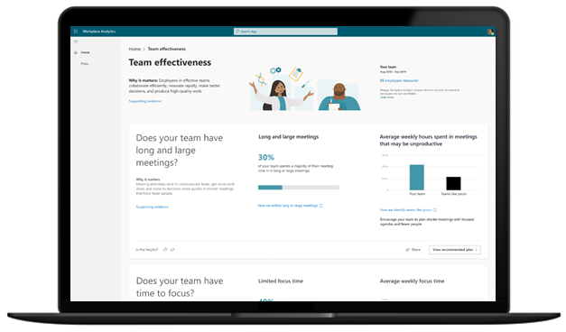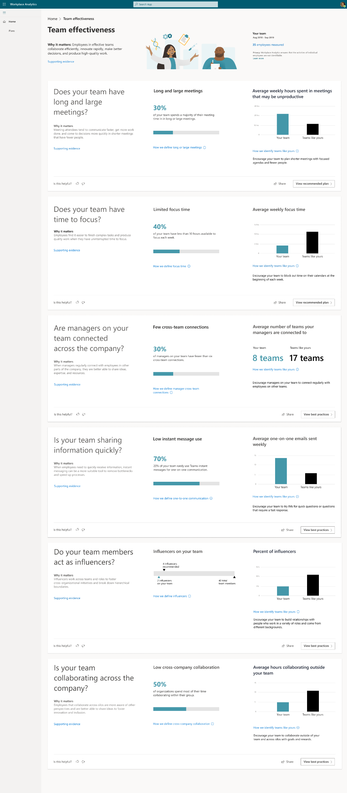

# How can Manager Insights help

|  |  |  |
| --- | --- | --- |
| Develop a culture of 1:1 coaching  See how much time team members spend one-on-one with their managers, and make sure it aligns with the culture you're striving for. | |  |
|  | Improve meeting and email habits  Help your team reduce excessive meetings and improve email habits to support team effectiveness and productivity. | |
| Support team wellbeing  Check on your team’s after-hours work habits and use these insights to balance schedule flexibility and the need to disconnect. | |  |
|  | Cross-team collaboration  Review how your team is collaborating with the rest of the organization and reflect on how you can help expand the networks of your team. | |

# Why is this important?

Managers have a huge impact on team productivity and wellbeing. Check out the research:

* Managers account for 70% variance in employee engagement scores. ([Gallup](https://nam06.safelinks.protection.outlook.com/?url=https%3A%2F%2Fnews.gallup.com%2Fbusinessjournal%2F182792%2Fmanagers-account-variance-employee-engagement.aspx&data=04%7C01%7Cdheepakr%40microsoft.com%7Cde7e377cbada4d0e8cc208d80c9cf716%7C72f988bf86f141af91ab2d7cd011db47%7C1%7C0%7C637273215605101532%7CUnknown%7CTWFpbGZsb3d8eyJWIjoiMC4wLjAwMDAiLCJQIjoiV2luMzIiLCJBTiI6Ik1haWwiLCJXVCI6Mn0%3D%7C-1&sdata=8p7h6tVr8NDR2%2FHCQ6c11k3EzRQ7lJGIYJs90GQDxI8%3D&reserved=0))
* Employees tend to model their behaviours after their managers. ([M365 Insights](https://nam06.safelinks.protection.outlook.com/?url=https%3A%2F%2Fhbr.org%2F2016%2F12%2Fwhat-great-managers-do-daily&data=04%7C01%7Cdheepakr%40microsoft.com%7Cde7e377cbada4d0e8cc208d80c9cf716%7C72f988bf86f141af91ab2d7cd011db47%7C1%7C0%7C637273215605111524%7CUnknown%7CTWFpbGZsb3d8eyJWIjoiMC4wLjAwMDAiLCJQIjoiV2luMzIiLCJBTiI6Ik1haWwiLCJXVCI6Mn0%3D%7C-1&sdata=gaOqrPfGXpW6XKJaAX4b3enpB3S22MofbR7jfsbRTcY%3D&reserved=0))
* Employees who regularly connect with their manager while working remotely are less impacted by increases in workday span and collaboration hours. ([M635 Insights](https://nam06.safelinks.protection.outlook.com/?url=https%3A%2F%2Finsights.office.com%2Fworkplace-analytics%2Fthe-new-manager-11-nurturing-employee-resiliency-during-disruption-and-change%2F&data=04%7C01%7Cdheepakr%40microsoft.com%7Cde7e377cbada4d0e8cc208d80c9cf716%7C72f988bf86f141af91ab2d7cd011db47%7C1%7C0%7C637273215605121521%7CUnknown%7CTWFpbGZsb3d8eyJWIjoiMC4wLjAwMDAiLCJQIjoiV2luMzIiLCJBTiI6Ik1haWwiLCJXVCI6Mn0%3D%7C-1&sdata=NwGNppIb9w4VtHmngaAdgInJRvS5vgNQsTfk1wdOHdk%3D&reserved=0))

TIP: customize with organization objective

# Data and Privacy

This dashboard uses anonymized data from emails, meetings, and chats in Outlook and Teams to uncover insights about collaboration in your organization. Managers will only ever see aggregated data for their teams with no access to individual insights.

# How to get started

* Stay tuned! In a few days, you’ll receive a welcome email with more info about how to log in and get started with Manager Insights.
* *< communication channel for managers to reach out :* Have questions? Review our <FAQ> or talk to us @ >

TIP: customize with program specifics