CS160

Logic Gate Assignment

SHOW YOUR WORK ON ALL PROBLEMS

Draw truth tables for the following logical expressions:

1. AB

**A B AB**

0 0 0

0 1 0

1 0 0

1 1 1

1. A+B

**A B AB**

0 0 0

0 1 1

1 0 1

1 1 1

1. ABC

**A B C ABC**

0 0 0 0

0 0 1 0

0 1 0 0

0 1 1 0

1 0 0 0

1 0 1 0

1 1 0 0

1 1 1 1

1. AB + C

**A B C AB + C**

0 0 0 0

0 0 1 1

0 1 0 0

0 1 1 1

1 0 0 0

1 0 1 1

1 1 0 1

1 1 1 0

Draw a logic gate diagram for the following logical expressions:

1. X + Y

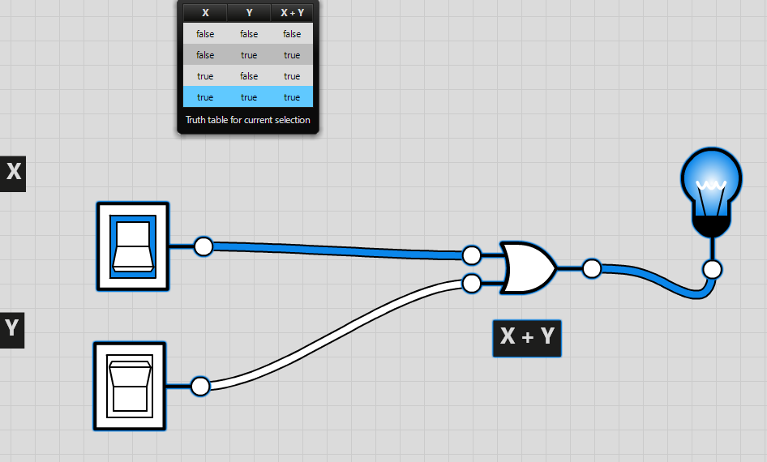

1. (XY) + Z

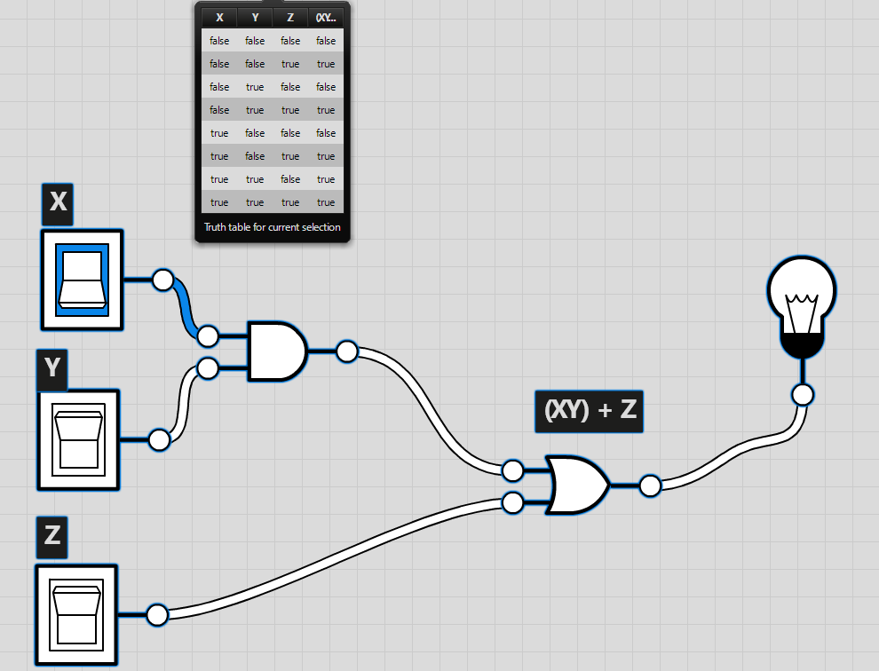

1. (X + Y)Z

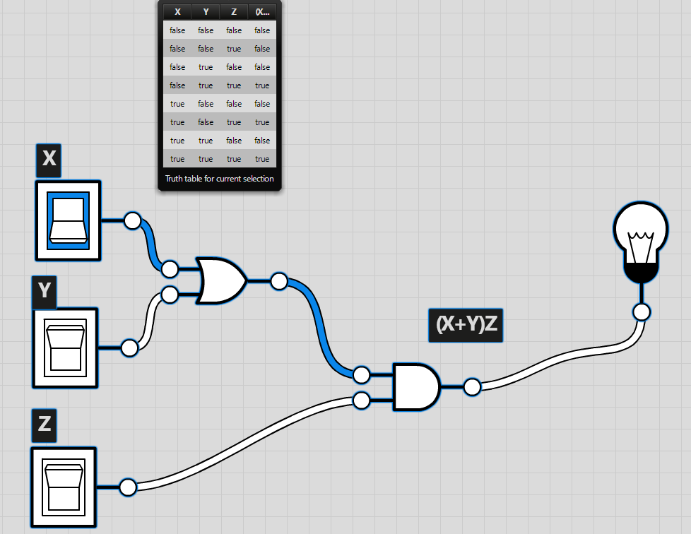

1. (X + Y) + (Y + Z)

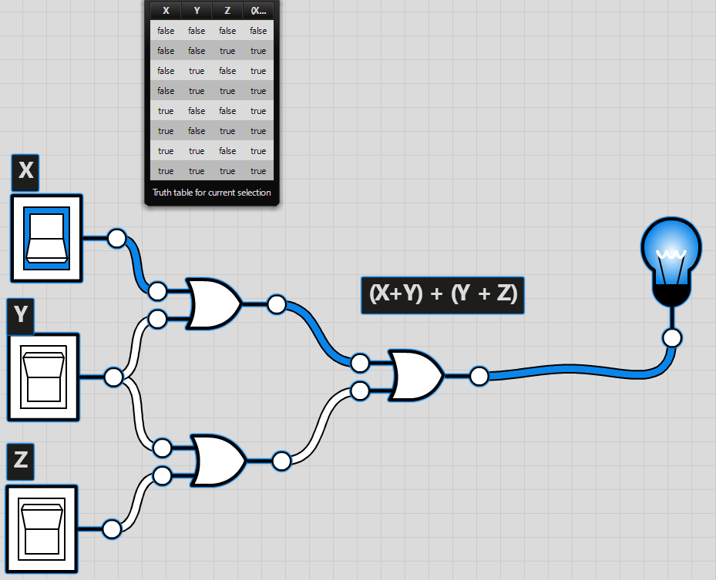

Create a truth table AND a logic gate diagram to represent the following logical expressions:

1. FG + HJ

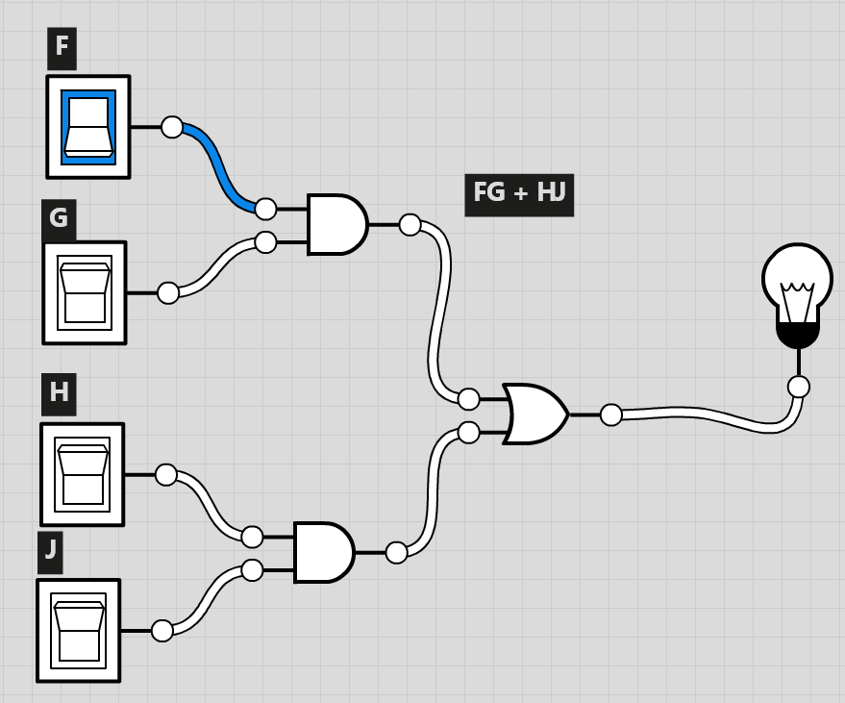

**F G H J FG + HJ**

0 0 0 0 0

0 0 0 1 0

0 0 1 0 0

0 0 1 1 1

0 1 0 0 0

0 1 0 1 0

0 1 1 0 0

0 1 1 1 1

1 0 0 0 0

1 0 0 1 0

1 0 1 0 0

1 0 1 1 1

1 1 0 0 1

1 1 0 1 1

1 1 1 0 1

1 1 1 1 1

1. F + G + H + J

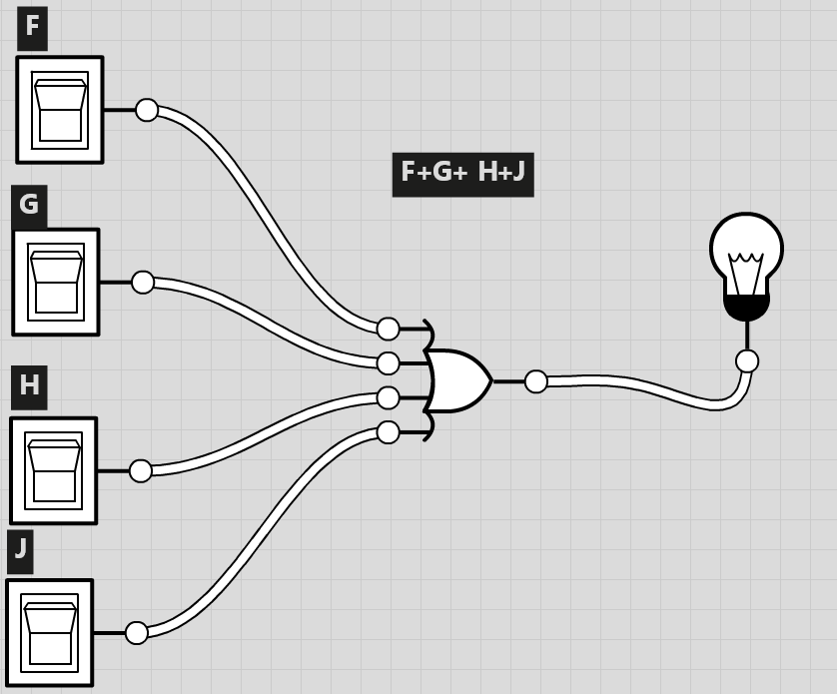

**F G H J F+G + H+J**

0 0 0 0 0

0 0 0 1 1

0 0 1 0 1

0 0 1 1 1

0 1 0 0 1

0 1 0 1 1

0 1 1 0 1

0 1 1 1 1

1 0 0 0 1

1 0 0 1 1

1 0 1 0 1

1 0 1 1 1

1 1 0 0 1

1 1 0 1 1

1 1 1 0 1

1 1 1 1 1