**HW6 (50 pts Due November 22 by 11:59 pm)**

1. (20 pts) Use Bellman-Ford algorithm to find shortest path from vertex s to all the other vertices on the following graph. Clearly show all your steps in the algorithm by filling the table as in the class

1. (15 pts) Using Matrix Chain Multiplication algorithm determine minimum number of multiplications to compute the following matrix sequence $A_{1}A_{2}A_{3}A_{4}A_{5}A_{6}A_{7},$ where sequence of row-column of the above matrices is: <10,20,5,6,20,15,10,20>. Clearly show how two-dimensional matrix is completed to determine minimum number of multiplications. Also show what is the best multiplication order in the above matrix sequence. Fill the following recurrence table:

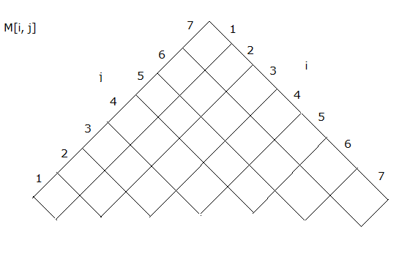

1. (15 pts) Apply longest subsequence dynamic-programming algorithm to find LCS of these two sequences:

X=<1,0,1,1,0,1,0,1,1,0,0,0,1,1,1,0> and Y=<1,0,1,1,0,1,1,0,1,0,1,1,0,0>. Clearly fill out your table.