**ESP32 - tiny embedded system**

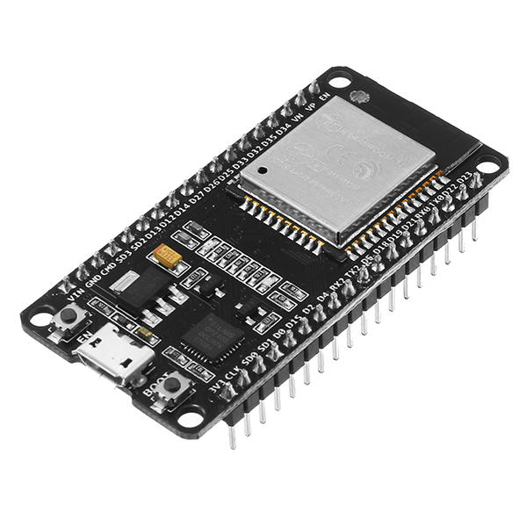

Features of the ESP32 include the following:[3]

Processors:

CPU: Xtensa dual-core (or single-core) 32-bit LX6 microprocessor, operating at 160 or 240 MHz and performing at up to 600 DMIPS

Ultra low power (ULP) co-processor

Memory: 520 KiB SRAM

Wireless connectivity:

Wi-Fi: 802.11 b/g/n

Bluetooth: v4.2 BR/EDR and BLE

Peripheral interfaces:

12-bit SAR ADC up to 18 channels

2 × 8-bit DACs

10 × touch sensors (capacitive sensing GPIOs)

Temperature sensor

4 × SPI

2 × I²S interfaces

2 × I²C interfaces

3 × UART

SD/SDIO/CE-ATA/MMC/eMMC host controller

SDIO/SPI slave controller

Ethernet MAC interface with dedicated DMA and IEEE 1588 Precision Time Protocol support

CAN bus 2.0

Infrared remote controller (TX/RX, up to 8 channels)

Motor PWM

LED PWM (up to 16 channels)

Hall effect sensor

Ultra low power analog pre-amplifier

**Rsapberry Pi 3 - linux board**

**[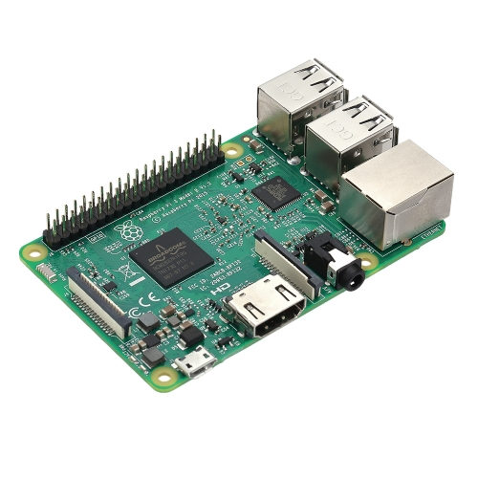](https://www.tomtop.com/javascript:void(0))**

SoC: Broadcom BCM2837.

CPU: 4× ARM Cortex-A53, 1.2GHz.

GPU: Broadcom VideoCore IV.

RAM: 1GB LPDDR2 (900 MHz)

Networking: 10/100 Ethernet, 2.4GHz 802.11n wireless.

Bluetooth: Bluetooth 4.1 Classic, Bluetooth Low Energy.

Storage: microSD.

GPIO: 40-pin header, populated.

**RC522 - RFID reader**

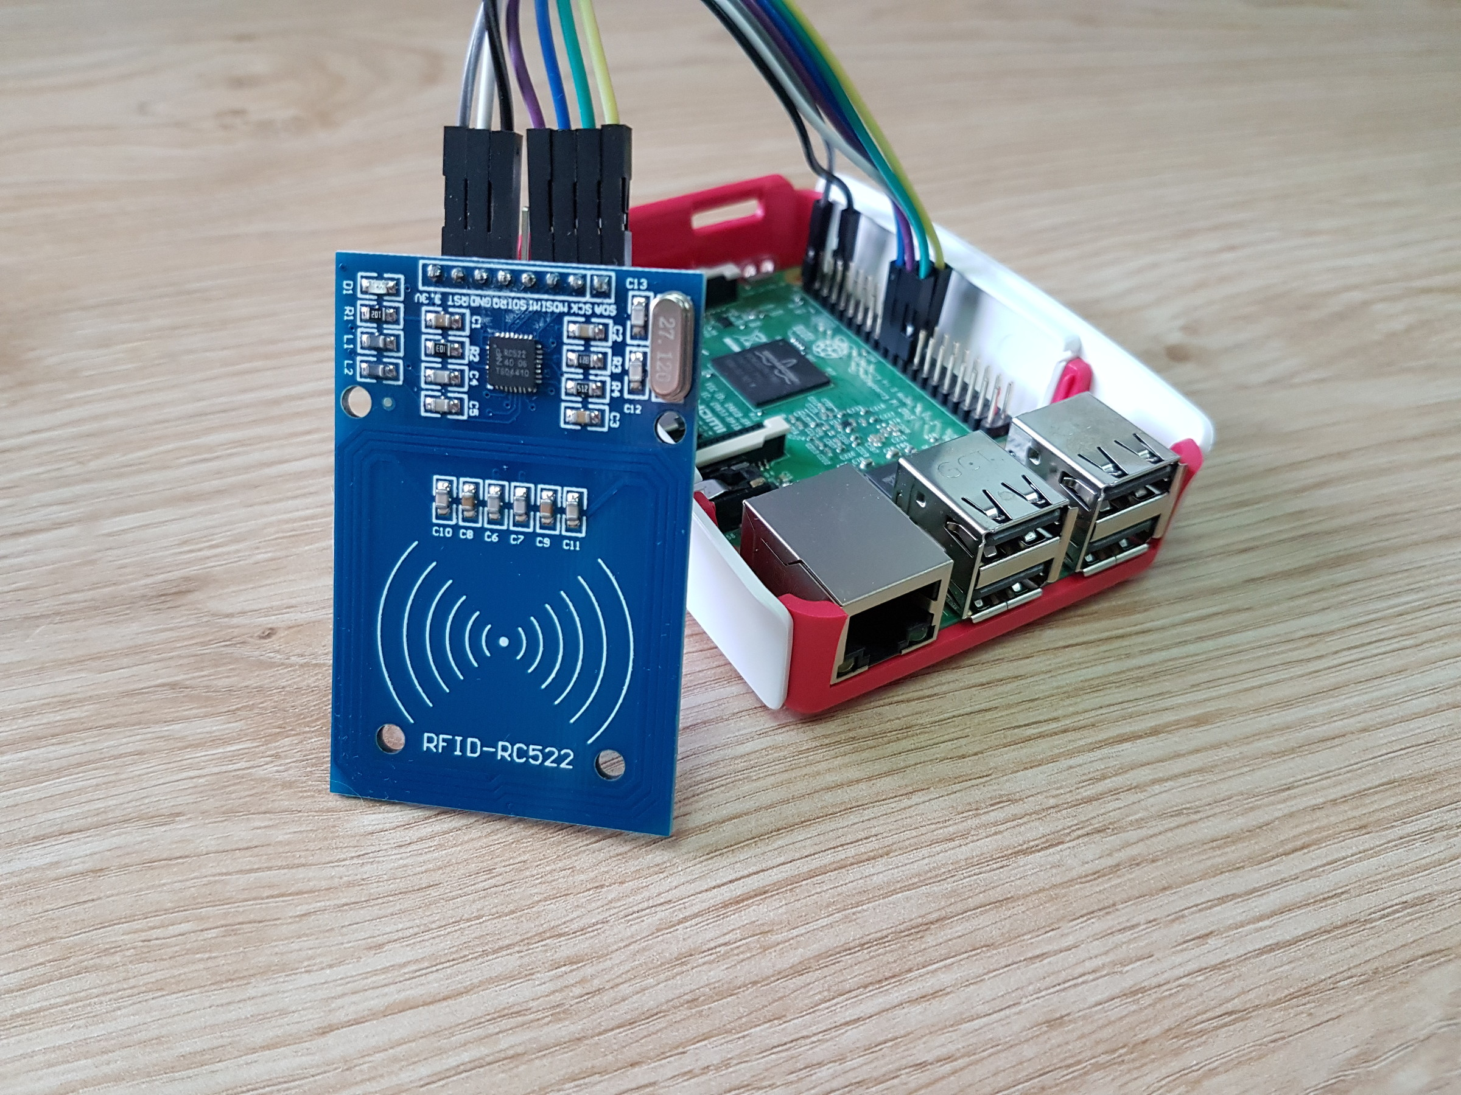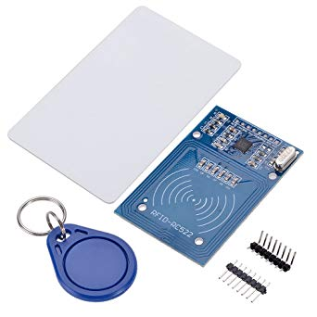

Module Name:MF522-ED

Working current：13 - 26mA / DC 3.3V

Standby current：10 - 13mA / DC 3.3V

Sleep current：<80uA

Peak current：<30mA

Working frequency：13.56MHz

Card reading distance ：0～60mm （Mifare1 card）

Protocol：SPI

Data communication speed：10Mbit/s Max.

Card types supported: Mifare1 S50, Mifare1 S70, Mifare UltraLight, Mifare Pro, Mifare Desfire

Dimension：40mm × 60mm

Working temperature：-20—80 degree

Storage temperature：-40—85 degree

Humidity：relevant humidity 5%—95%

**nRF24L01+ - 2.4GHz module**

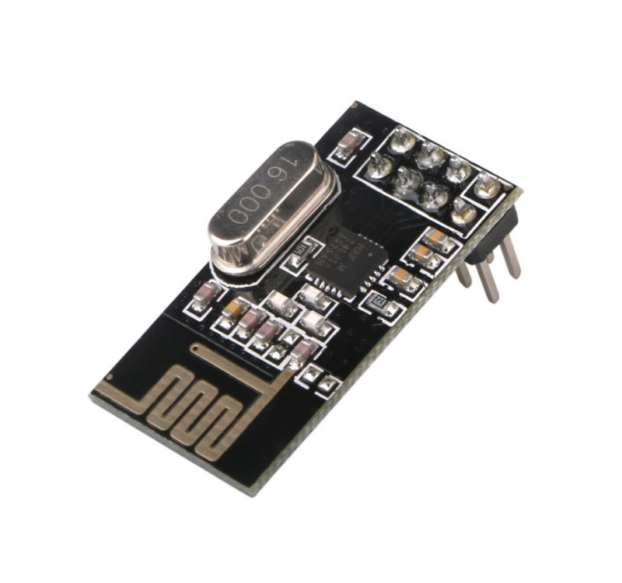

**2 channels switch module**

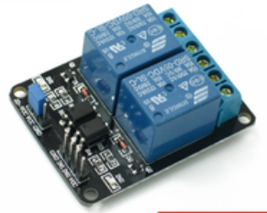

The modules above will be used in our project. Also, A laptop and a WiFi router will be here. There is a light-weight version IPsec implementation that is written by the C language. A server software that is written by Python3 will perform Layer 3 & Layer 7 ACLs and auditing. At the same time, a MySQL server is running on the server, and it records the accounts of users and records of users.

**What had we done?**

* Purchasing modules.
* Circuit design&connection

**What we do next?**

* Coding ipsec, server, RFID driver
* Test the system