WORD FILE II

Alexander Konkin

BPS212

Plot 1. Histograms combined in one line

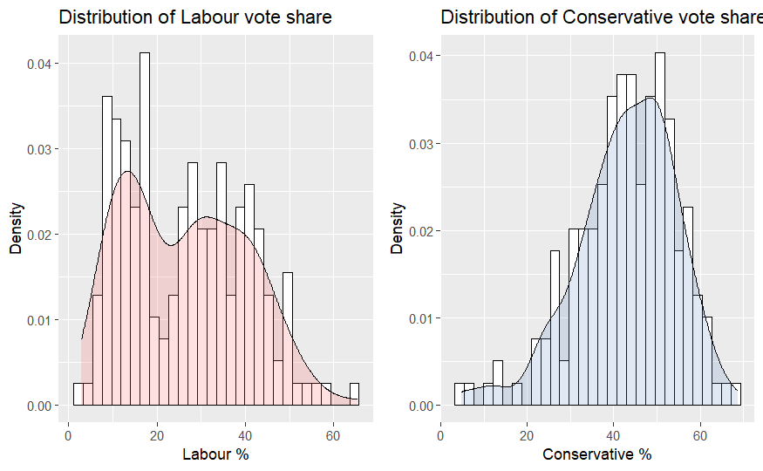

Plot 2. Graph combining boxplots

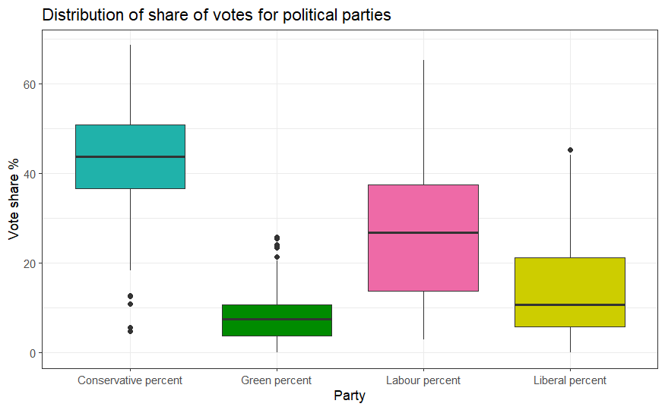

Plot 3. One OR 5 unified scatterplots

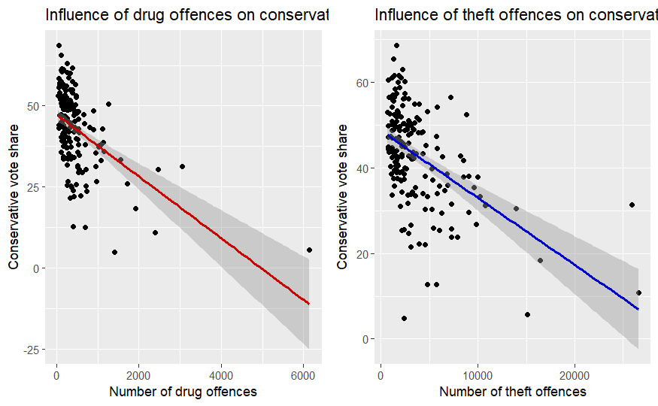

Plot 6. Q-Q plot

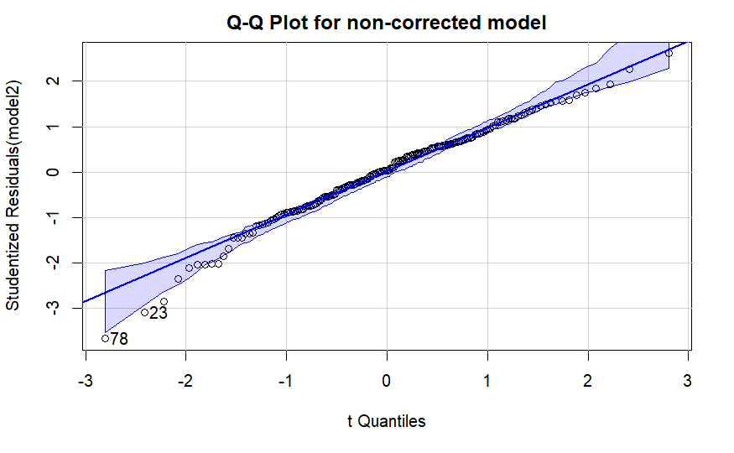

Plot 7. crPlots

