

PRISM
Profit Pool Risk & Intelligence Simulation Model

Methodology, Data & Technical Documentation
Prepared for Henkel Consumer Brands

CONFIDENTIAL
April 2026 | Version 3.1

Table of Contents

1 Executive Summary
2 What is PRISM?
3 The Six Strategic Forces
4 How Trends Are Sourced and Evaluated
5 The Source Credibility Tier System
6 The Trend Database
7 How the Simulation Engine Works
8 Materialization: How Trends Unfold Over Time
9 Reading the Output: The Shift Matrix
10 Resource Allocation Optimizer
11 Advanced Risk Analytics
12 The AI Layer: Augmenting Human Judgment
13 Expert Elicitation: The Delphi Protocol
14 Governance & Quality Assurance
15 Glossary of Key Terms

1. Executive Summary

PRISM (Profit Pool Risk & Intelligence Simulation Model) is a probabilistic simulation platform purpose-built for Henkel Consumer Brands. It answers a deceptively simple question: How will our profit pools shift over the next decade, and what should we do about it?
Traditional strategic planning relies on point estimates and expert intuition. PRISM replaces this with a rigorous, data-driven approach that combines Bayesian statistics with structured expert judgment. It does not predict the future with false precision. Instead, it generates thousands of plausible scenarios, revealing the range of possible outcomes and their relative likelihood.
Key Principle: PRISM generates probabilistic ranges, not single-point forecasts. Every output includes confidence intervals so decision-makers can see both the expected outcome and the uncertainty around it.

The model tracks 82 strategic trends across six forces (Consumer, Customer, Technology, Government, Environmental, Competitive) and simulates their combined impact on 12 product categories over an 11-year horizon (2026–2036). The output is a Shift Matrix: a table of percentage shifts that can be applied directly to financial models in Excel or Power BI.
Each trend is anchored to verifiable external sources classified through a rigorous credibility tier system (S through E), with a hard gate rejecting any trend supported only by weak or unverifiable sources. Trends are initially identified through a combination of AI-assisted market scanning and expert nomination, then rigorously scored through a structured Delphi protocol involving senior strategists with deep FMCG domain expertise.
PRISM was developed in partnership between the Henkel Consumer Brands Strategy team and a senior partner-led team from leading strategy consultancies, with input from 20+ senior consultants with backgrounds spanning L’Oréal, P&G, Unilever, Apple, and banking. The trend database reflects an April 2026 market intelligence snapshot.

2. What is PRISM?

The Problem It Solves
Strategic planning at a multi-billion-euro consumer goods company involves assessing dozens of external forces simultaneously: regulatory changes, technology disruption, shifting consumer preferences, competitive moves, and environmental pressures. Each of these forces interacts with others in complex, non-linear ways.
A traditional approach might assign each force a qualitative rating (high/medium/low) and discuss implications in a workshop. This approach has three fundamental limitations. First, it conflates probability with impact, treating a highly likely but minor trend the same as a low-probability but transformative one. Second, it ignores interactions between forces, even though a regulation (e.g., EU PFAS ban) might trigger technology investment (bio-based chemistry) which in turn creates competitive advantage. Third, it produces point estimates rather than ranges, giving false confidence in inherently uncertain projections.

How PRISM is Different
PRISM addresses each of these limitations through a structured, quantitative methodology:
Two-dimensional scoring: Every trend is scored on two independent dimensions: probability of materialization (1–5 scale) and economic scope, meaning the maximum percentage of category gross profit that could be affected (0–100%). This prevents the common error of conflating a highly probable but economically minor trend with a low-probability but transformative one.
Correlated simulation: Rather than treating trends independently, PRISM models statistical dependencies between them using a copula framework. When EU regulation tightens, correlated environmental and technology trends shift in tandem, just as they would in reality.
Probabilistic output: Instead of a single forecast, PRISM generates 10,000 Monte Carlo scenarios and reports results as probability distributions with confidence intervals (p10 through p90), giving decision-makers an honest view of uncertainty.

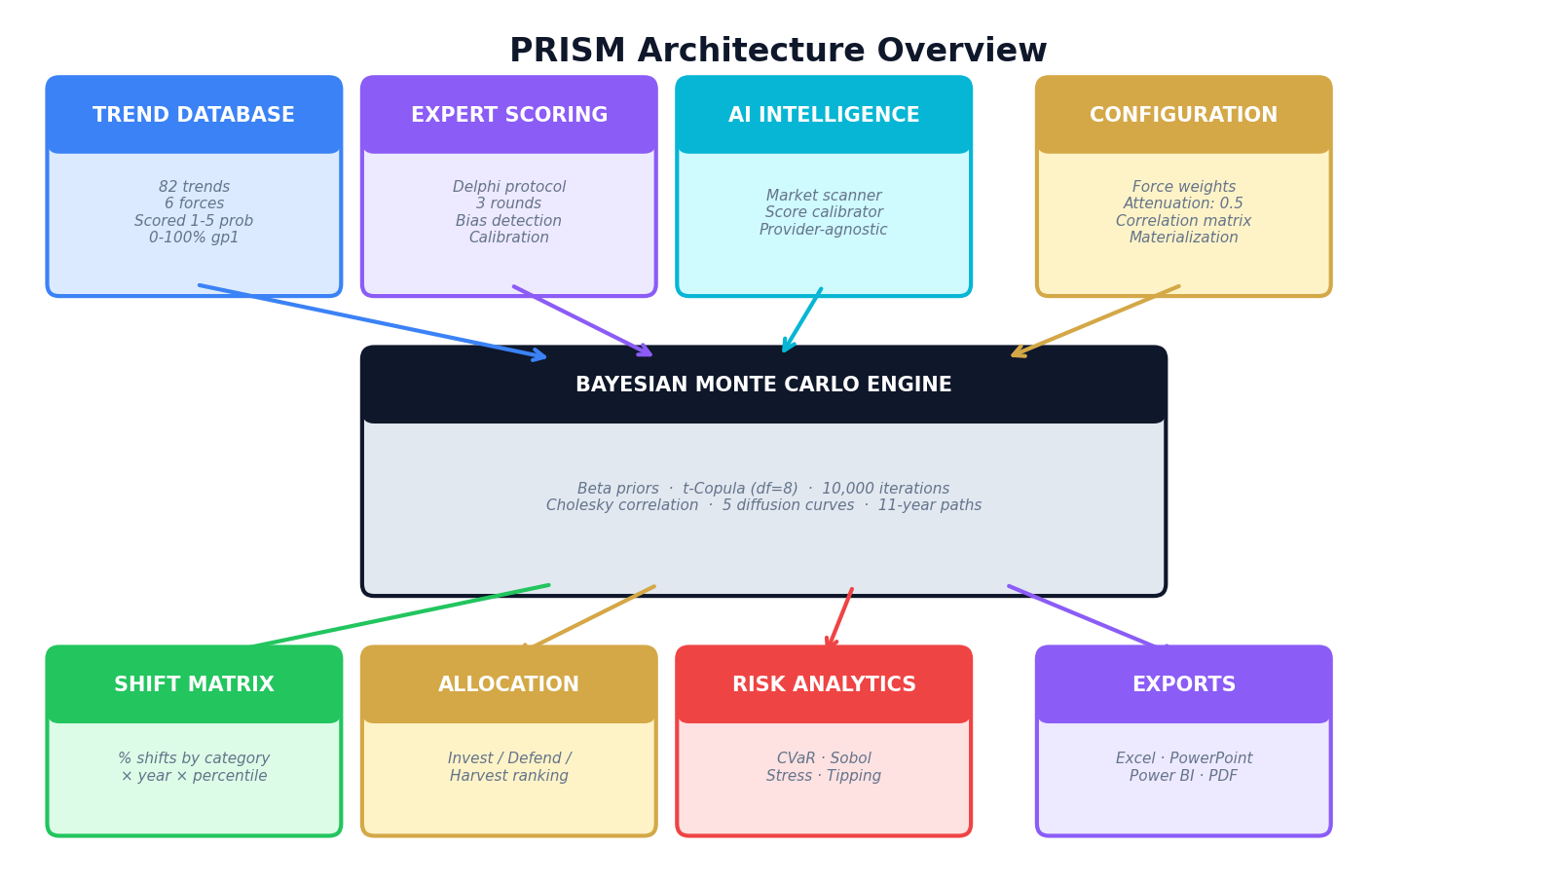
Exhibit 1: PRISM Architecture Overview — from inputs through simulation engine to decision outputs

What PRISM Produces
PRISM’s primary output is the Shift Matrix: a structured dataset showing the projected percentage change in gross profit for each of Henkel’s 12 product categories, for each year from 2026 to 2036, at five confidence levels. Users apply these shifts to their own financial baselines using a simple formula:
Projected GP = Actual GP × (1 + shift_median) | Example: If Hair Color GP is €100M and the 2030 median shift is –1.4%, projected GP = €100M × 0.986 = €98.6M

Crucially, PRISM operates exclusively in relative terms (percentage shifts). It never stores or processes absolute financial figures. This preserves confidentiality and ensures the model remains a strategic lens rather than a financial planning tool.

3. The Six Strategic Forces

PRISM organizes all external factors into six mutually exclusive strategic forces. This taxonomy ensures comprehensive coverage without double-counting. Every trend in the database belongs to exactly one force.


Exhibit 2: The Six Strategic Forces Framework — 82 trends organized into 6 MECE forces
Force | # Trends | Key Themes | Example Trends
Consumer | 23 (28%) | Demand shifts, behavioral change, demographics | Private Label penetration, GLP-1 reallocation, Gen Z dupe culture, Longevity economy
Technology | 16 (20%) | Innovation, digital disruption, new capabilities | AI-driven formulation, Precision fermentation, Agentic commerce, Smartwash
Government | 12 (15%) | Regulation, compliance, policy | EU PFAS restriction, PPWR packaging, EU AI Act, Digital Product Passport
Competitive | 12 (15%) | Industry structure, competitor moves | Amazon PL expansion, L’Oréal-NVIDIA, DTC M&A wave
Environmental | 11 (13%) | Resource scarcity, climate, sustainability | Palm oil disruption, Freshwater scarcity, Scope 3+, Climate formulation
Customer | 8 (10%) | Retail evolution, channel power | TikTok Shop, Retail media networks, Agentic retail media

Force Interactions: The Calibrated Overlap Matrix
Forces do not operate in isolation. PRISM explicitly models the statistical coupling between forces using two calibrated overlap matrices — one for cross-force overlap (how much does Force A’s signal duplicate Force B’s?) and one for within-force overlap (how much do trends inside the same force duplicate each other?). Both were empirically calibrated from the full 82-trend database in April 2026 using a rigorous three-step methodology. No values are assumed.
Calibration Methodology (Three Steps)
Step 1 — Empirical weighted Jaccard: For every pair of trends across two different forces, the system computes the weighted Jaccard similarity over their 12-category exposure vectors (0–5 scores). This produces a mean pairwise Jaccard for each force pair. To isolate genuine mechanism overlap from the structural floor (the baseline similarity any two FMCG trends share simply because the same 12 categories exist), a random-pair baseline J₀ = 0.485 is subtracted: excess overlap = max(0, mean_J – J₀) / (1 – J₀). This removes noise and isolates the signal.
Step 2 — Asymmetry adjustment: The excess overlap is multiplied by √(n_j / n_i), capped at 1.5×, where n_i and n_j are the number of trends in each force. This reflects that a narrow force (e.g., Customer with 8 trends) is more likely to be “covered” by a broad one (e.g., Consumer with 23 trends) than vice versa. The matrix is therefore asymmetric by design: Environmental → Government = 0.432, but Government → Environmental = 0.405.
Step 3 — Mechanism coupling adjustment: A manual additive adjustment of ±0.05–0.10 per cell, based on documented FMCG causal couplings. For example, PFAS regulation is both a Government and Environmental phenomenon — the statistical overlap alone understates the mechanism linkage, so a positive adjustment is applied. Conversely, where statistical similarity reflects coincidence rather than shared causation, a negative adjustment brings the value down.
Cross-Force Overlap Matrix (Calibrated April 2026)
The resulting asymmetric cross-force overlap matrix captures how much of each force’s signal is already represented by another force. The top calibrated couplings are:
Force Pair (A → B) | Overlap | Rationale
Environmental → Government | 0.432 | PFAS, PPWR, EUDR, DPP: regulatory mandates ARE the environmental trends
Government → Environmental | 0.405 | Same nexus, reverse direction (slightly lower: Gov also covers non-env regulation)
Government → Technology | 0.367 | Regulation directly triggers reformulation R&D and digital compliance (DPP)
Customer → Government | 0.300 | Retailer compliance burden (PPWR, CSRD) scales with regulatory intensity
Customer → Technology | 0.266 | Retail media, agentic commerce = customer trends that are inherently technological
Environmental → Technology | 0.266 | Supply constraints (PFAS, palm oil) drive bio-chemistry and green-tech R&D
Technology → Government | 0.237 | AI Act, DPP digital mandates create tech requirements from regulatory origins
Consumer → Competitive | 0.080 | Private label growth is simultaneously a consumer preference and competitive shift
Consumer → other forces | ~0.05 | 23 highly diverse trends (including 6 geographic) share almost no mechanism overlap
Competitive → other forces | ~0.05–0.09 | 12 competitor-specific trends are mechanistically independent

Consumer and Competitive forces show near-zero overlap with most other forces. This is not a modeling choice but an empirical result: Consumer’s 23 trends span premiumization, sustainability, demographics, occasions, geographic expansion, and value trading — too diverse to overlap structurally with any single force. Competitive’s 12 trends each describe a different competitor’s strategy (Reckitt, P&G, Unilever, L’Oréal, Amazon, DTC, K-beauty, etc.), making them genuinely independent.
Within-Force Overlap (Calibrated April 2026)
Within-force overlap captures how much trends inside the same force duplicate each other. The calibration uses the same weighted Jaccard methodology but applied to all trend pairs within each force. Government leads at 0.426 because 8 of its 12 trends stem from the European Green Deal legislative package (PFAS, PPWR, Green Claims, EUDR, DPP, AI Act, biodiversity, textile circularity) — genuine legislative redundancy. Consumer and Competitive are floor-clamped at 0.10 because their empirical excess overlap is effectively zero.
Force | Within-Force Overlap | Empirical Signal | Rationale
Government | 0.426 | Raw J=0.678, excess=0.376 | 8 of 12 trends from EU Green Deal; shared regulatory DNA
Environmental | 0.269 | Raw J=0.597, excess=0.219 | Tight climate→water→palm→energy interconnections
Technology | 0.232 | Raw J=0.579, excess=0.182 | Two clusters: AI (8 trends) + bio-chemistry (5 trends)
Customer | 0.157 | Raw J=0.566, excess=0.157 | Channel power cluster + digital commerce cluster
Consumer | 0.100 (floor) | Raw J=0.387, excess=0.000 | 23 diverse trends across 6 domains; no excess overlap
Competitive | 0.100 (floor) | Raw J=0.455, excess=0.000 | 12 competitor-specific strategies; genuinely independent

These two matrices — cross-force and within-force — drive the dynamic attenuation system described in Step 4 of the simulation methodology (Chapter 6). Their combined effect replaces what was originally a flat 0.5 attenuation factor with a principled, empirically grounded dampening system that varies by force and by the number of active trends in each category.

4. How Trends Are Sourced and Evaluated

The quality of PRISM’s output depends entirely on the quality of its trend database. This chapter explains how trends are identified, evaluated, and admitted into the model — a process designed to balance comprehensiveness with intellectual rigor.

Phase 1: Trend Identification
Trends enter the candidate pool through three channels:
Expert nomination: Senior strategists with deep FMCG domain expertise nominate trends based on their industry knowledge, competitive intelligence, and strategic foresight. This captures emerging signals that may not yet appear in published research.
Systematic literature review: A structured scan of tier-1 research sources — management consultancy reports (McKinsey, BCG, Deloitte), market research providers (Euromonitor, NielsenIQ, Mintel), regulatory filings (ECHA, EUR-Lex, European Commission), and academic journals — identifies trends with documented evidence.
AI-assisted scanning: PRISM’s AI scanner module analyzes market intelligence feeds and identifies potential trends or changes to existing trends. Every AI-suggested trend is tagged as such and requires human review before entering the database. The AI does not score trends — it surfaces candidates for expert evaluation.

Phase 2: Source Verification and Tier Assignment
Every candidate trend must be anchored to verifiable external sources. Each source is classified into one of nine credibility tiers (S through E), and the trend itself must pass a hard credibility gate before it can be scored or included in the simulation. This gate is enforced programmatically: the system will reject any trend that lacks at least one source rated B– or higher.
The current database of 82 active trends is supported by over 300 individual source citations, distributed across the tier spectrum with heavy weighting toward S and A-tier sources.

Phase 3: Structured Scoring
Once a trend passes the credibility gate, it enters the scoring process. Each trend receives an initial score based on the sourced evidence — the research team assigns a preliminary probability (1–5) and economic scope (GP1 % affected) based on the weight of evidence. These initial scores are then refined through the Delphi protocol (Chapter 13), where multiple experts independently validate, challenge, and calibrate the scores through structured multi-round elicitation.

Phase 4: Ongoing Maintenance
The trend database is not static. Trends are reviewed quarterly through the AI scanner refresh and annually through a full Delphi re-scoring. Trends can be retired when they have fully materialized or structurally failed (e.g., “Post-COVID Hygiene Premium” was retired in v3.1 as the behavior normalized). New trends can be added at any time, provided they pass the credibility gate and scoring protocol.

5. The Source Credibility Tier System

PRISM implements a nine-level source credibility framework that governs which evidence can support a trend’s inclusion in the model. This system is not advisory — it is enforced programmatically as a hard gate at the database ingestion layer.
Tier | Classification | Description | Examples
S | Sovereign / Regulatory | Government data, official regulations, international agencies, peer-reviewed academic journals | European Commission, ECHA, IPCC, UN, WHO, Eurostat, Nature journals, EUR-Lex
A | Tier-1 Analyst / Research | Leading management consultancies and market research providers | McKinsey, BCG, Deloitte, Euromonitor, NielsenIQ, Mintel, JP Morgan Research
A– | Tier-2 Analyst | Established research firms and specialist consultancies | eMarketer, Kline Group, IAPP, CB Insights, PitchBook
B+ | Data Tools / Associations | Quantitative data platforms and major trade associations | WRI Aqueduct, Similarweb, Marketplace Pulse, Consumer Brands Association
B | Trade Press / Market Data | Reputable trade publications and secondary market reports | CosmeticsDesign-Europe, BeautyMatter, FMCG Gurus, GVR, Technavio
B– | Company Disclosures | Annual reports, earnings transcripts, investor presentations | L’Oréal Annual Report, Amazon 10-K, Henkel IR disclosures
C | News / General Media | Credible news outlets with moderate analytical depth | Reuters, S&P Global, Financial Times, Bloomberg
D | Weak Signal | Market forecasts from generic aggregators, limited-credibility sources | Generic Statista reports, unattributed market sizing
E | Unverifiable | Social media, user-generated content, unverified claims | Reddit, Twitter/X, influencer claims, anonymous blogs

The Credibility Gate (Rule E1)
Every trend in PRISM must satisfy the following hard rule before it can be scored or included in any simulation:
Credibility Gate: A trend must have at least one source rated B– or higher. Trends supported exclusively by D-tier or E-tier sources are rejected at ingestion. E-tier sources (social media, unverified) are permitted only as corroborating signals alongside a B–-or-better primary source.

This gate is enforced at the API level: attempting to create a trend with only weak-tier sources returns a validation error. The gate exists to prevent the model from being contaminated by unverifiable market rumors or social media noise, while still allowing weak signals to supplement stronger evidence.
In practice, the current database is heavily weighted toward high-credibility sources: approximately 30% of citations are S-tier (government and academic), 61% are A-tier (analyst and research), and only 3% fall in D-tier or below — always accompanied by stronger corroborating sources.

6. The Trend Database

The trend database contains 82 individually researched and scored trends, each representing a specific external force that could shift Henkel Consumer Brands’ profit pools. This chapter explains how each trend is defined and how the scoring system works.

How Each Trend is Defined
Attribute | Type | Description | Example (EU PFAS Ban)
Probability | Integer (1–5) | Likelihood of materialization within the time horizon | 5 (Near-certain: already in effect Jan 2026)
GP1 % Affected | Decimal (0.0–1.0) | Maximum share of category GP1 exposed at full materialization | 0.12 (12% of affected categories’ GP1)
Direction | Expansion / Contraction | Whether the trend grows or shrinks the profit pool | Contraction (forces reformulation cost)
Diffusion Curve | 5 types | How quickly the trend materializes over the 11-year horizon | front_loaded (regulatory deadline-driven)
Peak Year | 2026–2036 | Year at which the trend reaches full impact | 2027 (Phase 1 enforcement deadline)
Category Exposure | 0–5 per category | How exposed each of the 12 categories is to this trend | Hair Color: 3, LHC FCN: 5, LHC HDW: 4
VC Exposure | 0–5 per step | Impact along the 8-step value chain | Formulation: 5, Manufacturing: 4
Regional Exposure | 0–5 per region | Geographic concentration of impact | Europe: 5, N. America: 3, Asia: 2
Source Citations | Tiered references | Verified external sources with credibility tier assignment | ECHA (S), Deloitte PFAS Report (A)

The Scoring System: Probability × Economic Scope
PRISM uses a deliberately simple two-dimensional scoring framework. Each trend’s normalized score is computed as:
Normalized Score = E[Beta(α, β)] × GP1 % Affected × Direction Sign (+1 or –1)
where α = probability score, β = 6 – probability score

This design was a conscious choice to avoid the common pitfall of traditional frameworks that conflate likelihood with magnitude. A trend with probability 5 and GP1 scope of 2% (e.g., a near-certain but minor packaging regulation) scores very differently from a trend with probability 2 and GP1 scope of 25% (e.g., an unlikely but transformative technology disruption).
The probability score maps directly to a Beta distribution for simulation purposes. A score of 4 out of 5 becomes Beta(4, 2), which has a mean of 0.67 and a characteristic right-skewed shape, reflecting genuine uncertainty. A score of 5 becomes Beta(5, 1), sharply concentrated near 1.0 but still allowing some downside. This is more honest than treating a “4 out of 5” as a fixed 80% probability.

GP1 % Affected: Calibrated Economic Anchoring
The GP1 % Affected parameter deserves special attention because it is PRISM’s primary guard against inflated impact estimates. It answers: “If this trend fully materializes at maximum severity, what percentage of the category’s gross profit is exposed?”
This parameter is calibrated by archetype using industry benchmarks:
Trend Archetype | Typical GP1% Range | Calibration Logic
Market structure shifts (PL, channel) | 15–25% | PL at 40-50% volume; branded margin defense limits exposure to price-gap erosion
Regulatory / reformulation | 5–15% | Affects COGS via reformulation, not the entire margin stack
Consumer behavioral shifts | 8–20% | Shifts willingness-to-pay for segments, not entire category
Technology / innovation | 3–10% | Affects efficiency or niche segments, not category-wide GP1
Category creation / expansion | 3–8% | Additive new pools, not displacement of existing GP1
Competitive moves | 5–15% | Affects share in specific overlapping segments

Every trend’s GP1 % Affected carries a written rationale in the database explaining the calibration logic. For example, the EU PFAS Universal Restriction is set at 12% because cosmetics PFAS ban compliance costs affect formulation COGS, which represents approximately 12% of exposed categories’ gross profit structure.

Direction Split
Of the 82 active trends, 38 are classified as Expansion (positive profit pool impact) and 44 as Contraction (negative impact). This slight tilt toward contraction reflects the current regulatory and competitive environment in European FMCG. However, significant expansion opportunities exist in AI-driven formulation, premiumization, the longevity economy, and emerging market growth.

7. How the Simulation Engine Works

The simulation engine is the mathematical core of PRISM. It transforms the scored trend database into a probabilistic Shift Matrix through a five-step process, repeated 10,000 times (Monte Carlo simulation). This chapter explains each step for a sophisticated non-technical audience.

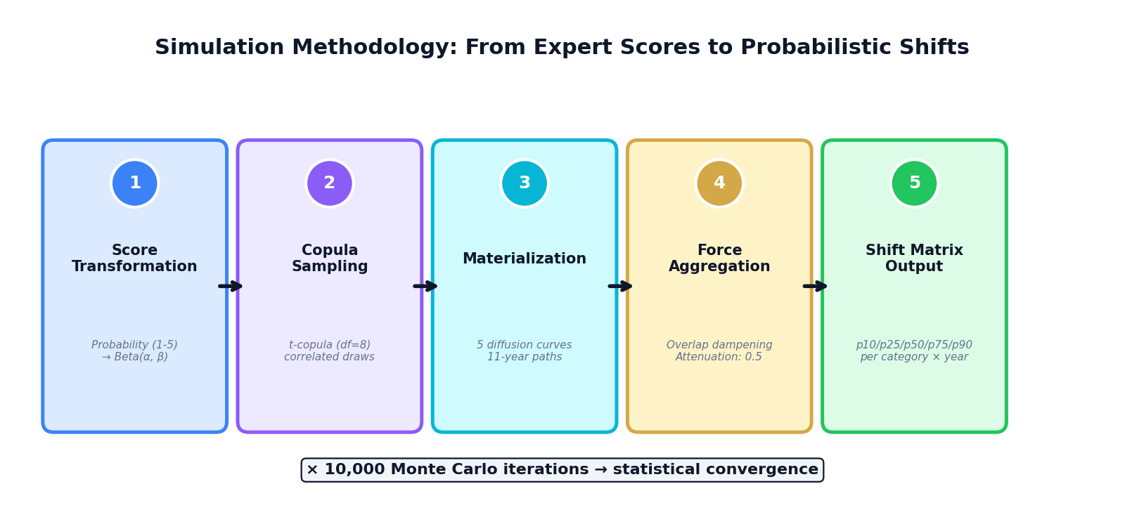
Exhibit 3: The five-step simulation methodology, from expert scores to probabilistic shift output

Step 1: Score Transformation — From Ratings to Distributions
Expert probability scores (1–5) are not treated as fixed numbers. Instead, each score is converted into a Beta distribution, a continuous probability curve that represents genuine uncertainty around the expert’s assessment.
The conversion follows a simple rule: a score of N becomes Beta(α = N, β = 6 – N). For example, a score of 4 becomes Beta(4, 2), which peaks near 0.67 but spreads from roughly 0.3 to 0.95. This approach respects the expert’s judgment while acknowledging that no one can assign exact probabilities to future events.
Why Beta distributions? They are bounded between 0 and 1 (matching probability), flexible in shape (symmetric, left-skewed, or right-skewed), and update naturally when new evidence arrives (Bayesian updating). They are the standard choice in academic and industry Bayesian modeling.

Step 2: Copula Sampling — Modeling Correlated Uncertainty
In reality, trends do not behave independently. When EU environmental regulation tightens, it simultaneously affects PFAS restrictions, microplastics bans, packaging requirements, and green claims rules. A simulation that treats these as independent would underestimate the probability of “everything goes wrong at once” scenarios.
PRISM handles this through a t-copula with 8 degrees of freedom. In non-technical terms, this means the simulation draws correlated random samples that respect the dependency structure between trends, with heavier tails than a normal distribution. The heavier tails capture “crisis correlation”: the empirical observation that in extreme scenarios, things tend to go wrong together more than simple correlation would suggest.
The correlation structure uses the empirically calibrated overlap matrix described in Chapter 3. Within the same force, trends share a within-force correlation that varies by force: Government trends have the highest intra-force overlap (0.426), reflecting the EU Green Deal regulatory cluster where 8 of 12 trends share common legislative drivers. Consumer trends have the lowest (0.100, floor-clamped), reflecting the diversity across 23 independent behavioral trends. Across forces, correlations range from 0.432 (Environmental → Government) to near zero (independent force pairs). Note that the copula correlation matrix (symmetric, used for sampling) is distinct from the overlap matrix (asymmetric, used for attenuation) — both are calibrated independently.

Step 3: Materialization — How Trends Unfold Over Time
Not every trend arrives all at once. A regulatory deadline hits fully in its enforcement year, while a consumer behavior shift unfolds gradually over a decade. PRISM models this through diffusion curves, which determine what fraction of a trend’s total impact has materialized by each year.

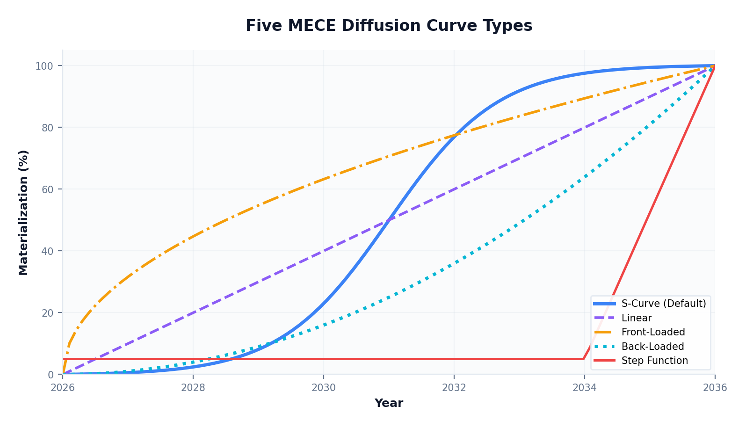
Exhibit 4: Five MECE diffusion curve types govern how trends materialize over the 11-year horizon
Curve Type | Shape | Best For | Example Trend
S-Curve (Default) | Slow start, rapid middle, plateau | Most trends — adoption follows a logistic pattern | AI-driven formulation (T-01)
Front-Loaded | Fast start, gradual plateau | Regulatory deadlines, shocks with fixed dates | EU PFAS restriction (G-01)
Back-Loaded | Slow start, rapid late acceleration | Technologies requiring infrastructure buildup | Precision fermentation (T-15)
Linear | Steady, constant rate of change | Gradual structural shifts with no inflection | Silver economy (C-05)
Step Function | Near-zero, then sudden jump | Binary events with a trigger date | PPWR enforcement (G-04)

Each trend also has a peak year, the year at which it reaches 100% of its potential impact. The combination of curve type and peak year fully determines the materialization schedule. For example, the EU PFAS restriction (front-loaded curve, peak year 2027) reaches approximately 60% impact by 2026, reflecting the hard regulatory timeline. In contrast, precision fermentation (back-loaded curve, peak year 2034) remains below 10% impact until 2030, reflecting the long lead time for industrial biotechnology scale-up.

Step 4: Force Aggregation — Dynamic Attenuation
With each trend’s probability sampled, economic scope applied, and materialization fraction computed, the engine aggregates these into a net shift for each product category. This is the most architecturally distinctive step in PRISM: a two-layer dampening system that converts raw trend scores into calibrated force impacts without double-counting.
Layer 1: Within-Force Overlap Dampening
All trends belonging to the same force are summed for each category, weighted by their category exposure scores (0–5, normalized to 0–1). However, when multiple trends within the same force score a given category, they often capture overlapping phenomena. For example, three Government trends — PFAS restriction, Green Claims Directive, and PPWR — all affect Fabric Cleaning through the same EU Green Deal legislative package. Simply adding their scores would overstate the combined regulatory impact.
PRISM corrects this through a calibrated within-force dampening formula:
Dampened Sum = Raw Sum × (1 – within_force_overlap × (n_active – 1) / n_active)
Where:
• Raw Sum = sum of all trend scores in that force for that category
• within_force_overlap = calibrated overlap coefficient for the force (see table below)
• n_active = number of trends in that force with non-zero exposure to the category
The formula scales naturally: with 1 trend, there is no dampening (the multiplier is 1.0). As the number of overlapping trends grows, the dampening approaches (1 – overlap) as an asymptotic floor.

The within-force overlap coefficients are calibrated from the 82-trend database using pairwise weighted Jaccard similarity (see Chapter 3 for methodology). Their effect in practice:
Force | Overlap | Example: 8 Trends Active | Effect
Government | 0.426 | 1 – 0.426 × 7/8 = 0.627 | Raw sum reduced by ~37% (high legislative redundancy)
Environmental | 0.269 | 1 – 0.269 × 7/8 = 0.765 | Raw sum reduced by ~24% (interconnected climate-resource web)
Technology | 0.232 | 1 – 0.232 × 7/8 = 0.797 | Raw sum reduced by ~20% (AI + bio-chem clusters)
Customer | 0.157 | 1 – 0.157 × 7/8 = 0.863 | Raw sum reduced by ~14% (channel power overlap)
Consumer | 0.100 | 1 – 0.100 × 7/8 = 0.913 | Raw sum reduced by ~9% (highly diverse, light dampening)
Competitive | 0.100 | 1 – 0.100 × 7/8 = 0.913 | Raw sum reduced by ~9% (independent competitor strategies)

Layer 2: Cross-Force Compounding with Dynamic Attenuation
After within-force dampening, the six force-level impacts are combined multiplicatively (not additively). Each force’s contribution is scaled by a force-specific effective attenuation factor, computed from the cross-force overlap matrix. The formula is:
Effective Attenuation (force i) = Base Attenuation × (1 – mean overlap with other forces)
The base attenuation is 0.5. The mean overlap for force i is computed as the average of all non-zero cross-force overlap values in that force’s row (only counting force pairs with positive overlap, not all five).

This produces the following calibrated effective attenuation values per force:
Force | Non-Zero Cross Pairs | Mean Cross Overlap | Effective Attenuation
Consumer | 3 (Cust 0.05, Env 0.05, Comp 0.08) | 0.060 | 0.5 × (1 – 0.060) = 0.470
Customer | 4 (Tech 0.27, Gov 0.30, Env 0.16, Comp 0.09) | 0.205 | 0.5 × (1 – 0.205) = 0.398
Technology | 4 (Cust 0.18, Gov 0.24, Env 0.15, Comp 0.08) | 0.162 | 0.5 × (1 – 0.162) = 0.419
Government | 3 (Cust 0.20, Tech 0.37, Env 0.41) | 0.324 | 0.5 × (1 – 0.324) = 0.338
Environmental | 4 (Con 0.05, Cust 0.12, Tech 0.27, Gov 0.43) | 0.217 | 0.5 × (1 – 0.217) = 0.392
Competitive | 2 (Con 0.05, Cust 0.09) | 0.069 | 0.5 × (1 – 0.069) = 0.466

The logic is intuitive: Government, which shares strong mechanism overlap with Environmental (0.41) and Technology (0.37), receives the lowest effective attenuation (0.338) — meaning its contribution is dampened most aggressively to avoid double-counting effects already captured by those correlated forces. Consumer and Competitive, with near-zero overlap to most other forces, retain almost the full base attenuation (0.47 and 0.47 respectively), because their effects are genuinely additive.
The multiplicative compounding then combines these attenuated force impacts for each category:
Net Category Shift = ∏ (1 + force_contribution_i × eff_att_i) – 1
For 6 forces: (1 + Con × 0.470) × (1 + Cust × 0.398) × (1 + Tech × 0.419) × (1 + Gov × 0.338) × (1 + Env × 0.392) × (1 + Comp × 0.466) – 1

This two-layer system — within-force dampening followed by cross-force dynamic attenuation — ensures that: (a) trends within the same force sharing common mechanisms are not naively stacked, (b) forces that overlap in their influence channels are not double-counted when compounded, and (c) genuinely independent forces retain their full explanatory power. The entire calibration carries the label “calibrated_v3.1_april2026” in the system configuration, distinguishing it from the earlier assumed flat attenuation and signaling that it is based on empirical trend data rather than expert assumption.

Step 5: Output Generation — The Shift Matrix
After 10,000 iterations of Steps 1–4, the engine has 10,000 complete scenarios. These are condensed into the Shift Matrix by computing percentiles:
Percentile | Meaning | Use Case
p10 | Only 10% of scenarios are better than this | Optimistic bound for planning
p25 | Lower quartile of outcomes | Mild downside scenario
p50 (Median) | Central estimate — half of scenarios above, half below | Base case for financial planning
p75 | Upper quartile of outcomes | Moderate stress scenario
p90 | Only 10% of scenarios are worse than this | Severe stress / contingency planning

The engine also computes velocity (year-over-year change in shift) and acceleration (change in velocity), enabling strategists to identify not just where profits are headed but how fast they are moving and whether that pace is increasing or decreasing. Convergence diagnostics (R-hat statistic, Effective Sample Size) verify that 10,000 iterations are sufficient for stable results.

8. Reading the Output: The Shift Matrix

The Shift Matrix is designed to be immediately actionable. This chapter shows how to read and interpret the output.

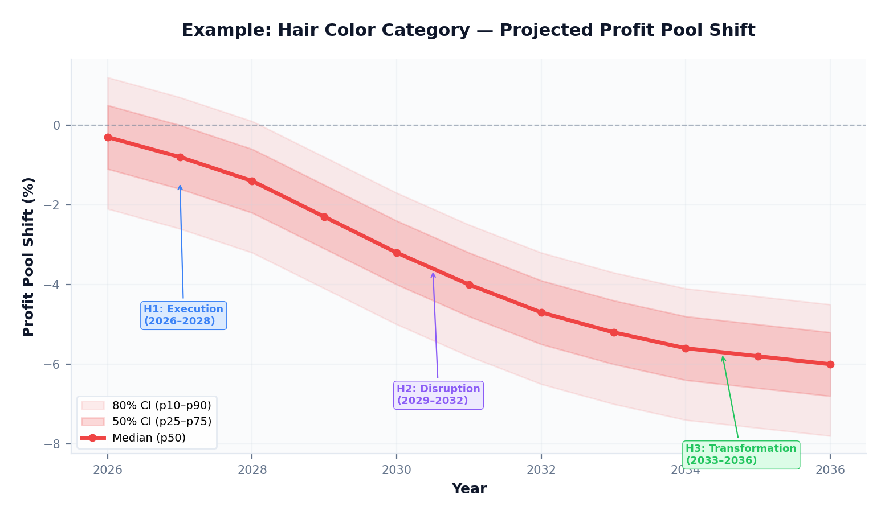
Exhibit 5: Illustrative shift path for Hair Color showing median trajectory with 50% and 80% confidence intervals
The chart above shows an illustrative trajectory for the Hair Color category. The red line represents the median (p50) outcome: a projected profit pool contraction of approximately 6% by 2036. The shaded bands show the range of uncertainty: the inner band (p25–p75) captures the most likely 50% of scenarios, while the outer band (p10–p90) captures 80% of scenarios.

Three Strategic Horizons
H1 — Execution Horizon (2026–2028): Trends already in motion with clear timelines. EU PFAS and PPWR enforcement deadlines, GLP-1 behavior lock-in, agentic commerce arrival. Actions here are operational: reformulate, comply, secure supply, build digital capabilities.
H2 — Disruption Horizon (2029–2032): Emerging trends reaching critical mass. Bio-manufactured ingredients, algorithmic shelf, Africa and Southeast Asia tipping points. Actions here are strategic investments: R&D pipeline, geographic expansion, partnerships.
H3 — Transformation Horizon (2033–2036): Long-term structural shifts. Longevity economy maturity, full lifecycle accountability, post-surfactant chemistry. Actions here are portfolio and business model decisions.

The 12 Product Categories
Division | Code | Category Name | Key Brands
Hair | Hair: Color | Hair Coloration | Schwarzkopf, Palette, got2b, Igora, BlondMe
Hair | Hair: Care | Hair Care & Shampoo | Schwarzkopf, Gliss, Schauma, Syoss, Olaplex
Hair | Hair: Styling | Hair Styling | got2b, Taft, Osis+, Sexy Hair
Hair | Hair: Body | Body Care | Fa, Dial, Barnängen, La Toja
LHC | LHC: FCN | Fabric Cleaning (Detergent) | Persil, All, Purex, Weißer Riese, Dixan
LHC | LHC: FCA | Fabric Care (Delicates) | Perwoll
LHC | LHC: FFI | Fabric Finisher (Softener) | Vernel, Silan, Snuggle
LHC | LHC: LAD | Laundry Additives | Snuggle Scent Boosters, Purex Boosters
LHC | LHC: HDW | Hand Dish Wash | Pril, Pur, Nelsen
LHC | LHC: ADW | Automatic Dish Wash | Somat, Pril Automatic
LHC | LHC: HSC | Hard Surface Cleaner | Bref, WC Frisch, Soft Scrub, DAC
LHC | LHC: IC | Insect Control | Catch, Home Mat

9. Resource Allocation Optimizer

Beyond projecting shifts, PRISM includes a resource allocation optimizer that translates the Shift Matrix into actionable investment recommendations. The optimizer uses mean-variance portfolio theory — the same mathematical framework used in institutional investment management — adapted for strategic resource allocation across product categories.

How It Works
The optimizer takes two inputs directly from the simulation: the expected shift for each category (used as a proxy for return) and the empirical covariance matrix between categories (computed from the raw Monte Carlo samples, reflecting actual simulated joint distributions). It then solves for the portfolio of category weights that maximizes expected return for a given level of risk, subject to practical constraints: each category receives between 2% and 25% of total allocation, and a turnover constraint limits how much allocation can shift in a single planning cycle.
A critical design feature handles the scenario where all categories show the same directional shift (e.g., all negative in a contraction-dominated environment). In this case, the optimizer transforms to relative returns, so the “least impacted” categories are correctly identified as the best relative opportunities. This scenario is logged transparently in the output.

Output: Invest, Defend, Harvest
Invest More: Categories with the most favorable risk-return profile — expansion potential with manageable downside. Recommendation: increase resource allocation, accelerate innovation.
Defend: Categories facing significant headwinds but with important strategic value. Recommendation: maintain resources, focus on competitive positioning and regulatory compliance.
Harvest: Categories where the risk-return profile is least favorable. Recommendation: optimize for cash generation, reduce incremental investment.
The allocation optimizer produces relative weights (summing to 100%), never absolute euro amounts. The translation to budget allocations is a management decision incorporating factors beyond the model’s scope.

10. Advanced Risk Analytics

Conditional Value-at-Risk (CVaR)
CVaR answers: “In the worst X% of outcomes, what is the average loss?” While p90 shows the boundary of the worst 10% of scenarios, CVaR looks at the average across all scenarios beyond that boundary. This captures tail risk: the magnitude of loss in truly adverse scenarios.

Sobol Sensitivity Analysis
Sobol analysis answers: “Which trend parameters drive the most uncertainty in our output?” It decomposes total output variance into first-order contributions (direct effect of each parameter) and total-order contributions (including interaction effects). A trend with a high Sobol index but uncertain scoring should be prioritized for deeper research.

Reverse Stress Testing
Reverse stress testing works backwards: “What combination of trend changes would cause a 10% profit pool contraction in Hair Care?” The optimizer finds the minimum parameter perturbations needed to produce the target outcome, identifying concentrated structural vulnerabilities.

Tipping Point Detection
The tipping point module scans shift paths for structural inflection points: moments where a category crosses from expansion to contraction, where acceleration changes sign, or where a critical threshold is breached. These mark strategic decision deadlines.

11. The AI Layer: Augmenting Human Judgment

PRISM uses artificial intelligence as an augmentation layer, not a decision-making engine. The AI layer is deliberately constrained to preserve human control over all strategic judgments.

What the AI Does
Trend identification and suggestion: The AI scanner surfaces candidate trends from market intelligence analysis. It classifies candidates by force, direction, and potential category exposure. Every AI-suggested trend is flagged as “AI-suggested” and requires human review and approval before entering the database. The AI does not assign final scores.
Score calibration support: The AI calibrator cross-validates expert scores against external market signals and academic literature, flagging discrepancies for review. If an expert scored a trend at 3/5 probability but market data suggests higher likelihood, the calibrator surfaces this for discussion. It never auto-corrects scores.
Executive narrative generation: The narrator module converts the Shift Matrix into structured executive narratives, translating statistical output into strategic language while maintaining the nuance of probabilistic results.
Conversational query interface: Strategists can query the model in natural language. For example, “Which categories are most exposed to EU regulation?” The interface filters responses to prevent exposure of absolute financial figures.

What the AI Does Not Do
The AI does not make final scoring decisions: all scores are validated by human experts through the Delphi protocol. It does not auto-update the trend database: every change requires explicit human approval. It does not perform the simulation: the Bayesian Monte Carlo engine is a deterministic mathematical process with zero AI involvement. It does not have access to absolute financial data. And it does not search external APIs in real time — trend intelligence is curated through the structured sourcing process described in Chapter 4.
Design Principle: AI augments human judgment, never replaces it. Every AI suggestion requires explicit human approval. The simulation engine itself contains zero AI components — it is pure mathematics.

12. Expert Elicitation: The Delphi Protocol

The Delphi protocol is the quality assurance mechanism for PRISM’s trend scores. It ensures that scores reflect calibrated expert consensus rather than individual biases or anchoring effects.

Three-Round Structure
Round 1 — Blind Scoring: Each expert independently scores trends on probability (1–5) and economic scope (GP1 % affected). No discussion occurs. This captures uncontaminated individual judgment and prevents anchoring to a dominant voice.
Round 2 — Distribution Review: The score distribution from Round 1 is shared anonymously. Each expert sees where their scores fall relative to the group and can adjust. Research consistently shows this step improves calibration without creating false consensus.
Round 3 — Outlier Discussion: Scores that remain more than one standard deviation from the group mean are flagged for structured discussion. The outlier expert explains their rationale, and the group evaluates whether the outlier has unique information or a systematic bias.

Bias Detection
The Delphi module includes automated detection for three common cognitive biases. Anchoring bias is detected when Round 2 scores are suspiciously close to Round 1 despite strong group feedback. Optimism bias is flagged when an expert systematically scores expansion trends higher and contraction trends lower than the group. Recency bias is detected when recently reported trends receive disproportionately high scores. When detected, biases are flagged to the facilitator for discussion, never auto-corrected.
Inter-rater reliability is measured using Krippendorff’s alpha, a statistical measure of agreement between raters. A coefficient above 0.67 is considered acceptable; above 0.80 is strong.

13. Governance & Quality Assurance

Audit Trail
Every action in PRISM is logged in a tamper-evident audit trail: trend score changes (with before/after values and rationale), configuration parameter adjustments, simulation runs, AI suggestions and their disposition (accepted/rejected), and user access events.

Convergence Monitoring
After each simulation run, PRISM computes convergence diagnostics including the R-hat statistic (values below 1.05 indicate convergence) and Effective Sample Size (values above 1,000 indicate adequate sampling). Multi-chain runs (default: 3 chains) enable split-R-hat convergence verification.

Annual Planning Cycle
Quarter | Activity | PRISM Action
Q1 (Jan–Mar) | Annual calibration | Parameter review, Delphi Round 1, bias assessment
Q2 (Apr–Jun) | Strategic planning | Full MC run (50K iterations), Shift Matrix delivery, allocation recommendation
Q3 (Jul–Sep) | Mid-year review | Trend refresh, trigger check, velocity review
Q4 (Oct–Dec) | Budget integration | Final Shift Matrix, competitive update, ExCo presentation, version archive

Known Limitations
The attenuation system is empirically calibrated but not yet backtested. The per-force effective attenuation values (0.338–0.470) and within-force overlap coefficients (0.100–0.426) are derived from the 82-trend database using weighted Jaccard similarity, asymmetry adjustment, and mechanism coupling analysis (labeled “calibrated_v3.1_april2026”). However, the base attenuation of 0.5 and the calibration methodology have not yet been validated against historical outcomes. As past PRISM projections can be compared to actual market shifts, both the base and the overlap matrices should be refined through backtesting.
Trend scores reflect a point-in-time snapshot. The April 2026 database captures market intelligence as of that date. The database requires periodic refresh (quarterly through systematic review, annually through full Delphi re-scoring).
Competitive game theory is not modeled. While competitive trends are tracked, PRISM does not model second-order competitive responses (e.g., if Henkel invests in AI formulation, how does L’Oréal respond?). This remains a future development area.
Causal chains are approximated. The force correlation matrix captures statistical co-movement but does not model explicit causal propagation pathways. A Causal DAG module is designed for future implementation.

14. Glossary of Key Terms

Term | Definition
Attenuation Factor | A per-force dampening coefficient that moderates force compounding to avoid double-counting. Base = 0.5, dynamically adjusted per force using the calibrated cross-force overlap matrix. Range: 0.338 (Government, highest overlap) to 0.470 (Consumer, most independent).
Beta Distribution | A probability distribution bounded between 0 and 1, used to model uncertainty around expert probability scores. Parameterized by α and β shape parameters.
Copula | A statistical technique for modeling dependencies between random variables. PRISM uses a t-copula with 8 degrees of freedom for heavier tail dependence.
Credibility Gate (E1) | A hard rule requiring every trend to have at least one source rated B– or higher. Enforced programmatically at the database ingestion layer.
CVaR | Conditional Value-at-Risk: the average loss in the worst X% of scenarios. More informative than percentiles for tail risk.
Delphi Protocol | A structured expert elicitation method with multiple blind scoring rounds, distribution sharing, and outlier discussion to reduce bias.
Diffusion Curve | The shape of a trend’s materialization over time. Five MECE types: S-curve, linear, front-loaded, back-loaded, step function.
Force | One of six strategic dimensions (Consumer, Customer, Technology, Government, Environmental, Competitive).
GP1 | Gross Profit 1 — the primary profitability metric for Henkel Consumer Brands product categories.
GP1 % Affected | The maximum share of a category’s GP1 that is exposed to a specific trend at full materialization (0–100%).
Monte Carlo Simulation | A technique that runs thousands of random scenarios to build a probability distribution of outcomes.
Overlap Matrix (Cross-Force) | An asymmetric 6×6 matrix measuring how much of each force’s signal is already captured by another force. Calibrated via 3-step methodology: weighted Jaccard → asymmetry adjustment → mechanism coupling. Range: 0.000–0.432.
Overlap (Within-Force) | A per-force coefficient measuring mechanism redundancy among trends in the same force. Range: 0.100 (Consumer/Competitive) to 0.426 (Government). Applied as dampening to raw within-force sums.
Shift Matrix | PRISM’s primary output: a table of percentage shifts by category × year × percentile.
Sobol Sensitivity Index | A measure of how much each input parameter contributes to total output variance.
Source Tier | One of nine credibility classifications (S, A, A–, B+, B, B–, C, D, E) assigned to each evidence source.
t-Copula | A copula with heavier tails than Gaussian, capturing crisis correlation. PRISM uses 8 degrees of freedom.
Within-Force Overlap | Calibrated per force (0.10–0.43): the degree to which trends within the same force share common drivers.

PRISM v3.1
Profit Pool Risk & Intelligence Simulation Model

Prepared by the Strategy × Technology × Quant Partnership
April 2026

CONFIDENTIAL — Internal Use Only
This document contains proprietary methodology and strategic analysis. Distribution restricted to authorized personnel.

