PRISM
Profit Pool Risk & Intelligence Simulation Model

Model Documentation & Methodology Transparency
Henkel Consumer Brands — Strategy & Intelligence
Delivered to: VP Strategy, HCB & LHC Leadership Team

Prepared by:
Strategy & Technology Partnership
April 2026 | Version 3.0 | CONFIDENTIAL — Internal Use Only

Table of Contents

1. Executive Summary
PRISM (Profit Pool Risk & Intelligence Simulation Model) is a probabilistic simulation engine that forecasts strategic profit pool shifts across the consumer brands landscape. It transforms a static, Excel-based Strategic Force Assessment into a living, AI-augmented strategic decision platform deployed as a production web application.
Core design principle: PRISM delivers relative shifts in percent only — never absolute € values. Users apply these shifts to their own financial models. This separation ensures PRISM informs strategic direction without replacing financial planning.

The model answers three strategic questions. First: which profit pool categories will expand or contract over the next 5 years, and with what probability? Second: which strategic forces drive these shifts, and how fast do they materialize? Third: how should resources be allocated based on these projections?
Methodology: Bayesian Monte Carlo simulation with Gaussian copula dependencies, 10,000 iterations, 61 expert-scored trends across 6 strategic forces, 12 profit pool categories, continuous 5-year paths (2026–2030) with 5 percentile bands (p10 through p90), and mean-variance resource allocation optimization.
Production status (April 2026): Fully deployed on Vercel with Neon PostgreSQL. 30+ live API endpoints, authenticated War Room dashboard (Next.js 14), professional Excel/PowerPoint/Power BI export, complete audit trail. Model version: bayesian_copula v2.4.0.
What PRISM is not: It is not a financial forecasting tool (no €M outputs), not a competitive game theory simulator (competitors modeled as static trends), and not an autonomous decision-maker (every AI suggestion requires human approval).

2. The Strategic Problem PRISM Solves

2.1 Limitations of Traditional Approaches
Traditional profit pool analyses in FMCG suffer from three systematic weaknesses that undermine their value for strategic resource allocation:
- Static point estimates: A single value per category suggests false precision. Reality operates in probability distributions, not point forecasts. When leadership asks “what is the expected shift for Hair Color?”, the honest answer is not “–3.2%” but “between –1.5% and –6.5% with 80% confidence.”
- Isolated trend assessment: Trends are scored individually as if independent. In reality, they correlate: a regulatory trend (e.g., EU Green Claims Directive) triggers reformulation costs (Technology), which shifts consumer behavior (Consumer), which reshapes competitive dynamics (Competitive). Ignoring these cascades systematically underestimates tail risk.
- Missing time dynamics: Classic analyses show an end-state, not the path. For operational planning, the critical question is not just whether a shift occurs but when the largest annual impact hits. A –3.2% shift that materializes linearly requires different action than one that hits as a step function in 2028.

2.2 PRISM’s Solution Architecture
PRISM addresses each weakness with a specific methodological innovation:
- Probabilistic simulation instead of point estimates: Bayesian Monte Carlo generates 10,000 possible futures. Results are probability bands (p10 to p90), not single numbers. Decision-makers see the range of plausible outcomes and can plan for best case, base case, and worst case simultaneously.
- Copula-modeled dependencies: Trends are not simulated in isolation. Mathematical copula functions model how trends co-occur and mutually amplify or dampen each other. This prevents the model from generating unrealistic scenarios where all positive trends materialize while all negative ones fail to appear.
- Continuous time paths with diffusion curves: Five MECE diffusion curve types (S-curve, linear, front-loaded, back-loaded, step function) model how rapidly each trend materializes. Combined with a peak year per trend, this enables precise operational timing.

3. The PRISM Process End-to-End
The following diagram shows the complete data flow from trend capture to strategic resource allocation recommendation:
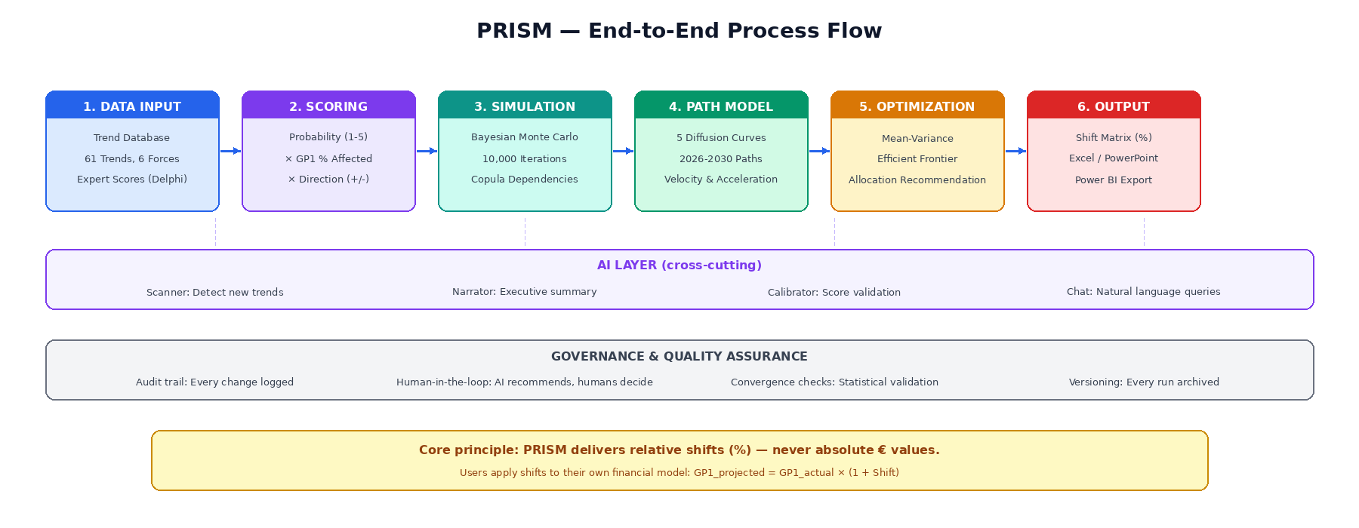
The process runs in six sequentially dependent phases. Each phase is modular: it can be independently validated, configured, and — where needed — adjusted by an administrator. The AI layer and governance framework operate cross-functionally across all phases.

3.1 Phase 1: Data Foundation — The Trend Database
The starting point is a database of 61 fully specified trends: 55 global and 6 regional. Each trend is assigned to one of six strategic forces and includes structured metadata: description, data source, source type, source credibility tier (S through E, where S represents highest credibility such as peer-reviewed research and regulatory filings), confidence level, and last update date.
The database represents the market intelligence snapshot as of April 2026. It is updated through quarterly review cycles (Q1 calibration, Q3 mid-year refresh) and can receive ad hoc updates when the AI scanner identifies material new developments.
Important: Trends are seeded automatically on first system startup if the database is empty. The source credibility gate (E1 tier requirement) ensures only trends meeting minimum evidence thresholds enter the active simulation.

3.2 Phase 2: Scoring — Two-Dimensional Assessment
Each trend is evaluated on two independent dimensions — not one. This is a deliberate methodological choice: a trend that is highly likely but affects only a niche of the market (e.g., specialty ingredient regulation) should not score the same as one that is moderately likely but affects the entire market (e.g., inflationary consumer downtrading).
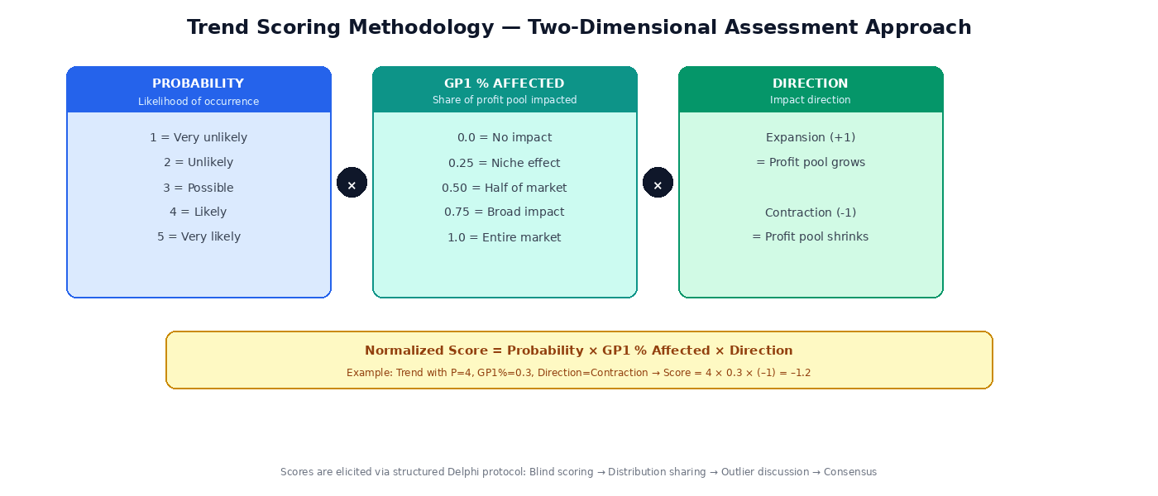
Dimension 1 — Probability (1–5): How likely is it that this trend materializes within the planning horizon? Scale: 1 (very unlikely) to 5 (very likely).
Dimension 2 — GP1 % Affected (0.0–1.0): What share of the total profit pool is potentially impacted? 0.25 represents a niche effect, 1.0 affects the entire market. This is the economic anchoring variable — it caps each trend’s maximum scope and prevents a low-probability trend from dominating the simulation simply because it scored high on probability.
Dimension 3 — Direction: Expansion (+1) if the trend grows the pool; Contraction (–1) if it shrinks it. The normalized score is the product: Probability × GP1 % Affected × Direction.
Category-specific exposure: Additionally, each of the 12 categories receives an individual exposure score (0–5) per trend. A trend like “Clean Beauty Demand” scores Exposure 5 on Hair: Care but Exposure 0 on LHC: Insect Control. This granularity is what enables category-level allocation decisions.

3.3 Phase 3: Simulation — Bayesian Monte Carlo
The simulation engine is the mathematical core of PRISM. It is detailed in Chapter 5. In summary: expert scores are translated into Beta-distributed Bayesian priors, correlated via Gaussian copula, and sampled 10,000 times to produce probability distributions of profit pool shifts per category per year.

3.4 Phase 4: Path Model — Diffusion Curves
The path model distributes the simulated total shift across the 5-year horizon (2026–2030) according to each trend’s assigned diffusion curve type. This is detailed in Chapter 6. The output is a continuous annual path with velocity (year-over-year change) and acceleration (change of velocity) for each category.

3.5 Phase 5: Optimization — Resource Allocation
The optimizer translates simulated shifts into actionable resource allocation recommendations. It uses mean-variance optimization — the same methodology established in financial portfolio theory (Markowitz) — to construct an efficient frontier of category allocations that maximize expected return (positive shift) for a given level of risk (shift variance).
Each category is classified into one of three strategic postures:
Posture | Criterion | Strategic Implication
INVEST MORE | Above-average expected expansion at moderate risk | Category with disproportionate growth potential — increase resource commitment
DEFEND | Contraction expected, but strategically critical | Category under pressure — protect market position, drive efficiency
HARVEST | Significant contraction with high uncertainty | Declining pool — optimize margins, redirect resources to growth categories

Critical note: The optimizer outputs relative weights (summing to 1.0), never absolute € amounts. The translation to budget figures occurs in the financial planning process, not in PRISM.

3.6 Phase 6: Output — The Shift Matrix
PRISM’s primary deliverable is the Shift Matrix: a table of percentage shifts per category and year, broken down by five probability bands (p10, p25, median, p75, p90). This matrix is the bridge between PRISM and any downstream financial model.
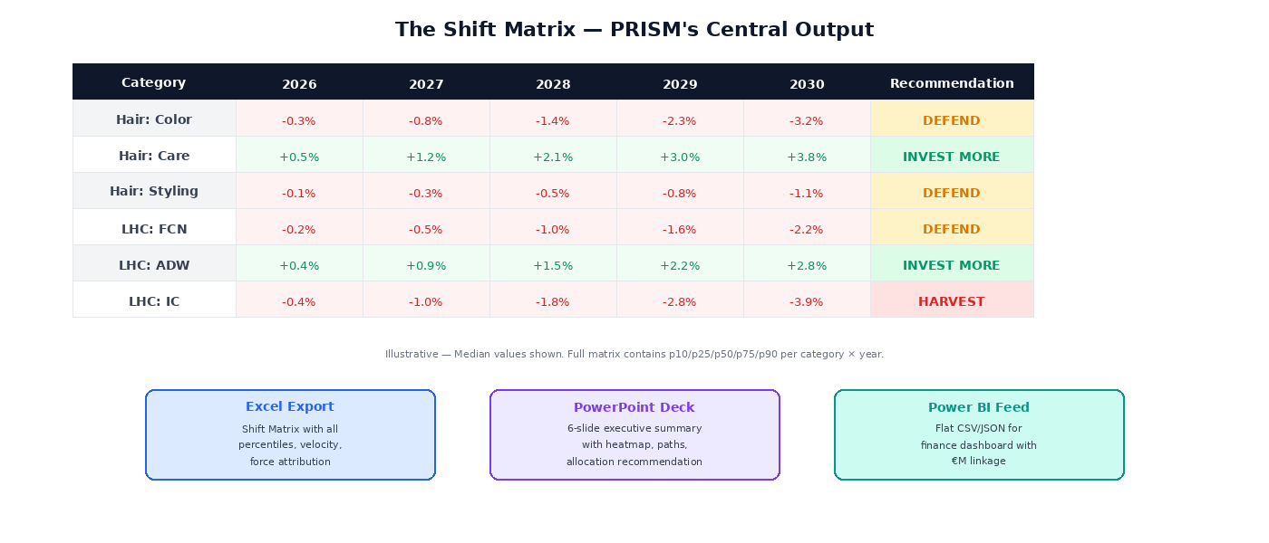
Application formula: GP1_projected = GP1_actual × (1 + Shift_median). Example: At GP1 = €100M and Shift = –3.2%, GP1_projected = €96.8M.

The Shift Matrix is exported in three formats, each serving a distinct audience:
- Excel workbook: Multi-sheet export with Shift Matrix (all percentiles), velocity & triggers, allocation weights, and run metadata. Henkel-branded formatting with color-coded expansion (green) and contraction (red).
- PowerPoint deck: 6-slide executive summary: Title, Heatmap, Allocation, Path Timeline, Methodology, Appendix. Designed for ExCo presentation with professional color-coded visuals.
- Power BI / CSV feed: Flat JSON or CSV with one row per category × year. Includes velocity, force attribution, and all percentiles. Designed for ingestion into a Power BI semantic model where €M financials are applied.

4. Two-Audience Delivery Model
PRISM serves two distinct audiences with fundamentally different information needs. This separation is by design — it ensures that the strategy team has the interactive, drill-down capability they need for scenario planning, while the executive committee and finance receive governance-approved, version-controlled outputs in their familiar €M language.
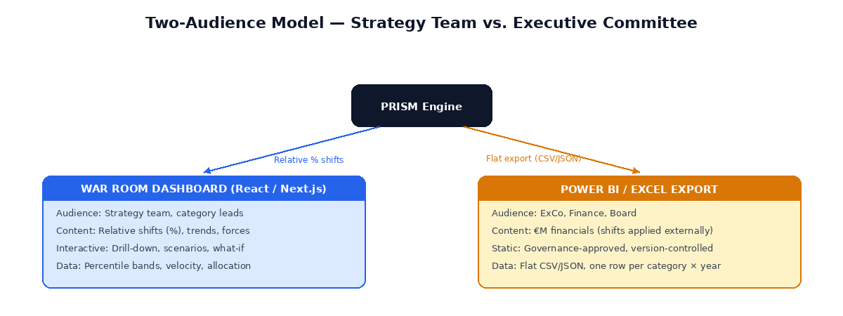
Dimension | War Room Dashboard | Power BI / Excel Export
Audience | Strategy team, category leads, analytics | ExCo, Finance, Board
Data format | Relative shifts (%), percentile bands, velocity | Flat CSV/JSON; €M applied externally
Interactivity | Full drill-down: scenarios, what-if, trend explorer | Static, governance-approved snapshots
Technology | Next.js 14 React app (Vercel) | Excel/CSV export from PRISM API
Update cycle | Real-time (connected to live API) | Quarterly (version-controlled releases)

The unidirectional data flow is deliberate: PRISM outputs relative shifts. Power BI applies them to €M financials. Data flows one way only — PRISM never sees absolute figures. This preserves data confidentiality and ensures PRISM remains a strategic direction tool, not a financial system.

5. The 6-Forces Framework
PRISM structures all strategic drivers along six macro-forces. This framework extends Porter’s Five Forces by adding Technology and Environmental as standalone forces — both carry independent strategic weight in the consumer brands context that is not adequately captured by the traditional framework.
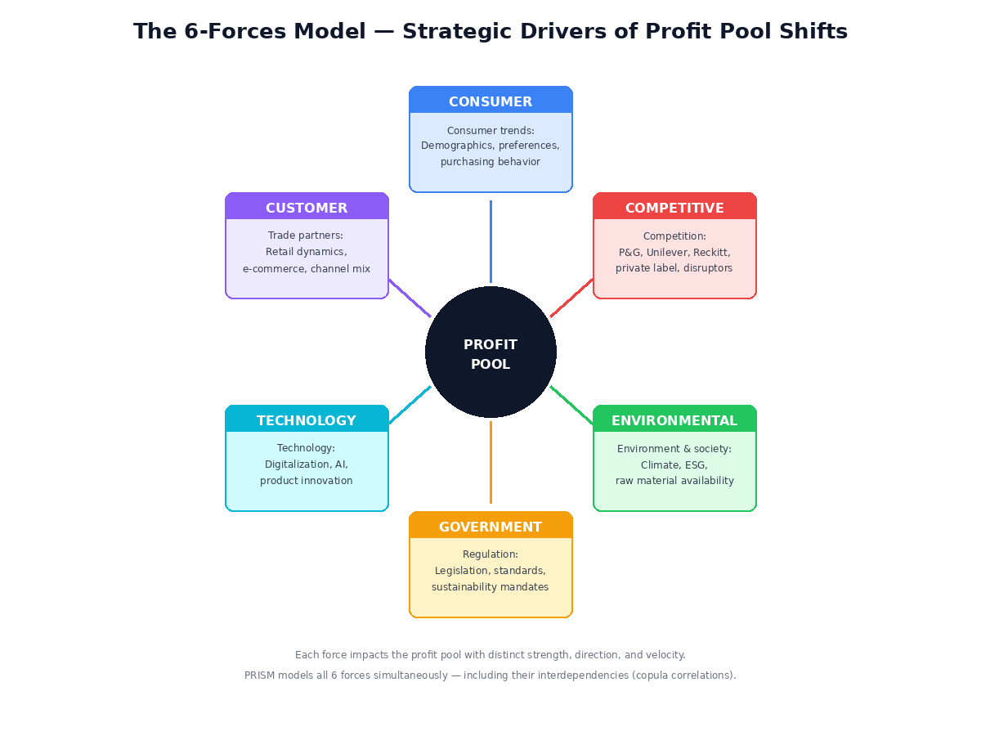
Force | Definition | Example Trends (from live database)
Consumer | Demographic, behavioral, and values-driven changes in consumer demand | Aging population, clean beauty demand, e-commerce penetration, Gen-Z purchasing behavior
Customer | Changes in the trade landscape, channel dynamics, and retailer strategies | Discounter growth, retail media, private label expansion, quick commerce
Technology | Technological innovations changing products, processes, or business models | AI/ML in formulation, biotechnology, personalization, smart packaging
Government | Regulatory interventions, legislation, standards, and trade barriers | EU Green Claims Directive, microplastics ban, PFAS regulation, Digital Markets Act
Environmental | Sustainability requirements, ESG pressure, raw material availability | Water scarcity, circular packaging mandates, carbon pricing, raw material volatility
Competitive | Competitor actions, market entries, M&A activity, private label strategies | P&G innovation pipeline, Unilever sustainability play, indie brand disruption

Interdependencies: The six forces do not operate in isolation. PRISM models their co-movement through the copula dependency structure. A regulatory trend (Government) can trigger a technology adaptation (Technology), which in turn shifts consumer behavior (Consumer). These cascade effects are captured in the simulation through cross-force correlation parameters.

6. The 12 Profit Pool Categories
PRISM models profit pool shifts for 12 categories across two business divisions: Hair Consumer Business (4 categories) and Laundry & Home Care (8 categories). Each category is simulated independently because trend exposures vary substantially across the portfolio.
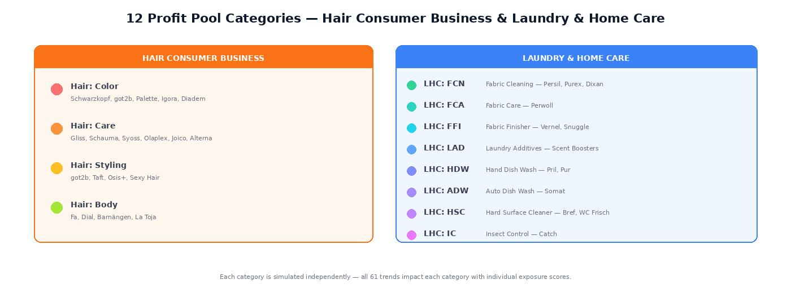
The category-specific simulation ensures that a trend like “Clean Beauty Demand” exerts its full impact on Hair: Care (exposure score 5) while having zero effect on LHC: Automatic Dish Wash (exposure score 0). This granularity is what makes PRISM’s allocation recommendations actionable at the category level rather than delivering generic portfolio-level guidance.
Coverage completeness: The 12 categories are MECE within Henkel Consumer Brands. Hair covers Color, Care, Styling, and Body. LHC covers Fabric Cleaning (FCN), Fabric Care (FCA), Fabric Finisher (FFI), Laundry Additives (LAD), Hand Dish Wash (HDW), Automatic Dish Wash (ADW), Hard Surface Cleaner (HSC), and Insect Control (IC). Each maps to specific brand portfolios as shown in the diagram above.

7. Inside the Simulation Engine
This chapter explains the mathematical methodology behind PRISM in non-technical language. The goal is full transparency about how expert scores are systematically converted into probability distributions — opening the “black box.”
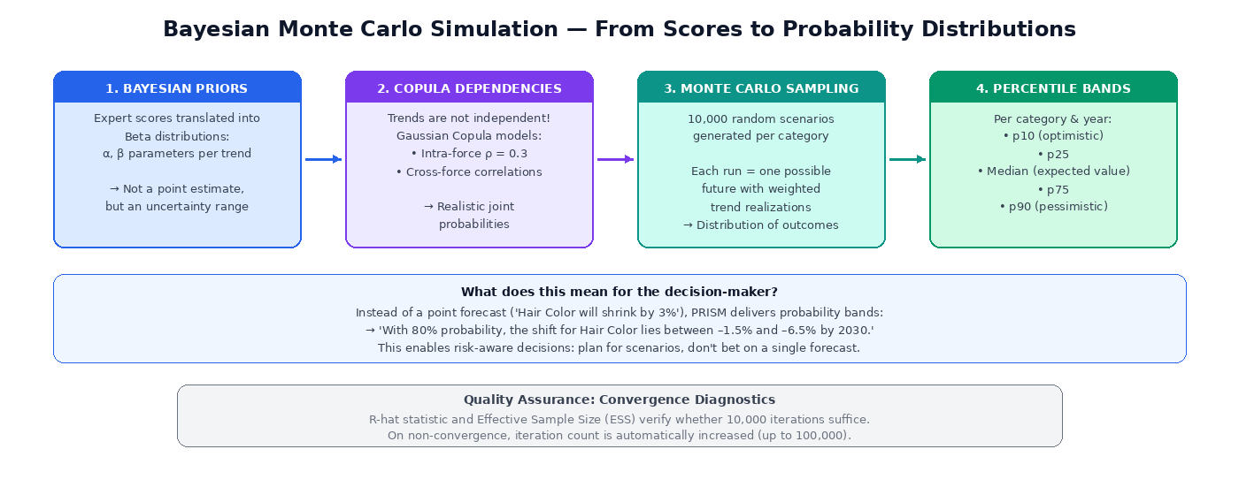

7.1 Step 1: From Scores to Distributions (Bayesian Priors)
An expert score of “Probability = 4” is not an exact number. It is an expression of judgment with inherent uncertainty. PRISM respects this uncertainty by translating the score into a Beta distribution — a mathematical function that expresses: “the true value is probably around 4, but could also be 3.5 or 4.3.”
The width of this distribution is calibrated by two factors: the number of independent experts who scored the trend (more scorers = narrower distribution = higher confidence), and the variance among their scores (lower variance = narrower distribution). This is the Bayesian logic: prior beliefs are updated as more evidence accumulates.

7.2 Step 2: Modeling Dependencies (Copula)
In reality, trends do not occur independently. When raw material prices spike (Environmental), regulation often follows (Government). When a competitor launches a breakthrough product (Competitive), consumer preferences shift (Consumer). PRISM uses a Gaussian Copula with t-Copula tails to model these dependencies mathematically.
In practice, this means: trends within the same force (e.g., two Consumer trends) are linked with a baseline correlation of ρ = 0.3. Cross-force correlations are governed by a configurable correlation matrix. The t-copula tails specifically capture the empirical observation that extreme events tend to co-occur more frequently than a simple Gaussian model would predict — i.e., when things go wrong, they tend to go wrong together.

7.3 Step 3: Monte Carlo Sampling (10,000 Futures)
At the core of the simulation, 10,000 random scenarios are generated. In each scenario, a value is drawn from each of the 61 trends’ probability distributions — respecting the copula-correlated dependencies. Each trend value is then weighted by the category-specific exposure score and aggregated. The result is a distribution of 10,000 possible shifts per category.
Analogy for non-technical readers: Imagine 10,000 independent strategy analysts each estimating the future — each with slightly different assumptions. PRISM aggregates their collective judgment into a probability band.

7.4 Step 4: Percentile Bands
From the 10,000 scenarios, five percentile values are computed that together form the confidence band:
Percentile | Meaning | Interpretation
p10 | Only 10% of scenarios are better | Optimistic scenario — “best plausible case”
p25 | Lower quartile | Moderately optimistic above median
Median (p50) | 50/50 — expected value | Most likely single value — primary planning basis
p75 | Upper quartile | Moderate downside scenario
p90 | 90% of scenarios are better | Pessimistic scenario — “worst plausible case”

The spread between p10 and p90 is itself an important signal: a wide band indicates high uncertainty (requiring hedging or optionality), while a narrow band indicates high conviction (enabling decisive resource commitment).

7.5 Attenuation Factor
PRISM applies an attenuation factor (default: 0.5) that moderates extreme simulation outputs. This parameter acknowledges that real-world profit pool shifts are typically dampened by market inertia, organizational resistance, and counter-strategies from competitors. The attenuation factor is configurable by administrators and is documented in every simulation run’s metadata. It is currently set as an assumption (not empirically calibrated via backtesting) and labeled as such in all outputs.

8. Time Paths — How Trends Materialize
Not every trend hits at the same speed. A legislative change (e.g., microplastics ban) takes effect at a fixed date — its impact is immediate and binary. A technology adoption (e.g., AI-driven formulation) follows an S-curve: slow at first, then exponential growth, then saturation. PRISM captures these differences through five MECE diffusion curve types:
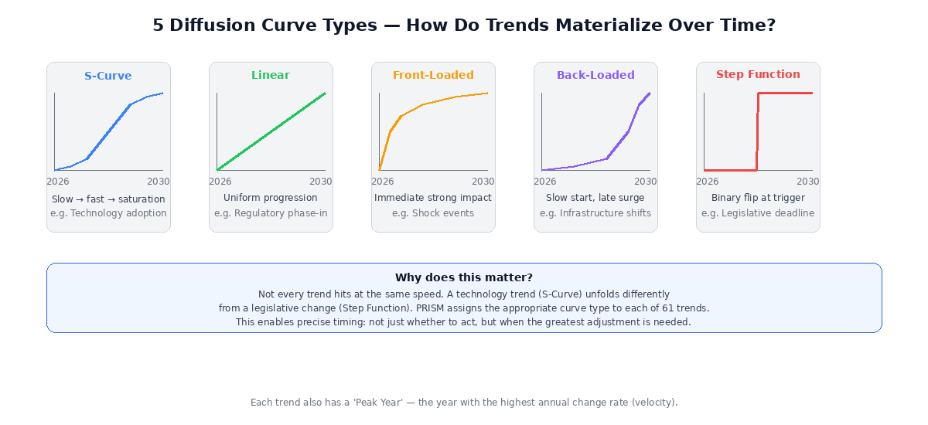
Curve Type | Trajectory | Typical Application
S-Curve | Slow start, rapid acceleration, saturation toward end | Technology adoption, consumer behavior change, innovation diffusion
Linear | Uniform progression throughout the period | Gradual regulatory phase-ins, demographic shifts
Front-Loaded | Immediate strong impact, then flattening | Shock events, abrupt market disruptions
Back-Loaded | Long flat runway, late exponential surge | Infrastructure transitions, long-cycle investments
Step Function | Binary flip: 0% before trigger, 100% after | Legislative deadlines, regulatory cutoff dates

Each trend is also assigned a peak year — the year in which the annual rate of change (velocity) is highest. This is operationally critical: it answers not just whether to act, but when the greatest adjustment is required. The combination of curve type + peak year creates a precise timing profile for each trend.

9. The AI Layer — What Artificial Intelligence Does (and Does Not Do)
PRISM uses Large Language Models (LLMs) as strategic augmentation, not as a decision-making authority. The AI layer is modular, provider-agnostic (supports Anthropic Claude, Azure OpenAI, and local models via Ollama), and always bound to a human-in-the-loop approval process.

9.1 Four AI Modules in Production

Scanner — Trend Intelligence
The scanner analyzes external sources (market reports, industry news, regulatory announcements) against PRISM’s existing trend database. It identifies potential new trends and suggests adjustments to existing scores. Every suggestion flows into a review queue: the scanner recommends, the strategy team decides. No AI suggestion is ever auto-applied.

Narrator — Executive Summary Generator
The narrator translates quantitative simulation results into concise strategic narratives. Instead of a numbers table, it produces statements like: “Hair: Color faces convergent pressure from three forces: rising clean beauty demand (Consumer), regulatory restrictions on chemical ingredients (Government), and competitive pressure from indie brands (Competitive). The primary impact materializes from 2028 onward (S-Curve diffusion).”

Calibrator — Score Validation
The calibrator cross-validates expert scores against external market signals and identifies systematic biases (e.g., optimism bias, anchoring effects, recency bias). It generates calibration suggestions that are fed back into the Delphi process.

Chat — Natural Language Queries
The chat module enables ad-hoc queries against model results in natural language. Example: “Which trends drive the contraction in Hair: Color most strongly?” or “What happens to LHC: ADW if we double the Technology force weight?” A financial data filter ensures the chat never exposes absolute € figures.
Non-negotiable guardrail: AI never generates absolute financial values (€). All AI outputs reference relative shifts, trend classifications, and strategic narratives only.

10. Advanced Analytics Suite
Beyond the core simulation, PRISM provides four advanced analytical tools deployed in production. Each answers a distinct strategic question:

10.1 CVaR (Conditional Value-at-Risk)
Question it answers: “In the worst X% of scenarios, what is the average loss?”
CVaR — also known as Expected Shortfall — quantifies tail risk. While the median shows the “normal” case, CVaR reveals what happens when things go badly. If CVaR at 5% for Hair: Color is –6.5%, it means: in the 500 worst scenarios out of 10,000, the average contraction is 6.5%. This is the stress scenario the business should be prepared for.

10.2 Sobol Sensitivity Analysis
Question it answers: “Which trend parameters drive the most output variance?”
Sobol analysis decomposes the total output variance into contributions from individual trend parameters. It distinguishes first-order effects (the direct influence of a single trend) from total-order effects (including all interactions with other trends). The result is a ranking: “Trend X explains 23% of the output variance for Hair: Care.” This tells the strategy team where to focus calibration effort and monitoring resources.

10.3 Reverse Stress Testing
Question it answers: “What is the minimum parameter combination that would cause a >10% contraction in Category X?”
While standard simulation runs forward (inputs to outputs), reverse stress testing works backward. It uses mathematical optimization (differential evolution) to find the smallest set of parameter changes that produce a specified adverse outcome. This identifies the most vulnerable points in the model and enables targeted hedging strategies.

10.4 Tipping Point Detection
Question it answers: “Where are the structural inflection points in the time paths?”
The tipping point analyzer searches for regime changes in the simulated paths: where does acceleration change sign? Where does a category flip from expansion to contraction? Where are critical thresholds breached? This early-warning system enables proactive strategic adjustment before inflection points are reached.

11. Governance & Quality Assurance

11.1 Delphi Expert Elicitation Protocol
Trend scoring is not a single-person exercise. It follows a structured Delphi protocol designed to minimize individual bias and build collective intelligence:
- Round 1 — Blind scoring: Each expert scores trends independently without seeing others’ assessments. This prevents anchoring to the first opinion expressed.
- Round 2 — Distribution sharing: Anonymized score distributions from Round 1 are shared. Experts can adjust their scores in light of the group’s collective view.
- Round 3 — Outlier discussion: Significant outliers are flagged for structured discussion. The question is not “who is wrong?” but “what information do they have that others don’t?”
The system automatically computes inter-rater reliability (Krippendorff’s alpha) and flags known bias patterns: anchoring bias, optimism bias, and recency bias. All Delphi rounds are persisted in the database with full audit trail.

11.2 Audit Trail
Every change in the system is logged without exception: who changed which score, when, and why. Which AI recommendation was accepted, which was rejected, with what rationale. The audit logger uses atomic transactions — the domain write and the audit log entry are written as a single operation, eliminating race conditions. This ensures complete traceability and satisfies internal governance requirements.

11.3 Convergence Diagnostics
The Monte Carlo simulation is automatically validated for statistical convergence using two metrics: R-hat verifies whether multiple independent simulation chains converge to the same result (values close to 1.0 indicate convergence). Effective Sample Size (ESS) measures how many of the 10,000 iterations contribute genuinely independent information. When convergence criteria are not met, the system automatically increases the iteration count (up to 100,000).

11.4 Authentication & Access Control
The production system implements JWT-based authentication with role-based access control. Access tokens expire after 1 hour, refresh tokens after 7 days. Passwords are hashed with bcrypt. Admin users can modify model parameters; viewer users can access the dashboard and exports but cannot alter configuration. User management is available through dedicated API endpoints.

11.5 RACI Matrix
Activity | Strategy VP | Category Leads | Data/Analytics | AI/Tech
Trend scoring (Delphi) | A | R | C | I
Score override authority | A | R | C | I
Scenario definition | A | R | C | I
Shift Matrix sign-off | A | R | C | I
AI suggestion accept/reject | I | R | C | A
Model calibration | I | C | A | R
Parameter review (annual) | A | C | R | C
Dashboard access provisioning | I | I | A | R

R = Responsible (does the work), A = Accountable (final decision), C = Consulted, I = Informed

11.6 Annual Planning Cycle Integration
Quarter | Activity | PRISM Role
Q1 (Jan–Mar) | Annual calibration | Parameter review, Delphi Round 1, trend database refresh
Q2 (Apr–Jun) | Strategic planning input | Full MC run (50K iterations), allocation optimizer, Shift Matrix delivery
Q3 (Jul–Sep) | Mid-year review | AI scanner refresh, trigger review, velocity assessment
Q4 (Oct–Dec) | Budget integration | Final Shift Matrix, competitive update, ExCo deck, version archive

12. How to Read and Use PRISM Outputs
This chapter provides practical guidance for decision-makers on interpreting PRISM’s outputs and translating them into strategic action.

12.1 Reading the Shift Matrix
- Median = planning basis: Use the median (p50) as the primary input for base-case planning. It represents the single most likely outcome.
- p10–p90 = scenario range: The spread between p10 and p90 defines the range of plausible outcomes. Use p10 for best-case and p90 for worst-case scenario planning.
- Band width = uncertainty: A narrow band (e.g., p10 = –1.0%, p90 = –2.0%) indicates high conviction. A wide band (e.g., p10 = +2.0%, p90 = –8.0%) indicates high uncertainty — build in optionality.
- Velocity = timing: The velocity column shows which years carry the largest annual change. A high velocity in 2028 means that’s when the strategy team needs to be execution-ready.

12.2 Translating Allocation Recommendations
- INVEST MORE ≠ “throw money at it”: It means the risk-return profile is favorable. Validate against competitive position and capability readiness before committing resources.
- DEFEND ≠ “do nothing”: It means the category is under pressure but worth protecting. Focus on efficiency, innovation velocity, and market share defense.
- HARVEST ≠ “abandon”: It means the pool is declining. Optimize margins, reduce discretionary spend, and redeploy freed resources to growth categories.

12.3 What to Do When Bands Are Wide
Wide confidence bands are not a model failure — they are an accurate reflection of genuine uncertainty. When bands are wide, the recommended response is to invest in reducing uncertainty (commission focused research on the dominant variance drivers identified by Sobol analysis), build optionality (stage investments rather than making irreversible commitments), and monitor trigger conditions (set up early-warning thresholds that trigger action when a trend crosses a defined velocity threshold).

13. Model Limitations — What PRISM Cannot Do
Transparency about model limitations is as important as presenting its capabilities. PRISM has the following deliberate constraints:

13.1 No Absolute Financial Forecasts
PRISM delivers relative shifts in percent, not absolute € values. The translation into monetary amounts occurs externally in the user’s financial model. This is by design: PRISM informs strategic direction, it does not replace financial planning.

13.2 No Causal Modeling (Correlation Only)
The current model captures correlations between trends (via copula) but not causality. It can state “Trend A and Trend B tend to co-occur” but not “Trend A causes Trend B.” A causal module (Directed Acyclic Graph) is architecturally designed but not yet implemented. The copula correlation matrix serves as a pragmatic alternative.

13.3 No Dynamic Competitive Response
Competitor behavior is currently represented as static trends in the database, not as dynamic strategic responses. The system does not model how P&G or Unilever would react to a Henkel strategic move. Competitive intelligence endpoints exist and serve current competitor data, but game-theoretic modeling is not yet implemented.

13.4 Assumed (Not Calibrated) Priors
The Bayesian priors are derived from expert scores, not from historical backtesting data. The attenuation factor (0.5) is a reasoned assumption, not an empirically calibrated value. A backtesting engine that validates historical force assessment versions (V1–V11) against actual market shifts exists in partial form (calibration framework and reporting implemented; period-level backtesting not yet connected). All assumptions are transparently labeled in outputs.

13.5 Sensitivity Analysis Not Yet Operational
Traditional sensitivity analysis methods (tornado charts, breakeven analysis, force elimination) are architecturally defined but not yet connected to the simulation engine. The advanced analytics suite (CVaR, Sobol, reverse stress testing, tipping points) provides alternative and arguably superior sensitivity insights.

13.6 Model Risk Register
Risk | Likelihood | Impact | Mitigation
AI hallucinations in scanner/narrator | Medium | Medium | Human-in-the-loop; no AI suggestion auto-applied
Missing backtesting calibration | High | Medium | Priors labeled “assumed, not calibrated” in all outputs
Copula misspecification | Low | High | Sobol analysis identifies dominant drivers; correlation matrix configurable
Expert bias in Delphi rounds | Medium | Medium | 3-round protocol, bias flags, calibrator AI cross-validation
Cold-start latency (Vercel serverless) | Medium | Low | Retry logic in serverless adapter; graceful degradation
Single attenuation factor assumption | High | Medium | Configurable; sensitivity to this parameter visible in advanced analytics

14. Configurable Model Parameters
All model parameters are transparent and administrator-adjustable. Every parameter change is logged in the audit trail and triggers a cache invalidation (requiring re-simulation to reflect the new configuration).
Parameter | Default | Description & Impact
Iterations | 10,000 | Number of Monte Carlo scenarios. Higher = more stable percentiles, longer runtime. Configurable up to 100,000.
Attenuation factor | 0.5 | Dampening multiplier for extreme outputs. 0.0 = no dampening; 1.0 = full raw output. Accounts for market inertia.
Force weights | Equal (1.0 each) | Relative importance of each of the 6 forces. Can be adjusted to reflect sector-specific views.
Intra-force correlation | ρ = 0.3 | Baseline correlation between trends within the same force. Higher = stronger co-movement.
Cross-force matrix | Configurable | Pairwise correlation between forces. Governs cascade effects across force boundaries.
Path years | 2026–2030 | Simulation horizon. Base year is 2025 (latest actuals).
Diffusion curves | Per trend | One of 5 MECE types assigned per trend. Determines materialization speed.

15. Glossary of Key Terms
Term | Definition
Attenuation | Dampening factor (0–1) that moderates extreme simulation outputs. Default: 0.5.
Bayesian Prior | Initial belief (before data) that is progressively updated as new information arrives.
Beta Distribution | Probability distribution for values between 0 and 1 — ideal for modeling uncertainty in bounded scores.
Copula | Mathematical function that models the dependency structure between multiple variables without constraining their individual distributions.
CVaR / Expected Shortfall | Average loss in the worst X% of scenarios. Measures tail risk beyond standard percentiles.
Delphi Protocol | Structured expert elicitation method using multiple rounds with anonymous feedback to build consensus.
Diffusion Curve | Describes how quickly a trend reaches its full impact over time. Five MECE types in PRISM.
Exposure Score | Category-specific impact rating per trend (0 = not affected, 5 = maximum exposure).
GP1 % Affected | Share of the profit pool potentially impacted by a trend (0.0–1.0). Economic anchoring variable.
Human-in-the-Loop | Design principle: every AI recommendation requires human approval before implementation.
Monte Carlo Simulation | Statistical method generating thousands of random scenarios to estimate probability distributions.
MECE | Mutually Exclusive, Collectively Exhaustive — a classification is MECE when categories don’t overlap and fully cover the space.
Percentile (p10–p90) | Statistical thresholds: p10 = only 10% of outcomes fall below this value.
Shift Matrix | PRISM’s central output: percentage profit pool shift per category and year, with 5 percentile bands.
Sobol Index | Metric indicating what share of output variance is explained by a specific input parameter.
Tipping Point | Structural inflection point where the trajectory fundamentally changes (e.g., expansion to contraction).
Velocity | Year-over-year change rate of a shift (first derivative). Indicates acceleration vs. deceleration.

16. Appendix: Data Foundation

16.1 Trend Database Summary
The current database (as of April 2026) contains 61 fully specified trends. Distribution by force and direction:
Force | Total Trends | Expansion | Contraction
Consumer | 12 | 7 | 5
Customer | 9 | 4 | 5
Technology | 10 | 8 | 2
Government | 8 | 2 | 6
Environmental | 9 | 3 | 6
Competitive | 7 | 3 | 4
Regional | 6 | 4 | 2
TOTAL | 61 | 31 | 30

Observation: The near-equal split between expansion (31) and contraction (30) trends reflects a balanced assessment. This is a quality indicator — a significantly skewed ratio would suggest systematic directional bias in the scoring.

16.2 Source Credibility Tier System
Every data source is classified according to a credibility tier system (S through E). Tier S represents the highest credibility (peer-reviewed research, regulatory filings, audited financials). Tier E represents the lowest (social media signals, individual opinions, unverified reports). The source credibility tier influences the width of the Bayesian prior: higher-credibility sources produce narrower distributions (higher confidence), while lower-credibility sources produce wider distributions (higher uncertainty). A minimum credibility gate (E1 tier) must be met for a trend to enter the active simulation.

16.3 Technology Stack
PRISM runs as a web application on Vercel (frontend: Next.js 14 with TypeScript; backend: Python FastAPI as serverless function). The production database is PostgreSQL via Neon Serverless; local development uses SQLite. The simulation engine relies on NumPy/SciPy for numerical computation and SALib for Sobol analysis. Exports are generated via openpyxl (Excel), python-pptx (PowerPoint), and reportlab (PDF). Authentication uses JWT tokens with bcrypt password hashing. The serverless runtime is optimized for cold-start performance with automatic retry logic.

End of Document
PRISM v3.0 — April 2026 — CONFIDENTIAL — Internal Use Only

