CONFIDENTIAL | Henkel Consumer Brands | Project PRISM
PRISM
Profit Pool Risk & Intelligence Simulation Model

Methodology, Architecture & Operating Manual
Project Closure Documentation
April 2026 | Version 3.1
PREPARED FOR
Henkel Consumer Brands Strategy Office
PREPARED BY
Bain & Company — Strategy × Quant × Technology Practice
in partnership with the Henkel AI Centre of Excellence
This document supersedes PRISM_Methodendokumentation_v3.docx (Feb 2026).

Table of Contents
This manual has four parts. Part I positions the problem and the artifact PRISM delivers. Part II unpacks the methodology — the mechanics inside what can otherwise feel like a black box. Part III covers data, analytics, and architecture. Part IV is operational: how to use the system, what its honest limits are, and where it goes next.

1. Executive Summary
PRISM is a probabilistic strategic-decision platform. It replaces a static, deterministic profit-pool spreadsheet with a living simulation engine that quantifies uncertainty, models trend dependencies, and produces a structured recommendation for where to invest, defend, and harvest across Henkel Consumer Brands' twelve category lines over the 2026–2036 horizon.

1.1 What PRISM is
PRISM — Profit Pool Risk & Intelligence Simulation Model — is an AI-augmented simulation engine that transforms Henkel's V11 strategic force assessment into a living, probabilistic decision tool. Its output is the Shift Matrix: a table of category × year percentage shifts, each with a full probability distribution (p10, p25, median, p75, p90). Category leads apply these shifts to their financial plans in Excel; Finance consumes the same output through Power BI.
Under the hood, PRISM runs 10,000 Bayesian Monte Carlo iterations per scenario. Each iteration samples the probability and economic scope of all 82 active trends, propagates their copula-correlated co-movements across the Six Forces (Consumer, Customer, Technology, Government, Environmental, Competitive), applies a trend-specific diffusion curve to determine when impact materialises, and aggregates to a category-level shift. The result is a full probability distribution — not a point estimate — for every category in every year of the eleven-year horizon.

1.2 What it delivers
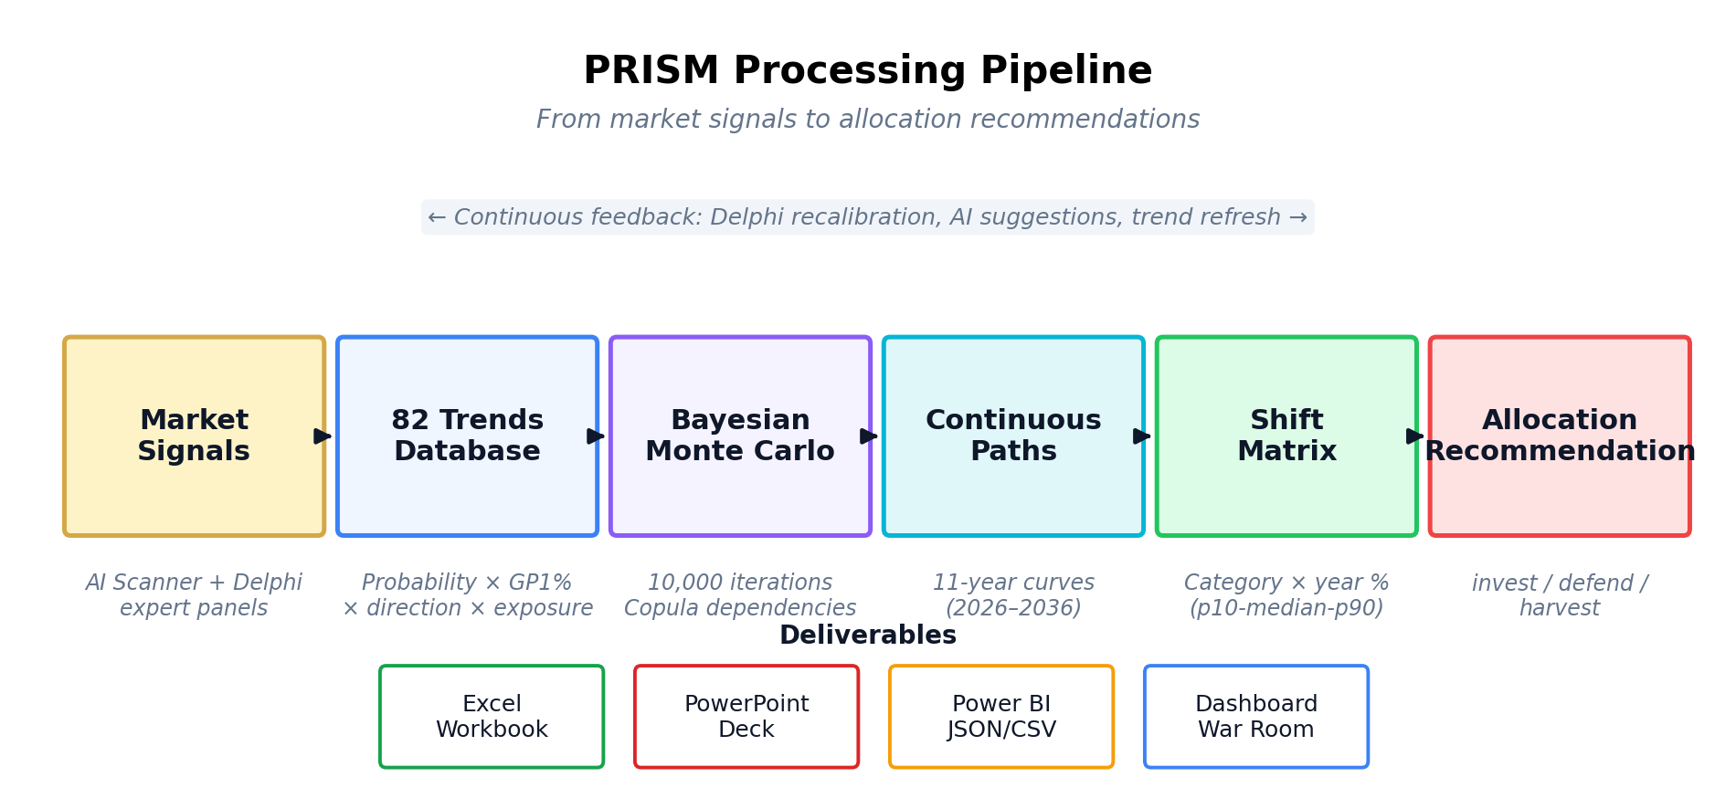
Figure 1.1 — The PRISM processing pipeline: from raw market signals to executable allocation advice.
PRISM delivers four tangible artifacts at the end of each simulation run:
- The Shift Matrix itself — JSON and Excel — showing every category's annual path with five percentile bands and derived velocity and acceleration metrics.
- An allocation recommendation, produced by a mean-variance optimiser, ranking the twelve categories into invest-more / defend / harvest tiers.
- An executive deck in PowerPoint: six slides covering the heatmap, category allocation, path timelines, methodology, and methodology appendix.
- A Power BI-ready flat export — one row per category-year — for the Finance team to apply PRISM shifts to their absolute €M plans.

1.3 Three design choices you need to know
Three choices shape everything that follows, and understanding them is enough to interpret every output PRISM produces.
First — PRISM is probabilistic, not deterministic. A traditional planning model might tell you Hair Color will contract by 3.2% in 2030. PRISM tells you the median outcome is –3.2%, but in the worst decile it's –6.5% and in the best it's –1.0%. This matters because allocation decisions should be robust across plausible futures, not bet on a single forecast.
Second — PRISM speaks in relative shifts, not absolute euros. Every output is a percentage change against a 2025 baseline. PRISM never sees, stores, or produces absolute €M profit pool figures. This is a deliberate architectural choice: it keeps confidential financial data out of the AI layer, and it lets Finance apply the same PRISM shifts to whichever baseline they trust (most recent actuals, budget, approved forecast). The absolute-money translation happens in Power BI, not in PRISM.
Third — the AI layer augments, never replaces, human judgment. Every AI-suggested trend, every narrative, and every calibration proposal passes through a human reviewer with accept/reject authority. The audit log captures every decision. PRISM is not a crystal ball; it is a disciplined way to combine 82 curated trend signals with expert scoring and probabilistic math.

1.4 How to read the rest of this manual
This document is written for Category Leads and the Strategy Office team members who will use PRISM in the 2026 planning cycle and beyond. It assumes strategic fluency but not quantitative or software-engineering background. Technical artefacts — the Python simulation engine, Next.js dashboard, PostgreSQL schema — are described at the level needed to interpret outputs and trust the system, not to modify it.
Each chapter closes with a short section labelled 'So what?' — the strategic implication. If you read only the Lead paragraphs, the figures, and the 'So what?' boxes, you will have a sufficient working understanding of PRISM within thirty minutes.
Reading guide
Chapters 2–3 frame the problem PRISM solves and define the Shift Matrix as its central artefact.
Chapter 4 unpacks the Bayesian Monte Carlo engine, copulas, and diffusion curves — the methodology chapter.
Chapters 5–7 describe the data foundation (82 trends), Delphi expert elicitation, and the advanced analytics suite (CVaR, Sobol, reverse stress, tipping points).
Chapter 8 explains the AI layer. Chapter 9 documents the system architecture. Chapter 10 is a usage guide.
Chapter 11 is an honest limitations register. The appendix contains the glossary and trend reference list.

2. The Strategic Problem We Solved
Henkel Consumer Brands operates in twelve categories across four regions with an eleven-year strategic horizon. The tools previously used to navigate that horizon — static spreadsheets, force assessments, scenario narratives — produce false precision, suppress uncertainty, and ignore the correlations that actually drive outcomes. PRISM replaces them with a quantified, probabilistic, and auditable alternative.

2.1 Why static spreadsheets fail
The V1 through V11 strategic force assessments were, by any reasonable measure, best-in-class for their genre. They canvassed expert opinion across six forces. They produced direction and magnitude scores. They generated scenarios. They were, however, deterministic: each scenario yielded a single number for each category, with no explicit quantification of confidence, no mechanism to express that some trends are more likely than others, and no way to model the fact that a consumer shift and a regulatory move are not independent events.
Three specific failure modes repeatedly emerged in the Strategy Office's planning cycles:
- Anchoring on central estimates. When a deck shows '–3% by 2030' the number anchors the discussion. The actual information — 'our best estimate is –3% but we think the 80% confidence interval runs from 0% to –8%' — gets lost in the transcription from analysis to presentation.
- Silent independence assumptions. Scenarios treated trends as additive. If the GLP-1 weight-loss trend contracts Hair: Body by 2% and the shift-to-liquid-personal-care trend contracts it by 1%, the scenario simply reports –3%. It ignored the possibility that both trends share a common driver (the same health-and-wellness consumer) and therefore co-move.
- No audit trail for the underlying belief. When an executive asked 'how do we know?' the answer was 'our expert panel believes so.' There was no probability attached to that belief, no record of how much it had moved from the previous assessment, and no quantified distribution of opinion within the panel.

2.2 The three-horizon challenge
The 2026 Bain trend review concluded that the active horizon must extend from the original five years (2026–2030) to eleven years (2026–2036). The reasons were structural. Three distinct strategic horizons are now visible:
H1 • Execution (2026–2028)
Agentic commerce arrives in mainstream retail. GLP-1 behaviour change locks in. The EU regulatory cliff (CSRD, microplastics, chemical restrictions) moves from announcement to enforcement. These are largely known-knowns; the question is execution pace, not whether.
H2 • Disruption (2029–2032)
Bio-manufactured and precision-fermented ingredients cross cost parity. Algorithmic shelf management replaces physical negotiation in key retailers. Africa and Southeast Asia tip from growth market to majority of new consumer formation. These are higher-uncertainty, structurally disruptive moves with multi-billion-euro implications.
H3 • Transformation (2033–2036)
Longevity economy matures into a mainstream spending category. Full lifecycle accountability (carbon, water, biodiversity) becomes pre-competitive. Post-surfactant chemistries begin displacing legacy laundry and dish formulations. At this horizon, scenario distributions widen substantially — but ignoring them sets up a strategic blind spot.
PRISM models all three horizons in a single continuous-path forecast, with the confidence interval naturally widening as the horizon extends — exactly the behaviour an honest eleven-year forecast must exhibit.

2.3 The information asymmetry we closed
Before PRISM, strategic intelligence lived in three incompatible places: the V11 scoring workbook (expert opinions), external consultancy decks (market data), and category P&L files (financials). There was no canonical join. A category lead wanting to understand how a regulatory trend would flow into their 2029 margin had to manually synthesise across three artefacts, each in a different format and updated on a different cadence.
PRISM closes this gap by establishing a single canonical data model — 82 trends, each with probability, scope, direction, diffusion curve, and category/value-chain/regional exposure — persisted in a PostgreSQL database, refreshed via structured Delphi cycles, and connected to both the strategy dashboard and the Power BI financial overlay. The Shift Matrix is the one artefact every team agrees on.
So what?
The gap PRISM closes is not about better forecasts — anyone can produce a forecast. It is about closing the gap between expert belief, quantified uncertainty, and executable financial action. Everything else in this document is machinery in service of that gap-closing.

3. The Shift Matrix — PRISM's Core Output
The Shift Matrix is the one artefact that matters. It is a table of category × year percentage shifts with full probability distributions. Everything upstream — the 82 trends, the Bayesian engine, the copula model — exists to produce it. Everything downstream — the Excel workbook, Power BI, PowerPoint, allocation optimiser — reads from it.

3.1 What the Shift Matrix contains
For each of Henkel's twelve categories, in each of the eleven years between 2026 and 2036, the Shift Matrix records five percentile values (p10, p25, median, p75, p90) of the relative profit-pool shift against the 2025 baseline. Those five values describe the full probability distribution — a narrow band signals high confidence, a wide band signals fundamental uncertainty.
Alongside the percentiles, the Shift Matrix carries two derived diagnostics per category-year: the velocity (year-over-year change in the median shift, indicating speed of movement) and the acceleration (change in velocity, indicating whether the trajectory is inflecting). These are critical early-warning indicators: a category with near-zero median shift but high positive velocity is about to enter a growth phase; a category with negative acceleration is entering an inflection point.
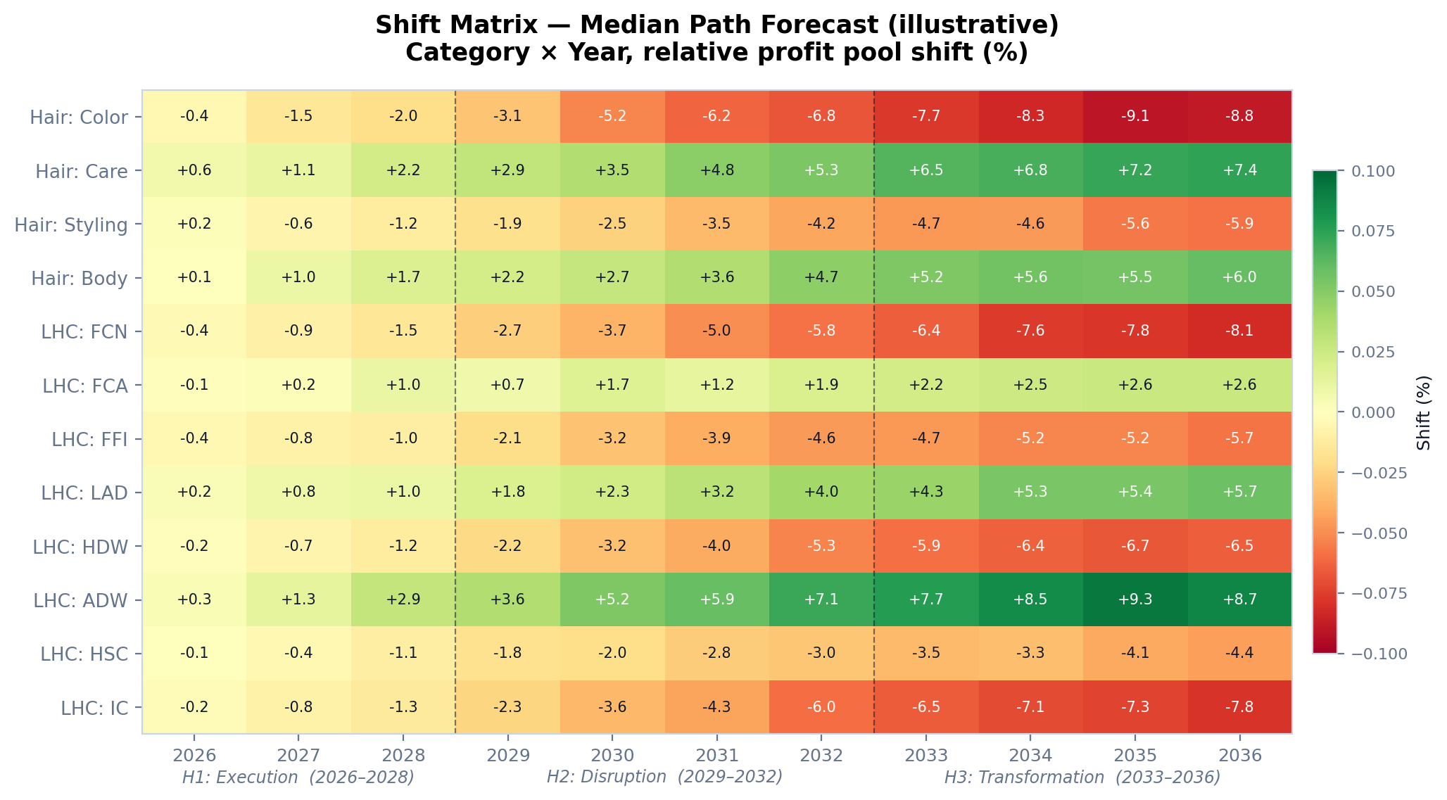
Figure 3.1 — Illustrative Shift Matrix heatmap. Green indicates profit-pool expansion; red indicates contraction. Values shown are medians; the full matrix additionally carries p10, p25, p75, p90 per cell.

3.2 How to read one entry
Consider a single cell: Hair: Color in 2030. A simplified entry reads:
Hair: Color × 2030 (median path)
Percentile distribution: p10 = –0.018, p25 = –0.025, median = –0.032, p75 = –0.048, p90 = –0.065
Velocity (year-over-year Δ median): –0.008 (accelerating contraction)
Acceleration (Δ of velocity): –0.002 (the contraction is speeding up, not stabilising)
Driving forces (top 3 by contribution to variance): Consumer (54%) • Technology (22%) • Competitive (14%)
The correct reading is: 'In our central case, Hair: Color's profit pool shrinks by 3.2% relative to 2025 by year 2030. We are 80% confident the actual shift lies between –1.8% and –6.5%. The contraction is accelerating, driven primarily by consumer behaviour change — with technology-driven personalisation and competitive intensity as secondary contributors.' Nothing more; nothing less.

3.3 How to apply it
Applying a Shift Matrix entry to a financial plan is a single multiplication:
GP1_projected_2030 = GP1_baseline_2025 × (1 + shift_median)
Equivalent formulas exist for the p10, p25, p75, and p90 scenarios. In practice, category leads carry three numbers into their plan: the median (central case), the p25 (conservative planning case for cost and capacity commitments), and the p75 (ambitious case for opportunity sizing). Finance typically uses the median for budget consolidation and the p10 for downside stress tests.

3.4 Why relative shifts, not absolute euros
PRISM's outputs are deliberately percentage shifts against an unspecified baseline. The absolute-money translation lives in Power BI, in the Finance team's control. This separation is load-bearing for four reasons:
- Confidentiality. No absolute profit pool figures ever leave the Finance data boundary. PRISM — including its AI layer — operates entirely on relative %s.
- Baseline neutrality. The same PRISM shift can be applied to the most recent actuals, to the approved budget, or to whatever baseline Finance deems appropriate at the time of planning.
- Regional flexibility. A 3% shift maps to different €M figures across the four regional profit pools. Keeping PRISM region-agnostic on absolute money lets the same simulation inform multiple regional plans.
- Governance integrity. The audit trail clearly separates methodological outputs (PRISM) from financial commitments (Power BI / Finance). No-one can claim the AI quietly moved an absolute figure.
So what?
Treat the Shift Matrix like a rate card rather than a forecast. PRISM quantifies the directional pressure on each category's profit pool. Finance translates that pressure into euros. Strategy translates it into allocation. Keep the layers separate and the workflow remains clean and auditable.

4. Methodology — The Blackbox Unpacked
This chapter is deliberately long. It is the chapter that matters most if you are ever asked to defend PRISM's numbers. The methodology combines six ideas — probabilistic priors, force taxonomy, Bayesian updating, copula dependencies, diffusion curves, and attenuation — each of which is well-established in applied statistics but which together form the engine specific to PRISM.

4.1 First principles — why probabilistic, not deterministic
Every trend in PRISM's database carries two numeric attributes that, together, define its potential strategic impact: a probability (how likely is the trend to materialise?) and a GP1-percent-affected value (if it materialises, what fraction of the category profit pool is at stake?). The product of these two, signed by direction (+1 for expansion, –1 for contraction), produces what PRISM internally calls the 'normalised score.' A trend with probability 5 (near-certain) and GP1% 0.10 (10% of the pool) contributing in the contraction direction has a normalised score of –0.50.
Storing these as distributions rather than point estimates is the difference between deterministic and probabilistic modelling. Probability is stored as a Beta-distributed posterior — two numbers, alpha and beta — which captures not just our central estimate but also how much evidence supports it. GP1-percent-affected is stored as a triangular distribution with min, mode, and max values, reflecting the range of expert opinion on the magnitude of the effect.
A point estimate is a lie we tell ourselves about certainty. PRISM's first methodological commitment is to refuse that lie — every trend carries a distribution.

4.2 The Six Forces framework
PRISM's core taxonomy partitions the universe of strategic trends into six forces. Each force captures a distinct causal channel through which external change translates into category profit-pool impact.
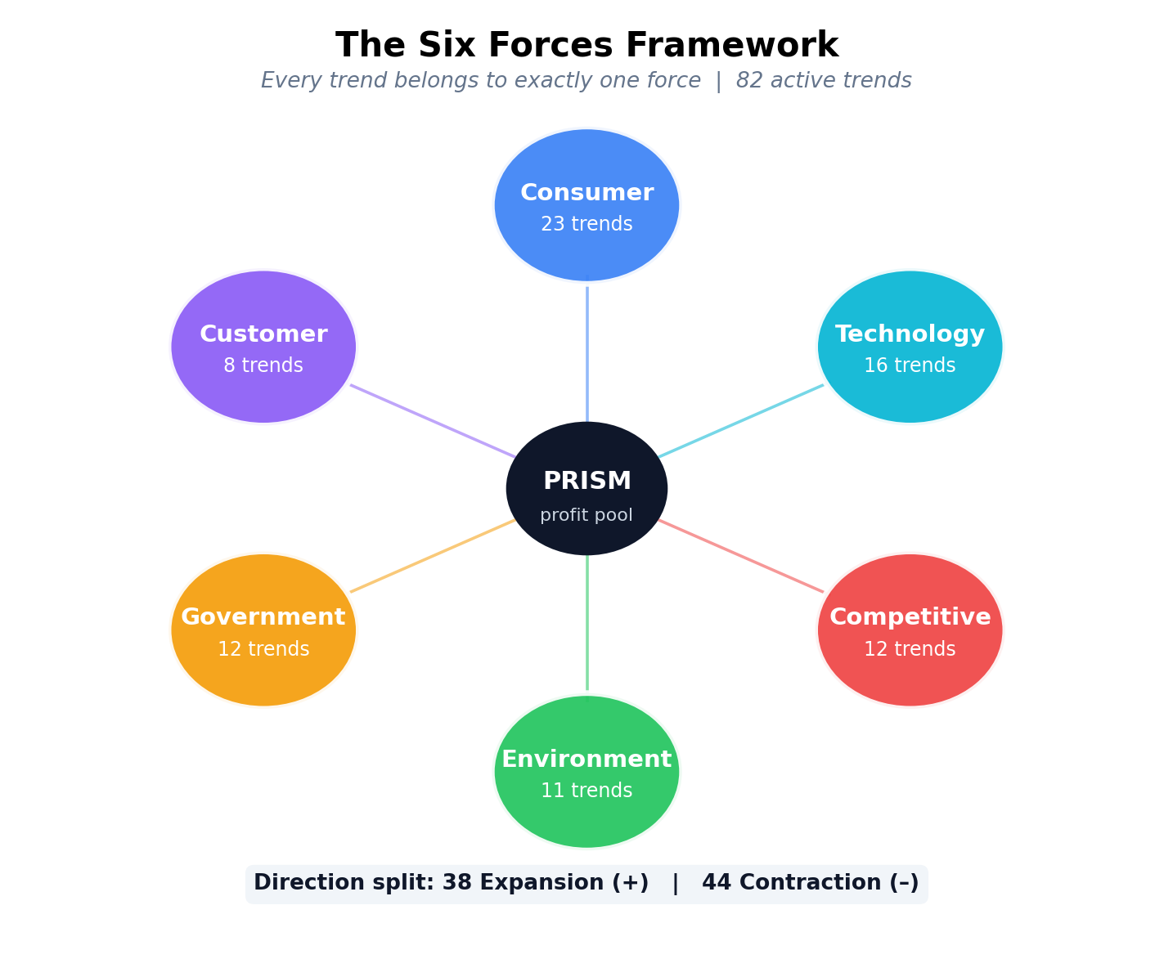
Figure 4.1 — The Six Forces framework. Each trend belongs to exactly one force. The force partition is MECE: every trend fits, none fit two.
The force classification is not decorative; it is load-bearing for three reasons. First, forces have different default diffusion curves — regulatory forces tend to materialise as step functions (everything changes on enforcement day), while consumer forces follow S-curves (slow adoption, then rapid acceleration, then saturation). Second, correlations within a force tend to be higher than across forces — two consumer trends driven by wellness will co-move more tightly than a consumer trend and a competitive trend. Third, force-level aggregation supports root-cause analysis: when a category shows surprising acceleration, the first question is 'which force is driving it?'.

4.3 Trend scoring — probability × scope × direction
Every trend in the PRISM database is scored on three dimensions. Probability is scored on a five-point ordinal scale (1 = highly unlikely, 5 = near-certain) by an expert panel via the Delphi protocol (Chapter 6). GP1-percent-affected is scored as a continuous value between 0.0 and 1.0 — the share of the category's profit pool at risk if the trend materialises — again by the expert panel, anchored to a set of reference magnitudes from comparable historical trends. Direction is categorical: expansion or contraction.
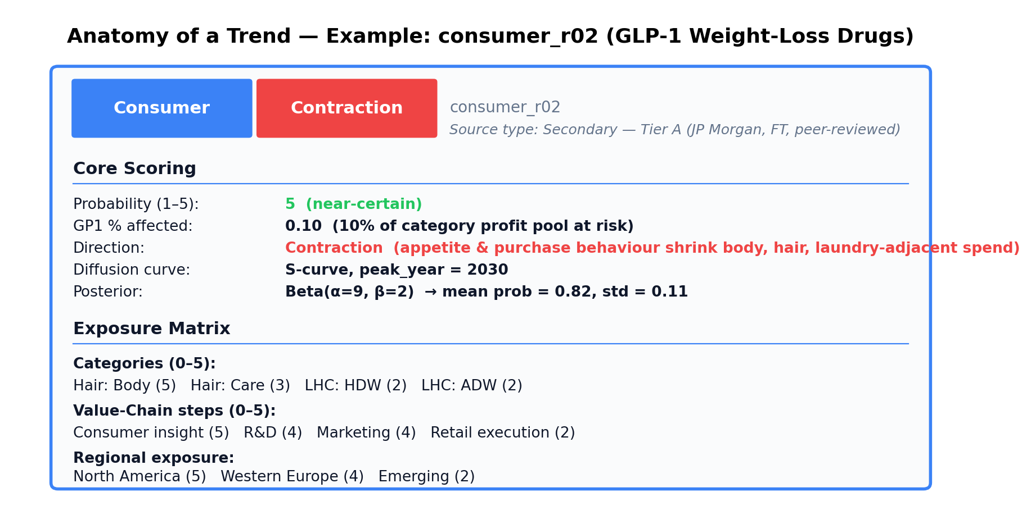
Figure 4.2 — Anatomy of a trend. Every trend in PRISM carries this exact structure, which enables aggregation, audit, and replay.
Two credibility controls protect the database against low-quality inputs. First, every trend carries a source-credibility tier (S / A / B / C / D / E, with S reserved for peer-reviewed longitudinal studies and E for unverified anecdote). PRISM refuses to score trends sourced only at tier E — a hard gate. Second, the 'scorer_count' and 'score_variance' fields record how many experts scored a trend and how much they disagreed; high-variance trends surface in the Delphi round 3 outlier discussion and in the dashboard's low-confidence view.

4.4 The Bayesian Monte Carlo engine
The simulation engine itself is a Bayesian Monte Carlo with copula-correlated dependencies. This section explains each of those words in turn.

4.4.1 What 'Monte Carlo' means
A Monte Carlo simulation runs the model many thousand times, each run sampling random values from the input distributions. The output is not a single number but a distribution of outcomes — one draw per iteration. PRISM runs 10,000 iterations by default (configurable to 100,000 for more demanding analyses). Each iteration samples, for every trend: one probability draw, one GP1% draw, and — via the copula structure described below — a correlated draw for every other trend in the same force.
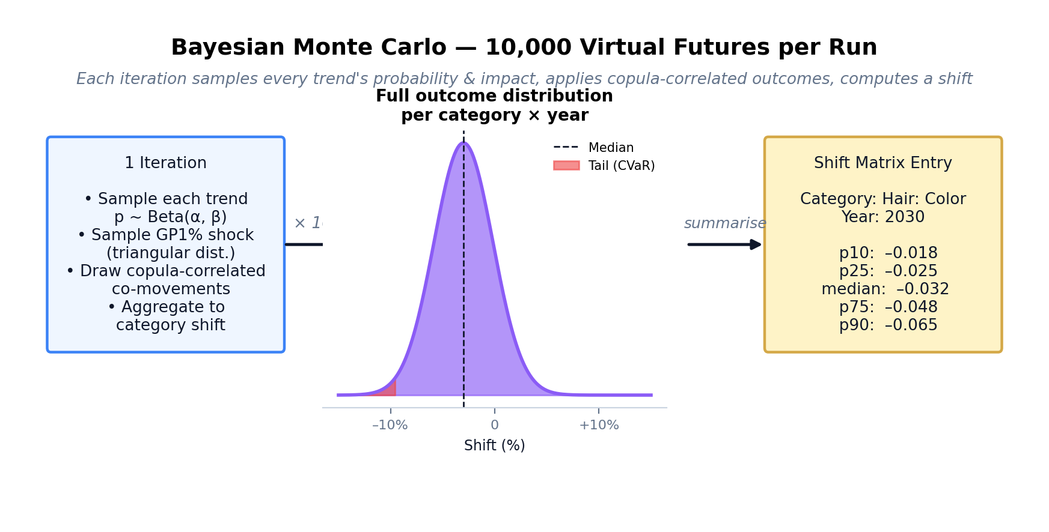
Figure 4.3 — Each Bayesian MC iteration samples every trend's probability and scope, propagates correlated co-movements, and aggregates to a category-year shift. Ten thousand such iterations produce the full output distribution.

4.4.2 What 'Bayesian' adds
A plain Monte Carlo samples from fixed distributions. A Bayesian one updates those distributions as evidence arrives. In PRISM, a trend's probability is stored as a Beta distribution with parameters alpha and beta. When a Delphi round produces new scores, the posterior parameters update: alpha grows if experts scored higher, beta grows if they scored lower. Formally, this is the standard Beta–Binomial conjugate update; informally, it is the mechanism that turns a trend's probability into a living estimate rather than a frozen snapshot.
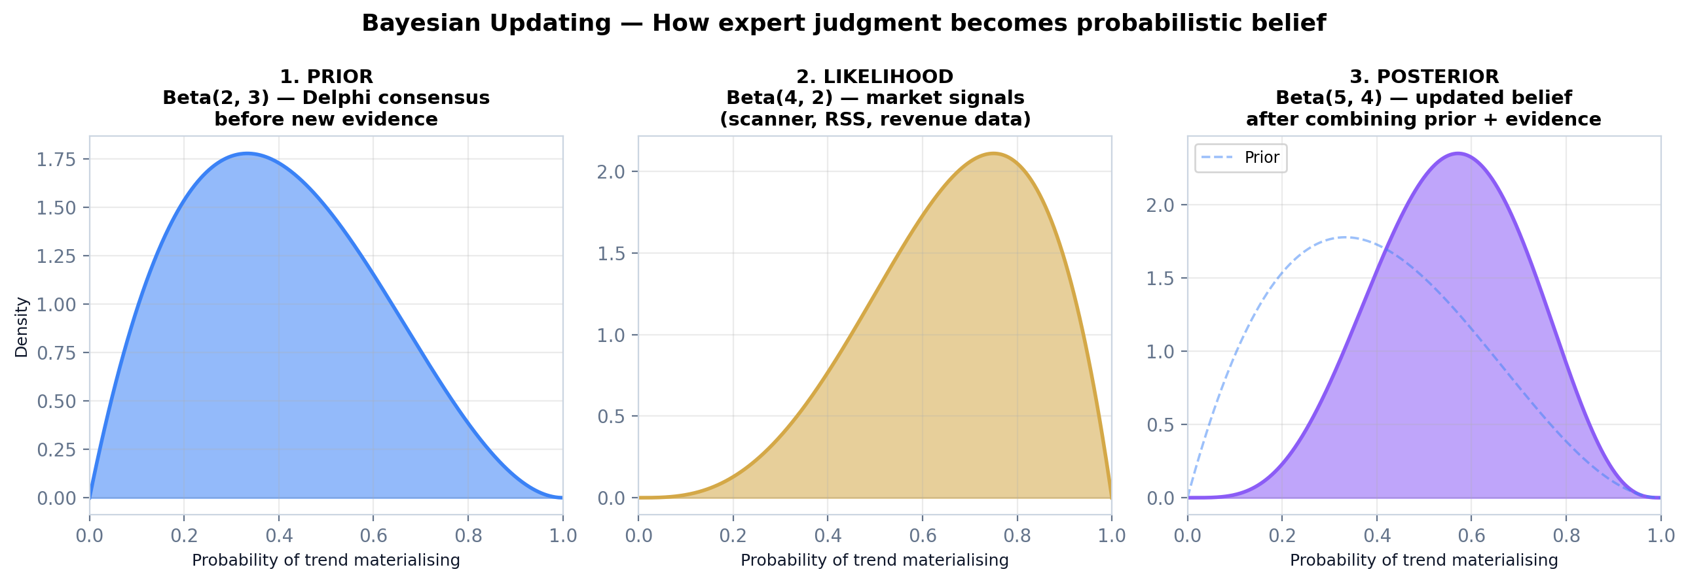
Figure 4.4 — Bayesian updating. The prior (blue) encodes the Delphi consensus before new evidence. The likelihood (gold) encodes what recent market signals tell us. The posterior (purple) is the combined belief — narrower than either input, and shifted toward the weight of evidence.

4.4.3 What 'copula-correlated' means and why it matters
A copula is a mathematical construction that couples marginal distributions (what each trend looks like on its own) to a joint dependency structure (how they co-move). Without copulas, the simulation would implicitly treat every trend as independent — which would understate tail risk by a large margin, because in the real world, trends correlate. A wellness-driven consumer shift and a regulatory push toward sugar reduction do not move independently; they share the health-consciousness driver.
PRISM uses a Gaussian copula for the bulk of the joint distribution, combined with a t-copula for the tails (which captures the empirical regularity that extreme events are more correlated than moderate ones). Default within-force correlation is ρ = 0.3; cross-force correlations are configurable in the model parameters. The copula is implemented via Cholesky decomposition of the correlation matrix, which is standard numerical practice.
The practical consequence: if the scenario generates a bad draw for one consumer trend, it is more likely — not independently likely — to generate a bad draw for other consumer trends. This correctly widens the tail of the output distribution, which in turn correctly widens the stress-test and CVaR estimates.

4.5 Diffusion curves — when impact materialises
A trend's impact does not arrive instantaneously in the year of peak relevance. A regulatory cliff may produce a step-function impact in the enforcement year. A slow consumer adoption follows an S-curve. A technology with high early adopter enthusiasm may be front-loaded. PRISM's methodology therefore separates how much impact a trend carries from when it arrives.
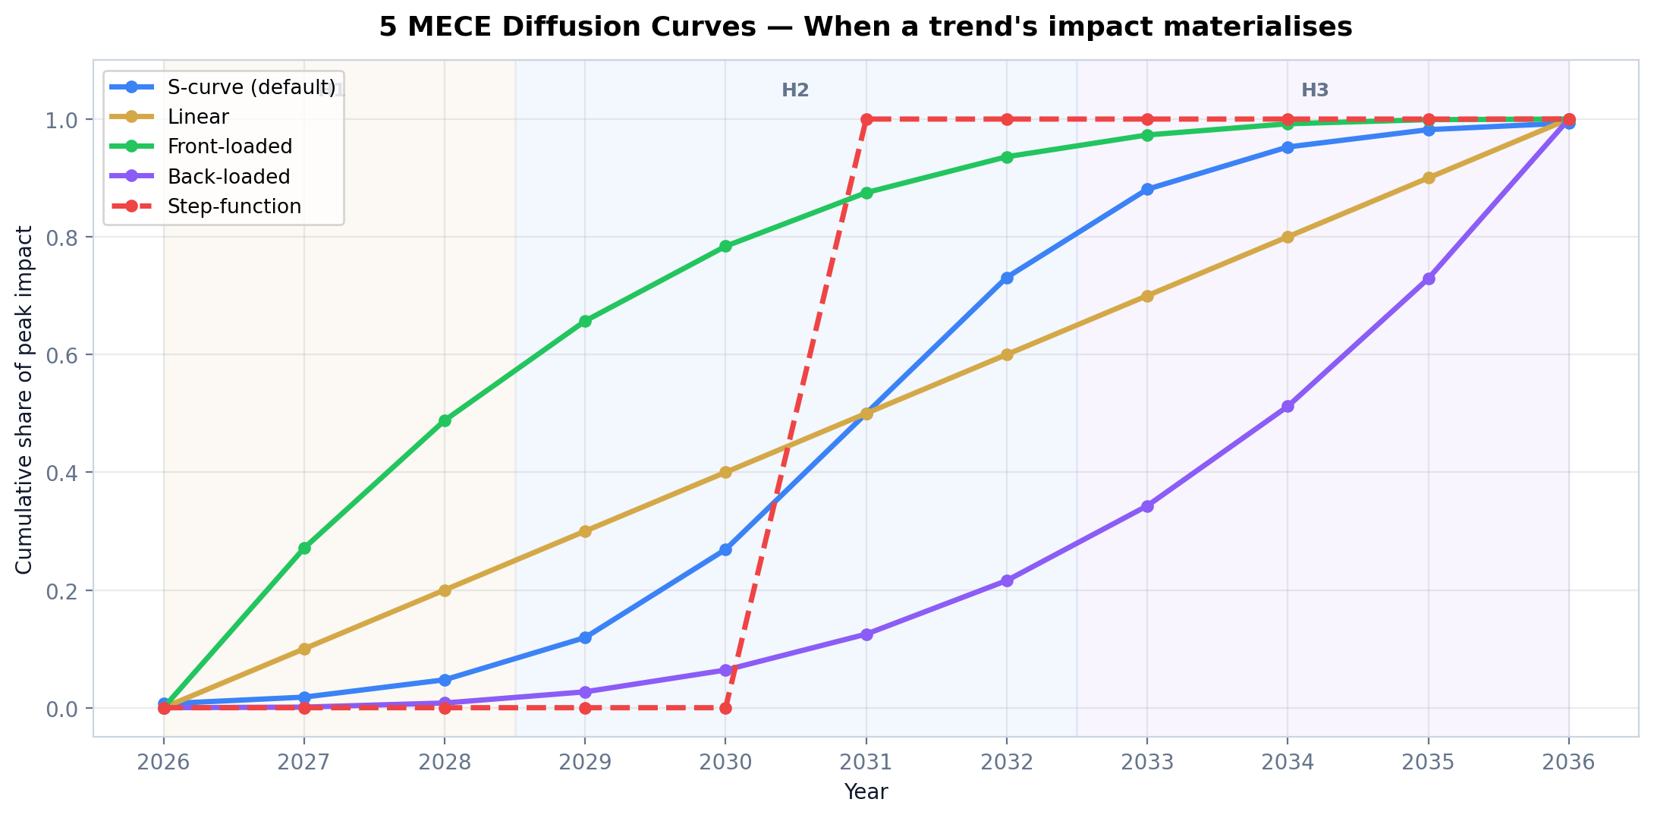
Figure 4.5 — The five MECE diffusion curve types. Each trend is assigned exactly one curve and a 'peak year' at which the cumulative impact reaches its maximum.
The five curve types are exhaustive and mutually exclusive: S-curve (the default, used for most consumer and technology trends), linear (gradual proportional adoption), front-loaded (rapid initial impact that plateaus), back-loaded (slow start that accelerates), and step-function (binary switch, typical of regulatory cliffs). Each curve type has a closed-form cumulative impact function that is computed against the eleven-year horizon during simulation.

4.6 Continuous paths, velocity, and acceleration
Because PRISM models time continuously rather than as a single snapshot, every category-year cell carries not just a level (the shift magnitude) but a velocity (how fast it is changing) and an acceleration (whether it is speeding up or stabilising). These derived quantities are the early-warning system inside the Shift Matrix.
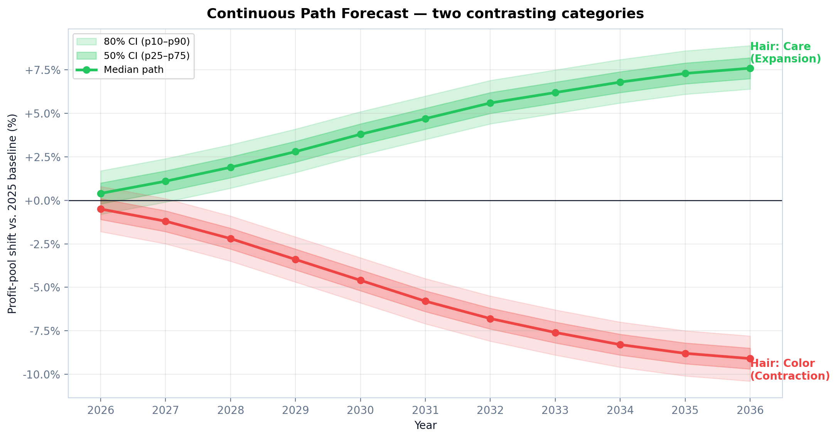
Figure 4.6 — Continuous path forecast for two contrasting categories. The shaded bands are the confidence intervals (50% inner, 80% outer). Paths widen over time — exactly the behaviour an honest eleven-year forecast must exhibit.
A category with near-zero shift but high positive velocity will soon move into expansion territory. A category with established contraction but near-zero acceleration has found its floor. Category leads and the strategy office should scan both level and velocity in every planning cycle; PRISM's dashboard heatmap is click-through to the underlying path view for exactly this reason.

4.7 Attenuation — from direct effect to profit pool
Not all direct effects translate one-for-one into profit-pool shifts. A 10% reduction in category demand does not produce a 10% reduction in profit pool — firms respond by cutting cost, adjusting pricing, rationalising SKUs, and so on. PRISM captures this response via an attenuation factor (default = 0.5), which scales the raw force-level impact before aggregation to the category level.
The 0.5 default is assumed, not calibrated against historical data. This is the single largest methodological caveat in PRISM today, and the limitations chapter discusses it explicitly. The attenuation factor is a configurable model parameter (admin-only) and all scenario runs record the attenuation value they used in the config snapshot, so sensitivity to attenuation can be tested by running matched scenarios at, say, 0.4 and 0.6.
So what?
The methodology is not exotic — each component (Bayesian updating, Monte Carlo, copulas, diffusion curves, attenuation) is standard in applied quantitative finance or operations research. What PRISM does is assemble them, wire them to a trend database with Delphi elicitation, and expose the output in an operational dashboard. The integrated system is the innovation, not any individual technique.

5. Data Foundation — 82 Trends
PRISM is only as good as the trends it scores. This chapter describes the eighty-two active trends that constitute PRISM's current knowledge base, the source-credibility regime that protects against low-quality inputs, the Bain-led trend expansion that produced the v3.1 release, and how new trends enter the system.

5.1 The trend database at a glance
As of April 2026, the PRISM trend database contains 82 active trends. The figure reflects the outcome of the Bain Senior Partner-led strategic review of March 2026, which expanded the previous v3.0 baseline of 61 trends by adding 23 new trends across six identified gap areas, upgrading 2 trends to reflect new market evidence, and retiring 2 trends that had either normalised or structurally failed.
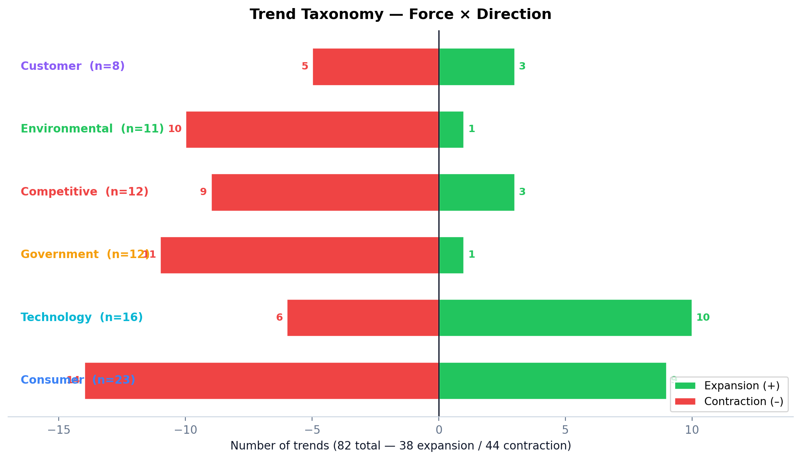
Figure 5.1 — Trend taxonomy by force and direction. Green bars on the right indicate expansion trends; red bars on the left indicate contraction trends. Total: 82 trends, 38 expansion, 44 contraction.
The distribution is deliberately asymmetric. Consumer trends dominate (23 of 82) because consumer behaviour change is the most-often mispriced driver in traditional assessments. Technology follows (16 trends) reflecting the intensity of the 2024–2026 agentic-commerce and bio-ingredient wave. Government and competitive are balanced around 12 each; environmental at 11 and customer at 8 reflect smaller but still structurally important force channels.

5.2 Source credibility tiers
Every trend carries a source-credibility tier. The tier governs whether the trend can enter the production database, how much weight its prior should receive, and how it is flagged on the dashboard.
Tier | Description | Use in PRISM
S | Peer-reviewed longitudinal studies; regulator-published official data | Production; strong Bayesian prior
A | Named industry research (Kantar, Nielsen, Euromonitor); major business media with methodology disclosed | Production; standard prior
B | Reputable business media without methodology; consultancy decks with attributed sources | Production; wider prior
C | Trade press; single-source industry reports | Production; flagged for Delphi scrutiny
D | Analyst opinion; individual expert calls without triangulation | Delphi-only; cannot seed a prior
E | Unverified anecdote; single social-media observation | Hard gate — refused entry to the production database
The hard gate at tier E is enforced in code: the ingestion pipeline rejects any trend whose only source is tier E. This prevents PRISM from quantifying opinion that is merely loud. Trends with mixed-tier sourcing are recorded at the lowest tier among their sources — a single B-tier sourcing does not 'upgrade' a trend to B if it also has C-tier sourcing.

5.3 The v3.1 Bain expansion — what changed and why
The March 2026 Bain review, conducted by a 20-person team of senior consultants drawn from L'Oréal, P&G, Unilever, Apple, and tier-1 investment banking, identified six gap areas in the previous v3.0 trend database. The v3.1 expansion fills each gap with 2–3 new trends and upgrades two existing trends whose evidence base has strengthened materially.
Gap area | Trends added (v3.1) | Rationale
Agentic commerce | 3 (AI shopping agents, algorithmic shelf, hyper-personalised formulation) | The 2025–2026 shift from recommendation engines to goal-delegating agents was not in v3.0; JP Morgan now projects $100B+ category impact.
Geographic expansion | 3 (Africa rising, SEA middle class, LatAm premiumisation) | Emerging-market profit pools cross 50% of global new consumer formation by 2032; v3.0 underweighted this.
Longevity economy | 2 (longevity consumer, peptides & bioactives) | From niche wellness to mainstream category, driven by GLP-1 behaviour spillover.
Ingredients & bio-manufacturing | 2 (precision fermentation, designer surfactants) | Post-surfactant chemistries cross cost parity in H2; v3.0 treated this as too distant.
Regulatory | 3 (EU AI Act, EUDR biodiversity, microplastics/textile) | Three distinct regulatory cliffs, each with category-level profit-pool implications.
Other (consumer, customer, competitive, environmental) | 10 across four forces | Gap-filling after systematic review of the existing trend base against 2025–2026 market developments.
Two upgrades of particular note: consumer_r02 (GLP-1 weight-loss drugs) moved from probability 4 to probability 5, and its GP1-percent-affected increased from 0.04 to 0.10, reflecting the JP Morgan projection of a $100B+ category reshaping. Customer_r04 (TikTok Shop) moved from probability 3 to 5 with GP1% from 0.04 to 0.10, reflecting the $23.4B US projection for 2026.
Two retirements: consumer_r12 (Post-COVID Hygiene Upgrade) is retired because the trend has normalised — hygiene spending returned to baseline by late 2024. Customer_r05 (Quick Commerce) is retired because the structural economics failed — major quick-commerce players in Europe and the US have substantially scaled back.

5.4 Anatomy of a trend — the data model
Every trend record in PRISM's PostgreSQL database conforms to a strict data model. Figure 5.2 showed a single trend; the structured fields are:
- Identity: id (namespace_XX), force, sub-category, name, description, direction (expansion/contraction).
- Scoring: probability (1–5 ordinal), gp1_pct_affected (0.0–1.0 continuous), probability_posterior (JSON: alpha, beta for Bayesian posterior).
- Temporal: start_year, diffusion_curve (one of five MECE types), peak_year.
- Exposure: category exposure matrix (trend × 12 categories, 0–5 scoring), value-chain exposure (trend × 8 VC steps), regional exposure (trend × 4 regions).
- Provenance: data_source, source_type (primary/secondary/expert), confidence (high/medium/low), scorer_count, score_variance.
- Governance: ai_suggested flag, user_override flag, debiasing_applied flag, created_at, updated_at timestamps.
The exposure matrices are the data model's most important feature. A trend does not impact 'Hair' uniformly; it impacts Hair: Color strongly, Hair: Care moderately, and Hair: Body weakly. Recording this gradient is what allows the simulation to produce category-level rather than force-level outputs.

5.5 How trends enter and leave the database
Trend entry follows a four-step funnel. First, the AI Scanner (Chapter 8) surfaces candidate trends from curated market intelligence sources. Second, a strategy analyst reviews the candidate and attaches source documentation, meeting the minimum tier-D threshold. Third, the candidate enters a Delphi scoring round, where the expert panel scores it across probability, GP1%, and direction. Fourth, the audit logger records the entry with the analyst's identity and the Delphi outcomes.
Trend exit follows an analogous path: a trend is marked for retirement when either (a) its probability posterior has converged on a near-zero mean (it did not materialise within expected time), or (b) it has been absorbed into mainstream baseline assumptions (it did materialise and is now the status quo, not a trend). The v3.1 retirements of consumer_r12 and customer_r05 are examples of each case respectively.
So what?
The trend database is the raw material for every PRISM output. Category leads should treat it as a living artefact, not a one-off input. Every Delphi cycle is an opportunity to refine it. The hard gate at tier-E and the structured entry funnel are load-bearing for credibility — preserve them.

6. Delphi Expert Elicitation
PRISM's probability and GP1% scores come from human experts, not from black-box machine learning. The Delphi protocol is the disciplined multi-round process by which those human scores are elicited, debiased, and converged. This chapter explains why Delphi exists, how PRISM implements it, and how its outputs flow into the Bayesian engine.

6.1 Why expert elicitation — and why multi-round
For forward-looking strategic trends — especially those without direct historical analogues — expert judgment is the best available input. But raw expert judgment suffers from three well-documented biases: anchoring (the first number mentioned dominates), groupthink (deference to seniority suppresses disagreement), and optimism (trend-supporters overestimate probability, skeptics underestimate). A single-round survey of experts captures all three biases; a multi-round Delphi process substantially reduces all three.
The Delphi method, originally developed at RAND in the 1950s, is structured around three principles: anonymity (reduce deference), iteration (allow update on reflection), and controlled feedback (show the group distribution but not individual identities). PRISM implements the classical three-round Delphi with PostgreSQL-persisted round history and per-expert calibration factors.
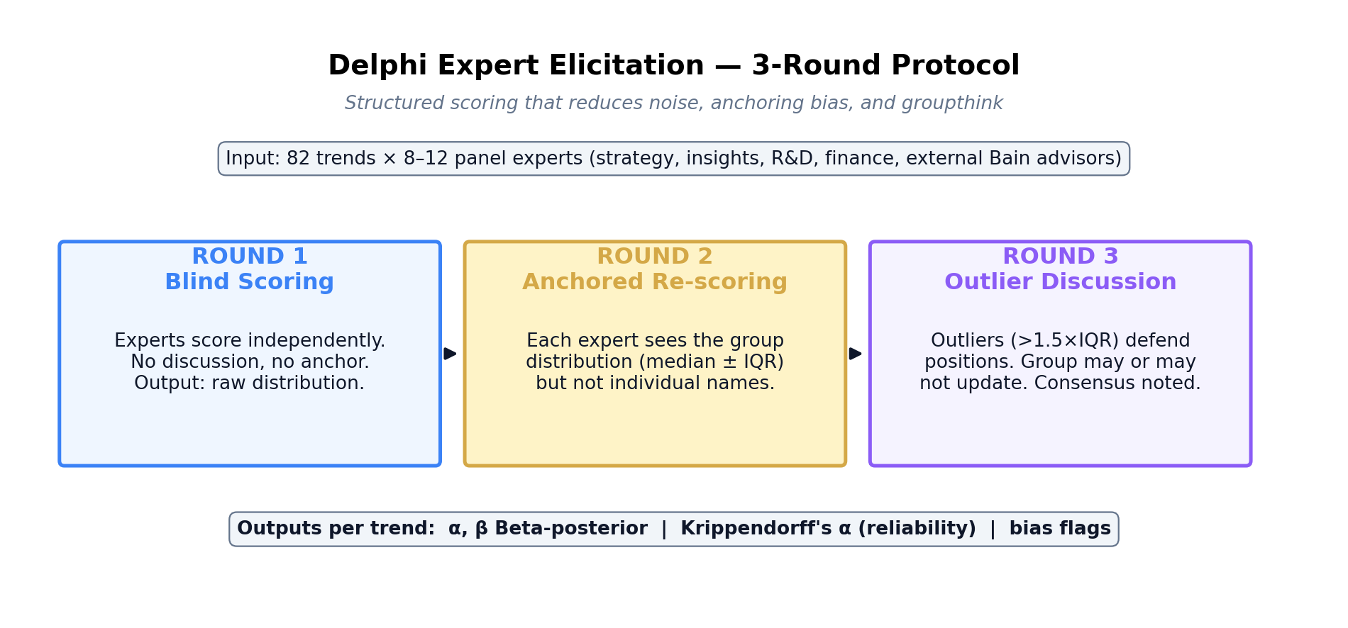
Figure 6.1 — The three-round Delphi protocol. Round 1 is fully blind; Round 2 introduces anchoring to the group distribution only (no names); Round 3 is facilitated discussion of outliers.

6.2 Round 1 — blind scoring
Round 1 is conducted with experts working independently. Each scores every trend on probability (1–5), GP1% (0.0–1.0), and direction (expansion/contraction). Experts may also provide a free-text rationale. No-one sees anyone else's scores. The output is a raw distribution per trend: for example, '8 experts scored, median probability = 4, interquartile range [3.5, 4.5], one outlier at 2.'
At the end of Round 1, PRISM computes per-trend descriptive statistics (median, IQR, min, max, variance) and inter-rater reliability using Krippendorff's alpha. A trend with Krippendorff's alpha below 0.4 is flagged as 'low agreement' and marked for specific attention in the later rounds.

6.3 Round 2 — anchored re-scoring
In Round 2, each expert sees the group distribution from Round 1 (the median and IQR) but not the individual names. They may then revise their scores. Most experts do — typically moving toward the group median, though not always. Experts whose Round 1 score was an outlier are prompted with a specific note: 'Your score was outside the IQR. Please either revise your score or provide a rationale for holding your position.'
The output of Round 2 is a typically narrower distribution — the pure anchoring effect — plus a set of outlier rationales that form the agenda for Round 3.

6.4 Round 3 — outlier discussion
Round 3 is the only facilitated round. Outlier experts (those who held their position outside the IQR in Round 2) present their rationale to the group. The group may or may not update their scores after the discussion. Crucially, the facilitator does not push for consensus — if real disagreement exists, the final distribution should reflect it. PRISM explicitly stores the post-Round-3 distribution with its dispersion intact; a wide distribution is information, not noise.

6.5 From Delphi scores to Bayesian posterior
At the end of Round 3, each trend's probability distribution is fit to a Beta distribution via method-of-moments: the sample mean and variance produce alpha and beta parameters directly. These become the probability_posterior field in the trend record. The Bayesian Monte Carlo engine then samples probability draws from this Beta distribution in every iteration.
The Beta distribution is the natural conjugate prior for probability estimates — it has the right mathematical properties (bounded [0,1], flexible shape) and it updates cleanly when new evidence arrives (the conjugate Beta–Binomial update from Chapter 4). Using it for PRISM's probability storage is standard Bayesian practice.

6.6 Bias detection
PRISM runs three specific bias checks on Delphi results. Anchoring bias is detected by comparing Round 1 to Round 2 dispersion: a collapse from wide to narrow that does not correspond to any outlier-rationale-driven change suggests pure anchoring. Optimism bias is detected at the expert level — experts whose Round-1 scores consistently exceed the group median by more than 1 standard deviation are flagged and their scores receive a lower calibration factor. Recency bias is detected by comparing scores on trends with obvious recent news events against trends without — a systematic skew toward recency signals are flagged for the Strategy Office to re-examine.
So what?
The Delphi protocol is what makes PRISM's 'AI-augmented' branding honest. The quantitative machinery sits on top of disciplined human expert judgment — not around it. Running Delphi cycles every quarter, debiasing carefully, and preserving dispersion where real disagreement exists are the practices that keep the inputs credible.

7. Advanced Analytics Suite
A shift matrix with percentile bands is necessary but not sufficient. Four additional analyses — CVaR, Sobol sensitivity, reverse stress testing, and tipping-point detection — turn the raw simulation output into strategic insight. All four are in production and exposed through dedicated API endpoints. A mean-variance allocation optimiser sits on top and turns the analytics into a concrete recommendation.

7.1 CVaR — what happens in the tail
Conditional Value-at-Risk (CVaR), also called Expected Shortfall, answers a specific question: in the worst X% of simulated outcomes, what is the average loss? If the 5% CVaR for a category is –12%, it means: 'in the bottom one-in-twenty outcomes, we expect an average profit-pool contraction of 12%.' This is a risk measure that, unlike the simple 5% percentile, respects the full shape of the left tail — a heavy-tailed distribution produces a much worse CVaR than a symmetric one, even at the same VaR.
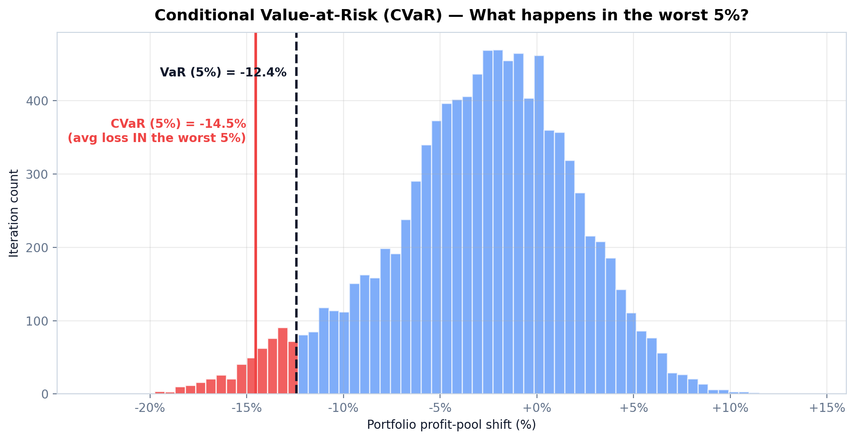
Figure 7.1 — CVaR visualised. The dashed line is the 5% VaR (the percentile); the solid red line is the 5% CVaR (the average loss in the worst 5%). CVaR is always more conservative than VaR and captures tail thickness.
PRISM's CVaR analysis is exposed through POST /analytics/cvar and produces both the portfolio-level CVaR across all categories and a per-category risk contribution — identifying which categories drive the most tail risk. The allocation optimiser (Section 7.5) uses these risk contributions directly.

7.2 Sobol sensitivity — what drives the variance
Sobol indices are a global sensitivity analysis technique. For each trend parameter, they compute the share of total output variance attributable to that parameter (first-order index, S1), the share attributable to interactions with other parameters (second-order, S2), and the total share including all interaction effects (total-order, ST). If a trend has S1 = 0.15, it means 15% of the variance in the Shift Matrix output is explained by that single trend in isolation.
Sobol analysis answers the question: 'if we could reduce uncertainty on one parameter, which one would give us the most information?' The highest-ST trends are the priority targets for deeper Delphi cycles, additional market intelligence, or explicit early-warning triggers. PRISM implements Sobol via the SALib library using Saltelli sampling; the analysis is exposed through POST /analytics/sobol.

7.3 Reverse stress testing — what breaks the thesis
Where CVaR asks 'what happens in the worst 5%,' reverse stress testing asks 'what is the minimum combination of parameter changes that would produce a target adverse outcome?' The user specifies the adverse outcome — for example, 'the median 2030 shift for Hair turns negative' — and PRISM uses scipy's differential evolution algorithm to search for the minimum-cost parameter perturbation that achieves it.
The output is a ranked list of stress configurations. The top-ranked configuration might read: 'if consumer_r02 probability increases from 5 to 5 (already max) and technology_r11 GP1% increases from 0.04 to 0.09, the Hair median turns negative.' This is strategic signal — it tells you which trend combinations pose the most concentrated risk and therefore which specific early-warning triggers deserve investment.

7.4 Tipping-point detection
A tipping point is a year in which a category's trajectory structurally inflects — a sign reversal in the median path, a sharp acceleration, or a threshold breach. PRISM's tipping-point detector uses second-derivative analysis on the eleven-year continuous path to identify these inflection points automatically.
Three detection modes run in parallel: sign reversal (the category crosses from expansion to contraction or vice versa), threshold breach (the category's median crosses a configurable absolute threshold, e.g., ±5%), and regime change (the acceleration changes sign for two or more consecutive years). Each detected tipping point is tagged with the dominant driving force. Tipping points with dominance above 50% from a single force are flagged as 'high-confidence' inflections in the dashboard.

7.5 Allocation optimiser — the recommendation
All of the above feeds a mean-variance portfolio optimiser, which treats the twelve categories as a portfolio of allocation options. 'Return' is the median shift (positive = profit-pool expansion); 'risk' is the standard deviation of the shift distribution; the empirical covariance between categories comes directly from the 10,000 raw MC samples.
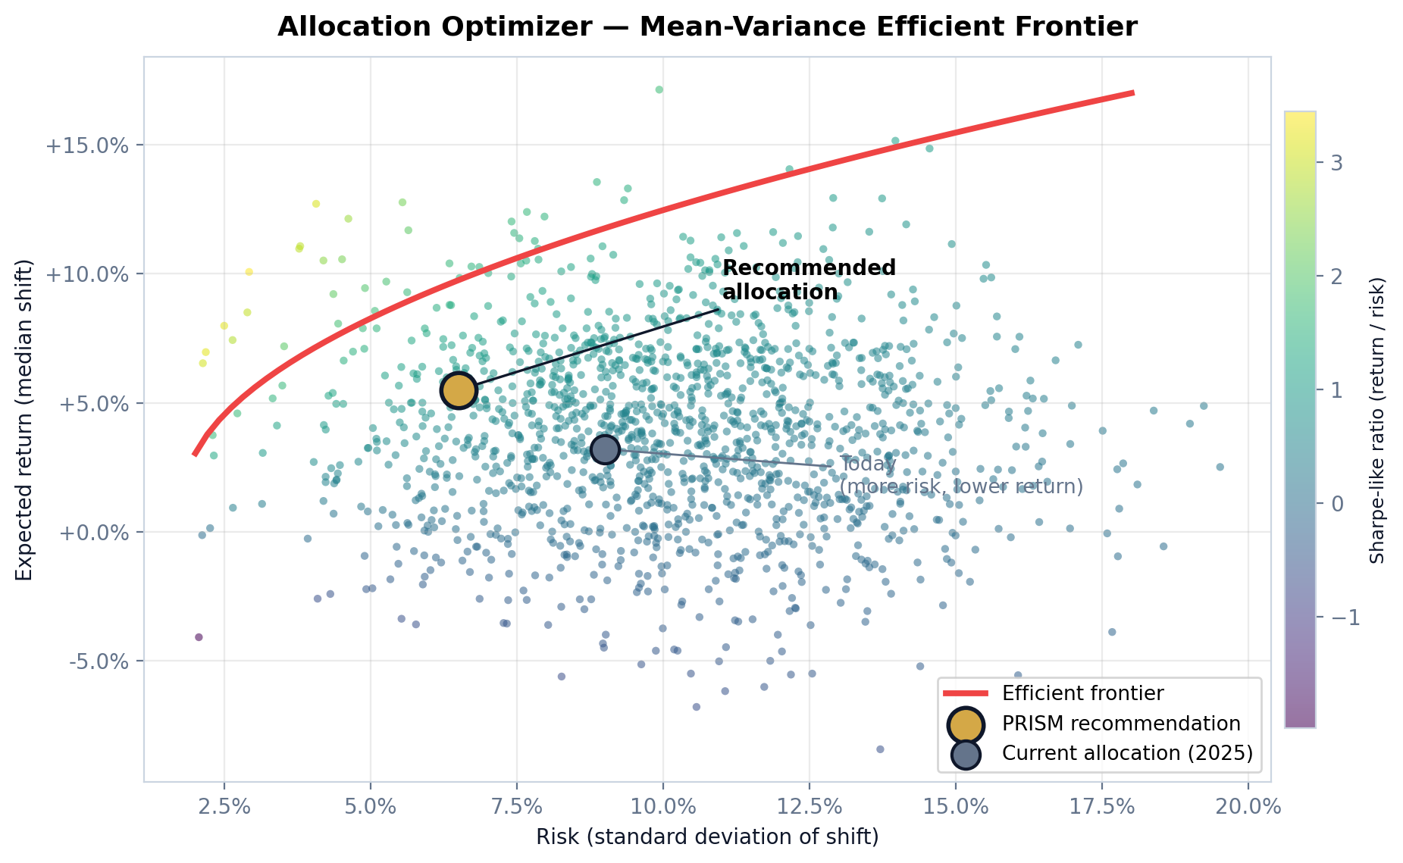
Figure 7.2 — Mean-variance efficient frontier. Every dot is a possible allocation of the twelve categories. The red curve is the efficient frontier (maximum return for each level of risk). The gold star is PRISM's current recommended allocation; the grey dot is Henkel's 2025 actual allocation, which is dominated — lower return at higher risk.
The optimiser outputs relative weights (summing to 1.0, never absolute €M) and a three-tier ranking: invest-more (categories where the optimiser would increase allocation relative to status quo), defend (maintain allocation, protect the position), and harvest (reduce allocation, redeploy to higher-opportunity categories). The recommendation never overrides Finance's hard constraints (cash availability, capex planning) — it is an input to that process, not a substitute for it.
So what?
The four analytics views answer the four questions every strategic decision must address: (1) What's the tail risk? (CVaR); (2) Where is our uncertainty concentrated? (Sobol); (3) What breaks the plan? (reverse stress); (4) When does the world change shape? (tipping points). The allocation optimiser synthesises all four into a concrete 'more / defend / less' recommendation.

8. The AI Layer
PRISM includes four AI modules — Scanner, Narrator, Calibrator, and Chat — each wrapping a large language model behind a purpose-specific interface. All four operate under strict human-in-the-loop rules: the AI proposes, a human disposes, and the audit log records every decision. This chapter explains what each module does, where its outputs plug in, and what the AI never touches.

8.1 Design principles
Three principles constrain every AI module in PRISM. First, AI augments human judgment — never replaces it. Every AI-generated output passes through a human reviewer before entering production data. Second, AI is provider-agnostic. PRISM defines an abstract LLM provider interface and ships three concrete implementations (Anthropic Claude, Azure OpenAI, Ollama for local open-source models); the provider choice is a configuration setting. Third, AI never sees absolute financial data. The input feed is scrubbed through a financial-filter that strips € values, margin figures, and absolute profit-pool data before it reaches the LLM.

8.2 Scanner — trend intelligence
The Scanner module is the inbound pipeline for new trend candidates. It operates on a configurable cadence (by default, weekly) and pulls from a curated set of market-intelligence sources: trade press RSS feeds, regulatory filings, financial-market news, and — when connected — Google Trends and Reddit signals. For each candidate trend, the Scanner produces a structured TrendSuggestion record: proposed force, proposed category exposure, source URLs, initial probability and GP1% estimates, and a summary rationale.
The human reviewer — typically a strategy analyst — accepts, modifies, or rejects each TrendSuggestion. Accepted suggestions enter the Delphi pipeline for expert scoring. Rejected suggestions are recorded with a rejection reason (duplicate, out-of-scope, insufficient source credibility, etc.) which feeds back into the Scanner's own learning loop.

8.3 Narrator — executive narrative generation
The Narrator converts the quantitative Shift Matrix into an executive narrative — a written explanation of 'what changed, why, and what matters.' It is the module most directly exposed to ExCo audiences. A typical Narrator output reads: 'The central path for Hair: Color contracts by 3.2% by 2030. The primary driver is consumer force — specifically the wellness-driven shift away from permanent coloring (consumer_r04, contributing 54% of variance), reinforced by the rise of at-home digital colour tools (technology_r08, 22%). The contraction is accelerating, not stabilising; early-warning trigger: permanent-colour salon volumes in Western Europe.'
The Narrator never invents data. Every claim it makes is grounded in a specific Shift Matrix cell or Sobol index. The prompt engineering includes a grounding check: before generating, the Narrator retrieves the relevant numerical evidence and is required to cite it. The output is passed through a human reviewer before inclusion in any executive deck.

8.4 Calibrator — cross-validation against external signals
The Calibrator compares PRISM's internal Delphi scores against external market signals for a given trend. For example: PRISM currently scores consumer_r02 (GLP-1) with probability 5 and GP1% 0.10; the Calibrator checks whether recent market signals (JP Morgan revisions, FT reporting, Novo Nordisk / Eli Lilly quarterly filings) are consistent with these scores or whether they suggest PRISM is systematically over- or under-scoring. When discrepancies are detected, the Calibrator produces a CalibrationSuggestion for the next Delphi cycle.
The Calibrator does not auto-update scores — the suggestion is an input to the next human Delphi round. This preserves the principle that every production data change is sanctioned by a human reviewer.

8.5 Chat — natural-language query
The Chat module is the conversational interface to PRISM's outputs. A strategy analyst can ask 'why is Hair: Color contracting in 2030?' and receive a grounded answer drawn from the current Shift Matrix, the active trend set, and the Sobol analysis. The Chat module is stateful (maintains conversation history within a session) and scoped (cannot access anything outside the current simulation run's outputs and the trend database).
The Chat's financial filter is particularly strict. It refuses to engage with any query framing that includes absolute € values, margin figures, or profit-pool sizes. When a user asks 'what's the €M impact?', the response is: 'PRISM operates in relative shifts. For €M impact, please consult Power BI with the Shift Matrix export.' This is a deliberate boundary — it keeps the AI layer safely on the PRISM side of the architecture.

8.6 Provider abstraction
All four modules use a shared abstract interface (pulse/ai/provider.py) which defines four methods: complete, stream, embed, and audit_log. Three concrete implementations ship with PRISM: ClaudeProvider (Anthropic API), AzureOpenAIProvider (Microsoft Azure OpenAI), and OllamaProvider (local open-source models for fully on-premises deployments). Switching providers is a configuration change, not a code change. Every API call is logged with token counts and cost estimates for governance review.
So what?
The AI layer is where most organisations get into trouble. PRISM's design keeps it well-contained: provider-agnostic, financial-data-scrubbed, human-in-the-loop, and fully audited. Treat the AI outputs as structured drafts, not conclusions. The audit log is your defence if anything is ever challenged.

9. System Architecture
PRISM is deployed as a Next.js 14 web application on Vercel with a Python FastAPI simulation engine behind it and Neon serverless PostgreSQL as the system of record. A local-development mode with SQLite supports offline work. This chapter describes the architecture at the level needed to interpret the system from outside — not to modify it.

9.1 The production stack
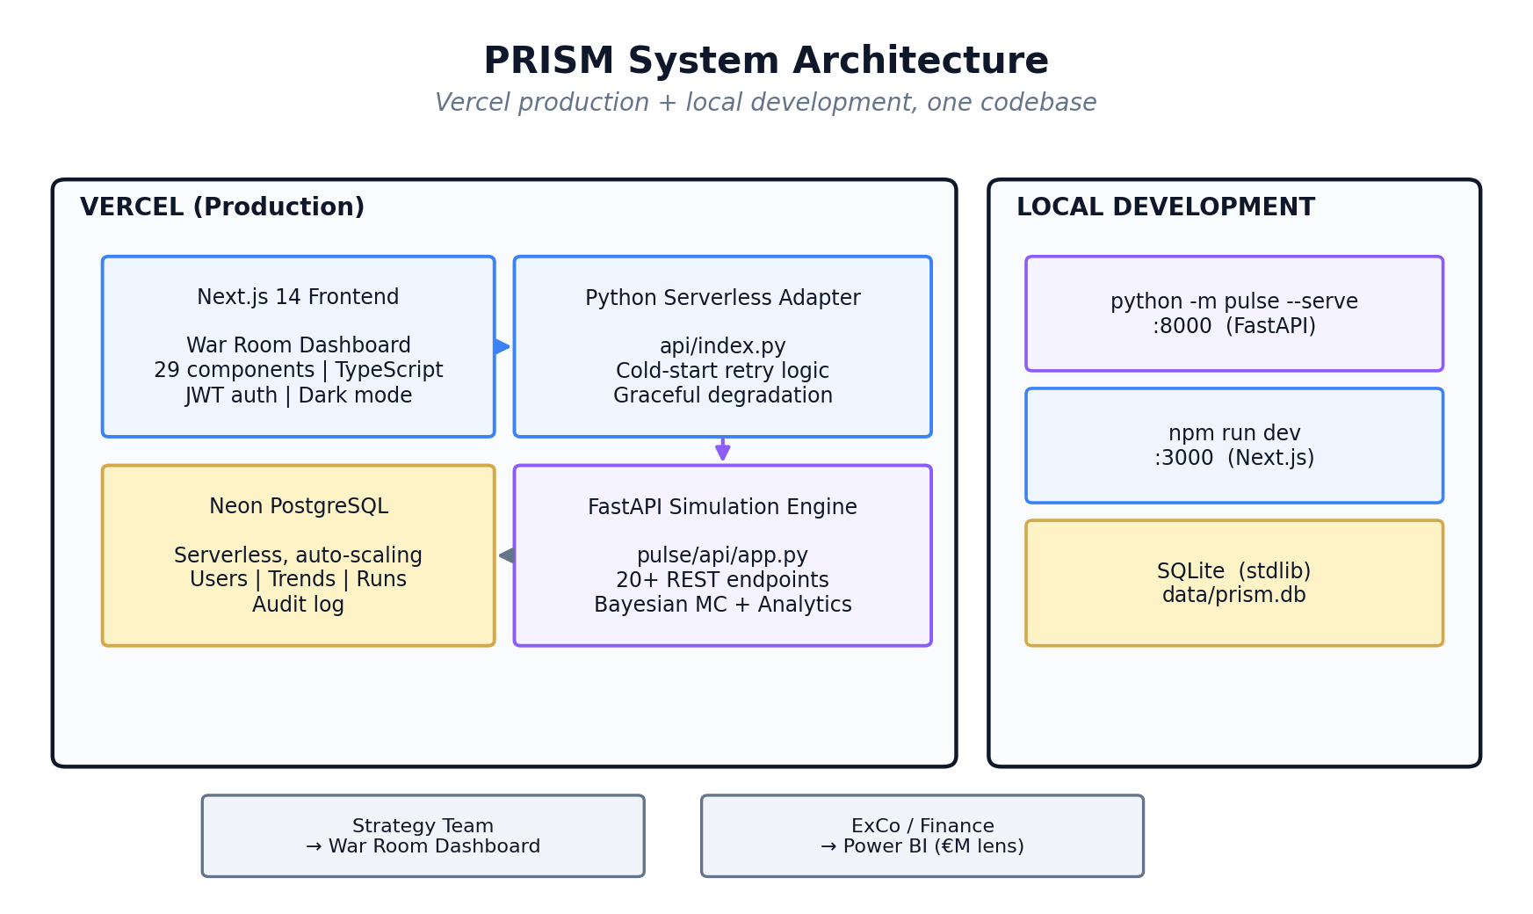
Figure 9.1 — PRISM system architecture. Production runs on Vercel with a serverless Python adapter and Neon PostgreSQL. Local development runs the same codebase against SQLite.
The production stack has four components. The Next.js 14 frontend — the War Room dashboard — is a TypeScript-typed React 18 application deployed as static and server-rendered assets on Vercel's global edge network. It has 29+ dashboard components, JWT-based authentication, dark mode, and onboarding tooltips. The Python Serverless Adapter (api/index.py) wraps the FastAPI simulation engine in a Vercel-compatible handler with cold-start retry logic and graceful degradation. The FastAPI Simulation Engine (pulse/api/app.py) exposes 20+ REST endpoints covering simulation, analytics, Delphi, authentication, and export. Neon PostgreSQL, a serverless PostgreSQL offering, serves as the system of record for users, trends, simulation runs, config snapshots, Delphi rounds, triggers, AI suggestions, and the audit log.

9.2 Local development
The local-development mode uses the same codebase. The backend runs via 'python -m pulse --serve' at localhost:8000; the frontend runs via 'npm run dev' at localhost:3000. The database swaps from Neon PostgreSQL to SQLite (local file at data/prism.db) through a dual-mode abstraction in pulse/database.py. This means developers can run full PRISM simulations offline; it also means QA can spin up isolated test environments without touching production data.

9.3 Two-audience output model
The architecture is deliberately designed to serve two distinct audiences. The React War Room is for the Strategy Office — interactive, relative %, dense with diagnostics. Power BI is for ExCo and Finance — €M, governance-grade, applied against real financial baselines. The same Shift Matrix feeds both, which prevents the two audiences from operating on divergent numbers. This is the 'one source of truth, two lenses' design.

9.4 REST API surface
The FastAPI engine exposes endpoints across eight functional areas. The full surface is documented in the CLAUDE.md specification; the key groupings for a non-technical reader are:
Endpoint family | Purpose | Primary consumer
/trends | Read, update, add trends and their exposure data | Strategy analyst
/simulate | Run Bayesian MC with continuous paths | Strategy Office / Category leads
/analytics/* | CVaR, Sobol, tipping points, reverse stress | Strategy Office
/delphi/* | Create sessions, submit scores, calibration exercises | Delphi panel
/scanner/* | Trigger trend scans, check scan status | Strategy analyst
/auth/* | Register, login, refresh, user management (admin) | All users / IT admin
/export/* | Generate Excel, PowerPoint, Power BI JSON/CSV | Strategy Office / Finance
/audit/log | Read the full audit trail | Governance / IT audit

9.5 Database schema
The PostgreSQL schema is explicitly financial-data-free. There are no columns for absolute € values, no columns for margin percentages, no columns for profit-pool sizes. The schema carries trends, their exposures, simulation runs (storing the Shift Matrix output as JSON), config snapshots, Delphi round records, triggers, AI suggestions, an audit log, and users. All of these are either metadata or relative percentages.
A simulation run record carries: run timestamp, scenario name, iteration count, model type, config snapshot id (for full reproducibility), the Shift Matrix results (JSON), the allocation recommendation (JSON), and convergence diagnostics (R-hat, effective sample size). Rerunning historical simulations is a single API call supplying the config snapshot id.

9.6 Reproducibility
Every simulation run is fully reproducible. The config snapshot captures every tunable parameter — attenuation factor, force weights, category names, materialization schedule, copula parameters, iteration count. The simulation itself can be seeded (python -m pulse --seed 42), producing bit-identical output across runs. This is critical for both debugging and audit: when a category lead questions a result, the analyst can reproduce it exactly.
So what?
The architecture is load-bearing for the trust guarantees PRISM makes. The financial-data-free schema, the provider-agnostic AI layer, the full config snapshot-based reproducibility, and the separation between PRISM (relative shifts) and Power BI (absolute money) are all design choices that make PRISM auditable and governable at scale. Preserve them.

10. Using PRISM in Practice
PRISM is a production system with four user-facing surfaces: the War Room dashboard (daily use), the Excel Shift Matrix workbook (planning cycles), the PowerPoint summary deck (exec reviews), and the Power BI export (financial integration). This chapter is a concise operating guide — not a feature-by-feature reference, but enough for a new Category Lead to be productive in the first week.

10.1 The War Room dashboard
The War Room dashboard at <deployment-url>/dashboard is the day-to-day interface. After login, the landing view shows the Headline KPI bar (current net shift, confidence interval, velocity), a Force × Category heatmap, and an AI Insights notification bar. From there, six core workflows branch off:
- The Heatmap is the primary navigation device. Click any cell to drill into that category's full path, percentile bands, Sobol drivers, and narrative.
- The Path Timeline shows the continuous 2026–2036 trajectory with confidence bands. It is the view to share with category team meetings.
- The Trend Explorer lists all 82 trends with filter controls (force, direction, peak year, tier). Click any trend for its full record, posterior distribution, and Delphi history.
- The Force Waterfall and Radar charts decompose a category's shift by force — which of the six forces contributes most to the projected movement?
- The Delphi Panel is used during scoring cycles. Experts submit scores, see the round distribution, and handle outlier rationales.
- The Analytics tabs (CVaR, Sobol, Tipping Points, Reverse Stress) surface the advanced analytics output with visualisations tailored for each.

10.2 The Excel Shift Matrix workbook
At the end of each simulation run, PRISM produces an Excel workbook downloadable from /export/excel. The workbook has four sheets. Sheet 1 ('Shift Matrix') is the raw numerical matrix: 12 categories × 11 years × 5 percentile bands. Sheet 2 ('Velocity & Triggers') carries the derived velocity and acceleration plus any fired trigger alerts. Sheet 3 ('Allocation') carries the mean-variance optimiser output with invest/defend/harvest rankings. Sheet 4 ('Metadata') carries the config snapshot — every parameter that produced the run, plus the run timestamp and run id.
Category leads typically use Sheet 1 for planning input, Sheet 2 for early-warning monitoring, Sheet 3 for allocation debates, and Sheet 4 for governance/reproducibility. The workbook is Henkel-branded in its styling (category colours match the brand colour system — see the design-system reference) but its numerical content is the identical Shift Matrix that feeds Power BI and the dashboard.

10.3 The PowerPoint summary deck
The six-slide executive deck downloadable from /export/pptx is purpose-built for ExCo and senior-leader presentations. Slide 1 is the title. Slide 2 is the Shift Matrix heatmap — the single most important visual. Slide 3 is the allocation recommendation. Slide 4 is a selected path timeline (category lead picks which category to highlight). Slide 5 is a one-page methodology overview. Slide 6 is the technical appendix (iteration count, convergence, copula parameters). The deck is Henkel-branded in colour scheme and carries the simulation run ID in the footer of every slide for audit traceability.

10.4 Power BI integration
The Power BI export at /export/shift-matrix produces a flat JSON/CSV file: one row per category × year. Each row carries all five percentiles, the velocity, the acceleration, the force attribution, and the run id. This flat format is designed for ingestion into a Power BI semantic model where Finance applies the shifts to their absolute €M baselines.
The canonical Finance workflow: load the PRISM flat export into the Power BI dataset, join to the master financial baseline (most recent actuals or approved budget), multiply the baseline by (1 + shift_median) to produce the central case, and by (1 + shift_p25) and (1 + shift_p75) to produce the planning range. Finance retains full control of which baseline is used and how the percentile bands translate into planning envelopes.

10.5 The annual planning cycle
PRISM is embedded in Henkel Consumer Brands' annual strategic planning cycle at four points. In Q1 (January–March), the Strategy Office runs the annual calibration — parameter review, a full Delphi Round 1, and a governance check on trend retirements/additions. In Q2 (April–June), the full 50,000-iteration simulation runs, producing the annual Shift Matrix, the allocation recommendation, and the category review decks. In Q3 (July–September), a mid-year refresh runs — AI Scanner pass, trigger check, velocity review, limited Delphi updates on any trend that has moved materially. In Q4 (October–December), the final Shift Matrix is integrated into budget planning and the ExCo presentation.
So what?
PRISM rewards disciplined, cyclical use. One-off consultation produces one-off insight. Running the full annual cycle, preserving the config snapshots, and treating the Shift Matrix as a canonical artefact in every planning discussion is what converts PRISM from a dashboard into a strategic operating system.

11. Limitations & What's Next
PRISM is a production system with honest, well-documented limits. Pretending otherwise would be inconsistent with the discipline the system is trying to enforce. This chapter lists, with no hedging, what is fully built, what is stubbed, and what remains in the architectural vision.

11.1 Production — fully built and operating
Module | Status
Bayesian Monte Carlo with Gaussian + t-copula dependencies, Beta priors | Production
Continuous path modelling with 5 MECE diffusion curves (2026–2036) | Production
CVaR computation with per-category risk decomposition | Production
Sobol global sensitivity (S1, S2, ST via SALib Saltelli sampling) | Production
Reverse stress testing (scipy differential evolution) | Production
Tipping-point detection (second-derivative analysis) | Production
Mean-variance allocation optimiser with efficient frontier | Production
Delphi expert elicitation with multi-round DB persistence | Production
AI Scanner, Narrator, Calibrator, Chat — all four modules | Production
Excel / PowerPoint / Power BI export center | Production
War Room dashboard (Next.js, 29+ components, auth, dark mode) | Production
FastAPI REST API (20+ endpoints) with JWT auth and admin roles | Production

11.2 Stub — method signatures present, implementation incomplete
One module is currently a stub: the sensitivity.py module that would provide tornado analysis, breakeven analysis, and force-elimination analysis. The method signatures exist in pulse/simulation/sensitivity.py but all five methods raise NotImplementedError. The workaround is that CVaR and Sobol analyses provide the critical sensitivity insights — Sobol for 'which trend matters most' and CVaR for 'what happens in the tail'. Tornado analysis, which would give a per-trend one-at-a-time perturbation ranking, is a complement rather than a substitute. The module is on the H1 2026 roadmap.

11.3 Not yet built — roadmap items
Four modules are fully designed in the architectural specification but not yet built:
- Causal DAG module (pulse/causal/dag.py). This would model explicit directed-acyclic-graph propagation between the six forces with lag structures — for example, a regulatory event triggering reformulation costs triggering shelf-price changes triggering consumer-behaviour shifts, each with a configurable lag. The current workaround is the force correlation matrix in config.py, which provides simplified dependency modelling. A full causal DAG would improve resolution on cross-force transmission mechanics.
- Game theory layer (pulse/game_theory/competitive.py). This would model explicit competitive-response archetypes (premium defender, sustainability leader, cost challenger, etc.) for P&G, Unilever, Reckitt, and others. The current workaround represents competitive intelligence as static trends in the trend database, which captures the direct effect of competitor moves but not the strategic game structure.
- Backtesting engine (pulse/backtesting/engine.py). This would calibrate the attenuation factor — currently assumed at 0.5 — empirically against historical V1 through V11 assessments and actual realised profit-pool shifts. The prerequisite is that historical version data be made available in a structured form. Until then, the attenuation is labelled 'assumed, not calibrated' in every run's metadata.
- External API integrations (pulse/integrations/). A set of 19 free-tier APIs was mapped in the original architectural vision (GDELT, ECHA, EUR-Lex, SEC EDGAR, Google Trends, Reddit, FRED, and others). The AI Scanner currently uses the LLM provider for trend intelligence rather than direct API integration. Wiring the specific APIs would add signal redundancy and reduce dependency on the LLM for sourcing.

11.4 Known methodological caveats
Three methodological caveats deserve explicit acknowledgment:
- The attenuation factor is assumed, not calibrated. Without the backtesting module, PRISM cannot empirically derive attenuation from historical data. A scenario-sensitivity run at attenuation 0.4 and 0.6 should accompany any high-stakes use of a PRISM output.
- Copula parameters are assumed, not calibrated. The default within-force correlation ρ = 0.3 and the cross-force correlation matrix are based on expert judgment, not historical fit. The system is designed to update these as calibration data becomes available.
- Trend probabilities above 5 and GP1% above 1.0 are structurally impossible. In a small number of cases — most notably consumer_r02 GLP-1 — expert opinion may genuinely hold that the probability is near-certain and the scope is larger than 10% of the category pool. These cases are capped at 5 and 1.0 respectively, which may produce a slight downward bias in the most-aggressive scenarios. An expanded scoring scale is under consideration for v3.2.

11.5 Roadmap priorities
In priority order, the next build-phase targets are: (1) Implement the sensitivity.py stub to production quality. (2) Wire the first five external APIs into the Scanner — GDELT, ECHA, EUR-Lex, FRED, Google Trends. (3) Add a scheduled Power BI sync to eliminate the manual re-export step. (4) Build the Causal DAG module against a simplified two-force pilot before scaling to all six. (5) Build the backtesting engine once historical V1–V11 data is structured.
So what?
PRISM in April 2026 is production-ready for the Strategy Office's 2026 planning cycle and will get better over 2026–2027 as the roadmap is delivered. The honest limitation register is more valuable than a feature list — it tells you where PRISM should be challenged and where a second pair of eyes adds the most value.

12. Appendix

A. Glossary
Strategic terms, methodological terms, and acronyms used in this manual and in PRISM's outputs.
Term | Definition
Acceleration | Year-over-year change in velocity; second derivative of the path. Positive acceleration = speeding up; negative = stabilising.
Allocation optimiser | Mean-variance portfolio optimisation module that turns Shift Matrix output into an invest/defend/harvest recommendation.
Attenuation | Scaling factor (default 0.5) that translates direct force impact to realised profit-pool shift. Currently assumed, not calibrated.
Bayesian Monte Carlo | Simulation technique that samples from distributions (not fixed inputs) and updates those distributions as evidence accumulates.
Beta distribution | Continuous probability distribution on [0,1] with two shape parameters (α, β). Used to store PRISM's probability estimates.
Calibrator | AI module that cross-validates PRISM's internal scores against external market signals and produces CalibrationSuggestions.
Category | One of twelve Henkel Consumer Brands business lines (Hair: Color / Care / Styling / Body; LHC: FCN / FCA / FFI / LAD / HDW / ADW / HSC / IC).
Copula | Mathematical construction coupling marginal distributions to a joint dependency structure. PRISM uses Gaussian + t-copula tails.
CVaR | Conditional Value-at-Risk; average loss in the worst X% of outcomes. Tail-risk measure.
Delphi | Multi-round structured expert-elicitation protocol. PRISM uses the classical three-round variant.
Diffusion curve | Functional form describing when a trend's impact materialises. PRISM supports five MECE types.
Direction | Trend attribute: expansion (+) or contraction (–).
Force | One of six top-level drivers of category shifts: Consumer, Customer, Technology, Government, Environmental, Competitive.
GP1 % affected | Trend attribute: continuous value in [0.0, 1.0] indicating share of category profit pool at stake.
Horizon | H1 = Execution (2026–2028); H2 = Disruption (2029–2032); H3 = Transformation (2033–2036).
Krippendorff's α | Statistical measure of inter-rater reliability used in Delphi round 1 diagnostics.
Narrator | AI module that converts Shift Matrix output into executive narrative.
Posterior | In Bayesian updating, the distribution after combining prior and new evidence.
Prior | In Bayesian updating, the distribution before new evidence is incorporated.
Reverse stress test | Analysis that finds the minimum parameter perturbation producing a target adverse outcome.
Shift Matrix | PRISM's primary output: category × year table with five percentile values per cell. Relative, not absolute.
Sobol indices | Global sensitivity decomposition into first-order (S1), second-order (S2), and total-order (ST) contributions to output variance.
Tier (source) | Credibility classification for trend sources, S through E. Tier E sources are refused at entry.
Tipping point | Structural inflection in a category's continuous path: sign reversal, threshold breach, or regime change.
Velocity | Year-over-year change in median shift; first derivative of the path.

B. Category × Brand mapping
Reference mapping of the twelve categories to Henkel Consumer Brands' brand portfolio.
Code | Category | Representative brands
Hair: Color | Hair Color | Schwarzkopf Keratin Color, Palette, Igora, BlondMe, Diadem, got2b Color
Hair: Care | Hair Care | Schwarzkopf, Gliss, Schauma, Syoss, Olaplex, Joico, Kenra, Alterna
Hair: Styling | Hair Styling | got2b, Taft, Osis+, Sexy Hair
Hair: Body | Body Care | Fa, Dial, Barnängen, La Toja
LHC: FCN | Fabric Cleaning (Laundry Detergent) | Persil, All, Purex, Weißer Riese, Dixan, Le Chat, Sun
LHC: FCA | Fabric Care (Delicates) | Perwoll
LHC: FFI | Fabric Finisher (Softener) | Vernel, Silan, Snuggle, Purex Softener
LHC: LAD | Laundry Additives | Snuggle Scent Boosters, Purex Fragrance Boosters, Purex Dryer Sheets
LHC: HDW | Hand Dish Wash | Pril, Pur, Nelsen
LHC: ADW | Automatic Dish Wash | Somat, Pril Automatic, Top Shelf
LHC: HSC | Hard Surface Cleaner | Bref, WC Frisch, Sonasol, Blue Star, Soft Scrub, DAC
LHC: IC | Insect Control | Catch, Home Mat, Home Keeper

C. Technical specifications summary
One-page reference for the technical reader.
Specification | Value
Simulation iterations (default) | 10,000 per run; configurable to 100,000
Time horizon | 11 years (2026–2036), baseline 2025
Path discretisation | Annual continuous paths; 5 percentile bands per cell
Copula | Gaussian (bulk) + t-copula (tails); Cholesky decomposition
Default within-force correlation | ρ = 0.3
Default attenuation | 0.5 (assumed, not calibrated)
Diffusion curves | 5 MECE types: S-curve, linear, front-loaded, back-loaded, step-function
Trend probability storage | Beta(α, β) posterior, updated via Beta-Binomial conjugacy
Active trends | 82 (55 original global + 6 regional + 21 net v3.1 expansion)
Force classification | 6 forces, MECE partition
Categories | 12 (4 Hair + 8 LHC)
Value-chain steps | 8
Regions | 4
Source tiers | S, A, B, C, D, E (E hard-gated)
Delphi rounds | 3 (blind, anchored, outlier-discussion)
Backend framework | FastAPI (Python) + Uvicorn (local), Vercel Serverless (production)
Frontend framework | Next.js 14, React 18, TypeScript 5
Database (production) | Neon serverless PostgreSQL
Database (local) | SQLite (stdlib)
LLM providers supported | Anthropic Claude, Azure OpenAI, Ollama (local)
Auth | JWT (Jose), bcrypt password hashing, access 1h + refresh 7d
Export formats | Excel (.xlsx), PowerPoint (.pptx), PDF, JSON, CSV
Model version (April 2026) | bayesian_copula_v2.4 / PRISM spec v3.1

D. Document control
Title: PRISM — Methodology, Architecture & Operating Manual (Project Closure)
Version: 3.1 — 21 April 2026
Supersedes: PRISM_Methodendokumentation_v3.docx (February 2026)
Classification: Confidential — Henkel Consumer Brands internal use only
Prepared by: Bain & Company — Strategy × Quant × Technology Practice, in partnership with the Henkel AI Centre of Excellence
Contact: Strategy Office, Henkel Consumer Brands (Düsseldorf)
— End of document —

