## CSEE 5590 0001- Python and Deep Learning

## Fall 2018

## Python Lab Assignment 1

## Submitted On 9/18/2018

## Name: Alexandria Piatt and Alexander Larios

## Class IDs (respectively): 23 15

## TABLE OF CONTENTS

## 1. Author

## 2. Objective

## 3. Features

## 4. Configuration

5. Input/Output Screenshots

6. Implementation & Code Snippet

7. Limitations

8. References

**AUTHORS**

This is the lab report for the first Lab Assignment in CS 5590 0001 Special Topics. The authors of this document are ALEXANDRIA PIATT (ID: 23) and ALEXANDER LARIOS (ID: 15), both Seniors pursuing a Bachelors in Computer Science at University of Missouri Kansas City. The course is taught by Saria Goudarzvand.

**OBJECTIVE**

This lab’s objective was to solidify the in class work to learn basic python structures and concepts. The specific skills practiced in this lab are listed below.

* Sets
* Web Scraping
* Searching through strings and list manipulation
* Classes and inheritance

This is accomplished by completing a series of six tasks. A brief description of these tasks are:

* Searching a string to find the first non-repeating characters
* After being given a list of students in two separate classes, return students that are in one class but not the other.
* Using BeautifulSoup, return a table on a given website.

**FEATURES**

Task 1:

***Find the first non repeated character in a string***

The program can take a user inputted string. It will search through the string for unique characters and will return the first one it finds.

Task 2:

***Read in two text files and output the words from file1 that are not present in file2***

The program reads in both text files and adds all the elements separated by spaces into two arrays. The words in the array from the second file are then checked against the words from the first file and if a word is present it is removed from the array of words from the first file. Once all the words have been checked the new array of words from the first file that were not present in the second file are output.

Task 3:

***Find students in the python class but not in the web application class***

Given a list of students for each class, the code will return which students are enrolled in only the python class.

Task 4:

***Create the classes for a hospital admission system***

The program creates a object of every class and calls their methods and then calls their print details() method to output their attribute data.

Task 6:

***Using requests library output the results of a table from a specified website to a file***

Given a website (listed in the assignment), use the requests library (and BeautifulSoup) to scrape the table from the website and out

**CONFIGURATION**

All of the code in this lab was written and built using PYCHARM IDE, in an Anaconda3 environment and using Python 3.6.

**INPUT/OUTPUT SCREENSHOTS**

Task 1:

The below screenshot shows the user inputted string and returns the first unique character. The string is not just restricted to letters and numbers, but also works with characters such as !@#$%^&*() as well.

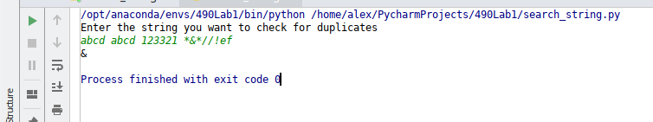

Task 2:

The below screenshot shows the output of FileDifference.py , Three arrays are output, one from the first text file, one from the second text file, and the words from the first text file that were not present in the second text file.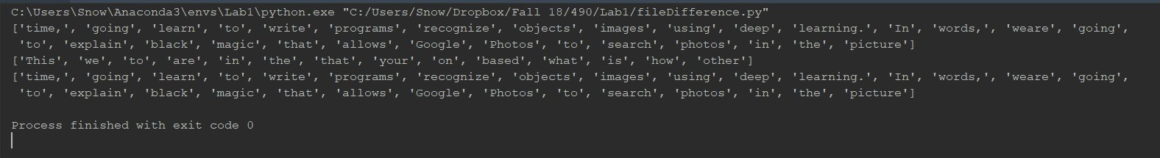

Task 3:

The below screenshot shows the output from the small script that determines the students that are only enrolled in Python Class but not Web Applications class.

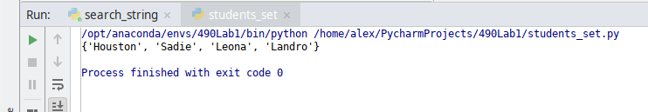

Task 4:

The below screenshot shows output from the program that constructs objects of multiple hospital classes and outputs their attribute details.

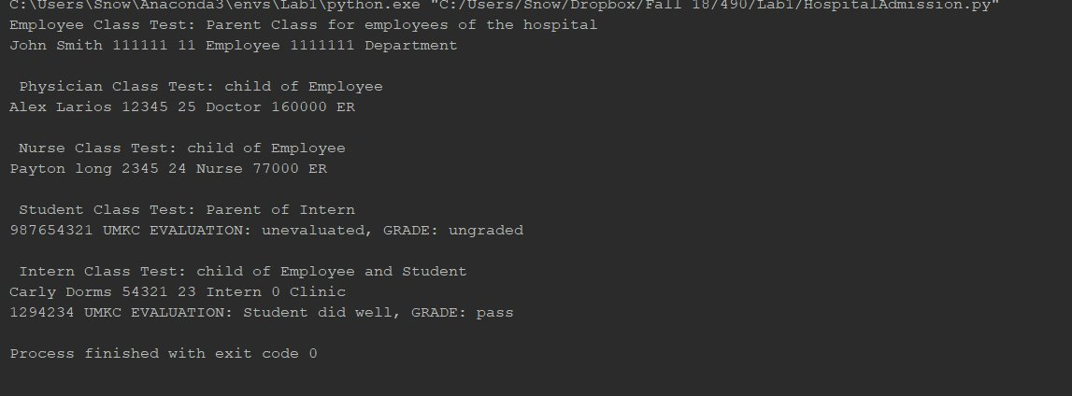

Task 6:

The code takes a URL and parses the HTML code. It finds a table and then outputs the table on the page to a text document.

The below screenshot shows the tables outputted to the file. There are multiple tables on the page, so there are multiple outputs.

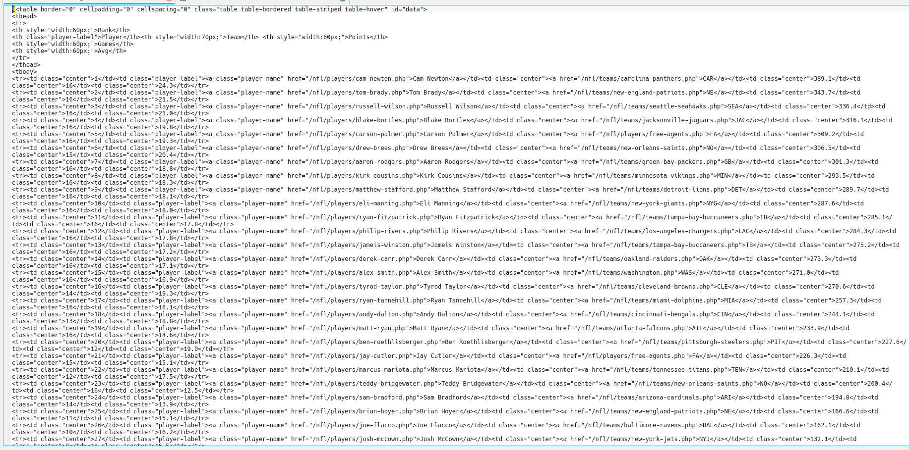

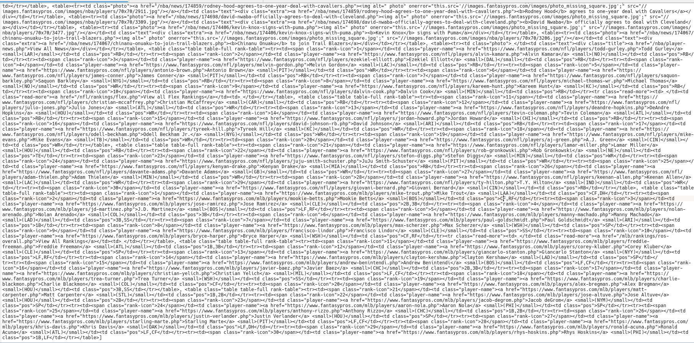

**IMPLEMENTATION & CODE SNIPPET**

Task 1:

Python has flexible variable typing. By breaking the string into a list of characters, it was simple to iterate through the list and count each character’s occurrences in the list. Because of the flexibility of the string variable type, there are not any restrictions on what the user can type in.

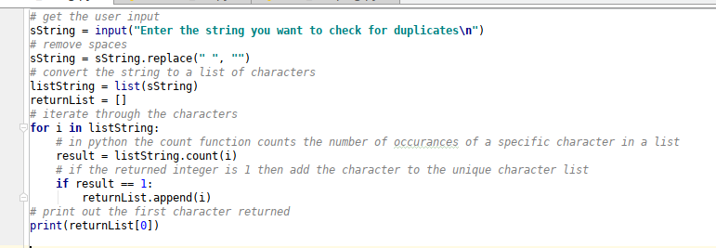

Task 2:

There are two functions. One for reading in the initial text files and adding the words to two arrays. The second function takes both arrays and checks if any of the words in the second array are present in the first, if so then it removes that word from the first array.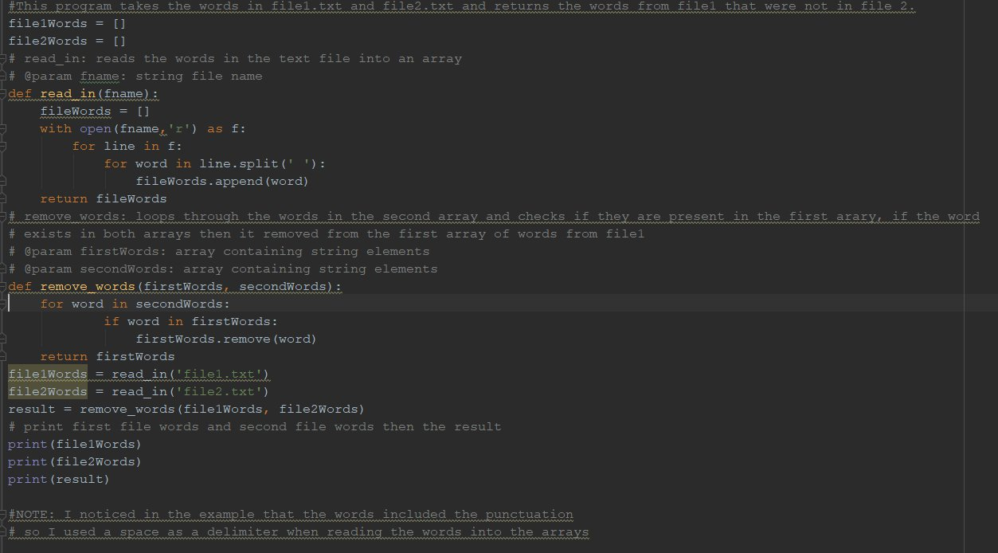

Task 3:  
Finding the differences between two unique lists of data (sets) in python is very simple in python. With the use of sets, it will only take a few lines of code.

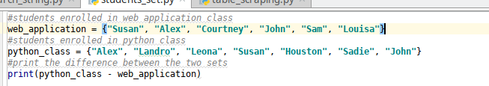

Task 4:

5 classes are initialized. 3 of the classes are child classes that inherent from Employee or both Employee and Student. Objects are then constructed at the end and a call is made to their print_details() method to output their attributes.

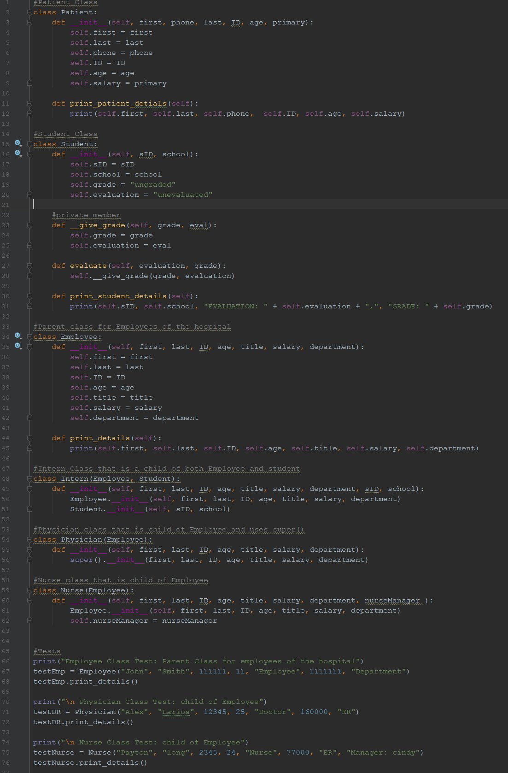

Task 6:

The first step of working with websites in python is importing the appropriate libraries. In this case, I used BeautifulSoup and requests. The first step is to process the url and store the data from the website in a variable. This is done using the request library. Next is to convert the raw data from the website into a text format. Afterwards, use BeautifulSoup to parse the text into an object that uses the power of the BeautifulSoup library. The find_all function in the BeautifulSoup library searches through the parsed html data and returns all of the tables on the site. The last thing to do is output it to a text file.

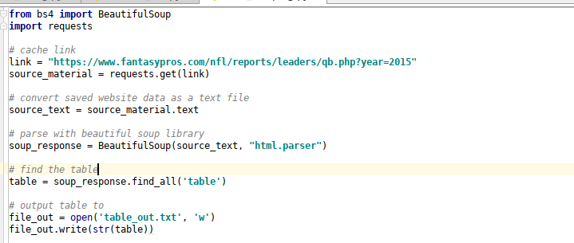

**LIMITATIONS**

**REFERENCES**

<https://docs.python.org/3/tutorial/inputoutput.html>

https://www.analyticsvidhya.com/blog/2015/10/beginner-guide-web-scraping-beautiful-soup-python/