Alexander Lauinger (al60) Booster HW 0 Writeup

Q1: Which joints are actuated, and how can you tell from the XML alone?
The slider joint is actuated. I can tell from the XML alone due to the slider joint being surrounded by <actuator> tags

Q2: What is the total actor observation dimension, and why is the pole angle 2 numbers instead of 1?

The total actor observation dimension is 2. The pole angle is 2 numbers (cos theta and sin theta) to remove discontinuity of going from an angle of 2pi to an angle of 0. Using the cos and sin values allow the input to stay at a continuous when rotating a full 360 degrees/2pi.

Q3: With --agent zero in Balance mode, roughly what reward does viser show, and why isn't it exactly 1.0? (Hint: reset events.)

Viser shows the smooth reward starting around .998 This is likely due to the position of slider and hinge on reset. On reset, the python script sets the position of the slider within the range (-0.1, 0.1) and the position of the hinge within the range (-0.034, 0.034). Because the positions are not perfectly center, and perfectly vertical, the reward will not start at exactly 1.0
Q4: From the log: roughly how many env-steps/second did you get?

I got around 420,000 steps per second

Q5: Play the resulting checkpoint (use the Step 6 command with the cartpole task). Describe in one or two sentences what the policy does.

The policy moves the cart to one side and then back to the middle in a quick motion to build the pole’s momentum and bring it over the top of the cart. It then slows down, applying force in the opposite direction of the pole's movement,causing the pole to balance. Interestingly and intuitively, the cart seems to make the same motion when the pole is below and above it, and it only uses one half of the rails.

My reward design was very similar to the reward design for the single cartpole reward system. The main change was adding a second hinge reward for the new hinge. The reward for this second hinge is the same as that for the first hinge, as since we want both hinges to be upright, the reward will be 1 when the hinges are upright. I multiplied the rewards of both of the hinges, along with the reward of the cart position. This means that the reward will be zero even if one of the hinges is vertical and the cart is in the middle, as we only want to reward the system if all 3 factors are good.

- When watching early training checkpoints of the swingup operation, I see the cartpole swinging constantly at a high velocity. It makes sense to terminate a run once the velocity gets to a certain level, as a high velocity will probably never lead to a successful run. The reward system also rewards lower velocities so runs where the cartpole swings at a high velocity are always rewarded poorly.
- There is no “pole fell over” termination on the swingup task because the pole always starts in a “fallen over” state when at the bottom of the cart. If the termination existed during the swingup task, the training would never occur because each run would terminate as soon as it started due to the starting state of the pole.

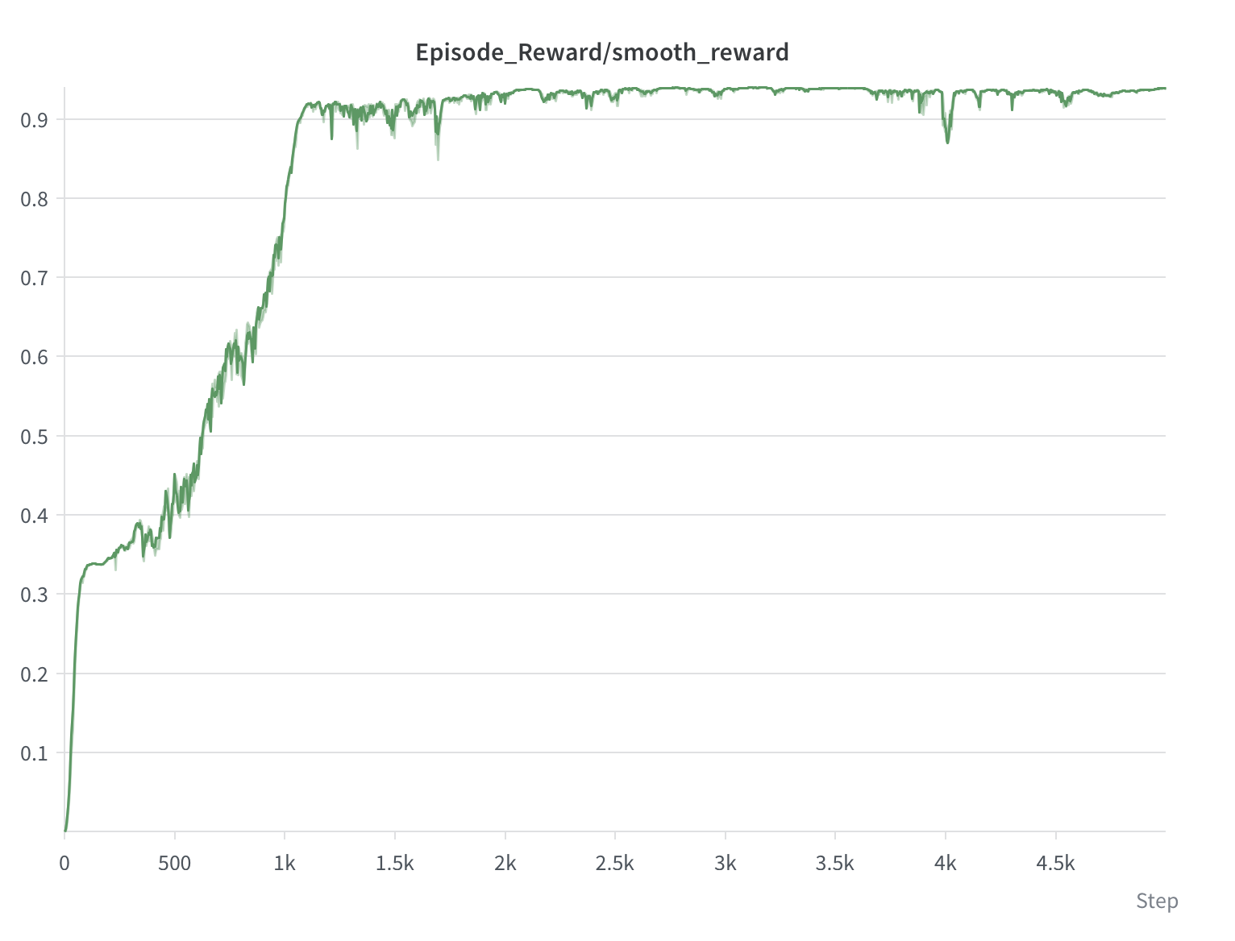
Task ID: Course-Cartpole-Double-Swingup
Run Directory: hw0/logs/rsl_rl/cartpole_double/2026-09-16_21-08-25
Checkpoint Filename: model_4999.pt

