Module New Venture Strategy (MNA1201)
Name of Student Alexander Meehan
Student ID A00091665
Word Count 1370

ConcussID - A New Venture to Increase Player Welfare and Safety

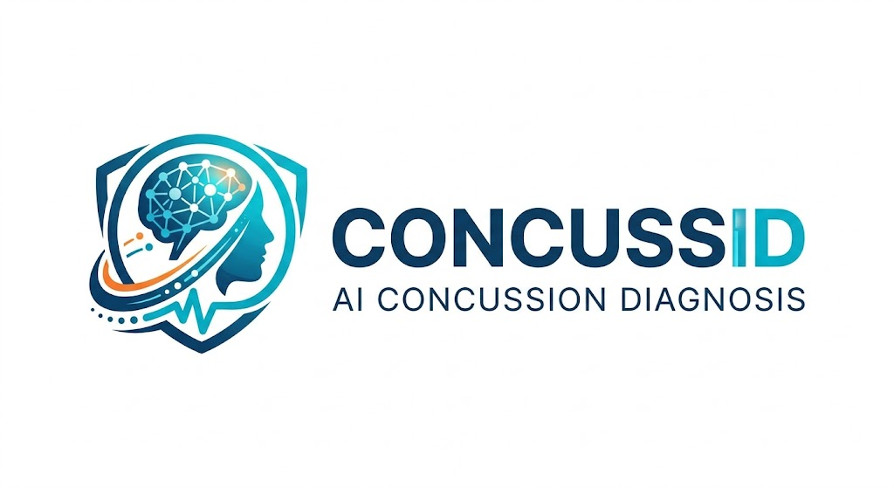
“We provide accessible concussion diagnosis for amateur athletes who do not have access to sports medicine professionals, improving the health and well-being of grassroots sports people.”

Venture Overview
Delayed concussion symptoms or missed head collisions are a growing problem in amateur sports today (Leahy et al., 2020), with many going unreported or undiagnosed. Speaking from my own experience both myself and my teammates have experienced a head collision resulting in a concussion that was missed by both match officials and coaching staff.

ConcussID is an AI app powered that uses facial and speech recognition and a host of baseline questions to help to identify concussion in grassroots athletes and those who participate in contact sports. ConcussID will be able to diagnose concussion and to provide a tailored rehabilitation plan based on the player's symptoms during their recovery.

ConcussID aims to help amateur players of contact sports and coaches that may not have immediate access to a physiotherapist or doctor to diagnose concussions on the pitchside. Current IRFU guidelines do not allow for a HIA (Head Injury Assessment) during a game. By law, those who have suffered contact to the head are to be taken off the field of play, but oftentimes these collisions go unnoticed by match officials and either the player remains on the pitch, or refuses to leave the field of play. Continuing to play without allowing adequate recovery time, resulting in more injury to the brain and increasing the risk of Traumatic Brain Injury (TBI), blood clots and CTE (Chronic traumatic encephalopathy) (Cleveland Clinic, 2024).
SDG Alignment
ConcussID will be built to align with SGD 3 as it aims to improve the health and wellbeing of those involved in contact team sports by allowing access to concussion diagnosis and protocol where a doctor or physio might not be available to a team.
SDG 3 ensures healthy lives and promotes well-being at all ages (UN DESA, 2026). By using ConcussID to screen for concussion symptoms in amateur players, player welfare and well-being will be improved and protected, allowing them to participate in sport in a safe and healthy manner.
ConcussID also aligns with SDG 10 aiming to reduce inequalities (UN DESA, 2026), which aims to empower and promote the social, economic and political inclusion of all. In Irish amateur sport, access to pitchside medical care is largely determined by a club's financial resources. Well-funded clubs and teams routinely have physiotherapists and sports medicine physicians present at games and training, while the majority of grassroots clubs do not. This disproportionately affects athletes in lower-resourced communities. ConcussID directly addresses this inequality by providing an accessible, affordable concussion screening tool that gives every player access to immediate concussion diagnosis and aftercare.

Target Market & Beneficiaries

The primary user and customer of this app will be sports clubs and team coaches. The pain point being addressed by ConcussID is the inability to access a sports medicine professional to diagnose concussion and implement a safe rehabilitation protocol for the player.
Beyond sports clubs and team coaches, ConcussID will also help parents who have children participating in amateur sport, and of course ConcussID will help players and their families by providing peace of mind that they have access to immediate concussion care, reducing inequalities within sports medicine at an amateur level.

There is a clear need for this product among amateur players of contact sports. The three most popular contact sports in Ireland are Gaelic Football, Hurling and Rugby . All of these sports put the player at high risk of a head injury due to the physical nature. In Ireland there are approximately 22,000 amateur sports clubs and teams, consisting of multiple mens, ladies and underage teams that can avail of ConcussID. The Service Obtainable Market (SOM) would be roughly 6.5 thousand units, based on an estimate of 2,200 GAA clubs in all 32 counties (GAA, 2026), and 200+ amateur rugby union clubs within Ireland, all consisting of mens, ladies and underage teams. This SOM assumes that at least three of the teams within these clubs will not have the funding or resources for a physiotherapist to be present at every game and training. This means that ConcussID has both market demand and scalability potential.

Addressable Market | Units | Rationale
Total Addressable Market | 22,000 | Each club with ≈ 10 teams
Serviceable Addressable Market | 13,200 | Assuming that 40% of these teams have full time access to a sports medicine physician
Serviceable Obtainable Market | 6,500 | The total obtainable market based on an assumption that 6,500 teams cannot afford or access a sports medicine physician

Venture Model

The app will be released digitally on both the Google Playstore and the App Store, meaning that it will be available on all mobile devices on launch. The app will be made accessible to both organisations on a subscription based model, and individuals on a one-time-payment model. Organizations who purchase the subscription will be provided with a product key to allow an allotted amount of devices to access ConcussID’s features. Individuals who wish to avail of the services can pay for one-time-use (OTU) evaluation. The price points have been chosen to provide a lifetime value (LTV) three times larger than the customer acquisition cost (CAC).
An example of the revenue model can be seen below:

Club Based Subscription Model
1 year subscription for one to three teams = €650/year,
1 year subscription for three to five teams = €825/year,
1 year subscription for five to ten teams = €1050/year.

Individual One-Time-Payment
One time access to the software = €1.99.

Although app development will be carried out by crowdfunding, an application will be made to sport Ireland to avail of the Digital Catalyst Grant. This grant supports digital transformation endeavours for the Irish sports sector (Sport Ireland, 2026). After initial set up and grant approval, the IRFU and GAA will be approached to become a major stakeholder in the company, allowing for integration with the IRFU’s return to play protocols. Partnering with the IRFU and GAA will also aid in tracking the incidence of concussion in amateur sport, allowing for more research to be carried out on the subject, further fulfilling SDG 3 and SDG 10.

Feasibility & Challenges

Initial investment will be bootstrapped via crowdfunding. An initial investment of €85,000 will be needed to fund the hiring of an app developer, consultation with sports medicine physicians, use of the training set and for marketing purposes. The hiring of a sports medicine physician is essential as this will ensure that the app will meet all medical and ethical standards when diagnosing concussion.
Beyond the initial investment needed to build the app, Sport Ireland will be approached to provide funding for the project via the Sports Ireland Digital Catalyst Fund (Sport Ireland, 2026), as will the IRFU and GAA will then be approached to endorse ConcussID, as to aid in nationwide adoption of the app within local communities.

By using machine learning and AI facial and speech recognition software, this app will help players and coaching staff to identify players with a concussion without a clinician present. Ethical concerns may arise from the use of facial and voice mapping, and from the storage of health data. Applying and adhering to EU GDPR Art 6 (Intersoft Consulting, 2026) would reduce the risk of a data breach. Furthermore, designing the app in accordance with both IRFU and HSE data and privacy guidelines will ensure that the app would be safe for users.

Impact Measurement
Many grassroots teams in contact sports do not have immediate access to physios or doctors on the pitch side, be it through stressed resources or lack of funding. This often leads to players who have suffered a mild to moderate head injury to remaining on the pitch. Addressing this issue will fulfill SDG 3 by improving player welfare and wellbeing through early diagnosis and prevention or further injury.
With surveys finding that almost three-quarters (72.7%) of participants had sustained a suspected concussion in the past, however only 39.8% had received a medical diagnosis of concussion (Leahy et al., 2020). Tracking the rate of positive diagnosis made by ConcussID, metric will allow for an impact analysis, to ensure that ConcussID is meeting the goals set out by SDG3. An increase in diagnosis will also be indicative of a more inclusive and equal world in sports medicine.

Business Model Canvas

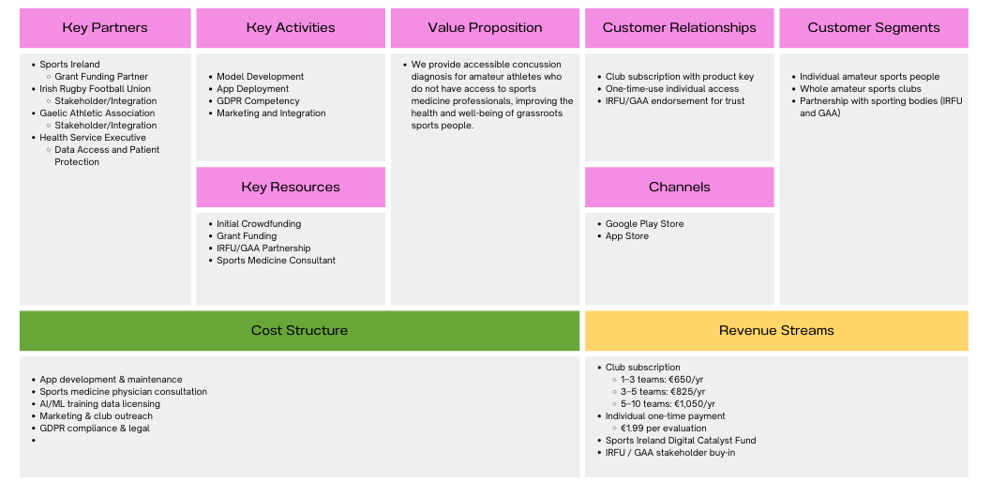

References
Leahy, R., Farrington, S., Whyte, E. and O'Connor, S., 2020. Concussion reporting, knowledge and attitudes in Irish amateur Gaelic games athletes. Physical therapy in sport, 43, pp.236-243.
Cleveland Clinic (2024) Concussion. Available at: https://my.clevelandclinic.org/health/diseases/15038-concussion (Accessed: 18 March 2026).
United Nations Department of Economic and Social Affairs (no date) Ensure healthy lives and promote well-being for all at all ages – Goal 3. Available at: https://sdgs.un.org/goals/goal3 (Accessed: 16 March 2026).
United Nations Department of Economic and Social Affairs (no date) Promote sustained, inclusive and sustainable economic growth – Goal 10. Available at: https://sdgs.un.org/goals/goal10 (Accessed: 16 March 2026).
Gaelic Athletic Association (2026) About the GAA. Available at: https://www.gaa.ie/the-gaa/about-the-gaa (Accessed: 18 March 2026).
Intersoft Consulting (2026) Art. 6 GDPR – Lawfulness of processing: General Data Protection Regulation (GDPR). Available at: https://gdpr-info.eu/art-6-gdpr/ (Accessed: 18 March 2026).
Sport Ireland (2026) Digital Catalyst Fund 2026. Available at: https://www.sportireland.ie/research/digital-catalyst-fund-2026 (Accessed: 17 March 2026).

AI Declaration
Declaration of AI Use:
☐ No AI tools were used
☐ AI tools were used (details below)
AI Tools Used:
Gemini
Purpose of AI Use:
- Checking Grammar
- Image generation (ConcussID logo)
Critical Evaluation of AI Use:
AI outputs were reviewed and critically evaluated by the group before being incorporated into the report. The suggestions that were generated were only used to assist with paraphrasing, grammar checking, and improving document structure. All content produced by the AI was checked against academic sources and adapted where necessary to ensure accuracy, relevance, and alignment with the arguments presented in the report. The final wording, analysis, and conclusions were revised and approved by the group members to ensure the work reflects our own understanding and academic judgement.
Declaration:
I confirm that all AI use has been fully declared and that we take full responsibility for the academic content of this work.

Student Name | Student Number | Signature | Date
Alexander Meehan | A00091665 | Alexander Meehan | 18/03/2026

