Research Proposal - A research proposal - the causal effect that physical activity can have on improved mental health as part of prescribed treatment.

ECON305000- Field Experiments in Social Science

Table of Contents:
- Introduction/Research Question
- Previous Sample/Models
- Sample
- Ethical Concerns
- Hypothesis
- Randomisation
- Implementation
- Logistics
- Quality of Implementation
- Compliance
- Expected Effect Size
- Power Calculation

A research proposal - the causal effect that physical activity can have on improved mental health as part of prescribed treatment.

I. Introduction/ Research Question:
For our experiment, we aim to find the causal effect that physical activity can have on improved mental health. The reason we chose to conduct our field experiment on this topic is due to the important nature of mental health illnesses in today's world, with a significant proportion of our population being affected by them. Field experiments have gained huge importance in our society today, as they are now widely used to test for the “causal impact of a service /policy / programme / treatment / intervention on a measured outcome in a real life setting”. Therefore, this topic makes for the perfect field experiment.

A 2022 study undertaken by NUIM, TCD and NCI concluded that 42% of adults in Ireland met the diagnostic requirements for at least one mental health condition, with most of this statistic being younger in age (Hyland et.al, 2022). This is why we decided to base our experiment on a small selection of Ireland’s population. Our aim is to find more effective methods, linked to physical activity, which can be used to combat mental illness. Some prior known benefits in which physical activity has on mental health includes, reduced symptoms of anxiety and depression, improved cognitive function, improved confidence and self-esteem, enhancement of sleep quality and providing an opportunity for social interaction. Regular exercise has been demonstrated to be a successful therapy for both depression and anxiety due to an increase in levels of endorphins, which can improve mood and reduce feelings of stress and anxiety (Craft & Perna, 2004). Exercise undoubtedly improves sleep quality and duration due to core body temperatures falling after a period of physical activity. Group exercises provide people with the opportunity to socialise which in turn, reduces feelings of loneliness and isolation. Understanding the link between physical exercise and mental health can also have significant implications for preventive and intervention efforts given the high incidence of mental health concerns worldwide.

II. Previous Studies/ Models:
A previous experiment carried out by Schuh & Vancampfort concluded that “Increases in physical activity levels in populations are likely to reduce the mental health burden. Exercise interventions should be incorporated into the routine care of people with mental disorders due its multiple benefits on physical and mental health outcomes”. This 2021 study attains many similar characteristics as our field experiment. Our aim is to raise awareness of the benefits of physical activity on mental health and finding the optimal ways to exercise in this case. Our field experiment can be linked with the Economics of Mental Health, whereby increased mental health leads to increased productivity and lower government healthcare costs. The economics of mental health claims that people with mental illnesses are less likely to be employed and, if they are, are more likely to be absent from work or perform at a subpar level (Layard, 2017). If we transcribe this into our scenario, our samples' productivity in relation to their occupation and everyday routine, are likely to be impacted if they are suffering with anxiety disorders and are not maintaining regular physical activity and/or traditional treatment methods. This field experiment is also grounded by the biopsychosocial (BPS) model of health. The BPS model states that social, psychological, and physical health issues are interrelated and influence one another- “For example, insults to the bodily health of a patient may be exacerbated by problems in their mental or social spheres of health” (Department of Surgery, 2021). The BPS model signifies the effects that poor mental health can have on other aspects of life, social and biological. Therefore, our experiment aims to observe the best possible ways to combat mild to moderate anxiety due to the subsequent effects it can have on other aspects of our daily lives.

III. Sample:
Our proposed field experiment aims to evaluate: “what is the causal effect of physical therapy as a form of treatment for mild to moderate mood and anxiety disorders?”. We will do this by manipulating the treatment through randomisation which will measure changes in the outcome. An intervention in a field experiment is a modification or therapy given to a specific condition or group with the goal of determining its impact on a certain result of interest. We will use a needs analysis to help us design an appropriate intervention for our field experiment. We have partnered up with 4 different practices, which include 2
psychologist practices and two local general practices. These include ZestLife, Mind & Body Works, Churchtown Medical and Solas Medical Centre. We firstly identified that mild to moderate anxiety disorders are prevalent within Ireland’s population today by carrying out a survey on the patients who were willing to comply. To find our sample, we will use the PHQ-9 scale (a baseline survey) which is a questionnaire used for screening purposes. This questionnaire will consist of scores from 0-3, 0 being someone who does not suffer with anxiety disorder at all, and 3 being someone who is affected by it almost every day. This will rule out outliers for our experiment's purposes and ensure that our sample attains a similar level of anxiety disorder. Secondly, we identified that individuals' general attitude towards physical activity is mostly positive due to the young and fit age assumption of our participants in ZestLife and Mind & Body Works. Both of these counselling services have previously been in partnership with UCD and are offered to students throughout their time of study in this college. We also partnered up with Churchtown Medical and Solas Medical Centre which are local GP’s, so that we could get a more diverse age range in our sample. This is to ensure that there is no bias in our age group.

Our sample will consist of 76 individuals who are seeking treatment for mild to moderate mental illness. Phase-in design would be most applicable to this study due to the nature of examining those who are actively battling illness. Physical therapies will be provided for by us, in partnership with UCD gym, club, and pools for the individual subjects to use these facilities free of charge, it will be part of their “prescription”. Our control group will receive traditional measures of treatment for anxiety disorder, like medication and therapy (Cognitive behavioural therapy for example), and our treatment group will be assigned 4-5 hours of exercise weekly. In doing this, we will be able to test the effects that physical activity has on mental health, in comparison to the traditional measures of treatment. Our theory of change would be that the input of exercise on adult individuals suffering with anxiety disorders, will lead to an output of decreased levels of anxiety and overall, improved mental wellbeing.

Furthermore, we will divide our treatment group into subgroups. With 38 individuals in the treatment group, we will further separate them dividing this number by 2, with each group carrying out different forms of physical activity. Therefore, we will have one group completing conventional strength training classes and the second group completing Yoga/Pilates classes. By doing this, we will be able to analyse which forms of exercise are more effective in comparing mild to moderate anxiety disorders. From previous research, we would expect that the subgroup who are undertaking yoga/ pilates as a form of physical activity will experience the highest levels of anxiety relief. Mindful physical activity is known to be extremely effective for relieving symptoms of anxiety due to its techniques involving breathing exercises and relaxing activity. Researchers have said that “physical activity is 1.5 times more effective than counselling or the leading medications” (Singh, 2023). Our aim is to raise awareness on the brilliant benefits that physical activity can have on mental illness that many people overlook. While counselling and medication is a necessity for many individuals, exercise can be used as an additional resource or as a substitute in improving mild to moderate anxiety levels.

- Ethical Concerns:
The potential ethical concerns with imposing 4-5 hours of exercise weekly on our treatment group would include: consent, privacy & confidentiality and potential harm. Firstly, we would need to ensure that our participants (treatment group) are fully informed about the nature of the intervention and that they are aware of the potential risks associated with exercise. This ethical concern will be overcome by creating a form of consent for our participants to sign, which will include all the necessary benefits and risks associated with exercise. After our participants have read this, they will sign and date the consent form once they are ready to make an informed decision on their participation in this field experiment. Another ethical concern which should be addressed before conducting our experiment is privacy & confidentiality. Our participants will be assured that they’re personal information will be kept secure and confidential and will be offered the opportunity to provide a pseudonym, as opposed to using their real name. Lastly, we will take steps to prevent potential harm prior to our participants enduring our exercise plan. The potential harms associated with exercise would be injury or psychological distress associated with physical activity. We will ensure that our treatment group is physically able and mentally prepared for undertaking this intervention.

- Hypothesis

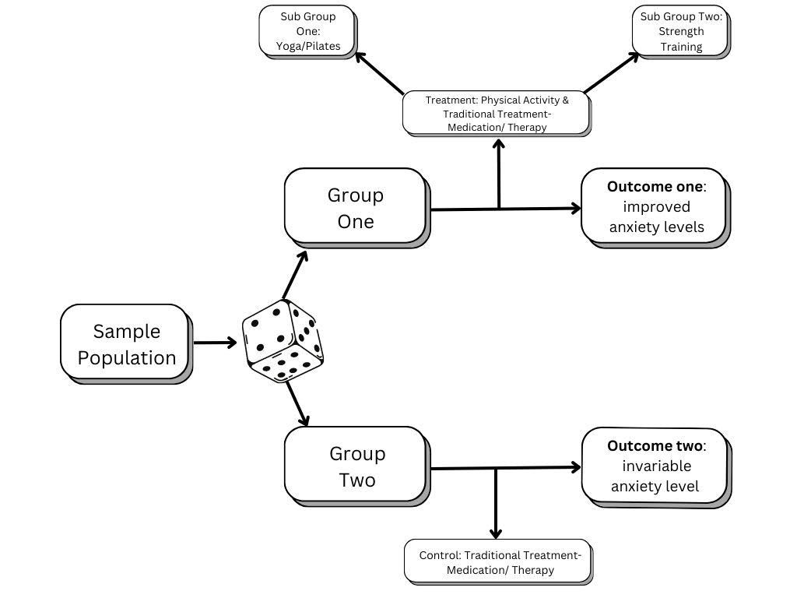

- Randomisation
Our approach in curating a purely randomised group will use a random number generator to allocate subjects to either the control or treatment group . We will use this approach to avoid any bias in the subjects that may affect either their mental health or their response to exercise, i.e., outliers by gender or age. As we have learnt from our power analysis, a minimum of 76 people will be needed to carry out the research. For our experimental design, we will use 76 subjects from our partner practices to evaluate the feasibility of our theory.

Allocation of the randomised groups
To attain an equal allocation ratio, we will allocate half of these participants to the control group, and the other half to the treatment group. This will result in a 1:1 ratio - thus eliminating any disparities in our eventual findings. Therefore, we will have a treatment group of 38 individuals, and a control group of 38 individuals. To add onto the strength of our experiment, we will also use a fixed list method of randomization, meaning that all participants will be randomly allocated to their assigned group. We will use this method for a multitude of reasons, to list a few, it is efficient for us conducting the experiment. It will also pave the way for not giving people an option, such as people who exercise often would be more likely to want to be in the treatment group, and vice versa for the control group and people who are generally inactive. This will therefore eliminate any bias in our findings, such as those who exercise frequently not noting much change in their mood. We will further discuss how these groups will be monitored, and how they will interact with our specialists throughout the duration of the experiment. Finally, we do not intend to isolate the participants, as we would expect a general increase in mood would also create a better environment for the participants. It is crucial that the students can be open and honest about their mood.

The treatment and control
These two groups; treatment, and control, will differ from each other. The treatment group will participate in 4-5 hours of exercise every week for a 24 week duration. They will report their mood and general mental health at the beginning of the 24 week, in week 12, and for a final time in week 24. The control group, who are not going to participate in this level of exercise, will report their mood and mental health alongside the treatment group. We will use the two groups to compare at the end of our experiment to analyse any changes in mood for the treatment group. Afterall, our hypothesis is to analyse the effectiveness of physical activity/therapy as a prescribed treatment for mental illness.

Our awareness of non-compliance, and how we will avoid that
As this is a randomised experiment, it is necessary that we are inclusive of all participants, and we understand that flexibility in their time is key to 100% participation. The students will have the freedom of choosing their own hours to exercise in, as students are generally required to attend campus at some point in their week. We will work in conjunction with partnered professionals to gain permission to invite their patients to participate in the study. We will use the UCD campus to provide easily accessible facilities for the subjects involved in the study. We will also work closely with medical professionals from UCD who will keep in close contact with these students, all the while reporting their progress. We will later discuss our efforts which we will implement to eradicate any noncompliance. As earlier discussed, regardless of an individual's living situation, their time studying on campus will grant them access to the facilities in UCD.

How we will keep track of our progress
As previously mentioned, we will work closely with specialist(s) with a background and knowledge in mental health disorders. They will keep in close contact with the participants- both treatment and control. There will be weekly checkups to analyse the participants' attitude towards how they're feeling generally, and the treatment group will report if they feel any benefits from the exercise. These benefits can be mental or physical, it is intended to be a very open and honest conversation. Alternatively, the participants can email something similar to a diary entry to these specialists. We are giving the participants these variety of options as afterall, we are aware that we may be dealing with individuals struggling with their mental wellbeing, and these conversations can be overwhelming. There will be no pressure for the participants to share their wellbeing, as afterall, this will may indicate an alternative hypothesis that perhaps states that the individual is not benefitting mentally from the exercise, or alternatively for the control group, it may highlight the lack of conversation may be as a result of their lack of physical activity. It is paramount that both groups participate in this aspect as we can later compare the two groups and identify any changes.

Our viewpoint on a comprised experiment
We do not expect there to be a chance of any factors that may compromise our experiment, as there is an “invisible” incentive of becoming generally better in health from the exercise. We have kept the required hours of exercise to a reasonable amount to avoid any people failing to complete all of the hours of exercise. As previously mentioned, we are also making convenience a top priority for us. As we are working within UCD, we will provide facilities, such as the gym and sessions with our medical professionals. To report again, we can also implement a virtual element, such as zoom sessions with our medical professionals for any participants who suffer with anxiety disorders and would wish to avoid this, or simply individuals who cannot regularly attend the campus on top of their exercise in the control group. We also understand that spillover effects may be an issue in this scenario, as it would be totally unethical to forbid our control group of any exercise for this sustained period. However, with the contribution to exercise from the treatment group, we would expect a drastic, positive change in environment for all involved- both treatment and control groups. Afterall, our expectations are that an increase in exercise will increase general mood, therefore our hypothesis should be evident throughout. This would create a positive spillover effect, as the increase in mood and decrease in mental health disorders would create a positive environment, especially in this university setting that we are focused on.

Randomisation concluded
To put our plan into action, we must set a randomisation strategy to ensure our experiment runs smoothly- not only for us conducting the experiment, but also for the convenience of our participants. In conclusion, we have our plan set in stone to continually evaluate both of our groups. It is vital in this experiment that we have this arrangement so that we can later reflect after the duration of the experiment and therefore identify any changes. We aim to accept our hypothesis and with our solid road map for the groups will make it very convenient and accessible to divide their full attention towards. All in all, this is an individual randomised experiment, as we are focusing on how each individual person performs mentally and physically throughout this trial.

VII. Implementation
The study will aim to deliver a treatment to those suffering from a mental health condition.
Those taking part in the research project will be screened using the PHQ-9 scale (Kroenke, 2001). This is to avoid giving the treatment to those suffering from serious to severe mental health conditions. Those suffering from mild to moderate mental health conditions will be monitored by a medical professional during the duration of the experiment to avoid potential deterioration in health and to provide an expert opinion on improvements in the health of the subject.
By the very nature of our experiment, we will pair with healthcare professionals to deliver the treatment. As per our research outline, doctors and mental health professionals will carry out a PHQ-9 scale examination to make sure that those participating in the experiment are well enough to do so. These professionals will also be employing traditional methods of treatment such as SSRI medications as well as counselling/therapy. The deployment of traditional methods of treatment is to avoid the deterioration of the subject's mental well-being in the case that the null hypothesis is not to be rejected.
Along with traditional healthcare workers such as GP’s and psychologists, we will also need to team up with physical therapists and personal trainers to ensure the physical well-being of the subjects. To ensure the rejection of the null hypothesis we must endeavour for our subjects to receive excellent physical therapy. We will request the presence of physical therapists and/or personal trainers to make a personalised plan for our subjects to suit their needs, capabilities and schedules. The secondary act of these physical health professionals is to monitor the subjects and ensure that they’re carrying out their treatment safely to avoid injury or burnout.
By pairing with healthcare professionals such as GP’s, psychologists, physiotherapists and personal trainers, we will also ensure that the subjects are to be provided with adequate facilities to undergo treatment. It is our hope that upon being requested to take part in this study that our partners will provide their facilities at a discounted rate for those taking part in the experiment. This will be discussed further as part of our strategy to measure and avoid non-compliance.

- Logistics
There are several logistical challenges to implementing our intervention. One of which is providing the facilities to the subjects of our study. As we are using UCD as our base for carrying out the experiment, we will request that the UCD facilities be provided to the participants in the study free of charge.
For those who cannot attend the UCD campus regularly, we will provide group sessions overseen by a personal trainer through zoom to ensure that all subjects if the study are administered equal treatment.
Another logistical challenge that we may encounter will be compensating medical professionals for their work. By partnering with us for this experiment, medical professionals will gain some level of exposure from participating in the study. By using a portion of our funding, we will also offer monetary compensation to our partnered professionals for ther time and expertise.

- Quality of Implementation
Tracking the quality of the implementation will take place via comparison. This will be undertaken by the various healthcare professionals that we intend to partner with. Counsellors and doctors will be prompted to deliver the PHQ-9 examination at the commencement of the experiment, during treatment and after the 24-week period has been completed. They will then be asked to rate the patient's mental health using both their professional opinion and the aforementioned PHQ-9 scale. By comparing the results of the PHQ-9 examination we can start to form an image of whether or not the subject's mental state has improved.
The PHQ-9 scale is a self-administered Patient Health Questionnaire which evaluates 9 depressive symptoms (Kroenke, 2002). The PHQ-9 scale measures the severity of depression on a scale of 1-27, find below the table of PHQ-9 scores and severity ratings:(Kroenke, 2002)
Our reasons for selecting the PHQ-9 scale as our means of tracking the quality of implementation are mainly due to the reliability and validity of the questionnaire, which has been rigorously tested. A study carried out by Molebatsi et al in 2020 used the PHQ-9 scale to collect the data of 257 adult primary care patients in Botswana. The results of the study concluded that “the PHQ-9 is a reliable and valid instrument to screen for depression in primary care facilities'' (Molebatsi et al, 2020)
Finally, we will meet with our partner healthcare professionals twice monthly and ask their opinions on the pace of recovery between the subjects in the treatment and the control group, if the professionals deem that those receiving treatment are recovering significantly faster than those who are not, we can confidently say that our implementation of treatment is of a high quality.

- Compliance
Compliance will be reported to us through the twice monthly check-ins that will occur between subjects and partnered medical practices. We will also issue sign in forms to the gyms and studios at which that subjects will attend for their therapy.
Non-compliance should not be an issue for us during this experiment, as our subjects are seeking to improve their mental health, however as a bonus incentive we will endeavour to offer free access to the gym/studio facilities that the subjects will use for their physical therapy. As such we will supply monetary compensation to our partner facilities. By providing these facilities for free we will hope that it will encourage individuals to attend the gym regularly. The other benefit of this is that it will mimic being a “prescription”, being provided for by a HSE proxy, being the researchers. We will provide these services using the funding that was secured by us after our research pitch.

- Effect Size
Our study was based upon an experiment previously carried out by several academics. Lynette Craft’s paper on “The Benefits of Exercise for the Clinically Depressed” (2004). In this paper, Craft highlights that over $40 billion is being spent each year on lost work productivity and medical treatment on the treatment of depression (Craft, 2004). This establishes that there is a clear economic cost to mental illness. Craft suggests that physical activity can be significantly beneficial to those suffering from depression, “Results indicated that the aerobic training program was associated with a clear reduction in depression compared with the control condition, and the improvements in depression were maintained at 3 months post intervention.” (Craft, 2004). While conducting the experiment, Craft observed an effect size of -0.72 in this paper. As such we will aim to use a similar effect size of 0.75.

- Power Calculation
As per the previous topic discussed above – our expected effect size will be based upon the effect size as observed by Craft in their 2004 paper. For our significance level we will use the standardised level of 0.05, finally we will test using a power level of 90%.

Effect size = 0.75
Significance level = 0.05
Power = .9
Entering these figures into Rstudio we get the following results, given a binary outcome (improvement; yes or no):

pwr.2p.test(h = 0.75, n = NULL, sig.level = 0.05, power = 0.9,+ alternative = c("two.sided"))

Difference of proportion power calculation for binomial distribution (arcsine transformation) h = 0.75 (effect size) n = 37.3597 (sample size per group) sig.level = 0.05 (significance level)
power = 0.9 alternative = two.sided
(NOTE: same sample sizes)
As per this power analysis, we will use a sample size of 76 subjects at a minimum in order to accurately test our hypothesis.

Reference List:
- Craft, L. L., & Perna, F. M. (2004). The Benefits of Exercise for the Clinically Depressed. Primary Care Companion to the Journal of Clinical Psychiatry. 6(3), 104–111.
- Department of Surgery. (2021, October 10). Three aspects of health and healing: The biopsychosocial model in medicine. Washington University of Medicine in St. Louis. https://surgery.wustl.edu/three-aspects-of-health-and-healing-the-biopsychosocial-model/
- Hyland, P., Vallières, F., Shevlin, M., Bentall, R. P., Butter, S., Hartman, T. K., Karatzias, T., Martinez, A. P., McBride, O., Murphy, J. and Fox, R. (2022). State of Ireland's mental health: findings from a nationally representative survey. Epidemiology and Psychiatric Sciences. 31, E47.
- Kroenke, K., M.D., & Spitzer, R. L., M.D. (2002). The PHQ-9: A new depression diagnostic and severity measure. Psychiatric Annals, 32(9), 509-515. Retrieved from https://ucd.idm.oclc.org/login?url=https://www.proquest.com/scholarly-journals/phq-9-new-de pression-diagnostic-severity-measure/docview/217052580/se-2
- Layard, R. (2017) The economics of mental health. IZA World of Labor. 321, 1. https://wol.iza.org/articles/economics-of-mental-health/long

