**Instruction to catalog of materials**

A system contains three role:

- User

- Moderator

- Admin

Exist three users (all with password “111111”) with:

-Simple (with user role);

-ModeratorUser (with moderator role);

-Admin (with moderator role)

Unauthorized person can just watch shorten information about uploads of other users :

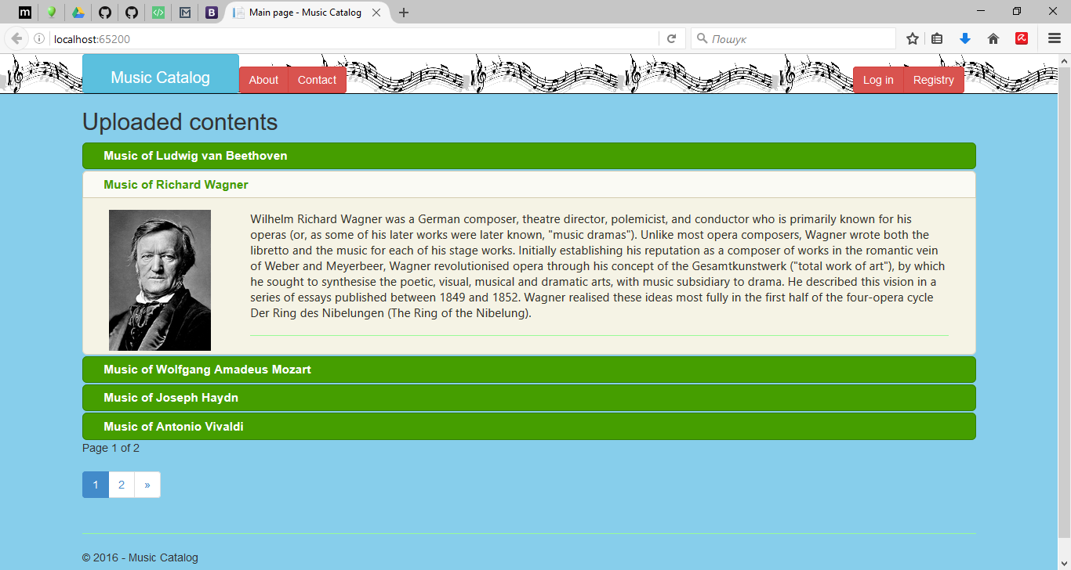

For other operations user should registry or enter in system. All registered users can access avaible functions throw “greetings” button:

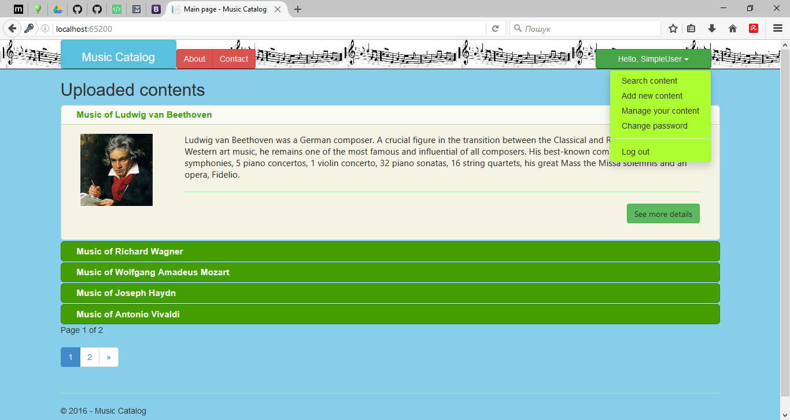

Simple user can add new content, interact with all existing content, manage own content, change password and search content:

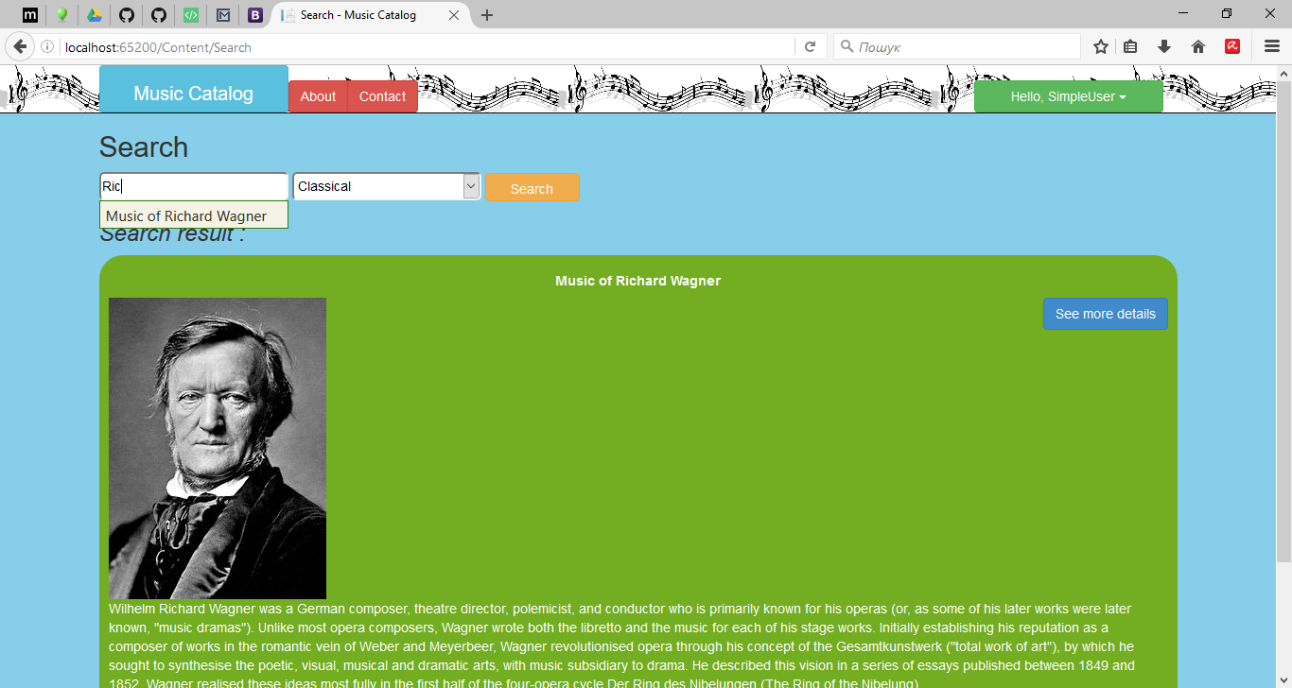

Interact user with content by reading additional information and play attached music:

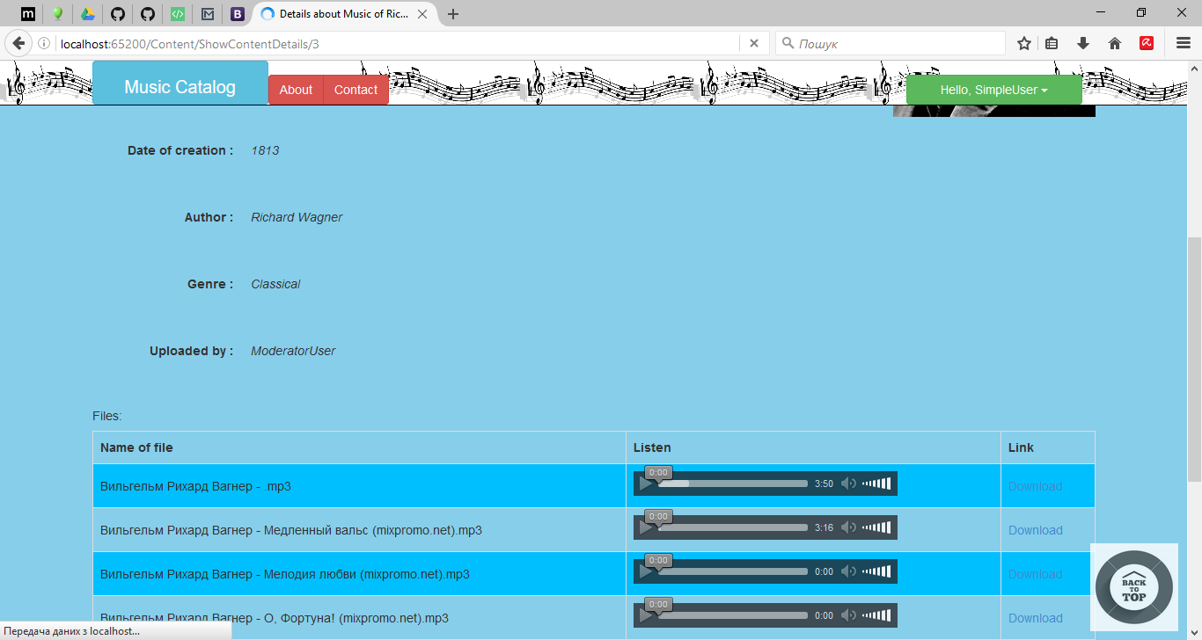

Moderator also can manage content of all users and manage genres of music in system:

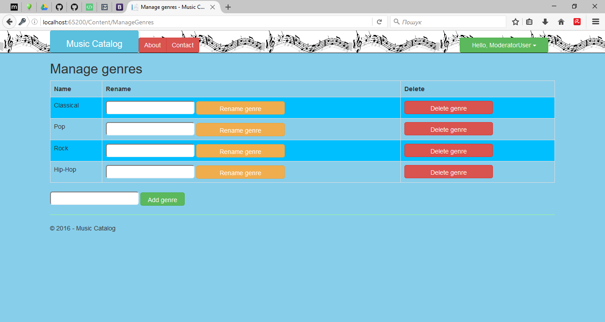

Admin also can add user to new role:

