**Part 1**

**Selfhost**

To use selfhost firstly I need give permissions to reserve the URL:

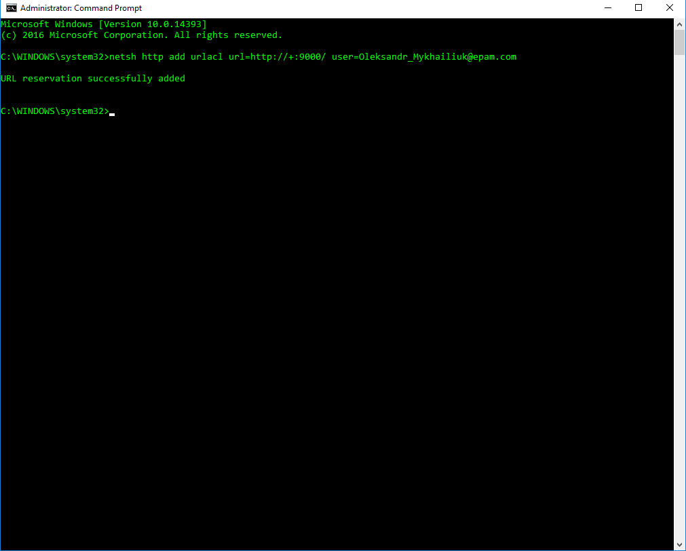

**Webhost**

I think that VS start by default on IIS, which can work like webhost.

**Showing response**

Response type depend on content-type of request so I use this