Interpreted program requirements
Reading in weather data of a certain format from a user-defined text file, storing that data, and displaying that data in the required format.
Thus, I would need features such as
- Handling user input (allowing the user to define the text file)
- FileIO (reading from file defined by the user)
- Data persistence throughout the lifetime of the program
- Console output, output manipulators (displaying of the data)

Diagram/illustrations of program design
From a high-level, the following is roughly what my call order looks like (heavily simplified)
Main()
WeatherApp::PrintMainMenu()
WeatherApp::HandleOption() // Handling of the chosen menu option
DataLoader::ParseFile() // If user chooses 1
DataLoader::ExtractGridRange()
DataLoader::ReadCityTextFile()
DataLoader::ReadGenericTextFile()
Renderer::RenderGrid() // If user chooses 2-6
SummaryReport::GenerateSummaryReport() // If user chooses 7
SummaryReport::ComputeGridAverage()
SummaryReport::ComputeRainProbability()

Summary of implementation details
I have a GridData struct that contains the following data:
int **cityData, **cloudData, **pressureData
Vec2D min, max; // Boundaries of the grid
bool isDataLoaded;
string cityNames[]
It basically encapsulates an instance of the data that would be loaded from the config files.
An instance of this is created at the top of main(), and is freely passed by reference to any function that requires it (avoiding any global variables, and making it explicit what functions require it).
The 2D arrays are to be populated later, via DataLoader::ParseFile()

My WeatherApp::PrintMainMenu() implementation may look a bit odd, but that was because I was trying to use a more declarative programming approach that would allow me to easily add more options in the future. Within Declarations.h, I have an enum called MENU_OPTION where you can define your menu options.
From there, it’s simply a matter of adding an additional switch case to handle the new menu option within WeatherApp::HandleOption().

DataLoader::ParseFile( string fileName, GridData &gridData ) is quite monolithic, as fault-tolerant file-parsing and data-loading make up a sizeable chunk of this assignment.
Here’s how this function roughly works:
- Initializes a new instance of GridData, we’ll call it newGridData
- Initializes multiple boolean flags, each to keep track that something has successfully loaded into newGridData (e.g rangeXInitialized, arrayInitialized, cityInitialized, etc.....)
- Read from config file, and try to parse and initialize the corresponding value in newGridData
  - i.e When you find the GridX_idxRange key and initialize the range within newGridData, set rangeXInitialized to true
- Along the way, have to invoke helper functions such as DataLoader::ExtractGridRange() and DataLoader::ReadCityTextFile(), all of which will also receive a reference to newGridData so that they may populate it with the appropriate data
- At the end of the function, if everything has indeed been properly initialized, you can start using this new instance of GridData – else, discard it.

Renderer::RenderGrid( int** my2dArray, Vec2D min, Vec2D max, RENDER_MODE renderMode ) This function takes in a 2D array, the boundary/size of said array, as well as a RENDER_MODE enum to conditionally render as city, index, or LMH.
Rough steps for printing are just as follows:
- Print roof of ‘#’ chars
- for each y (in reverse order), for each x – print char based on renderMode
- Print floor of ‘#’ chars

SummaryReport::GenerateSummaryReport( GridData &gridData )
As we are not allowed to use std::map, the way I chose to map the city ID to a name was via a fixed-sized array.
(currently 100, allowing the cityID range 0-99. Can be changed by modifying CITY_ID_COUNT).
The cityID would be the index into the array, for example:
[0] – “”
[1] – “Small_city”
[2] – “Mid_city”
...
[86] – “”
We can then iterate through all the city ID’s and print out a summary report for that city ID

Averaging the cloud and pressure data was done as follows:
- Initial scan through the map, keeping track of the min and max boundaries of your target city

- Expand the boundary by 1 unit in all directions, but keep it constrained by the size of the map

- Use the map-constrained expandedBoundary to find the cells that you need to average over

Additional Design Consideration(s):
- I chose to save the grid range as a boundary (min, max). This is good as if the grid were to not start from 0, it can easily be accounted for as I can easily transform from ‘grid space’ to ‘array space’ coordinates via offsetting by the “negative min” value
  - E.g If the grid’s X and Y range were 2-10 (as opposed to 0-8), a city location at [2, 2], should now be at [0, 0] of the array.
  - You can then just offset by -2 on both the x and y axis to get the array indices of [0, 0]
- Also, considering that the grid range may extend until the grid max x and y may span multiple digits, or that the ‘cityID’ may also be multiple digits – the grid will expand to account for that (note the following)

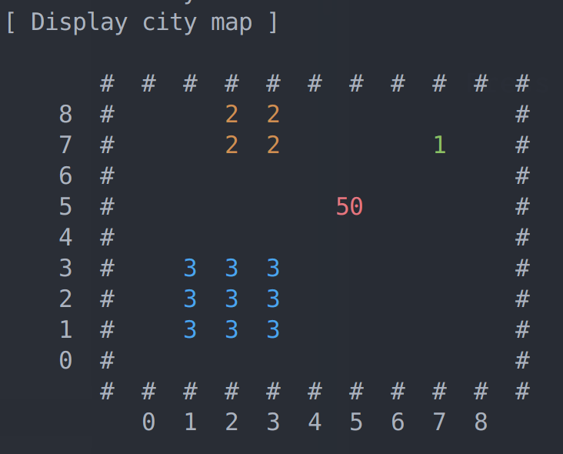
Example 1:
City boundaries are single digit, but a city ID ‘50’ is
double-digit, thus the grid-spacing expands horizontally

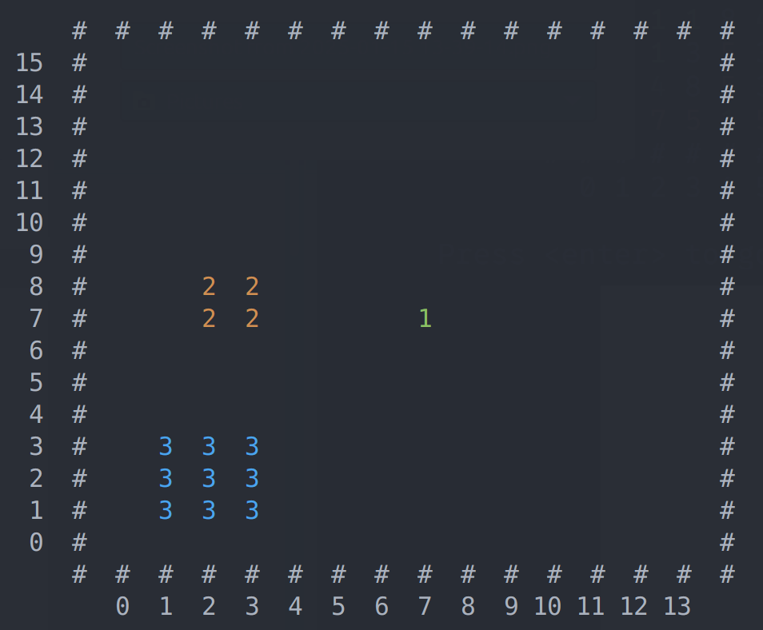

Example 2:
All city ID’s are single-digit, but the x and y boundaries encroach into double-digit territory – so the grid-spacing expands naturally

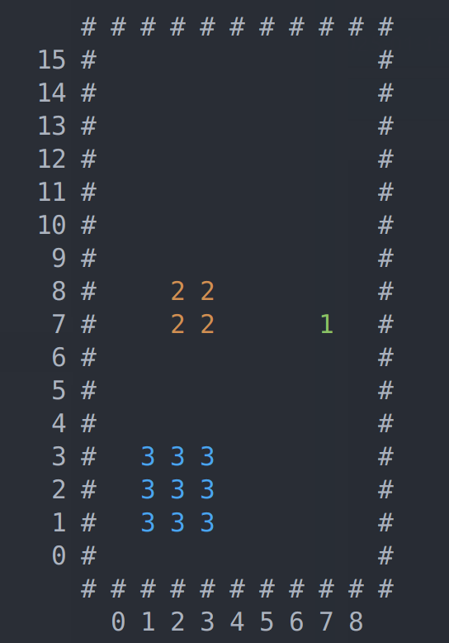
Example 3:
Only the y boundary goes into double-digit territory. The cityID’s and x boundary are single-digit.

Extra Feature:
For my extra feature, I tried made use of ANSI color codes within the console to make it easier to distinguish between the different city, index, and LMH values – as well as just to make the program more aesthetically pleasing (CLI programs tend to be very monochromatic)
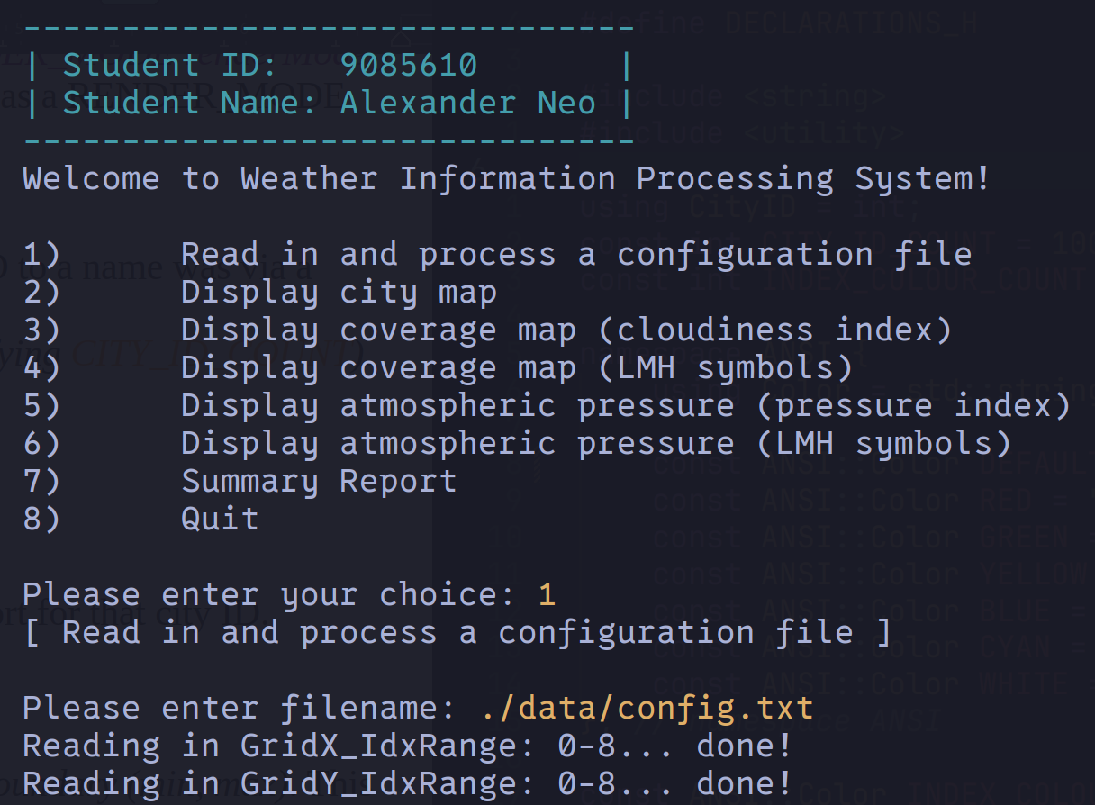
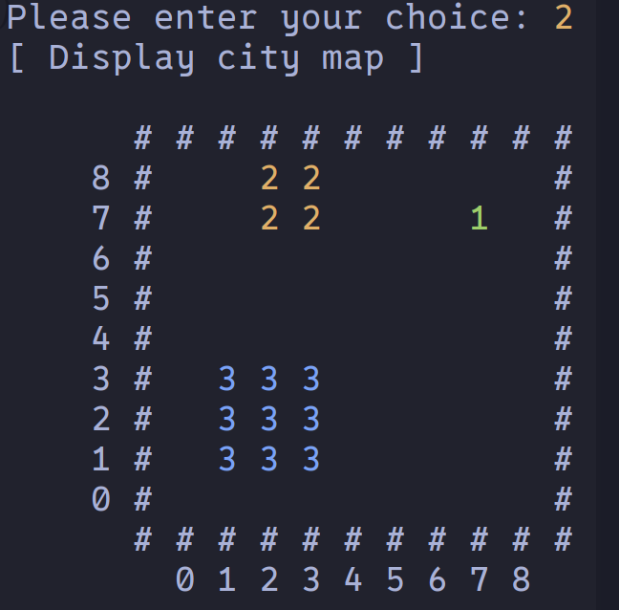
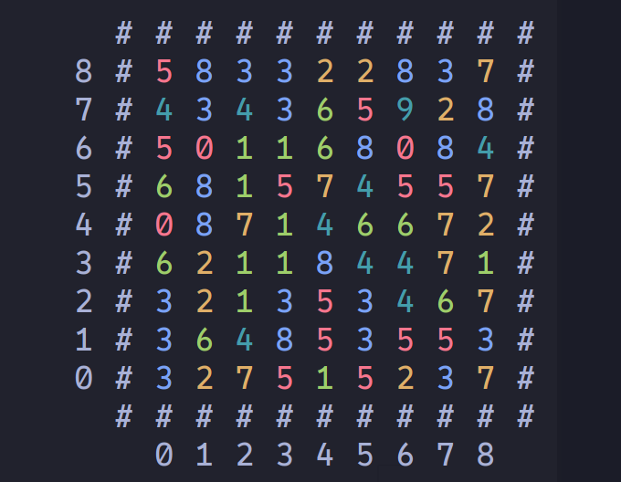

Reflections
Having previously used C++ exclusively in Windows with Visual Studio as an IDE, the details of building and running were abstracted behind a one-click button. Thus, the compilation and linking process was a black box to me.
Compiling via g++ in the CLI helped me peel back the black box, and I’ve even progressed to using simple makefiles to ease the pain of having to re-type the compilation command every time.

Additionally, mostly having used the given STL containers such as std::vector, I never had to take much care previously to ensure no memory leaks. Thus, for this assignment, I had to learn how to be careful to de-allocate any memory that I had previously allocated, as many basic functions such as TokenizeString() now required that memory be manually allocated and managed.
I also got to learn about CLI tools such as Valgrind which allowed me to extensively test my program for leaks.

I’ve also had to learn how to use output manipulars “<iomanip>” to properly ensure that my output is properly formatted, via functions such as
- std::setw(), std::left, std::right
- std::fixed, std::setprecision()

One assumption I made was on the portability (or lack thereof) of this program. Evidently, my makefile used for building, and certain commands system(“clear”) are OS-specific, and this program likely wouldn’t build on windows.
Thus, a possible improvement is on the portability of this program – being able to compile on multiple platforms.

Another possible improvement is to try and use CMake for my next project, as that is the industry standard.

