Eoghan Leonard

Eoghan.leonard@connect.qut.edu.au

Abstract

This is the personal portfolio of work contributed  
 to group 94 during this semester

Personal Portfolio

Eoghan Leonard

# Introduction

This project has now been in progress for 9 weeks and much progress has been made. The workload was split based on the skills that each member had so that each member to contribute in there are of expertise. As I am an information system student, my skills, relative to this project, lay in the area of database logic and development. The front end of our application was done by using Filemaker (which another member is very familiar with) which is where I gave as much aid as possible. Filemaker is a database software that allows for interfaces to be created and hosted online that are based on these backend databases. Given that one of the members was so familiar with Filemaker, he took on the responsibility of the aesthetic design of the interfaces where as I aid in the database development and some of the interface work.

# Artefact 1

For the 2 sprints leading up to the release I was firstly given the responsibility of creating a table inside the database to save all of the tenant details. This included their names etc. as well as their banking details and which property they were staying in. This is the first artefact that displays the table design for all tenants.

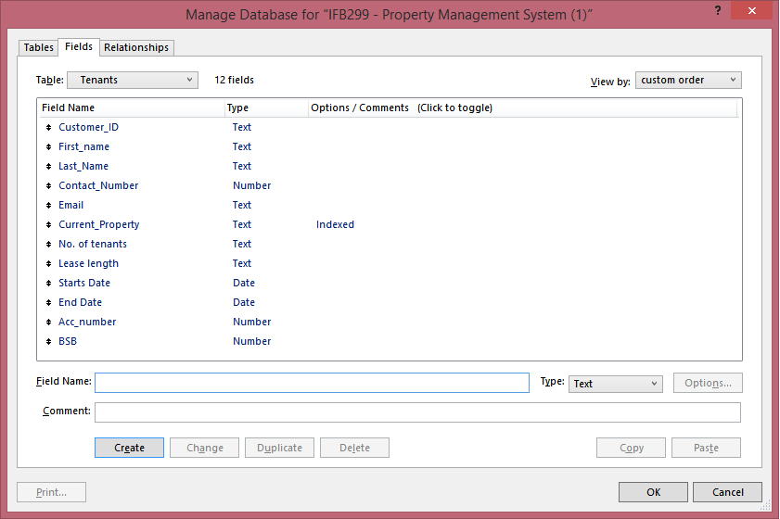

This is a screenshot from within Filemaker that displays all of the information that will be captured from the tenants and be stored. Initially I had thought it would be smarted to break all this information into separate tables and link the, based on foreign keys, but given the nature of our forms and Filemaker itself, this way was just smarter. This information will be used in both the front end and back end of our applications. This is due to customer needing to be able to edit their personal info and for the manager to track which tenants live where and how to bill them.

# Artefact 2

The next job front the first sprint was to populate the tenants table with fake information in order to test the future functionality of processes which access this table. The file maker program has a very simple way of importing data from an external source such as Microsoft excel. This si the platform in which I chose to create my fake data. You simply create a table of data and Filemaker will be able to recognise the data and then you which columns match the fields in your table. This is a sample of the fake data that I created for the tenants table.



This was the original set of data but it was later changed due to inconsistent data such as no ‘current_property’ having the number 41.

This information was then imported to the Filemaker database. This was a very simple process that matched the data with fields created. This is a screenshot of this process.

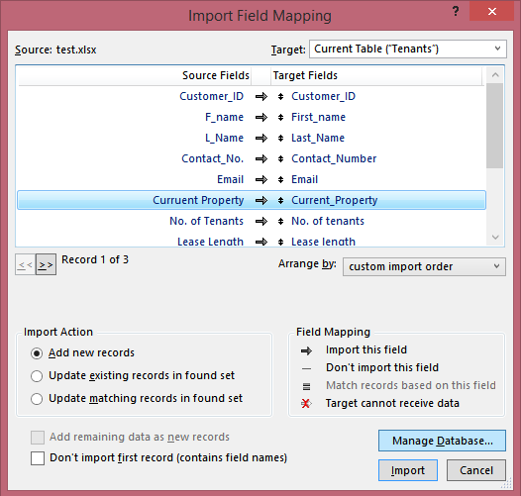

As you can see, it is a very comprehensive process. Once this was done, there is now an table within Filemaker full of tenant details.

# Artefact 3

The next artefact is the form where tenant information can be viewed and edited. The information can be viewed by any staff member and only tenants can view their own respective information. At this point the privileges based on login have not been set. Despite the login element not being operational, this form still needed to be developed as it was part of the first spring plan was to have a basic GUI interface for tenant details. This artefact required me to learn some more functionality of the Filemaker application but coupled with my information technology knowledge, it was not a long process. As mentioned earlier, it is smart to break up the data into basic personal details, lease details and banking. This is what I decided to do for this I have broken up these different categories of information into 3 different forms (tabs) within a Filemaker interface. The photo below is the first tab of entry fields.

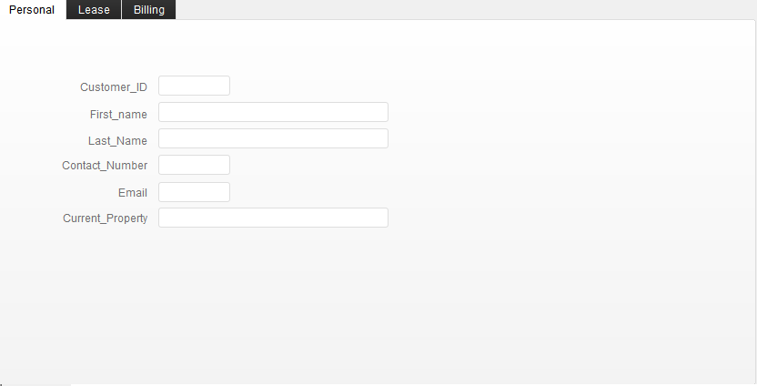

As you can see here it has all the personal information in one space that is relative to a single tenant. If you look to the top left corner you will see the possible tabs of information that the user can select from. This form is certainly not the final appearance, it is merely a raw version to show functionality. The next image is just to show the functionality of the tab system but I will not waste time and show the final tab. This is the Lease information tab.

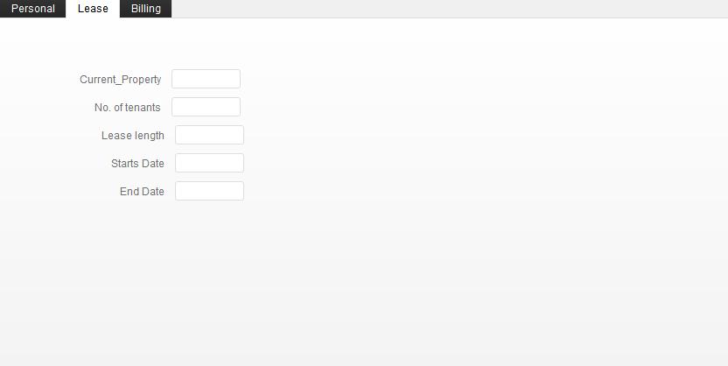

# Artefact 4

The fourth artefact of contribution was the testing of the above forms and their compatibility with the table of information that was designed for them. There were suspected troubles getting the data to match from tab to tab.

As expected the forms worked seamlessly with the data that was created prior. Below is a screenshot of a record of information, from our sample data, being displayed in the fields for tenants to view/edit. Once again please keep in mind this is not the final appearance of this form.

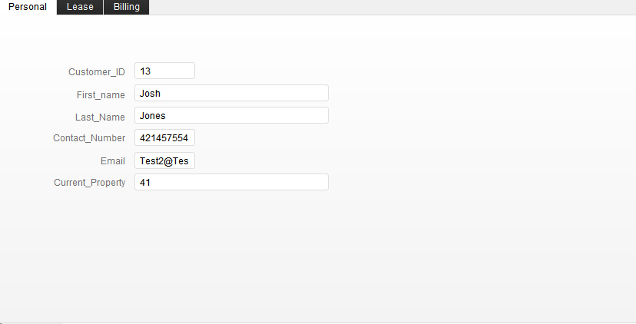

As you can see, data that was created in a previous artefact can be seen here in our interface. Since the personal, lease and billing info are all from the same table, making sure the information across all tabs were relative to the Customer_ID was reasonably simple.

# Artefact 5

The final artefact of work was the task from sprint 2 which was to test editing functionalities. This was a necessary tasks as we needed certain restriction on who could edit what. For example, we would not want a tenant to be able to change their lease information but it would be necessary for them to be able to change their contact information or billing information. This would require putting certain editing lock on certain fields based on the privilege or a given user. Another member was in charge of writing the script which gave different users different access but I had to develop edit the field properties for any given case.

For this sprint I was focusing on the editing privileges of the tenant. I didn’t want them to be able to change their name or lease information, but giving them the ability to change email, contact number and bank account was essential. Below is a screenshot of how it was done. Using the “inspector” element of Filemaker, I was able to change how the user could interact with the information.

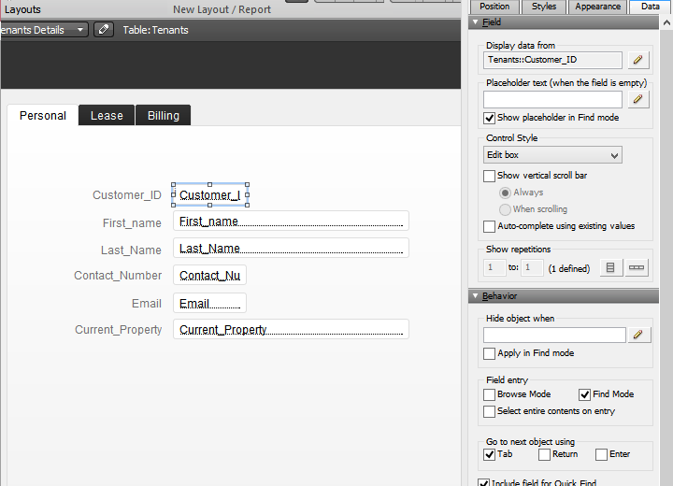

If you look on the sidebar here you can see the title ‘Field Entry’. This essentially puts a limit on what can be done with this field. I have changed the option to ‘Find mode’ only so that it can be seen, but not edited. This was repeated for the other appropriate fields. That was the task for sprint two, so this is only the limitations set on the tenant, but the rest is to come.

# Conclusion

I have contributed, using my skills in formation technology, to this project. However I have been restricted with my limited knowledge on computer science. I have tried to apply my database logic and development knowledge to this task and believe it has made useful contribution so far.