Bachelorproef Application Note
Elektronica-ICT | 2025-2026
Miniature autonomous driving bus platform
Auteur  Docent  Stagebegeleider  Bedrijf | Alexander Petry  Stijn Boutsen  Tommi Kokko  Lapland UAS
Abstract
This bachelor thesis presents the development of a 1:20 scale autonomous bus test platform for a simplified bus depot environment. The project explores how a modular small-scale system can be used to test autonomous driving software in a practical and flexible way.
The problem addressed is the difficulty of testing autonomous vehicle software in a realistic environment without requiring full-scale infrastructure. This thesis investigates how a scaled bus, a test depot, and supporting software can be combined into a usable platform within 14 weeks, while accounting for indoor localization, system integration, and the limits of small-scale testing.
The research was based on scientific literature, technical documentation, and practical experimentation. UWB localization was studied and applied because it is more suitable than GPS in an indoor environment, while ROS2 was used to structure the software into modular parts that can be extended later. Component selection was guided by availability in the lab, low cost, and simplicity.
The resulting system is divided into three layers: a mechanical frame, a base driving unit, and a brain unit. The platform currently supports manual radio driving, manual command driving, camera-based object detection, path planning, and position estimation. Autonomous driving is not yet stable because the pose estimation still needs improvement, but the main subsystems are in place.
In conclusion, the project delivers a functional and expandable base for future autonomous bus testing at scale. The platform can be further improved by refining localization, stabilizing autonomous driving, and adding additional sensors or features later on.

Inhoudsopgave
1 Reader’s guide 3
2 Introduction 3
2.1 The situation 3
2.2 The problem 3
2.3 The plan 3
3 Materials and methods 4
3.1 Research 4
3.2 Design 5
3.3 Decisions 5
4 Results 6
4.1 Overview 6
4.1.1 Design 6
4.1.2 Features 6
4.2 Mechanical frame 6
4.2.1 Design 6
4.3 Base driving unit hardware 7
4.3.1 Systems 7
4.3.2 PCB 9
4.3.3 Electrical Design 10
4.3.4 Components 10
4.4 Brain & processing unit hardware 11
4.4.1 Systems 11
4.4.2 Electrical Design 12
4.4.3 Components 12
4.5 Base driving unit software 13
4.5.1 Architecture 13
4.5.2 Process flow 13
4.6 Brain & processing unit software 13
4.6.1 Architecture 13
4.6.2 Process flow 14
4.7 Using the platform 14
5 Discussion 16
5.1 Interpretation of the results 16
5.2 Context & reflection 17
5.3 Critical analysis 17
5.4 Reflection on the X-factor 17
6 Conclusion 18
7 References 18
8 Apendix 18

- Reader’s guide
This application note is structured to bridge the gap between engineering theory and practical execution. It begins by establishing the research foundation and design methodology, which directly informs the system-level results documented in the subsequent technical chapters. These results are then critically evaluated in the discussion, where objective performance data is analyzed against project goals, institutional benchmarks, and broader societal impacts to provide a comprehensive conclusion.
- Introduction
This bachelor thesis focuses on creating a test setup to experiment with autonomous driving software using a 1:20 scale bus in a scaled bus depot environment. The project builds on earlier preparatory work and explores how such a setup can be used to test basic autonomous driving behavior, such as following routes and reacting to simple situations.
The aim is to better understand how a small-scale physical model can be used for testing, while taking into account practical limitations and the differences between scale models and real vehicles.
  - The situation
Developing and testing software for autonomous vehicles usually requires both hardware and software to work together. Testing on full-scale vehicles is often difficult to organize and not very flexible when changes are needed.
Using a smaller scale model makes it easier to experiment in a controlled environment. In this project, a 1:20 scale bus will be used together with a simplified version of a bus depot. The goal is to create a setup where basic driving behavior can be tested, such as following a route, avoiding obstacles, and performing simple maneuvers.
However, working at a smaller scale also introduces challenges. The behavior of the vehicle does not scale perfectly, which can affect how it drives and how sensors perform. These differences need to be considered when testing and interpreting results.
  - The problem
How can a test setup be designed and built within 14 weeks to test autonomous driving software for a 1:20 scale bus in a semi realistic environment?
This includes selecting and integrating basic components such as sensors and control systems, dealing with limitations caused by scaling, and creating test scenarios that are useful for evaluating the behavior of the system.
  - The plan
The main focus of the project is to build a working autonomous bus platform at scale 1:20 that can perform basic driving tasks such as following a route and reacting to its surroundings. Functionality is the main priority, while visual details are less important.
A simplified depot environment will be created to support testing, but it will remain limited in scope due to time constraints. The setup should allow for a few repeatable test scenarios rather than a fully detailed or realistic depot.
If time allows, small improvements can be made to the environment or testing methods, but the priority remains on getting a working and testable system
[schematic of requirements]

- Materials and methods
This section describes how the project is approached and which materials, tools, and methods are used to build and test a 1:20 scale autonomous bus system within a time frame of 14 weeks. The focus is on creating a working prototype that allows testing of basic autonomous driving behavior in a controlled environment.
  - Research
The research in this project is carried out using an iterative and practice-oriented approach. Instead of separating theory and implementation, small experiments and prototype tests are used to support the research process. This makes it possible to quickly verify ideas and identify limitations early on.
The process consists of gathering information, testing concepts on a small scale, and refining the understanding based on observations. This cycle is repeated throughout the project to gradually build insight into what works within the given constraints.

Information is collected from a combination of scientific literature, technical documentation, and online resources. Google Scholar is used to find academic papers related to autonomous vehicles, indoor localization, and small-scale robotics. In addition, general search engines are used to find practical implementations and examples.
Datasheets and documentation from hardware manufacturers (such as microcontrollers, sensors, and localization modules) are also an important source, as they provide concrete technical details needed for implementation.
The research focuses on several key areas. First, different methods for indoor localization are explored, since accurate positioning is important in a controlled environment where GPS is not reliable. Techniques such as Ultra-Wideband (UWB), vision-based methods, and other sensor-based approaches are investigated and compared at a conceptual level.
Second, software frameworks for robotics are studied to understand how different system components (such as sensors, control, and navigation) can be structured and communicate with each other.
Third, the behavior of small-scale vehicles is examined, including how scaling affects movement, control, and sensor performance. This helps to better understand the limitations of using a 1:20 model for testing.
In addition, different hardware components are explored and compared. This includes motors, controllers, sensors, and processing units. The goal is to identify components that are suitable for the project constraints without going into unnecessary complexity.

These topics are researched because they directly influence the feasibility and performance of the system. Indoor localization is essential to allow the vehicle to determine its position within the test environment. Software structure is important to manage system complexity and support further development.
Understanding scaling effects is necessary to correctly interpret the behavior of the model and avoid incorrect assumptions when comparing it to real-world systems.

For component selection, a simple ranking approach is used during the research phase. Components are first evaluated based on availability in the lab, since this reduces cost and setup time. If multiple options are available, preference is given to lower-cost components that still meet the basic requirements. Finally, simpler solutions are preferred over more complex ones, as they are easier to implement and debug within the limited project timeframe.
Overall, the research is aimed at building enough understanding to make informed design choices later in the project, while staying within the practical limits of time and available resources.
  - Design
The system is divided into three main parts:
- The mechanical frame of the bus
- The base controller, which handles motors and steering using a microcontroller (ESP32)
- The main processing unit (“brain”), consisting of a Raspberry Pi and connected sensors
This separation allows each part to be developed and tested more independently. The mechanical frame supports all components and defines the physical layout. The base controller is responsible for low-level control such as driving and steering, while the Raspberry Pi handles higher-level tasks like decision-making and sensor processing.
The test environment consists of a miniature street where basic scenarios such as route following and obstacle avoidance can be tested.
The following tools are used during development:
- Fusion360 for designing the frame
- 3D printing for producing custom parts
- ESP32 for motor and steering control
- Raspberry Pi for higher-level processing
- UWB modules for localization
- Programming tools for developing and testing software (including ROS2 where applicable)
- Basic electronics tools (such as a multimeter & soldering iron) for debugging and development
  - Decisions
Size
A 1:20 scale is chosen as a balance between size and practicality. It is large enough to include the required electronics and sensors, while still being small enough to test indoors and keep the setup manageable.
3 parts
The system is split into three parts (mechanical frame, base controller, and brain unit) to separate responsibilities. This makes debugging easier and allows parts of the system to be modified without redesigning everything.
Motor strength
TT motors are selected because they provide enough power for the required movement without being excessive. The goal is not high speed, but controlled and stable motion. Since the bus is intended to represent a realistic depot scenario, a maximum speed of around 1 m/s is sufficient. Stronger motors, such as those used in RC cars, are avoided because they would add unnecessary complexity and are not needed for this application.
Microcomputer & controller
An ESP32 is used for low-level control of motors and steering due to its simplicity and suitability for embedded tasks. A Raspberry Pi is used as the main processing unit to handle sensor input and higher-level logic. This combination allows a clear separation between real-time control and more complex processing.
UWB localization
UWB is chosen as the localization method because it performs better than GPS in indoor environments and at small scale. It allows the position of the vehicle to be estimated within the test setup using fixed anchors. The choice is based on its relatively good accuracy over short distances and the fact that it can be implemented without overly complex setup.
ROS2
ROS2 is selected as the software framework to organize communication between different parts of the system. It allows the project to be structured into separate modules (such as localization, control, and planning), which makes it easier to modify or expand later. While not all features of ROS2 may be used, it provides a solid base for future development.
- Results
  - Overview
    - Design
The bus system is divided into three main layers: the mechanical frame, the base driving unit, and the brain unit. These layers were developed as separate parts that can work independently, while still communicating through fixed interfaces. This makes the system easier to debug and allows parts to be replaced or improved later without changing everything at once.
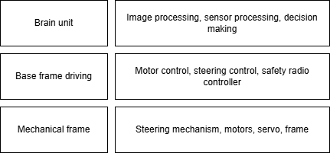
The layered structure was also a practical choice during development, because each part could be tested on its own before being connected to the rest of the system. In this way, the structure reflects both the development process and the final system layout.
[High level flow chart]
    - Features
The current system includes manual radio driving, manual command driving, camera-based object detection, path planning, and position estimation. Autonomous driving is not yet fully working because the pose estimation is still unstable, but most of the required systems are already in place.
[Table of all features and their purpose]

  - Mechanical frame
    - Design
The mechanical frame was designed to resemble a small-scale public transport bus and to support the technical parts of the system. It uses a 4-wheel configuration, with steering based on an Ackermann mechanism and a servo-driven lever. This gives the bus a steering layout that is closer to a real vehicle than a simple skid-steering design.
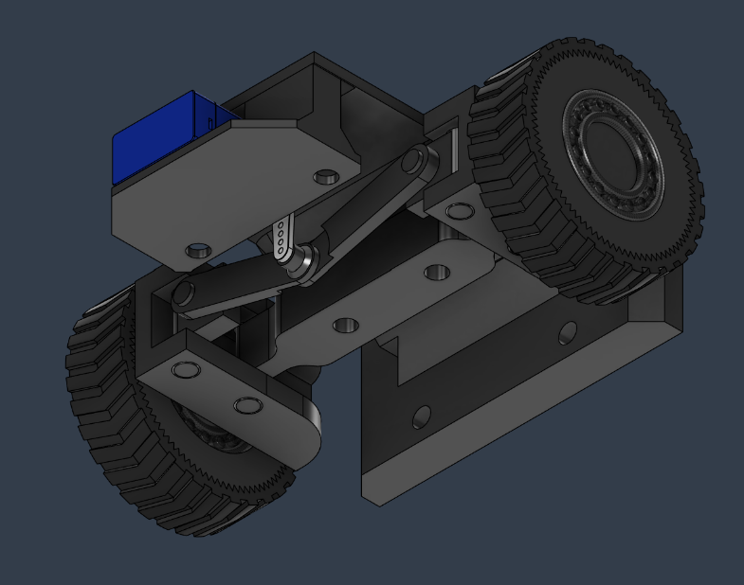
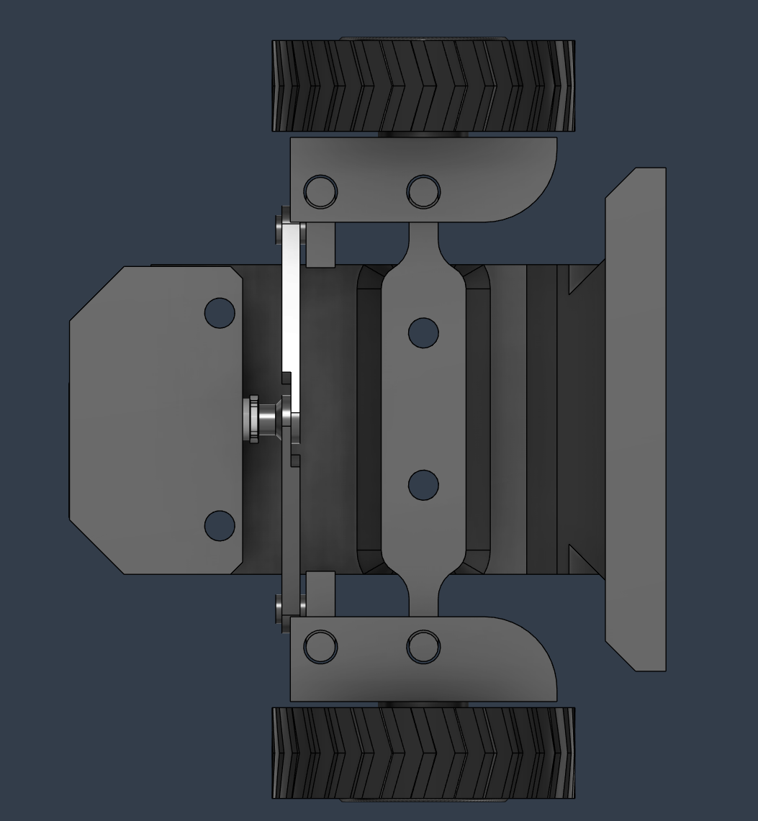

The driving system uses two TT motors connected directly to the wheels. This makes electrical differential control possible and keeps the mechanical design simpler, since no separate mechanical differential is needed.
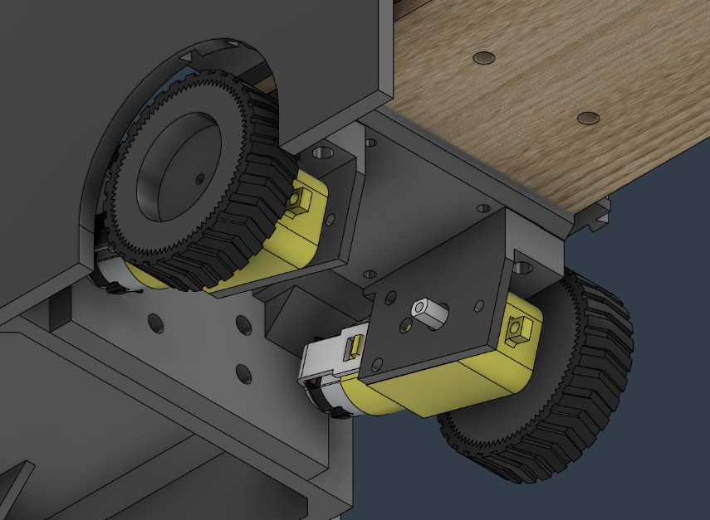
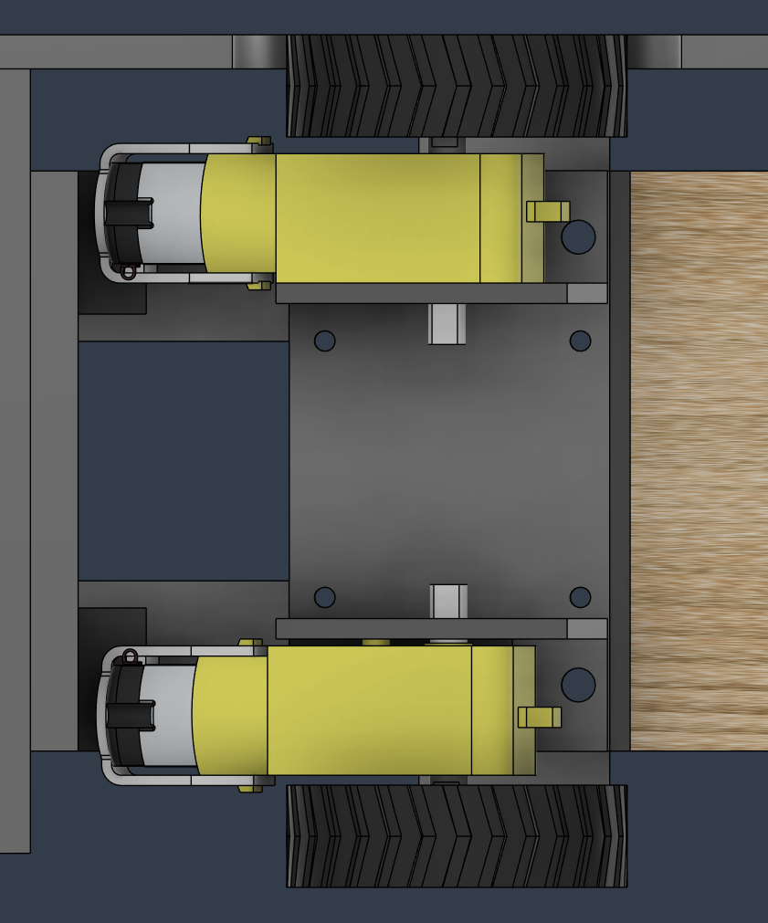

All main electronics are mounted on the frame in positions chosen for balance, access, and cable routing. The battery is placed low and centered because it is the heaviest component, while the Raspberry Pi is mounted above it for easier access. The ESP32 PCB is positioned between the driving controller and the Raspberry Pi, and the UWB module is mounted on the side because it needs a vertical orientation.
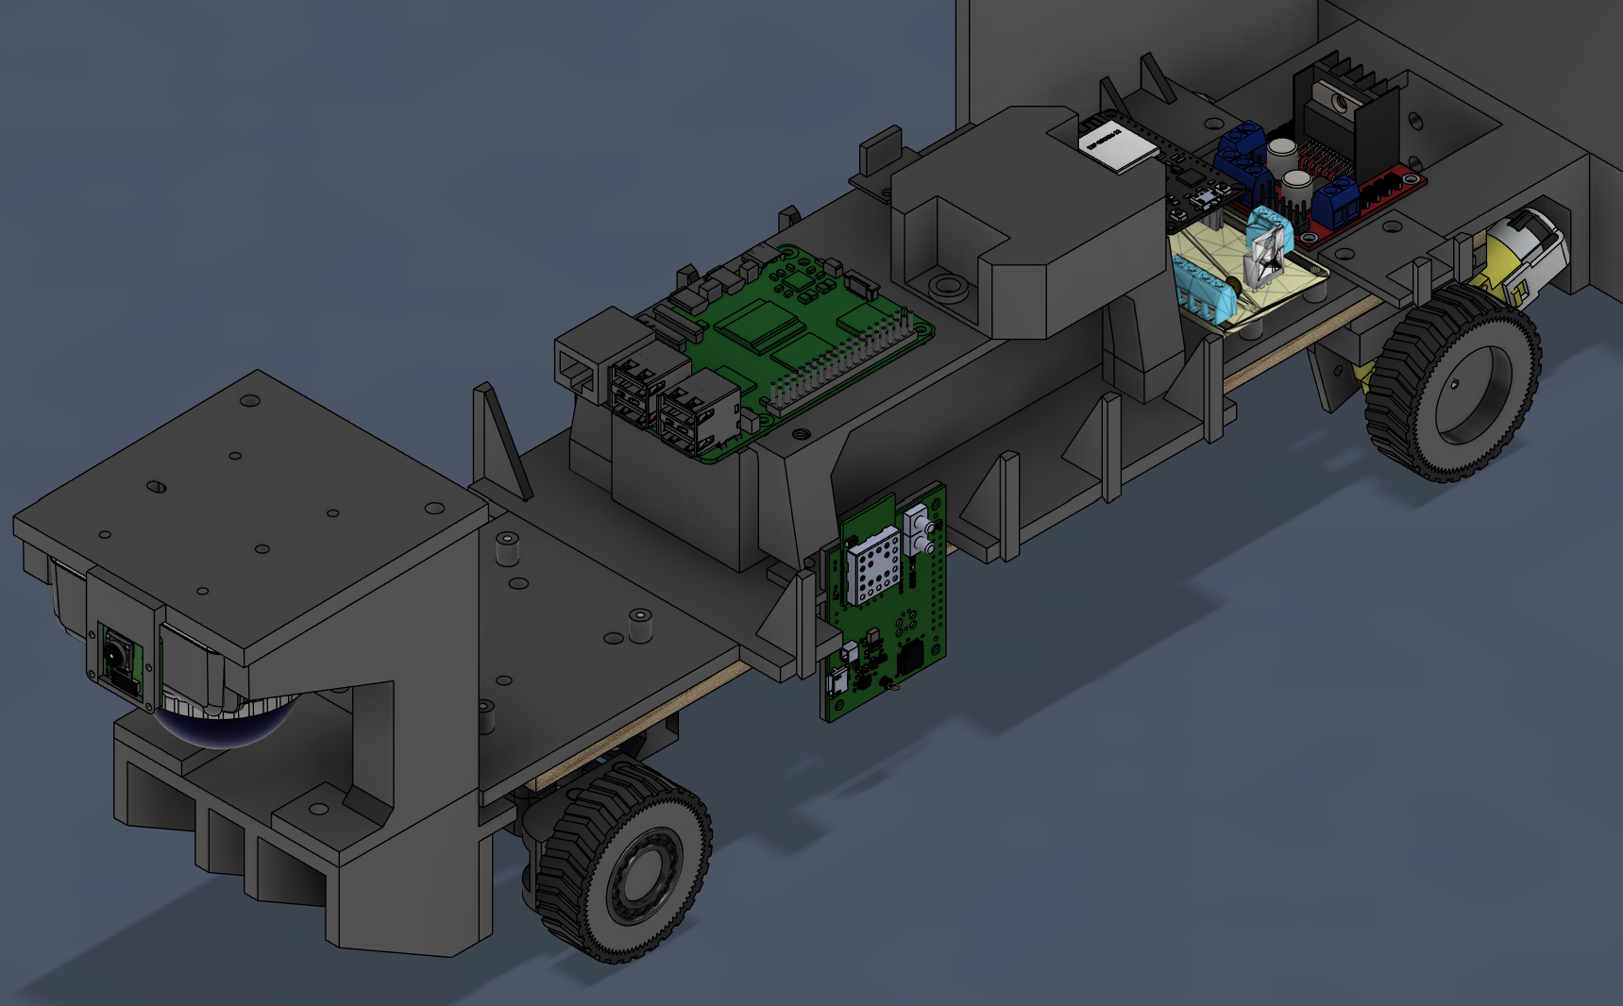

The shell is mainly visual and is intended to make the bus look more realistic. It will be attached with a simple removable slot-in mechanism, although this part is not yet fully implemented.
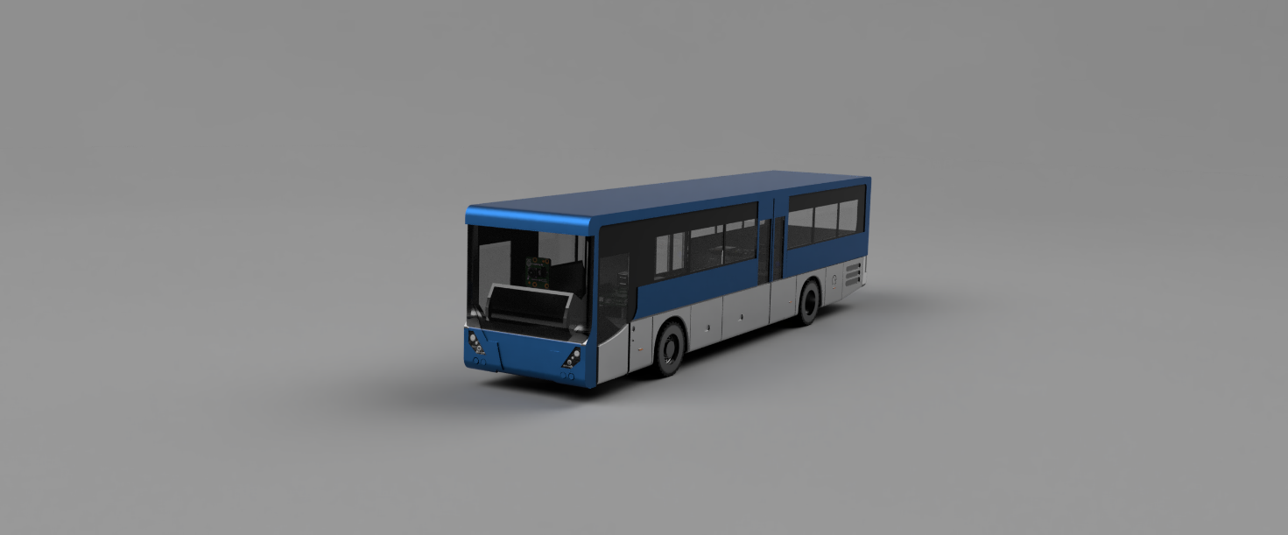

  - Base driving unit hardware
    - Systems
Driving
The driving system uses an L298N motor driver and two TT motors. The motors are controlled separately, which makes it possible to create differential motion electronically. The system is powered directly from the 11.1V battery, and PWM is used to control motor speed.
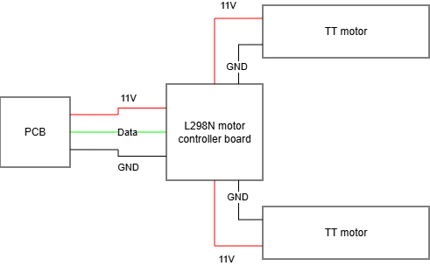
Steering
The steering system uses an SG90 servo connected to the mechanical steering linkage. The servo has a working range of about -35 to 35 degrees. The steering is open-loop at the moment, without feedback control.


Radio communication
The radio system uses a standard RC receiver that is read by the ESP32, allowing manual driving and providing an override option when needed. The channels output PWM signals ranging from 1000 us to 2000 us.
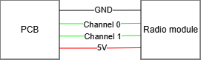
Power delivery
The PCB includes direct battery outputs for the motor controller and the brain unit, as well as an 11V-to-5V converter for powering the ESP32. This helps distribute power more cleanly and reduces wiring complexity.
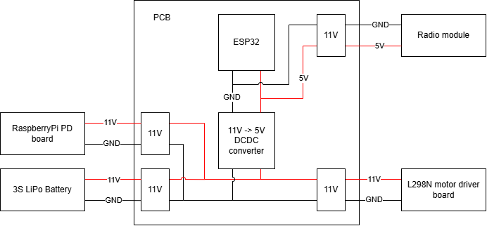
1

    - PCB
Purpose
The PCB was made to make the wiring cleaner and the connections more reliable. It houses the ESP32 and its connectors, and it also handles power distribution and voltage conversion. Capacitors were added across the power lines to reduce noise and spikes. It also includes boards for mounting to magnetic rotation sensor.
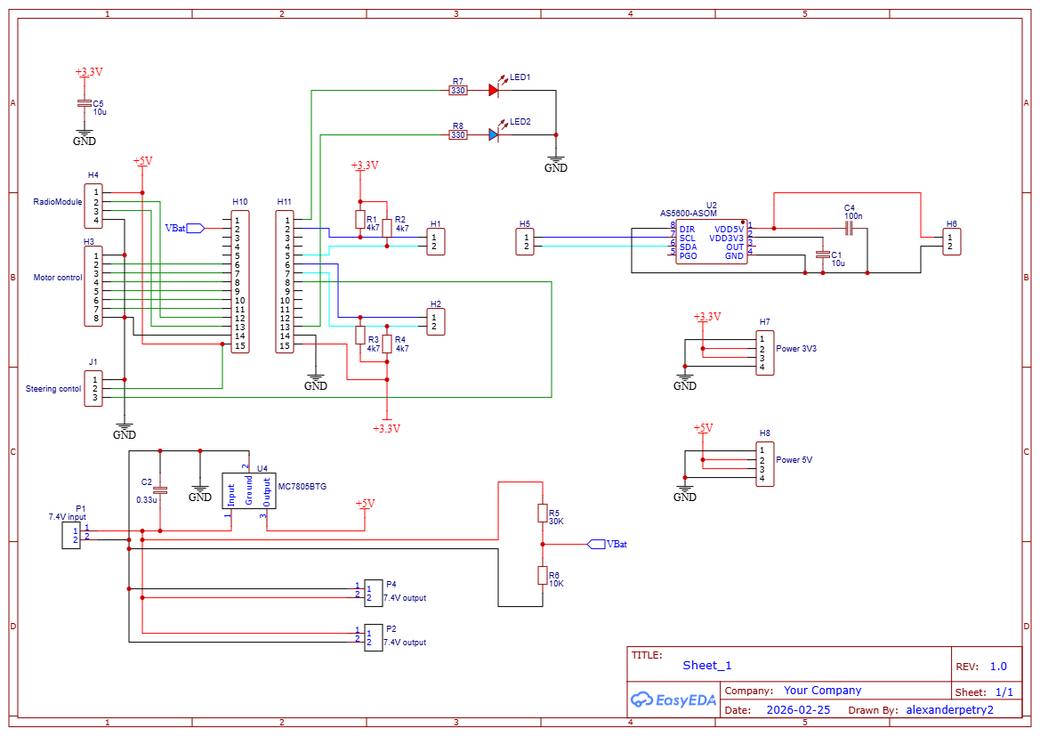

Routing explanation
The PCB layout was made to keep connections accessible and the design compact. Most components are placed underneath the ESP32 to save space and keep the board easy to mount.
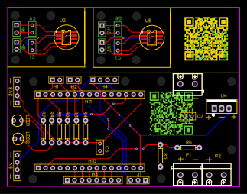
Features of the PCB
The board includes dedicated connectors for each peripheral, three 11V output lines, and onboard conversion from 11V to 5V for internal use.
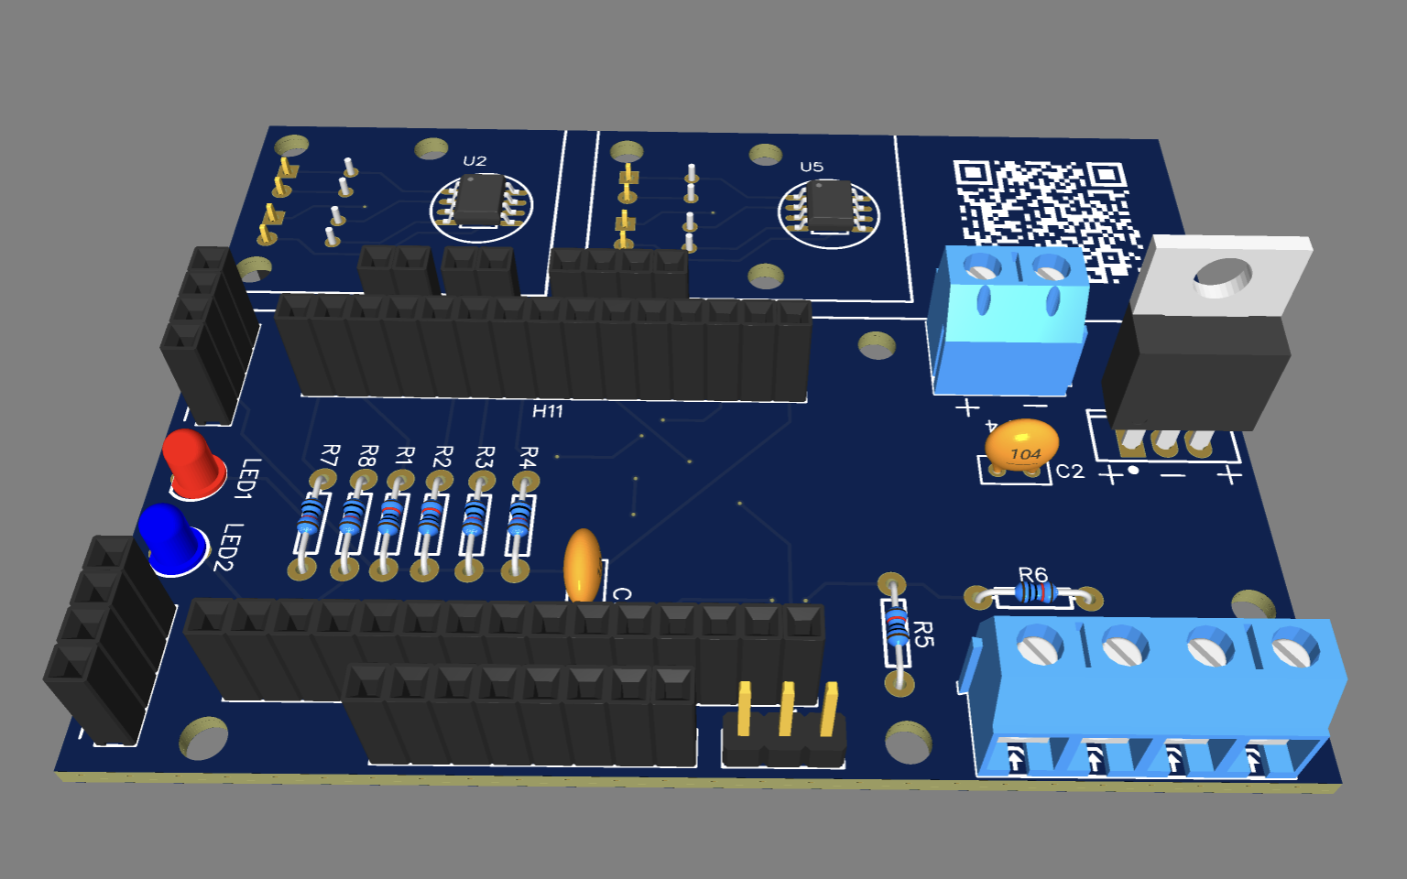
    - Electrical Design
The electrical design brings together the battery, motor driver, steering servo, radio receiver, ESP32, and power conversion on one system. This section shows how the main components are connected and how power and signals are distributed.
[Wiring schematic]
    - Components
[Table of components + reason why they are used]

  - Brain & processing unit hardware
    - Systems
Localization
The localization system uses a DWM1001 UWB module on the bus and three anchors in the environment. The anchors are currently movable because they are powered by power banks. The IMU is a SEN0142 board and is used together with UWB for odometry.
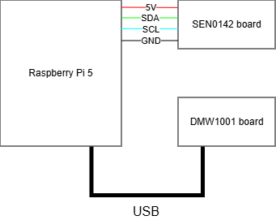
Perception
A Raspberry Pi Camera 2 is used for object detection. The camera runs YOLOv8 in real time, but the detections are currently not used for any control action.
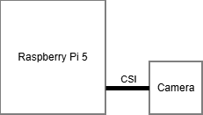
Processing
A Raspberry Pi 5 with 16 GB RAM is used as the main processing unit. It runs Ubuntu 24.04 and ROS2, and it handles the higher-level software tasks of the system.

Power distribution
Power is delivered via a 12 DCDC converter to the RPI5 PD Power board.
[schematic]

    - Electrical Design
The brain unit is connected to the ESP32, the UWB system, the IMU, and the camera. This section shows the wiring between these devices and the Raspberry Pi, including the communication links for localization and control.
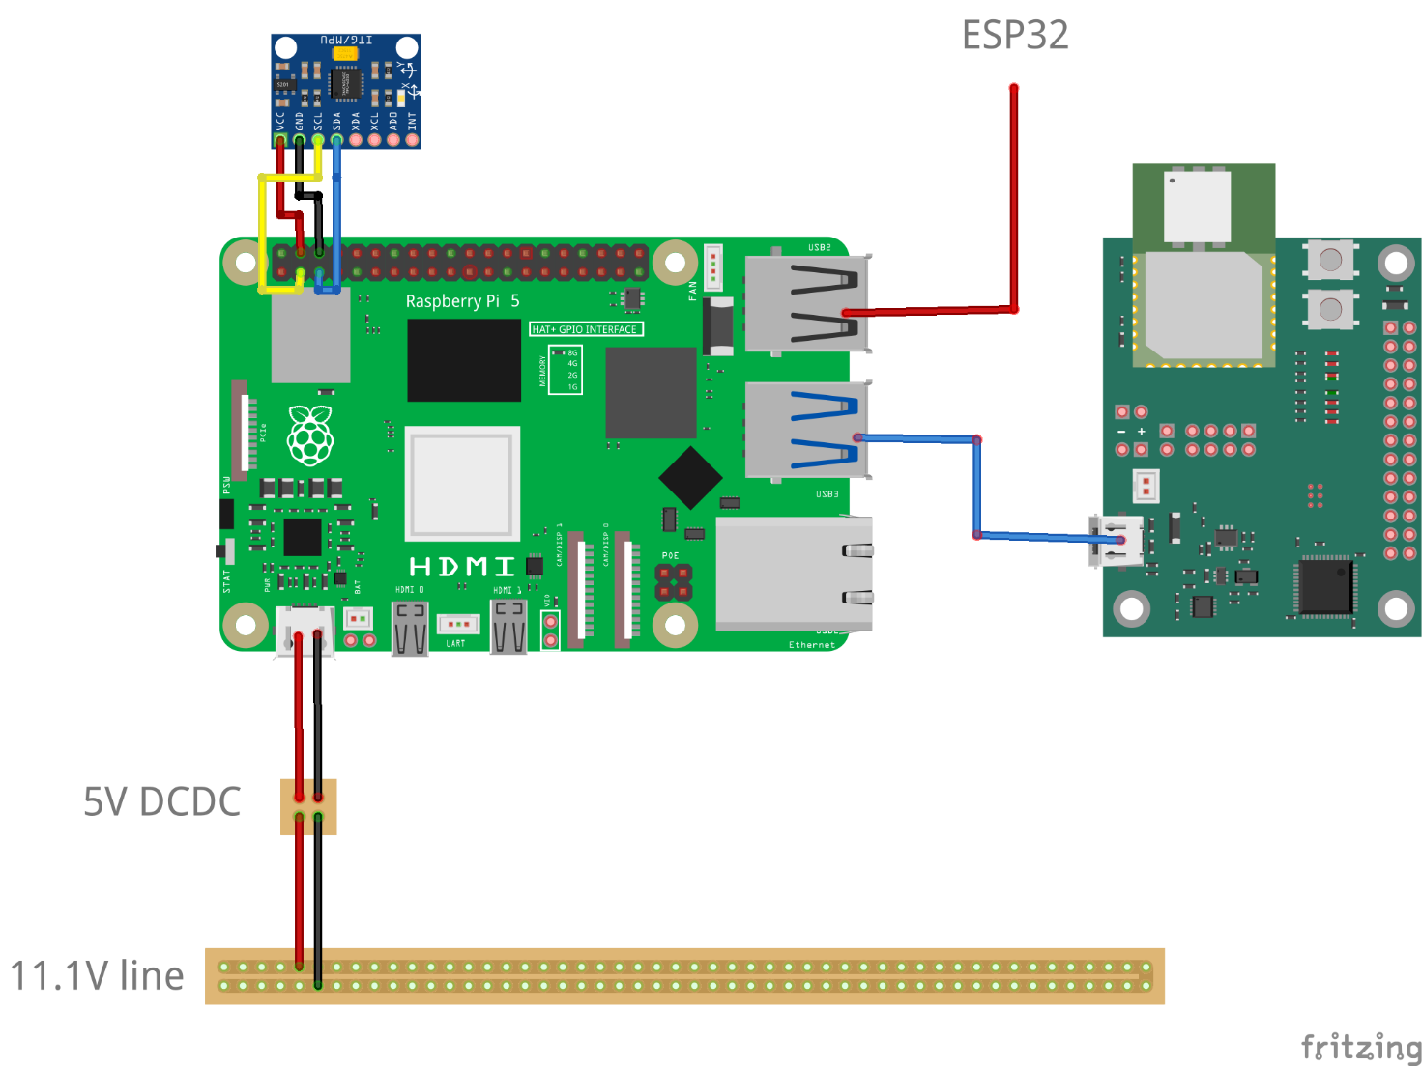

    - Components
Type | Component | Purpose
Processing | RaspberryPi 5 16 GB | Processing of localization and camera input to driving output
Localization | DWM1001 UWB board | Absolute (x,y) positioning
Localization | SEN0142 board | Accelerometer & gyro for determining movement
Power | RPI5 PD Power board | Converting a stable 12V 3A power supply to a stable 5V 5A power supply
Power | 12V DCDC converter | Converting the noisy 11.1V power line to a stable 12V line

  - Base driving unit software
    - Architecture
The ESP32 software handles steering, driving commands, and radio control. Communication with the Raspberry Pi happens through UART at 115200 baud. A PID feedback loop was planned but not implemented because it was not considered necessary during the current stage.
[ESP32 architecture diagram]
    - Process flow
The software flow starts with incoming commands from either the radio receiver or the Raspberry Pi. These commands are converted into motor and steering outputs, which are then sent to the hardware. Status data can also be sent back to the Raspberry Pi.
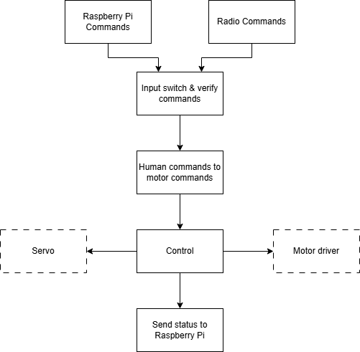
  - Brain & processing unit software
    - Architecture
The Raspberry Pi runs Ubuntu 24.04 and ROS2 Kilted Kaiju. The software is organized into packages for hardware communication, localization, navigation, perception, interfaces, and support. This structure makes it easier to separate functions while keeping the system expandable.
[high level architecture overview]

A mix of custom and existing packages is used. The hardware packages convert signals from sensors and the ESP32 into ROS-compatible data, while the logic packages handle localization, navigation, and object detection. The interface package provides the web server, and the support packages handle startup and shared data types.
Name | System | Custom made? | Purpose
Camera_ros | Hardware | No | Converting camera output to ROS signals
Py_bus_bringup | Support | Yes | For starting all nodes in the correct order.
Py_bus_driver | Hardware | Yes | Communication between the ESP32 and the ROS environment.
Py_bus_hmi | Interface | Yes | A web server for interacting with the system.
Py_bus_interfaces | Support | Yes | A supporting package that includes custom data types.
Py_bus_localisation_hw | Hardware | Yes | For converting raw signals of the UWB and IMU systems to ROS signals.
Py_bus_localisation_logic | Logic | Yes | For estimating position.
Py_bus_nav | Logic | Yes | Interfacing with the Nav2 server.
Py_bus_perception_logic | Logic | Yes | Running YOLOV8 on the camera input.
Nav2 server | Logic | No | A server that houses all path planning logic.

This schematic shows the ROS2 node structure of the brain unit. It connects the sensor nodes, localization pipeline, navigation stack, and user interface into one system.
[See apendix]
    - Process flow
The data flow starts with the camera, UWB, and IMU nodes. The camera data is passed to object detection, while the UWB and IMU data are combined in the pose estimator to generate odometry information. This data is then used by the navigation stack, which includes the transform database, planner, controller, and behavior server.
[Flowchart of data]

The schematic also shows how the web interface communicates with the system through rosbridge and the web visualization node. In addition, the driving command path is shown from Nav2 output through the drive mode arbiter and driver node toward the ESP32.
[Flowchart of data]
  - Using the platform
Setup
To use the platform, the battery is connected to power on the system. The bus can then be reached through Tailscale, and the web interface can be opened in a browser.
[Setup diagram]

The system has three control modes: manual radio driving, manual command driving, and autonomous driving. Manual radio driving bypasses the Raspberry Pi and directly controls the ESP32, which also makes it useful as a safety override. Manual command driving sends the same kind of commands through the web interface. Autonomous driving uses path planning and odometry to move toward a goal position.
[Control modes diagram]

  - Testing
To be added

- Discussion
  - Interpretation of the results
The most important result of this project is not a finished autonomous bus, but a solid and modular platform that can be further developed. The mechanical frame, base driving unit, and brain unit were successfully designed and integrated into one system, and the basic elements needed for autonomous driving are already present. Manual radio control, manual command driving, object detection, path planning, and pose estimation were all implemented, even though the final autonomous driving behavior is still not stable enough for reliable use.
A meaningful situation in this project was the realization of a working prototype that combines hardware, embedded control, and ROS2-based software in one platform. This result connects directly to the research question from the introduction, where the goal was to create a realistic and reliable 1:20 scale test setup within 14 weeks. It also links to the materials and methods section, where an iterative and practical development process was chosen. The results show that this approach worked well for the hardware side of the project, because the bus platform, electronics, and modular division into separate subsystems were all achieved in a usable form.
Looking back on this situation, the strongest part of the project was the hardware development. The mechanical structure, PCB design, power distribution, and split between ESP32 low-level control and Raspberry Pi high-level processing created a system that is clear, modular, and expandable. The software side also delivered many important building blocks, but the integration with the existing Nav2 library and the stability of the pose estimation proved more difficult than expected. This means that the main limitation is not the absence of core features, but the fact that the software is not yet refined enough to fully use the hardware platform.
The most important characteristics of this experience are therefore modularity, expandability, and functional completeness at a system level. The project shows that the chosen architecture is suitable as a base for future autonomous driving experiments. At the same time, it also shows that having all major subsystems present does not automatically result in a stable final behavior. In this case, the localization and odometry chain became the main bottleneck, which limits the performance of the otherwise working navigation setup.
Several alternatives can be identified that could lead to a better result in a future iteration. One important change would be to begin prototyping and testing earlier, instead of spending too much time on research before building. A second improvement would be to use more existing libraries instead of creating custom software for functions that are already available in the ROS2 ecosystem. This would reduce development time and likely improve reliability. A third change would be to use the updated PCB design, which would simplify wiring and reduce avoidable integration issues. These alternatives mainly affect the materials and methods section, because they would change the implementation strategy rather than the overall goal of the project.
If these alternatives are applied, the expected new result would not necessarily be a different platform, but a more refined and stable version of the same system. The project therefore answers the research question only partially: it succeeded in creating a realistic and modular test platform, but not yet in delivering fully reliable autonomous driving. Still, the current result is valuable because it provides a strong foundation on which future work can continue.
  - Context & reflection
This project contributes mainly to SDG 9 and SDG 11. SDG 9, which focuses on industry, innovation, and infrastructure, is relevant because the platform creates a low-cost and practical way to develop and test autonomous mobility systems on a smaller scale. SDG 11, which focuses on sustainable cities and communities, is relevant because autonomous and better-optimized public transport systems may contribute in the future to more efficient and smarter urban mobility.
Reflecting on this contribution, the project mainly adds value by making experimentation more accessible. A full-scale autonomous bus system is expensive, difficult to adjust, and not suitable for rapid prototyping in an educational context. By building a smaller and modular version, the project lowers the threshold for testing ideas related to autonomous mobility. This creates an indirect but meaningful contribution to innovation and more sustainable transport research.
The most important aspect here is that the setup is not only a demonstration model, but a technical platform that can be expanded further. Because the hardware is modular and the software is organized in ROS2, later improvements can be made without redesigning the full system. An alternative direction would be to add sensors such as LiDAR or improve the object handling pipeline, which could further strengthen the contribution to safer and more efficient mobility systems. In that sense, future extensions may also support broader sustainability goals.
  - Critical analysis
For Lapland UAS, the main value of this project lies in providing a reusable platform for demonstrations, software testing, and future student work. Instead of starting from zero in a later project, a next student or researcher can continue from an existing chassis, electronics platform, ROS2 structure, and localization setup. This makes the output of the project more valuable than a single prototype, because it supports continuity within the workplace.
At the same time, this value is not yet maximal. The platform still depends on further software refinement before it can be used as a fully reliable autonomous system. To increase its value for Lapland UAS, the next step should be to improve the localization and odometry pipeline, document the software setup clearly, and update the PCB and wiring according to the improved design. These improvements would make the platform easier to reuse, easier to teach with, and more suitable for simulation-linked demonstrations.
A critical point is that some parts of the system are still more custom than necessary. While custom development helped to better understand the system, it also increased complexity and maintenance effort. A better balance between custom development and existing software tools would likely improve long-term usability at the workplace.
  - Reflection on the X-factor
This project clearly involved several elements of the X-factor, especially multidisciplinarity, entrepreneurial and innovative action, international cooperation, and empathy and involvement. The strongest personal learning point was the need to combine mechanics, electronics, embedded programming, ROS2 software, and system integration into one coherent whole. That required not only technical knowledge, but also the ability to move between disciplines and understand how decisions in one part affect the others. A personal strength in this process was the ability to build connections between these parts and keep the broader system in mind. A pitfall was that attention could sometimes shift too much toward one subproblem, while system-level planning needed more structure.
Entrepreneurial and innovative action appeared in the effort to make practical choices under limits of time, budget, and available components. The project required initiative and continuous decision-making, especially when moving from theory to implementation. A strength here was the willingness to keep building and solving problems step by step. A weakness was that the planning could have been stronger, especially by starting testing earlier and relying more on existing tools where possible instead of developing too much from scratch.
International cooperation was present through the use of English-language documentation, scientific papers, datasheets, and technical frameworks, as well as through the context of working at Lapland UAS. This improved the ability to process technical information across language and domain boundaries. It also emphasized the importance of documenting decisions clearly so that others can continue the work.
Finally, empathy and involvement appeared in the idea that this project should not only work for the current research period, but also remain useful for future students, researchers, and demonstrations. This gave extra importance to modularity, documentation, and reuse. A key personal insight is that technical work becomes more meaningful when it is designed not only to function, but also to remain understandable, transferable, and valuable to others.

- Conclusion
The purpose of this project was to build a platform for simulating autonomous driving algorithms for buses in a miniature 1:20 scale environment. The main goal was not to create a fully finished autonomous vehicle, but to develop a realistic and modular base that could be used for testing, demonstration, and future expansion.
The outcome of the project is a working prototype that combines a mechanical frame, a base driving unit, and a brain unit into one system. The platform supports manual radio driving, manual command driving, object detection, path planning, and position estimation. This means that the essential building blocks for autonomous driving are present, even though the autonomous driving mode itself is not yet stable enough for reliable use.
The project shows that the chosen setup is a good starting point for future development. The hardware side was developed successfully, and the system is structured in a way that makes it expandable and easier to improve later. The main limitation is the software integration, especially the pose estimation and the use of the Nav2-based navigation stack. Because of this, the current system should be seen as a base platform rather than a final product.
Overall, the project achieved its main objective: it created a functional and modular test platform for autonomous bus development at scale. The final perspective is that this platform can still grow into a more complete system through improved software, better integration, and future additions such as extra sensors or more advanced autonomy features. For Lapland UAS, this creates a useful foundation for simulations, demonstrations, and future student projects.

- References
In deze sectie vermeld je in IEEE formaat de referenties van de bronnen die zijn aangehaald in de application note.
Indien gewenst kan je gebruik maken van referentie plugin software in microsoft word zodat de nummering en volgorde van de referentie lijst automatisch wordt gesynchroniseerd met de volgorde waarin de referenties voorkomen in de secties. Mendeley is een voorbeeld van referentie software.
- Apendix
Indien er belangrijke verwijzingen zijn die in eerste instantie niet via een IEEE referentie te maken zijn of indien de bron zelf gecreëerd is kan deze in de bijlage toegevoegd worden. Het komt slechts uitzonderlijk voor dat een eigen bron niet relevant genoeg is voor de hoofdsecties, maar relevant genoeg voor de bijlage. Het gebruik van de bijlage sectie moet daarom goed overwogen worden. Een voorbeeld van niet toe te voegen bronmateriaal: Het toevoegen van alle broncode die geschreven is, heeft geen enkele meerwaarde. Een voorbeeld van mogelijks relevant bronmateriaal: Een grafische weergave van resultaten van een test die een discussie paragraaf sterk verduidelijken. Deze grafische weergave bevat erg veel datapunten en moet dus op een groot formaat getoond worden in een bijlage wat niet mogelijk is in de resultaten sectie.

