**The Chinese University of Hong Kong**

**Department of Computer Science and Engineering**

**CSCI3280 Project Report**

**Peer-to-peer Karaoke System (C++)**

Poon Bing Chun 1155063232

Ka Chiu David Li 1155049531

Wong Chi Wa 1155062568

~~Wong Yee Lai 1155031343~~

1. **Workload Division**

|  |  |
| --- | --- |
| Poon Bing Chun | Coding (95%):   * Wave playback * Volume control * GUI design & implementation * Album art, artist photo, album info, etc retrieval * Lyrics retrieval * Regular expression search * Auto-scroll * JSON parsing * Visualisation * Streaming * Video playback * Multithreading   Project management:   * GitHub * Trello   Report (40%) |
| Ka Chiu David Li | Coding (4%):   * Wave playback * MP3 playback |
| Wong Chi Wa | Coding (<1%):   * Wave playback   Report (60%) |
| ~~Wong Yee Lai~~ | Free-rider |

1. **Program’s Operation Manual**

* The main window: \*\***photo\*\***
* The users can select different wave files. \*\***photo\*\***
* The user can search the files by keywords. **\*\*photo\*\***
* The users can play the files by clicking the “play” button. \*\***photo\*\***
* The users can connect to different computers. They can choose to be a server or a client. \*\***photo\*\***

1. **Features**

* Wave and MP3 playback, pause & stop
  + JSON music library
* Seamless streaming
* Animated & resizable GUI
* It increases the appeal of the music player.
* Beautiful buttons with glow effects, which are **NOT** graphics but manually coded using Bézier curves.
* Rearrangeable tabs
* Album art, artist photo, album information, and artist information retrieval
* Lyrics retrieval (manual parsing, **NOT** using any APIs!)
  + Support custom LRC lyrics as well
* Lyrics auto-scroll with speed control
* The lyrics can be scrolled automatically so that the user can follow the songs to view the lyrics easily. The GUI contains a knob control for the scrolling speed of lyrics.
* Line chart visualisation
  + An aesthetic feature.
* Drag & drop
* This function improves the user-friendliness of the user. It provides flexibility to listen to the songs.
* Minimise to tray
* This function clears space for the taskbar. The user can run the music player and do other things on their computer together.
* Volume control
* The user can control the volume of the players so that he can enjoy the songs with the optimal volume.

1. **Third-party Libraries and Application Used**
2. **Qt**

Ot is a cross-platform application framework that is used for developing C++ application software. We use Qt to develop our project. We use it to construct our GUI, regular expressions, HTTP requests, JSON, data structures and unit test. We implement our codes on Qt environment. It provides lots of libraries and applications to help us finish the project especially it provides lots of GUI applications which help us build the GUI easily.

1. **Genius API**

Genius API allows us to access and integrate the functionality of Genius with other applications. It is a text annotation platform where users can annotate and edit text line-by-line. We use it in our project to retrieve the album art and artist information. It is reminded that it does not support lyric retrieval on the go.

1. **Project Schedule**

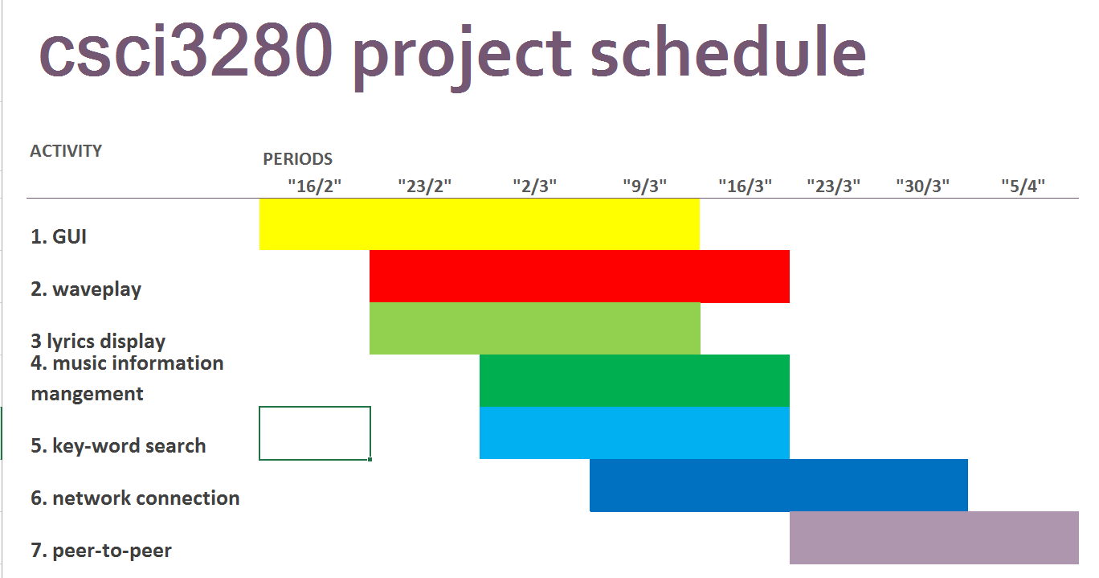

1. **Future Development**

**1). More format of audio files**

In future, we can develop to support different format of audio files such as AIFF, ASF, FLAC, Speex, MPC etc. As a result, the user then can run different format of audio files and enjoy different songs without any file conversion or any inconvenient.

**2). Support video format**

We decide to support video playing so that the user can add the video files to the play list. The user can run the video directly. For example, the user can watch the music MV in the player directly.

**3). Equalizer**

We decide to add an equalizer to the playing. It is used to enhance or reduce different frequency bands in the audio. The user can achieve different effects such as strong bass or large amount of high frequencies via the equalizer. It facilitates the flexibility and performance of the music player.