# UML Database Notation



* The NeighbouringFlats hosted table is a mapping calculated by the ‘Polygon Neighbors’ geoprocessing tool filtered by *BaseLevel* and *FloorHeight* within a close distance.
* Multiple sensor readings regarding the same flat and same issue will be counted as one task.
* Once a task has been assigned for a flat tacking a certain issue in the Web App, subsequent sensor reports concerning the same issue will be ignored. For instance, an overheating signal of 40°C has been issued, after work was assigned in the Web App, the same sensors still sends overheating signals of 42°C regularly, but they will not be counted by the Web App. (Under the hood, the Web App finds *MAX(AssignStatus)* for every *(BuildingCSUID, EnglishDisplayFloorName, UnitNumberName)* tuple. If it is not empty, than the Web App will ignore those records.)
* ArcGIS Pro supports reading MSSQL Views and performing definition queries and visualisation with them.

# GeoEvent Flowchart

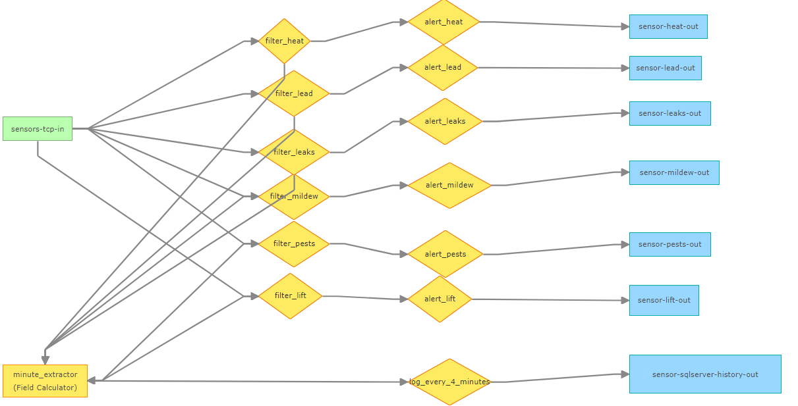

* Logs every ***n*** minutes: *minute_extractor* not only extracts the minute portion of the ReportTime, but also calculates the modulo (minute % n). *log_every_4_minutes* is a filter that will only forward GeoEvents within the acceptance period: modulo = 0 means that the acceptance period is one minute long; modulo = 0 OR modulo = 1 signifies that the period is two minutes long, and so on.
* MSSQL support of GeoEvent Server depends on a custom GeoEvent Output Connector. For more details, please visit <https://community.esri.com/t5/arcgis-geoevent-server-ideas/add-sql-server-as-an-input-to-geoevent/idi-p/967061> .