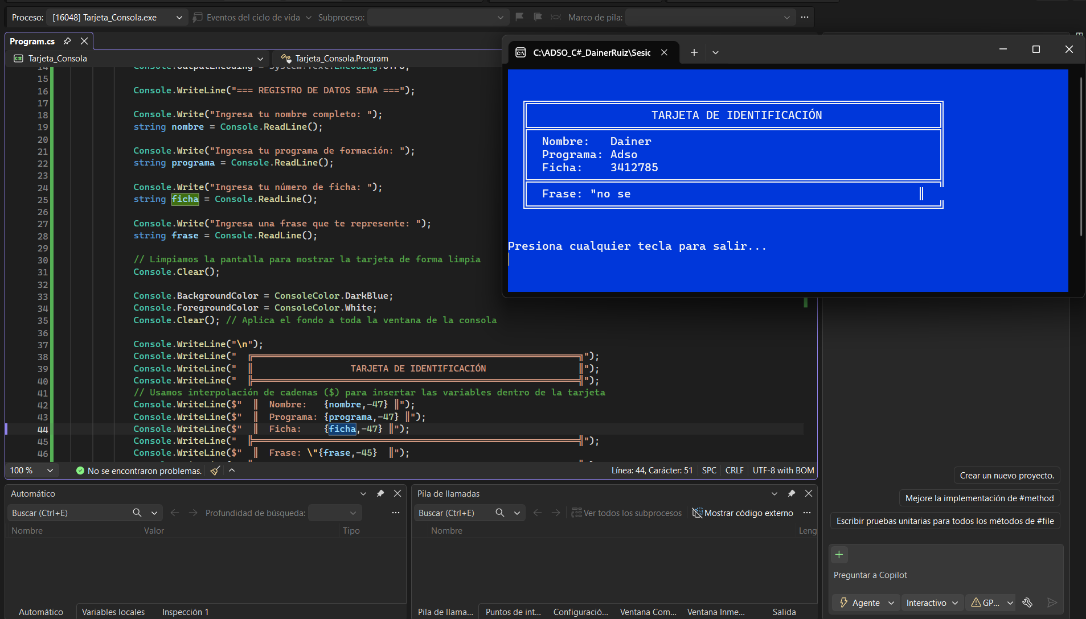
https://github.com/AlexanderRm16/csharp-adso-DainerRuiz

