Peter Schubert

Alexander Rosati

Nathan Carey

CIS 435 Project 3 Write Up

|  |  |
| --- | --- |
| Name | Contribution to the Project |
| Peter Schubert | Implemented Project 6-3, Tested Projects 6-1 through 6-5, wrote Write-up |
| Alexander Rosati | Implemented Projects 6-1 and 6-5 and created login page |
| Nathan Carey | Implemented Projects 6-2 and 6-4 |

**Instructions to use:**

1. In order to run the webpage, the folder containing the project “CIS435Proj3” must be placed directly into “htdocs” folder on the first level on htdocs (cannot be placed in any other folder within htdocs)
2. To access Projects 6-1 through 6-3 and 6-5, the user logged in must be an administrator
3. To access Project 6-4, the user logged in must be either an administrator or a customer
4. If the user is either not logged in as the correct user type for a project page (either 6-1, 6-2, 6-3, 6-4, 6-5), the page will display an alert/error message saying that “You are not authorized to access this page”

**Screenshots:**

Login Page:

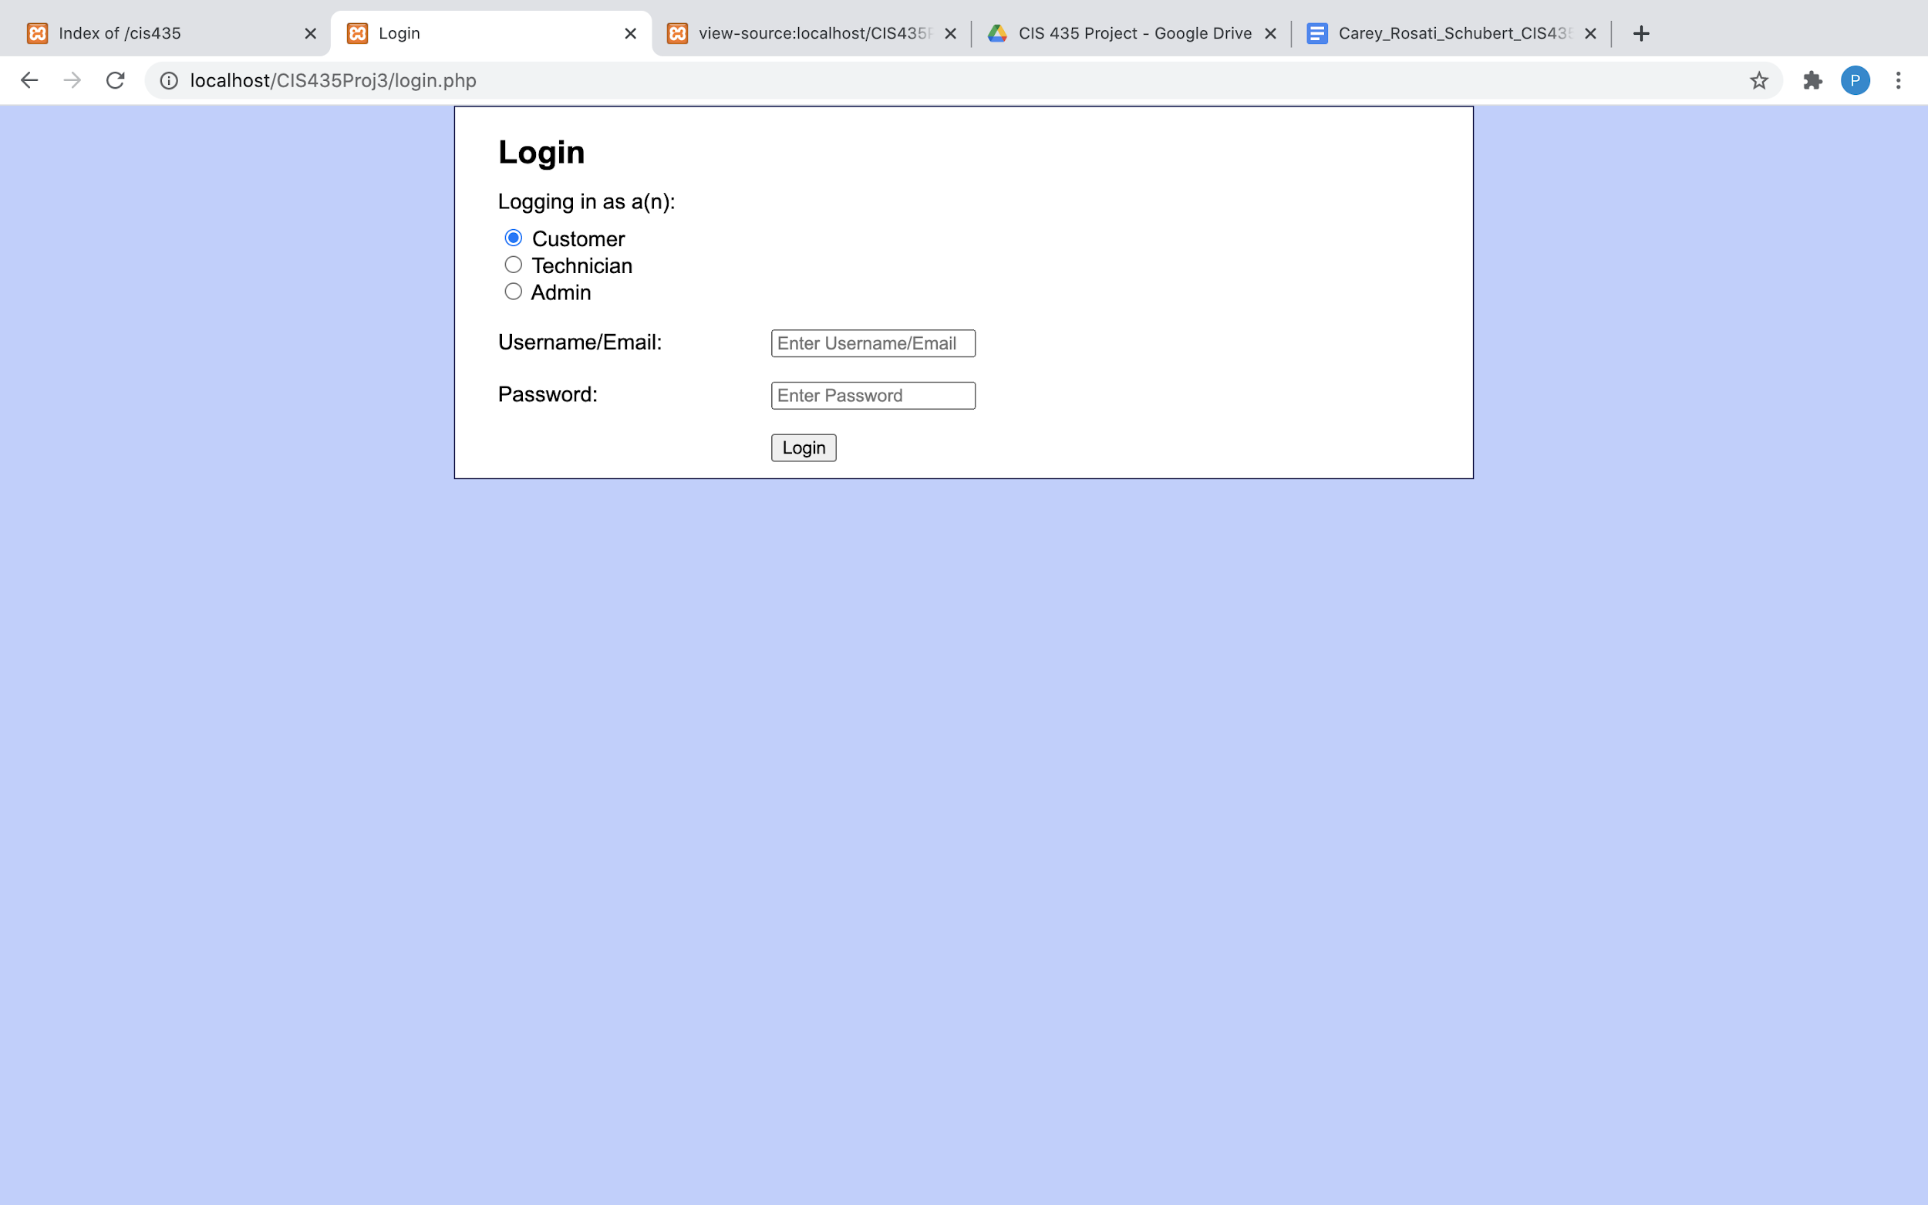

Project 6-1:

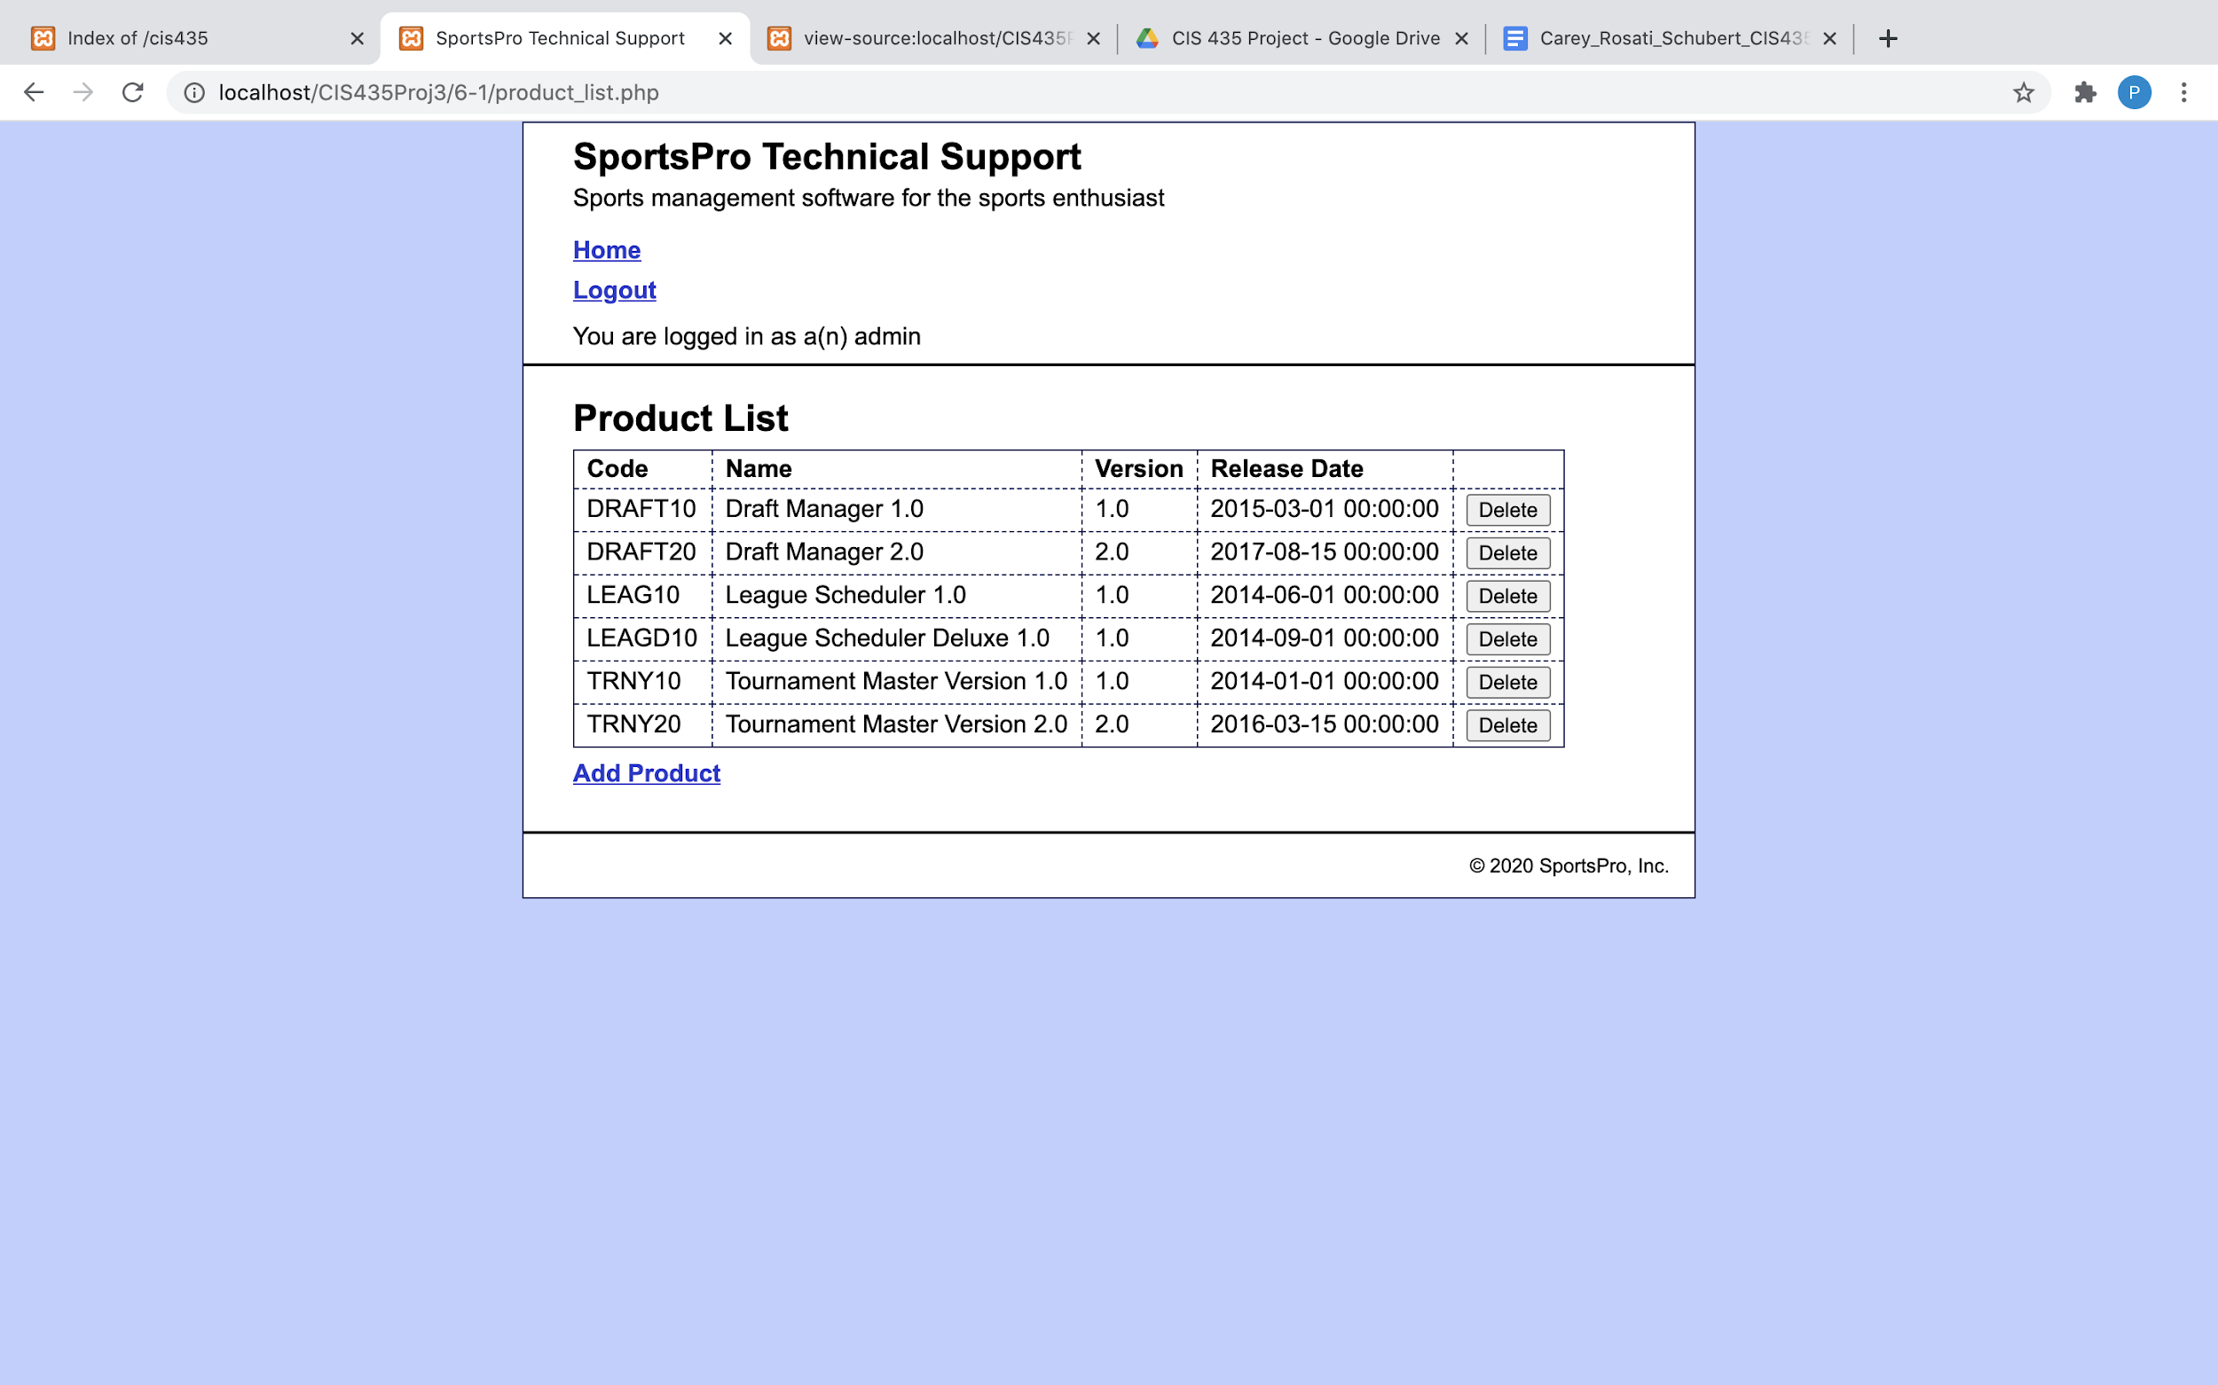

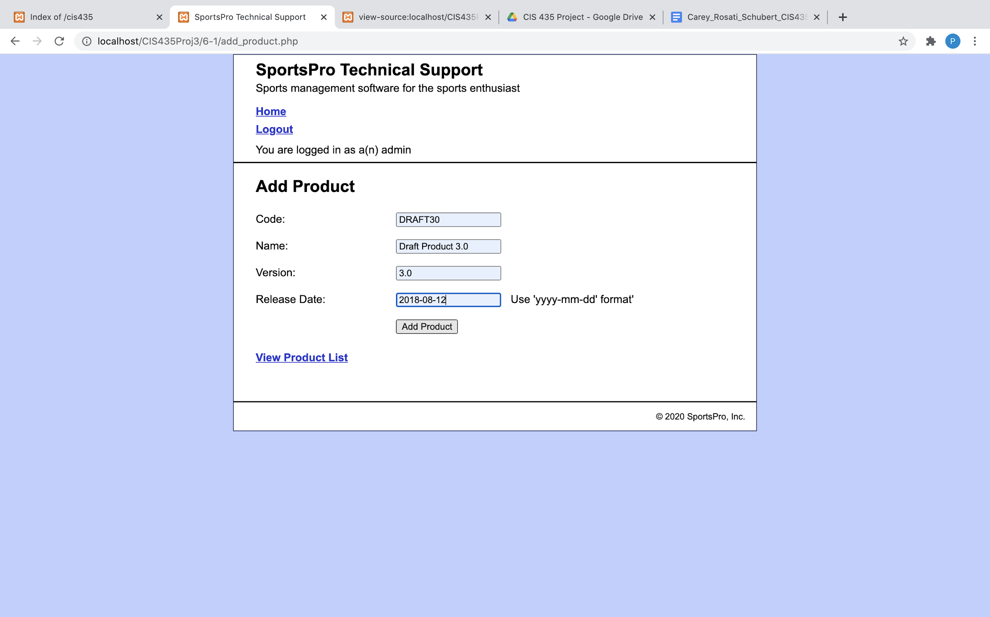

Project 6-2:

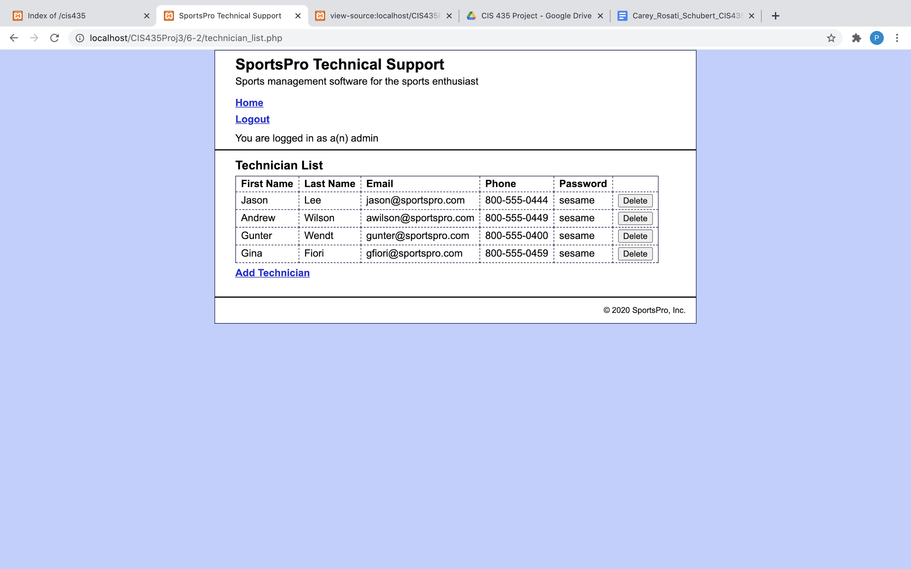

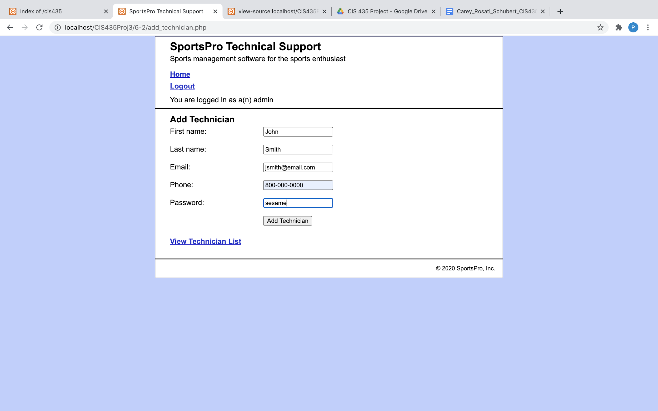

Project 6-3:

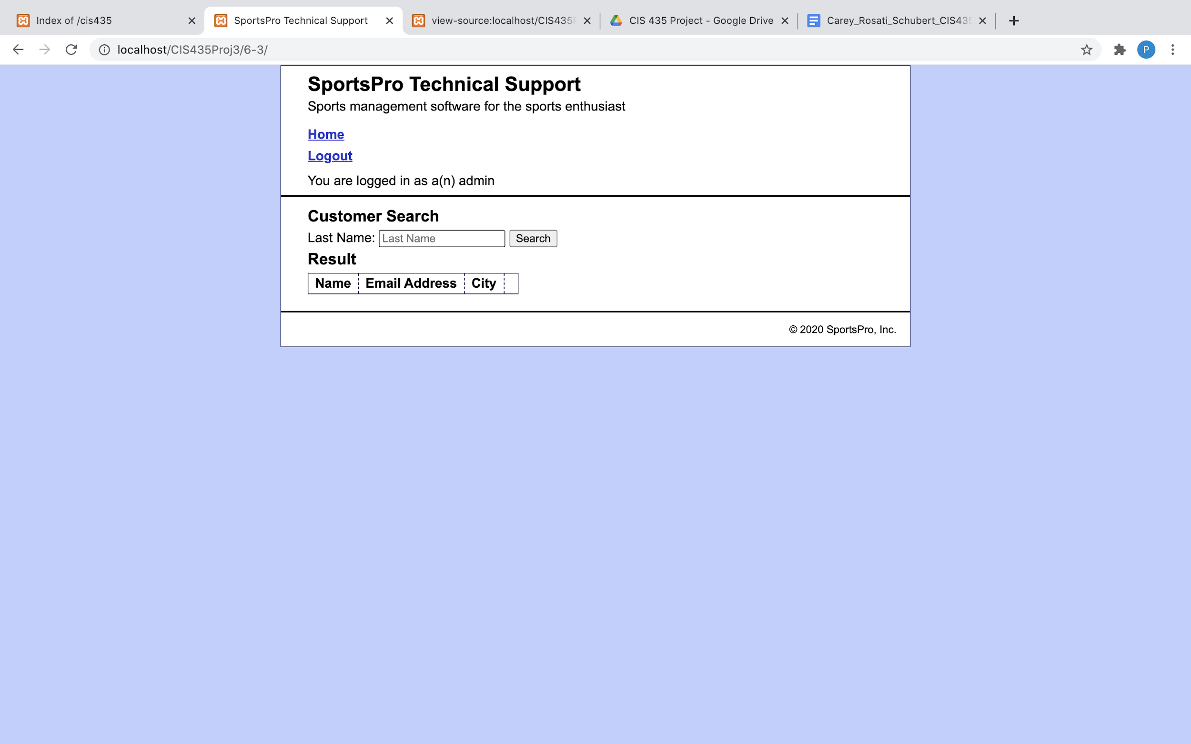

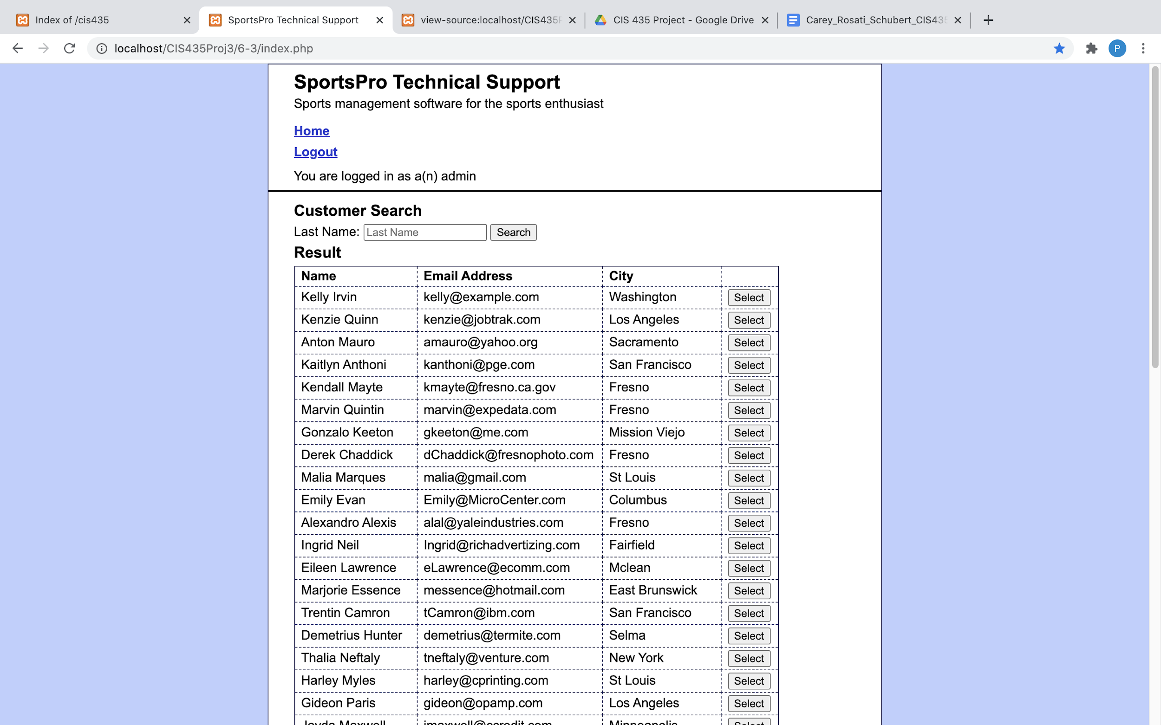

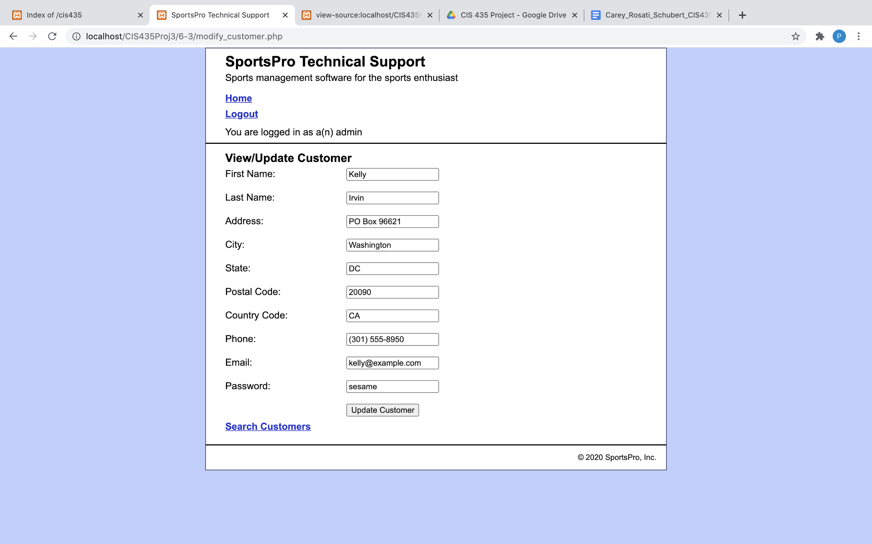

Project 6-4:

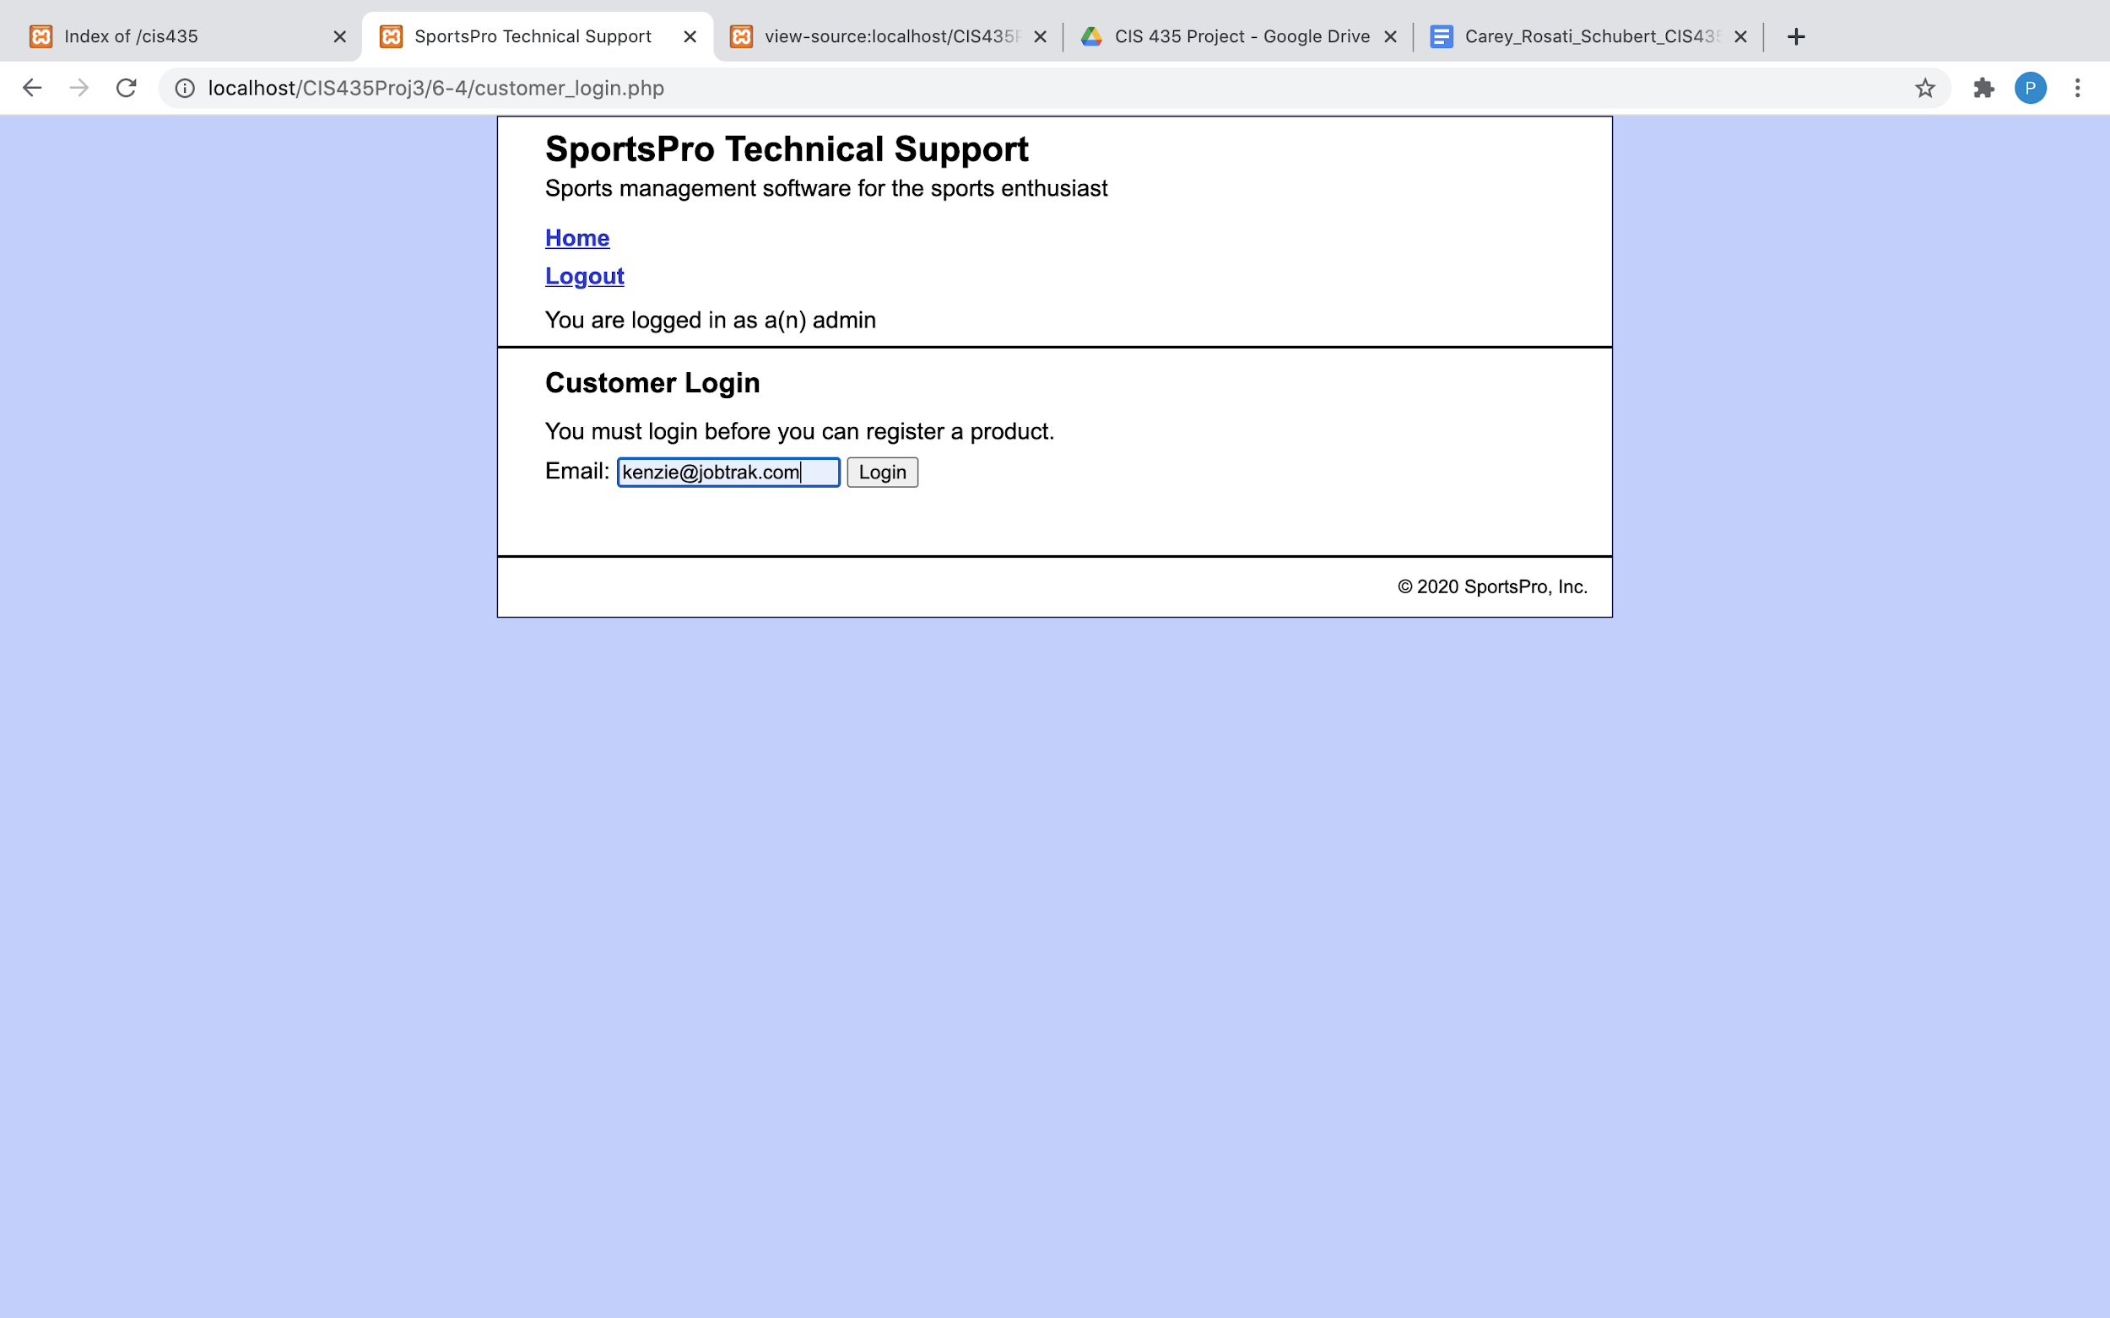

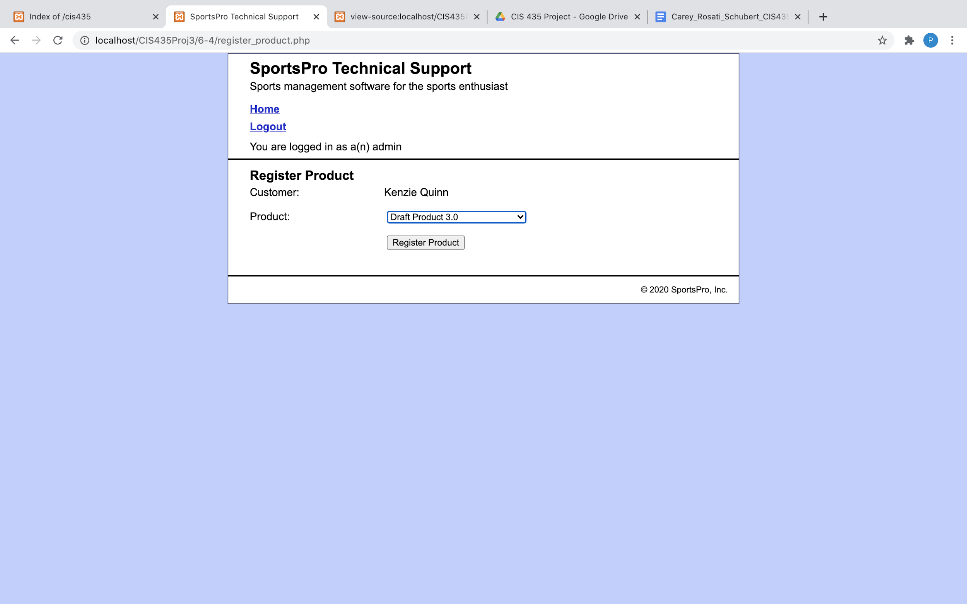

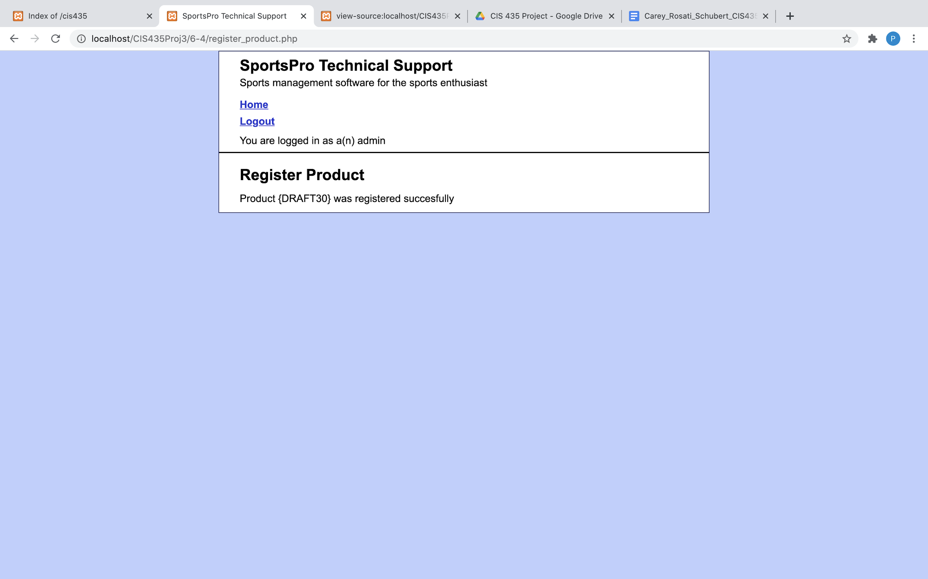

Project 6-5:

