Alexander Rosati

Avian Calado

Peter Schubert

**Citation Needed Description/ Tutorial**

**Initial Setup:**

In order to start the app, it must be loaded on android studio and started via the android virtual device (avd) manager.

**Navigating the Citation Needed App:**

1. When the app is initially launched, the Tab for adding a new citation is displayed. The user can enter citation information, such as the First Name, Last Name, Book Title (Optional), Tags and the Citation.

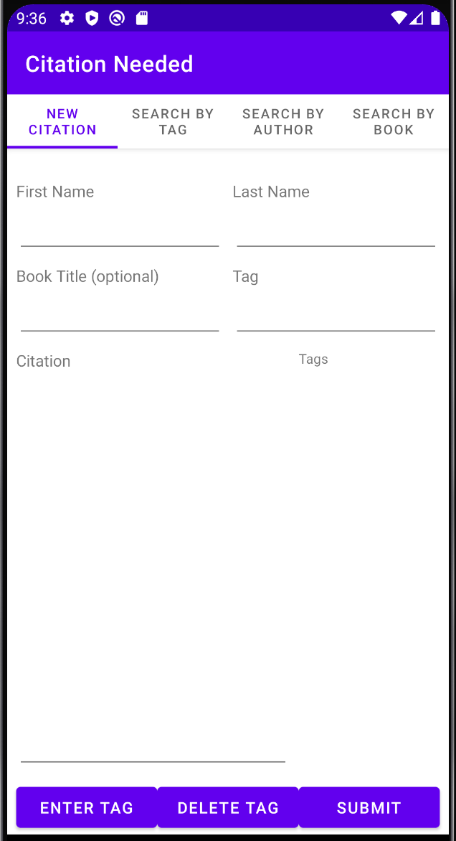

1. Entering a Tag
   1. To enter a tag, type in the tag name in the line below the Tag label
   2. Afterwards, click the “Enter Tag” button below

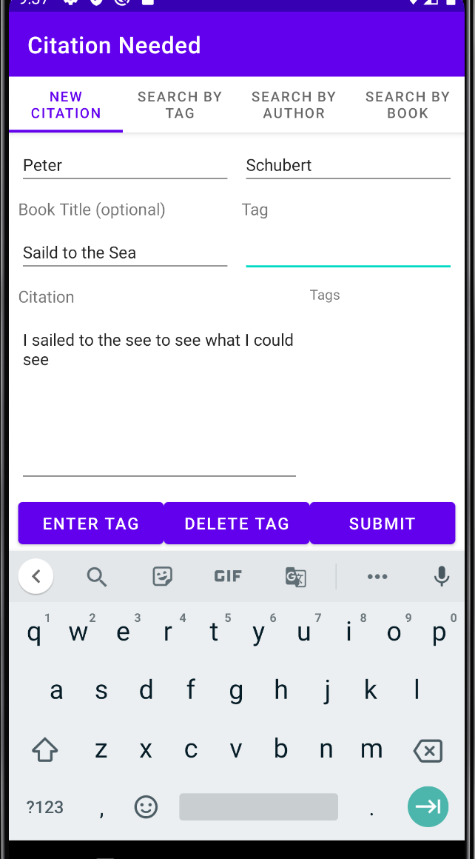 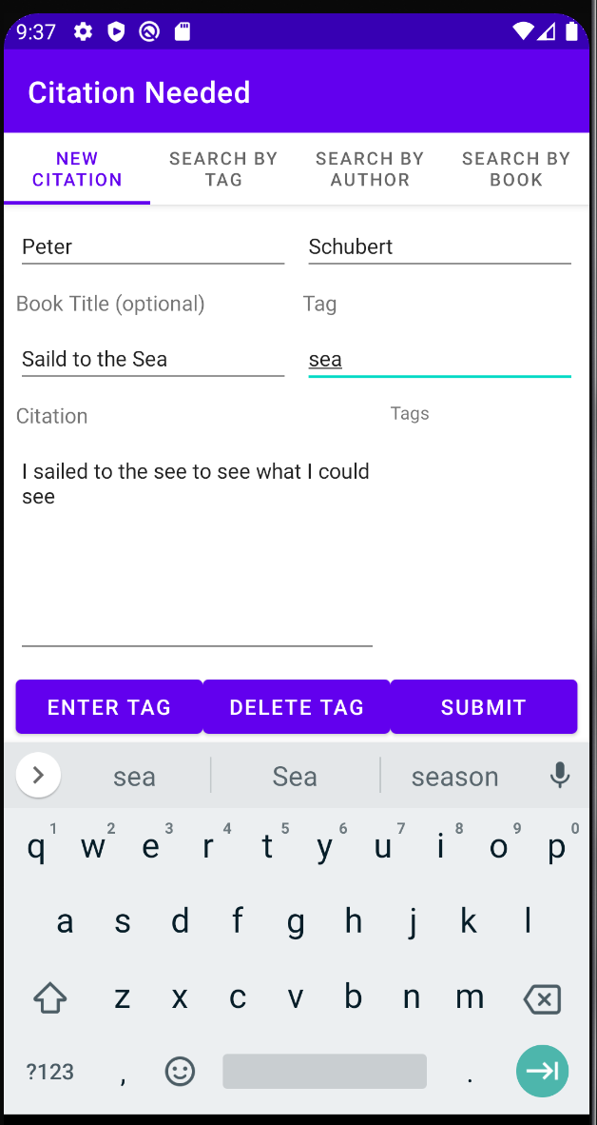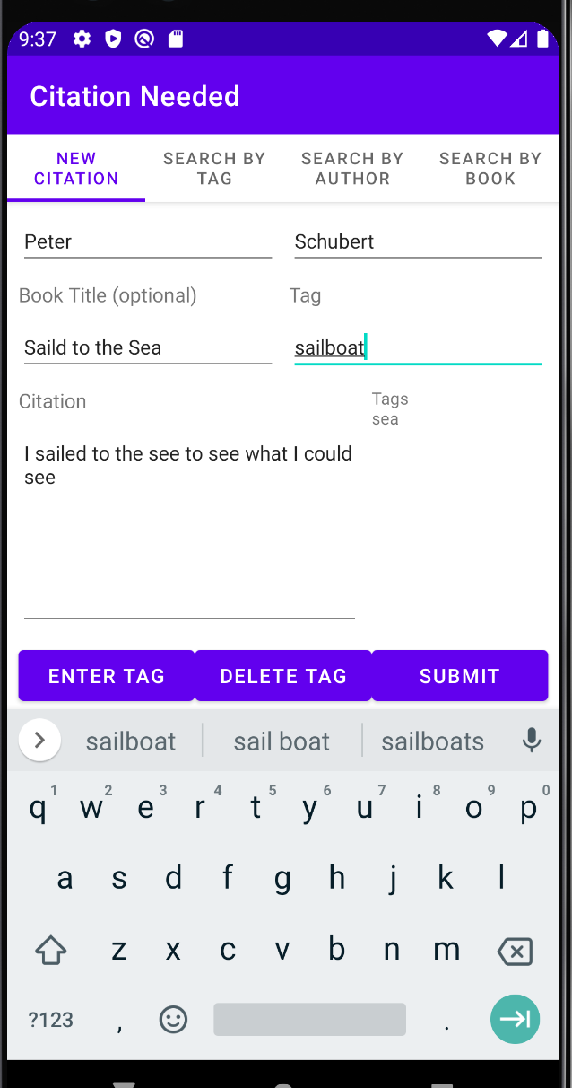

1. Deleting a tag
   1. To delete a tag just entered (bottom most tag) press the delete button at the bottom of the screen

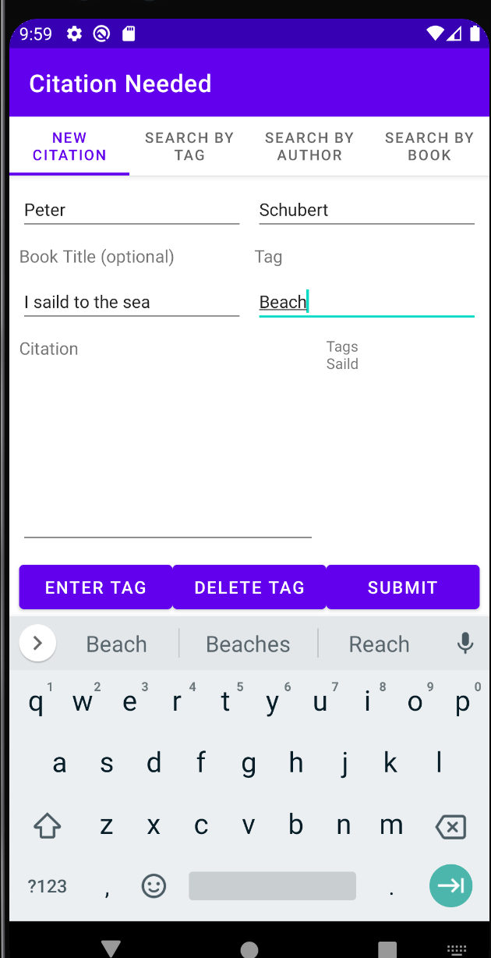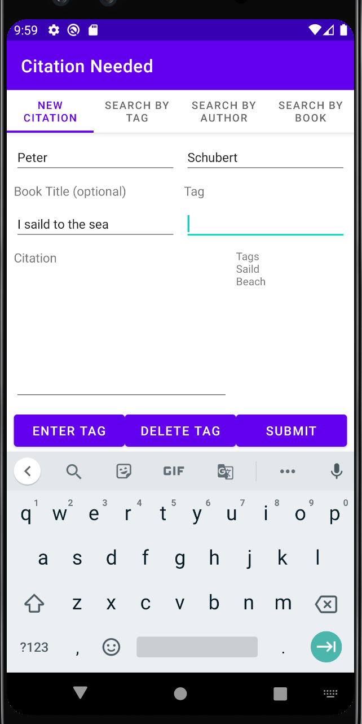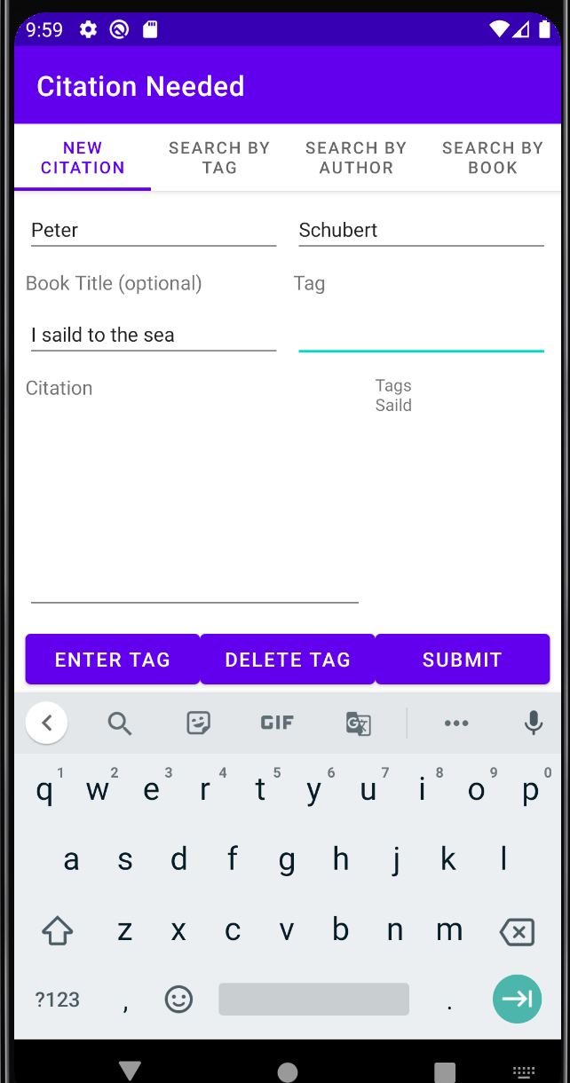

1. Search by Tag
   1. Enter the tag to search by and relevant citations with that tag entered will be displayed

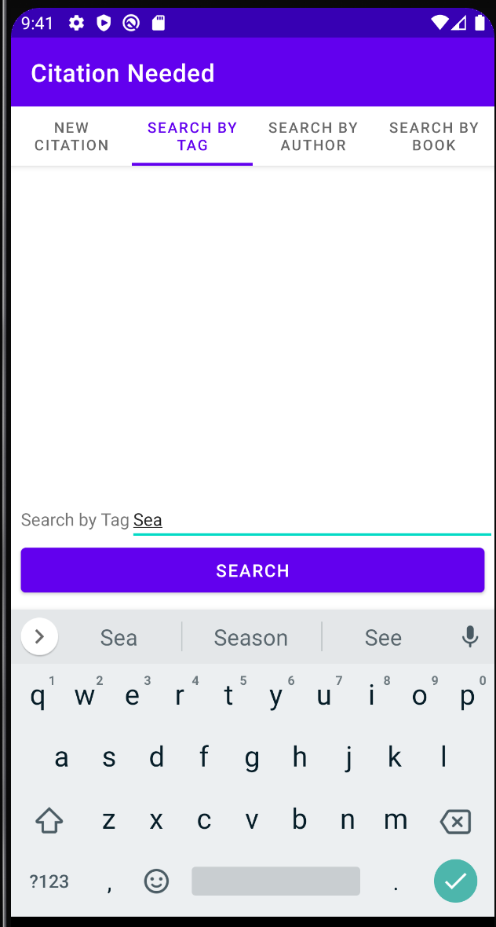 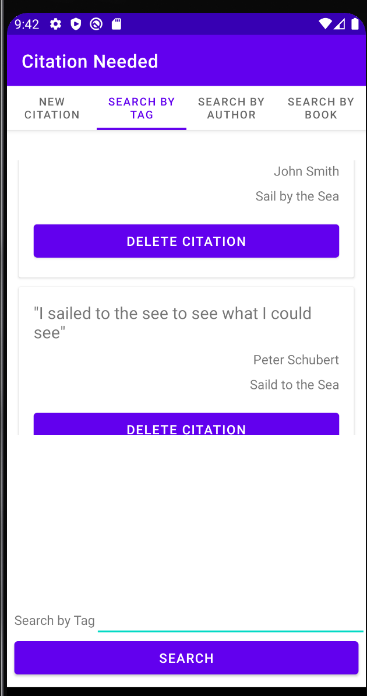

1. Search by Author
   1. Enter the author’s First and Last Names to search for citations. The relevant citations with the author’s First and Last name searched will be displayed

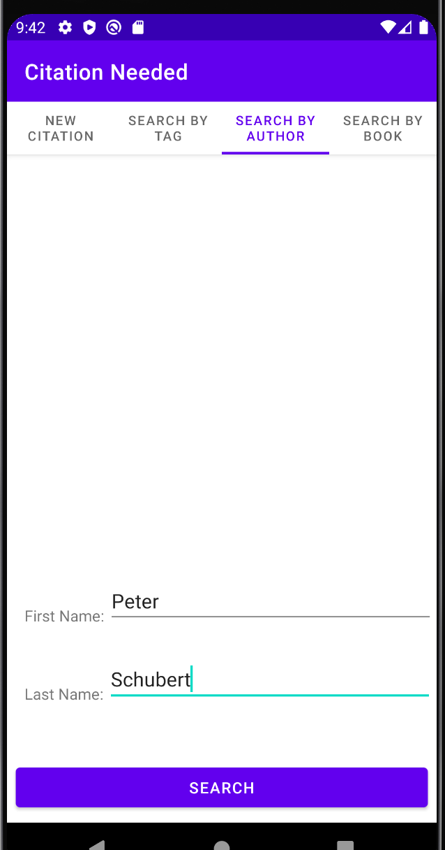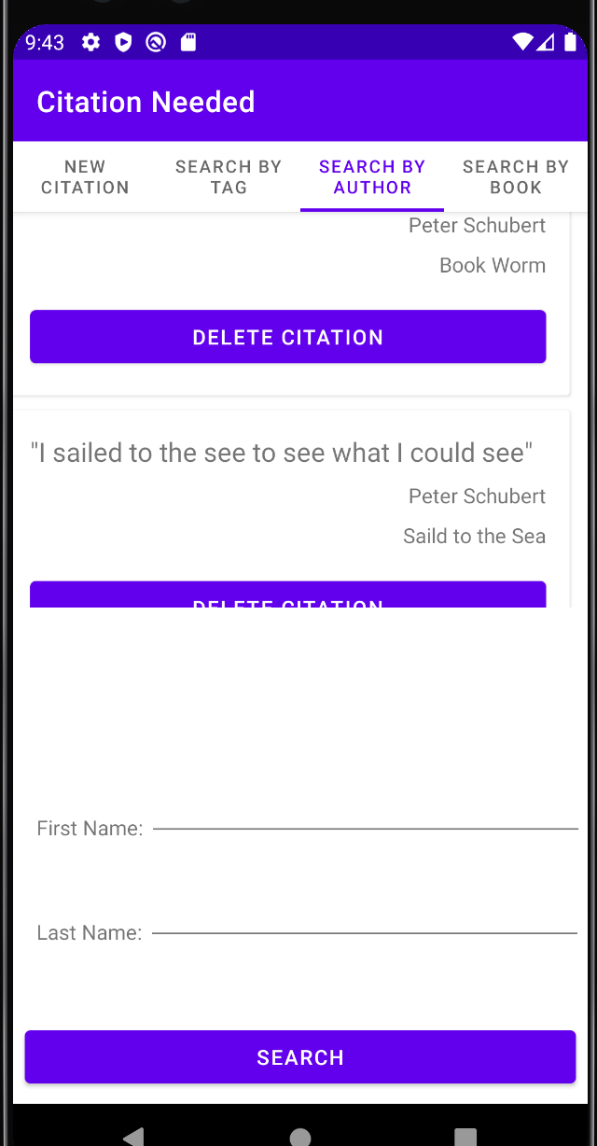

1. Searching by book
   1. Enter the book name as written without any spaces before or after the book title. The relevant books with the title searched will be displayed

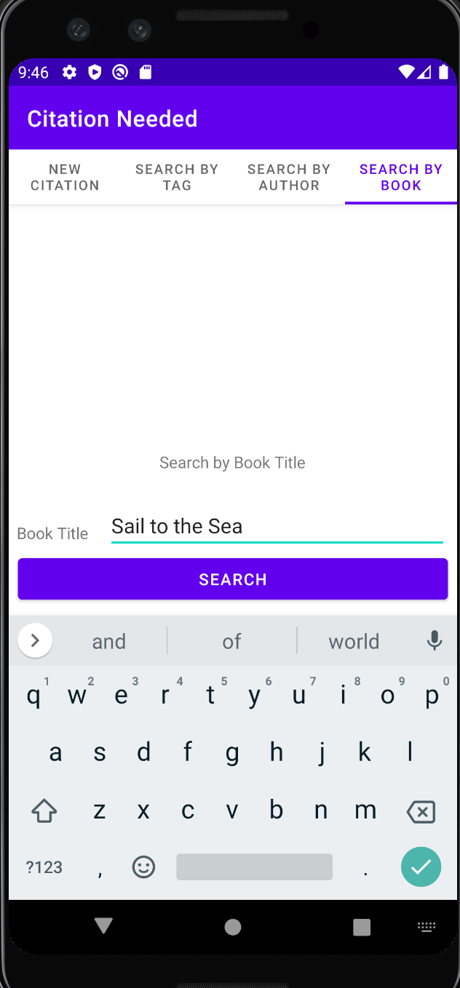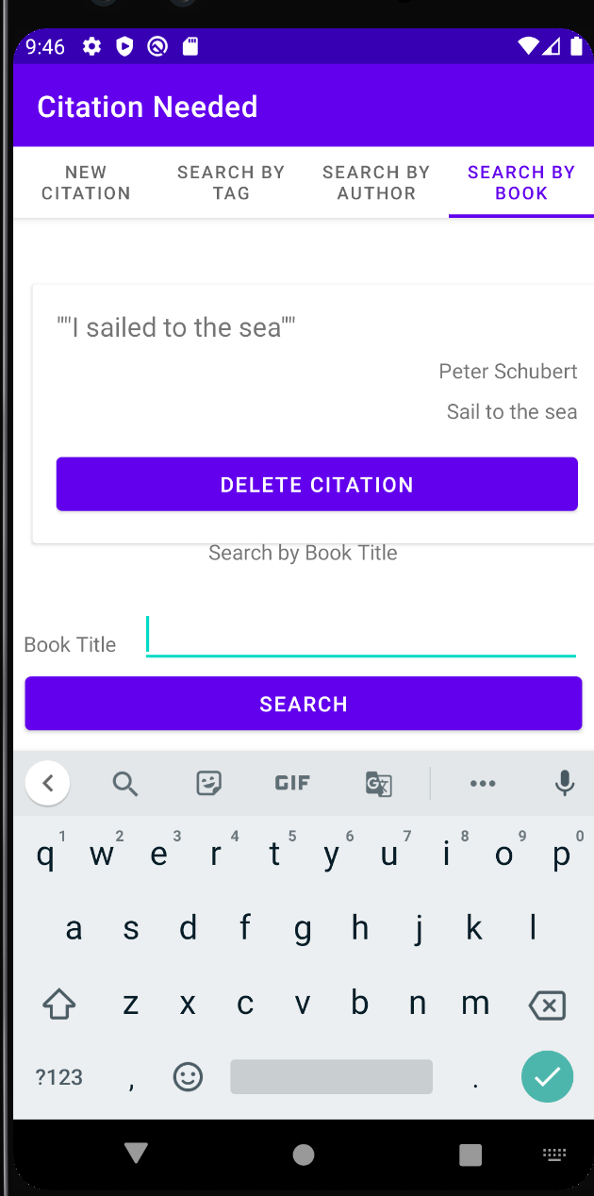

1. Deleting a Citation
   1. Anytime a user wishes to delete a citation, the user may, on any of the search tabs, press the delete citation button and the citation will be removed from the database completely

