Listen carefully to the conversation in a restaurant and do the exercises to practise and improve your listening skills.

Do the preparation exercise before you listen. Then do the other exercises to check your understanding.

## ***Ex.1. Eating out. Match the words and pictures.***

|  |  |  |  |  |  |  |  |
| --- | --- | --- | --- | --- | --- | --- | --- |
| fruit salad | tomato soup | | cheese burger | vegetables | omelet | | roast chicken |
|  |  | |  |  |  | |  |
| pasta | chips | | ice cream | cheese and biscuits | sausage | | grilled fish |
|  | | | | | | | |
|  | |  | |  | |  | |
|  | |  | |  | |  | |
|  | |  | |  | |  | |
|  | |  | |  | |  | |
| grilled fish | | fruit salad | | ice cream | | roast chicken | |
|  | |  | |  | |  | |
|  | |  | |  | |  | |
|  | |  | |  | |  | |
| chips | | vegetables | | tomato soup | | cheese and biscuits | |
|  | |  | |  | |  | |
|  | |  | |  | |  | |
|  | |  | |  | |  | |
|  | |  | |  | |  | |
|  | |  | |  | |  | |
| pasta | | cheese burger | | omelet | | sausage | |

***Ex. 2. Listen the record and do this exercises while you listen***



***Are the sentences true or false?***

1. The customers want two tables. T

Начало формы

Конец формы

2. There are two customers eating together. T

Начало формы

Конец формы

3. The two customers order the same starter. F

Начало формы

Конец формы

4. Both customers order the Thai chicken for their main course. T

Начало формы

Конец формы

5. The customers order cold drinks. T

Начало формы

Конец формы

6. Both customers order a dessert. F

Начало формы

***Write the correct word to fill the gaps.***

1. A table   two, please.

2. Are you   to order?

3. What would you  for your starter?

4. I'd  French onion soup, please.

5. What  you like to drink?

6. I'll  a fresh orange juice.

***Discussion***

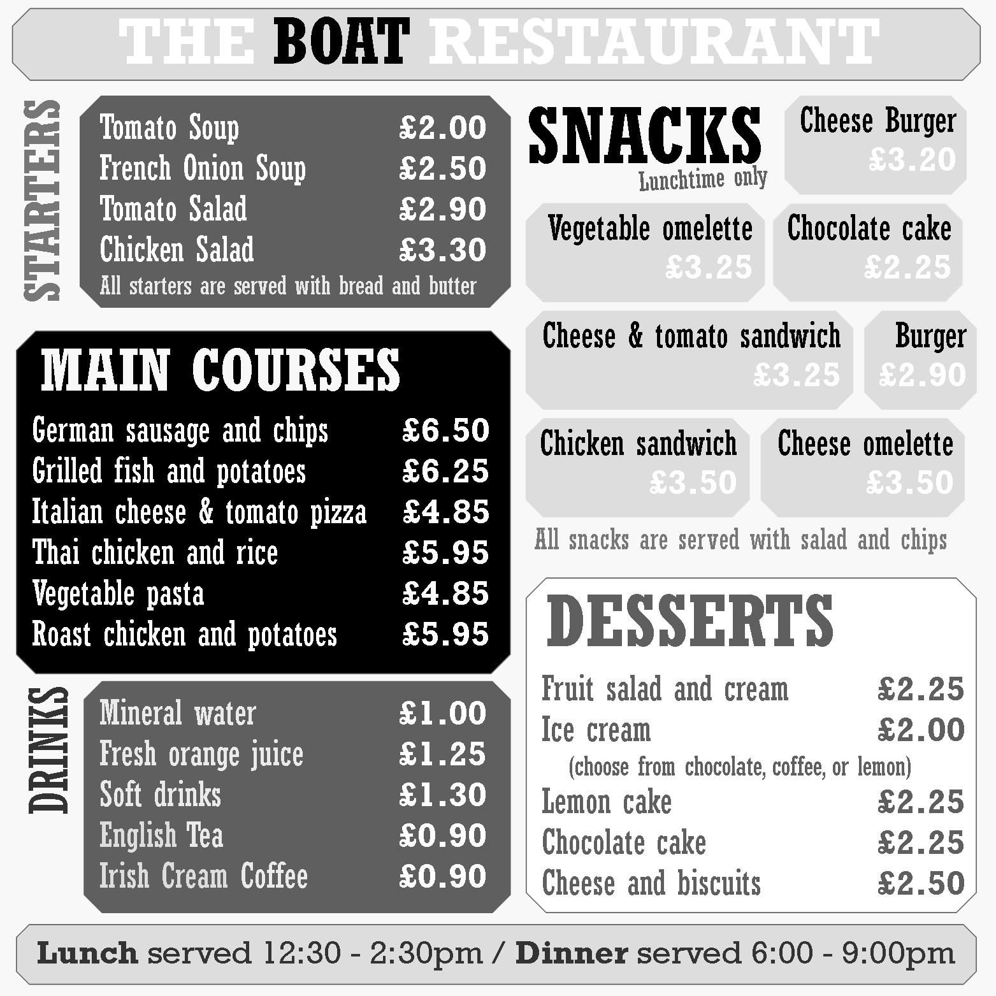What food and drink from this menu would you order?

Конец формы