

**Game Design Document**

**Project Name:** Klump Tower

**Team Members:**

Nick Berg - User Experience Programmer

Alison Cross - Character Designer / Animator

Jordan Elmer - Sound Designer

Lenny Flores - Documentation

Josh Gonzalez - Level Artist / Animator

Jeremy Green - Level Programmer

Mylene Haus - Programmer

Alex Jonic - Game Designer / Programmer

Kyle Kovack - Game Designer / Programmer

Joe Onesto - Hero

Cris Serrano - Level Programmer

Brandon Simmons - Food Boy

**Game Design Document Change Log**

|  |  |  |  |
| --- | --- | --- | --- |
| **Version** | **Date** | **Editor** | **Description** |
| 1.0 | 2/22 | Alex Jonic | Initial Document Creation |
| 1.1 | 2/23 | Brandon Simmons | Added: 5.1 |
| 1.2 | 2/23 | Nick Berg | Edited or added:  3.2, 3.9, 4.5, 5.1, 5.6 |
| 1.3 | 2/23 | Alex Jonic | Merged two conflicting versions of the document |
| 1.4 | 2/27 | Lenny Flores | Added:  5.4, 5.5, 5.7, 5,8  Edited:  5.6  Added another document to this one  Added the example level photo |
| 1.5 | 3/2 | Alison Cross | Edited:  3.7, 3.8, 4.6, 5.5 |

# 

# 

# **Table of Contents**

**Table of Contents** **3**

**1 Concept** **4**

1.1 Basic Concept 4

1.2 High Concept 4

**2 Design** **5**

2.1 Interactive Design 5

2.2 Interface and Controls 5

2.3 Perspective 6

2.4 Interactive Structure 6

2.5 Gameplay 6

2.6 Multi-Player 7

2.7 Difficulty 8

2.8 Length 8

**3 Story** **8**

3.1 Basic Story 8

3.2 Genre 8

3.3 Tone 8

3.4 Narrative 9

3.5 Core of the Story 9

3.6 Story Progression 9

3.7 Player’s Goal 9

3.8 Playable Characters 9

3.9 Key Characters 9

**4 Gameplay** **10**

4.1 Description of Play 10

4.2 Play Session Overview 10

4.3 Level Description 10

4.4 Characters and Enemies 11

4.5 Walkthrough 11

4.6 Sample Art 11

4.7 Sound Design 12

4.8 Cinematics 12

**5 Market** **13**

5.1 Target Audience 13

5.2 Target Gamers 13

5.3 Target Scope 13

5.4 Competitors 13

5.5 Key Competition 13

5.6 Product Appeal 13

5.7 Competitor Appeal 13

5.8 Competition in Development 13

5.9 Do’s and Don’ts 13

# **1 Concept**

## *1.1 Basic Concept*

Klump Tower is a two dimensional platformer, in which the player utilizes jumping mechanics to progress upwards through a level. The player will encounter obstacles which are thrown downward by the level’s boss, Klump. These obstacles will knock the player down the tower in order to slow or stop their progress. Upon reaching the top of the tower, the player will face off against Klump. The game is over when either the player has defeated Klump, or the player has fallen off the tower.

## *1.2 High Concept*

Klump Tower features vertically designed levels with procedurally generated backgrounds. The user will control a player character on the screen, and will be given the options to jump up and move left or right. The player character can only progress upwards through the level by jumping on platforms above them; if the player character falls below the screen they must restart the level.   
 Obstacles will be presented in order to give the player a challenge while climbing the level. These obstacles will be tossed from the top of the screen, or may be presented on the level layout itself. Warning indicators will appear somewhere horizontally along the top of the screen, signaling a falling object. The player must avoid these obstacles, or else they may be pushed off the platforms they’re on.   
 Occasionally, while advancing through the level, the player may stumble upon power ups which may help or hinder the player. Some power ups may improve the player’s jumping, or temporarily stop obstacles. Other power ups may hinder the player’s movement, or stun the player temporarily. Upon reaching the top of the level, the player will confront the boss, whom the game is named after, Klump.

# **2 Design**

## *2.1 Interactive Design*

## *2.2 Interface and Controls*

* Before beginning a level, the player will be given the option to play as a boy or girl character. The options will be large buttons, showing the respective characters. They will take up a majority of the screen, with a large banner which says “Choose Your Character” centered at the top of the screen. The choice of character will not impact gameplay in any way.
* The in-game user interface will be minimalistic. A counter for the player’s current height will be present in the corner of the screen. This height counter will be used to indicate the player’s score, and will help to inform the player how close they are to the top by prefacing the stage with a height measurement. Other interface features will include warning signs, which will appear at the top of the screen. These warning signs will indicate an object that is about to fall above the player.
* The player will control their character by using a mouse and keyboard, or by connecting an Xbox controller to their computer.
  + Keyboard controls will feature the option to either use the standard WASD configuration, or alternatively the arrow keys, in order to maneuver the level. The Escape key will be used to bring up the menu in game, which will allow the player to quit or restart the level.
  + The Xbox controls will use the left analog stick to maneuver left and right, while the player presses the A button to jump. The Start button will be used to bring up the menu in game, which will allow the player to quit or restart the level.
* The player will be able to jump and control the character mid-air, moving them left or right as they ascend and descend.
* Upon losing, the player’s height score will be shown in the middle of the screen with the words “GAME OVER” above it. They can then choose to restart, or quit the game.

## *2.3 Perspective*

* Klump Tower will feature a two dimensional, third person perspective. Characters and assets will appear facing toward a camera.

## *2.4 Interactive Structure*

* The game will be broken up into procedurally generated levels. Each level has a height value associated with it, which the player must get to in order to face the level’s boss.
* The player will only be able to climb the level; If the player falls off the screen the level ends. The screen will continuously move up with the player, but will never move down.

## *2.5 Gameplay*

* Klump Tower is a fast paced, vertical platforming game. Gameplay will consist of primarily jumping in order to progress up the tower, and moving left and right to avoid obstacles. The player should be on their toes, ready to avoid obstacles that are dropped from the top of the screen. Some obstacles may even be present on platforms, patrolling back and forth. The core gameplay will require precision timing, rewarding the player for calculated movement.
* The player’s success will be determined by two factors:

1. Height score: How high the player was able to get in one run.
2. Time: How long it took the player to get to the height they ended on.

* The gameplay will feature two kinds of powerups: good powerups, and anti-powerups. Both types of powerups will last for a short, temporary period of time. Powerups will occasionally drop from the top of the screen, similar to obstacles. They will slowly float down the screen, giving the player enough time to grab them.
  + Good powerups will provide the player with bonuses, including (but not limited to)

1. Increased jump height
2. Increased movement speed
3. Temporary Invulnerability
   * Anti-Powerups will provide the player with negative side-effects, including (but not limited to)
4. Temporarily stunning the player, keeping them locked in place

* The game will feature different types of platforms that the user may jump onto in order to move upwards through the level.

1. Normal platforms: window sills, fire escapes, and other similarly normal objects will function as normal platforms allowing the player to stand on them for as long as they wish.
2. Moving platforms: Platforms which move left and right, or up and down.
3. Decaying platforms: Platforms which only last for a moment after the player has touched them, “crumbling” away beneath the player’s feet.
4. Patrolled platforms: Platforms which have an enemy that patrols them. This enemy will knock the player backwards if the two come in contact.

## *2.6 Multi-Player*

* The game will feature a two player, hotseat-styled multiplayer system where players take turns trying to reach the highest point possible for each level. Points will be awarded in a “best of five” series of rounds. The player with the largest height score at the end of a level wins the round, and gets a point. After five games, the total games won are tallied, and a winner is chosen.
  + If both players manage to reach the top of the level, a winner will be chosen based on the time it took to reach the top.
* If the players both end at the same height, the round will be labeled as a draw, and neither player will receive a point.

## *2.7 Difficulty*

* Difficulty will scale with the level. As the player’s height value increases, so does the frequency of obstacles being thrown from the top of the screen. In addition, more obstacles may appear to patrol platforms. An increased rate of “anti-powerups” may appear the further along a player gets in the level.
* Overall, the game will be accessible to most audiences. The game will be easy enough to avoid frustrating the casual player, but will provide enough of a challenge to keep experienced players interested.

## *2.8 Length*

* Each level should only take roughly five to ten minutes to complete on average. This is to keep the player interested, and to promote an addictive replayability.

# **3 Story**

## *3.1 Basic Story*

* The game features a very minimalistic story. The all-powerful Klump rules over the land with a tyrannical fist. He resides at the top of his tower, overseeing all. It’s up to the player to put an end to Klump’s reign. The player must scale Klump’s fortress, and defeat him once and for all.

## *3.2 Genre*

* The game’s genre is a 2D obstacle-based platformer.

## *3.3 Tone*

* The game and its story will feature a lighthearted tone.

## *3.4 Narrative*

* At the beginning of the level, Klump will be floating above the player. He will then fly upwards, presumably to get to the top of his tower where he’s safe. Once the player reaches the top of the tower and defeats Klump, he loses all of his hair--his only source of power.

## *3.5 Core of the Story*

* Klump is taking over the world, and we need to stop them.

## *3.6 Story Progression*

* The story will feature no real progression, besides concluding with Klump losing his hair once the player defeats him.

## *3.7 Player’s Goal*

* The player’s goal is to reach the top of Klump’s tower in order to defeat him, putting an end to his tyrannical reign. The player is compelled to accomplish this as Klump is preventing the player’s success of climbing the tower by throwing obstacles down onto the player.

## *3.8 Playable Characters*

* The user will be given a choice to play as either a generic boy or girl character. These characters are available in different colors of clothing to distinguish between players during multiplayer.

## *3.9 Key Characters*

*Klump -* Klump is the ruler of the world. He rests atop his tower, commanding his forces with his long, flowing hair. He is the main antagonist of the game, constantly throwing obstacles down at the player in order to stop them from ending his reign.

*The Player-*

The Player, after seeing the darkness that Klump has spread across the world, seeks to usurp him from power. The Player begins their quest to ascend the tower and rid Klump of his power by striking at its source, his flowing hair.

# **4 Gameplay**

## *4.1 Description of Play*

The player must navigate left and right as they propel themselves upwards while they dodge incoming, falling objects. The player must use quick reflexes and precision timing to narrowly avoid falling obstacles and crumbling platforms.   
 Gameplay is relatively fast, leaving little time for the player to sit in one spot. As the player progresses, the background begins to change, and more obstacles appear. Enemy obstacles patrol platforms to knock players off. When the player falls below the screen, the game is over. If the player is skilled enough to make it to the top, they face off against the final boss: Klump.

## *4.2 Play Session Overview*

The player jumps up onto a regular platform. Suddenly, a marker appears at the top of the screen above the character. An object appears shortly after and descends towards the player. The player then jumps over to another platform to avoid the obstacle, only to find out they have jumped onto a crumbling platform (indicated by a different appearance from the other platforms).

The player then makes a decision to jump to a patrolled platform slightly higher up, where a mob is patrolling back and forth. The player lands on the platform, but touches the mob at the same time. The player is sent backwards with a small window of opportunity to correct their trajectory and land on another platform. However, the player is unable to do so, and falls off the screen. The level ends with a screen indicating the player’s height score displayed in the center of the screen.

## *4.3 Level Description*

Each level will be a vertical scrolling map with procedurally generating obstacles and platforms. The background of the level portrays a building, changing as the player scales it. The higher the player goes, the more difficult the level becomes.

The levels will feature obstacle mobs later on which will patrol platforms, shoving the players off if they come in contact.

## *4.4 Characters and Enemies*

**Enemies**

* *Klump*: The final boss of the game. Klump resides at the top of the tower, and can be defeated by jumping on his head. Hair loss is his one weakness.
* *Mobs*: Enemies that patrol back and forth across platforms during later sections of the level. These enemies cannot be defeated, only avoided.

## *4.5 Walkthrough*

* A Walkthrough for the levels cannot exist since the level are randomly generated. However a Walkthrough for the Klump fight is pending, as his method of defeat has not been decided yet.

## *4.6 Sample Art*

* *Player Character Designs*

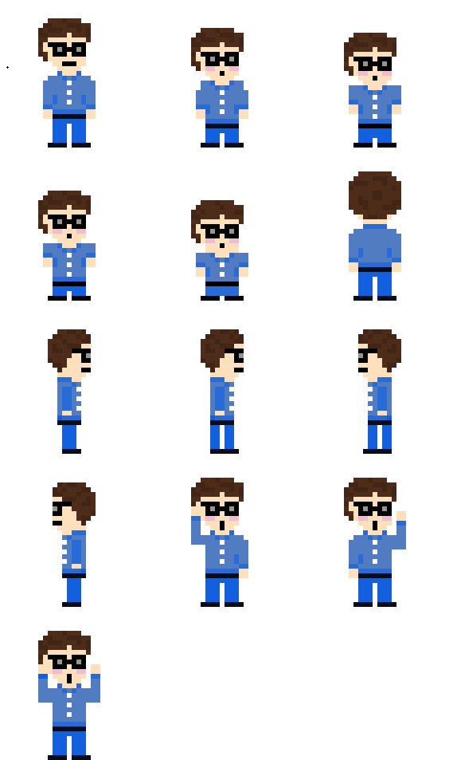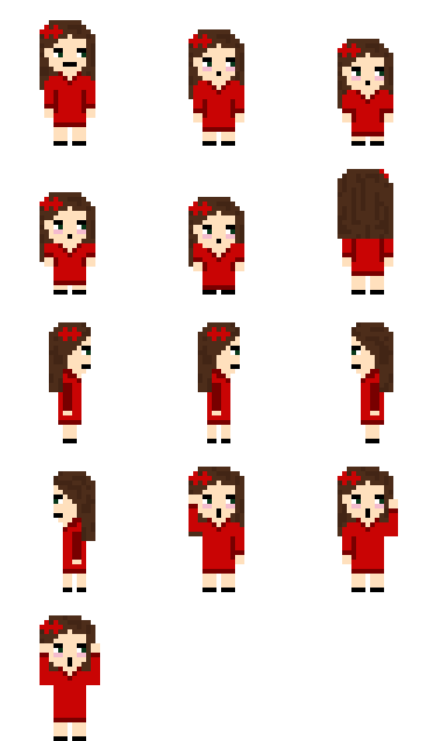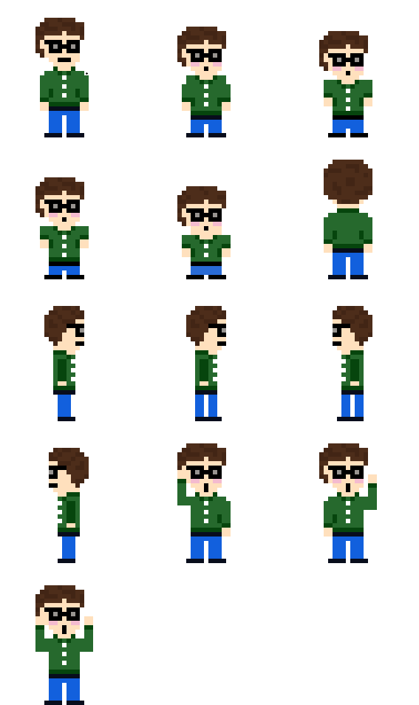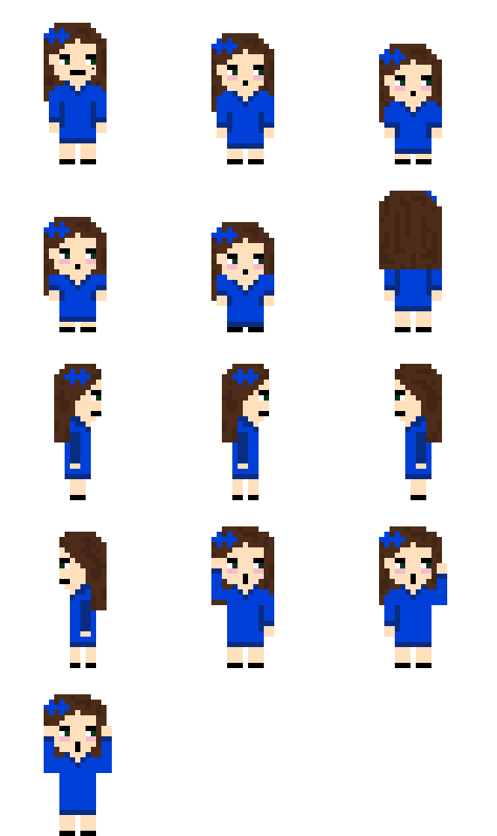

* *Klump*



* *Platform Design*

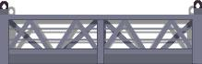

* *Sample Level*

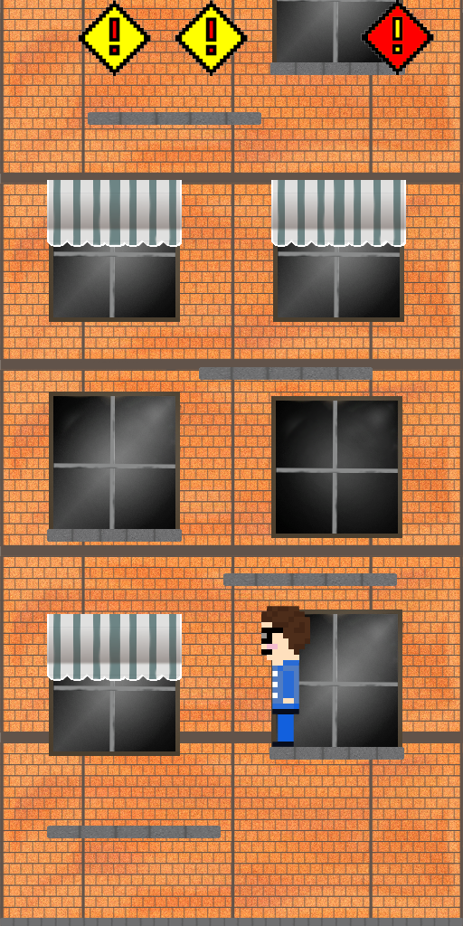

## *4.7 Sound Design*

* Mildly “special” music.

## *4.8 Cinematics*

* The opening of each level will feature Klump floating up off screen to give the player an indication as to where he is heading.

# **5 Market**

## *5.1 Target Audience*

* The targeted audience would be Casual gamers, because the basic gameplay elements are clear enough to the player that there should be little confusion to the average consumer. However, the gameplay is still complex enough for veteran gamers to keep them interested at a competitive level. The story is also straight-forward enough that anyone can follow it easily.
* Our game primarily targets students who have had to face the tyranny of evil professors. This is their time to take back the many years of oppression, and write all the wrongs that have been done to the innocent.

## *5.2 Target Gamers*

* Our game primarily targets the casual gamer audience; people who play mobile games and need something to pass the time.
* Ideally, our game should offer an incentive for a core audience to appreciate it. It should reward players who are able to master the mechanics of the game, and who want to play it competitively.

## *5.3 Target Scope*

* Our product should appeal to multiple audiences, and should generally be well received by most people who play it (regardless of their gaming preferences). It should be something that anyone can pick up and enjoy casually, while still rewarding players who prefer a bit of a challenge.

## *5.4 Competitors*

* This game is not as big as many of the other games of its kind so it might not get a huge launch as if a big gaming company would have. However, it does have a unique and interesting story that can captivate the audience and entertain them as well, wanting for more.

## *5.5 Key Competition*

* Some key competition could be other tower platformer games. One big example is Doodle Jump. This app is the original inspiration for the game. The big difference between Doodle Jump and Klump Tower is the devices that it is played on. While Doodle Jump is for mobile devices, Klump Tower is played on PC.
* Another major competitor is Ice Cream Jr., another 2D vertical platformer that is played on mobile devices. This game is similar to Klump Tower in that it is procedurally generated, however it has no end goal and therefore, no satisfaction for the player of dominating a boss and defeating a level. It also has no multiplayer capabilities.

## *5.6 Product Appeal*

* The appeal of our product is the charming art style, and the relatively simple gameplay. The power-ups and various obstacles and platforms in the game add another layer of complexity to the game. The added choice of using mouse and keyboard or a controller offers added comfort to which style of play is preferred by the user. Klump Tower also has a unique story based on the lives of the developers.

## *5.7 Competitors’ Appeal*

* We are not a big company that has its name going for them when they try to sell and promote the game. They also might have a bigger group to be able to split the work and therefore make the process go faster. Artwork could be worked on for longer and make it less pixelated.

## *5.8 Competition in Development*

* There are usually many starting developers that just make a fun game to show their skills. Some of them don’t have an advantage of working in a group. Many times the developers that created those “starter games” don’t update it and keep it going so they die off fairly quickly.

## *5.9 Do’s and Don’ts*

* Don’t run around naked.
* Don’t tell stories about natives around a pond.