**Evaluation of an open-source chemical process simulator using a plant wide oil and gas separation plant flowsheet model as basis**

Anders Andreasen1*

1 Ramboll Energy, Bavnehøjvej 5, DK-6700 Esbjerg, Denmark

**\*** Corresponding author, e-mail: [anra@ramboll.com](mailto:anra@ramboll.com)

**Abstract**

In this paper a detailed evaluation of the open source process simulator DWSIM is presented. Using a previously published simulation model of an oil and gas separation plant, the results obtained with DWSIM is compared to a commercial process simulator widely used in the industry. The modelled flow scheme comprises a vast number of unit operations including separators (flash vessels), valves, splitters, mixers, compressors, heat exchangers, pumps and recycles (tear streams). The results obtained with DWSIM compares very well with the data obtained using a commercial tool. The results are very encouraging and provides fidelity in the use of the investigated open source process simulation tools in a professional environment.

**Keywords**

Process simulation, oil and gas separation plant, thermodynamics

1 Introduction

The chemical process simulator is the workhorse for the modern chemical engineer. It is used widely in a variety of activities such as plant design, trouble shooting, bottleneck identification, equipment sizing and specification, process safety analysis, optimization etc. Many commercial process simulation tools exist each with their specific target markets, advantages and selling points. The term chemical process simulator may cover a rather broad suite of different tools, but in the context of the present paper we will define the following minimum requirements: A flow-sheeting software with a graphical user interface, implementing a number of property packages comprising different formulations for describing non-ideal multicomponent and multiphase VLE/VLLE as well as relevant transport property model. The simulator shall solve the relevant mass and energy balances and provide the most common unit operations for modelling a chemical plant including recycles/tear streams. It is outside the scope to list all available tools [1] but especially Aspen Plus, Aspen HYSYS, Honeywell Unisim Design, Aveva PRO/II are major players with a substantial market share within steady-state and dynamic process simulations. These tools are widely accepted and used throughout the process industry. However, common to all is the fact that they are closed sourced and comes with a substantial license fee. A large license fee may be prohibitive for students and smaller businesses and the closed source nature is prohibitive for studying the model implementations and debugging problematic and spurious simulation cases.

These two major drawbacks have been addressed by Daniel Wagner Madeiros by providing the free open source sequential modular CAPE-OPEN[2], [3] compliant process simulator DWSIM [4]. Previous attempts have been made to provide an open source chemical process simulator such as the *sim42* project [5], [6], unfortunately without considerable success. A few simulators are also available for free in the public domain without being fully open source; the COCO [7] simulator and the ALSOC/EMSO simulator [8]. Also it shall be a acknowledged that a number of relevant open source projects exists which provides a subset of the building blocks required to define a complete process simulator such as e.g. CoolProp [9], Reaktoro [10], Cantera [11], The Chemical Engineering Design Library (ChEDL) [12], thermopack [13] and OpenModelica [14] among others.

The chemical process industry is quite conservative when it comes to accepting new methods and simulation tools. For DWSIM and the like to become a trusted and accepted tool, validation and testing of the code is required. A few studies have been published comparing DWSIM to commercial tools. Tangsriwong *et al.* [15] modelled parts of a gas compression system both with DWSIM and Aspen Plus and compared the results to a reference case. It was found that the results from DWSIM and Aspen Plus compared well.

Omar *et al.* [16] simulated a PRICO LNG process using DWSIM and compared estimated COP values to previous work using Aspen Plus. It was concluded that the performance of the two tools was similar, although some details were lacking in order to make a thorough assessment. Nayak *et al.* [17] compared results obtained with DWSIM, Aspen Plus and a property package implementation in OpenModelica. A few examples involving distillation of water/methanol, ethylene glycol production including distillation of water and glycol/ethylene oxide as well as a conversion reactor (ethanol to ethylacetate) are shown. Generally, the results of DWSIM and Aspen Plus compare well.

The validations and benchmarks of DWSIM against commercial simulators published in the scientific literature are relatively sparse and the simulation cases contain only a fairly limited amount of unit operations and the model complexity is low to moderate. In this study we will extend these previous works by providing a more rigorous analysis of DWSIM and make a detailed comparison against a commercial process simulator. A complex model of an oil and gas separation plant containing a vast amount of material/energy streams and unit operations such as valves, separators, pumps, heat exchangers and compressors previously published [18] will be used as basis for a plant wide approach [19].

2 Methods and model description

2.1 Flowsheet and process description

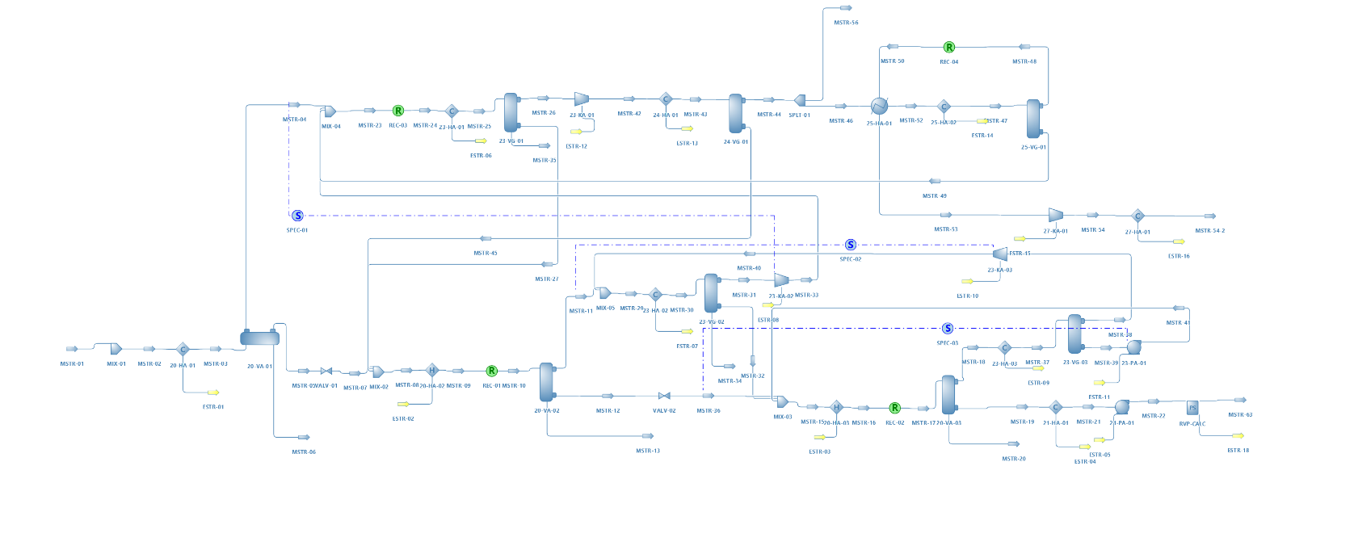The model implemented is mimicking and oil and gas separation plant is based on a HYSYS simulation file included in a previous publication [18]. The model has been rebuilt in DWSIM and the simulation flowsheet is visualized in Fig. 1.

Fig. 1 Oil and gas separation plant process simulation flowsheet as implemented in DWSIM

The well fluid is separated into oil and gas through three separators: first stage separator, 20-VA-01, the second stage separator, 20-VA-02, and the third stage separator, 20-VA-03. The well fluid is conditioned in the inlet heat exchanger, 20-HA-01 before separation. The temperature in the third stage separator is controlled by the second inter-stage heater, 20-HA-03. The separated oil is routed via a crude cooler, 21-HA-01, to the oil export pump, 21-PA-01.

The flash gas from each separation stage is compressed to a pressure equal to that from the previous separation stage and commingled with the flash gas from this stage. The gas

from the third stage separator is routed via the LP (3rd stage) compressor suction cooler, 23-HA-03, to the LP compressor suction scrubber, 23-VG-03. Liquid condensate is pumped by the condensate recycle pump, 23-PA-01, and discharged upstream to the third stage separator and second inter-stage heater. The gas from the scrubber is compressed in the LP compressor, 23-KA-03, and the compressed gas is commingled with the flash gas from the second stage separator, 20-VA-02. The commingled gas is cooled in the MP compressor suction cooler, 23-HA-02, and routed to the MP (2nd stage) compressor suction scrubber, 23-VG-02, where condensed liquid is knocked out and commingled with the liquid from the second stage separator as well as condensate from the condensate recycle pump, 23-PA-01. The gas from the MP compressor suction scrubber is compressed in the MP compressor, 23-KA-02, and commingled with the gas from the first stage separator, 20-VA-01. The commingled gas is further commingled with condensate from the LT knock-out drum, 25-VG-01 (part of the dew point control unit), before being cooled in the HP (1st stage) compressor suction cooler, 23-HA-01, and with subsequent condensate knock-out in the HP compressor suction scrubber, 23-VG-01.

The compressed gas is cooled in the dehydration inlet cooler, 24-HA-01 before being routed to the dew point control unit. Gas downstream 24-HA-01 is used as fuel gas. The gas is further processed in the dew point control unit, consisting of heat exchangers 25-HA-01 and 25-HA-02. The former is used for heat recovery with cross exchange with the dew point controlled dry gas, and 25-HA-02 is for simplicity assumed to be cooled by mechanical refrigeration. The cooled gas is routed to the LT knock-out drum, 25-VG-01, where condensed liquid is collected and routed to 23-VA-01/23-VG-01. The cold dew point controlled gas is used for cooling of the gas in the heat exchanger 25-HA-01 before being further pressurized in the export compressor 27-KA-01. Before leaving the facilities, the gas is cooled in the export gas cooler, 27-HA-01.

The key settings applied in the simulation are summarised in Table1. All pumps and compressors have been specified with an adiabatic and polytropic efficiency of 75%, respectively. Equipment pressure drops are only specified for heat exchangers as detailed in [18].

**Table 1** Simulation settings

|  |  |  |  |
| --- | --- | --- | --- |
| Parameter | Tag no. | Unit | Value |
| TSep1 | 20-HA-01 | ˚C | 70 |
| PSep1 | 20-VA-01 | barg | 31.5 |
| PSep2 | 20-VA-02 | barg | 8 |
| TSep3 | 20-HA-03 | ˚C | 65 |
| PSep3 | 20-VA-03 | barg | 1.5 |
| TScrub1 | 23-HA-01 | ˚C | 32 |
| TScrub2 | 23-HA-02 | ˚C | 32 |
| TScrub3 | 23-HA-03 | ˚C | 32 |
| PComp1 | 23-KA-01 | barg | 90 |
| Trefrig | 25-HA-02 | ˚C | 10 |
| Poil export | 21-PA-01 | barg | 60 |
| Toil export | 21-HA-01 | ˚C | 48.5 |
| Pgas export | 27-KA-01 | barg | 188.6 |
| Tgas export | 27-HA-01 | ˚C | 40 |

2.2 Fluid description and simulation settings

For the comparison Aspen HYSYS v11 is used and DWSIM v6.5.4.

The composition of the well fluid modelled both in [18] and in the present work is taken from [20]. The well fluid contains CO2 and simple alkanes from methane and up, and from C7+ the heavy fraction of the well fluid is characterized by 8 pseudo-components/hypotheticals. The Peng-Robinson equation of state is applied [21] with both liquid density and thermodynamic departure functions being calculated using the equation of state. This is a change from the original source [18] where COSTALD liquid density [22] was applied as well as Lee-Kesler for the departure functions. The change for liquid density was made since DWSIM does not implement COSTALD but uses Rackett for liquid density.

The 8 pseudo components included have been specified by molecular weight and liquid density and with critical properties and accentric factors estimated by the Twu method [23], [24]. The estimated properties have been used as input for the pseudo components, instead of using built-in methods in DWSIM, for consistency between the two simulation models. The pseudo-component properties are listed in Table 2.

**Table 2** Pseudo component properties

|  |  |  |  |  |  |
| --- | --- | --- | --- | --- | --- |
| MW | ρliquid | Tc | Pc | Vc | ω |
| g/mol | kg/m3 | C | barg | m3/kmole | -- |
| 108.47 | 741.1 | 302.5 | 26.88 | 0.4470 | 0.3265 |
| 120.40 | 755.0 | 326.3 | 24.90 | 0.4940 | 0.3631 |
| 133.63 | 769.5 | 351.2 | 23.04 | 0.5464 | 0.4021 |
| 164.78 | 799.0 | 394.9 | 20.62 | 0.6359 | 0.4654 |
| 215.94 | 838.7 | 454.0 | 18.01 | 0.7636 | 0.5594 |
| 274.34 | 875.4 | 517.5 | 15.33 | 0.9290 | 0.6870 |
| 334.92 | 907.3 | 574.5 | 13.40 | 1.0842 | 0.8157 |
| 412.79 | 957.5 | 650.2 | 12.22 | 1.2285 | 0.9723 |

DWSIM does currently not have an implementation of an RVP calculation routine following e.g. ASTM D323-73/79. In order to provide an RVP value of the oil export stream for comparison with the HYSYS a python unit operation script is added. The python script adjusts the vapour pressure of the export stream at 37.8 ˚C in order for the gas volume to be exactly 4 times the liquid volume.

3 Results

The first comparison made is with respect to the modelling of the fluid phase behaviour. Key parameters are compared in Table 3. As seen from the results DWSIM calculates slightly lower liquid density and slightly higher gas molecular weight, although the modelled properties in the two simulators match very well. The gas-oil-ratio (GOR) is also very well matched. The largest difference is seen on the critical properties. For comparison the phase envelope calculated with the two simulators is shown in

**Table 3** Well fluid phase behaviour

|  |  |  |  |  |
| --- | --- | --- | --- | --- |
|  | Unit | HYSYS | DWSIM | Difference (%) |
| Gas MW | kg/kmole | 22.78 | 22.81 | 0.114 |
| Gas mole flow | kmole/h | 5477.0 | 5479.8 | 0.051 |
| Liquid density | kg/m3 | 805.4 | 803.5 | -0.244 |
| Liquid MW | kg/kmole | 215.3 | 215.4 | 0.055 |
| Liquid mole flow | kmole/h | 2523.0 | 2520.2 | -0.112 |
| GOR | mole/mole | 2.171 | 2.174 | 0.163 |
| Tcrit | ˚C | 402.5 | 400.8 | -0.44 |
| Pcrit | barg | 191.2 | 190.4 | -0.41 |

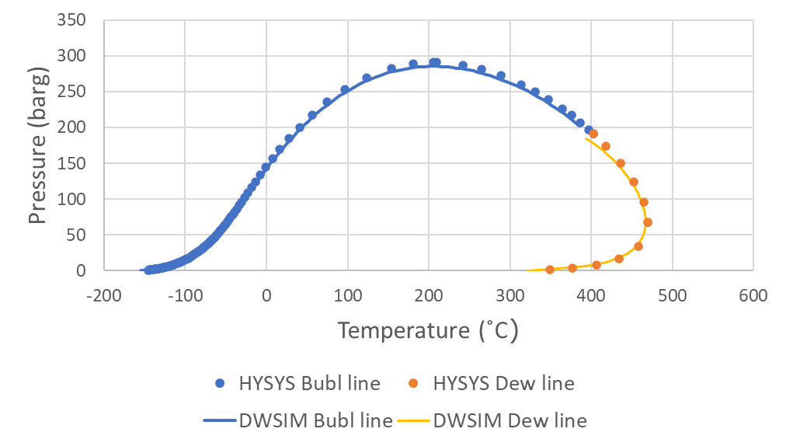

**Figure 2** Phase envelope for the well fluid used as input to the simulations. Phase envelope is calculated both in HYSYS and DWSIM

A comparison is made between the gas and oil export between DWSIM and HYSYS. The results are summarised in Table 4. As seen from the results the two simulators provide almost equal results.

A comparison is made for the power consumption for all the main mechanical drivers in the process: LP compressor, 23-KA-02, MP compressor, 23-KA-02, HP compressor, 23-KA-01, Export compressor 27-KA-01 and the oil export pump 21-PA-01. The results are shown in Fig. 3. Again, the match is very good, with the largest deviation slightly above 1% for the MP compressor duty.

**Table 4** Well fluid phase behaviour

|  |  |  |  |  |
| --- | --- | --- | --- | --- |
|  | Unit | HYSYS | DWSIM | Difference (%) |
| Gas export | kmole/h | 5102.0 | 5102.4 | 0.008 |
| Gas export MW | kg/kmole | 20.99 | 21.02 | 0.078 |
| Liquid export | kmole/h | 2764.3 | 2763.0 | -0.047 |
| Liquid export MW | kg/kmole | 201.9 | 201.9 | 0.007 |
| Liquid export RVP | psia | 10.1 | 10.1 | 0.056 |

**Figure 3** Main mechanical driver duties calculated with HYSYS and DWSIM. Numbers above the bars are the relative difference.



For comparison of the implemented models for calculating compressor discharge temperatures according to a polytropic model, the calculated compressor discharge temperatures using both DWSIM and HYSYS are compared in Fig. 4. As seen from the figure the calculated temperatures compare very well.



**Figure 4** Comparison of calculated compressor discharge temperatures.

The calculated duties for the various heat exchangers are compared in Fig. 5. Generally, the results are very similar. A few results stand out with slightly higher differences between the two simulation tools: The interstage heater 20-HA-03 between the 2nd and the 3rd stage separator and the cooler 25-HA-01 upstream the LT knock-out drum. For these two the deviation is -5.9% and -3.6%, respectively. That being said, the in absolute numbers the difference is moderate (30 kW and 22 KW).

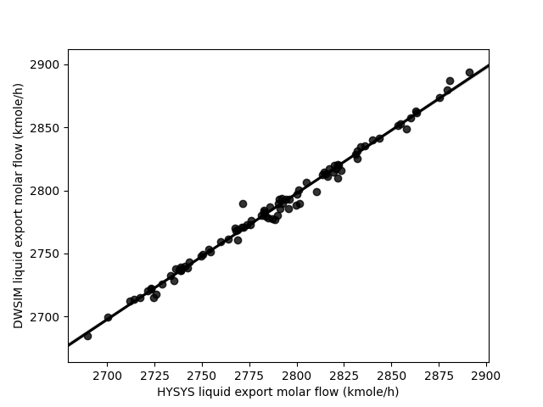

Figure 6 DWSIM vs HYSYS for calculated liquid export molar flowrate.



**Figure 5** Comparison of calculated heat exchanger duties

To further test DWSIM beyond a single converged simulation state, a parametric study has been performed. In order to efficiently conduct the parametric study in both DWSIM and HYSYS, a python wrapper is made for both simulation tools in a similar fashion as previous studies [18], [25], [26]. The parametric study is made by random/Monte Carlo sampling using the *lhsmdu* [27][28] package over 10 independent variables/factors. The independent variables and their bounds are shown in Table 5. A sampling plan is made using 100 samples and both sampling plans are run using the python wrapper around both HYSYS and DWSIM.

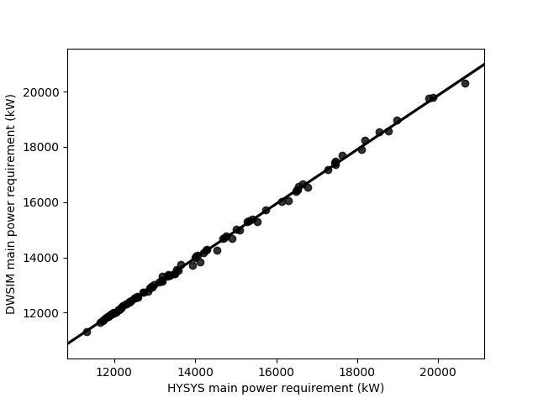

Figure 7 DWSIM vs HYSYS for calculated main power consumption

Table 5 Independent variables/factors used in Monte Carlo sampled parametric study and their bounds

|  |  |  |  |  |
| --- | --- | --- | --- | --- |
| Parameter | Tag no. | Unit | Lower | Higher |
| TSep1 | 20-HA-01 | ˚C | 40 | 70 |
| PSep1 | 20-VA-01 | barg | 10.5 | 31.5 |
| PSep2 | 20-VA-02 | barg | 3 | 10 |
| TSep3 | 20-HA-03 | ˚C | 50 | 75 |
| PSep3 | 20-VA-03 | barg | 0.5 | 2 |
| TScrub1 | 23-HA-01 | ˚C | 25 | 40 |
| TScrub2 | 23-HA-02 | ˚C | 25 | 40 |
| TScrub3 | 23-HA-03 | ˚C | 25 | 40 |
| PComp1 | 23-KA-01 | barg | 60 | 90 |
| Trefrig | 25-HA-02 | ˚C | -5 | 28 |

The dependent variables/responses compared between HYSYS and DWSIM are the export liquid molar flow rate, the main power consumption estimated as the sum of 21-PA-01 23-KA-01, 23-KA-02, 23-KA-03, 27-KA-01 cf. fig. 3, and the calculated RVP of the liquid export. For analysis of results the stack of numpy [29], pandas [30], seaborn [31] and statsmodels [32] is applied. During the calculation of the 100 samples, 9 samples where un-converged in DWSIM (samples index 24, 47, 52, 54, 55, 60, 65, 93, 96). A few samples also displayed unexpected deviation between HYSYS and DWSIM, and these samples where manually re-run. The 91 converged samples/simulation cases are analysed in more detail in fig. 7-9 and table 6.

As seen from the results there is generally good agreement between the two simulation tools. It is noticed that apparently the export liquid flow rate is the response with the poorest correlation as judged from R2, but both power and RVP responses have larger RMSE of approx. 0.5%. While deviation is noted, all responses generally have solid statistics.

Table 6 Statistics for the benchmark of DWSIM against HYSYS

|  |  |  |  |  |
| --- | --- | --- | --- | --- |
| Response | R2 | R2adjust | RMSE | RMSE(normalised) |
| Liquid flow | 0.9912 | 0.9911 | 4.34 | 0.0016 |
| Power | 0.9988 | 0.9988 | 78.6 | 0.0055 |
| RVP | 0.9991 | 0.9991 | 0.0489 | 0.0050 |

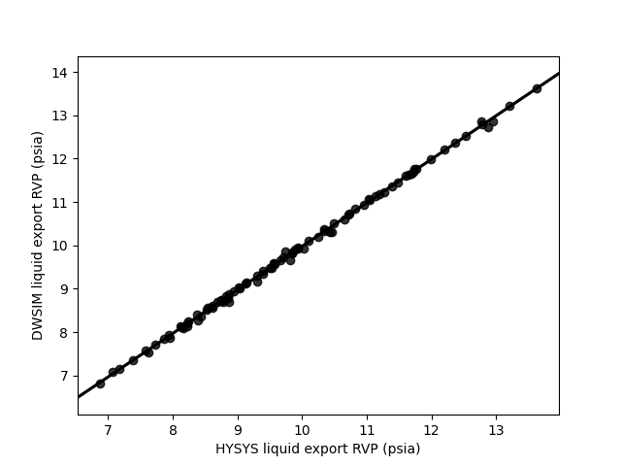

Figure 8 DWSIM vs HYSYS for calculated oil export RVP

5 Conclusion

The comparison made between the open source chemical process simulator DWSIM and a commercial (closed source) counter-part Aspen HYSYS shows that very little differences are observed. A detailed simulation flowsheet of an oil and gas separation plant has been used as basis for the comparison including a vast amount of different unit operations. Except for a few parameters the difference observed is typically less than 1%. This result is very encouraging and actually an enormous achievement considering the number of models and equations that needs to be implemented and to provide results which are very similar e.g. equation of state, PT flash algorithm, PH flash algorithm, PS flash algorithm, compressor model, heat exchanger model, pump model just to mention some.

The availability of a high-quality open source process simulator has many potential applications. One is for academic purposes, for students to learn the inner workings and model implementations and for students and researchers to implement their own models and methods. For usage in industry an open source process simulator also adds opportunities currently not present. For instance, massively parallel calculations implemented on a computer cluster (bare metal or virtual) is either not possible with the existing commercial tools or the license structure may be prohibitive. Using an open source simulator as DWSIM, which is cross platform, and can be deployed unlimited on compute nodes, this is now realizable. An open source process simulator can also enable global flowsheet optimisation studies from brute-force [33] to evolutionary algorithms which require a high number of flowsheet evaluations from 1,000-100,000 flowsheet evaluations taking a long time to converge [26][34][35]. Such studies may need long running times and would otherwise utilise a substantial amount of an available license pool, limiting other work.

Compared to the commercial counter-part DWSIM only solved 91% of the simulation cases in the defined parametric study. The remaining cases where un-converged, thus leaving room for some future improvement. As a side note, a legacy external FORTRAN dynamic linked library developed by late Prof. Michelsen implementing a flash algorithm [36]–[38] using the Peng-Robinson equation of state was used as an alternative to the built-in flash algorithm in DWSIM, but only for calculating the phase split/compositions. It is interesting to note that all 100 cases solved using Michelsen’s algorithm plugged in to DWSIM. While not a direct proof at least this indicates that the problem does not reside in the general flow sheet solver for converging the mass and energy balances but could be related to a slight instability in the calculated phase splits. This should be investigated in more detail.

Acknowledgement

Language secretary Susanne Tolstrup, Process & Technical Safety Department, Ramboll Energy, Field Development is acknowledged for proof-reading this manuscript.

References

[1] “List of chemical process simulators - Wikipedia.” https://en.wikipedia.org/wiki/List_of_chemical_process_simulators (accessed Nov. 14, 2021).

[2] G. Fieg *et al.*, “A standard interface for use of thermodynamics in process simulation,” *Comput. Chem. Eng.*, vol. 19, no. SUPPL. 1, pp. 317–320, Jun. 1995, doi: 10.1016/0098-1354(95)87056-3.

[3] M. Pons, B. Braunschweig, K. Irons, J. Köller, and A. Kuckelberg, “CAPE-OPEN (CO) standards: Implementation and maintenance,” *Proc. from 2nd IEEE Conf. Stand. Innov. Inf. Technol. SIIT 2001*, pp. 335–338, 2001, doi: 10.1109/SIIT.2001.968582.

[4] D. Madeiros, “DWSIM – The Open Source Chemical Process Simulator ,” 2021. https://dwsim.inforside.com.br/new/ (accessed Nov. 14, 2021).

[5] R. Cota, M. Satyro, C. Morris, W. Y. Svrcek, and B. R. Young, “Development of an Open Source Chemical Process Simulator,” in *Proceedings of the IASTED International Conference on Modelling, Simulation and Optimatization*, 2003.

[6] R. S. Dias, L. C. Silva, and A. J. De Assis, “Plant wide simulation using the free chemical process simulator Sim42: Natural gas separation and reforming,” *Comput. Appl. Eng. Educ.*, vol. 18, no. 3, pp. 476–484, Sep. 2010, doi: 10.1002/CAE.20200.

[7] “COCO - the CAPE-OPEN to CAPE-OPEN simulator.” https://www.cocosimulator.org/ (accessed Nov. 14, 2021).

[8] R. Rodrigues, R. P. Soares, and A. R. Secchi, “Teaching chemical reaction engineering using EMSO simulator,” *Comput. Appl. Eng. Educ.*, vol. 18, no. 4, pp. 607–618, Dec. 2010, doi: 10.1002/CAE.20255.

[9] I. H. Bell, J. Wronski, S. Quoilin, and V. Lemort, “Pure and pseudo-pure fluid thermophysical property evaluation and the open-source thermophysical property library coolprop,” *Ind. Eng. Chem. Res.*, vol. 53, no. 6, pp. 2498–2508, Feb. 2014, doi: 10.1021/IE4033999/SUPPL_FILE/IE4033999_SI_002.ZIP.

[10] “reaktoro/reaktoro: a unified framework for modeling chemically reactive systems.” https://github.com/reaktoro/reaktoro (accessed Nov. 14, 2021).

[11] D. G. Goodwin, R. L. Speth, H. K. Moffat, and B. W. Weber, “Cantera: An Object-oriented Software Toolkit for Chemical Kinetics, Thermodynamics, and Transport Processes,” Feb. 2021, doi: 10.5281/ZENODO.4527812.

[12] C. Bell, “CalebBell/thermo: 0.2.7 release,” Jun. 2021, doi: 10.5281/ZENODO.4892196.

[13] Ø. Wilhelmsen *et al.*, “Thermodynamic Modeling with Equations of State: Present Challenges with Established Methods,” *Ind. Eng. Chem. Res.*, vol. 56, no. 13, pp. 3503–3515, Apr. 2017, doi: 10.1021/ACS.IECR.7B00317.

[14] P. Fritzson *et al.*, “The OpenModelica integrated environment for modeling, simulation, and model-based development,” *Model. Identif. Control*, vol. 41, no. 4, pp. 241–285, 2020, doi: 10.4173/MIC.2020.4.1.

[15] K. Tangsriwong, P. Lapchit, T. Kittijungjit, T. Klamrassamee, Y. Sukjai, and Y. Laoonual, “Modeling of chemical processes using commercial and open-source software: A comparison between Aspen Plus and DWSIM,” *IOP Conf. Ser. Earth Environ. Sci.*, vol. 463, no. 1, p. 012057, Mar. 2020, doi: 10.1088/1755-1315/463/1/012057.

[16] M. N. Omar, M. N. H. Shaidan, and S. Hussain, “Simulation comparison on PRICO LNG process using open and proprietary sources,” *ACM Int. Conf. Proceeding Ser.*, pp. 36–39, Feb. 2018, doi: 10.1145/3185089.3185106.

[17] P. Nayak *et al.*, “Chemical Process Simulation Using OpenModelica,” *Ind. Eng. Chem. Res.*, vol. 58, no. 26, pp. 11164–11174, May 2019, doi: 10.1021/ACS.IECR.9B00104.

[18] A. Andreasen, “Applied Process Simulation-Driven Oil and Gas Separation Plant Optimization Using Surrogate Modeling and Evolutionary Algorithms,” *ChemEngineering*, vol. 4, no. 1, pp. 1--21 (Article no. 11), 2020, doi: 10.3390/chemengineering4010011.

[19] A. Andreasen, K. R. Rasmussen, and M. Mandø, “Plant Wide Oil and Gas Separation Plant Optimisation using Response Surface Methodology,” *IFAC-PapersOnLine*, vol. 51, no. 8, pp. 178–184, 2018, doi: 10.1016/j.ifacol.2018.06.374.

[20] A. Bahadori, H. B. Vuthaluru, and S. Mokhatab, “Optimizing separator pressures in the multistage crude oil production unit,” *Asia-Pacific J. Chem. Eng.*, vol. 3, no. 4, pp. 380–386, Jul. 2008, doi: 10.1002/apj.159.

[21] D.-Y. Peng and D. B. Robinson, “A New Two-Constant Equation of State,” *Ind. Eng. Chem. Fundam.*, vol. 15, no. 1, pp. 59–64, Feb. 1976, doi: 10.1021/i160057a011.

[22] R. W. Hankinson and G. H. Thomson, “A new correlation for saturated densities of liquids and their mixtures,” *AIChE J.*, vol. 25, no. 4, pp. 653–663, 1979, doi: 10.1002/aic.690250412.

[23] C. H. Twu, “An internally consistent correlation for predicting the critical properties and molecular weights of petroleum and coal-tar liquids,” *Fluid Phase Equillibria*, vol. 16, no. 2, pp. 137–150, 1984, doi: 10.1016/0378-3812(84)85027-X.

[24] C. H. Twu, J. E. Coon, and J. R. Cunningham, “A generalized vapor pressure equation for heavy hydrocarbons,” *Fluid Phase Equilib.*, vol. 96, pp. 19–31, 1994, doi: 10.1016/0378-3812(94)80085-5.

[25] A. Andreasen, “Optimisation of carbon capture from flue gas from a Waste-to-Energy plant using surrogate modelling and global optimisation,” *Oil Gas Sci. Technol.*, vol. 76, 2021, doi: 10.2516/OGST/2021036.

[26] E. R. Olsen, J. O. J.-O. Hooghoudt, M. Maschietti, and A. Andreasen, “Optimization of an Oil and Gas Separation Plant for Different Reservoir Fluids using an Evolutionary Algorithm,” *Energy Fuels*, vol. 35, no. 6, pp. 5392–-5406, Mar. 2021, doi: 10.1021/acs.energyfuels.0c04284.

[27] J. L. Deutsch and C. V. Deutsch, “Latin hypercube sampling with multidimensional uniformity,” *J. Stat. Plan. Inference*, vol. 142, no. 3, pp. 763–772, Mar. 2012, doi: 10.1016/J.JSPI.2011.09.016.

[28] S. Moza, “sahilm89/lhsmdu: Latin Hypercube Sampling with Multi-Dimensional Uniformity (LHSMDU): Speed Boost minor compatibility fixes,” Jul. 2020, doi: 10.5281/ZENODO.3929531.

[29] C. R. Harris *et al.*, “Array programming with {NumPy},” *Nature*, vol. 585, no. 7825, pp. 357–362, 2020, doi: 10.1038/s41586-020-2649-2.

[30] W. McKinney, “Data Structures for Statistical Computing in Python,” in *Proceedings of the 9th Python in Science Conference*, 2010, pp. 51–56.

[31] M. L. Waskom, “seaborn: statistical data visualization,” *J. Open Source Softw.*, vol. 6, no. 60, p. 3021, 2021, doi: 10.21105/joss.03021.

[32] S. Seabold and J. Perktold, “Statsmodels: Econometric and statistical modeling with python,” in *9th Python in Science Conference*, 2010.

[33] M. Maschietti, “Effect of the Number of Stages and Feed Composition on Offshore Oil and Gas Separation Train,” *Chem. Eng. Trans.*, vol. 74, pp. 847–852, 2019, doi: 10.3303/CET1974142.

[34] I. H. Kim, S. Dan, H. Kim, H. R. Rim, J. M. Lee, and E. S. Yoon, “Simulation-Based Optimization of Multistage Separation Process in Offshore Oil and Gas Production Facilities,” *Ind. \& Eng. Chem. Res.*, vol. 53, no. 21, pp. 8810-–8820, 2014.

[35] M. Ghaedi, A. N. Ebrahimi, and M. R. Pishvaie, “Application of genetic algorithm for optimization of separator pressures in multistage production units,” *Chem. Eng. Commun.*, vol. 201, no. 7, pp. 926–938, 2014, doi: 10.1080/00986445.2013.793676.

[36] M. L. Michelsen, “The isothermal flash problem. Part I. Stability,” *Fluid Phase Equilib.*, vol. 9, no. 1, pp. 1–19, Dec. 1982, doi: 10.1016/0378-3812(82)85001-2.

[37] M. L. Michelsen, “THE ISOTHERMAL FLASH PROBLEM. PART II. PHASE-SPLIT CALCULATION,” *Fluid Phase Equilib.*, vol. 9, pp. 21–40, 1982.

[38] J. Mollerup and M. L. Michelsen, *Thermodynamic Models: Fundamentals & Computational Aspects*, 2nd ed. Tie-Line Publications, 2007.