**Evaluation of an open-source chemical process simulator using a plant-wide oil and gas separation plant flowsheet model as basis**

Anders Andreasen1*

1 Ramboll Energy, Bavnehøjvej 5, DK-6700 Esbjerg, Denmark

**\*** Corresponding author, e-mail: [anra@ramboll.com](mailto:anra@ramboll.com)

**Abstract**

In this paper, a detailed evaluation of the open source process simulator DWSIM is presented. Using a previously published simulation model (Andreasen, 2020 [1]) of an oil and gas separation plant, the results obtained with DWSIM are compared to a commercial process simulator widely used in the industry. The modelled flow scheme comprises a vast number of unit operations including separators (flash vessels), valves, splitters, mixers, compressors, heat exchangers, pumps and recycles (tear streams). The results obtained with DWSIM both for characterisation of the inlet fluid as well as for a single operating state for the entire process, compare very well with the data obtained using a commercial tool. A rigorous comparison is made and generally, compared results are within 1% in deviation with a few exceptions. Further, an elaborate comparison is made for over 90 simulations with different settings where 10 independent variables are randomly varied over a wide range. Again, good agreement is found between the two tools. The results are very encouraging and provide fidelity in the use of the investigated open source process simulation tools in a professional environment.

**Keywords**

Process simulation, oil and gas separation plant, thermodynamics

1 Introduction

The chemical process simulator is the workhorse for the modern chemical engineer. It is used widely in a variety of activities such as plant design, troubleshooting, bottleneck identification, equipment sizing and specification, process safety analysis, optimization etc. Many commercial process simulation tools exist each with their specific target markets, advantages and selling points. The term chemical process simulator may cover a rather broad suite of different tools, but in the context of the present paper we will define the following minimum requirements: A flow-sheeting software with a graphical user interface, implementing a number of property packages comprising different formulations for describing non-ideal multi-component and multiphase VLE/VLLE as well as relevant transport property models. The simulator shall solve the relevant mass and energy balances and shall provide the most common unit operations for modelling a chemical plant including recycles/tear streams. It is outside the scope to list all available tools [2] but especially Aspen Plus, Aspen HYSYS, Honeywell UniSim Design, AVEVA PRO/II are major players with a substantial market share within steady-state and dynamic process simulations. These tools are widely accepted and used throughout the process industry. However, common to all is the fact that they are closed source and come with a substantial license fee. A large license fee may be prohibitive for students and smaller businesses and the closed source nature is prohibitive for studying the model implementations and debugging problematic and spurious simulation cases.

These two major drawbacks have been addressed by Daniel Wagner Oliveira de Medeiros by providing the free open source sequential modular CAPE-OPEN [3], [4] compliant process simulator DWSIM [5]. Previous attempts have been made to provide an open source chemical process simulator such as the *sim42* project [6], [7] unfortunately without considerable success. A few simulators are also available for free in the public domain without being fully open source; the COCO [8] simulator and the ALSOC/EMSO simulator [9][10] (free for academic/non-commercial usage). Also, it shall be a acknowledged that a number of relevant open source projects exist, which provide a subset of the building blocks required to define a complete chemical process simulator, such as e.g. CoolProp [11], Reaktoro [12], Cantera [13], The Chemical Engineering Design Library (ChEDL) [14], thermopack [15] and OpenModelica [16], among others.

The chemical process industry is quite conservative when it comes to accepting new methods and simulation tools. For DWSIM and the like to become a trusted and accepted tool, validation and testing of the code is required. A few studies have been published comparing DWSIM to commercial tools. Tangsriwong *et al.* [17] modelled parts of a gas compression system both with DWSIM and Aspen Plus and compared the results to a reference case. It was found that the results from DWSIM and Aspen Plus compared well.

Omar *et al.* [18] simulated a PRICO LNG process using DWSIM and compared estimated COP values to previous work using Aspen Plus. It was concluded that the performance of the two tools was similar, although some details were lacking in order to make a thorough assessment. Nayak *et al.* [19] compared results obtained with DWSIM, Aspen Plus and a property package implementation in OpenModelica. A few examples involving distillation of water/methanol, ethylene glycol production including distillation of water and glycol/ethylene oxide as well as a conversion reactor (ethanol to ethylacetate) are shown. Generally, the results of DWSIM and Aspen Plus compare well.

The validations and benchmarks of DWSIM against commercial simulators published in the scientific literature are relatively sparse and the simulation cases contain only a fairly limited amount of unit operations and the model complexity is low to moderate. In this study, we will extend these previous works by providing a more rigorous analysis of DWSIM and make a detailed comparison against a commercial process simulator. A complex model of an oil and gas separation plant containing a vast amount of material/energy streams and unit operations such as valves, separators, pumps, heat exchangers and compressors previously published [1] will be used as basis for a plant wide approach [20].

2 Methods and model description

2.1 Flowsheet and process description

The model implemented is mimicking an oil and gas separation plant is based on a HYSYS simulation file included in a previous publication [1]. The model has been rebuilt in DWSIM and the simulation flowsheet is visualized in Fig. 1.

The well fluid is separated into oil and gas through three separators: first stage separator, 20-VA-01, the second stage separator, 20-VA-02, and the third stage separator, 20-VA-03. The well fluid is conditioned in the inlet heat exchanger, 20-HA-01 before separation. The temperature in the third stage separator is controlled by the second inter-stage heater, 20-HA-03. The separated oil is routed via a crude cooler, 21-HA-01, to the oil export pump, 21-PA-01.

The flash gas from each separation stage is compressed to a pressure equal to that from the previous separation stage and commingled with the flash gas from this stage. The gas

from the third stage separator is routed via the LP (3rd stage) compressor suction cooler, 23-HA-03, to the LP compressor suction scrubber, 23-VG-03. Liquid condensate is pumped by the condensate recycle pump, 23-PA-01, and discharged upstream of the third stage separator and second inter-stage heater. The gas from the scrubber is compressed in the LP compressor, 23-KA-03, and the compressed gas is mixed with the flash gas from the second stage separator, 20-VA-02. The mixed gas is cooled in the MP compressor suction cooler, 23-HA-02, and routed to the MP (2nd stage) compressor suction scrubber, 23-VG-02, where condensed liquid is knocked out and commingled with the liquid from the second stage separator as well as condensate from the condensate recycle pump, 23-PA-01. The gas from the MP compressor suction scrubber is compressed in the MP compressor, 23-KA-02, and commingled with the gas from the first stage separator, 20-VA-01. The blended gas is further commingled with condensate from the LT knock-out drum, 25-VG-01 (part of the dew point control unit), before being cooled in the HP (1st stage) compressor suction cooler, 23-HA-01, and with subsequent condensate knock-out in the HP compressor suction scrubber, 23-VG-01.

The compressed gas is cooled in the dehydration inlet cooler, 24-HA-01, before being routed to the dew point control unit. Gas downstream 24-HA-01 is used as fuel gas. The gas is further processed in the dew point control unit, including heat exchangers 25-HA-01 and 25-HA-02. The former is used for heat recovery with cross exchange with the dew point controlled dry gas, and 25-HA-02 is a simple cooler assumed to be cooled by a refrigerant. The cooled gas is routed to the LT knock-out drum, 25-VG-01, where the condensed liquid is routed to 23-VA-01/23-VG-01. The cold dew point controlled gas is used for cooling of the hydrocarbon wet gas in the heat exchanger 25-HA-01 before being further pressurized in the export compressor 27-KA-01. Before leaving the facilities, the gas is cooled in the export gas cooler, 27-HA-01.

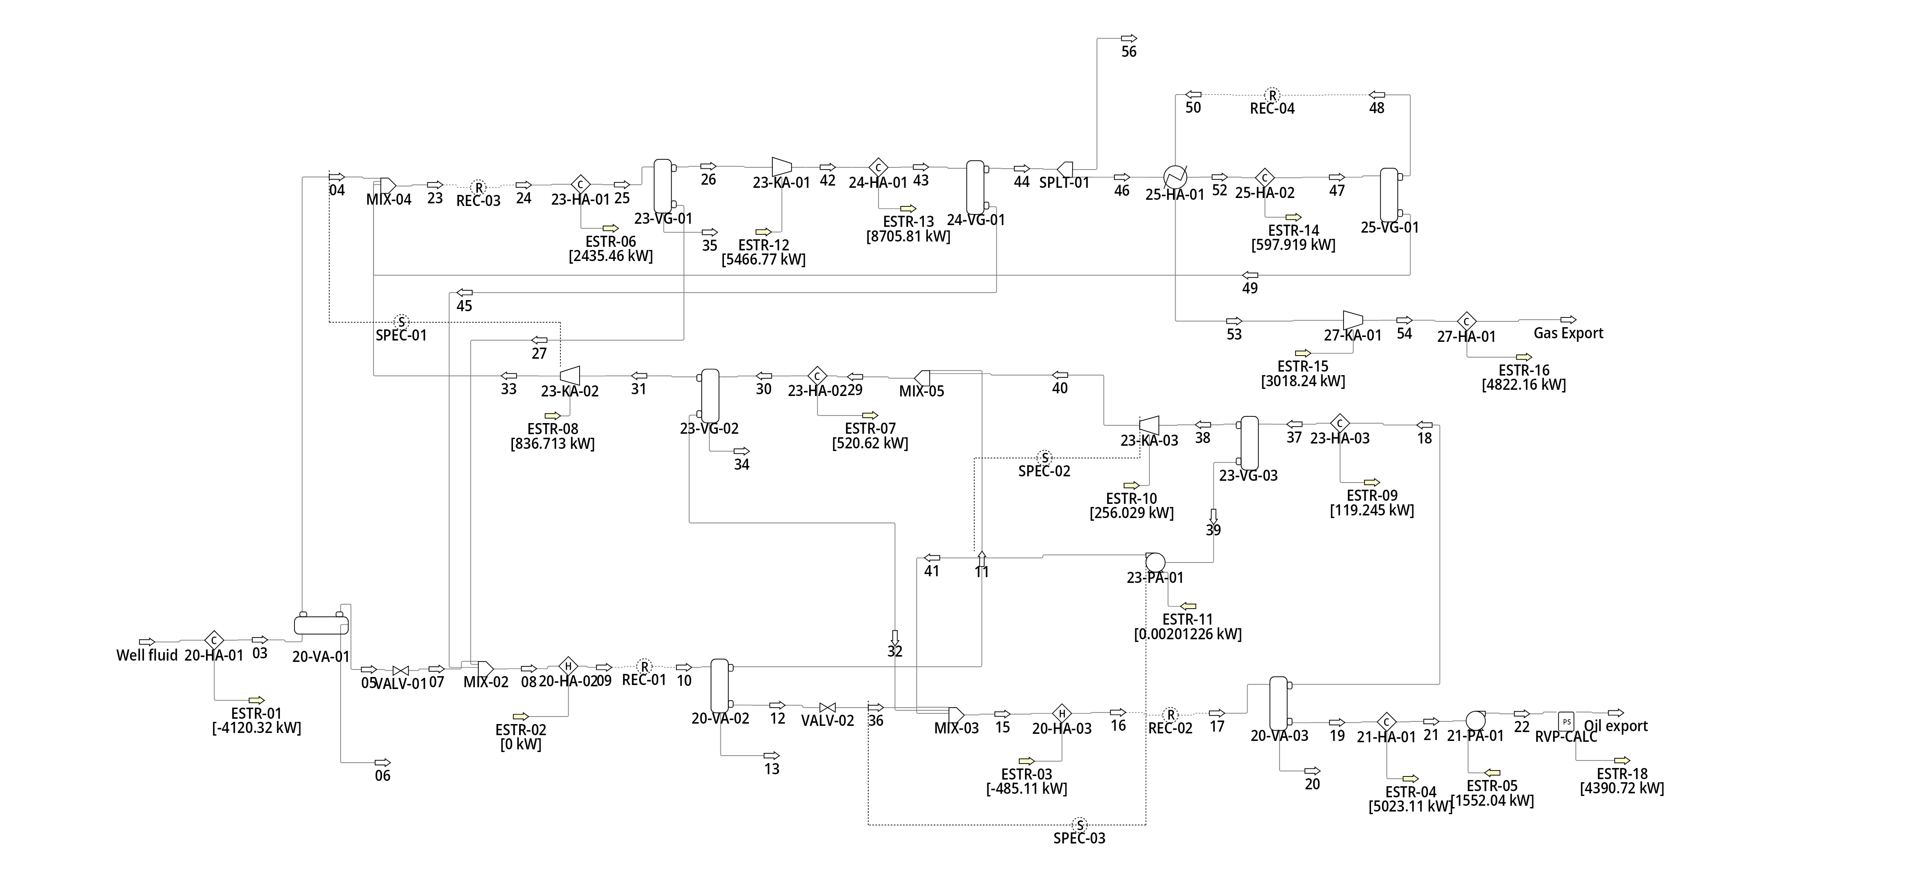

Figure 1 Oil and gas separation plant simulation flowsheet as implemented in DWSIM

**Table 1** Simulation settings

|  |  |  |  |
| --- | --- | --- | --- |
| Parameter | Tag no. | Unit | Value |
| TSep1 | 20-HA-01 | °C | 70 |
| PSep1 | 20-VA-01 | barg | 31.5 |
| PSep2 | 20-VA-02 | barg | 8 |
| TSep3 | 20-HA-03 | °C | 65 |
| PSep3 | 20-VA-03 | barg | 1.5 |
| TScrub1 | 23-HA-01 | °C | 32 |
| TScrub2 | 23-HA-02 | °C | 32 |
| TScrub3 | 23-HA-03 | °C | 32 |
| PComp1 | 23-KA-01 | barg | 90 |
| Trefrig | 25-HA-02 | °C | 10 |
| Poil export | 21-PA-01 | barg | 60 |
| Toil export | 21-HA-01 | °C | 48.5 |
| Pgas export | 27-KA-01 | barg | 188.6 |
| Tgas export | 27-HA-01 | °C | 40 |

2.2 Fluid description and simulation settings

For the comparison, Aspen HYSYS v11 is used and DWSIM v6.7.0.

The composition of the well fluid modelled both in [1] and in the present work is taken from [21]. The well fluid contains CO2 and simple alkanes from methane and up, and from C7+ the heavy fraction of the well fluid is characterized by 8 pseudo-components/hypotheticals. The Peng-Robinson equation of state is applied [22] with both liquid density and thermodynamic departure functions being calculated using the equation of state. This is a change from the original source [1], where COSTALD liquid density [23] was applied as well as Lee-Kesler for the departure functions. The change of liquid density was made, since DWSIM does not implement COSTALD but uses Rackett for liquid density[1].

The 8 pseudo-components included have been specified by molecular weight and liquid density and with critical properties and acentric factors estimated by the Twu method [24], [25]. The estimated properties have been used as input for the pseudo-components, instead of using the built-in methods in DWSIM, for consistency between the two simulation models. The pseudo-component properties are listed in Table 2.

**Table 2** Pseudo-component properties

|  |  |  |  |  |  |
| --- | --- | --- | --- | --- | --- |
| MW | ρliquid | Tc | Pc | Vc | ω |
| kg/kmole | kg/m3 | °C | barg | m3/kmole | -- |
| 108.47 | 741.1 | 302.5 | 26.88 | 0.4470 | 0.3265 |
| 120.40 | 755.0 | 326.3 | 24.90 | 0.4940 | 0.3631 |
| 133.63 | 769.5 | 351.2 | 23.04 | 0.5464 | 0.4021 |
| 164.78 | 799.0 | 394.9 | 20.62 | 0.6359 | 0.4654 |
| 215.94 | 838.7 | 454.0 | 18.01 | 0.7636 | 0.5594 |
| 274.34 | 875.4 | 517.5 | 15.33 | 0.9290 | 0.6870 |
| 334.92 | 907.3 | 574.5 | 13.40 | 1.0842 | 0.8157 |
| 412.79 | 957.5 | 650.2 | 12.22 | 1.2285 | 0.9723 |

DWSIM does currently not have an implementation of an RVP calculation routine following e.g. ASTM D323-73/79. In order to provide an RVP value of the oil export stream for comparison with the HYSYS, a python unit operation script is added. The python script adjusts the vapour pressure of the export stream at 37.8°C in order for the gas volume to be exactly 4 times the liquid volume.

The two tools have different ways and granularity for setting calculation tolerances e.g. for recycle operations where details down to component level can be specified in HYSYS, but only for total flow in DWSIM. Generally, for the mass balance the error in recycle blocks are below 1 kg/h in both HYSYS and DWSIM and any significant discrepancies are considered not to be due to mass balance errors.

2.3 Parametric study

To further test DWSIM beyond a single converged simulation state, a parametric study is set up, exploring similarities and differences over a wider range of parameter settings. In order to efficiently conduct the parametric study in both DWSIM and HYSYS, a python wrapper is made for both simulation tools in a similar fashion as previous studies [1], [26], [27]. The parametric study is made by random/Monte Carlo sampling using the *lhsmdu* [28] [29] package over 10 independent variables/factors. The independent variables and their bounds are shown in Table 5. A sampling plan is made using 100 samples and both sampling plans are run using a python wrapper around both HYSYS and DWSIM.

Table 5 Independent variables/factors used in Monte Carlo sampled parametric study and their bounds

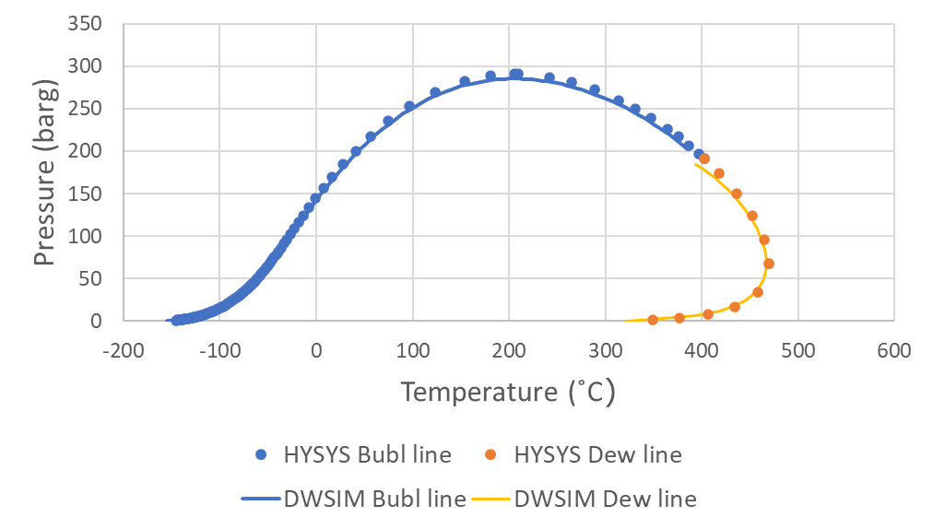

**Figure 2** Phase envelope for the well fluid used as input to the simulations. Phase envelope is calculated both in HYSYS and DWSIM

|  |  |  |  |  |
| --- | --- | --- | --- | --- |
| Parameter | Tag no. | Unit | Lower | Higher |
| TSep1 | 20-HA-01 | °C | 40 | 70 |
| PSep1 | 20-VA-01 | barg | 10.5 | 31.5 |
| PSep2 | 20-VA-02 | barg | 3 | 10 |
| TSep3 | 20-HA-03 | °C | 50 | 75 |
| PSep3 | 20-VA-03 | barg | 0.5 | 2 |
| TScrub1 | 23-HA-01 | °C | 25 | 40 |
| TScrub2 | 23-HA-02 | °C | 25 | 40 |
| TScrub3 | 23-HA-03 | °C | 25 | 40 |
| PComp1 | 23-KA-01 | barg | 60 | 90 |
| Trefrig | 25-HA-02 | °C | -5 | 28 |

3 Results

The first comparison made is with respect to the modelling of the fluid phase behaviour. Key parameters are compared in Table 3. The results are obtained for the stream “Well fluid” as shown in Figure 1, with temperature and pressure adjusted to standard conditions. As seen from the results, DWSIM calculates slightly lower liquid density and slightly higher gas molecular weight, although the modelled properties in the two simulators match very well. The gas-oil-ratio (GOR) is also very well matched. The largest difference is seen on the critical properties. For comparison, the phase envelope calculated with the two simulators is shown in Fig. 2.

**Table 3** Well fluid phase behaviour

|  |  |  |  |  |
| --- | --- | --- | --- | --- |
|  | Unit | HYSYS | DWSIM | Difference (%) |
| Gas MW | kg/kmole | 22.78 | 22.81 | 0.114 |
| Gas mole flow | kmole/h | 5477.0 | 5479.8 | 0.051 |
| Liquid density | kg/m3 | 805.4 | 803.5 | -0.244 |
| Liquid MW | kg/kmole | 215.3 | 215.4 | 0.055 |
| Liquid mole flow | kmole/h | 2523.0 | 2520.2 | -0.112 |
| GOR | mole/mole | 2.171 | 2.174 | 0.163 |
| Tc | °C | 402.5 | 400.8 | -0.44 |
| Pc | barg | 191.2 | 190.4 | -0.41 |

A comparison is made between the gas and oil export between DWSIM and HYSYS. The results are summarised in Table 4. As seen from the results, the two simulators provide almost equal results.

A comparison is made for the power consumption for all the main mechanical drivers in the process: LP compressor, 23-KA-02, MP compressor, 23-KA-02, HP compressor, 23-KA-01, Export compressor 27-KA-01 and the oil export pump 21-PA-01. The results are shown in Fig. 3. Again, the match is very good with the largest deviation slightly above 1% for the MP compressor duty.

**Table 4** Export stream quality of gas and liquid

|  |  |  |  |  |
| --- | --- | --- | --- | --- |
|  | Unit | HYSYS | DWSIM | Difference (%) |
| Gas export | kmole/h | 5102.0 | 5102.4 | 0.008 |
| Gas export MW | kg/kmole | 20.99 | 21.02 | 0.078 |
| Liquid export | kmole/h | 2764.3 | 2763.0 | -0.047 |
| Liquid export MW | kg/kmole | 201.9 | 201.9 | 0.007 |
| Liquid export RVP | psia | 10.1 | 10.1 | 0.056 |

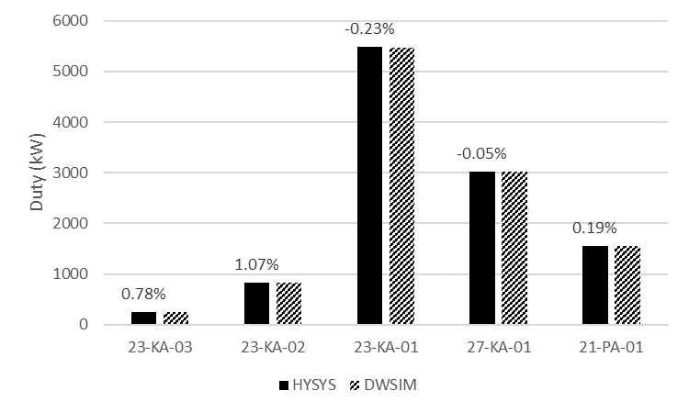

**Figure 3** Main mechanical driver duties calculated with HYSYS and DWSIM. Numbers above the bars are the relative difference.

For comparison of the implemented models for calculating compressor discharge temperatures according to a polytropic model, the calculated compressor discharge temperatures using both DWSIM and HYSYS are compared in Fig. 4. As seen from the figure, the calculated temperatures compare very well.



**Figure 4** Comparison of calculated compressor discharge temperatures.

The calculated duties for the various heat exchangers are compared in Fig. 5. Generally, the results are very similar. A few results stand out with slightly higher differences between the two simulation tools: The interstage heater 20-HA-03 between the 2nd and the 3rd stage separator and the cooler 25-HA-01 upstream the LT knock-out drum. For these two, the deviation is -5.8% and -3.9%, respectively. That being said, in absolute numbers the difference is moderate (30 kW and 24 kW). One reason for the interstage heater to show larger deviation can be explained by the fact that 20-HA-03 has a very small temperature difference (1.9°C in DWSIM). Even a small difference in the inlet stream will result in a relatively large deviation. The same can be argued for 25-HA-02 which also has a relatively small temperature difference (4.7°C). All the other heat exchangers have a significantly higher temperature difference and thus a smaller relative deviation.

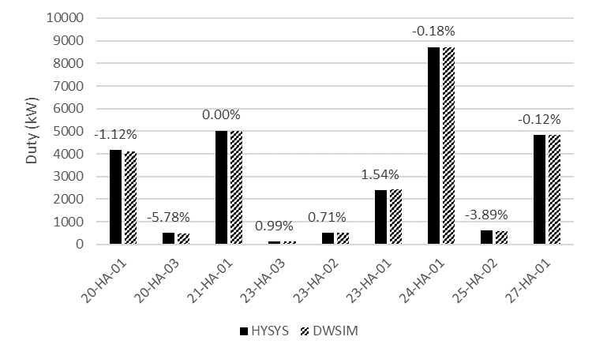

**Figure 5** Comparison of calculated heat exchanger duties



In addition to the rigorous comparison of a single operating point show in the previous text, a more elaborate comparison is made for 100 randomly selected simulations where 10 independent variables are varied as described in the Methods section.

The dependent variables/responses compared between HYSYS and DWSIM are the export liquid molar flow rate, the main power consumption estimated as the sum of 21-PA-01 23-KA-01, 23-KA-02, 23-KA-03, 27-KA-01, cf. Fig. 3, and the calculated RVP of the liquid export. For analysis of results, the software stack of numpy [30], pandas [31], seaborn [32] and statsmodels [33] is applied. During the calculation of the 100 samples, 9 samples were un-converged in DWSIM (sample indexes 24, 47, 52, 54, 55, 60, 65, 93, 96 in the generated DACE provided as a part of the supplementary information). A few samples also displayed unexpected deviations between HYSYS and DWSIM, and these samples were manually re-run. The 91 converged samples/simulation cases are analysed in more detail in Fig. 6-8 and Table 6.

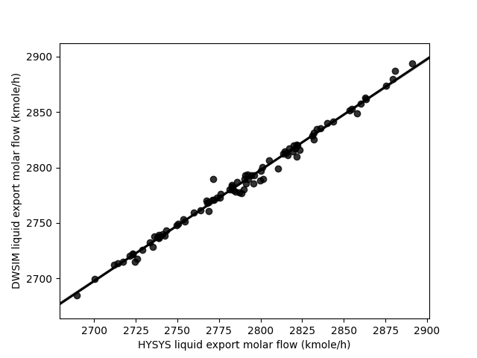

Figure 6 DWSIM vs HYSYS for calculated liquid export molar flow rate

As seen from the results, there is generally good agreement between the two simulation tools. It is noticed that apparently the export liquid flow rate is the response with the poorest correlation as judged from R2, but both power and RVP responses have larger RMSE of approx. 0.5%. While the deviation is noted, all responses generally have solid statistics.

Table 6 Statistics for the benchmark of DWSIM against HYSYS

|  |  |  |  |  |
| --- | --- | --- | --- | --- |
| Response | R2 | R2adjust | RMSE | RMSE(normalised) |
| Liquid flow | 0.9912 | 0.9911 | 4.34 | 0.0016 |
| Power | 0.9988 | 0.9988 | 78.6 | 0.0055 |
| RVP | 0.9991 | 0.9991 | 0.0489 | 0.0050 |

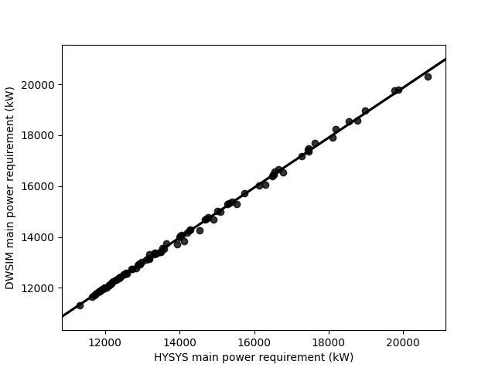

Figure 7 DWSIM vs HYSYS for calculated main power consumption

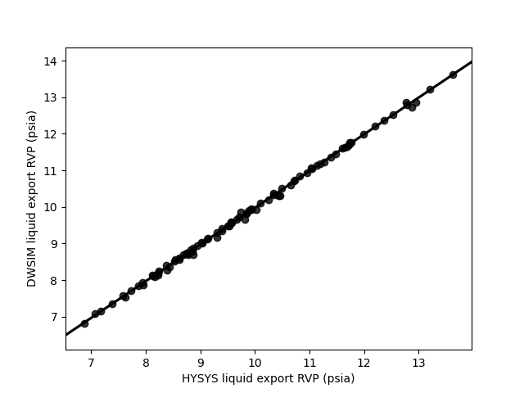

Figure 8 DWSIM vs HYSYS for calculated oil export RVP

5 Conclusion

The comparison made between the open source chemical process simulator DWSIM and a commercial (closed source) counter-part Aspen HYSYS shows that very little differences are observed. A detailed simulation flowsheet of an oil and gas separation plant has been used as basis for the comparison including a vast amount of different unit operations. Except for a few parameters, the difference observed is typically less than 1%. This result is very encouraging and actually an enormous achievement considering the number of models and equations that needs to be implemented and needs to provide results, which are very similar e.g. equation of state, PT flash algorithm, PH flash algorithm, PS flash algorithm, compressor model, heat exchanger model, pump model - just to mention some.

The availability of a high-quality open source process simulator has many potential applications. One is for academic purposes, for students to learn the inner workings and model implementations and for students and researchers to implement their own models and methods. For usage in the industry, an open source process simulator also adds opportunities currently not present. For instance, massively parallel calculations implemented on a computer cluster (bare metal or virtual) are either not possible with the existing commercial tools, or the license structure may be prohibitive. Using an open source simulator as DWSIM, which is cross platform and can be deployed unlimited on compute nodes, this is now realizable. An open source process simulator can also enable global flowsheet optimisation studies from brute-force [34] to evolutionary algorithms, which require a high number of flowsheet evaluations from 1,000-100,000 flowsheet evaluations often taking excessive time to converge [27] [35] [36]. Such studies may need long running times and would otherwise utilise a substantial amount of an available license pool, limiting other work.

Compared to the commercial counter-part, DWSIM only solved 91% of the simulation cases in the defined parametric study. The remaining cases were un-converged, thus leaving room for some future improvement. As a side note and not presented in more detail, a legacy external FORTRAN dynamic linked library developed by late Prof. Michelsen implementing a flash algorithm [37]–[39] using the Peng-Robinson equation of state was used as an alternative to the built-in flash algorithm in DWSIM, but only for calculating the phase split/compositions. It is interesting to note that all 100 cases solved using Michelsen’s algorithm plugged into DWSIM. While not a direct proof, at least this indicates that the problem does not reside in the general flowsheet solver for converging the mass and energy balances but could be related to a slight instability in the calculated phase splits. This should be investigated in more detail.

Acknowledgement

Language secretary Susanne Tolstrup, Process & Technical Safety Department, Ramboll Energy, Field Development is acknowledged for proof-reading this manuscript.

Supplementary information

The simulation files and scripts, which have formed the basis of the present paper, are publicly available on GitHub as well as the random computer experiment design and the sample simulation output:

https://github.com/andr1976/dwsim-paper

Symbols

Pi Pressure in unit operation *i*

Pc Critical pressure

Ti Pressure in unit operation *i*

Tc  Critical temperature

Vc Critical volume

ρ Density

ω Acentric factor

Abbreviations

COSTALD Corresponding States Liquid Density

DACE Design and Analysis of Computer Experiments

GOR Gas-Oil-Ratio

HP High Pressure

LNG Liquid Natural Gas

LP Low Pressure

LT Low Temperature

MP Medium Pressure

MW Molecular Weight

PH Pressure-Enthalpy

PS Pressure-Entropy

PT Pressure-Temperature

RMSE Root Mean Squared Error

RVP Reid Vapour Pressure

VL(L)E Vapour Liquid (Liquid) Equilibrium

References

[1] A. Andreasen, “Applied Process Simulation-Driven Oil and Gas Separation Plant Optimization Using Surrogate Modeling and Evolutionary Algorithms,” *ChemEngineering*, vol. 4, no. 1, pp. 1--21 (Article no. 11), 2020, doi: 10.3390/chemengineering4010011.

[2] “List of chemical process simulators - Wikipedia.” https://en.wikipedia.org/wiki/List_of_chemical_process_simulators (accessed Nov. 14, 2021).

[3] G. Fieg *et al.*, “A standard interface for use of thermodynamics in process simulation,” *Comput. Chem. Eng.*, vol. 19, no. SUPPL. 1, pp. 317–320, Jun. 1995, doi: 10.1016/0098-1354(95)87056-3.

[4] M. Pons, B. Braunschweig, K. Irons, J. Köller, and A. Kuckelberg, “CAPE-OPEN (CO) standards: Implementation and maintenance,” *Proc. from 2nd IEEE Conf. Stand. Innov. Inf. Technol. SIIT 2001*, pp. 335–338, 2001, doi: 10.1109/SIIT.2001.968582.

[5] D. Medeiros, “DWSIM – The Open Source Chemical Process Simulator,” 2021. https://dwsim.inforside.com.br/new/ (accessed Nov. 14, 2021).

[6] R. Cota, M. Satyro, C. Morris, W. Y. Svrcek, and B. R. Young, “Development of an Open Source Chemical Process Simulator,” in *Proceedings of the IASTED International Conference on Modelling, Simulation and Optimatization*, 2003.

[7] R. S. Dias, L. C. Silva, and A. J. De Assis, “Plant wide simulation using the free chemical process simulator Sim42: Natural gas separation and reforming,” *Comput. Appl. Eng. Educ.*, vol. 18, no. 3, pp. 476–484, Sep. 2010, doi: 10.1002/CAE.20200.

[8] “COCO - the CAPE-OPEN to CAPE-OPEN simulator.” https://www.cocosimulator.org/ (accessed Nov. 14, 2021).

[9] R. de P. Soares and A. R. Secchi, “EMSO: A new environment for modelling, simulation and optimisation,” *Comput. Aided Chem. Eng.*, vol. 14, no. C, pp. 947–952, Jan. 2003, doi: 10.1016/S1570-7946(03)80239-0.

[10] R. Rodrigues, R. P. Soares, and A. R. Secchi, “Teaching chemical reaction engineering using EMSO simulator,” *Comput. Appl. Eng. Educ.*, vol. 18, no. 4, pp. 607–618, Dec. 2010, doi: 10.1002/CAE.20255.

[11] I. H. Bell, J. Wronski, S. Quoilin, and V. Lemort, “Pure and pseudo-pure fluid thermophysical property evaluation and the open-source thermophysical property library coolprop,” *Ind. Eng. Chem. Res.*, vol. 53, no. 6, pp. 2498–2508, Feb. 2014, doi: 10.1021/IE4033999/SUPPL_FILE/IE4033999_SI_002.ZIP.

[12] “reaktoro/reaktoro: a unified framework for modeling chemically reactive systems.” https://github.com/reaktoro/reaktoro (accessed Nov. 14, 2021).

[13] D. G. Goodwin, R. L. Speth, H. K. Moffat, and B. W. Weber, “Cantera: An Object-oriented Software Toolkit for Chemical Kinetics, Thermodynamics, and Transport Processes,” Feb. 2021, doi: 10.5281/ZENODO.4527812.

[14] C. Bell, “CalebBell/thermo: 0.2.7 release,” Jun. 2021, doi: 10.5281/ZENODO.4892196.

[15] Ø. Wilhelmsen *et al.*, “Thermodynamic Modeling with Equations of State: Present Challenges with Established Methods,” *Ind. Eng. Chem. Res.*, vol. 56, no. 13, pp. 3503–3515, Apr. 2017, doi: 10.1021/ACS.IECR.7B00317.

[16] P. Fritzson *et al.*, “The OpenModelica integrated environment for modeling, simulation, and model-based development,” *Model. Identif. Control*, vol. 41, no. 4, pp. 241–285, 2020, doi: 10.4173/MIC.2020.4.1.

[17] K. Tangsriwong, P. Lapchit, T. Kittijungjit, T. Klamrassamee, Y. Sukjai, and Y. Laoonual, “Modeling of chemical processes using commercial and open-source software: A comparison between Aspen Plus and DWSIM,” *IOP Conf. Ser. Earth Environ. Sci.*, vol. 463, no. 1, p. 012057, Mar. 2020, doi: 10.1088/1755-1315/463/1/012057.

[18] M. N. Omar, M. N. H. Shaidan, and S. Hussain, “Simulation comparison on PRICO LNG process using open and proprietary sources,” *ACM Int. Conf. Proceeding Ser.*, pp. 36–39, Feb. 2018, doi: 10.1145/3185089.3185106.

[19] P. Nayak *et al.*, “Chemical Process Simulation Using OpenModelica,” *Ind. Eng. Chem. Res.*, vol. 58, no. 26, pp. 11164–11174, May 2019, doi: 10.1021/ACS.IECR.9B00104.

[20] A. Andreasen, K. R. Rasmussen, and M. Mandø, “Plant Wide Oil and Gas Separation Plant Optimisation using Response Surface Methodology,” *IFAC-PapersOnLine*, vol. 51, no. 8, pp. 178–184, 2018, doi: 10.1016/j.ifacol.2018.06.374.

[21] A. Bahadori, H. B. Vuthaluru, and S. Mokhatab, “Optimizing separator pressures in the multistage crude oil production unit,” *Asia-Pacific J. Chem. Eng.*, vol. 3, no. 4, pp. 380–386, Jul. 2008, doi: 10.1002/apj.159.

[22] D.-Y. Peng and D. B. Robinson, “A New Two-Constant Equation of State,” *Ind. Eng. Chem. Fundam.*, vol. 15, no. 1, pp. 59–64, Feb. 1976, doi: 10.1021/i160057a011.

[23] R. W. Hankinson and G. H. Thomson, “A new correlation for saturated densities of liquids and their mixtures,” *AIChE J.*, vol. 25, no. 4, pp. 653–663, 1979, doi: 10.1002/aic.690250412.

[24] C. H. Twu, “An internally consistent correlation for predicting the critical properties and molecular weights of petroleum and coal-tar liquids,” *Fluid Phase Equillibria*, vol. 16, no. 2, pp. 137–150, 1984, doi: 10.1016/0378-3812(84)85027-X.

[25] C. H. Twu, J. E. Coon, and J. R. Cunningham, “A generalized vapor pressure equation for heavy hydrocarbons,” *Fluid Phase Equilib.*, vol. 96, pp. 19–31, 1994, doi: 10.1016/0378-3812(94)80085-5.

[26] A. Andreasen, “Optimisation of carbon capture from flue gas from a Waste-to-Energy plant using surrogate modelling and global optimisation,” *Oil Gas Sci. Technol.*, vol. 76, 2021, doi: 10.2516/OGST/2021036.

[27] E. R. Olsen, J. O. J.-O. Hooghoudt, M. Maschietti, and A. Andreasen, “Optimization of an Oil and Gas Separation Plant for Different Reservoir Fluids using an Evolutionary Algorithm,” *Energy Fuels*, vol. 35, no. 6, pp. 5392–-5406, Mar. 2021, doi: 10.1021/acs.energyfuels.0c04284.

[28] J. L. Deutsch and C. V. Deutsch, “Latin hypercube sampling with multidimensional uniformity,” *J. Stat. Plan. Inference*, vol. 142, no. 3, pp. 763–772, Mar. 2012, doi: 10.1016/J.JSPI.2011.09.016.

[29] S. Moza, “sahilm89/lhsmdu: Latin Hypercube Sampling with Multi-Dimensional Uniformity (LHSMDU): Speed Boost minor compatibility fixes,” Jul. 2020, doi: 10.5281/ZENODO.3929531.

[30] C. R. Harris *et al.*, “Array programming with {NumPy},” *Nature*, vol. 585, no. 7825, pp. 357–362, 2020, doi: 10.1038/s41586-020-2649-2.

[31] W. McKinney, “Data Structures for Statistical Computing in Python,” in *Proceedings of the 9th Python in Science Conference*, 2010, pp. 51–56.

[32] M. L. Waskom, “seaborn: statistical data visualization,” *J. Open Source Softw.*, vol. 6, no. 60, p. 3021, 2021, doi: 10.21105/joss.03021.

[33] S. Seabold and J. Perktold, “Statsmodels: Econometric and statistical modeling with python,” in *9th Python in Science Conference*, 2010.

[34] M. Maschietti, “Effect of the Number of Stages and Feed Composition on Offshore Oil and Gas Separation Train,” *Chem. Eng. Trans.*, vol. 74, pp. 847–852, 2019, doi: 10.3303/CET1974142.

[35] I. H. Kim, S. Dan, H. Kim, H. R. Rim, J. M. Lee, and E. S. Yoon, “Simulation-Based Optimization of Multistage Separation Process in Offshore Oil and Gas Production Facilities,” *Ind. \& Eng. Chem. Res.*, vol. 53, no. 21, pp. 8810-–8820, 2014.

[36] M. Ghaedi, A. N. Ebrahimi, and M. R. Pishvaie, “Application of genetic algorithm for optimization of separator pressures in multistage production units,” *Chem. Eng. Commun.*, vol. 201, no. 7, pp. 926–938, 2014, doi: 10.1080/00986445.2013.793676.

[37] M. L. Michelsen, “The isothermal flash problem. Part I. Stability,” *Fluid Phase Equilib.*, vol. 9, no. 1, pp. 1–19, Dec. 1982, doi: 10.1016/0378-3812(82)85001-2.

[38] M. L. Michelsen, “THE ISOTHERMAL FLASH PROBLEM. PART II. PHASE-SPLIT CALCULATION,” *Fluid Phase Equilib.*, vol. 9, pp. 21–40, 1982.

[39] J. Mollerup and M. L. Michelsen, *Thermodynamic Models: Fundamentals & Computational Aspects*, 2nd ed. Tie-Line Publications, 2007.

1. This has been included in the most recent version of DWSIM