ALINX-based FORTH AI REBECCA Accelerator to Run on the EXA-Developed REBECCA Emulation Platform the SML-developed YoloV8 Model for Harbor Structure Crack Detection, as Developed by ALM and AQUA

HW/SW Interface v.2.1 , May 12, 2026

- Dollas, A. Sifakis, E. Perakis (FORTH)
R. Garcia Crespo, J.A. Gómez (SML)
P. Malakonakis (EXA)
R. Berci-Hajnovics, T. van Eckenvort (AQUA)

- Introduction
This document is an entirely new definition of the interface between that YoloV8 model developed by SML, the corresponding FPGA-based AI Accelerator, developed by FORTH, and the ALINX-based REBECCA emulation platform developed by EXA. The model, weights, biases, and datasets were originally developed by ALM, but were substantially updated and are provided to the UC4 partners by AQUA.
Summary of the V1 interface specifications: The VCU FPGA full-fledged 128 Processing Element (PE) YoloV11 REBECCA FORTH AI Accelerator by far exceeds the capabilities of the REBECCA ALINX-based Evaluation Platform. Given that all parameters are restrictive (external memory, URAM, BRAM, DSP, etc.), following up on the March 16, 2026 WP6 telco and the subsequent March 17 telco with Mr. Pavlos Malakonakis (EXA) who develops the ALINX-based REBECCA Emulation Platform, a smaller, 16-PE version was deemed appropriate to develop. The purpose of the first version (V1.0) of the HW/SW interface was to provide the initial characteristics of the 16-PE Accelerator so that it could be integrated with RISC V – based software into the ALINX-based platform. The purpose of the V1 document was to provide the protocol that will be used for a REBECCA demo, on the YoloV8 model that has been developed by Mr. Raul Garcia Crespo (SML). All references to YoloV11 are due to the model of the FORTH AI Accelerator, the present Accelerator merely performs 16 3X3 convolutions at a time, processed line-by-line.
Summary of the main similarities and differences between V1 and the current version V2: As the end goal remains the same, i.e. to have a demo in the ALINX-based platform, the main characteristics of the model (YoloV8), the sizing of the Accelerator (16 Processing Elements) and the line-by-line processing of 3 X 3 convolutions remains the same as in V1. However, following a telco with Mr. Pavlos Malakonakis, it was deemed appropriate to pass to the AI Accelerator the learning parameters, weights and biases, and to receive results directly in DDR via UBUF definitions, and only pass layer-specific parameters via AXI messages. This document is complete and it includes material from the V1 document, so that no further reference to V1 is needed.
- Sizing, Capabilities and Target Performance of the 16 PE Accelerator
The reduced accelerator with 16 PEs will be able to perform both types of the YoloV11 (or YoloV8) 3 X 3 convolutions, i.e. convolutions with stride 1 or stride 2, as shown below, plus the addition of bias. With LP the Learning Parameter is indicated, and with X the neighbors with which the dot products are performed are shown, below (image credit to SML):
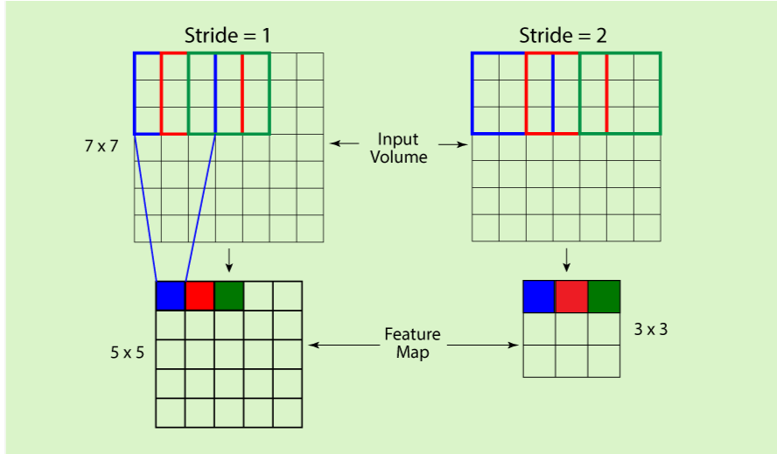
Each PE performs a full 3X3 convolution plus the addition of a bias offset, for a total of 9 MUL operations and 9 ADD operations (8 ADD operations for the convolution plus 1 ADD for the bias offset). All operands (Learning Parameters and Weights) are 32-Bit single precision floating point numbers (FLOAT), whereas for purposes of directives (e.g. which type of convolution is to be performed) 32-bit fixed point numbers (INT) are used (the choice of 32-bits is in order to avoid alignment problems). Hence, each call will correspond to a batch that is a multiple of 16 X (9 MUL + 9 ADD) = 288 FLOAT operations, and the datapath latency for the response is expected to be around 20 cycles for 16 3 X 3 convolutions, so that the software can use (through the driver) polling on the AXI when the learning parameters are passed. The convolutions are performed line-by-line in order to overlap data transfer with processing, and the weights and bias need not be reloaded between convolutions.
The proposed HW/SW interface comprises of one type of calls from the software which is running on the RISC V processor on the ALINX FPGA to the 16 PE Accelerator running on the second ALINX FPGA. Although somewhat unconventional, no ACK is provided at present by reason of the performance penalty that it would incur. Given that the Accelerator is expected to have a very low latency (of the order of 20 cycles) no extensive synchronization protocol is included, but it may be easily added in case there are reliability issues. There is, however an initialization packet which can be used for sync purposes, and processing is performed by the AI Accelerator in batches, indicatively of 4K 3X3 convolutions (plus bias) at a time.
The call from the RISC V to the Accelerator does not pass Weights and Learning Parameters, but merely parameters regarding grouping of the Learning Parameters, information such as the 4th dimension, and as needed (this needs to be determined by EXA) UBUF base addresses in the DDR memory.
The size of the UBUFs will be fixed in advance, e.g. to 4Mbytes each, so that the values of UBUF1, UBUF2, UBUF3 may be fixed. The 4Mbytes limit has to do with the maximum BRAM of the ALINX, which should not be exceeded (for input and output buffers additively), as in the the contrary case the accelerator would need to get and place individual data in DDR, thus negating its usefulness.

- Weight and Type of Convolution Weight and Bias Passing from SW to the Accelerator
Call from SW to HW: None, all parameters are passed via a UBUF1
Overall Format: FLOAT, …, FLOAT
All weights in the form of 32-bit FLOAT are written in DDR memory in sequence, followed by all biases, also in 32-bit FLOAT numbers. The number of weights is passed to the AI Accelerator as a separate call (see Section 5, below).
- Learning Parameter Passing from SW to Accelerator
Call from SW to HW: None, all parameters are passed via a UBUF2 or UBUF3
Overall Format: FLOAT, FLOAT, …, FLOAT
The learning parameters are stored in sequence in DDR, with one of two specific base addresses, i.e. UBUF2 or UBUF3. The reason for the two-address option is that in some cases, output of one layer may be the input of the next layer, both of which are to be processed by the AI Accelerator. In this case no memcpy() is needed, but rather designation of the completed layer’s UBUF as input, with the other one becoming the output. This information is passed via a call to the AI Accelerator.
SML Note: we believe it is important to state the structure of the weights, bias and learning parameters after a memcpy() from the software. Our library stores this data internally as Tensors following a row-major order and, unless a modification is needed, the same structure will be kept when copying the Tensor contents to the UBUFs.
- Sizing information, Processing Parameter Passing, Synchronization and Initialization
Call from SW to HW: one call via AXI
All of the above are performed via a call from the SW to the HW, after the learning parameters and the weights and biases are written in the appropriate UBUFs in the DDR memory. In some cases there may not be needed to write anything, e.g. in case a layer is too large and it is processed in batches, in which case it may not need new weights and biases, or, in case the output of one layer is the input for the next layer, in which case only the weights and biases are written, but the UBUF for input is designated to be the previous output. Once these UBUFs are written, a call is made via AXI to the HW in order to commence processing. All parameters are 32-bit INT or FLOAT numbers even if they are not needed, so that there will not be any alignment problems. This call has the following parameters (please check in order to add or change what is needed):
- Image dimension (32-bit INT). This is only one of the X,Y numbers, and it is assumed that the image is square (so that we do not need to pass the other value).
- Input filter (32-bit INT) Size of the third dimension of the input (e.g. in layer 0 it is 3, in layer 1 it is 16, etc.). In the SML memo, this is the parameter IZ of the input information.
- Output filter (32-bit INT) Size of the third dimension for the output (in the SML memo this is the Z parameter).
- Number of weights (32-bit INT). This is the number of weights needed for the processing, the biases will follow immediately after that.
- Stride (Value = 1 or 2 for the corresponding stride)
- Padding (four 32-bit FLOAT values for padrt,padrb,padcl,padcr, per table 4, below). Note that Table 4 has the corresponding values as INT but if possible it is best to convert these to FLOAT in software in order to avoid the corresponding hardware circuitry and delays. SML: No problem, we can perform the conversion at software level.
- Input UBUF base address (64-bit INT, takes the value of UBUF2 or UBUF3)
- Output UBUF base address (64-bit INT, takes the value of UBUF2 or UBUF3)
- Weights and biases UBUF base address (64-bit INT, takes the value of UBUF1

Note: Regarding the UBUF base addresses there may need to be separate calls, per the EXA interface, in which case there will be multiple types of calls to the hardware in order to pass all of the relevant information, as shown above.
- Parametrization of the model and Input/Output Parameters, as Provided by SML
For completeness of this document, the model parameters, as provided by SML, are included here – the hardware accelerator should fully support part of the model, i.e., it may not support all layers (e.g. there will be no support for 1 X 1 convolutions in the Accelerator), and in some cases larger learning parameter datasets may need to be processed in batches, however, those elements that are supported will perform operations as these are done in the SML implementation with the ALM/AQUA weights, biases, and datasets. The details of the model we have implemented are as follow:
- Model architecture: YOLOv8 nano trained only for detection (not segmentation)
- Input size: 3x128x128
- Number of parameters: 3006876

Parameters require to compute convolution’s forward operation

Kernel information
Parameter | Description | Data format
K | Kernel Tensor | 4D Tensor
K->ptr | Pointer to kernel weights | *float
kr | K->shape[2]  Kernel rows | int
kc | K ->shape[3]  Kernel rows | int
kz | K ->shape[1]  Kernel batch size | int
nk | K ->shape[0]  Number filters in kernel | int

Input information
Parameter | Description | Data format
I | Convolution input | 4D Tensor
I->ptr | Pointer at input data | *float
in | Batch size  I->shape[0] | int
iz | Input channels  I->shape[1] | int
ir | Input rows  I->shape[2] | int
ic | Input cols  I->shape[3] | int

Output information
Parameter | Description | Data format
O | Convolution output | 4D tensor
O->ptr | Pointer to output data | *float
z | Output Depth/Number of filters  Same as nk | int
r | Output Height/Number of rows  Computed taking into account input size, padding, stride and dilation | int
c | Output Width/Number of cols  Computed taking into account input size, padding, stride and dilation | int

Padding information
Parameter | Description | Data format
padrt | Padding Row Top | int
padrb | Padding Row Bottom | int
padcl | Padding column Left | int
padcr | Padding column right | int

Stride information
Parameter | Description | Data format
sr | Stride rows | int
sc | Stride cols | int

Bias information
Parameter | Description | Data format
bias | Bias | 1D Tensor of “nk” length
Bias->ptr | Pointer to bias values | *float

