Strengthening security

## SQL Injection

When creating claims view and getting list of fields, make sure to remove check box in the Identifier column for the field “id”.

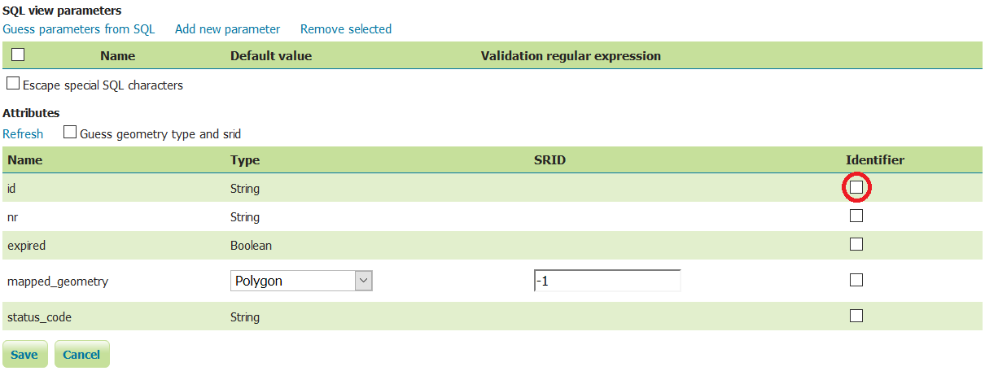

## Directory traverse

This issue was discovered with GF version 4.1 in 2015 (<https://www.exploit-db.com/exploits/39441/>) and was promised to fix in the next major release. Nevertheless, the issue still exists in the latest GF 4.1.2.