MaxSubSum1:

Rough estimate =

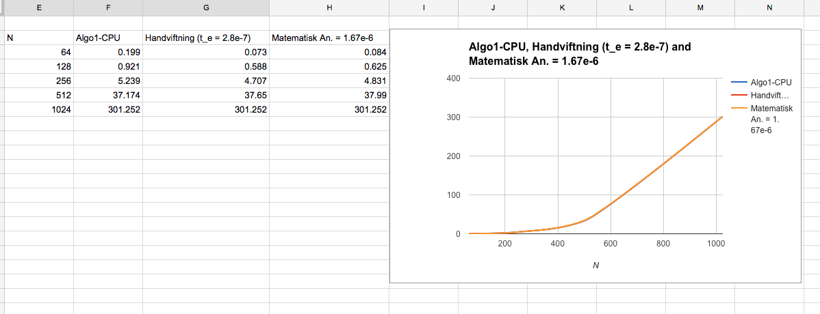

MaxSubSum2

Rough Estimate =

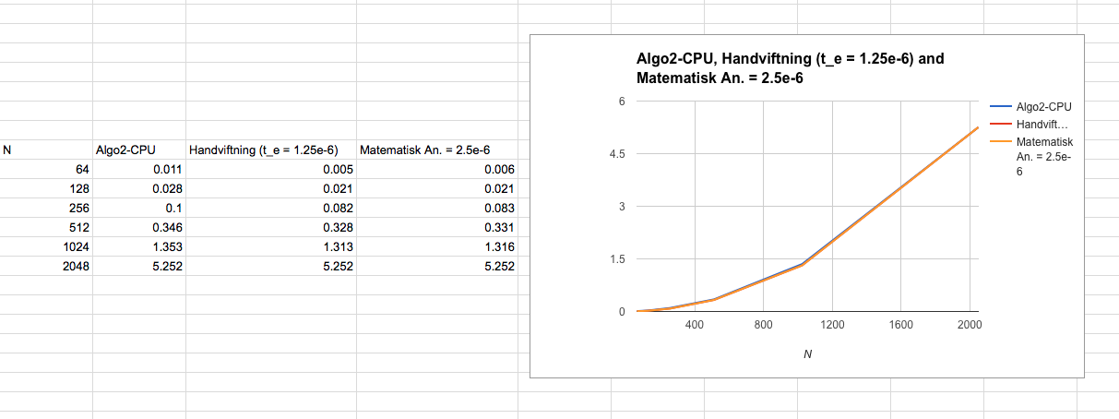
MaxSubSum3

Rough Estimate =

Pedantisk analys:

