**SMAD Coursework**

**Topic:**

*„Statistical Analysis of Airborne Fine Particulate Matter in the City of Pomorie, Bulgaria”*

Faculty Number: 371223006

Technical University of Sofia

*2.12.2024*

*1. Description of the experiment*

This study aims to **analyze the average daily levels of fine particulate matter (PM2.5 and PM10) in the air over the months of February 2023 and February 2024 in Pomorie, Bulgaria.** The data for this analysis will be sourced from **AirTube**, a monitoring platform that provides real-time and historical **air quality information.**

The collected data will be used to assess **air pollution trends** and potential changes in **fine particulate matter concentrations** between the two years. The data in Table 1 has been processed using **histograms**, **control charts, scatter plots and hypothesis testing**.

*Table 1. Extracted Excel data*

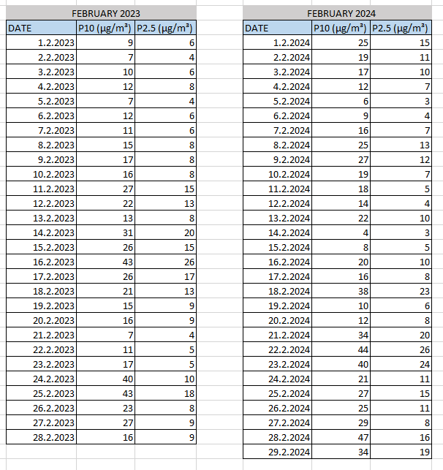

In the picture above you can see the collected data from <https://airtube.info/stats.php>. The information is separated into 2 tables – one for February 2023 and one for February 2024. We have 3 columns per table – one for date, one for the P10 index and one for the P2.5 index.

*2. Analysis of FPM* P10 index for February 2023*

*FPM – Fine Particulate Matter

In Figure 1 we can see a **histogram**, representing the P10 index FPM analysis for **February 2023**. From the data we can see that for **around half of the month the P10 index was on the lower end** – In the range of 7 µg/m³ to 17 µg/m³. For 10 days it was in the **middle** – from 17 µg/m³ to 33 µg/m³ and for 3 days (February 16, 24 and 25) it was quite **high** – from 40 µg/m³ to 43 µg/m³.

*Figure 1. FPM Histogram (P10 index) for February 2023*

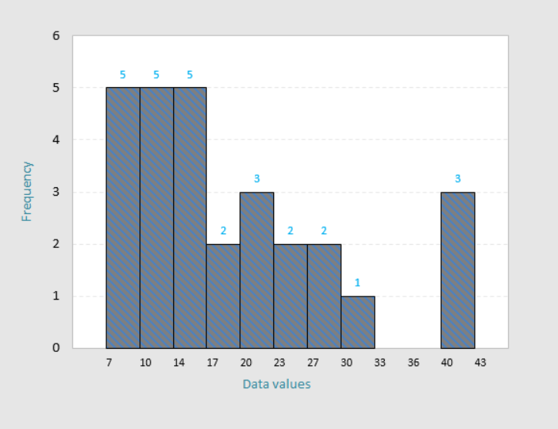

*Figure 2. Distribution characteristics FPM data (P10 index) for February 2023*

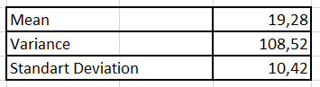

In Figure 3 we can see a **control chart** for the P10 FPM index in **February 2023**. It can be observed that the process is **out of control** – we have 3 observations that are **outside the upper control limit** and more than 3 observations that are **outside the one sigma limit.** We can also see a sequence of 7 observations **below the average**, followed by a **drastic upward trend** in points 13 to 16. We can observe more **drastic upward and downward trends** in the chart – from observation 16 to observation 21 and from observation 21 to observation 25.

*Figure 3. Control chart for FPM P10 index for February 2023*

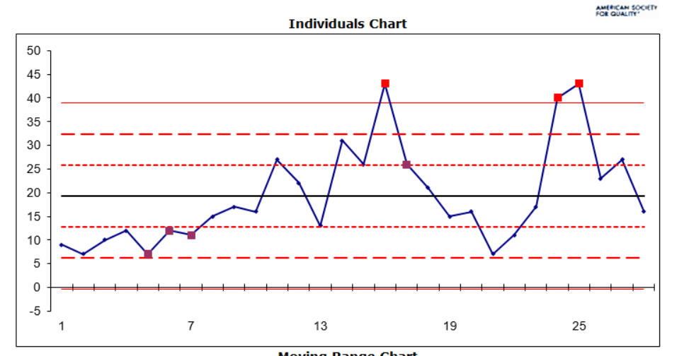

*3. Analysis of FPM* P2.5 index for February 2023*

In Figure 3 we can see a **histogram**, representing the P2.5 index FPM analysis for **February 2023**. From the data we can see that **for most of the month (20 days)** the P2.5 index was very **low** – from 4 µg/m³ to 10 µg/m³. **For 7 days it was in the range** of 12 µg/m³ to 20 µg/m³ and only **one day** (February 16th) it was on the **high** **side** - 26 µg/m³.

*Figure 3. FPM Histogram (P2.5 index) for February 2023*

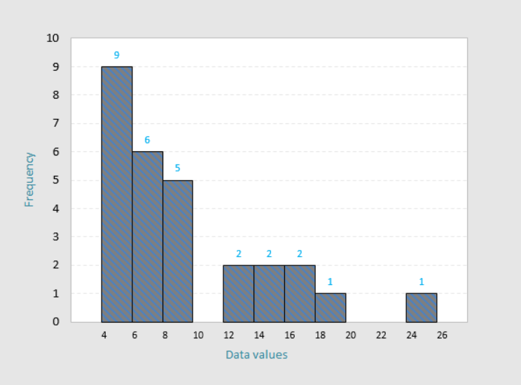

*Figure 4. Distribution characteristics FPM data (P2.5 index) for February 2023*

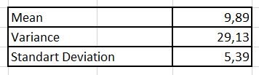

In Figure 5 we can see a **control chart** for the P2.5 FPM index in F**ebruary 2023**. It can be observed that the process is **out of control** – we have 1 observation that is **outside the upper control limit**, 3 observations **outside the two sigma limit** and 3 consecutive observations that are **outside the one sigma limit** **(3 times).**

*Figure 5. Control chart for FPM P2.5 index for February 2023*

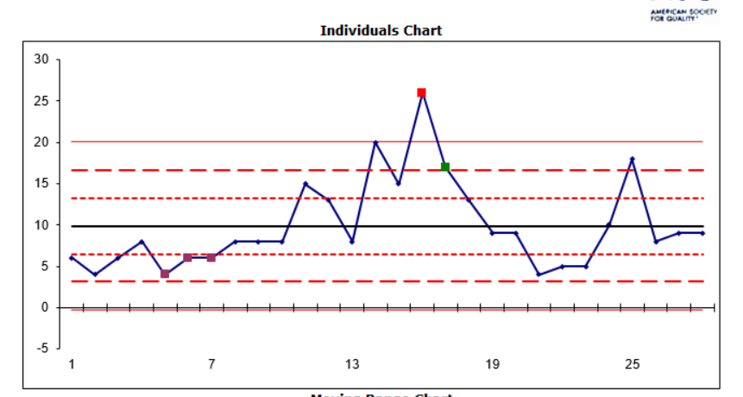

*4. Analysis of FPM P10 index for February 2024*

In Figure 6 we can see a **histogram**, representing the P10 index FPM analysis for **February 2024**. From the data we can see that **for 8 days the P10 index was low** – from 4 µg/m³ to 16 µg/m³. **For 14 days it was around the mean** – 16 µg/m³ to 27 µg/m³ and **for 7 days it was high** – from 27 µg/m³ to 47 µg/m³.

*Figure 6. FPM Histogram (P10 index) for February 2024*

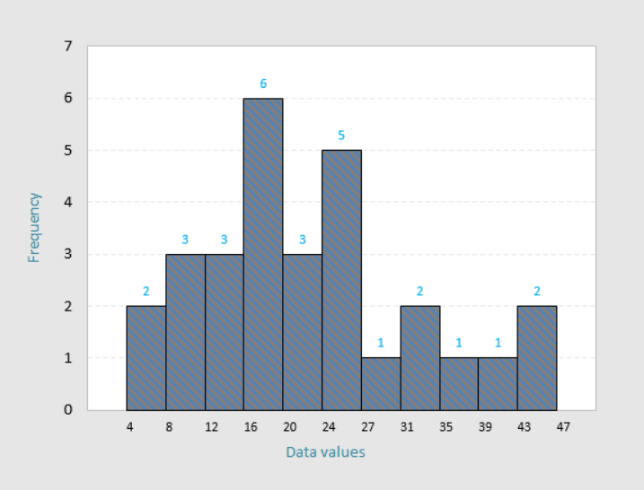

*Figure 7. Distribution characteristics FPM data (P10 index) for February 2024*

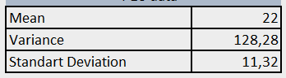

In Figure 8 we can see a **control chart** for the P10 index for **February 2024**. It can be observed that the process is **out of control** – we have 1 observation that is **outside the upper control limit** and 3 observations **outside the two sigma limit.**

*Figure 8. Control chart for FPM P10 index for February 2024*

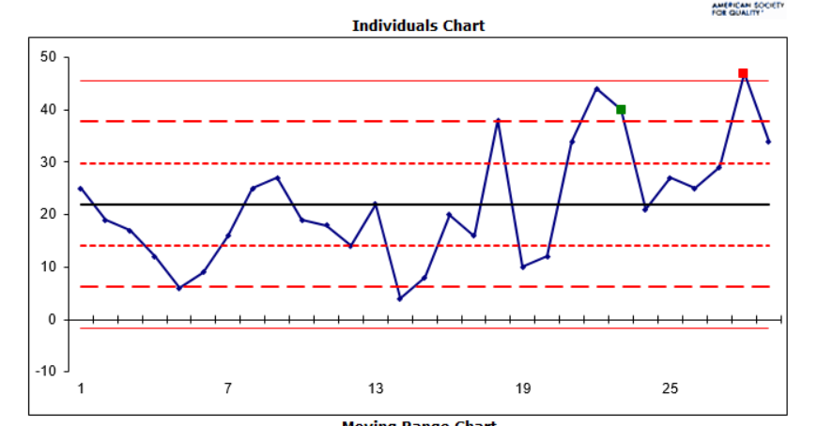

In Figure 9 we can see a **histogram**, representing the P2.5 index FPM analysis for **February 2024**. From the data we can see that for 13 days the P2.5 index was low – from 3 µg/m³ to 9 µg/m³. **For 10 days it was** **close to the mean** – 9 µg/m³ to 16 µg/m³ and **for 6 days it was high** – from 16 µg/m³ to 26 µg/m³.

*Figure 9. FPM Histogram (P2.5 index) for February 2024*

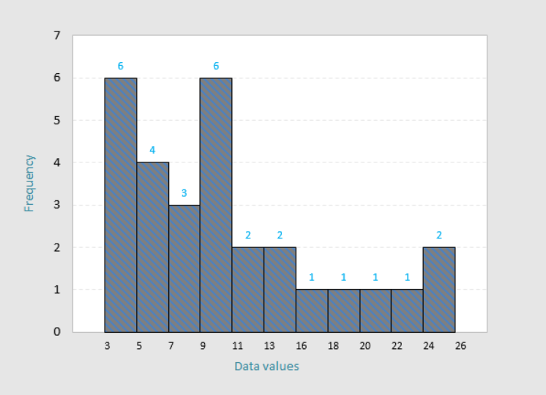

*Figure 10. Distribution characteristics FPM data (P2.5 index) for February 2024*

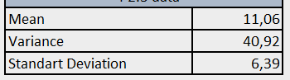

In Figure 11 we can see a **control chart** for the P2.5 index for **February 2024**. It can be observed that the process is **out of control** – we have 1 observation that is **outside the upper control limit**, 8 observations in a row are **below the mean** (observation 10 to observation 17), 2 observations **outside the** **two sigma limit** and 8 observations **outside the one sigma limit.**

*Figure 11. Control chart for FPM P2.5 index for February 2024*

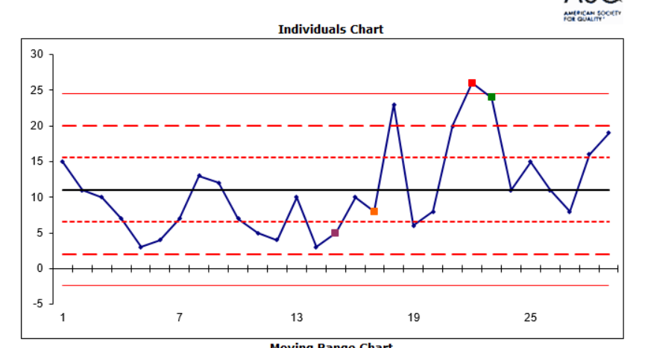

*5. Joint Analysis of the FPM’s*

*5.1 February 2023*

In Figure 12 we can see a scatter plot of FPM’s for February 2023. We can see that there is a **strong positive** **linear** **relationship** between the two examined indexes P10 and P2.5. This is also confirmed by the **correlation coefficient**, which is also a **strong positive (0.84).**

*Figure 12. Scatter plot of FPM’s for February 2023*

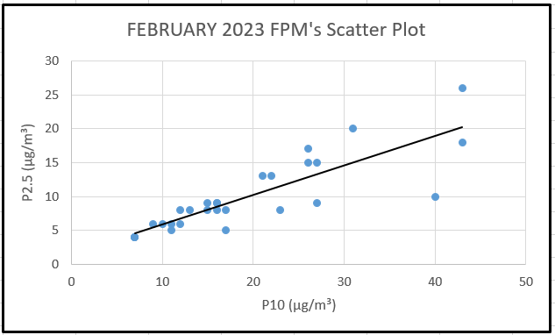

A hypothesis test for the **significance of the correlation coefficient** was conducted with the following hypothesis options:

* **Null Hypothesis (H₀):** There is no correlation between PM10 and PM2.5.
* **Alternative Hypothesis (H₁):** There is a significant correlation between PM10 and PM2.5.

The calculated value of the test statistic is:

* p-value = < .00001, while the tabulated value is p = 0.05.

Since **p (calculated) < p (tabular)**, the null hypothesis (**H₀**) is **rejected** and the alternative hypothesis (**H₁**) is **accepted**.

*5.2 February 2024*

In Figure 13 we can see a scatter plot of FPM’s for February 2024. We can see that there is a **strong positive** **linear** **relationship** between the two examined indexes P10 and P2.5. This is also confirmed by the **correlation coefficient**, which is also a **strong positive (0.90).**

*Figure 13. Scatter plot of FPM’s for February 2024*

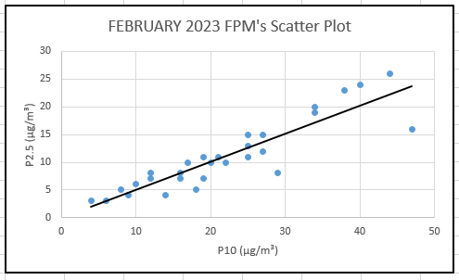

A hypothesis test for the **significance of the correlation coefficient** was conducted with the following hypothesis options:

* **Null Hypothesis (H₀):** There is no correlation between PM10 and PM2.5.
* **Alternative Hypothesis (H₁):** There is a significant correlation between PM10 and PM2.5.

The calculated value of the test statistic once again is:

* p-value = < .00001, while the tabulated value is p = 0.05.

Since **p (calculated) < p (tabular)**, the null hypothesis (**H₀**) is **rejected** and the alternative hypothesis (**H₁**) is **accepted**.

*6. Conclusion*

The conducted **histograms**, **scatter** **plots** and **hypothesis** **testing** has shown us that there is a **strong linear correlation** between the two FPM indexes (**P10 and P2.5**). The scatter plot revealed a **clear linear trend**, further supporting the hypothesis of mutual correlation. Additionally, the histograms for both PM10 and PM2.5 showed **similar distributions**, suggesting that their variations are **closely linked.**

The **strong correlation coefficients** for **February 2023** and **February 2024** (**0.84 and 0.90 respectfully**) indicated a **significant positive relationship** between the two FPM indexes, which is **consistent with expectations**, as both pollutants often share **common sources**, such as **vehicle emissions**, **industrial processes**, and **natural phenomena** like dust storms.

The strong correlation between these indices is **crucial** for **air quality management** in Pomorie, Bulgaria, as it highlights the need for integrated **strategies to control both types of particulate matter.** This analysis can guide future policy decisions and **public health initiatives** aimed at **reducing air pollution and its associated health risks.**