**Alexander Alexandrov Svilarov – 371223006**

**SMAD TASKS**

**Task 1**

*1.1 Pareto Chart*

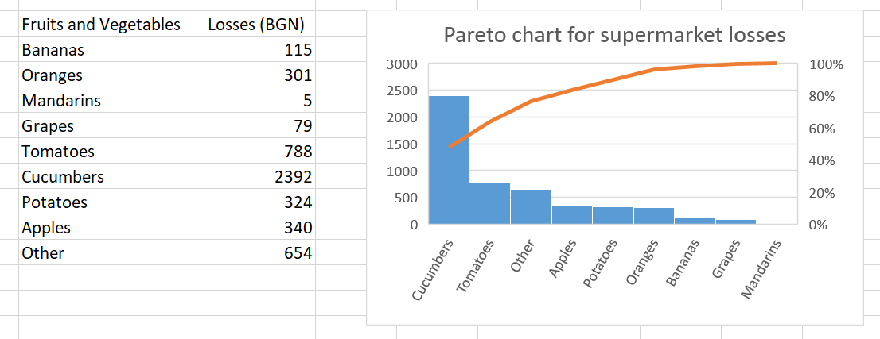

*1.2 Table with additional columns*

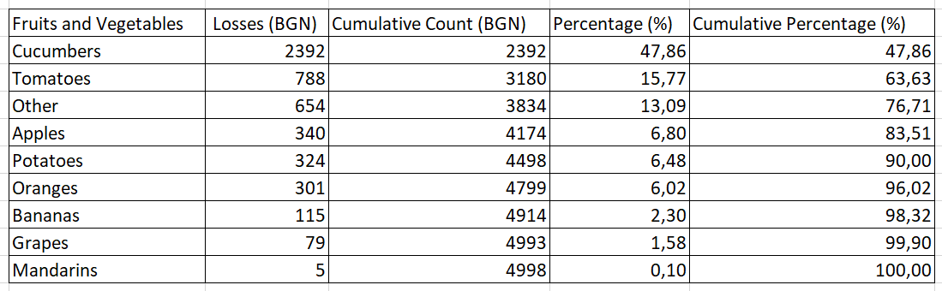

*1.3 Analysis:*

The Pareto chart analysis for the supermarket's losses reveals that **cucumbers and tomatoes contribute the most to the losses**, with cucumbers alone accounting for **47,86%.** These two items though are **not enough** for the Pareto principle (80-20 rule) to be true about the data, because they combined make **63,63%** of the total losses (which is below the 80% threshold).

**Task 2**

*2.1 Histogram*

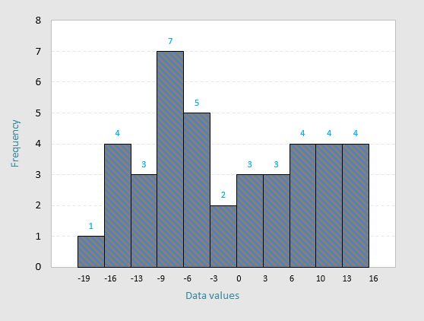

*2.2 Analysis*

The analysis of the axial runout data for magnetic disk blanks indicates that **all values fall within the specified tolerance limits of -20 to 20**, suggesting **good process control**. The distribution of values is roughly centered around the target value of 0, with a **slight positive skew (0.163 to be precise)**, indicating that most measurements are within acceptable bounds with minimal variation.

**Task 3**

*3.1 Scatter plot*

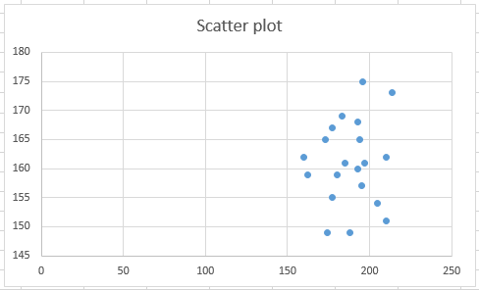

*3.2 Analysis*

The scatter plot suggests a **moderate range** of heights for both men and women. The **cluster** between approximately 150-200 on the x-axis (man’s height) and 150-175 on the y-axis (woman’s height) implies that **most couples fall within this height range.**

The data does **not show a strong linear correlation**, meaning there **isn’t a clear trend** where taller men are always with taller women or vice versa. However, the clustering suggests that many couples have **similar height ranges**. This pattern might reflect social or personal preferences for partner height, though variability in the y-axis indicates some diversity in these preferences.

**Task 4**

*4.1 X-bar and Range control chart*

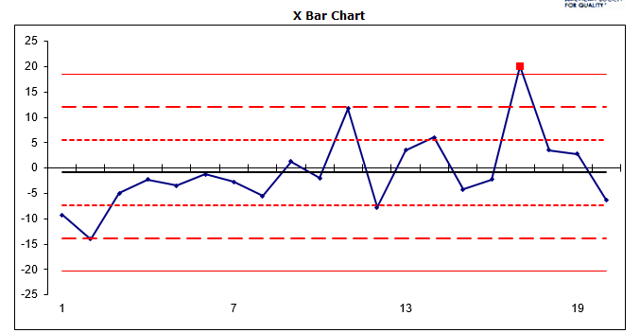

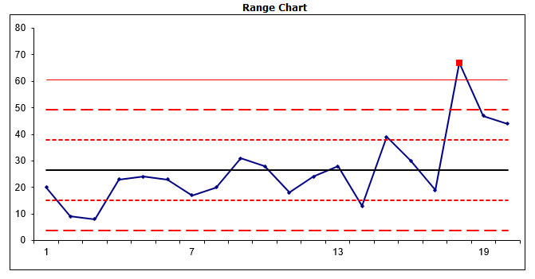

*4.2 Analysis*

In the **X-bar chart** shown above, a single point (around point 18) **exceeds the upper control limit** (three sigma), indicating a potential **out-of-control situation and unstable process**. This suggests a **significant** **variation** in the process mean for that sample.

In the **Range chart**, a similar point **exceeds the upper control limit** (also around point 18), which suggests an unusual **increase** **in process variation**. This point's alignment in both charts indicates an effect that affects both the process average and variability simultaneously, possibly due to an external or assignable factor affecting this sample.