# Motive for Branch

The motive behind creating this branch is to fulfill a personal request for a feature. I want a window to come up every time I run IHG that will allow me to pick a download directory, change IHG settings, allow the settings to be session only or global, and give an option to suppress the dialog until it is turned back on via the IHG menu.

# Background

The XPCOM library currently does not have a nice way of adding a “filer picker” within another window. The Linux versions of FF come with a file picker dialog which is defunct in windows. The solution is to write an implementation of the file picker for windows. Since we only need the directories, the implementation will be less laborious.

# Concept

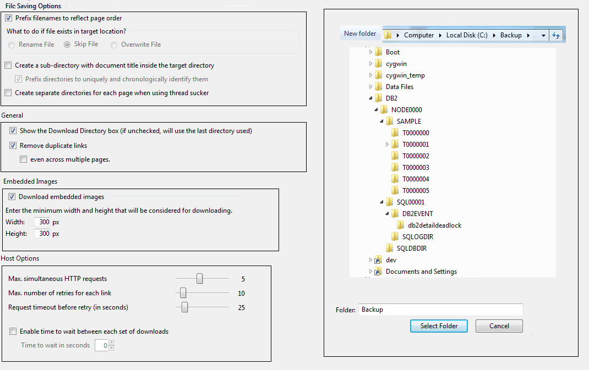

# Milestones

Current work is located under “chrome/content/interfaces/filepicker”. A file should be located in there that will list what work has been done, and/or needs to be done.

# Tasks

Don’t know yet