Reinforcement Learning Assignment 3: Pacman Capture the Flag

Ciem Cornelissen, Elias Malomgré, Thibault Van Tricht

Your task is to design intelligent agents to play Pacman Capture the Flag using Multi-Agent Reinforcement Learning (MARL) techniques.

Game overview
In Pacman Capture the Flag, two teams compete to steal food from the opposing side while protecting their own. Players earn 1 point for each piece of enemy food they collect and successfully return to their team’s field
If an opposing ghost catches a player, all the food they are carrying is dropped at the location where they were caught, and the player is sent back to their spawn point.
The game lasts for 300 time steps, or until one team steals all the opponent’s food, whichever comes first. The team with the highest score at the end of the game wins.
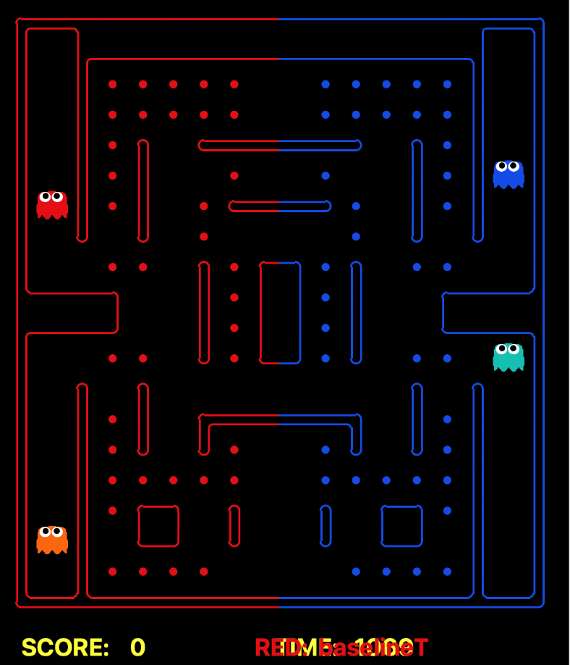

Assignment Structure
We provide you with a Jupyter notebook and supporting code. You need to complete the following three steps.
1. Implement the QMix Algorithm
You will begin by building the core components of the QMix architecture. This involves creating the individual agent networks and the crucial mixing network that enables centralized training. You will then implement the complete training loop and the QMix loss function to bring your agents to life. The goal here is to establish a solid, working implementation.
2. Specialize in an Advanced Technique
With a functional QMix agent, each student will choose one specific area to focus on for improvement. This allows you to explore a state-of-the-art MARL topic in depth. Your options will include implementing advanced mixing networks (such as QTran or QPLEX), sophisticated exploration strategies (such as count-based exploration), or enhancing individual agents with techniques from the Rainbow paper.
3. Explore and Innovate
In the final section, you will build upon the insights gained in Part 2. Based on your experiments, you will be able to identify a promising direction for further improvement and implement it. This is an open-ended challenge where you can explore advanced topics such as policy gradient methods (MAPPO), novel exploration techniques, generalization to random maps, or better observation representations for your agents.

Final submission
For the final submission, you will provide a report detailing your work across all three parts of the assignment. This report is a critical component of the project, as it allows you to document your journey and showcase what you have learned.
We place a high value on reflection. We want to see more than just final results, as we want to understand your thought process. Explain why you made certain design choices, what challenges you encountered, and what your experiments (incl. the ones that failed) taught you about the algorithms you implemented. Your insights are just as important as the outcomes.
To communicate your findings effectively, please use plots and tables to visualize your results. A clear graph of win rates or training rewards often holds more information than a thousand words. While there is no hard page limit, we encourage you to be concise and clear. Focus on crafting a well-structured, insightful analysis of your project.
We expect you to submit the following things for the final submission:
- The report
- The notebook
- Any custom code you wrote
- Your final agents for the tournament (in the format mentioned in the assignment description PDF)

Tournaments
Tournaments Overview
During this assignment, there will be four tournaments conducted in a round-robin format, where each team will compete against others:
3 intermediate tournaments: These serve as checkpoints to test your models and evaluate your training strategies.
    - Monday 30 November before 10 am
    - Monday 7 December before 10 am
    - Friday 12 December before 1 pm
1 final tournament: This determines the ultimate winner! Who will enter the Hall of Fame as the first winner ever in the RL course?
The tournament results will not impact your grade.
Tournament Details
- Map: The tournaments will be on “bloxCapture.lay”, so make sure to train your agents on this map because otherwise your agents will fail.
- Opponents: You will play in a round robin style tournament against all groups that submitted their agents, all baseline teams, the best group from last year, and, for the final tournament, the TA team.
- Team Roles: During tournaments, your agent will play as both the Red Team and the Blue Team. However, training with only the Blue Team is sufficient. The provided myTeam.py file mirrors observations to ensure agents behave consistently as Team Blue.
- Deadlocks: During tournaments, deadlocks occur often when, for example, all agents select “stop” as a greedy action, then they will all be stuck, or if they move back and forth between cells. To counter this, we detect when deadlocks happen and force a random action. The sequence of random actions is always the same.
Submission Guidelines
It is essential to submit your code in the correct format; otherwise, your team’s tournament code will fail, leading to disqualification. Follow these steps:
Run the validation function:
At the bottom of the team file, there is a function that does some basic checks to see if the team file is configured correctly (some edge cases might still exist)
Rename Files:
Rename myTeam.py to YOUR_GROUP_NAME.py.
Save Models
- Save the entire model (and not just the weights) to files named YOUR_GROUP_NAME_Q_X.pth, where X is the agent ID. Since you need to submit two agents, set X=1 and X=3.
- Refer to this guide for saving models correctly.
Load Models
Ensure that both agents in your team file load their respective models correctly.
Create Submission File
- Zip your files into a single archive named YOUR_GOUP_NAME.zip.
- Do not place the files in a subfolder within the zip file.
For group1, this would result in the following files zipped in “group1.zip”:
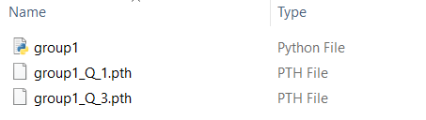

Code Documentation

Map layouts
Available maps
The layouts folder already contains various map files that you can use by providing their file paths in the reset function of the Gym environment. Below are some notable maps:
- tinyCapture.lay: A very small map useful for quickly verifying if your algorithm is learning.
- smallCapture.lay: a small map used for Part 1 of the assignment.
- bloxCapture.lay: the map to be used for Parts 2 and 3. This is also the map on which the tournaments will be played.
- randomLayouts: the environment contains code that randomly generates layouts. These can be used to make your agents more generalizable; however, training on these might be more difficult.
Creating Custom Maps
You can create your own maps by adding a .lay file with your desired layout to the layouts folder. Use the following symbols to define the map:
- %: Wall
- .: Food
- o: Capsule
- 1-4: Spawn points for agents
- (Space): Empty spaceBaseline Agents

Baseline Agents
The agents folder contains baseline agents of varying skill levels for training. To load a team, provide the file path without the extension. For example, to load the baseline team, use: “agents/baselineTeam”. These agents can serve as benchmarks to test and improve your models during development.
The agents folder includes pre-built teams categorized by difficulty to help you test and train your models.
Easy Agents:
- randomTeam.py: Agents with completely random actions.
Intermediate Agents:
- baselineTeam.py: Basic agents with simple strategies.
- approxQTeam.py: Agents that use approximate Q learning to select actions.
- MCTSTeam.py: Agents that use Monte Carlo Tree Search to estimate the best possible actions.
Difficult Agents:
- heuristicTeam.py: Agents that use heuristics to select actions.
- AstarTeam.py: Agents that use A* search to estimate the best possible actions.

Gym Environment
The Gym environment provides several configurable options during initialization and runtime, providing flexibility in training and testing
Initialization Options
When initializing the environment, you can configure the following:
- Episode Length: Set the maximum number of steps per episode.
- Reward Properties: Toggle specific reward features, such as:
- Rewards for good actions.
- Defensive rewards for prioritizing protective strategies.
- Enemy Team: Specify the opponent team by providing its name.
- Display: Set it to True or False depending on whether you want to see them play.
Agent Configuration and Actions
The environment maintains a consistent order for the agents:
- Players 0 and 2: Red Team.
- Players 1 and 3: Blue Team.
- Step Function Dictionary:
  - Keys: Agent indices (0, 1, 2, 3).
  - Values: Corresponding actions for each agent.
Reset Function
The reset function allows dynamic adjustments during training:
• Enemy Team: Change the opponent by specifying its name.
• Map Layout: Switch to a different map by providing its layout file name.
Evaluation Environment
The evaluation.py script allows you to test two teams against each other on a selected map without running any training code. This is particularly useful for debugging and verifying that your models load correctly.
Visualization
Set the Display option to True when running the script on your local machine to visualize the game in a pop-up window. This is highly recommended before submitting your code to Ufora to ensure everything works as expected.
Observation Space
The environment's observation space is a tensor of shape (8, height_map, width_map), with 8 channels representing different game elements. Here’s a breakdown of the channels:
Walls (%)
- Observer Agent (current agent): 0 if not present, 1 + number of food carried if present.
- Blue Capsules (o on the Blue Team’s side)
- Red Capsules (on the Red Team’s side)
- Ally Agents
- Enemy Agents
- Red Food (on the Red Team’s side)
- Blue Food (on the Blue Team’s side)
Each channel is one-hot encoded (values are either 0 or 1), except for the agent’s location, which is a continuous value. The agent's location is an exception: it is either 0 or 1 + the number of food it carries.

Action Space
Action Space
The environment uses a discrete action space with 5 possible actions:
- North
- East
- South
- West
- Stop
Legal Actions
Not all actions are legal, as agents cannot move through walls. If you give an illegal action to the step function, the environment will interpret it as doing nothing. Rather than masking illegal actions, we recommend the following approach:
- Replace any illegal action with “Stop” during execution.
- Update the network with the original illegal action to allow the agent to learn and avoid such actions in the future.
To discourage illegal actions, you may also provide a reward for legal actions (see below).

Reward function
The environment includes a pre-implemented reward function composed of several components:
- Food Returned to Own Field: Reward of 1.0 for each piece of food successfully returned. Food is automatically dropped when entering the base.
- Food Collected on Opponent’s Side: Reward of 0.1 for picking up food on the opponent’s field. Food is automatically collected when entering a location with food. There is no separate collect action.
- Capturing Enemy Pacman Carrying Food: Reward of 0.25 for capturing an opposing Pacman carrying food.
- Legal Actions: Reward of 0.01 for taking any legal action.
Modifications
You are allowed to modify the reward function to better align with your training strategy. Consider experimenting with the weights of each reward component to encourage specific behaviours in your agents.
You are also allowed to modify the observation space; however, you should start from our observation space. You should also make the appropriate changes in your myTeam.py file so that these modifications are also applied when you participate in the tournament.
The code is meant to be flexible and easy to use, so if you want to make any other changes, go ahead! Just keep in mind that for the tournament, we will not use these changes.

The game used in this assignment was originally designed at Berkeley (https://ai.berkeley.edu/contest.html ). For this assignment, it has been optimized and refined to better suit our learning objectives.

