# Sample Results

This is a short summary of our results from the user-based-algorithm.

All runs were made with the user, that has the **id 1**.

## Top 15 Movies from the user

## Top 10 Movies Recommended Movies with the neighbour size: 20

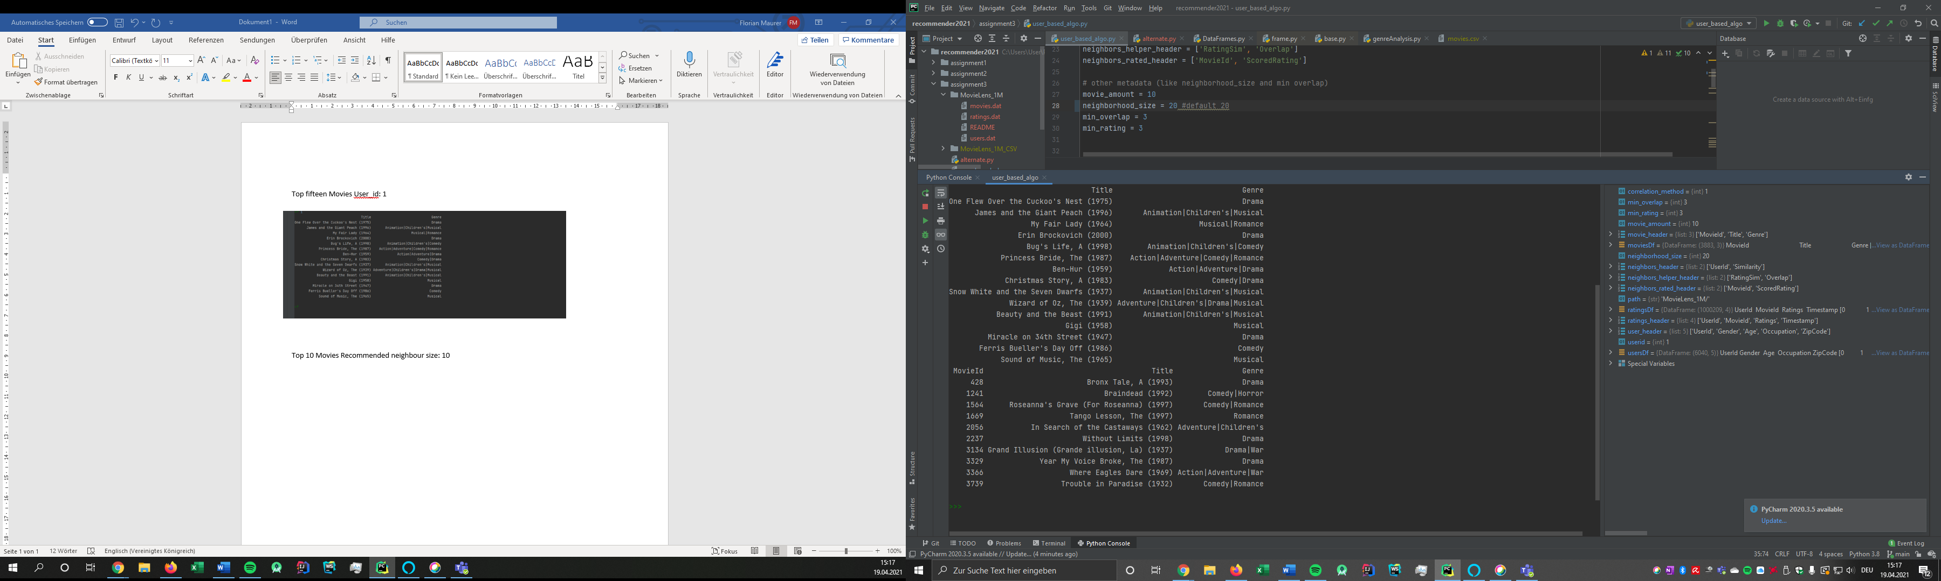

## Top 10 Movies Recommended Movies with the neighbour size: 5

If we change the neighbour size, we can see that the results of the user-baser-algorithm has changed. Only two Movies from above appear in this list. (Grand Illusion (1937) and Tango Lesson (1197))

## Sample Size: first 10000 entries

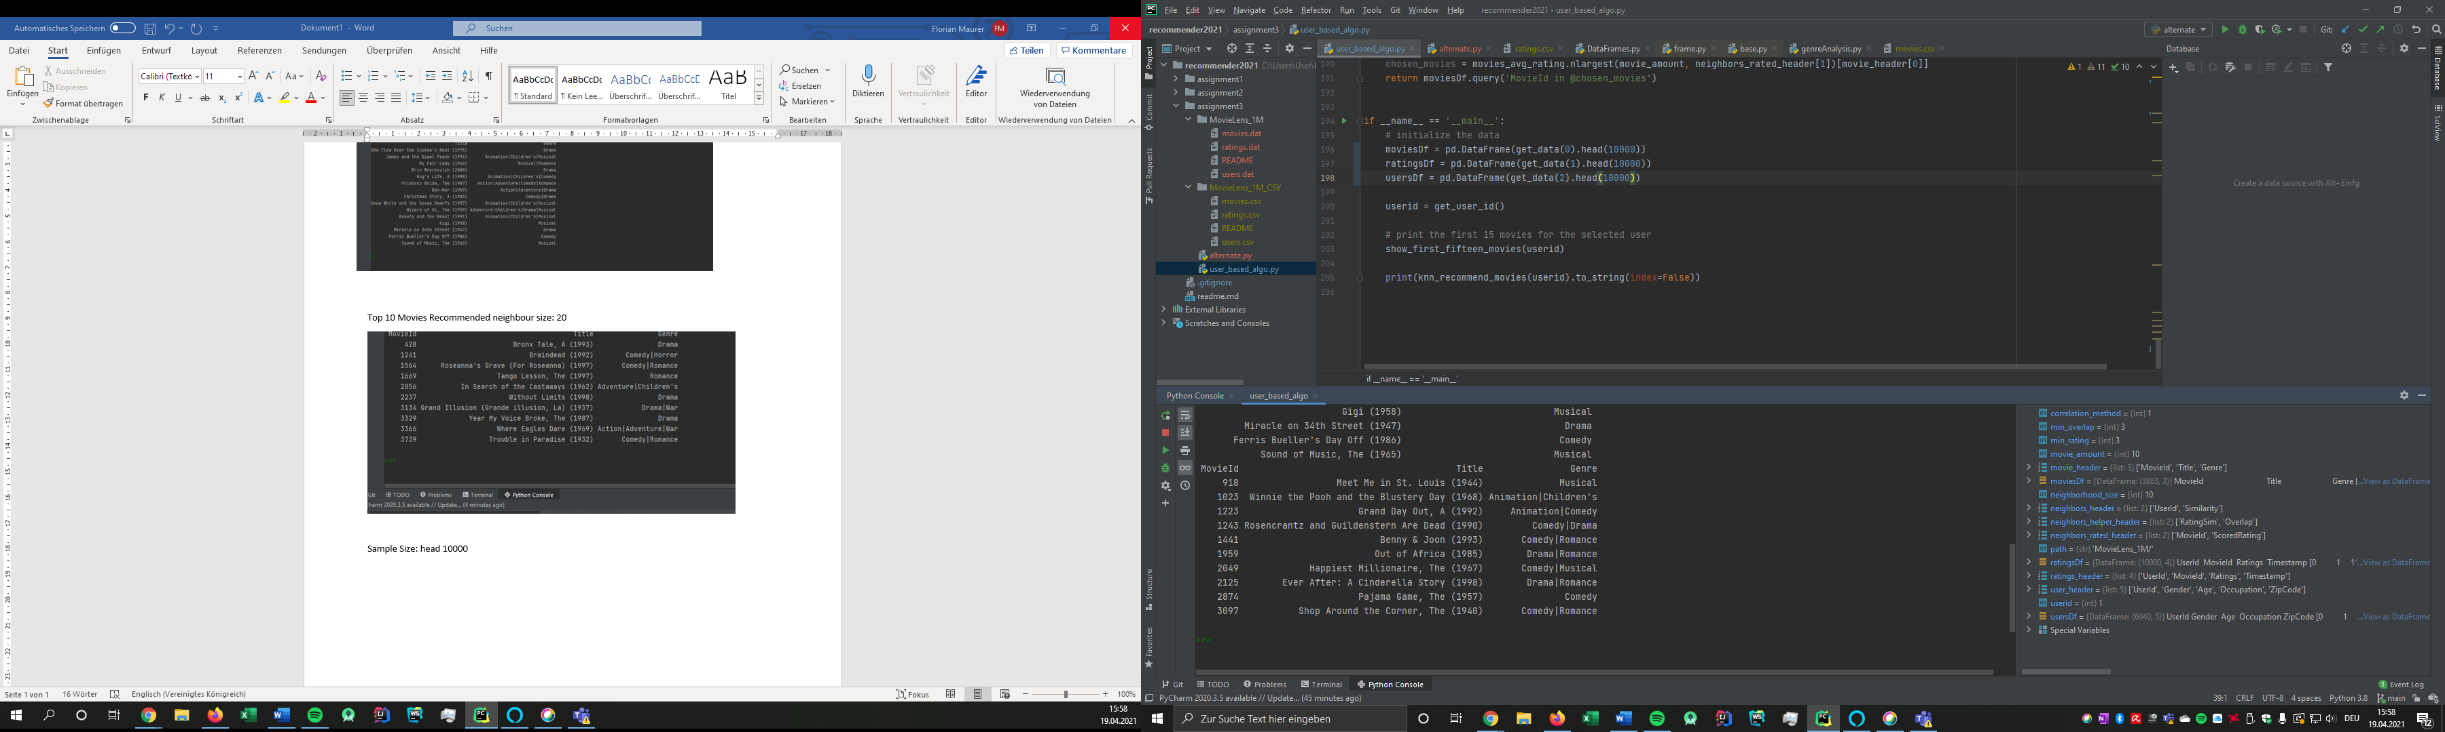

All those Movies in this case were rated by User with the id 10 and all those movies were rated with 5. Based on this result, it can be assumed that the algorithm works.