test file

test file

test file

test file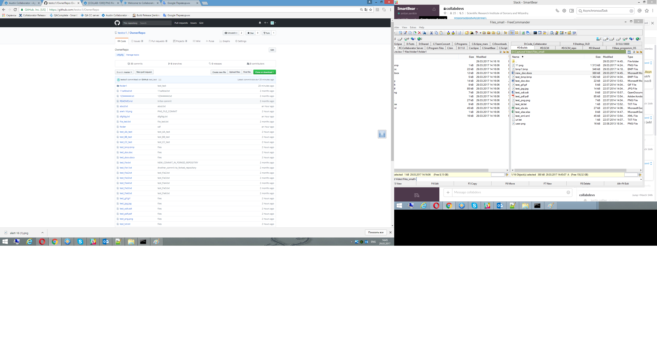

test file

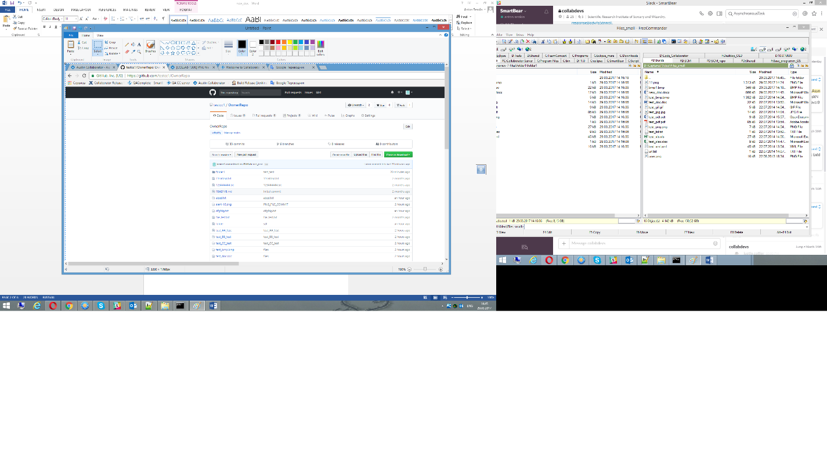

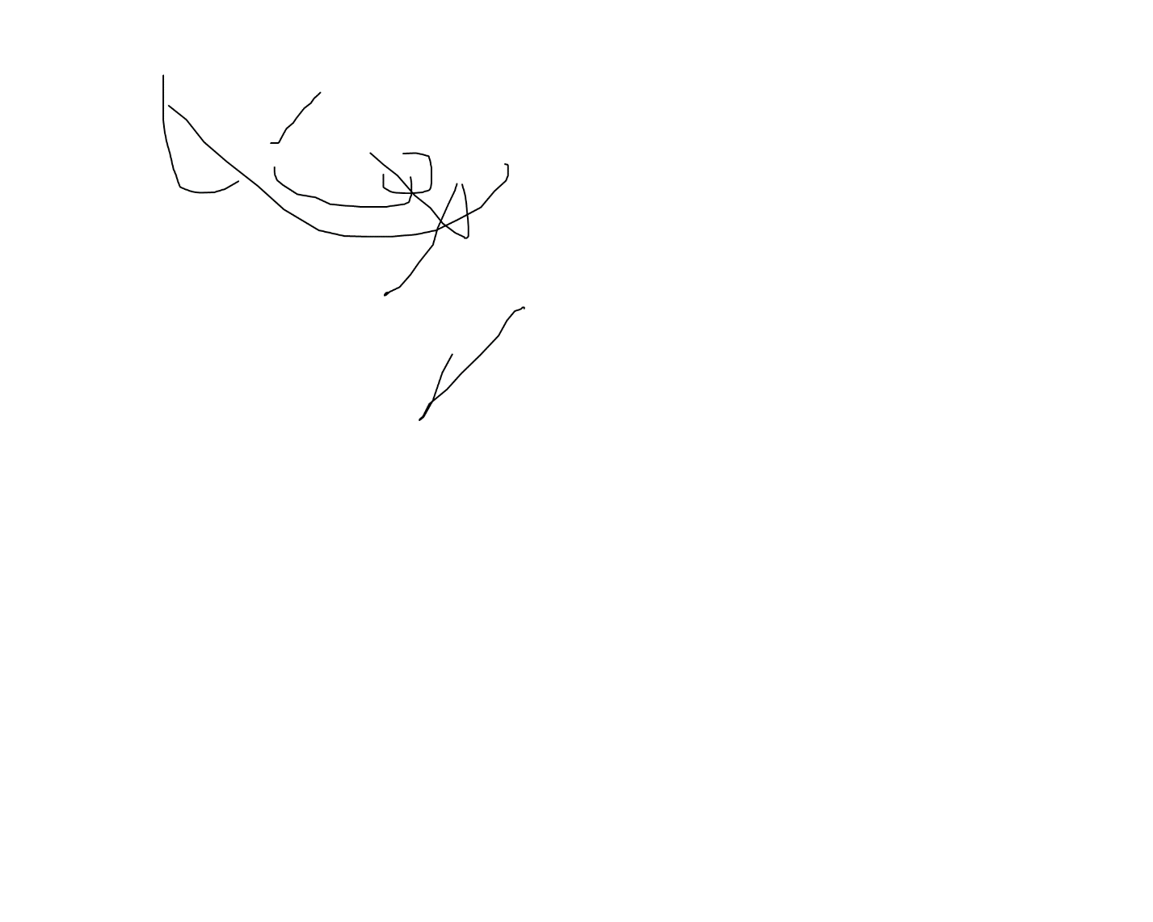

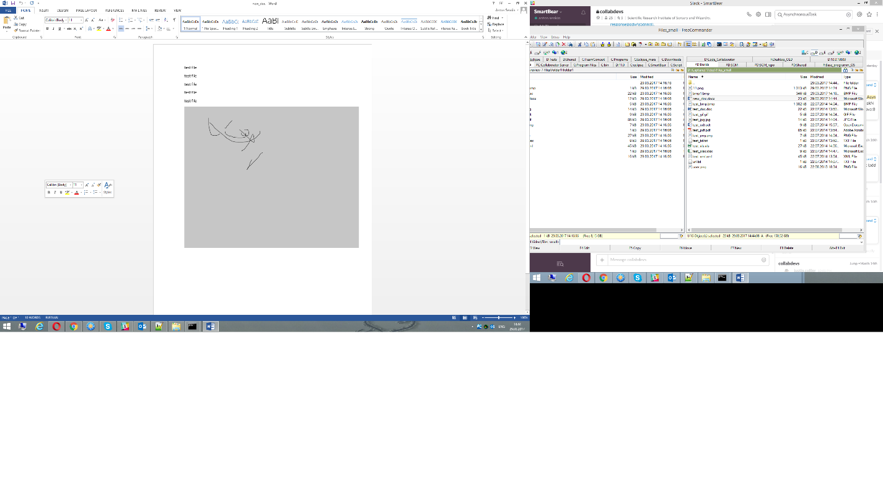

Sdfsdf

Sdf

Sdf

Sdf

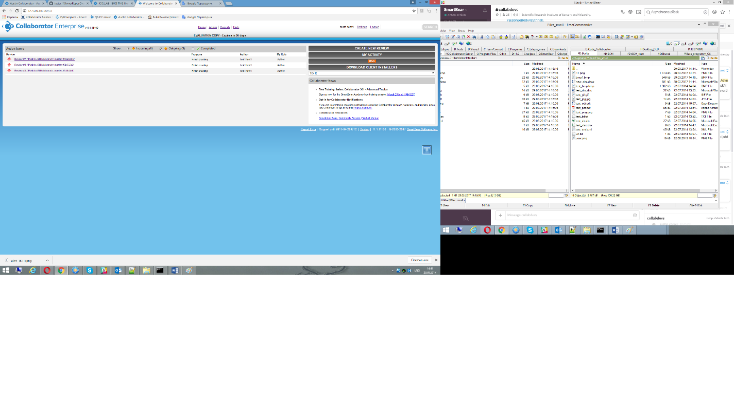

test file

test file

test file

test file

test file





Sdfsdf

Sdf

Sdf

Sdf

