Project made by: Alexander Zaytsev

Group number:TI12S1

Student’s number:1204156

Project: Map quiz!

Description: A user is asked to locate towns of Finland on the map.

Main page: On the main page sector “Latest news” using javascript gets info from server. In order to start the app- click picture in the middle

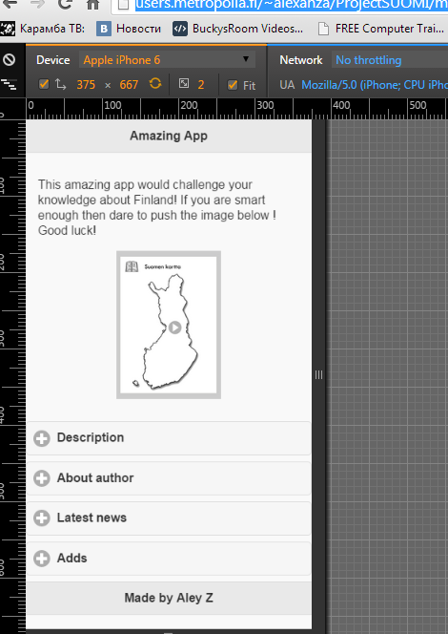

App page: the question on the top. In order to answer click on the page where you thing town is situated

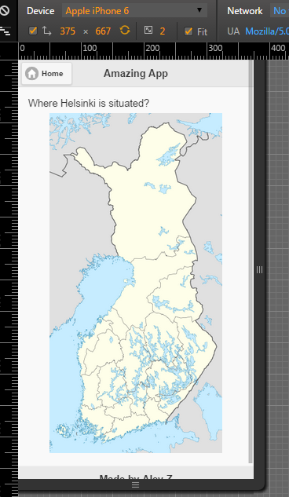

App page2: After you click. Red and black areas appear. Red-your answer, black-right answer. Also new button “Next ” appear .In order to get next question push it.

