Name: Alexander Abdu
Student Number: 202336006

TASK 1
The dataset to be studied is an image dataset to train a CNN model. In previous model training we’ve worked with logistic regression, polymetric regression and classification models, asides from the use case of each model one noticeable difference is the dataset fed into the model. Simpler linear models requires a dataset with a categorical dependent variable, which can be binary (two outcomes), ordinal (ordered outcomes), or multinomial (three or more unordered outcomes), these datasets work with flat vectors whereas a CNN uses the spatial structure of the images to extract hierarchical features, making it far more effective for this dataset’s visual complexity.
In this dataset our target variable (y) is the “labels” of the images, therefore implying the images are (X) we will be training this model with about 60,000 images. The size of the dataset is noticeably larger when compared to the dataset fed into linear models, this is because for CNN models the size of the dataset must be large to fix the risk of overfitting.

Loading the dataset
Due the structure of this dataset;
triplemnist/
├── train/
│ ├── 001/
│ │ └── 64_001.png
│ ├── 002/
│ │ └── 83_002.png
│ ├──….
│ │ └── … .png
│ └──
├── test/
│ ├── 001/
│ │ └── 10_001.png
│ ├── 002/
│ │ └── 12_002.png
│ └── ….
├── val/
│ ├── 001/
│ │ └── 83_001.png
│ ├── 002/
│ │ └── 45_002.png
│ ├── 003/
│ │ └── 25_003.png
└──

Importing the dataset into the project would be done as a tensorflow dataset after importing necessary libraries(tensorflow, pandas, numpy ..etc);
train_ds = tf.keras.preprocessing.image_dataset_from_directory(
"triple_mnist/train/",
image_size= img_size,
batch_size=batch_Size,
color_mode='grayscale',
shuffle=True
)
This function automatically:
- reads all images
- assigns labels based on folder names
- resizes images
- batches them into a “tf.data.Dataset”

Visualising the dataset
Before visualizing our dataset we first preprocess it by normalizing and concerting the image to grey scale then one-hot rncoding the labels.
def pre_processing(img, label):
img = tf.cast(img, tf.float32)/255.0
return img, label
train_ds = train_ds.map(pre_processing)
test_ds = test_ds.map(pre_processing)
val_ds = val_ds.map(pre_processing)

The data set is then visualized by sampling random samples off the dataset, unlike tabular datasets that are visualized using “.head()” from the pandas library to get an overview, but image datasets need to be plotted, using the matplot library in this case

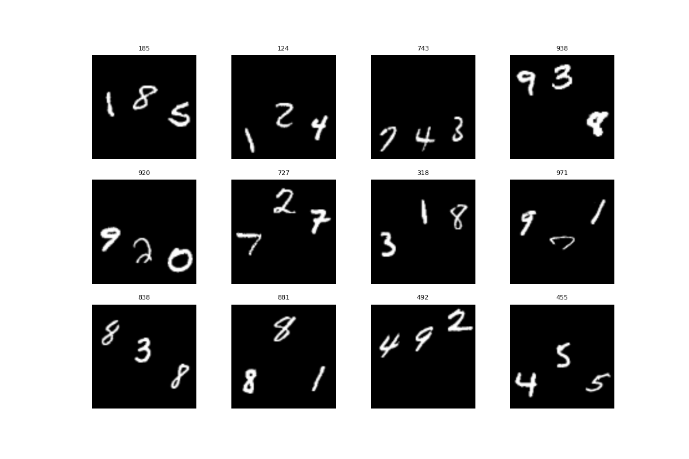

Unlike the structure of a csv file these images don’t follow much dimension restrictions, the dataset reveals that each image contains multiple handwritten digits with high variability in position, size, and orientation, making this problem significantly more complex than standard single-digit classification and far more suited to CNN-based architectures than logistic regression.
Images have a single channel after converting to greyscale.
Each image has multiple digits(three to be exact), each variation of the sequence of numbers represents a class, which is its label.

How this Problem differs from a typical classification Task
- Multi-object Images; A typical classification problem has one object per image, here each image has multiple digits (objects) per image forming a sequence. This makes he problem a sequence classification problem
- High spatial variability; by visualizing the images we can see that they each have varied centers, size, positions, width and height unlike a balanced and structured tabular dataset. Linear models cannot handle spatial structure but CNNs can extract position-invariant features.
- Hierarchical patterns: Each digit has curves and strokes; these features must be learnt at different levels. This requires convolution layers.
- Larger Dataset requirement: Visual complexity means the model needs more example to learn patterns and generalize unlike tabular datasets that have distinct data.

TASK2
Based of the nature of the Triple MNIST dataset which contains complex spatial patterns, overlapping digits and noise the default model performance hierarchy would be.
- Convolutional Neural Network: The CNN model was the most effective model because it is designed specifically for two-dimensional grid data. Even though the model trained was a standard CNN model and it wouldn’t be considered a “good model” by any standards It would still outperform the logistic regression model
- Logistic Regression: Logistic Regression is the baseline, while it is fast and interpretable it struggles significantly with high dimensional image data
In this case, the performance evaluation of both models revealed that neither approach achieved acceptable predictive accuracy on the Triple-MNIST dataset. The dataset has an unusual structure compared to classic datasets used for ml model training. Its training classes(640) don’t match its test (200) or validation classes (160), producing a challenging environment. Both the Logistic Regression model and the standard CNN model exhibited extremely low accuracy and F1-scores, indicating severe underfitting.
Despite that, a comparison across metrics such as training time, prediction time and validation accuracy shows that the logistic Regression model delivered the best result overall, while the standard CNN was the least effective. Logistic Regression trained faster and produced quicker prediction times while achieving results that, although poor, were at least marginally better than those of the CNN. In contrast, the CNN required significantly more computational time and still failed to improve on the linear model’s baseline performances.
The counter-intuitive outcome -where a CNN performs worse than Logistic Regression on an image-based problem, can be traced to three core factors.
First, Triple MNIST is substantially more complex than single digit MNIST; overlapping digits demand robust spatial feature extraction. A shallow tuned CNN, trained on a small sample size, cannot learn meaningful filters.
Second, the intentional class imbalance and distribution sift between train, validation and test splits penalize high-capacity models more severely. Logistic Regression tends to collapse into a majority-class baseline under such conditions producing uniformly poor results, whereas CNN attempts to represent minority classes without enough support and consequently exhibits unstable and ineffective learning.
Finally, the behavior observed when altering the number of the output classes further exposes the CNN’s sensitivity to model configuration. When assigning an exaggerated calls count of 1000 to match default knowledge of the dataset, the CNN model massively overfits because the model capacity dwarfs the available data.
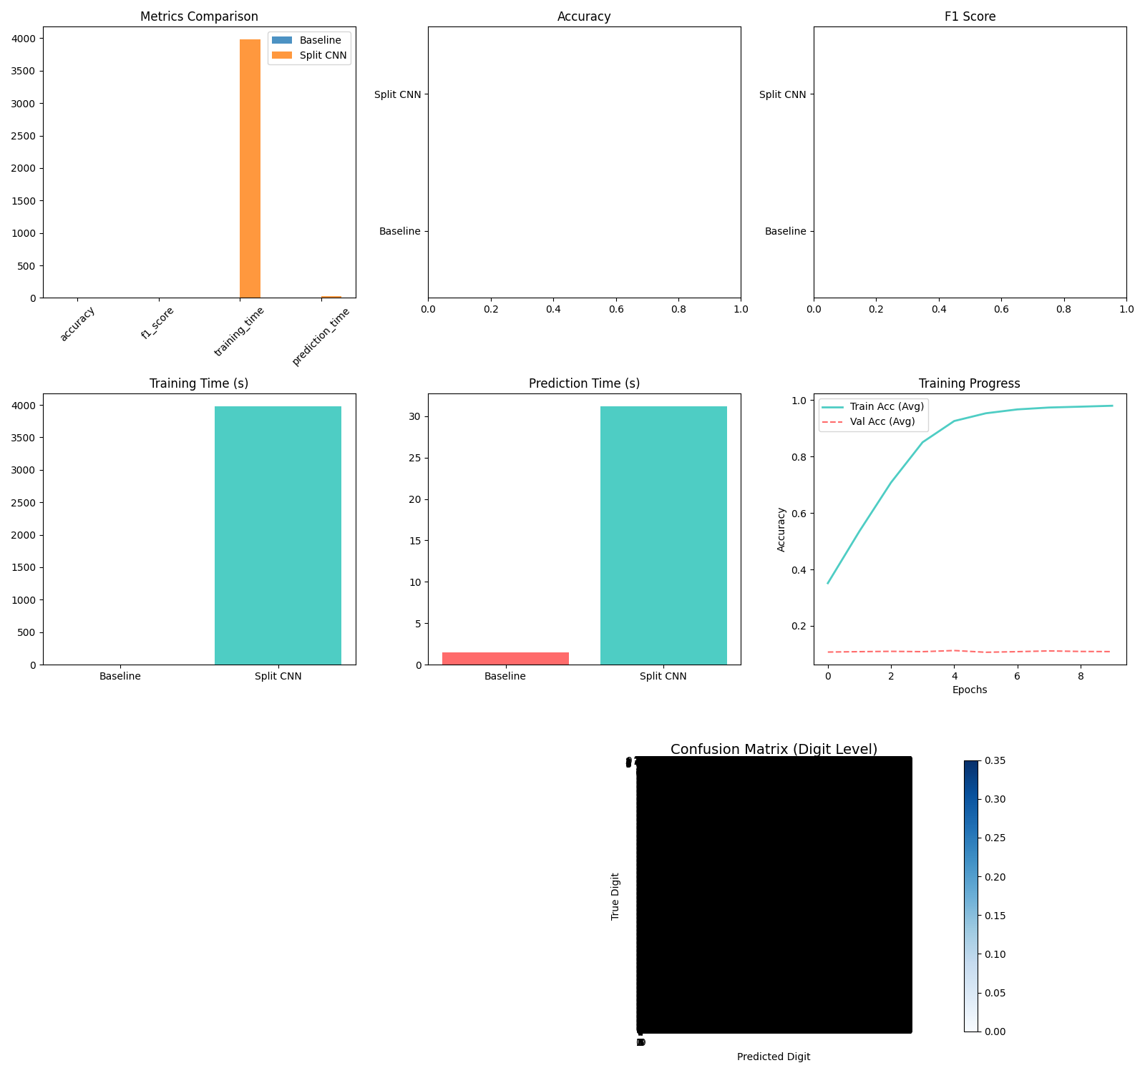
When restricting the class count to the actual classes present in training, the model underfits, lacking the ability to separate the complex digit overlaps.
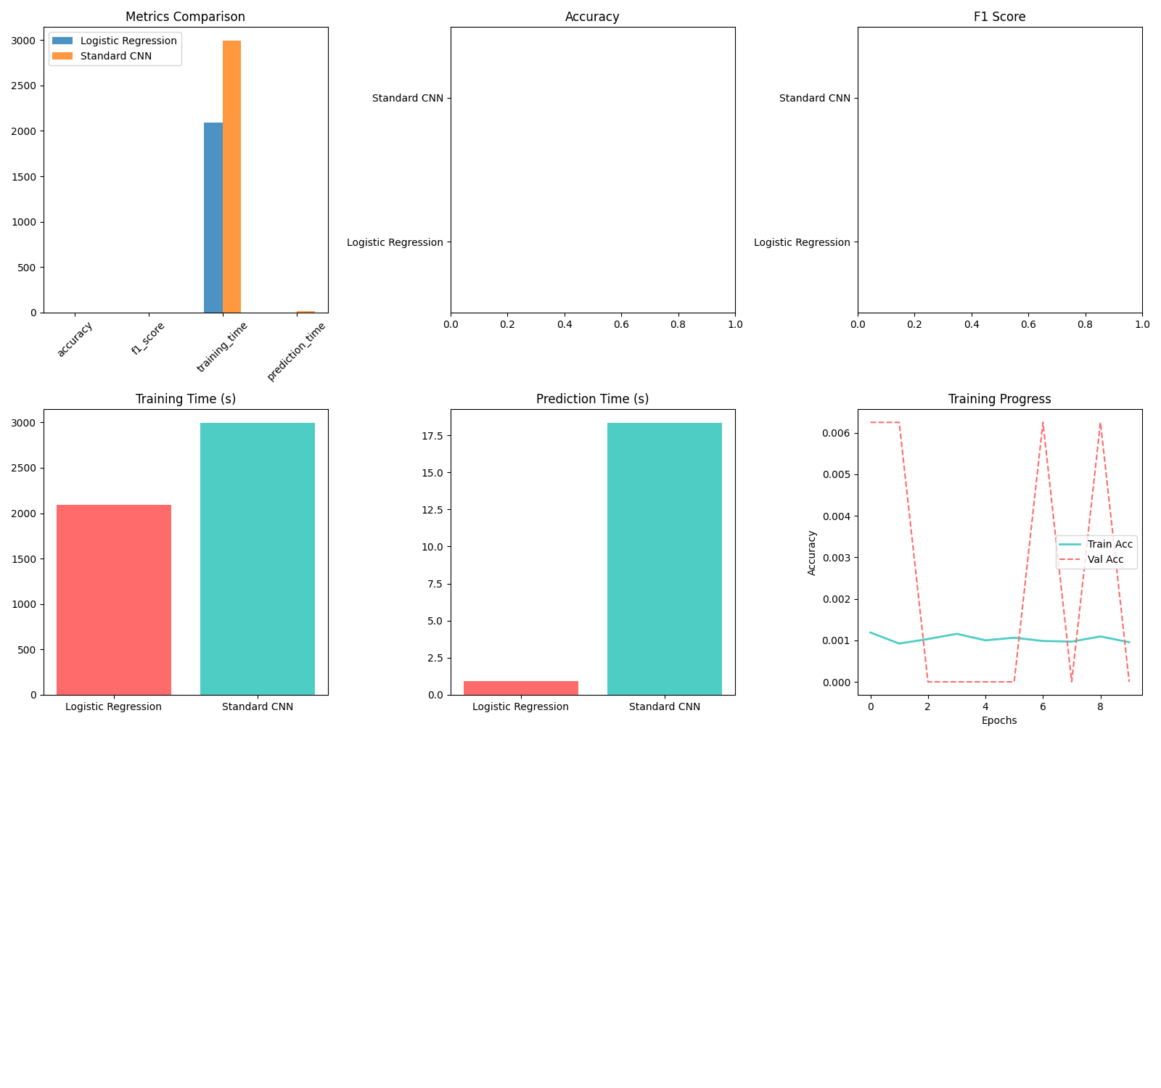
Logistic Regression, having far lower capacity, remains consistently underfit but stable regardless of output dimensionality. That stability, although not synonymous with accurate predictions, explains why it outperformed the CNN in this constrained setting.
The hyper parameter tuning was automated for both logistic regression and CNN model, logistic regression using regularization to prevent overfitting by penalizing large weights. This is implemented through flattening to convert the 2D images to 1D and then iterating through values of $C$ training on “train” dataset and calculating accuracy on “val” dataset to see which C value generalises best. The candidate values of C are [0.1, 1.0, 10]
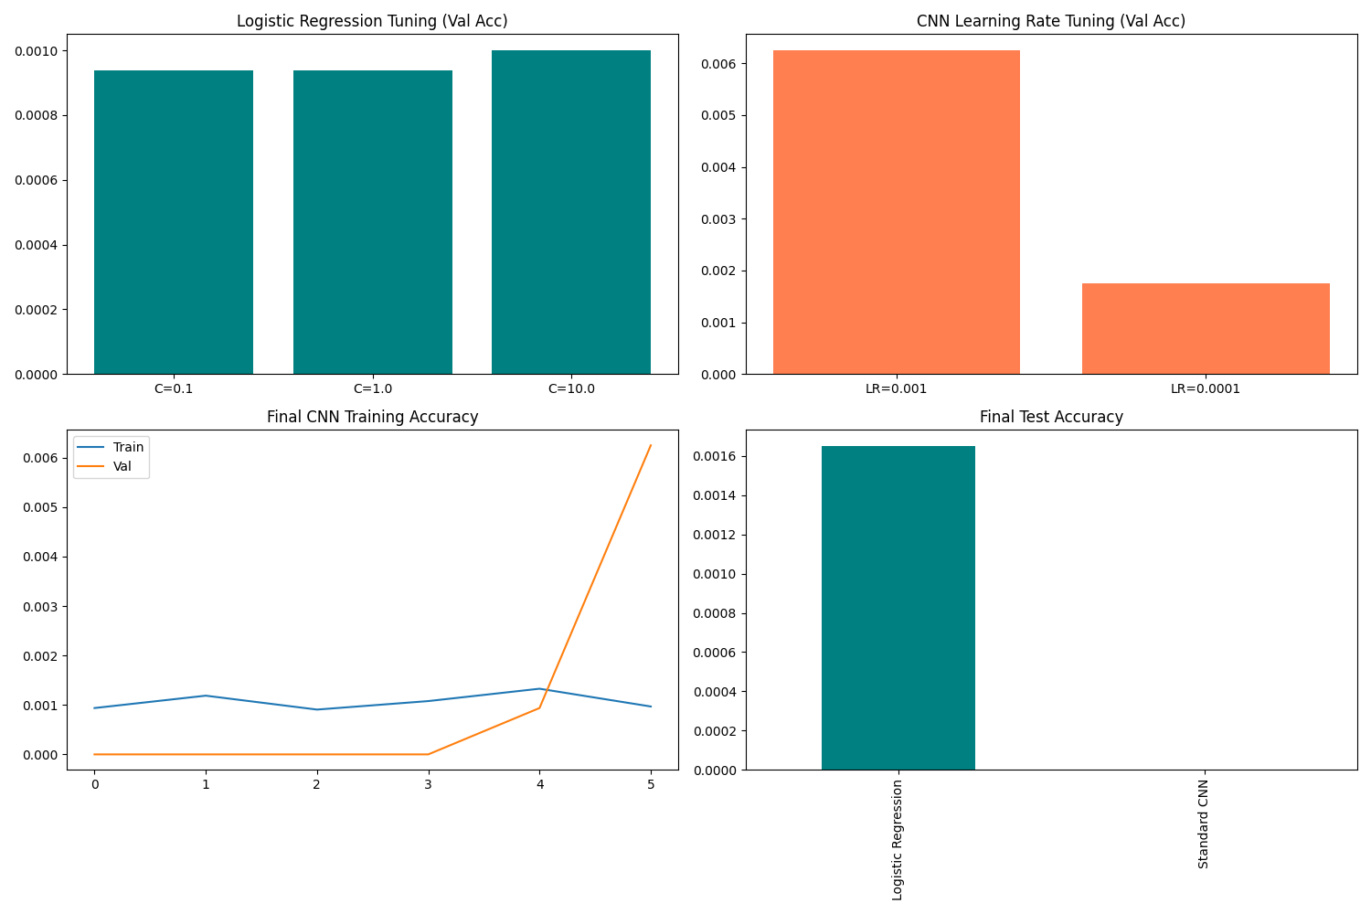
For the CNN model, we tune by testing various learning rates as learning rate is arguably the most important hyperparamter for Deep Learning. The logic behind this is that if LR is too high(0.001), the model might train too quickly but “overshoot” the optimal solution, causing unstable performance. On the other hand if LR is too low(0.0001) the model learns very relaibly but might be too slow to reach the best accuracy within the given epochs.
The code uses a “Sanity checks” approach, it trains the CNN for only two epochs per candidate LR. This is a computational efficient way to identitfy which learning rate starts the model on the best trajectory before fulliy commiting to a complete training session.The candidates LRs are [0.001, 0.0001]

These validation tuning did not significantly improve the models, therefor the next option was to try other hyper-parameters. In this instance data-augmentation and Dropout was the chosen method.
Data augmentation was the logical the optimum technique because of the nature of the dataset, the tripleMNIST dataset is a collection of “hand-written” digits meaning it’s not perfectly aligned horizontally or vertically, neither is it placed in the same spacial dimensions consistently, therefore augmentation prevents over-fitting.
To mimic this imperfection;
- layers.RandomTranslation(height_factor = 0.1, width_factor = 0.1) to shift the image vertically and horizontally by up to 10% of the total height/width
- layers.RandomRotation(factor = 0.05) to rotate the image by a random amount within the range of [-5% to +5%] of a full circle (roughly ±18°)
- layers.RandomZoom(height_factor = 0.1) to randomly zoom in or out of the image by up to 10 %
Drop-out , forces the network to become “redundant” and more resilient by randomly turning off a percentage of neurons during each training step. The logic is if 25% of neurons are missing at any given moment, the remaining neurons cannot rely on their neighbors to do the work. This prevents Co-adaptation, where neurons only work when specific other neurons are present.
The result of this is the model is forced to learn multiple independent representation of the same digit.
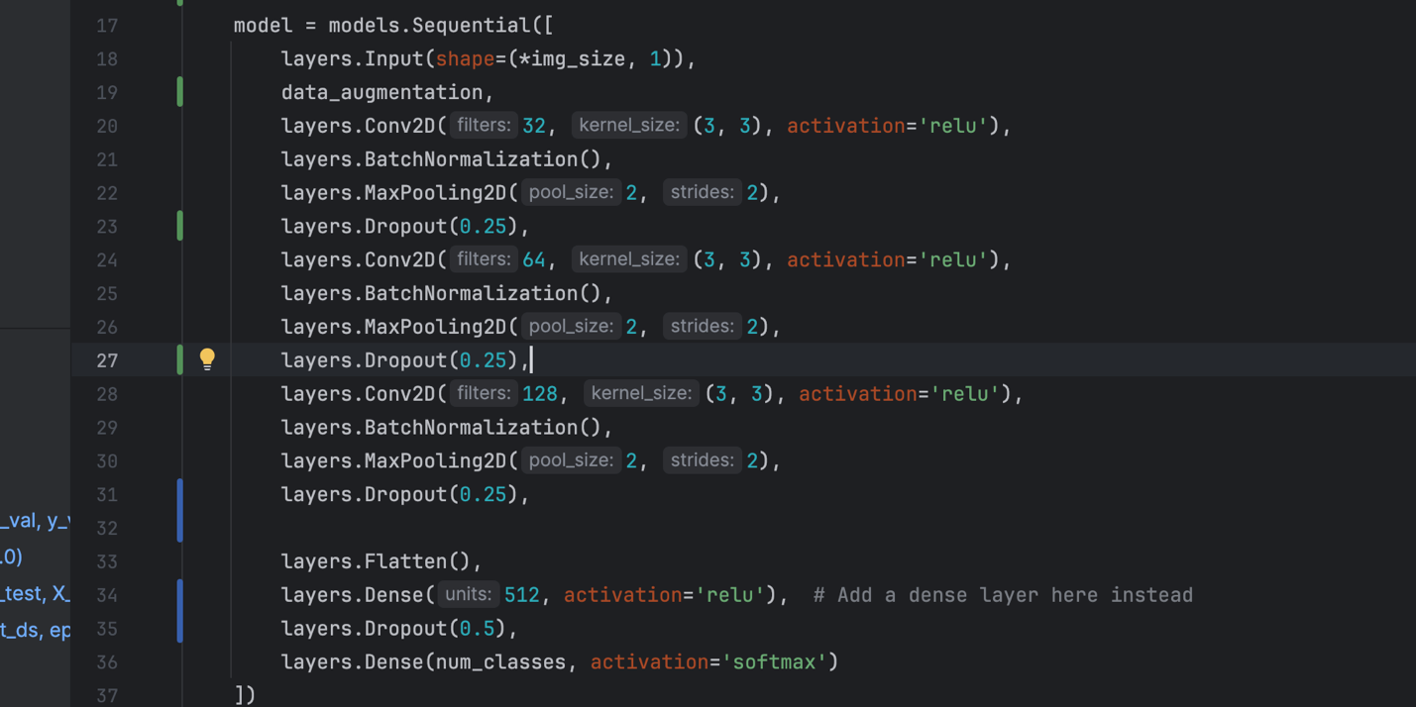

After implementing these techniques and hyper-parameter tweaks, we notice an improvement in performance from the CNN model, it still isn’t a good model but it outperforms the logistic regression model.
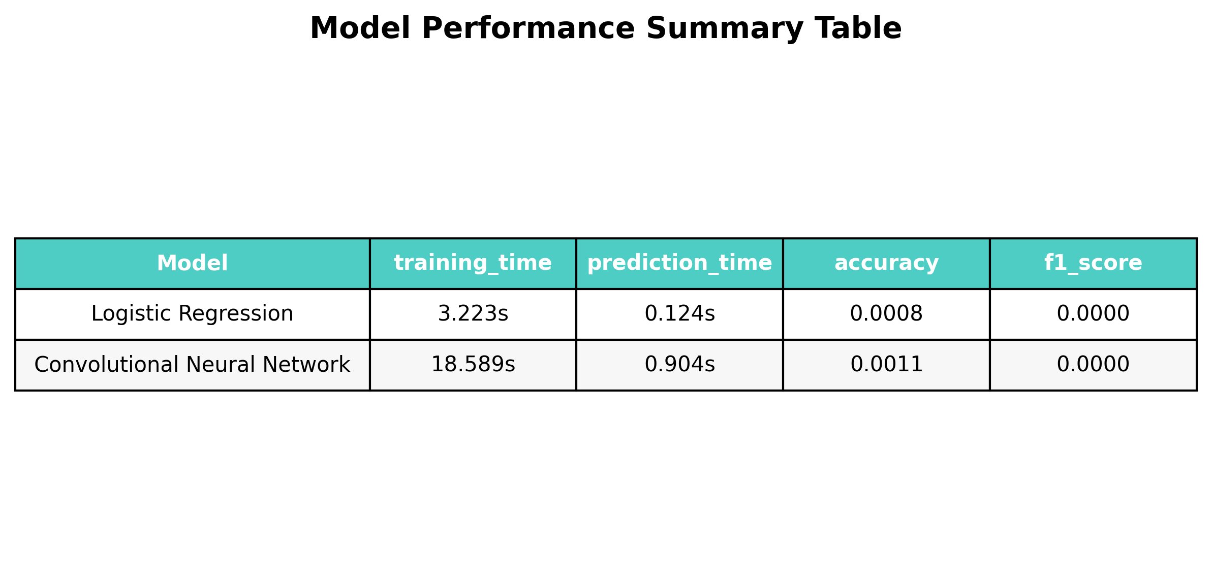
In task4, prediction on the triple MNIST dataset was tackled differently by using a modified version of a standard CNN model. Using Split Siamese Convolutional Neural Network model approach; three subnetworks and a shared weights across all three outputs, basically teaching the model that “3” (the digit of choice for explanation purposes) in 3 – 1 – 4 is also “3” in 4 – 1 – 3.
Results:
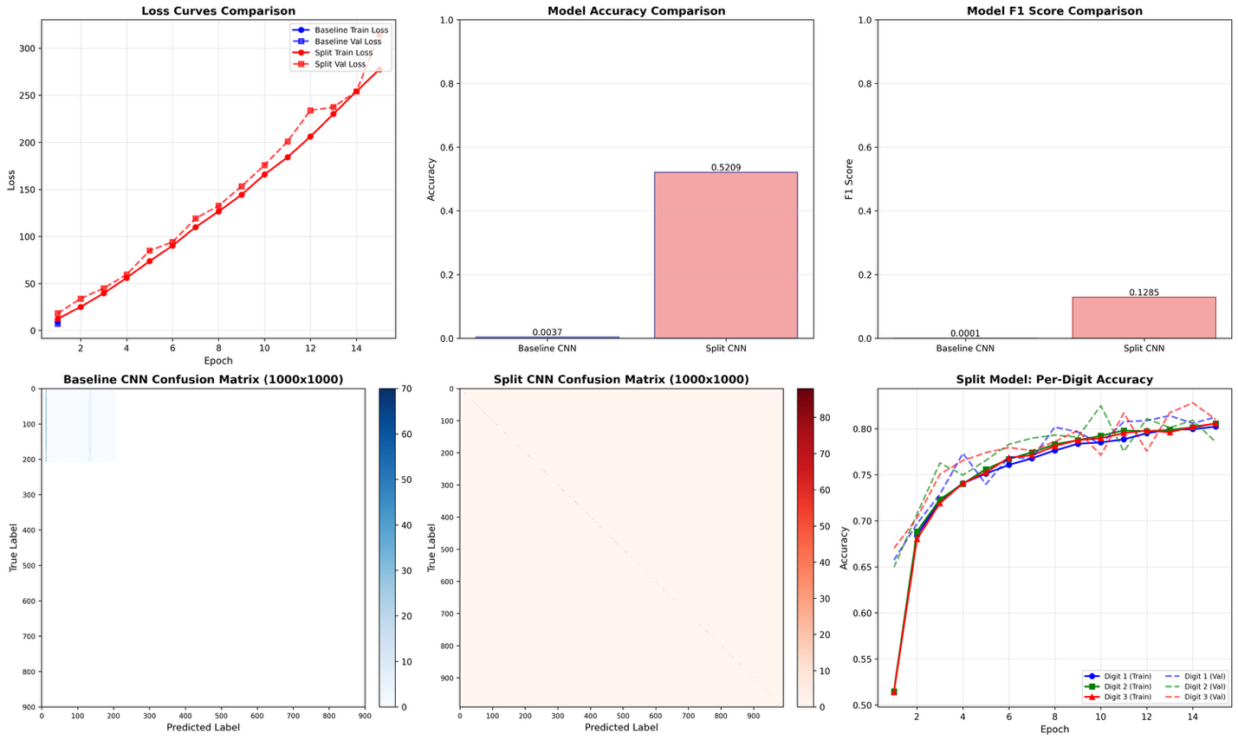
The image is taken in and split into three 84 x 28 vertical strips. This operation provides a strong inductive bias ; instead of forcing the network to spend thousands of training iterations discovering that the information is clustered into three vertical zones, this spatial zone is prior encoded into the pipeline
By isolating each digit, the model no longer has to deal with complex spatial relations or overlapping features that occur when treating the image as a single 84 x 84 block.
These splits of each image is passes through the Siamese backbone with shared set of weights( consists of layers like Conv2D, BatchNormalisation, MaxPooling2D) which is instantiated only once.
This “weight sharing” is the architectural masterstroke of the Task 4 model. Because “3” in the first position looks fundamentally as a “3” in the second or third position. It is redundant to train three separate feature extractors. By using a shared backbone, the model forces the convolutional filters to learn a “universal digit recognizer”.

Input: 84×84 image
↓
[Split into three 84×28 strips]
↓
┌─────┼─────┐
↓ ↓ ↓
[Left] [Mid] [Right]
↓ ↓ ↓
[Shared CNN Backbone] ← Same weights used 3 times
↓ ↓ ↓
[Digit1][Digit2][Digit3]
↓ ↓ ↓
0-9 0-9 0-9

Learning Dynamics; why split model Learns better in Comparison to standard CNN.
- Gradient Flow analysis
In standard CNN:
- Gradient must flow through the entire network to update 1000 output nodes
- Each combination receives gradient only from its class
- Rare combinations get insufficient gradient signal
In split CNN:
- Each digit receives gradient from all images containing that digit
- Digit “3” gets training signal from images : 003, 312, 413, ….
- ~100x more gradient signal per digit class
- Per-digit Training Curves
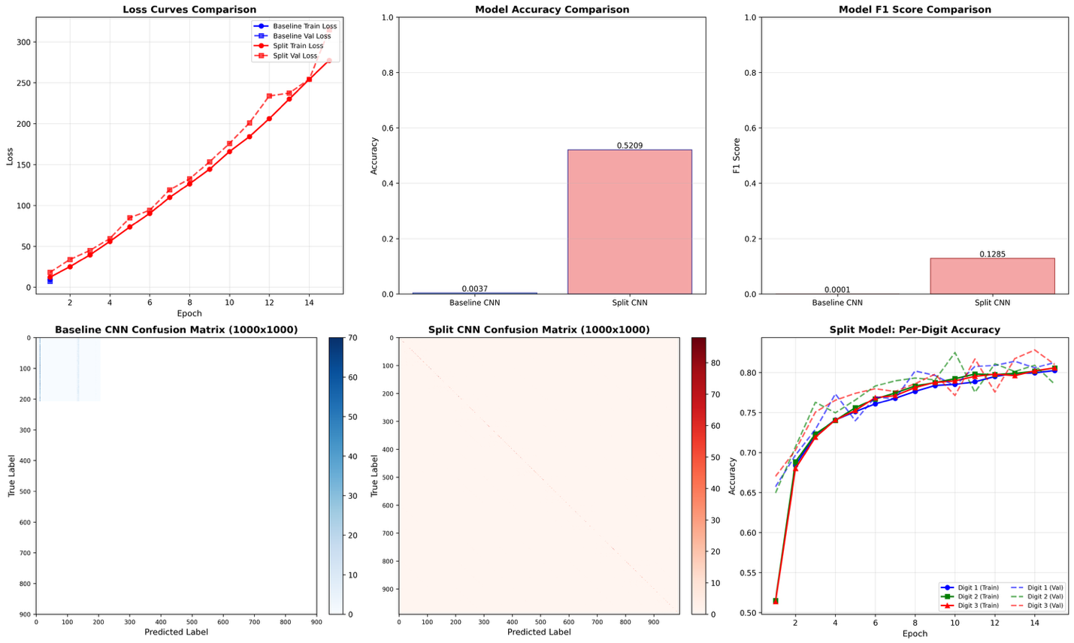
The “split Model: per-Digit Accuracy” plot reveals:
Synchronised learning :
- All three digit positions learn at nearly identical rates
- Training and validation curves track closely for each digit
- No position-specific overfitting
Rapid Initial learning:
- Steep improvement in first five epochs
- Demonstrates effectiveness of shared features
Convergence:
- All positions converge to ~80-82% accuracy
- Slight variance between digits
- Validation accuracy remains close to training
Loss curve analysis;
For training loss it starts off at ~15 which is high but reasonable then decreases smoothly to ~5, we notice no oscillation or instability.
Validation loss doesn’t stray much from training loss.
In comparison to standard CNN, the loss of standard CNN goes from 10 – 275 which is a catastrophic failure in comparison to split’s loss of ~15 – 5.

