Week_1
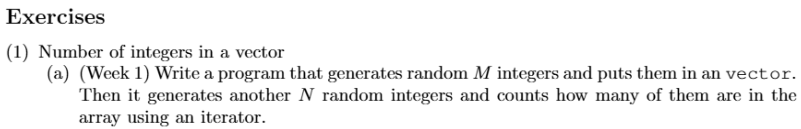
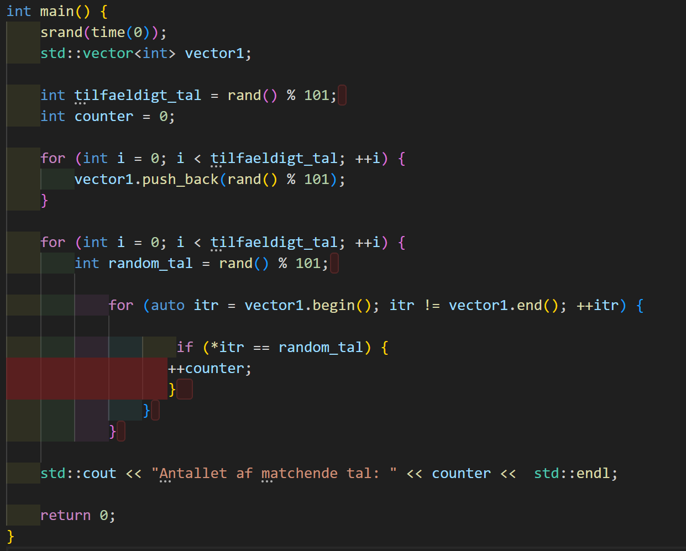
We are going to ignore the very first for-loop since the nested one is more demanding. The next for-loop runs as many times as the number of elements in the vector. For each run in the vector, the nested for-loop containing the iterator runs tilfaeldigt_tal times. For this reason the the Big-Oh notation is $O(N^{2})$. The more elements in the vectors there is, the amount of operations the program will need, will rise with tilfaeldigt_tal * elements in the vectors. In Big-Oh notation it will be: $N * N$ = $O(N^{2})$
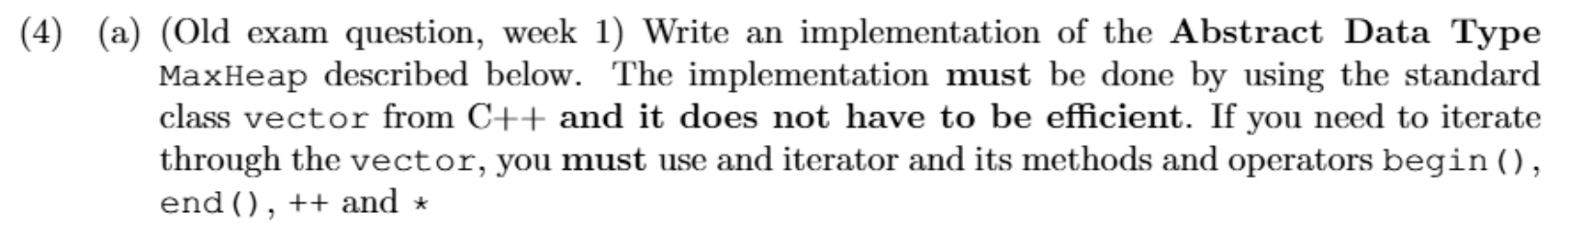
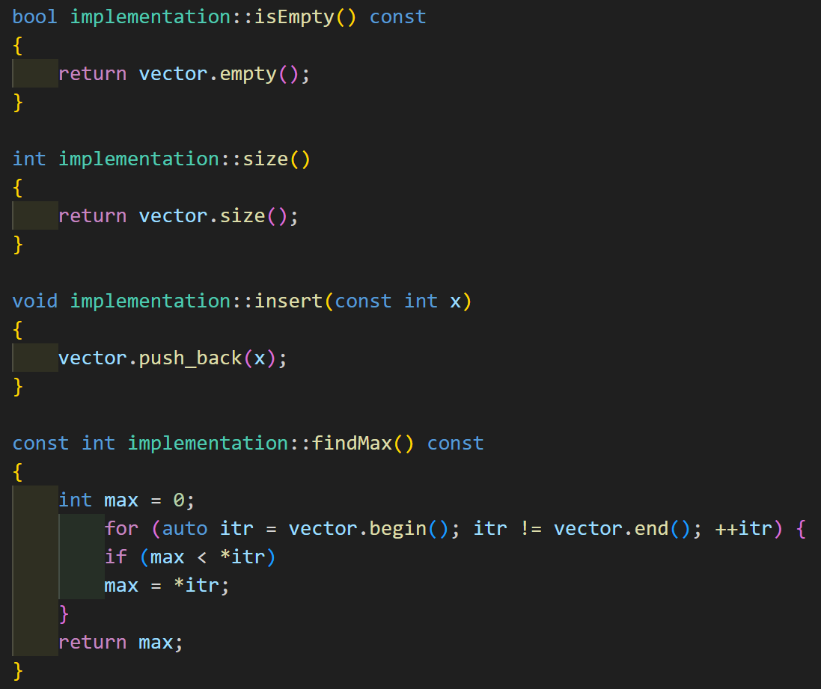
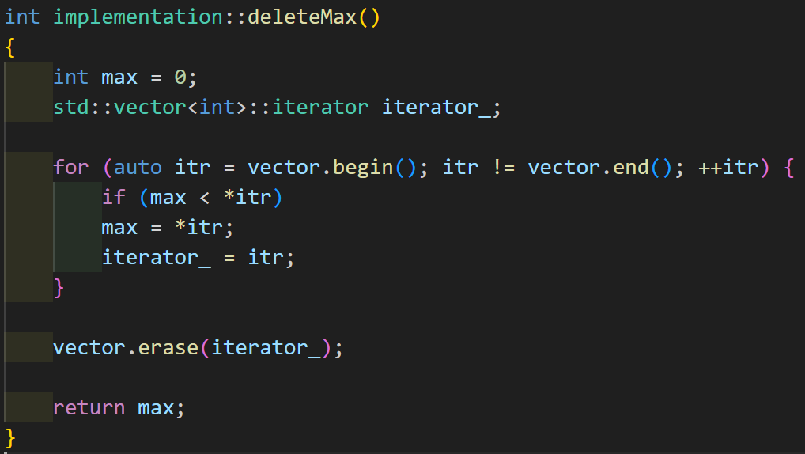

The time complextity for each method is as follow:
isEmpty(); | Constant.
Size(); | Constant.
Insert(); | Constant.
findMax(); | Linear.
deleteMax(); | Linear.

Week_2
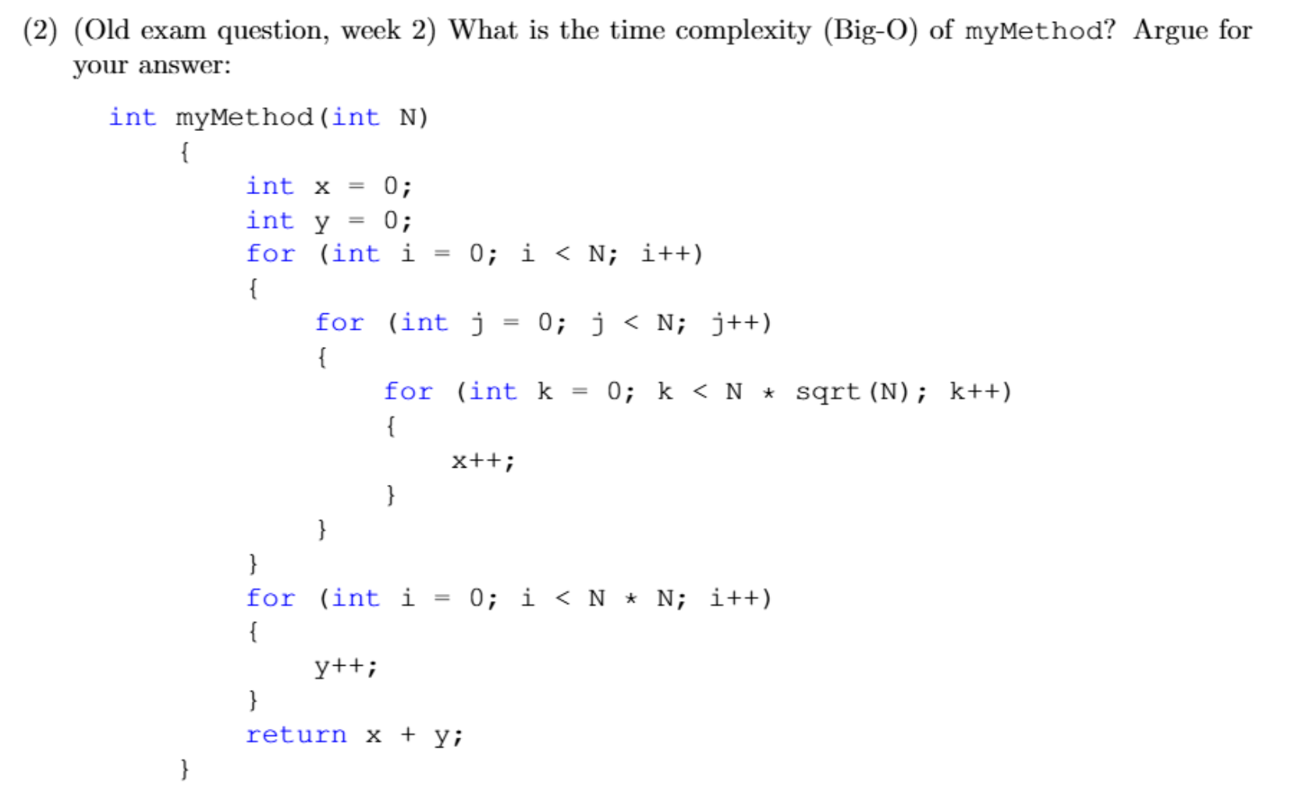
myMethod will be:
$$N·N·\left(N·sqrt\left(N\right)\right).$$
$$sqrt\left(N\right)=N^{0.5}$$
$$N·N^{0.5}=N^{1.5}$$
$$N·N=N^{2}$$
$N^{2}·N^{1.5}=N^{3.5}$.
Der er altså tale om kubisk tid. Den sidste for-løkke er underordnet for Big-Oh notationen, da det første led er større.

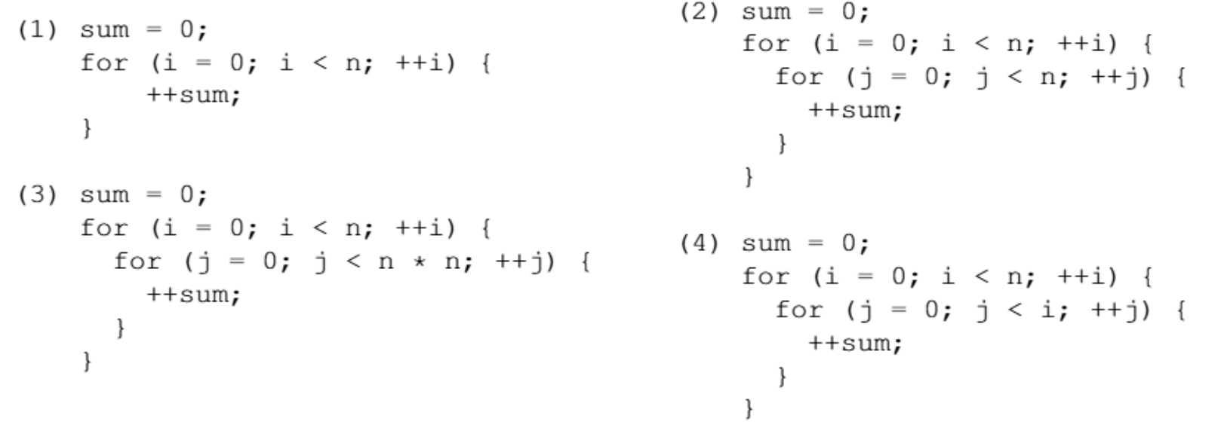
 | Description.
Code #1 | $$O(N)$$  The loop will run n times.
Code #2 | $$O(N^{2})$$  The loop will be run $n * n$ times. For each run of the first loop, the second loop will run through the whole of n. The whole shebang will run as many times as n.
Code #3 | $$O\left(N^{3}\right)$$  For first loop will run n times. For every n time the nested for-loop will run $n*n$ times. $O(n*n*n)=O(N^{3})$
Code #4 | $$O\left(N^{2}\right)$$  The first time the loop will run, it will skip the nested for-loop. The second time, j will be reset and the for-loop will run. So the Big-Oh will be $n*i = O(N^{2})$. Since the first time the nested wont run it will be n-1. Since we ignore constants we’re back to $O(N^{2})$.

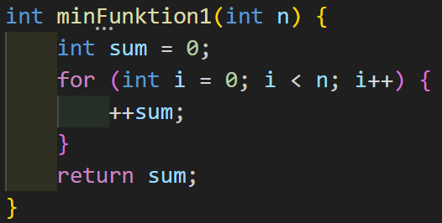
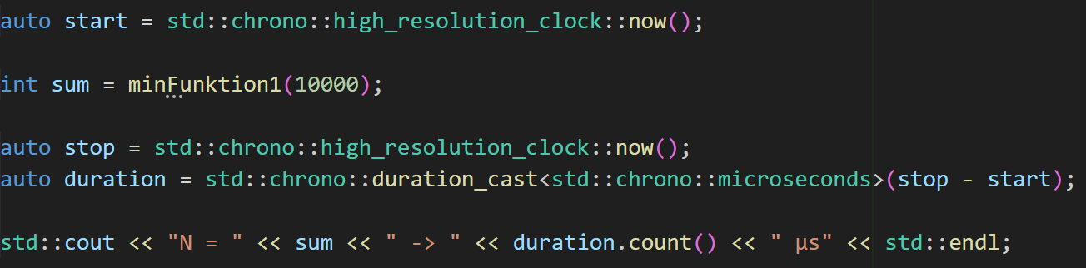
Number of operations = 1000000000 -> 333028 μs
Number of operations = 2000000000 -> 659592 μs
$$\frac{659592}{333028}=\frac{164898}{83257}≈1,98059$$
When the number of operations is doubled, the time the programs takes to run it is multiplied by two. It fits the analysis as well since $O\left(N\right)=linear time$.

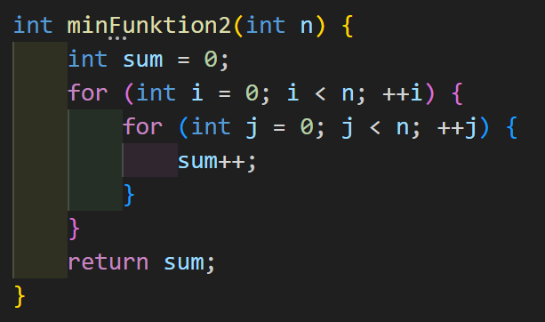
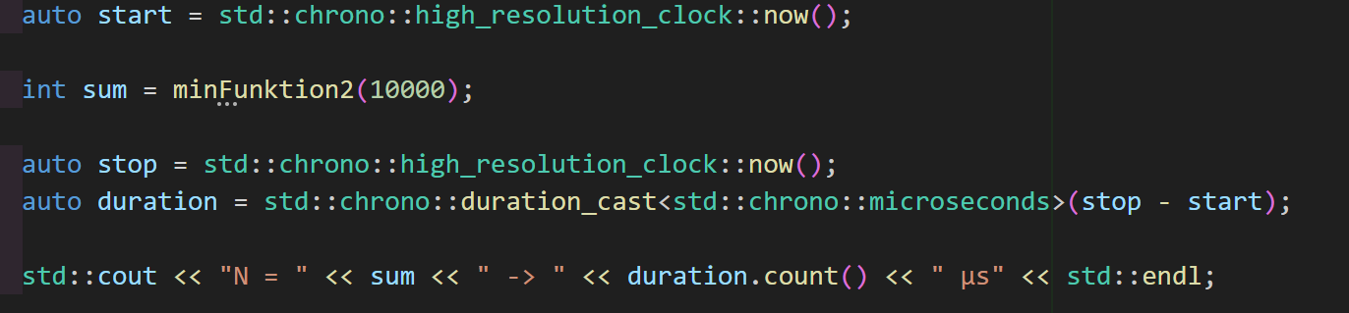
n = 10000
Number of operations = 100000000 -> 29453 μs
n = 20000
Number of operations = 400000000 -> 121746 μs
$$\frac{121746}{29453}≈4,133569$$
Everytime n is double, the number of operations will be quadrupled. The fits the analysis as well since we argumented for it being $O(N^{2})$, quadratic time.

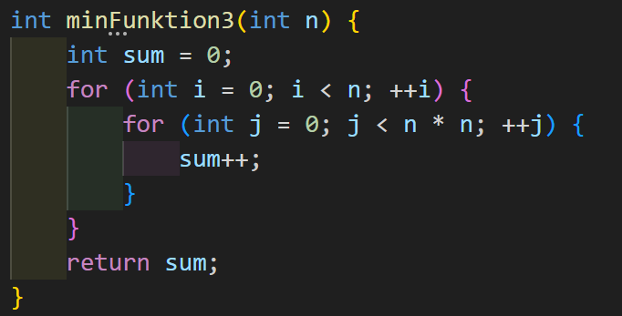
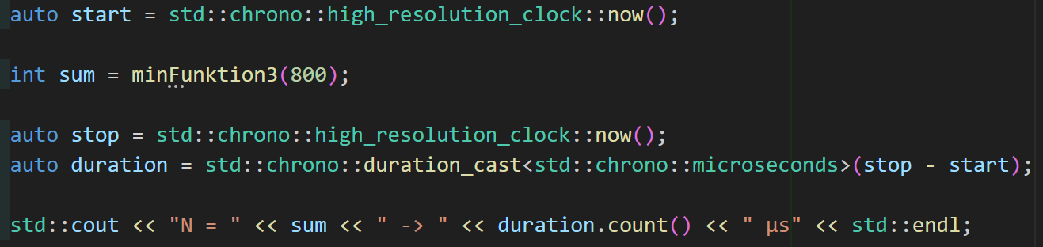
n = 400
Number of operations = 64000000 -> 22900 μs
n = 800
Number of operations = 512000000 -> 189973 μs
$$\frac{189973 }{22900 }=\frac{189973}{22900}≈8,295764$$
Whenever n is doubled, the number of operations are ~8 doubled. This fits the analysis as well given we concluded it was cubic time, $O(N^{3})$.

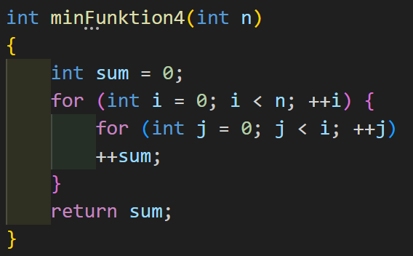
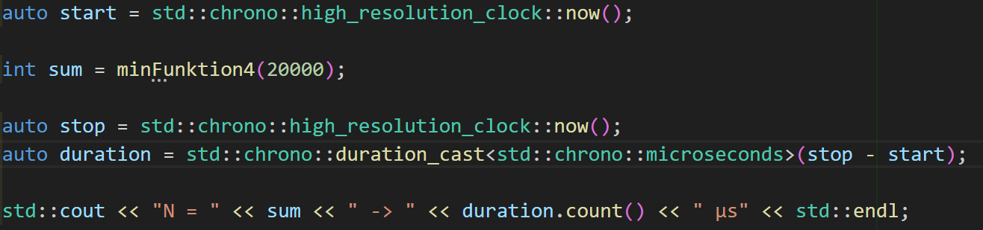
n = 20000
Number of operations = 199990000 -> 64008 μs
n = 40000
Number of operations = 799980000 -> 251080 μs
$$\frac{251080 }{64008 }=\frac{31385}{8001}≈3,922635$$
Whenever n is doubled, the number of operations are quadrupled which again fits the analysis that concluded $O\left(N^{2}\right)$.

