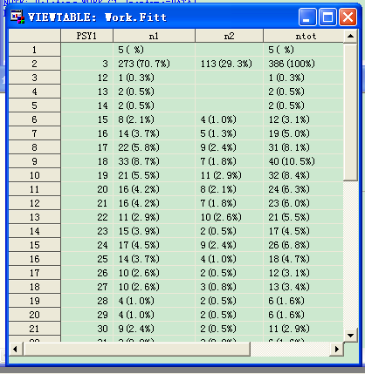
Figure 1:the result of %freq
freq.elong(by table)

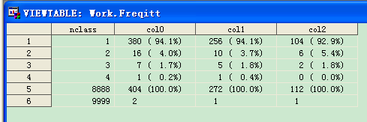
Figure 2:the result of %freq.elong
freq.elong(by column)

