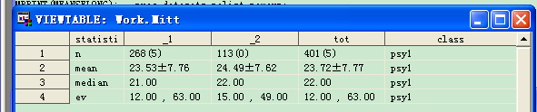
Figure 1: The result of %meansElong

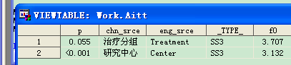
Figure2: The result of %AnovaElong

