DEDAN KIMATHI UNIVERSITY OF TECHNOLOGY
SCHOOL OF COMPUTER SCIENCE AND INFORMATION TECHNOLOGY
DEPARTMENT OF INFORMATION TECHNOLOGY

MACHINE LEARNING-BASED DECISION SUPPORT SYSTEM FOR PREDICTING OPTIMAL HAZARDOUS WASTE INCINERATION PARAMETERS FOR ENVIRONMENTAL MONITORING: A CASE STUDY OF THE NATIONAL ENVIRONMENT MANAGEMENT AUTHORITY (NEMA), KENYA

Name: Alexander Muluko Musyoki

Institution: DEDAN KIMATHI UNIVERSITY OF TECHNOLOGY

Course: BBIT
Reg No: C027-01-2188/2023

Date: 8th July 2026

ABSTRACT
Hazardous waste incineration plays a critical role in reducing hazardous waste volume and minimizing environmental pollution. However, the incineration process generates large volumes of operational data that are often underutilized in supporting environmental monitoring and decision-making. Manual analysis of this data can be time-consuming and may limit the ability of environmental officers to identify optimal operating conditions and potential environmental risks.
This study proposes the development of a Machine Learning-Based Decision Support System for Predicting Optimal Hazardous Waste Incineration Parameters for Environmental Monitoring, using the National Environment Management Authority (NEMA) as a case study. The system will analyze historical hazardous waste incineration data, preprocess the data, and apply machine learning techniques to predict optimal operating parameters that support environmental monitoring and regulatory decision-making.
The proposed system will provide a simple user interface through which environmental officers can upload historical operational data, view prediction results, analyze process trends, and generate reports. The study is expected to demonstrate how machine learning can enhance data-driven decision-making, improve the utilization of historical operational data, and support effective environmental monitoring in hazardous waste management.
Keywords: Machine Learning, Decision Support System, Hazardous Waste Incineration, Environmental Monitoring, Predictive Analytics, NEMA.

CHAPTER ONE: Introduction
1.0 Introduction
Environmental protection has become a global priority due to the increasing generation of hazardous waste from industries, hospitals, and manufacturing plants. Improper disposal of hazardous waste can lead to environmental pollution and pose serious risks to human health. One of the most effective methods of treating hazardous waste is incineration, which destroys harmful substances and significantly reduces waste volume.
The efficiency of the incineration process depends on several operating parameters such as furnace temperature, oxygen concentration, fuel consumption, airflow, and emission levels. These parameters must be maintained within appropriate ranges to ensure efficient combustion and compliance with environmental regulations. However, analyzing large amounts of operational data to determine suitable operating conditions can be difficult when done manually.
Machine learning offers an effective way of analyzing historical operational data and identifying patterns that support decision-making. By learning from previous operational records, machine learning models can generate predictions that help users make informed decisions.
This study proposes the development of a Machine Learning-Based Decision Support System for Predicting Optimal Hazardous Waste Incineration Parameters for environmental monitoring. The system is intended to support environmental officers at the National Environment Management Authority (NEMA) by analyzing historical incineration data, predicting optimal operating parameters, and presenting prediction results through a simple user interface to support environmental monitoring and regulatory decision-making.

1.1 Background of the Study
Hazardous waste is generated by many sectors including healthcare, chemical industries, manufacturing industries, and research laboratories. If not properly treated, hazardous waste can contaminate air, water, and soil, leading to environmental degradation and health hazards. Incineration has become one of the preferred treatment methods because it destroys hazardous materials and reduces waste volume before disposal.
Environmental agencies such as the National Environment Management Authority (NEMA) are responsible for ensuring that industries comply with environmental regulations. During inspections and monitoring activities, large volumes of operational and emission data are generated from hazardous waste incineration facilities. Although this data contains valuable information, it is often analyzed manually, making it difficult to quickly identify trends or predict future operating conditions.
Recent developments in machine learning provide an opportunity to improve environmental monitoring by analyzing historical operational data and generating predictive insights. A machine learning-based decision support system can assist environmental officers in interpreting operational data, monitoring process performance, and supporting evidence-based environmental decisions.
1.2 Problem Statement
Hazardous waste incineration facilities generate large amounts of operational and emission data. However, environmental officers often rely on manual analysis of this data during monitoring and inspection activities. Manual analysis can be time-consuming and may make it difficult to identify patterns that support informed decision-making.
As a result, opportunities to use historical operational data for predicting suitable operating conditions are often missed. This limits the ability to make timely, data-driven environmental decisions. Therefore, there is a need for a machine learning-based decision support system that can analyze historical hazardous waste incineration data and generate predictive insights to support environmental monitoring by NEMA.
1.3 Main Objective
To develop a machine learning-based decision support system for predicting optimal hazardous waste incineration parameters to support environmental monitoring by NEMA.

1.4 Specific Objectives
- To collect and preprocess historical hazardous waste incineration operational data.
- To develop a machine learning model for predicting hazardous waste incineration operating parameters.
- To develop a simple decision support system that enables environmental officers to visualize data and generate prediction results.
- To evaluate the performance of the developed machine learning model.

1.5 Research Questions
- How can historical hazardous waste incineration data be prepared for machine learning analysis?
- How accurately can machine learning predict hazardous waste incineration operating parameters?
- How can a decision support system assist environmental officers in interpreting prediction results?
- How effective is the developed system in supporting environmental monitoring?

1.6 Justification of the Study
Environmental monitoring requires timely and accurate analysis of operational data to ensure compliance with environmental standards. This study demonstrates how machine learning can be applied to support environmental monitoring by transforming historical operational data into useful predictive information.
The proposed system will assist environmental officers in making informed decisions based on data rather than relying solely on manual analysis. It also demonstrates the practical application of machine learning in environmental management while contributing to improved utilization of operational data.

1.7 Scope of the Study
This study focuses on the development of a machine learning-based decision support system for predicting hazardous waste incineration operating parameters using historical operational data. The system will allow environmental officers to upload data, generate predictions, visualize results, and view basic analytical reports through a simple user interface.
The study will not include real-time monitoring, automatic process control, sensor integration, or direct control of incineration equipment. The system will only provide predictive insights to support environmental monitoring and decision-making.

1.8 Limitations of the Study
The study will rely on historical operational data, and the quality of predictions will depend on the quality and completeness of the available dataset. The system will not perform real-time monitoring or automatically control incineration equipment. In addition, the developed model will be evaluated using the available dataset and may require additional data for wider application in different hazardous waste treatment facilities.

CHAPTER TWO: LITERATURE REVIEW
2.0 Introduction
This chapter reviews literature related to hazardous waste management, hazardous waste incineration, decision support systems, and machine learning in environmental monitoring. It also examines existing systems, identifies the research gap, and presents the conceptual framework that guides the proposed study.
2.1 Hazardous Waste Management
Hazardous waste refers to waste materials that pose a risk to human health or the environment due to their chemical, biological, or physical properties (Hassan & Saleh, 2022). Common sources of hazardous waste include hospitals, manufacturing industries, chemical industries, laboratories, and mining activities. If not properly managed, hazardous waste can contaminate air, water, and soil, leading to serious environmental and health problems.
Hazardous waste management involves the collection, transportation, treatment, recycling, and disposal of hazardous materials in accordance with environmental regulations. Environmental agencies such as the National Environment Management Authority (NEMA) are responsible for ensuring that industries comply with these regulations to protect the environment and public health.
2.2 Hazardous Waste Incineration
Incineration is one of the most widely used methods for treating hazardous waste. The process involves burning hazardous materials at high temperatures to destroy toxic substances and reduce the volume of waste before final disposal.
The efficiency of the incineration process depends on maintaining appropriate operating conditions such as furnace temperature, oxygen concentration, fuel consumption, airflow, and emission levels. Poor operating conditions may lead to incomplete combustion, increased emissions, and reduced process efficiency. Therefore, continuous monitoring and proper analysis of operational data are important in achieving efficient and environmentally safe incineration (Hassan & Saleh, 2022; Tang et al., 2024).

2.3 Decision Support Systems
A Decision Support System (DSS) is a computer-based information system that helps users make informed decisions by analyzing data and presenting meaningful information. Decision support systems are widely applied in healthcare, business, agriculture, manufacturing, and environmental management.
A DSS does not replace human decision-making but provides useful information that enables users to evaluate different situations and make better decisions. In environmental management, decision support systems assist environmental officers by organizing large amounts of data, generating reports, and providing analytical insights that support regulatory activities.

2.4 Machine Learning in Environmental Monitoring
Machine learning is a branch of artificial intelligence that enables computers to learn patterns from historical data and make predictions. Instead of relying on predefined rules, machine learning algorithms identify relationships within data and use these relationships to predict future outcomes.
In environmental monitoring, machine learning has been applied in air quality prediction, pollution monitoring, waste management, climate analysis, and environmental risk assessment. By analyzing historical operational and environmental data, machine learning models can provide predictive insights that support environmental monitoring and decision-making (Alotaibi & Nassif, 2024).
In this study, machine learning will be used to analyze historical hazardous waste incineration data and predict operating parameters that can support environmental officers during monitoring and inspection activities.

2.5 Existing Systems
Several environmental monitoring systems have been developed to collect, store, and visualize environmental data. Most existing systems focus on monitoring emissions, recording operational data, and generating reports for regulatory compliance.
However, many of these systems mainly provide historical information and require users to manually analyze the collected data. They often lack predictive capabilities that can assist environmental officers in making proactive decisions based on historical operational trends.
The proposed system addresses this limitation by integrating machine learning into the decision-making process. Instead of only displaying historical data, the system will generate predictions that support environmental monitoring and improve data-driven decision-making (Hassan & Saleh, 2022).

2.6 Research Gap
Previous studies have demonstrated the importance of hazardous waste management and the application of decision support systems in environmental monitoring. Machine learning has also shown great potential in analyzing complex environmental datasets.
Despite these developments, there is limited application of machine learning-based decision support systems specifically for supporting environmental officers in monitoring hazardous waste incineration processes. Most existing approaches emphasize data collection and reporting rather than predictive decision support.
This study seeks to bridge this gap by developing a machine learning-based decision support system that analyzes historical hazardous waste incineration data and provides predictive insights to support environmental monitoring by NEMA (González et al., 2025).

2.7 Conceptual Framework
The proposed system uses historical hazardous waste incineration data as the input. The data is cleaned and preprocessed before being analyzed by a machine learning model. The model generates predictions that are displayed through a simple user interface. Environmental officers use these predictions to support environmental monitoring and decision-making.
Conceptual Framework
Input
- Historical hazardous waste incineration data
- Operational parameters
- Emission measurements
Process
- Data preprocessing
- Machine learning model training
- Prediction generation
Output
- Predicted operating parameters
- Prediction reports
- Data visualizations
Outcome
- Improved environmental monitoring
- Better data-driven decision-making
- Enhanced regulatory compliance

CHAPTER THREE: METHODOLOGY
3.0 Introduction
This chapter describes the methodology that will be used to develop the proposed Machine Learning-Based Decision Support System for Predicting Optimal Hazardous Waste Incineration Parameters. It explains the research design, system requirements, system design, data collection process, data preprocessing techniques, machine learning approach, system architecture, and evaluation methods. The methodology provides a structured approach to ensure that the developed system effectively supports environmental officers at the National Environment Management Authority (NEMA) in environmental monitoring and decision-making.

3.1 Research Design
This study will adopt an experimental research design. Historical hazardous waste incineration data will be collected, cleaned, and analyzed using machine learning techniques to identify relationships between operational variables and the expected outputs. The trained machine learning model will then be integrated into a Django-based decision support system that enables environmental officers to upload data, generate predictions, visualize results, and produce monitoring reports.
The experimental design is suitable because it allows the performance of different machine learning models to be tested and evaluated before selecting the most appropriate model for the system.

3.2 System Analysis
The proposed system is intended to support environmental officers at the National Environment Management Authority (NEMA) during environmental monitoring activities. Currently, environmental officers mainly rely on manual analysis of historical operational and emission data when assessing hazardous waste incineration processes. This approach can be time-consuming and may not fully utilize the available data for informed decision-making.
The proposed system will automate the analysis process by applying machine learning techniques to historical operational data. It will provide a platform where users can upload datasets, generate prediction results, visualize operational trends, and generate reports that support environmental monitoring and regulatory decision-making.
3.3 Functional Requirements
The proposed system shall be able to:
- Allow authorized users to securely log into the system.
- Upload hazardous waste incineration datasets in supported formats such as CSV or Excel.
- Store uploaded datasets for analysis.
- Preprocess uploaded data before prediction.
- Generate predictions using the trained machine learning model.
- Display prediction results through charts and tables.
- Generate and download environmental monitoring reports.
- View previous prediction records and reports.
- Allow the administrator to manage users and update the machine learning model.

3.4 Non-Functional Requirements
The proposed system should satisfy the following non-functional requirements:
- Provide an easy-to-use and user-friendly interface.
- Produce prediction results within a reasonable response time.
- Ensure secure user authentication and authorization.
- Maintain data confidentiality and integrity.
- Be reliable and available whenever required by authorized users.
- Support future improvements and machine learning model updates.
- Be compatible with modern web browsers.

3.5 System Design
The proposed system will be developed using the Django framework integrated with a machine learning model developed in Python. The system will consist of the following modules:
- User Authentication Module
- Data Upload Module
- Data Preprocessing Module
- Machine Learning Prediction Module
- Results Visualization Module
- Report Generation Module
These modules will work together to support environmental officers during environmental monitoring activities. After a user uploads historical operational data, the system will preprocess the data, generate predictions using the trained model, and present the results through charts, tables, and downloadable reports.

3.6 Proposed System Architecture
The proposed system architecture consists of several components that work together to process data and generate prediction results.
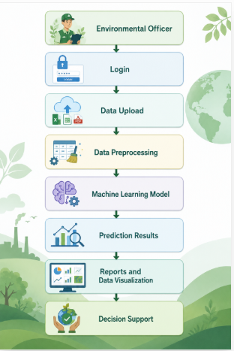
Figure 3.1: system architecture
The architecture allows environmental officers to interact with the system through a simple web interface while the machine learning model performs the prediction tasks in the background.
3.7 Use Case Diagram
Actors
- Environmental Officer
- System Administrator
Environmental Officer Use Cases
- Login
- Upload Dataset
- View Uploaded Data
- Generate Prediction
- View Prediction Results
- View Charts and Graphs
- Generate Reports
- Download Reports
- Logout
System Administrator Use Cases
- Login
- Manage Users
- Manage Datasets
- Update Machine Learning Model
- View System Reports
- Logout
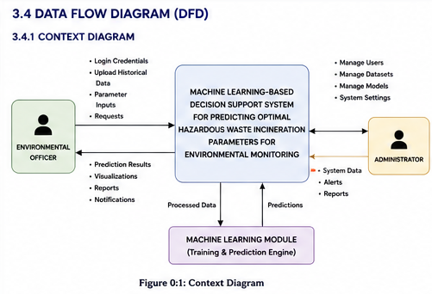
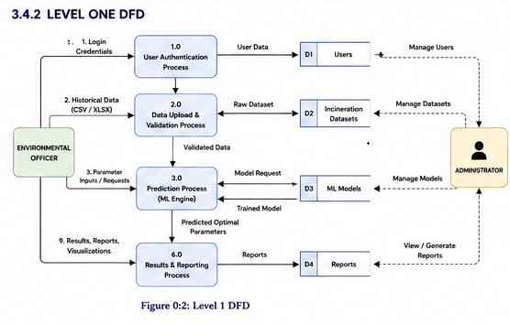
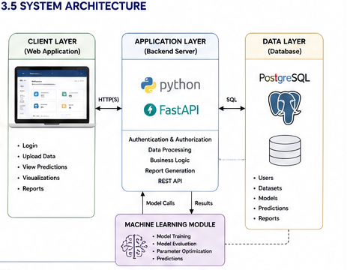
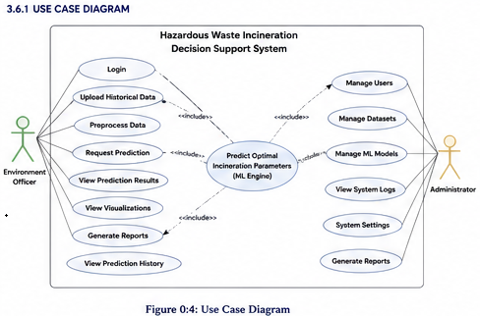
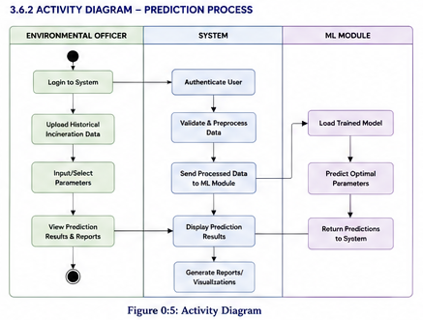
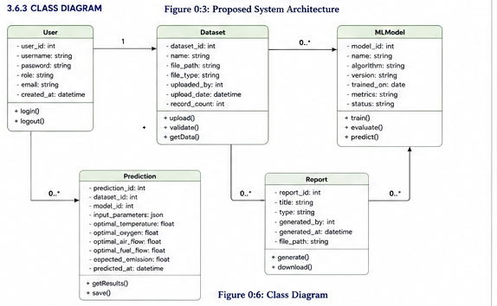
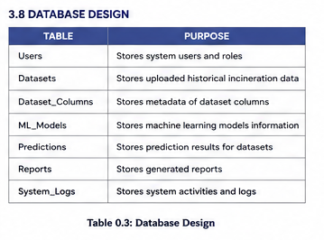
Figure 3.7: Entity Relationship Diagram (ERD)
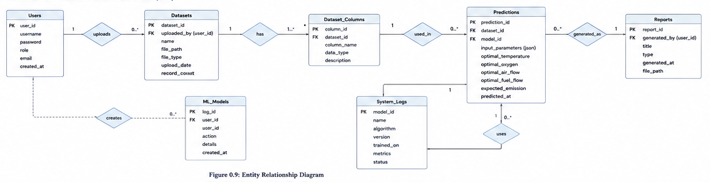
3.8 System Flowchart
The system will follow the following sequence of operations:
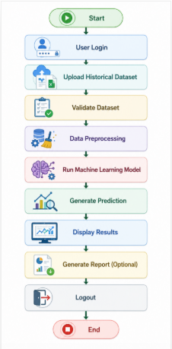
Figure 3.2: System Flowchart

3.9 Data Collection
The study will use historical hazardous waste incineration operational data obtained from existing records. The dataset contains operational process variables such as furnace temperature, oxygen concentration, airflow, fuel consumption, and emission measurements. These variables will be used to train and evaluate the machine learning model.
The collected data will be stored and organized before undergoing preprocessing to ensure consistency and improve model performance.

3.10 Data Preprocessing
Before training the machine learning model, the collected data will undergo preprocessing to improve its quality and suitability for analysis. Data preprocessing is important because machine learning models perform better when trained using clean and consistent data.
The preprocessing activities will include:
- Data cleaning
- Handling missing values
- Removing duplicate records
- Feature selection
- Data normalization where necessary
- Splitting the dataset into training and testing datasets
These steps will help improve the accuracy and reliability of the prediction model.

3.11 Machine Learning Model
The proposed system will use a supervised machine learning algorithm to learn patterns from historical hazardous waste incineration data. The model will be trained using the prepared dataset and later tested using unseen data to evaluate its prediction performance.
After successful training, the selected model will be integrated into the Django-based decision support system. Environmental officers will be able to upload operational data and receive prediction results through the web interface. The generated predictions will assist users in monitoring hazardous waste incineration processes and supporting environmental decision-making.

3.12 Model Evaluation
The developed machine learning model will be evaluated to determine its prediction accuracy and overall performance. The evaluation will be carried out using the testing dataset after the model has been trained.
The evaluation results will be used to assess whether the model is suitable for supporting environmental monitoring and decision-making. If necessary, different machine learning algorithms may be compared before selecting the model with the best performance.

3.13 Tools and Technologies
The project will utilize the following tools and technologies:
Tool/Technology | Purpose
Python | Machine learning model development and backend programming
Django | Development of the decision support system and web interface
Pandas | Data manipulation and preprocessing
NumPy | Numerical computations
Scikit-learn | Machine learning model development
Matplotlib | Data visualization
Plotly | Interactive charts and graphs
SQLite | Database management during development
Visual Studio Code | Code development
GitHub | Version control
Microsoft Excel | Dataset preparation and analysis

CHAPTER FOUR: PROJECT WORK PLAN
4.0 Work Plan
The project is expected to be completed within a period of eighteen (18) weeks. The activities to be carried out during the project are shown in Table 4.1.
Table 4.1: Project Work Plan (Gantt Chart)
Activity | W1-2 | W3-4 | W5-6 | W7-8 | W9-10 | W11-12 | W13-14 | W15-16 | W17-18
Proposal Writing | ✓ | ✓
Literature Review |  | ✓ | ✓
Requirements Analysis |  |  | ✓
Data Collection |  |  | ✓ | ✓
Data Preprocessing |  |  |  | ✓ | ✓
Machine Learning Model Development |  |  |  |  | ✓ | ✓
System Development (Django) |  |  |  |  |  | ✓ | ✓
System Testing and Evaluation |  |  |  |  |  |  | ✓ | ✓
Documentation |  |  |  |  |  |  |  | ✓ | ✓
Final Submission and Presentation |  |  |  |  |  |  |  |  | ✓

The activities may overlap depending on project progress and the availability of data.

CHAPTER FIVE
PROJECT BUDGET
5.0 Budget
The estimated budget for the development of the proposed system is presented in Table 5.1.
Table 5.1: Estimated Project Budget
Item | Estimated Cost (KES)
Internet and Data Bundles | 2,000
Printing and Photocopying | 2,000
Transport | 2,000
Stationery | 1,000
Contingency | 1,000
Total | 8,000

The estimated budget will cater for internet access, printing, transport, stationery, and other miscellaneous expenses required during the development and documentation of the project.

CONCLUSION
This proposal presents the development of a Machine Learning-Based Decision Support System for Predicting Optimal Hazardous Waste Incineration Parameters to support environmental monitoring by the National Environment Management Authority (NEMA). The proposed system aims to utilize historical hazardous waste incineration data and machine learning techniques to generate predictive insights that support environmental officers in making informed decisions during monitoring and regulatory activities.
The system is expected to provide a simple and user-friendly platform for uploading historical data, generating predictions, visualizing operational trends, and producing monitoring reports. By transforming historical operational data into useful information, the proposed system will promote data-driven environmental monitoring and improve the efficiency of decision-making.
The successful implementation of this project will demonstrate the practical application of machine learning in environmental management and provide a foundation for future enhancements, such as incorporating additional datasets, advanced prediction models, and real-time monitoring capabilities.

References
Alotaibi, E., & Nassif, N. (2024). Artificial intelligence in environmental monitoring: In-depth analysis. Discover Artificial Intelligence, 4(1). https://doi.org/10.1007/s44163-024-00198-1
González, S. G., García, D. C., Rubén Herrero Pérez, Sanchez, A. Á., & González, G. V. (2025). Autonomous Waste Classification Using Multi-Agent Systems and Blockchain: A Low-Cost Intelligent Approach. Sensors, 25(14), 4364–4364. https://doi.org/10.3390/s25144364
Hassan, A. I., & Saleh, H. M. (2022, January 1). Chapter 7 - Toxicity and hazardous waste regulations (D. Yadav, P. Kumar, P. Singh, & D. A. Vallero, Eds.). ScienceDirect; Elsevier. https://www.sciencedirect.com/science/article/pii/B9780128243442000124
Miller, T., Durlik, I., Kostecka, E., Kozlovska, P., Łobodzińska, A., Sokołowska, S., & Nowy, A. (2025). Integrating Artificial Intelligence Agents with the Internet of Things for Enhanced Environmental Monitoring: Applications in Water Quality and Climate Data. Electronics, 14(4), 696–696. https://doi.org/10.3390/electronics14040696
Tang, J., Wang, T., Xia, H., & Cui, C. (2024). An Overview of Artificial Intelligence Application for Optimal Control of Municipal Solid Waste Incineration Process. Sustainability, 16(5), 2042. https://doi.org/10.3390/su16052042

