ADFC Employee Attendance and Payroll System
Cadavero, Katrina Isabela
Osias, Alexander
Marone, Alvin

Project Overview
The Asian Development Foundation College (ADFC) is currently facing challenges with its employee attendance and payroll processes. The manual system, which relies on logbooks and paper, often leads to errors and takes a long time to process. This makes it difficult to record employee hours accurately, and payroll can end up delayed or incorrect. These issues cause frustration for employees and add unnecessary workload for the HR department. This project aims to address these problems.
The project is to develop the ADFC Employee Attendance and Payroll System. It will be a hybrid setup that uses a localhost-based QR scanner that can work offline, but also syncs data online when internet connection is available. Alongside this, a web-based application hosted on a server will handle employee management and payroll processing. The scanner records attendance even without internet and uploads the data automatically once connected. This paper will describe the problem, the proposed solution, and the plan for building the project.
Problem Summary
The current attendance process at ADFC is fully manual. Employees write their time in and out on a logbook, and the HR team has to compute work hours from these records. This leads to common issues such as unreadable handwriting, incorrect entries, and missing information.
There is also no real-time way to check who is present, late, or absent. Payroll is calculated manually, making the entire process slow and prone to errors. These tasks increase the workload of the HR department and can negatively affect employee morale.
This project solves these issues by introducing a digital system. It includes a localhost QR scanner that works offline and syncs online when possible, a hosted web application for employee and payroll management, and options for exporting or importing data. The system will not include biometric scanners or a mobile app; the focus is to build a reliable QR-based attendance system connected to a hosted payroll system.
IT Solution
The proposed solution is a hybrid web application with both offline and online functionality. Attendance will be recorded through a QR scanner installed on a dedicated computer equipped with a webcam. Employees will scan their unique QR codes to check in or out, and the system will capture a snapshot to verify identity and reduce proxy time-ins. The scanner operates on a localhost server for offline use, ensuring it continues working even without internet. When internet becomes available, all stored records (employee ID, timestamp, and image) will automatically sync to the hosted database.
For employee management and payroll, a separate web application will run on a cloud-hosted server. It will include features such as adding or editing employee information, generating QR codes, managing schedules and rates, and processing payroll based on synced attendance data. Export and import options will be included for backup or manual data handling.
The system will use MySQL for the hosted database, PHP for backend development, and JavaScript/HTML5 for the QR scanner interface. QR codes will be generated based on employee details (first name, last name, job position, and date joined) to maintain security and accuracy. Real-time syncing will be implemented to ensure data

integrity once internet connection is available.

Implementation Plan
This project will be built in successive phases to ensure its smooth and successful operation.
This is where the collection and preparation of all necessary information begins before starting the system's development. This includes creating a complete list of employees.
s
Data Gathering

s
System Design
In this phase, all parts of the system will be designed. The plan for the user interface of the web app will be created, including the database design.

s
System Development
This is the phase of actual programming and building the system. The web application's front-end will be built here.

s
Testing
In this phase, rigorous testing will be conducted to ensure that all functions are free of bugs and that the entire system works correctly.

s
Maintenance
This is the final phase focused on the long-term success of the system. There will be a plan for regular updates and bug fixes.

Group Description
The group operates under the principle of egoless collaboration, where all members contribute equally and are not restricted to a single fixed role. Instead of assigning rigid responsibilities, the team prioritizes teamwork, open communication, and shared ownership of tasks to ensure the successful completion of the project.
The team consists of individuals capable of handling the essential roles required in system development, including Programmer, UI/UX Designer, System Analyst, and Technical Writers. These roles are flexible and interchangeable, allowing members to assist one another whenever necessary. This setup enhances adaptability and promotes collective problem-solving.
The members of the group are:
- Cadavero, Katrina Isabela
- Osias, Alexander
- Marone, Alvin
Together, the group is developing the ADFC Employee Attendance and Payroll System, a project designed to streamline employee monitoring, attendance tracking, and payroll management. Through consistent collaboration and mutual support, the team ensures that the system is functional, user-friendly, and well-documented.

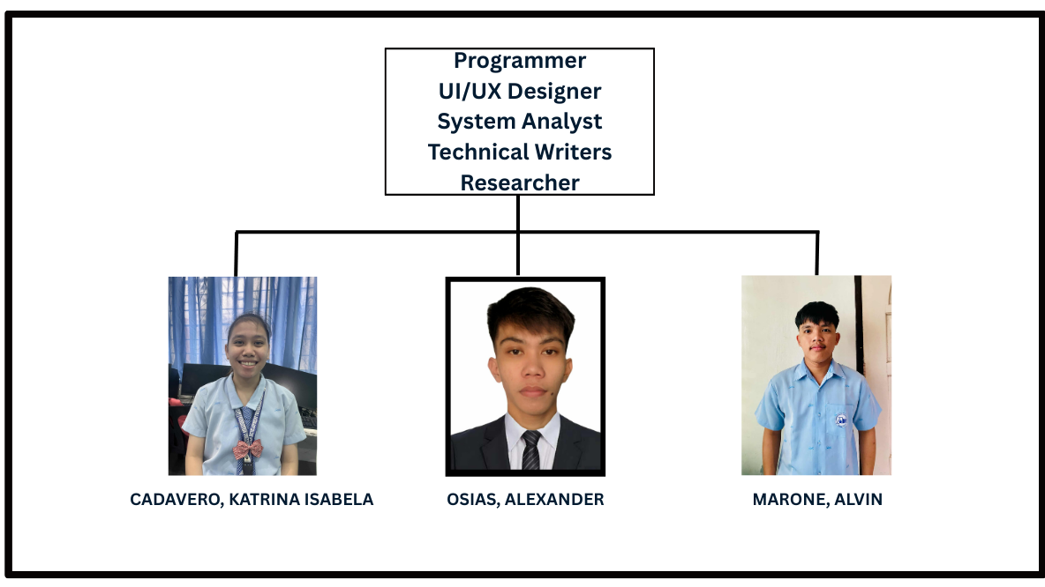

Schedule of Activities

ID | Activities | Date Started | Date Finished | Duration (Week/s) | Predecessor/s
A | Project Initialization | 09/01/25 | 09/02/25 | 0.3 | --
B | Analysis | 09/03/25 | 09/05/25 | 0.4 | A
C | Design Database Schema | 09/06/25 | 09/15/25 | 1.4 | B
D | Design Web App UI/UX | 09/16/25 | 09/29/25 | 2 | B
E | Develop System Architecture | 09/30/25 | 10/05/25 | 0.9 | C, D
F | Develop Back-End Logic | 10/06/25 | 10/26/25 | 3 | E
G | Build Front-End UI and Scanner | 10/06/25 | 10/22/25 | 2.4 | D
H | Integrate System Components | 10/27/25 | 11/09/25 | 2 | F, G
I | Testing and Quality Assurance | 11/10/25 | 11/23/25 | 2 | H
J | Documentation | 11/24/25 | 11/29/25 | 0.9 | I

