Shelby Alexander

CSCI S-12

Harvard Summer School, 2020

Strategy

* Name of Site:

“**CUT TO:**”

* Purpose and Goals of the Site:

The site will be a how-to on crafting a screenplay from idea to scene pages. The main focus of the site will be using sources/lessons from Dr. Susan Steinberg with examples from my current feature film project to give step-by-step instructions. For time purposes, the site will feature the first two steps: from inspiration to idea and from story to treatment/outline.

* Audiences
  1. Primary Audience: Amateur writers curious about the screenwriting process. The basic site/curriculum is designed as a stepping stone into more advanced theory and practice (Robert McKee, Aaron Sorkin, etc.)
  2. Secondary Audience: Experienced writers who are looking to adapt something they’ve written into a screenplay.

Scope

Home Page:

* Include my picture and biography and current project.
* An overview/summary of the site.
  + Key things you will learn

First Page: From Inspiration to Idea-

* I’ll use example from Stephen King: overheard conversation to opening scene of Gotham
* My example from documentary quotation to my film “Oh Oh”
  + The iteration of ideas – from animated movie to live action
    - storyboarding, timelines, name generation, etc.
* Worksheet to help them adapt inspirations into ideas/generate ideas
* Overall Resources: Quote from Stephen King, Video Clip of Gotham, Video Clip of Documentary (for quotation), Pictures of my “Oh Oh” notebook, ideation worksheet

Second Page: From Story to Treatment-

* Explain requirements of standard treatment: title, log line, tag line, dramatic premise, characters, opening scene, act 1, act 2, act 3.
  + Extra things to include to help yourself in the future: single-word summary/topic, timeline, setting description/pictures, research pages/links, related film/works.
* A basic how-to on each requirement and extras
* Overall Resources: My treatment for “Oh Oh,” supporting pictures/figures, treatment how-to document by Dr. Susan Steinberg

Third Page: Quiz/Review-

* This page will focus on showing my JavaScript skills. I’ll use a form to create a “quiz” and make my own calculator to relay the score.
* A basic quiz reviewing on the basic knowledge covered in the website.

Structure

The two main content pages are the two steps I’m focusing on for writing a screenplay (inspiration and treatment). They each stem off into sections. Each section has their basic contents listed underneath them in the picture below (ex. storyboarding, timelines, and name generation for the Resources for Ideation sub-page.)

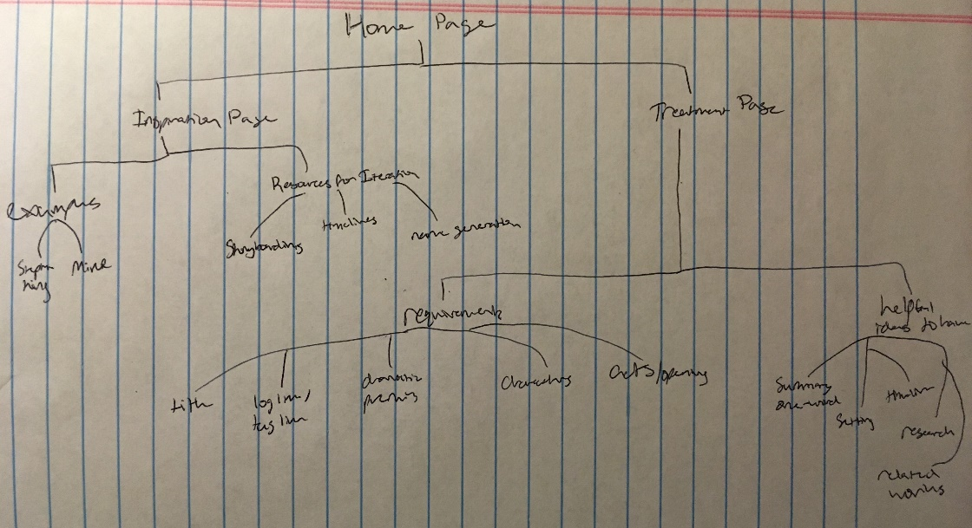The home page and quiz page are stand alone with little content.

**./cut_to**

**|-- images/**

**|-- styles/**

**|-- index.html**

**|-- idea.html**

**|-- treatment.html**

|-- script.html

|-- pitch.html

**|-- quiz.html**

Skeleton

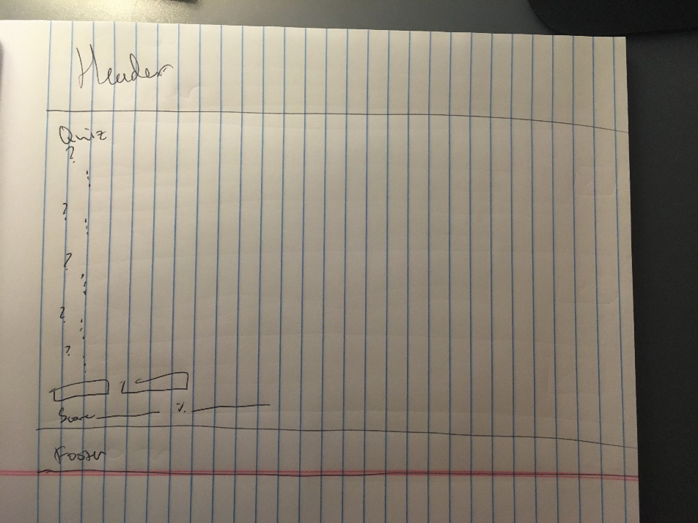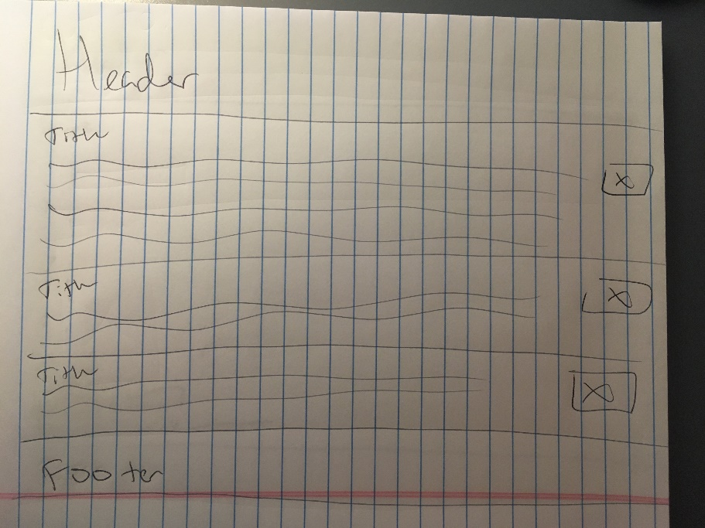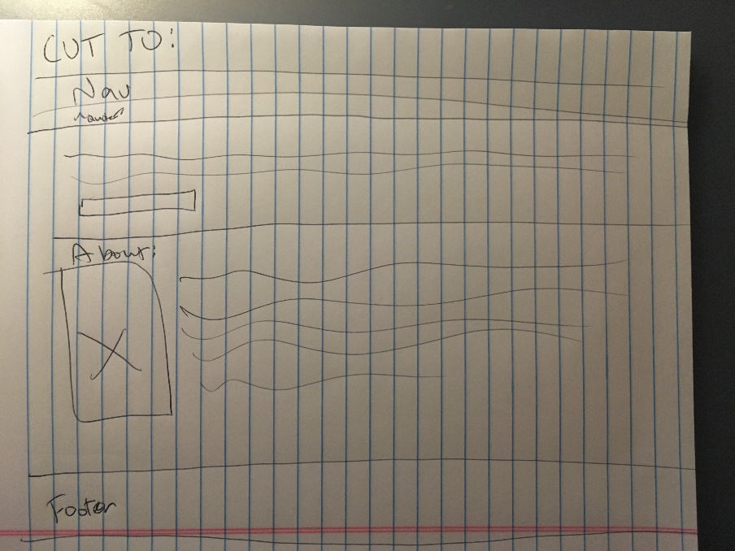The site will have mostly text with a couple of images here and there. Here is the home, idea/treatment, and quiz page.

Surface

<https://cs12students.dce.harvard.edu/~salexand/SNoElAleX_1206/cut_to/index.html>

<https://cs12students.dce.harvard.edu/~salexand/SNoElAleX_1206/cut_to/idea.html>

<https://cs12students.dce.harvard.edu/~salexand/SNoElAleX_1206/cut_to/treatment.html>

<https://cs12students.dce.harvard.edu/~salexand/SNoElAleX_1206/cut_to/quiz.html>

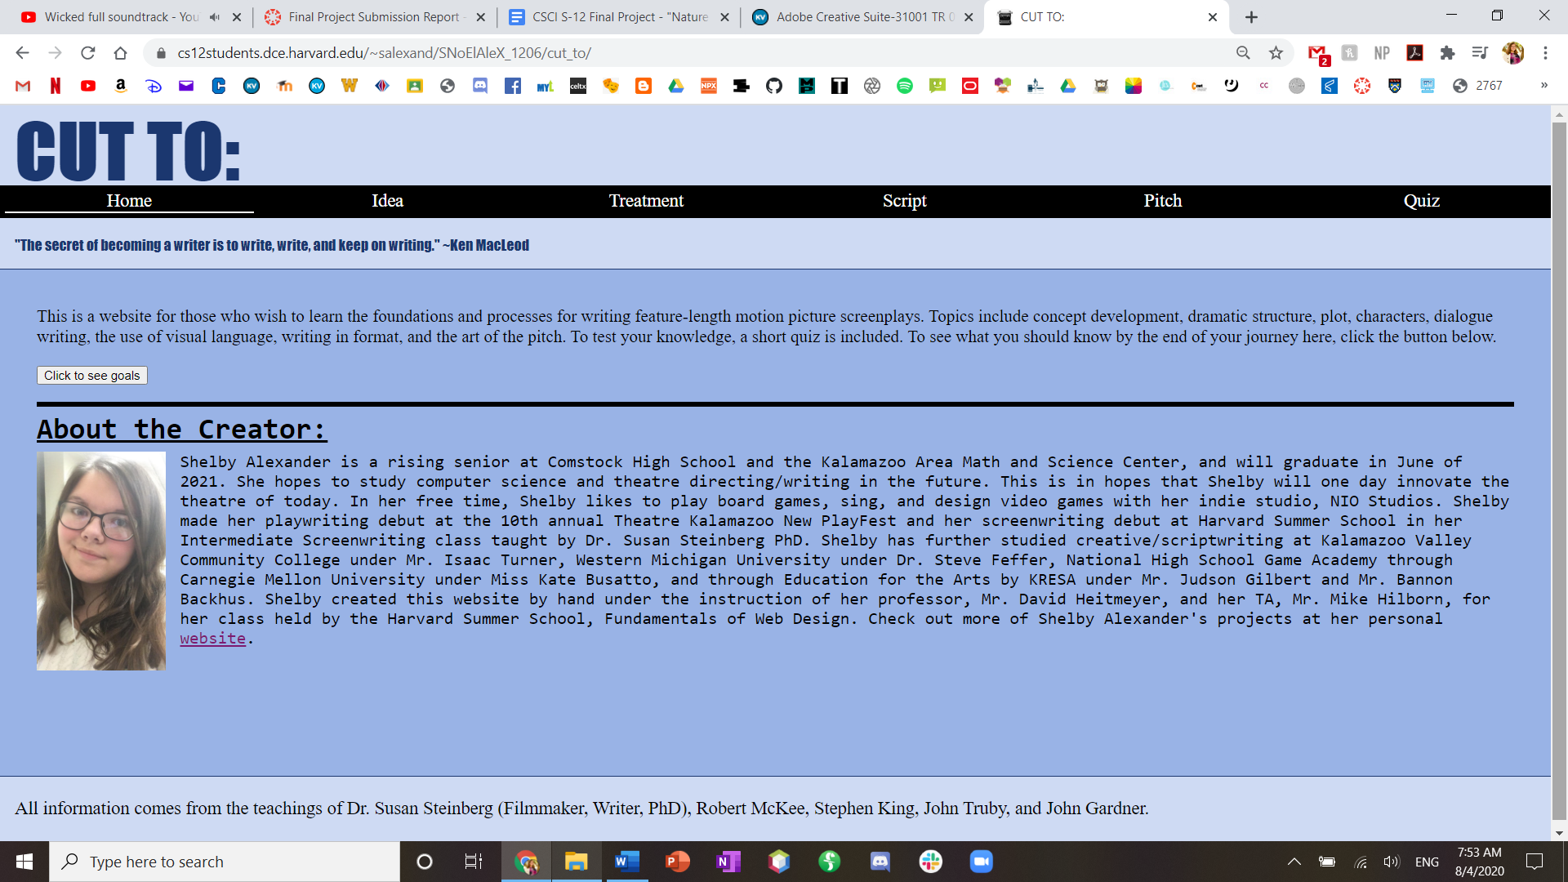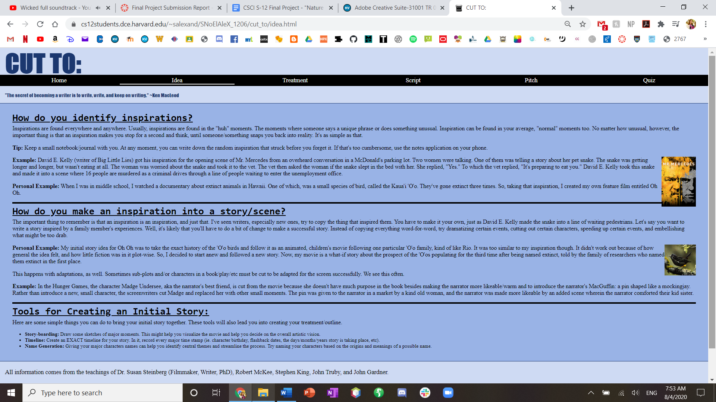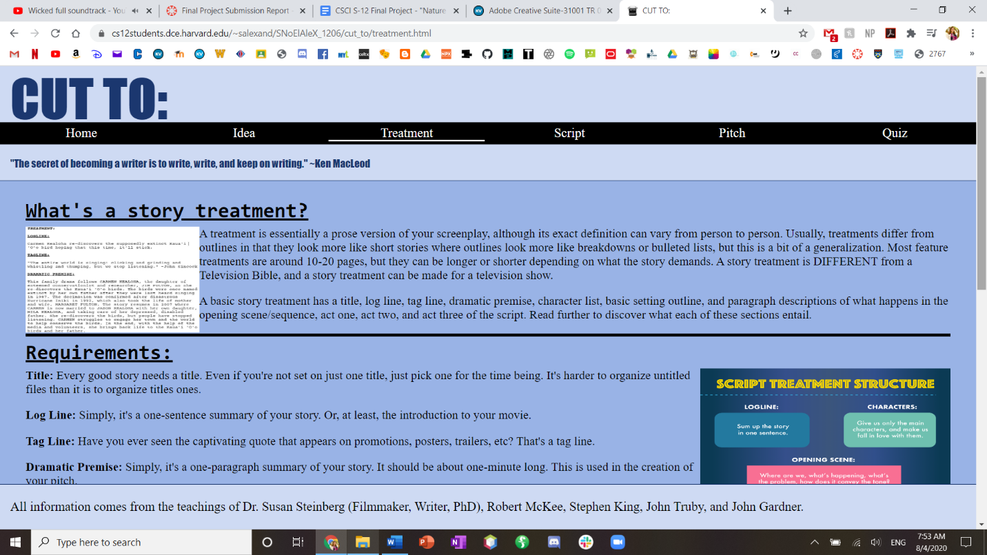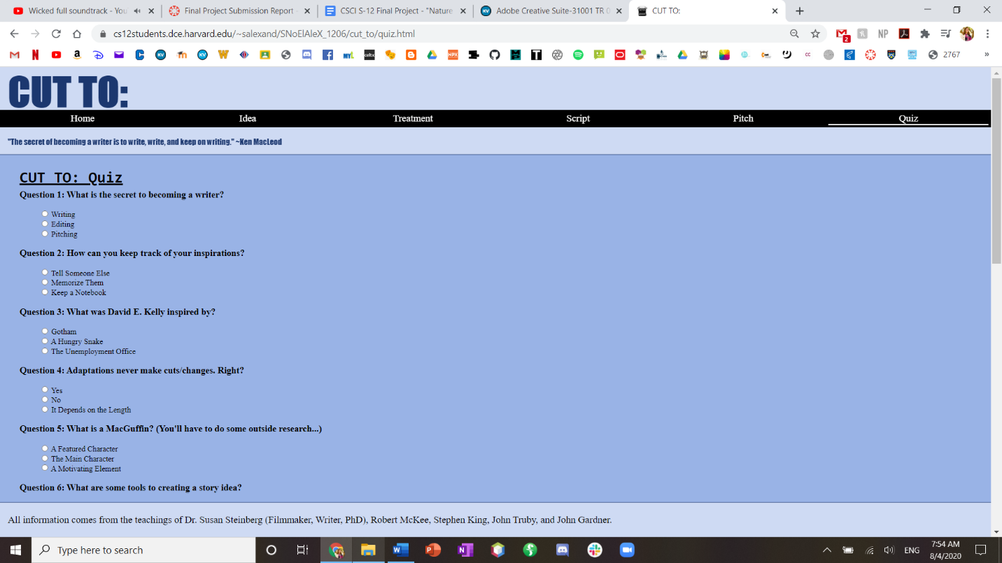

Implementation & Reflection

**I implemented four parts of the site:**

* The Home page, which includes a summary, basic JavaScript appendage function, and an about section.
* The Idea page, which follows the basic page layout, and has full text and two pictures pertaining to the topic of transforming an inspiration into an idea.
* The Treatment page, which follows the basic page layout, and has full text and two pictures pertaining to the topic of transforming an idea into a treatment.
* The Quiz page, which includes a functioning 15-question quiz.

**Technology**

* HTML5, CSS3, JavaScript
* I used Brackets.io as my code editor

**Content:**

* Readings in Story by Robert McKee, The Anatomy of Story by John Truby, The Art of Fiction by John Gardner, and On Writing by Stephen King.
* Teachings of Dr. Susan Steinberg PhD in her Intermediate Screenwriting class.
* My own knowledge/opinions.
* It was a lot easier than I thought it would to gather my information.

**Future Directions**

* Build out the rest of the pages using my resources.
  + Include another “Additional Resources” page with more direct links to the books/lectures I use.
* I’d like to add more pictures and create sub-pages rather than headings.
* In the script section, add a sub-page that specifically compares script to film to show what writers need to add visually.
* I’d like to use more film clips/script examples

**What worked (reasonably) well:**

* Building CSS up from previous assignments worked really well.
* Implementing and coding the quiz was a lot easier than I thought it would be
* I liked how my idea/treatment pages turned out. They are text-filled but really pretty.
* I’m glad I did a topic that I thoroughly enjoy and am building a portfolio for.

**What would I do differently:**

* I’d write out my content/scope section out differently. I planned based on resources rather than goals. And my site ended up doing the opposite focusing on the text rather than video clips/images.
* I’d do more research on json/jquery. That probably would’ve made my life easier.
* I’d find a different, better way to divide text sections: instead of using a div and a line through CSS.